Dwarfium Scope Archive – New User Guide
First, download the archive corresponding to your environment (Windows, Mac, or Linux), or use the Python version:
https://github.com/stevejcl/dwarfium-scope-archive/releases/latest
Download the zip for your system (Windows, macOS or Linux). To run from source instead, you need Python 3.10 or later (see the README).
Tip: Dwarfium-Hub (https://github.com/stevejcl/dwarfium-hub/releases/latest) can download, install and update Dwarfium Scope Archive and Dwarfium Lite for you.
Extract the archive and launch the application.
For example, on Windows, double-click DwarfiumScopeArchive.exe.

At the first launch, a screen will ask you to select a local directory to store a local copy of the data currently on your Dwarf (session names and stacked files). This also allows you to view the Dwarf content without having it connected to your computer.
Click Browse, choose the folder, then Save and continue: the application then opens the Dwarf Configuration page.
The Settings page behind this dialog is also where you choose the application language (English, Français, Deutsch, Español) and add your observation locations.
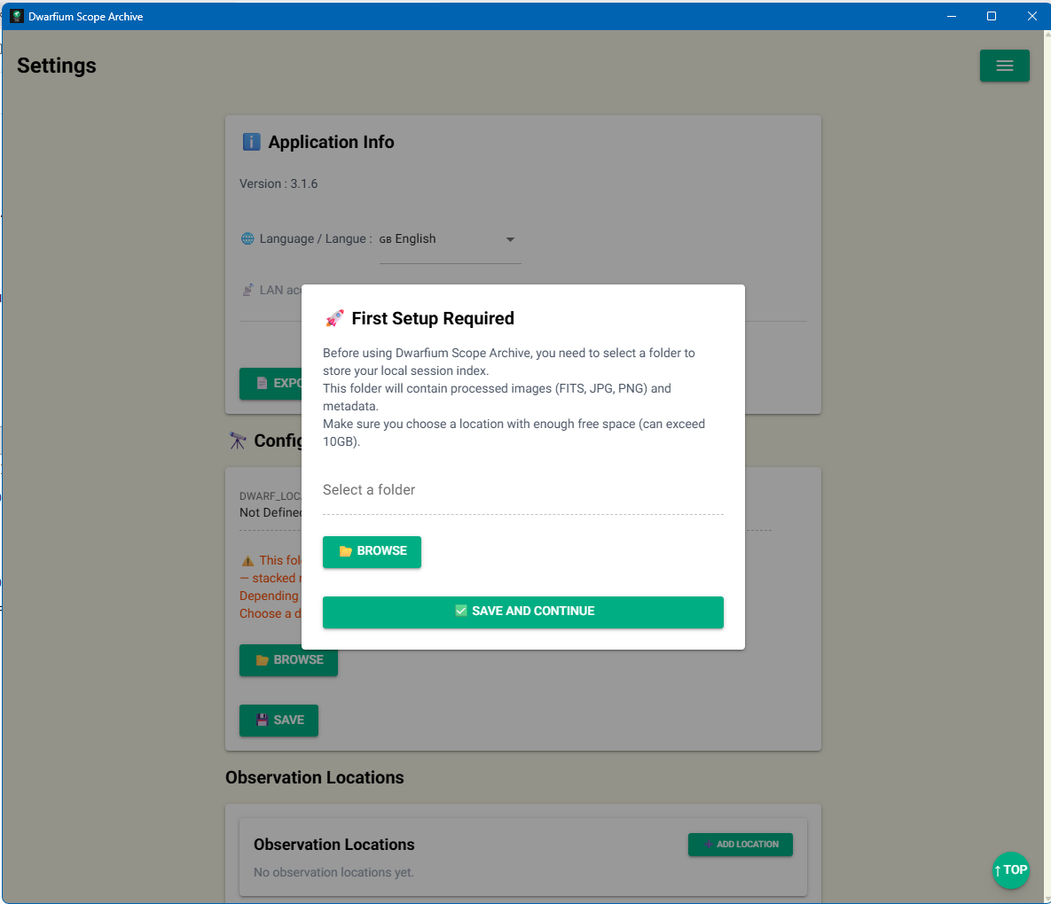

After the first initialization, when you launch the application, the Home screen will be displayed.

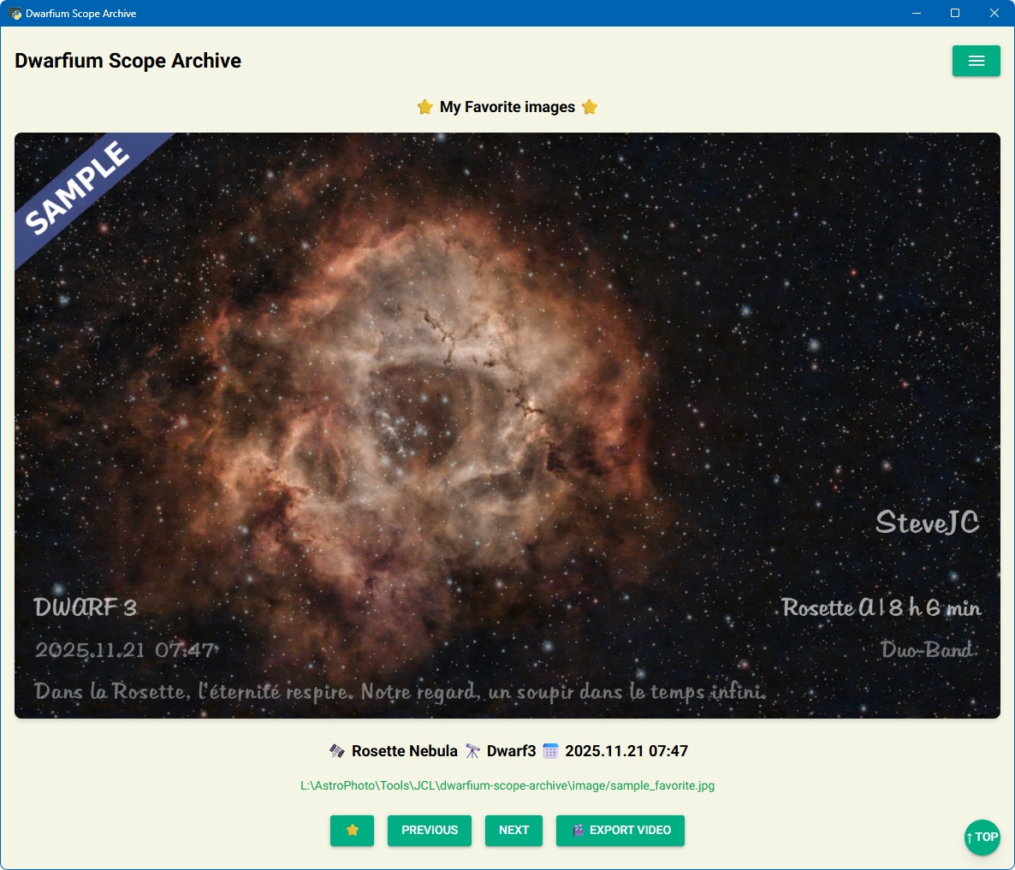

The Home page displays a panorama of your favorite images, which you can share using the Export Video button.

The first step is to add your Dwarf to the application.
At the first launch, the Dwarf Settings page will open automatically with the Help panel on the right.
If not, open the Dwarfs Settings from the Menu.
Switch your Dwarf on and plug it into a USB port of your computer.
See the Help panel on the right (if the Help panel is not visible, enable it from the menu).

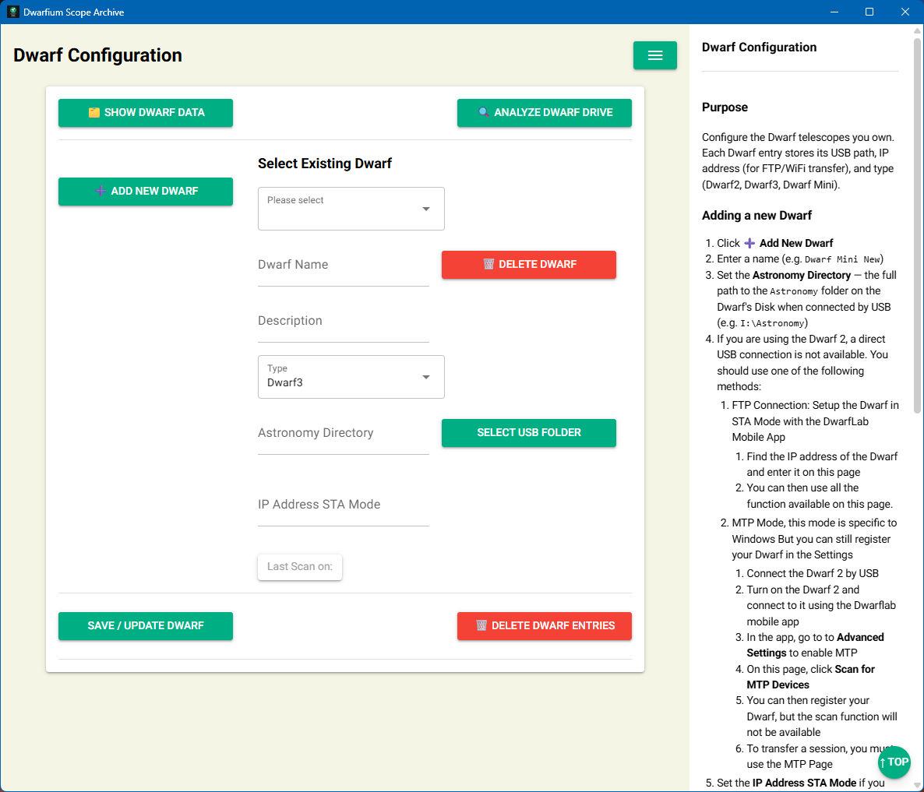

You need to enter a name (of your choice), select the correct Dwarf type, and select the Dwarf Astronomy directory using the SELECT USB FOLDER button.
Under the Astronomy Directory, ✅ Path detected tells you the Dwarf's disk is reachable (❌ Path not detected when it isn't plugged in; ⟳ checks again).
Dwarf ID (end of its MAC): enter the last 6 characters of the MAC address printed on your Dwarf - they also end its Bluetooth name, e.g. DWARF3_A1B2C3. You can paste the whole MAC address. With the Dwarf on your Wi-Fi and its IP filled in, Read from the Dwarf fills it in for you. This identifier lets the application check that the Dwarf connected is really the one selected (useful with two Dwarfs of the same model); Dwarfium-Hub also uses it to link the Dwarf to Dwarfium Lite.
IP Address STA Mode (optional): the Dwarf's IP on your Wi-Fi network, for FTP (wireless) transfers. A Dwarf 2 has no USB disk mode: it uses FTP, or MTP on Windows (see the Help panel).
Session IP (optional): a second IP for the same Dwarf, kept on this PC only - e.g. its address on a remote site reached through Tailscale. The application uses whichever IP answers.
Several Dwarfs? Identify makes the ring light of the Dwarf at this IP flash (needs Dwarfium Lite running; never during a capture).
Save your configuration with the SAVE / UPDATE DWARF button.

Example :
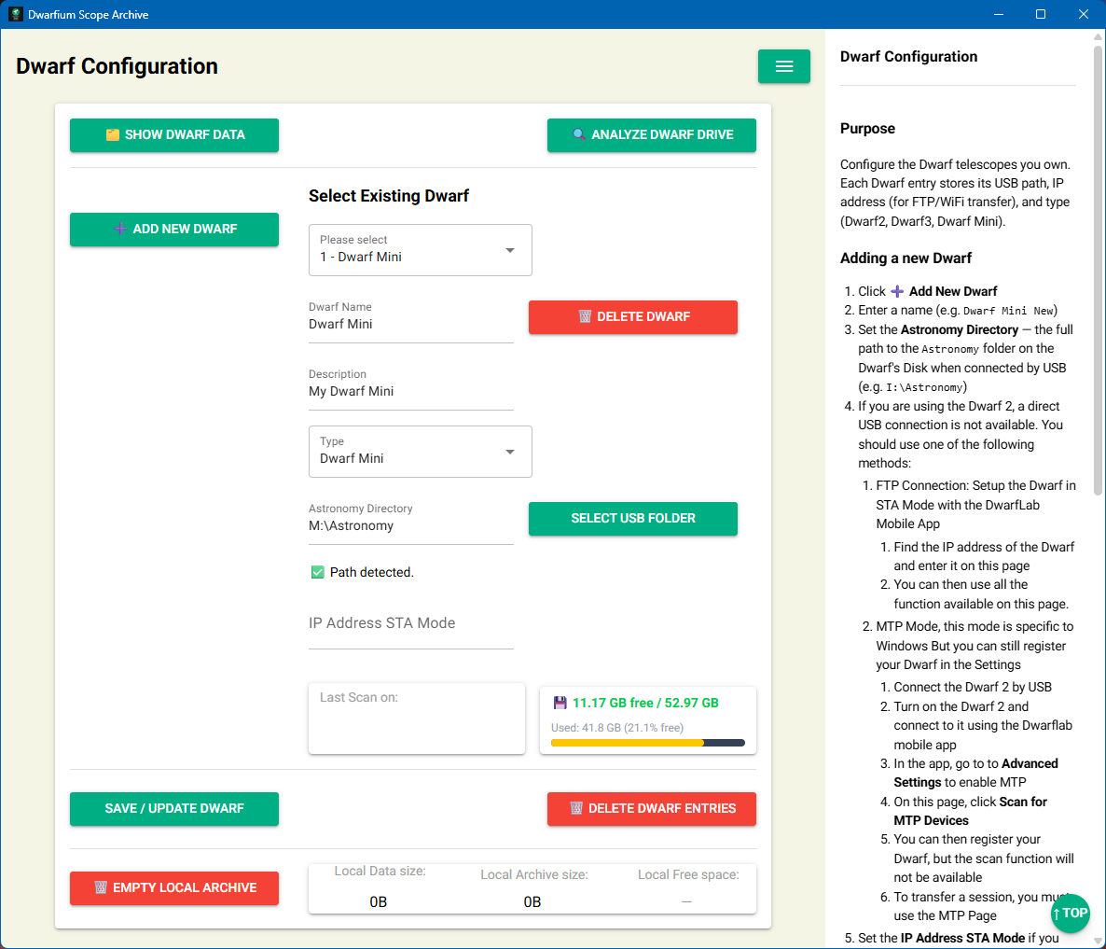

Then launch the analysis of the Dwarf sessions using the ANALYZE DWARF DRIVE button.
Before scanning, the application checks that the Dwarf connected is the one selected: its model, its Dwarf ID over FTP, and whether its sessions are already archived under another Dwarf. If something doesn't match, a warning lets you select the right Dwarf, or continue anyway if you are sure.
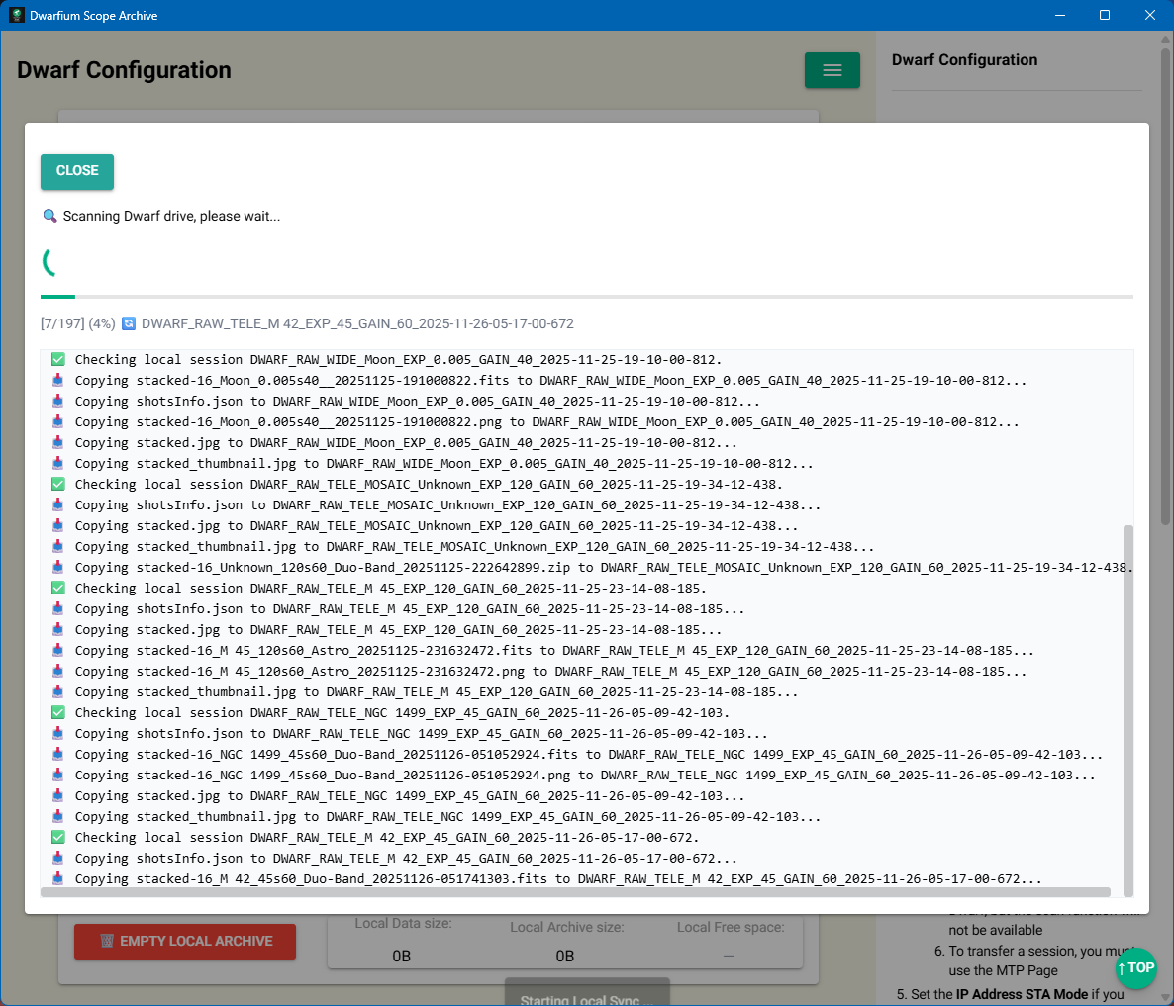
It takes time if you have many sessions…
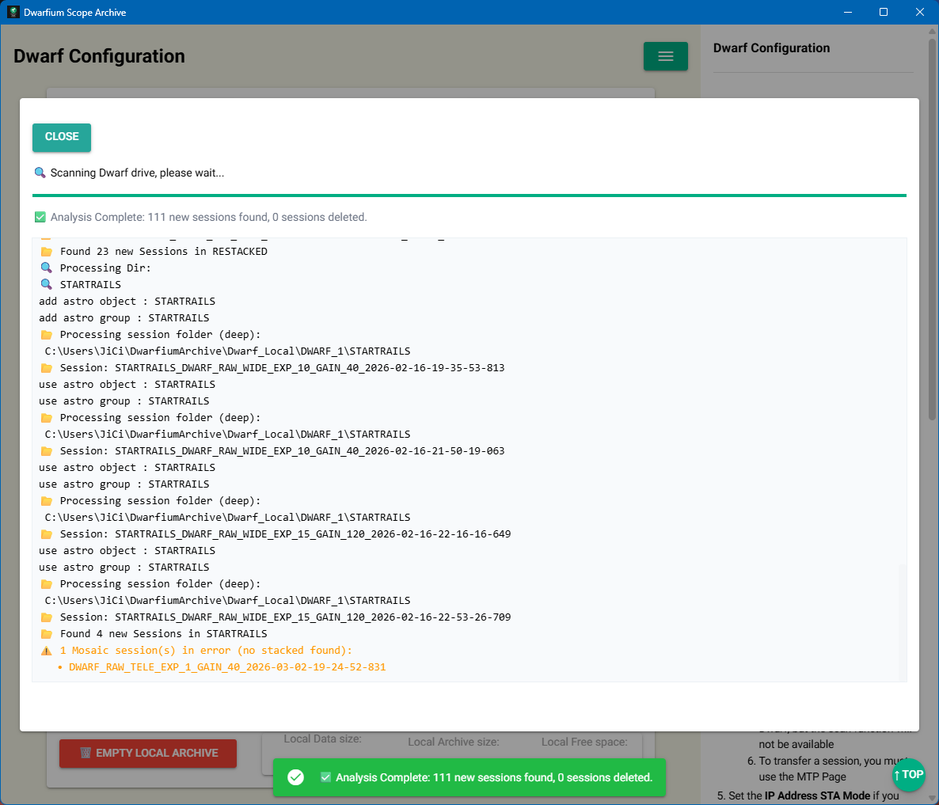
At the End it will display how many sessions have been found on your Dwarf.
The local data archive has been updated, and your data is ready to be backed up.
The ⚠️ Sessions in Error button appears when some sessions have no final stacked image: normal for a session stopped early; a mosaic in this list can be repaired from the Mosaic page.
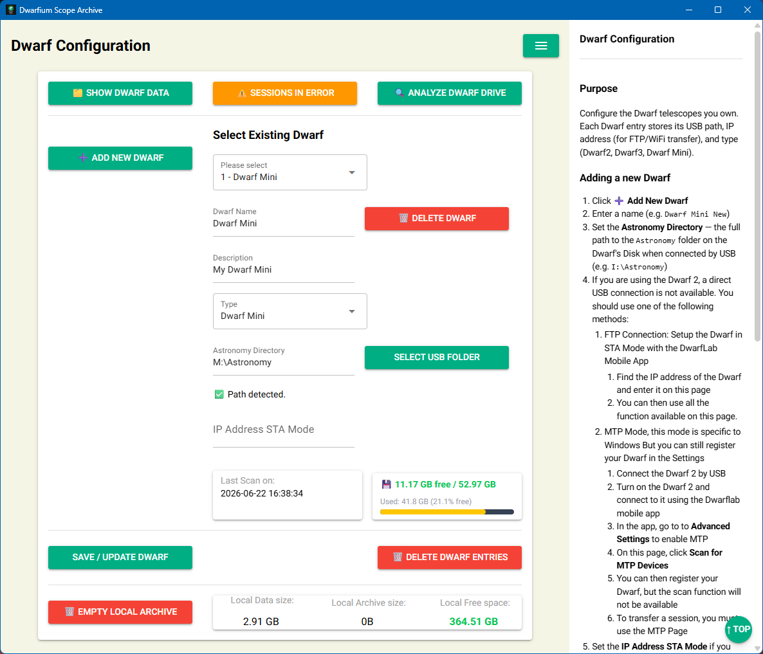

The Show Dwarf Data button will display the sessions found on the telescope.

This opens the Explore Page for the Current Dwarf Data
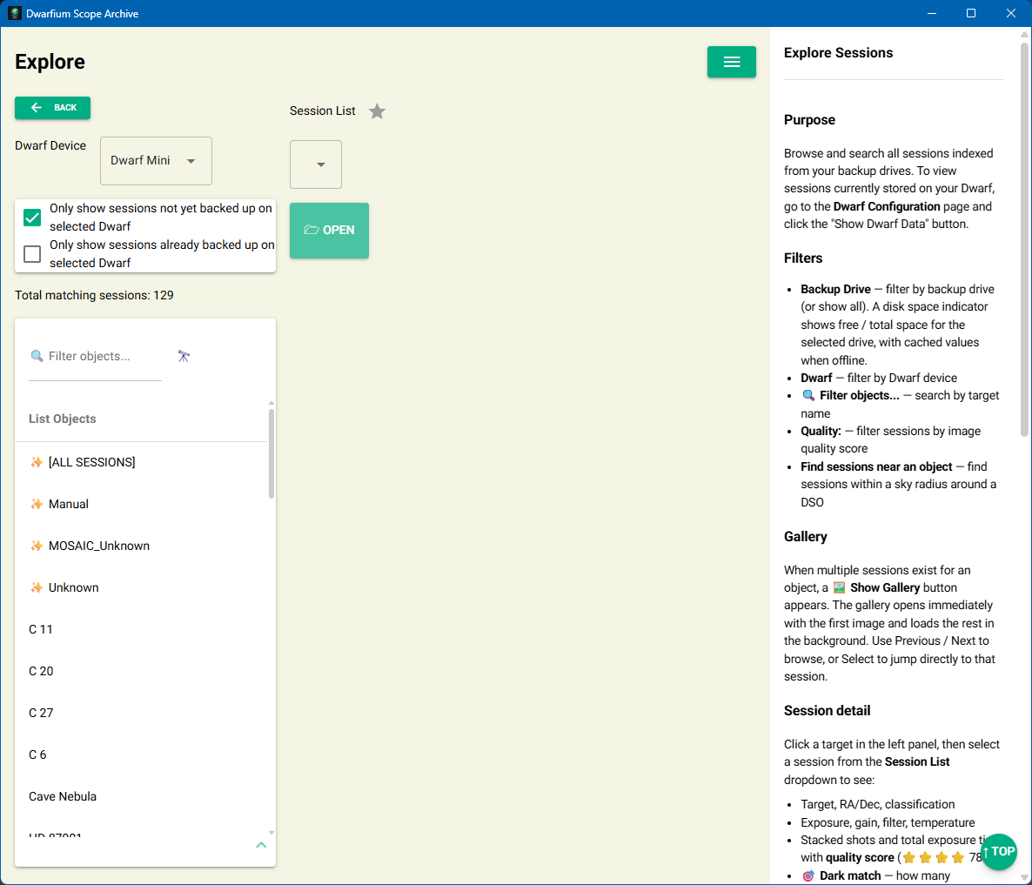
This page is split into two main areas.
Left side
- Dwarf list — choose which of your registered Dwarf devices you want to browse.
- Status filter — narrow down the sessions shown, based on their status.
The « not yet backed up » filter is selected at first run to permit backup
- Session/object list — the list of session objects found for the selected Dwarf.
Right side
- Session list — shows the sessions for the object you selected on the left. This list can be empty if the selected object has no matching sessions.
- Action buttons — actions you can run on the whole list or on a selected session. They are large icons, grouped by kind: hover over one to see its name (on a phone or tablet, the name is shown under the icon).
- Session details — once you select a session in the list, its details are shown here.
Selecting an object
You can select All Sessions to list every session found on the Dwarf, or pick a specific object from the list on the left.
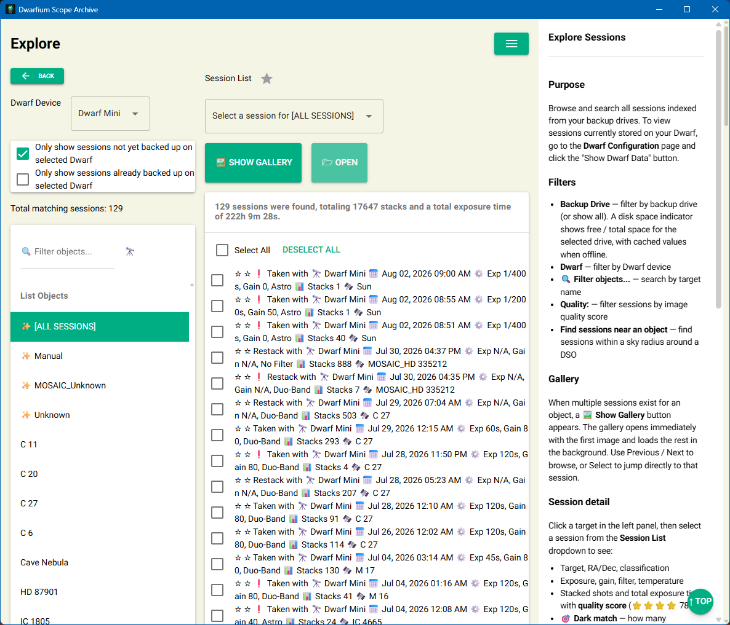
Selecting a session
Click a session in the session list to select it. Its details are shown in the Infos tab, and its picture in the Image tab (swipe between them on a touch screen).
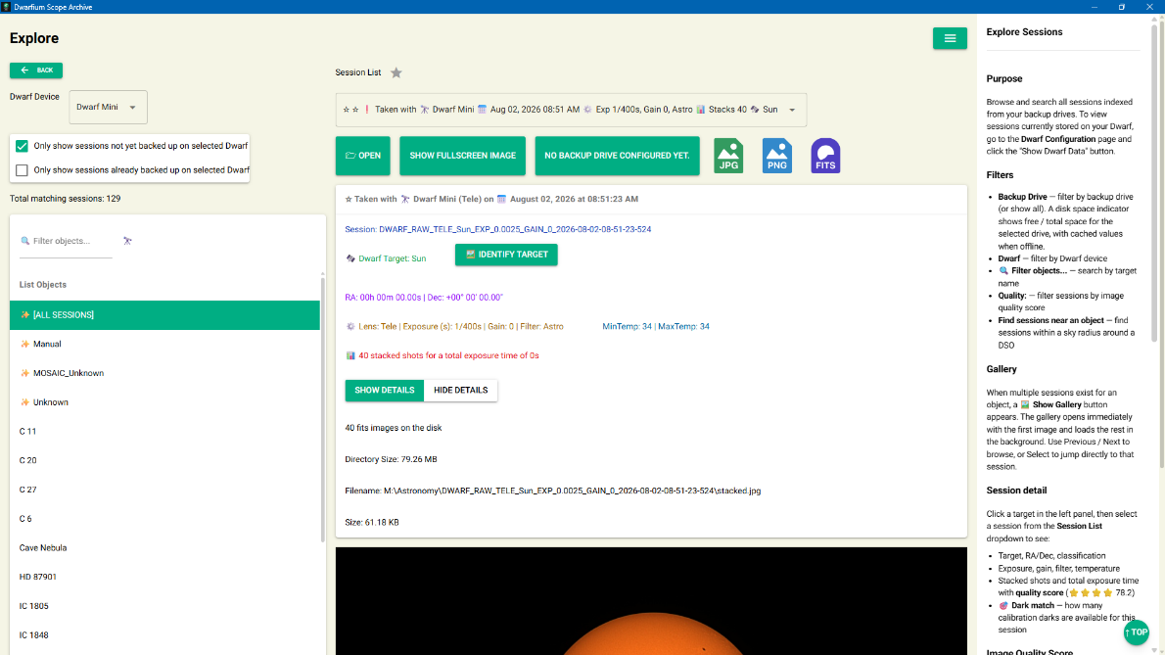
Backing up a session
To back up your session, click the "No Backup Drive configured yet" icon (a crossed-out cloud), then Go to Backup Settings. This takes you to the Backup Configuration page, where you can configure where your sessions are backed up.
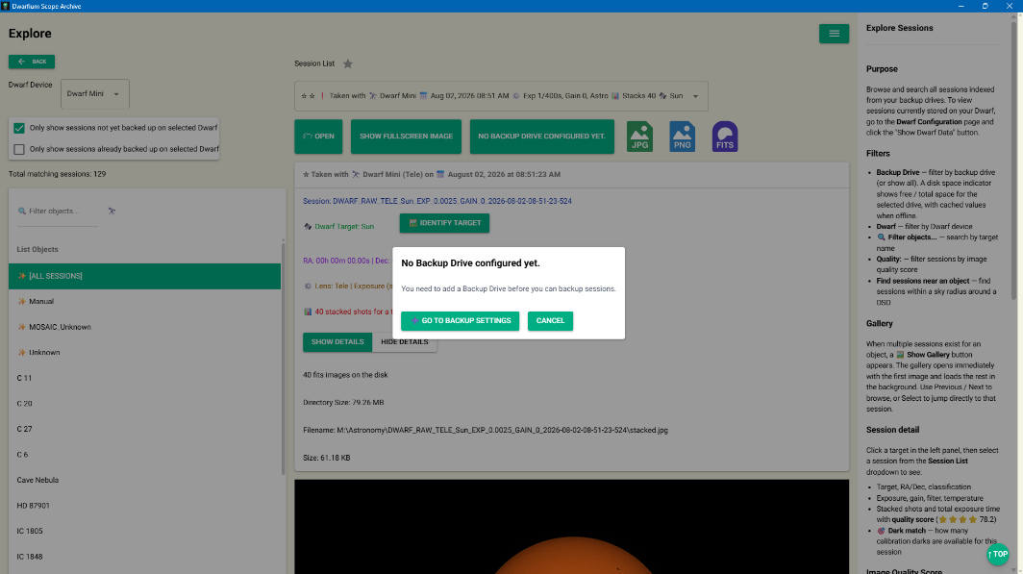
To create a backup drive, fill in:
- A name (of your choice).
- A description.
- A main directory, where all your data will be backed up — set it using the SELECT FOLDER button.
- A specific sub-directory, where the Dwarf sessions will be saved — set it using the SELECT SUB FOLDER button.
- The Dwarf associated with this backup — select the correct one from the list.
Save your configuration with the SAVE / UPDATE BACKUP DRIVE button.
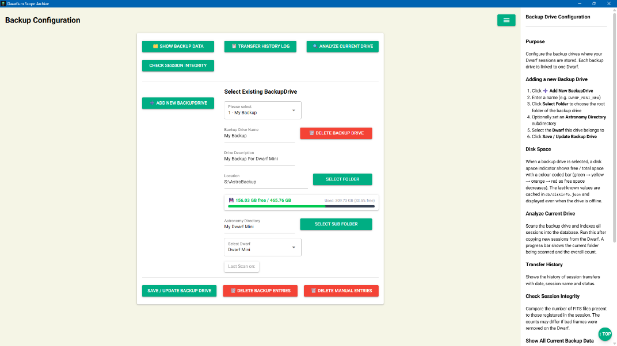

After saving, an information message dialog lets you go back to the Explore page to back up your data.
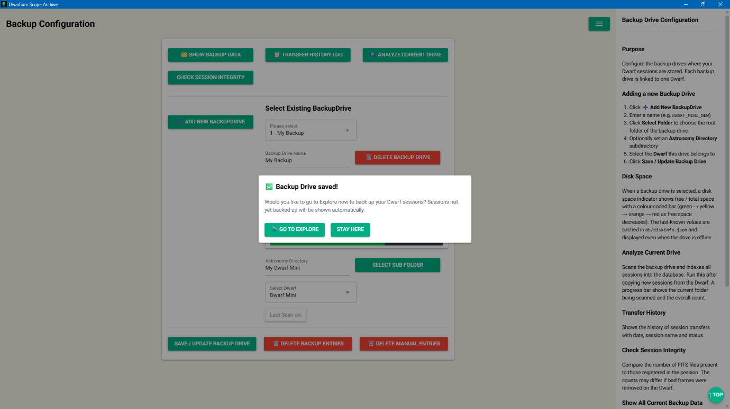

Now the Backup Session icon is available
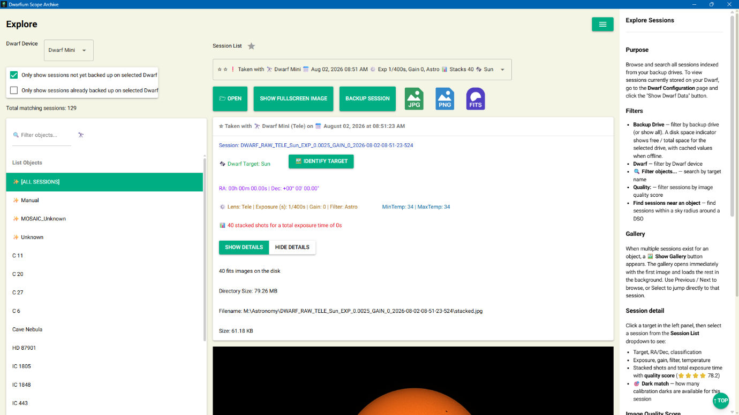

Click it, to open the Session Transfer page
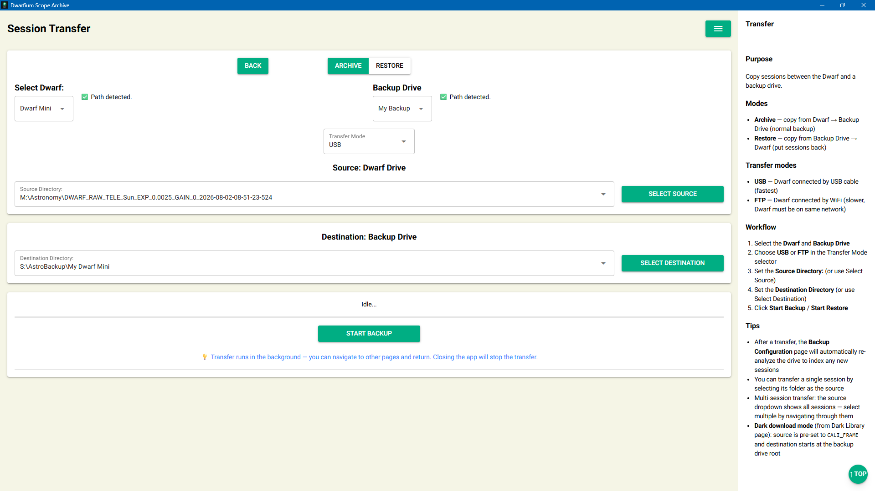

All the needed information has already been filled in — just click Start Backup.
The transfer runs in the background: you can go to other pages and come back. Closing the application stops it.
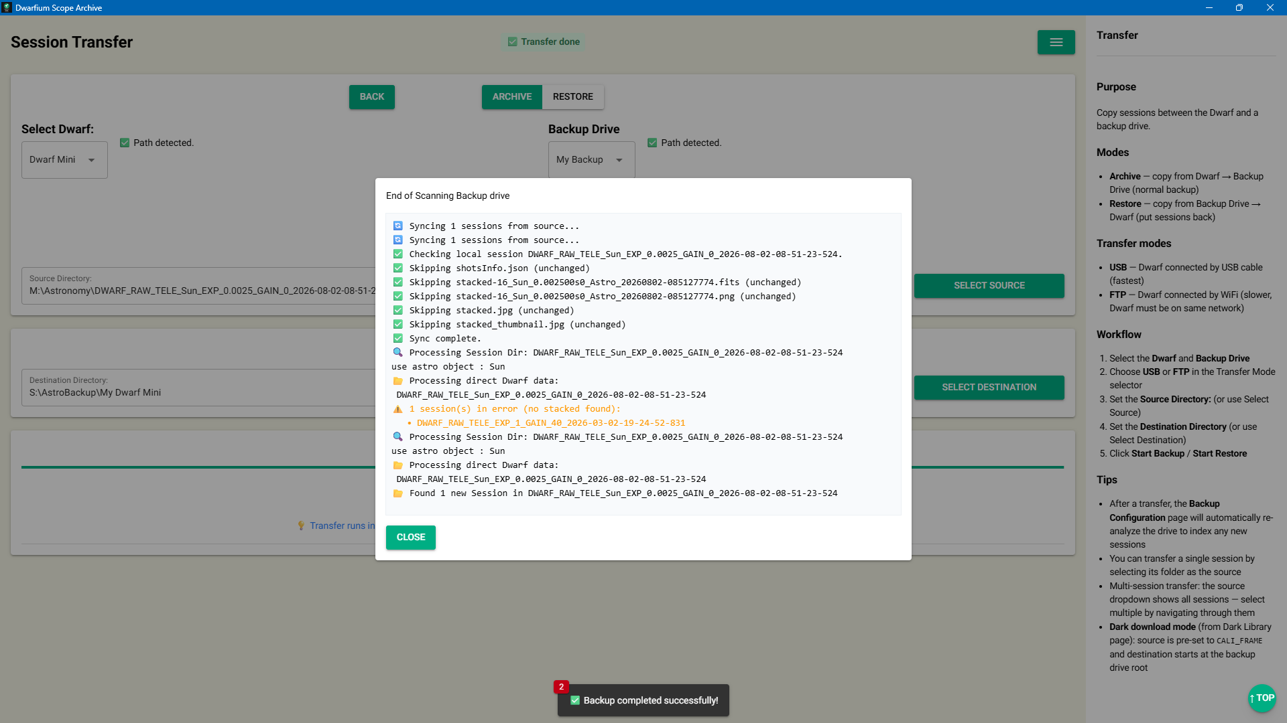

An information dialog confirms the backup of your session.

Remark: On the Explore page, if you've selected an object on the left that has multiple sessions, you can also select multiple sessions on the right.
The Backup Selected Sessions icon lets you back up all of them in one go.
You can even select the "All Sessions" object and Select All on the right to back up everything at once.

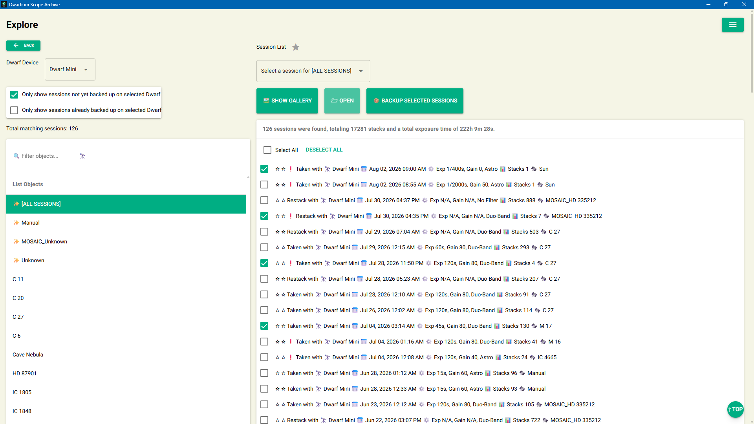

More to discover
- What to shoot tonight (menu, with the Dwarfium logo): ranks the targets visible tonight from your location, taking into account what you have already captured. With Dwarfium Lite running, its 📅 icon plans a target - or a list of targets - on your Dwarf. Add your observation location first, at the bottom of the Settings page.
- Analyze everything (menu): analyzes the local copy of every Dwarf and every backup drive in one go - useful if folders were changed outside the application (sessions moved by hand, another installation).
- Dark Library, Mosaic, Manual Sessions (images processed in Siril, GraXpert…), Sky Map, Storage Report: see each page's Help.
- Dwarfium Lite controls the Dwarf (captures, programs, schedules) and can send a session straight to Scope Archive to archive it; Dwarfium-Hub installs and links the applications.
What's next
Now you are ready to explore the other functions of Dwarfium Scope Archive.
Use the Menu to discover them, and the Help page (which can be shown or hidden from the Menu) will guide you.

