Model Report
19 Jan 2022 19:58:11


 | Purpose
 | Model Report | 2 | / 67

 | Views
 | Application Life Cycle Management
 | No viewpoint
 | 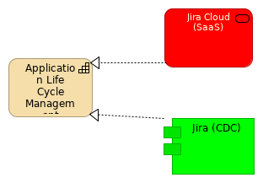
 | Elements
 | Element | Type
 | Application Life Cycle Management | Capability
 | Jira (CDC) | Application Component
 | Jira Cloud (SaaS) | Application Service
 | Model Report |  |  | 3 | / 67

 | Current State Landscape
 | No viewpoint
 | Model Report | 4 | / 67

 | 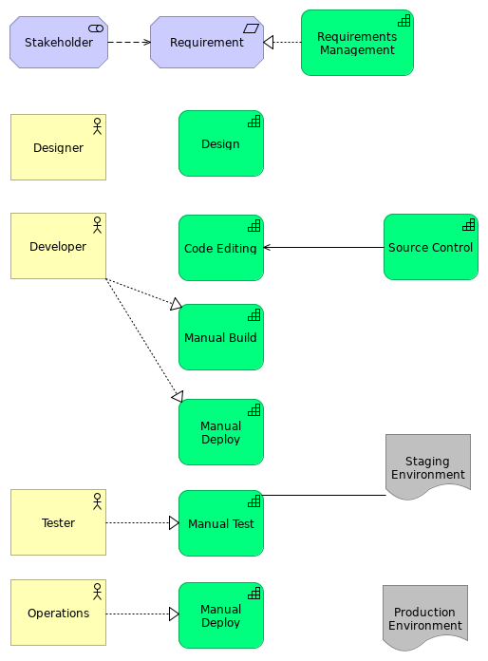
 | Model Report | 5 | / 67

 | Elements
 | Element | Type
 | Code Editing | Capability
 | Design | Capability
 | Designer | Business Actor
 | Developer | Business Actor
 | Manual Build | Capability
 | Manual Deploy | Capability
 | Manual Deploy | Capability
 | Manual Test | Capability
 | Operations | Business Actor
 | Production Environment | Deliverable
 | Requirement | Requirement
 | Requirements Management | Capability
 | Source Control | Capability
 | Staging Environment | Deliverable
 | Stakeholder | Stakeholder
 | Tester | Business Actor
 | Model Report |  | 6 | / 67

 | DevOps
 | No viewpoint
 | 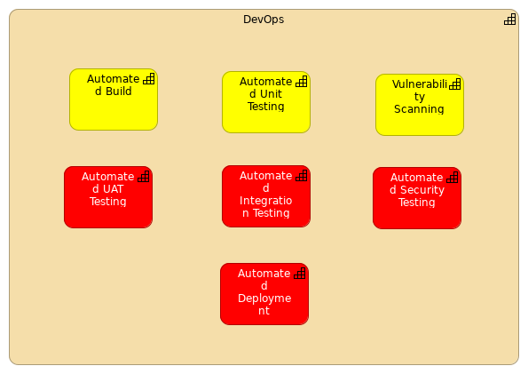
 | Elements
 | Element | Type
 | Automated Build | Capability
 | Automated Deployment | Capability
 | Automated Integration Testing | Capability
 | Automated Security Testing | Capability
 | Automated UAT Testing | Capability
 | Automated Unit Testing | Capability
 | DevOps | Capability
 | Vulnerability Scanning | Capability
 | Model Report |  | 7 | / 67

 | Lifecycle
 | Requirements Realization viewpoint
 | 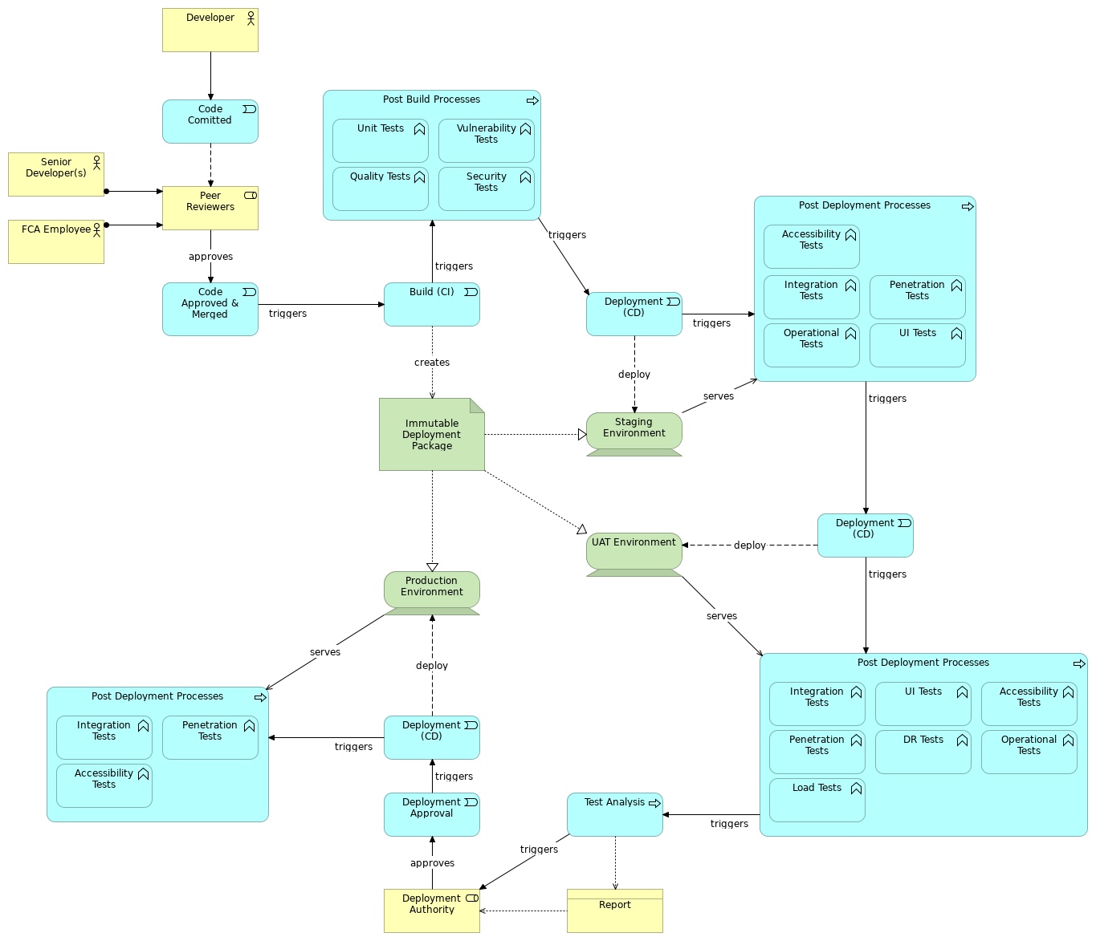
 | Elements
 | Element | Type
 | Accessibility Tests | Application Function
 | Accessibility Tests | Application Function
 | Accessibility Tests | Application Function
 | Build (CI) | Application Event
 | Code Approved & Merged | Application Event
 | Code Comitted | Application Event
 | Deployment (CD) | Application Event
 | Deployment (CD) | Application Event
 | Deployment (CD) | Application Event
 | Deployment Approval | Application Event
 | Deployment Authority | Business Role
 | Developer | Business Actor
 | Model Report |  | 8 | / 67

 | Element | Type
 | DR Tests | Application Function
 | FCA Employee | Business Actor
 | Immutable Deployment Package | Artifact
 | Integration Tests | Application Function
 | Integration Tests | Application Function
 | Integration Tests | Application Function
 | Load Tests | Application Function
 | Operational Tests | Application Function
 | Operational Tests | Application Function
 | Peer Reviewers | Business Role
 | Penetration Tests | Application Function
 | Penetration Tests | Application Function
 | Penetration Tests | Application Function
 | Post Build Processes | Application Process
 | Post Deployment Processes | Application Process
 | Post Deployment Processes | Application Process
 | Post Deployment Processes | Application Process
 | Production Environment | Device
 | Quality Tests | Application Function
 | Report | Business Object
 | Security Tests | Application Function
 | Senior Developer(s) | Business Actor
 | Staging Environment | Device
 | Test Analysis | Application Process
 | UAT Environment | Device
 | UI Tests | Application Function
 | UI Tests | Application Function
 | Unit Tests | Application Function
 | Vulnerability Tests | Application Function
 | Model Report |  | 9 | / 67

 | People & Processes
 | No viewpoint
 | 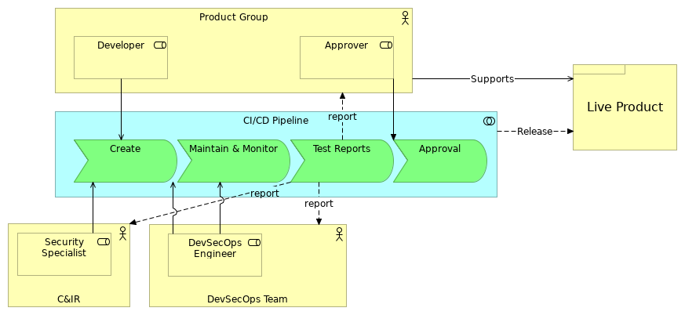
 | Elements
 | Element | Type
 | Approval | Application Event
 | Approver | Business Role
 | C&IR | Business Actor
 | CI/CD Pipeline | Application Collaboration
 | Create | Application Event
 | Developer | Business Role
 | DevSecOps Engineer | Business Role
 | DevSecOps Team | Business Actor
 | Live Product | Product
 | Maintain & Monitor | Application Event
 | Product Group | Business Actor
 | Security Specialist | Business Role
 | Test Reports | Application Event
 | Model Report |  | 10 | / 67

 | People Transitions
 | Implementation and Migration viewpoint
 | 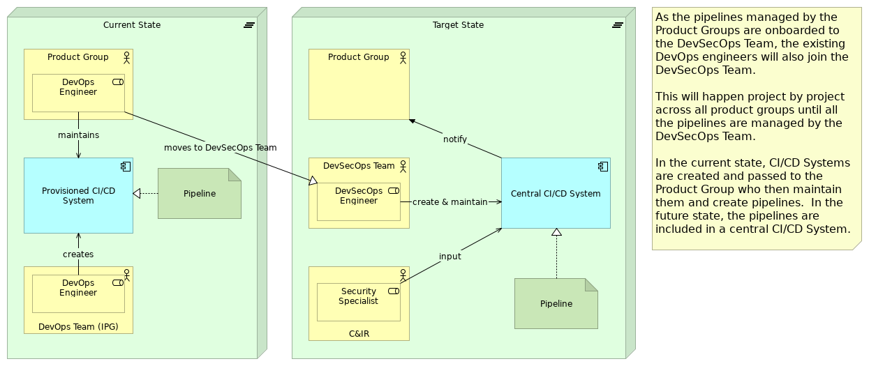
 | Elements
 | Element | Type
 | C&IR | Business Actor
 | Central CI/CD System | Application Component
 | Current State | Plateau
 | DevOps Engineer | Business Role
 | DevOps Team (IPG) | Business Actor
 | DevSecOps Engineer | Business Role
 | DevSecOps Team | Business Actor
 | Pipeline | Artifact
 | Pipeline | Artifact
 | Product Group | Business Actor
 | Provisioned CI/CD System | Application Component
 | Security Specialist | Business Role
 | Target State | Plateau
 | Model Report |  | 11 | / 67

 | SDLC Outcomes
 | Strategy viewpoint
 | 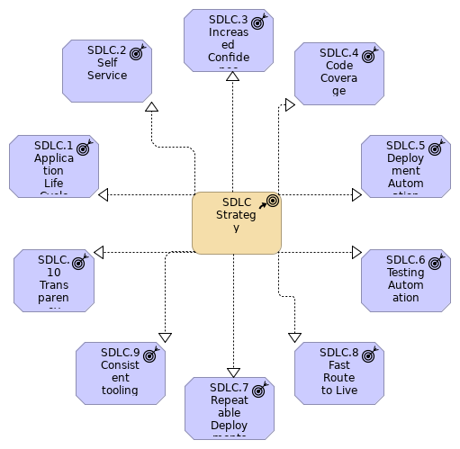
 | Elements
 | Element | Type
 | SDLC Strategy | Course of Action
 | SDLC.1 Application Life Cycle | Outcome
 | SDLC.10 Transparency | Outcome
 | SDLC.2 Self Service | Outcome
 | SDLC.3 Increased Confidence | Outcome
 | SDLC.4 Code Coverage | Outcome
 | SDLC.5 Deployment Automation | Outcome
 | SDLC.6 Testing Automation | Outcome
 | Model Report |  | 12 | / 67

 | Element | Type
 | SDLC.7 Repeatable Deployments | Outcome
 | SDLC.8 Fast Route to Live | Outcome
 | SDLC.9 Consistent tooling | Outcome
 | Model Report |  | 13 | / 67

 | SDLC.1 Application Life Cycle
 | No viewpoint
 | 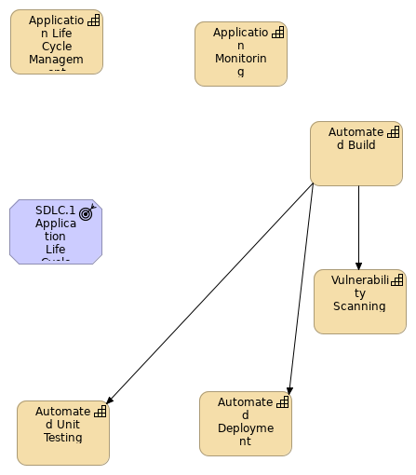
 | Elements
 | Element | Type
 | Application Life Cycle Management | Capability
 | Application Monitoring | Capability
 | Automated Build | Capability
 | Automated Deployment | Capability
 | Automated Unit Testing | Capability
 | SDLC.1 Application Life Cycle | Outcome
 | Vulnerability Scanning | Capability
 | Model Report |  | 14 |  | / 67

 | Model Report | 15 | / 67

 | SDLC.10 Transparency
 | No viewpoint
 | 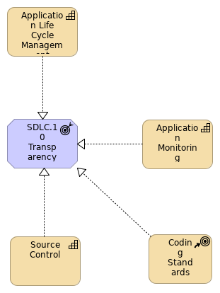
 | Elements
 | Element | Type
 | Application Life Cycle Management | Capability
 | Application Monitoring | Capability
 | Coding Standards | Course of Action
 | SDLC.10 Transparency | Outcome
 | Source Control | Capability
 | Model Report |  |  | 16 | / 67

 | SDLC.2 Self Service
 | No viewpoint
 | 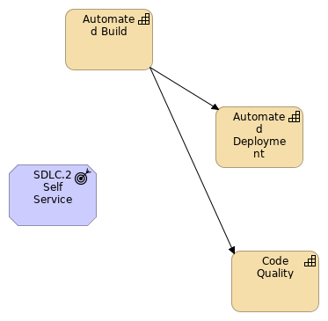
 | Elements
 | Element | Type
 | Automated Build | Capability
 | Automated Deployment | Capability
 | Code Quality | Capability
 | SDLC.2 Self Service | Outcome
 | Model Report |  |  | 17 | / 67

 | SDLC.3 Increased Confidence
 | No viewpoint
 | 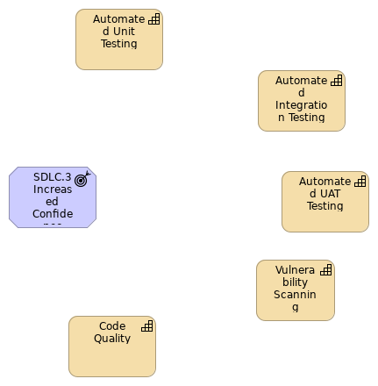
 | Elements
 | Element | Type
 | Automated Integration Testing | Capability
 | Automated UAT Testing | Capability
 | Automated Unit Testing | Capability
 | Code Quality | Capability
 | SDLC.3 Increased Confidence | Outcome
 | Vulnerability Scanning | Capability
 | Model Report |  | 18 |  | / 67

 | SDLC.4 Code Coverage
 | No viewpoint
 | 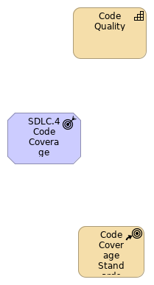
 | Elements
 | Element |  | Type
 | Code Coverage Standards |  | Course of Action
 | Code Quality |  | Capability
 | SDLC.4 Code Coverage |  | Outcome
 | Model Report |  |  | 19 | / 67

 | SDLC.5 Deployment Automation
 | No viewpoint
 | 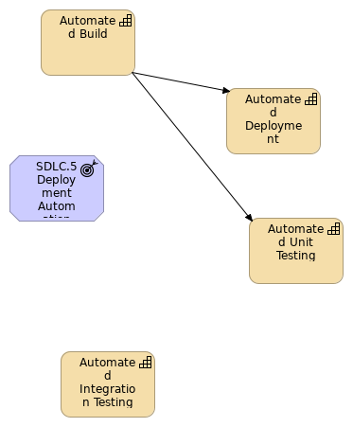
 | Elements
 | Element | Type
 | Automated Build | Capability
 | Automated Deployment | Capability
 | Automated Integration Testing | Capability
 | Automated Unit Testing | Capability
 | SDLC.5 Deployment Automation | Outcome
 | Model Report |  |  | 20 | / 67

 | SDLC.6 Testing Automation
 | No viewpoint
 | 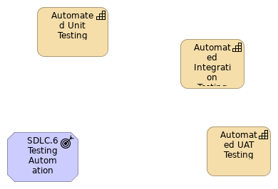
 | Elements
 | Element | Type
 | Automated Integration Testing | Capability
 | Automated UAT Testing | Capability
 | Automated Unit Testing | Capability
 | SDLC.6 Testing Automation | Outcome
 | Model Report |  |  | 21 | / 67

 | SDLC.7 Repeatable Deployments
 | No viewpoint
 | 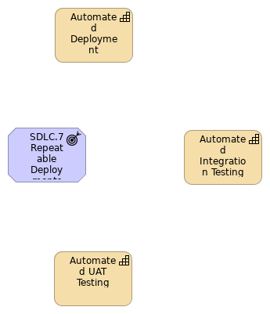
 | Elements
 | Element | Type
 | Automated Deployment | Capability
 | Automated Integration Testing | Capability
 | Automated UAT Testing | Capability
 | SDLC.7 Repeatable Deployments | Outcome
 | Model Report |  |  | 22 | / 67

 | SDLC.8 Fast Route to Live
 | No viewpoint
 | 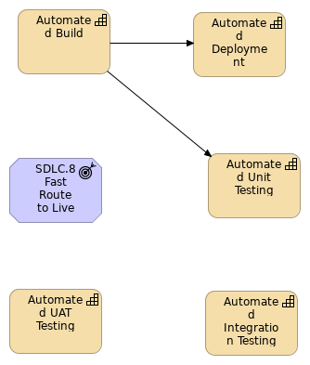
 | Elements
 | Element | Type
 | Automated Build | Capability
 | Automated Deployment | Capability
 | Automated Integration Testing | Capability
 | Automated UAT Testing | Capability
 | Automated Unit Testing | Capability
 | SDLC.8 Fast Route to Live | Outcome
 | Model Report |  |  | 23 | / 67

 | SDLC.9 Consistent tooling
 | No viewpoint
 | 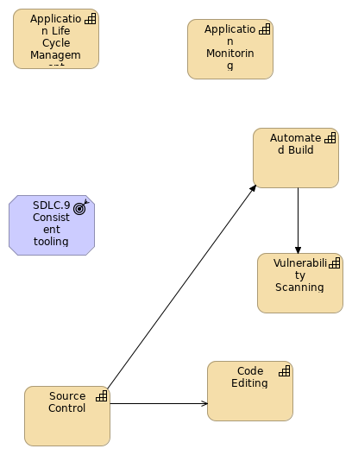
 | Elements
 | Element | Type
 | Application Life Cycle Management | Capability
 | Application Monitoring | Capability
 | Automated Build | Capability
 | Code Editing | Capability
 | SDLC.9 Consistent tooling | Outcome
 | Source Control | Capability
 | Vulnerability Scanning | Capability
 | Model Report |  | 24 |  | / 67

 | Model Report | 25 | / 67

 | Target State Capability Map - Tooling
 | No viewpoint
 | 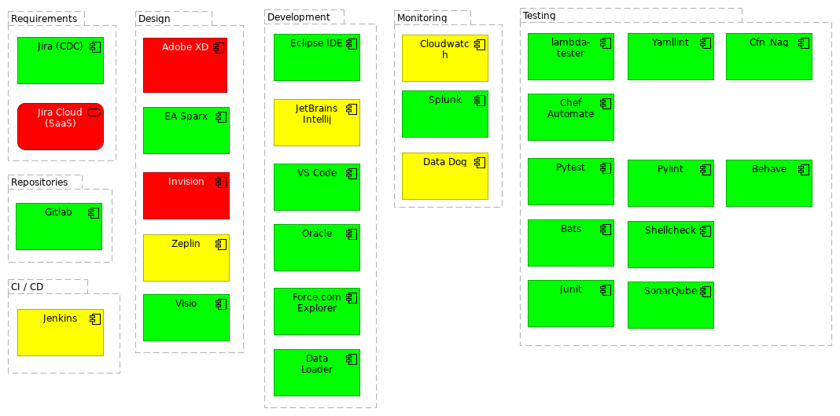
 | Elements
 | Element | Type
 | Adobe XD | Application Component
 | Bats | Application Component
 | Behave | Application Component
 | Cfn_Nag | Application Component
 | Chef Automate | Application Component
 | CI / CD | Grouping
 | Cloudwatch | Application Component
 | Data Dog | Application Component
 | Data Loader | Application Component
 | Design | Grouping
 | Development | Grouping
 | EA Sparx | Application Component
 | Eclipse IDE | Application Component
 | Force.com Explorer | Application Component
 | Gitlab | Application Component
 | Invision | Application Component
 | Jenkins | Application Component
 | JetBrains Intellij | Application Component
 | Jira (CDC) | Application Component
 | Jira Cloud (SaaS) | Application Service
 | Junit | Application Component
 | lambda-tester | Application Component
 | Monitoring | Grouping
 | Oracle | Application Component
 | Model Report |  | 26 | / 67

 | Element | Type
 | Pylint | Application Component
 | Pytest | Application Component
 | Repositories | Grouping
 | Requirements | Grouping
 | Shellcheck | Application Component
 | SonarQube | Application Component
 | Splunk | Application Component
 | Testing | Grouping
 | Visio | Application Component
 | VS Code | Application Component
 | Yamllint | Application Component
 | Zeplin | Application Component
 | Model Report |  | 27 | / 67

 | Target State Landscape
 | No viewpoint
 | 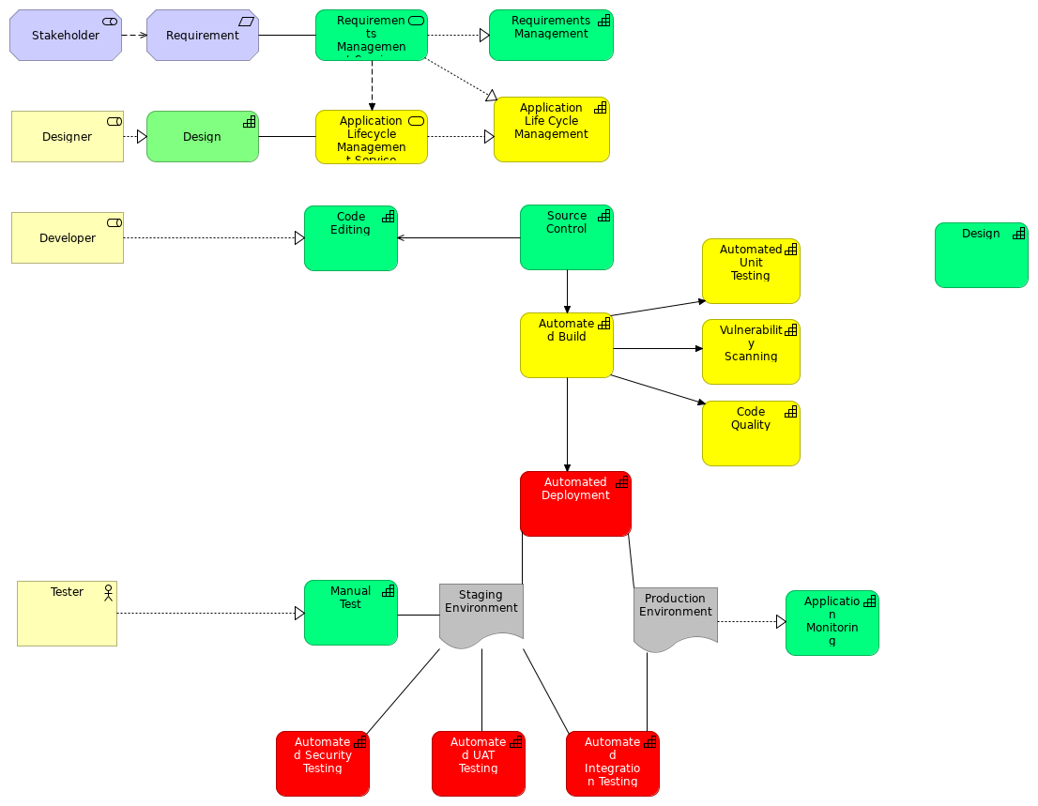
 | Elements
 | Element | Type
 | Application Life Cycle Management | Capability
 | Application Lifecycle Management Service | Application Service
 | Application Monitoring | Capability
 | Automated Build | Capability
 | Automated Deployment | Capability
 | Automated Integration Testing | Capability
 | Automated Security Testing | Capability
 | Automated UAT Testing | Capability
 | Automated Unit Testing | Capability
 | Code Editing | Capability
 | Code Quality | Capability
 | Design | Capability
 | Designer | Business Role
 | Developer | Business Role
 | Manual Test | Capability
 | Model Report |  | 28 | / 67

 | Element | Type
 | Production Environment | Deliverable
 | Requirement | Requirement
 | Requirements Management | Capability
 | Requirements Management Service | Application Service
 | Source Control | Capability
 | Staging Environment | Deliverable
 | Stakeholder | Stakeholder
 | Tester | Business Actor
 | Vulnerability Scanning | Capability
 | Model Report |  | 29 | / 67

 | Strategy Layer
 | Application Life Cycle Management
 | Type | Capability
 | Application Monitoring
 | Type | Capability
 | Approve
 | Type | Value Stream
 | Automated Build
 | Type | Capability
 | Automated Deployment
 | Type | Capability
 | Automated Integration Testing
 | Type | Capability
 | Automated Security Testing
 | Type | Capability
 | Automated UAT Testing
 | Type | Capability
 | Automated Unit Testing
 | Type | Capability
 | Code Coverage Standards
 | Type | Course of Action
 | Code Editing
 | Type | Capability
 | Code Quality
 | Type | Capability
 | Coding Standards
 | Type | Course of Action
 | Create
 | Type | Value Stream
 | Model Report |  | 30 | / 67

 | Create (copy)
 | Type | Value Stream
 | Design
 | Type | Capability
 | DevOps
 | Type | Capability
 | Maintain & Monitor
 | Type | Value Stream
 | Manual Build
 | Type | Capability
 | Manual Deploy
 | Type | Capability
 | Manual Deploy
 | Type | Capability
 | Manual Test
 | Type | Capability
 | Requirements Management
 | Type | Capability
 | SDLC Strategy
 | Type | Course of Action
 | Source Control
 | Type | Capability
 | Test Reports
 | Type | Value Stream
 | Vulnerability Scanning
 | Type | Capability
 | Model Report |  | 31 | / 67

 | Business Layer
 | Approver
 | Type | Business Role
 | Business Function
 | Type | Business Function
 | Business Process
 | Type | Business Process
 | C&IR
 | Type | Business Actor
 | Deployment Authority
 | Type | Business Role
 | Designer
 | Type | Business Actor
 | Designer
 | Type | Business Role
 | Developer
 | Type | Business Role
 | Developer
 | Type | Business Actor
 | DevOps
 | Type | Business Service
 | DevOps (CDC)
 | Type | Business Service
 | DevOps (EUC)
 | Type | Business Service
 | DevOps Engineer
 | Type | Business Role
 | DevOps Team (IPG)
 | Type | Business Actor
 | Model Report |  | 32 | / 67

 | DevSecOps Engineer
 | Type |  | Business Role
 | DevSecOps Engineer
 | Type |  | Business Role
 | DevSecOps Team
 | Type |  | Business Actor
 | FCA Employee
 | Type |  | Business Actor
 |  | To verify the code changes and to ensure test quality
 | Live Product
 | Type |  | Product
 | Operations
 | Type |  | Business Actor
 | Peer Reviewers
 | Type |  | Business Role
 | Product Group
 | Type |  | Business Actor
 | Report
 | Type |  | Business Object
 | Security Specialist
 | Type |  | Business Role
 | Senior Developer(s)
 | Type |  | Business Actor
 | Stakeholder
 | Type |  | Business Actor
 | Tester
 | Type |  | Business Actor
 | Model Report |  |  | 33 | / 67

 | Application Layer
 | Accessibility Tests
 | Type |  | Application Function
 |  | UAT
 | Accessibility Tests
 | Type |  | Application Function
 |  | Staging
 | Accessibility Tests
 | Type |  | Application Function
 |  | Production
 | Adobe XD
 | Type |  | Application Component
 | Application Lifecycle Management Service
 | Type |  | Application Service
 | Approval
 | Type |  | Application Event
 | Bats
 | Type |  | Application Component
 | Behave
 | Type |  | Application Component
 | Build (CI)
 | Type |  | Application Event
 | Central CI/CD System
 | Type |  | Application Component
 | Cfn_Nag
 | Type |  | Application Component
 | Chef Automate
 | Type |  | Application Component
 | Model Report |  |  | 34 | / 67

 | CI/CD Pipeline
 | Type |  | Application Collaboration
 | CI/CD Pipeline
 | Type |  | Application Service
 | Cloudwatch
 | Type |  | Application Component
 | Code Approved & Merged
 | Type |  | Application Event
 | Code Comitted
 | Type |  | Application Event
 | Create
 | Type |  | Application Event
 | Data Dog
 | Type |  | Application Component
 | Data Loader
 | Type |  | Application Component
  FCAType | Development Tool
 | Deployment (CD)
 | Type |  | Application Event
 |  | Deployment to staging environment
 | Deployment (CD)
 | Type |  | Application Event
 |  | Deployment to Production environment
 | Deployment (CD)
 | Type |  | Application Event
 |  | Deployment to UAT environment
 | Deployment Approval
 | Type |  | Application Event
 | DR Tests
 | Type |  | Application Function
 | Model Report |  |  | 35 | / 67

 |  | UAT
 | DR Tests
 | Type |  | Application Function
 | EA Sparx
 | Type |  | Application Component
 | Eclipse IDE
 | Type |  | Application Component
 | Force.com Explorer
 | Type |  | Application Component
  drill down | EAID_6B076B3F_3CE8_48c5_9872_6DC839C5AD7A
 | Gitlab
 | Type |  | Application Component
 | Integration Tests
 | Type |  | Application Function
 |  | Production
 | Integration Tests
 | Type |  | Application Function
 |  | UAT
 | Integration Tests
 | Type |  | Application Function
 |  | Staging
 | Invision
 | Type |  | Application Component
 | Jenkins
 | Type |  | Application Component
 | JetBrains Intellij
 | Type |  | Application Component
 | Jira (CDC)
 | Type |  | Application Component
 | Model Report |  |  | 36 | / 67

 |  | This is the CDC instance of Jira. Approval given to migrate to the SaaS version (Jira Cloud) in July 2019
 | Jira Cloud (SaaS)
 | Type |  | Application Service
 | Junit
 | Type |  | Application Component
 | lambda-tester
 | Type |  | Application Component
 | Load Tests
 | Type |  | Application Function
 | Load Tests
 | Type |  | Application Function
 |  | UAT
 | Maintain & Monitor
 | Type |  | Application Event
 | Monitoring
 | Type |  | Application Process
 | Monitoring
 | Type |  | Application Service
 | Operational Tests
 | Type |  | Application Function
 |  | UAT
 | Operational Tests
 | Type |  | Application Function
 |  | Staging
 | Oracle
 | Type |  | Application Component
 | Penetration Tests
 | Type |  | Application Function
 | Model Report |  |  | 37 | / 67

 |  | Staging
 | Penetration Tests
 | Type |  | Application Function
 |  | Production
 | Penetration Tests
 | Type |  | Application Function
 |  | UAT
 | Post Build Processes
 | Type |  | Application Process
 | Post Deployment Processes
 | Type |  | Application Process
 |  | Production
 | Post Deployment Processes
 | Type |  | Application Process
 |  | UAT
 | Post Deployment Processes
 | Type |  | Application Process
 |  | Staging
 | Provisioned CI/CD System
 | Type |  | Application Component
 | Pylint
 | Type |  | Application Component
 | Pytest
 | Type |  | Application Component
 | Quality Tests
 | Type |  | Application Function
 | Requirements Management Service
 | Type |  | Application Service
 | Model Report |  |  | 38 | / 67

 | Security Tests
 | Type |  | Application Function
 | Shellcheck
 | Type |  | Application Component
 | SonarQube
 | Type |  | Application Component
 | Splunk
 | Type |  | Application Component
 | Test Analysis
 | Type |  | Application Process
 | Test Reports
 | Type |  | Application Event
 | UI Tests
 | Type |  | Application Function
 |  | Staging
 | UI Tests
 | Type |  | Application Function
 |  | UAT
 | Unit Tests
 | Type |  | Application Function
 | Usage Analysis
 | Type |  | Application Function
 | Visio
 | Type |  | Application Component
 | VS Code
 | Type |  | Application Component
 | Vulnerability Tests
 | Type |  | Application Function
 | Model Report |  |  | 39 | / 67

 | Yamllint
 | Type | Application Component
 | Zeplin
 | Type | Application Component
 | Model Report |  | 40 | / 67

 | Technology & Physical Layer
 | Code
 | Type | Artifact
 | Design
 | Type | Artifact
 | Immutable Deployment Package
 | Type | Artifact
 | Pipeline
 | Type | Artifact
 | Pipeline
 | Type | Artifact
 | Production Environment
 | Type | Device
 | Staging Environment
 | Type | Device
 | UAT Environment
 | Type | Device
 | Model Report |  | 41 | / 67

 | Motivation
 | IPG
 | Type |  | Stakeholder
 | Requirement
 | Type |  | Requirement
 | Requirement
 | Type |  | Requirement
 | Requirement
 | Type |  | Requirement
 | Requirement
 | Type |  | Requirement
 | SDLC.1 Application Life Cycle
 | Type |  | Outcome
  drill down | EAID_545C6720_6B18_4707_A7BF_344E46C3F6F7
 |  | Defined application life cycle that everyone understands and subscribes to, from concept to design to development to testing to live
 | SDLC.10 Transparency
 | Type |  | Outcome
  drill down | EAID_786039EF_C844_4a88_B42B_FE8EDD48A646
 |  | The status of projects is available to all. Also information regarding the performance and usage of applications and adherence to coding standards.
 | SDLC.2 Self Service
 | Type |  | Outcome
 |  | Self Service to reduce dependencies on specialist IT staff. Being able to update project status, commit code to source control, trigger a new build and deployment to staging environments.
 | SDLC.3 Increased Confidence
 | Type |  | Outcome
 |  | Increased confidence in software/systems delivered. This is delivered by increasing the amount of automated testing that is run every time the code is built and deployed, along with checks for code quality.
 | SDLC.4 Code Coverage
 | Type |  | Outcome
 | Model Report |  |  | 42 | / 67

 |  | Increased code coverage through unit testing
 | SDLC.5 Deployment Automation
 | Type |  | Outcome
 |  | Automation of deployments preferably through 1-click
 | SDLC.6 Testing Automation
 | Type |  | Outcome
 |  | Automation of testing during the compilation phase of the life cycle to ensure that changes have not broken existing functionality
 | SDLC.7 Repeatable Deployments
 | Type |  | Outcome
 |  | Repeatable deployments through environments for easy promote forward and roll back
 | SDLC.8 Fast Route to Live
 | Type |  | Outcome
 |  | Faster route to live giving regular deployments and increased visibility to stakeholders
 | SDLC.9 Consistent tooling
 | Type |  | Outcome
 |  | Consistent tooling to promote re-use across the FCA reducing support and maintenance costs
 | Stakeholder
 | Type |  | Stakeholder
 | Stakeholder
 | Type |  | Stakeholder
 | Model Report |  |  | 43 | / 67

 | Implementation and Migration
 | Current State
 | Type | Plateau
 | Production Environment
 | Type | Deliverable
 | Report
 | Type | Deliverable
 | Staging Environment
 | Type | Deliverable
 | Target State
 | Type | Plateau
 | Work Package
 | Type | Work Package
 | Model Report |  | 44 | / 67

 | Other
 | CI / CD
 | Type | Grouping
 | Design
 | Type | Grouping
 | Development
 | Type | Grouping
 | Monitoring
 | Type | Grouping
 | Repositories
 | Type | Grouping
 | Requirements
 | Type | Grouping
 | Testing
 | Type | Grouping
 | Model Report |  | 45 | / 67

 | Relations
 | Association relation
 | Type | Association relation
 | Source | Manual Test
 | Target | Staging Environment
 | Realization relation
 | Type | Realization relation
 | Source | Source Control
 | Target | SDLC.10 Transparency
 | Realization relation
 | Type | Realization relation
 | Source | Jira Cloud (SaaS)
 | Target | Application Life Cycle Management
 | Realization relation
 | Type | Realization relation
 | Source | SDLC Strategy
 | Target | SDLC.8 Fast Route to Live
 | Realization relation
 | Type | Realization relation
 | Source | Developer
 | Target | Create
 | Composition relation
 | Type | Composition relation
 | Source | Target State
 | Target | Central CI/CD System
 | Composition relation
 | Type | Composition relation
 | Source | Post Deployment Processes
 | Target | Integration Tests
 | Composition relation
 | Type | Composition relation
 | Source | Post Deployment Processes
 | Target | Penetration Tests
 | Composition relation
 | Type | Composition relation
 | Model Report |  | 46 | / 67

 | Source | Current State
 | Target | Central CI/CD System
 | Realization relation
 | Type | Realization relation
 | Source | SDLC Strategy
 | Target | SDLC.10 Transparency
 | Assignment relation
 | Type | Assignment relation
 | Source | CI/CD Pipeline
 | Target | Approval
 | Assignment relation
 | Type | Assignment relation
 | Source | Product Group
 | Target | Work Package
 | Realization relation
 | Type | Realization relation
 | Source | Immutable Deployment Package
 | Target | Staging Environment
 | Realization relation
 | Type | Realization relation
 | Source | Work Package
 | Target | CI/CD Pipeline
 | Realization relation
 | Type | Realization relation
 | Source | Usage Analysis
 | Target | Monitoring
 | Serving relation
 | Type | Serving relation
 | Source | CI/CD Pipeline
 | Target | Developer
 | Access relation
 | Type | Access relation
 | Source | Developer
 | Target | Code
 | Model Report |  | 47 | / 67

 | Realization relation
 | Type | Realization relation
 | Source | Operations
 | Target | Manual Deploy
 | Composition relation
 | Type | Composition relation
 | Source | Target State
 | Target | Pipeline
 | Realization relation
 | Type | Realization relation
 | Source | Immutable Deployment Package
 | Target | Production Environment
 | Serving relation
 | Type | Serving relation
 | Source | Deployment (CD)
 | Target | DevSecOps Team
 | Composition relation
 | Type | Composition relation
 | Source | Post Deployment Processes
 | Target | Accessibility Tests
 | Composition relation
 | Type | Composition relation
 | Source | Current State
 | Target | DevOps Team (IPG)
 | Realization relation
 | Type | Realization relation
 | Source | Application Monitoring
 | Target | SDLC.10 Transparency
 | Composition relation
 | Type | Composition relation
 | Source | Post Build Processes
 | Target | Vulnerability Tests
 | Composition relation
 | Type | Composition relation
 | Source | Post Deployment Processes
 | Target | Accessibility Tests
 | Model Report |  | 48 | / 67

 | Realization relation
 | Type | Realization relation
 | Source | Approver
 | Target | Approve
 | Realization relation
 | Type | Realization relation
 | Source | Designer
 | Target | Design
 | Assignment relation
 | Type | Assignment relation
 | Source | DevOps Team (IPG)
 | Target | DevOps Engineer
 | Serving relation
 | Type | Serving relation
 | Source | DevSecOps Engineer
 | Target | Create
 | Association relation
 | Type | Association relation
 | Source | Automated Deployment
 | Target | Production Environment
 | Association relation
 | Type | Association relation
 | Source | Design
 | Target | Application Lifecycle Management Service
 | Serving relation
 | Type | Serving relation
 | Source | CI/CD Pipeline
 | Target | Product Group
 | Realization relation
 | Type | Realization relation
 | Source | Developer
 | Target | Manual Build
 | Realization relation
 | Type | Realization relation
 | Source | Code
 | Model Report |  | 49 | / 67

 | Target | Code Comitted
 | Composition relation
 | Type | Composition relation
 | Source | Post Deployment Processes
 | Target | Accessibility Tests
 | Composition relation
 | Type | Composition relation
 | Source | Post Deployment Processes
 | Target | Penetration Tests
 | Influence relation
 | Type | Influence relation
 | Source | Stakeholder
 | Target | Requirement
 | Serving relation
 | Type | Serving relation
 | Source | Build (CI)
 | Target | DevSecOps Team
 | Realization relation
 | Type | Realization relation
 | Source | Jira (CDC)
 | Target | Application Life Cycle Management
 | Association relation
 | Type | Association relation
 | Source | Staging Environment
 | Target | Automated Security Testing
 | Realization relation
 | Type | Realization relation
 | Source | SDLC Strategy
 | Target | SDLC.5 Deployment Automation
 | Realization relation
 | Type | Realization relation
 | Source | SDLC Strategy
 | Target | SDLC.3 Increased Confidence
 | Realization relation
 | Type | Realization relation
 | Model Report |  | 50 | / 67

 | Source | SDLC Strategy
 | Target | SDLC.1 Application Life Cycle
 | Composition relation
 | Type | Composition relation
 | Source | Current State
 | Target | DevSecOps Team
 | Composition relation
 | Type | Composition relation
 | Source | Post Deployment Processes
 | Target | Integration Tests
 | Composition relation
 | Type | Composition relation
 | Source | Post Deployment Processes
 | Target | DR Tests
 | Realization relation
 | Type | Realization relation
 | Source | SDLC Strategy
 | Target | SDLC.4 Code Coverage
 | Serving relation
 | Type | Serving relation
 | Source | Product Group
 | Target | CI/CD Pipeline
 | Composition relation
 | Type | Composition relation
 | Source | Post Build Processes
 | Target | Unit Tests
 | Triggering relation
 | Type | Triggering relation
 | Source | Approver
 | Target | CI/CD Pipeline
 | Realization relation
 | Type | Realization relation
 | Source | Work Package
 | Target | Build (CI)
 | Model Report |  | 51 | / 67

 | Serving relation
 | Type | Serving relation
 | Source | CI/CD Pipeline
 | Target | DevSecOps Team
 | Composition relation
 | Type | Composition relation
 | Source | Post Deployment Processes
 | Target | DR Tests
 | Serving relation
 | Type | Serving relation
 | Source | Source Control
 | Target | Code Editing
 | Association relation
 | Type | Association relation
 | Source | Test Reports
 | Target | DevSecOps Team
 | Influence relation
 | Type | Influence relation
 | Source | Requirements Management
 | Target | Stakeholder
 | Realization relation
 | Type | Realization relation
 | Source | Work Package
 | Target | Developer
 | Serving relation
 | Type | Serving relation
 | Source | Deployment (CD)
 | Target | DevSecOps Team
 | Assignment relation
 | Type | Assignment relation
 | Source | FCA Employee
 | Target | Peer Reviewers
 | Assignment relation
 | Type | Assignment relation
 | Source | C&IR
 | Target | Security Specialist
 | Model Report |  | 52 | / 67

 | Assignment relation
 | Type | Assignment relation
 | Source | DevSecOps Team
 | Target | DevSecOps Engineer
 | Composition relation
 | Type | Composition relation
 | Source | Current State
 | Target | Product Group
 | Association relation
 | Type | Association relation
 | Source | Test Reports
 | Target | Product Group
 | Composition relation
 | Type | Composition relation
 | Source | Post Deployment Processes
 | Target | Operational Tests
 | Access relation
 | Type | Access relation
 | Source | Deployment Authority
 | Target | Report
 | Association relation
 | Type | Association relation
 | Source | Test Analysis
 | Target | Report
 | Composition relation
 | Type | Composition relation
 | Source | Post Deployment Processes
 | Target | UI Tests
 | Composition relation
 | Type | Composition relation
 | Source | Current State
 | Target | Pipeline
 | Flow relation
 | Type | Flow relation
 | Source | Code Comitted
 | Model Report |  | 53 | / 67

 | Target | Peer Reviewers
 | Realization relation
 | Type | Realization relation
 | Source | Product Group
 | Target | Requirement
 | Assignment relation
 | Type | Assignment relation
 | Source | CI/CD Pipeline
 | Target | Test Reports
 | Assignment relation
 | Type | Assignment relation
 | Source | CI/CD Pipeline
 | Target | Maintain & Monitor
 | Composition relation
 | Type | Composition relation
 | Source | Post Build Processes
 | Target | Security Tests
 | Serving relation
 | Type | Serving relation
 | Source | Developer
 | Target | Create
 | Realization relation
 | Type | Realization relation
 | Source | Requirements Management Service
 | Target | Application Life Cycle Management
 | Assignment relation
 | Type | Assignment relation
 | Source | DevSecOps Team
 | Target | DevOps Engineer
 | Realization relation
 | Type | Realization relation
 | Source | CI/CD Pipeline
 | Target | Test Reports
 | Realization relation
 | Type | Realization relation
 | Model Report |  | 54 | / 67

 | Source | CI/CD Pipeline
 | Target | Approve
 | Realization relation
 | Type | Realization relation
 | Source | Application Life Cycle Management
 | Target | SDLC.10 Transparency
 | Realization relation
 | Type | Realization relation
 | Source | Immutable Deployment Package
 | Target | UAT Environment
 | Realization relation
 | Type | Realization relation
 | Source | Pipeline
 | Target | Provisioned CI/CD System
 | Association relation
 | Type | Association relation
 | Source | Automated Deployment
 | Target | Staging Environment
 | Realization relation
 | Type | Realization relation
 | Source | SDLC Strategy
 | Target | SDLC.9 Consistent tooling
 | Influence relation
 | Type | Influence relation
 | Source | Stakeholder
 | Target | Requirement
 | Realization relation
 | Type | Realization relation
 | Source | Tester
 | Target | Manual Test
 | Realization relation
 | Type | Realization relation
 | Source | CI/CD Pipeline
 | Target | Create
 | Model Report |  | 55 | / 67

 | Association relation
 | Type | Association relation
 | Source | Production Environment
 | Target | Automated Integration Testing
 | Access relation
 | Type | Access relation
 | Source | Application Lifecycle Management Service
 | Target | Design
 | Realization relation
 | Type | Realization relation
 | Source | Immutable Deployment Package
 | Target | Deployment (CD)
 | Composition relation
 | Type | Composition relation
 | Source | Post Deployment Processes
 | Target | Load Tests
 | Assignment relation
 | Type | Assignment relation
 | Source | Senior Developer(s)
 | Target | Peer Reviewers
 | Realization relation
 | Type | Realization relation
 | Source | Coding Standards
 | Target | SDLC.10 Transparency
 | Composition relation
 | Type | Composition relation
 | Source | Current State
 | Target | Provisioned CI/CD System
 | Realization relation
 | Type | Realization relation
 | Source | Developer
 | Target | Manual Deploy
 | Assignment relation
 | Type | Assignment relation
 | Source | DevSecOps Team
 | Target | DevSecOps Engineer
 | Model Report |  | 56 | / 67

 | Realization relation
 | Type | Realization relation
 | Source | Production Environment
 | Target | Application Monitoring
 | Realization relation
 | Type | Realization relation
 | Source | Work Package
 | Target | Approver
 | Realization relation
 | Type | Realization relation
 | Source | Pipeline
 | Target | Central CI/CD System
 | Realization relation
 | Type | Realization relation
 | Source | DevSecOps Engineer
 | Target | Create
 | Triggering relation
 | Type | Triggering relation
 | Source | Automated Build
 | Target | Vulnerability Scanning
 | Serving relation
 | Type | Serving relation
 | Source | DevSecOps Engineer
 | Target | CI/CD Pipeline
 | Triggering relation
 | Type | Triggering relation
 | Source | Developer
 | Target | Code Comitted
 | Realization relation
 | Type | Realization relation
 | Source | Security Specialist
 | Target | Create
 | Flow relation
 | Type | Flow relation
 | Source | Production Environment
 | Model Report |  | 57 | / 67

 | Target | Monitoring
 | Serving relation
 | Type | Serving relation
 | Source | DevSecOps Engineer
 | Target | Maintain & Monitor
 | Serving relation
 | Type | Serving relation
 | Source | Security Specialist
 | Target | Create
 | Assignment relation
 | Type | Assignment relation
 | Source | Approver
 | Target | Work Package
 | Triggering relation
 | Type | Triggering relation
 | Source | Automated Build
 | Target | Automated Unit Testing
 | Realization relation
 | Type | Realization relation
 | Source | DevSecOps Engineer
 | Target | Maintain & Monitor
 | Composition relation
 | Type | Composition relation
 | Source | Target State
 | Target | C&IR
 | Association relation
 | Type | Association relation
 | Source | Requirement
 | Target | Requirements Management Service
 | Assignment relation
 | Type | Assignment relation
 | Source | Product Group
 | Target | Approver
 | Realization relation
 | Type | Realization relation
 | Model Report |  | 58 | / 67

 | Source | Application Lifecycle Management Service
 | Target | Application Life Cycle Management
 | Composition relation
 | Type | Composition relation
 | Source | Post Deployment Processes
 | Target | UI Tests
 | Association relation
 | Type | Association relation
 | Source | Staging Environment
 | Target | Automated UAT Testing
 | Composition relation
 | Type | Composition relation
 | Source | Post Deployment Processes
 | Target | Integration Tests
 | Realization relation
 | Type | Realization relation
 | Source | SDLC Strategy
 | Target | SDLC.6 Testing Automation
 | Triggering relation
 | Type | Triggering relation
 | Source | Source Control
 | Target | Automated Build
 | Realization relation
 | Type | Realization relation
 | Source | Report
 | Target | Deployment Authority
 | Realization relation
 | Type | Realization relation
 | Source | Requirements Management
 | Target | Requirement
 | Realization relation
 | Type | Realization relation
 | Source | CI/CD Pipeline
 | Target | Maintain & Monitor
 | Model Report |  | 59 | / 67

 | Triggering relation
 | Type | Triggering relation
 | Source | Approver
 | Target | Approval
 | Assignment relation
 | Type | Assignment relation
 | Source | Product Group
 | Target | Developer
 | Realization relation
 | Type | Realization relation
 | Source | Code
 | Target | Code Approved & Merged
 | Triggering relation
 | Type | Triggering relation
 | Source | Automated Build
 | Target | Automated Deployment
 | Realization relation
 | Type | Realization relation
 | Source | Developer
 | Target | Code Editing
 | Realization relation
 | Type | Realization relation
 | Source | SDLC Strategy
 | Target | SDLC.7 Repeatable Deployments
 | Assignment relation
 | Type | Assignment relation
 | Source | CI/CD Pipeline
 | Target | Create
 | Composition relation
 | Type | Composition relation
 | Source | Post Build Processes
 | Target | Quality Tests
 | Triggering relation
 | Type | Triggering relation
 | Source | Automated Build
 | Target | Code Quality
 | Model Report |  | 60 | / 67

 | Composition relation
 | Type | Composition relation
 | Source | Target State
 | Target | Provisioned CI/CD System
 | Composition relation
 | Type | Composition relation
 | Source | Target State
 | Target | Product Group
 | Serving relation
 | Type | Serving relation
 | Source | Deployment (CD)
 | Target | DevSecOps Team
 | Composition relation
 | Type | Composition relation
 | Source | Post Deployment Processes
 | Target | Operational Tests
 | Flow relation
 | Type | Flow relation
 | Source | Requirements Management Service
 | Target | Application Lifecycle Management Service
 | Access relation
 | Type | Access relation
 | Source | Test Analysis
 | Target | Report
 | Triggering relation
 | Type | Triggering relation
 | Source | Product Group
 | Target | CI/CD Pipeline
 | Composition relation
 | Type | Composition relation
 | Source | Post Deployment Processes
 | Target | Penetration Tests
 | Serving relation
 | Type | Serving relation
 | Source | DevSecOps Team
 | Model Report |  | 61 | / 67

 | Target | Build (CI)
 | Realization relation
 | Type | Realization relation
 | Source | SDLC Strategy
 | Target | SDLC.2 Self Service
 | Access relation
 | Type | Access relation
 | Source | Designer
 | Target | Design
 | Access relation
 | Type | Access relation
 | Source | Peer Reviewers
 | Target | Code
 | Assignment relation
 | Type | Assignment relation
 | Source | Product Group
 | Target | DevOps Engineer
 | Influence relation
 | Type | Influence relation
 | Source | Stakeholder
 | Target | Requirement
 | Composition relation
 | Type | Composition relation
 | Source | Target State
 | Target | DevSecOps Team
 | Association relation
 | Type | Association relation
 | Source | Staging Environment
 | Target | Automated Integration Testing
 | Realization relation
 | Type | Realization relation
 | Source | Requirements Management Service
 | Target | Requirements Management
 | Composition relation
 | Type | Composition relation
 | Model Report |  | 62 | / 67

 | Source | Post Deployment Processes
 | Target | Load Tests
 | Serving relation
 | Type | Serving relation
 | Source | Test Analysis
 | Target | Deployment Authority
 | Access relation
 | Type | Access relation
 | Source | Designer
 | Target | Design
 | approves
 | Type | Triggering relation
 | Source | Deployment Authority
 | Target | Deployment Approval
 | approves
 | Type | Triggering relation
 | Source | Peer Reviewers
 | Target | Code Approved & Merged
 | create & maintain
 | Type | Serving relation
 | Source | DevSecOps Engineer
 | Target | Central CI/CD System
 | creates
 | Type | Serving relation
 | Source | DevOps Engineer
 | Target | Provisioned CI/CD System
 | creates
 | Type | Access relation
 | Source | Build (CI)
 | Target | Immutable Deployment Package
 | deploy
 | Type | Flow relation
 | Source | Deployment (CD)
 | Target | UAT Environment
 | Model Report |  | 63 | / 67

 | deploy
 | Type | Flow relation
 | Source | Deployment (CD)
 | Target | Production Environment
 | deploy
 | Type | Flow relation
 | Source | Deployment (CD)
 | Target | Staging Environment
 | edit
 | Type | Access relation
 | Source | DevSecOps Team
 | Target | Pipeline
 | input
 | Type | Access relation
 | Source | Security Specialist
 | Target | Pipeline
 | input
 | Type | Serving relation
 | Source | Security Specialist
 | Target | Central CI/CD System
 | maintains
 | Type | Access relation
 | Source | Product Group
 | Target | Pipeline
 | maintains
 | Type | Serving relation
 | Source | DevOps Engineer
 | Target | Provisioned CI/CD System
 | moves to DevSecOps Team
 | Type | Specialization relation
 | Source | DevOps Engineer
 | Target | DevSecOps Engineer
 | notifies
 | Type | Realization relation
 | Source | Pipeline
 | Target | Product Group
 | Model Report |  | 64 | / 67

 | notify
 | Type | Triggering relation
 | Source | Central CI/CD System
 | Target | Product Group
 | Release
 | Type | Flow relation
 | Source | CI/CD Pipeline
 | Target | Live Product
 | report
 | Type | Flow relation
 | Source | Test Reports
 | Target | C&IR
 | report
 | Type | Flow relation
 | Source | Test Reports
 | Target | Product Group
 | report
 | Type | Flow relation
 | Source | Test Reports
 | Target | DevSecOps Team
 | serves
 | Type | Serving relation
 | Source | UAT Environment
 | Target | Post Deployment Processes
 | serves
 | Type | Serving relation
 | Source | Staging Environment
 | Target | Post Deployment Processes
 | serves
 | Type | Serving relation
 | Source | Production Environment
 | Target | Post Deployment Processes
 | Supports
 | Type | Serving relation
 | Source | Product Group
 | Model Report |  | 65 | / 67

 | Target | Live Product
 | triggers
 | Type | Triggering relation
 | Source | Test Analysis
 | Target | Deployment Authority
 | triggers
 | Type | Triggering relation
 | Source | Deployment (CD)
 | Target | Post Deployment Processes
 | triggers
 | Type | Triggering relation
 | Source | Post Build Processes
 | Target | Deployment (CD)
 | triggers
 | Type | Triggering relation
 | Source | Post Deployment Processes
 | Target | Deployment (CD)
 | triggers
 | Type | Triggering relation
 | Source | Build (CI)
 | Target | Post Build Processes
 | triggers
 | Type | Triggering relation
 | Source | Post Deployment Processes
 | Target | Test Analysis
 | triggers
 | Type | Triggering relation
 | Source | Code Approved & Merged
 | Target | Build (CI)
 | triggers
 | Type | Triggering relation
 | Source | Deployment Approval
 | Target | Deployment (CD)
 | triggers
 | Type | Triggering relation
 | Model Report |  | 66 | / 67

 | Source | Deployment (CD)
 | Target | Post Deployment Processes
 | triggers
 | Type | Triggering relation
 | Source | Deployment (CD)
 | Target | Post Deployment Processes
 | Model Report |  | 67 | / 67

