Bristol Old Vic Archive System User Manual

Table of Contents

Table of Contents 2

User Login 3

User Management 3

Navigation 4

Actions (1) 4

Actions (2) 5

Logo Navigation 5

Dashboard 6

Drop-down Navigation 6

Breadcrumb navigation 7

Log out button 7

Adding a New User 8

Recommended Work Flow for Creating a new Production 9

Companies / Collaborations 10

Adding a new company: 10

Adding a new Performer 12

Adding a new staff member 13

Venues and Layouts: 15

Departments and Roles 17

Production Genres / Types 20

Funders 22

Productions 23

Adding a new Production: 23

Queries/search 26

Printing out reports 28

Troubleshooting 29

Forgotten Password? 29

Glossary 31

# User Login

Tick ‘remember’ for the system to remember your login details .

Upon accessing the interface from the supplied URL, you will be greeted with login screen. To enter the system, you must enter your username/ E-mail address and password.

Ticking ‘remember’ allows the system to remember your login details for the next time you enter.

# User Management

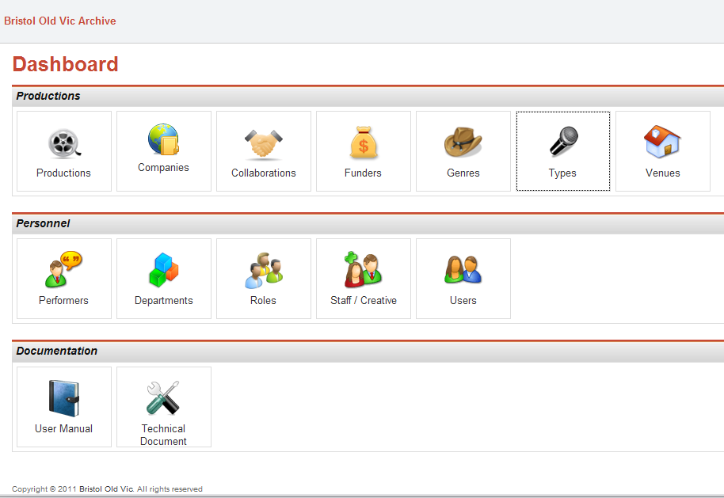

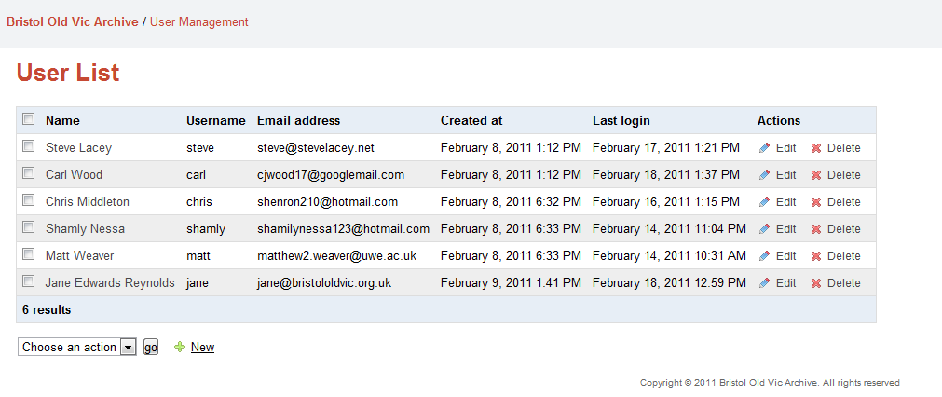

You can access all users of the system and if necessary, change/add email address; user names and passwords.

# Navigation

## Actions (1)

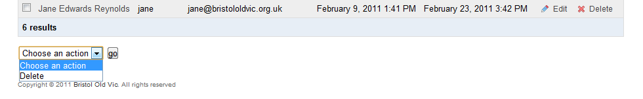

The actions interface is commonly found in the bottom-left hand corner of the add/edit interfaces. It is used with the checkboxes to delete one or more records. All records can be selected by clicking in the top-left checkbox (as seen below).

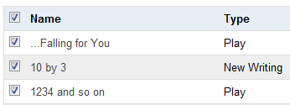

## Actions (2)

The information added in other tables within the system will appear inside the Productions table.

For example:

**Productions form**

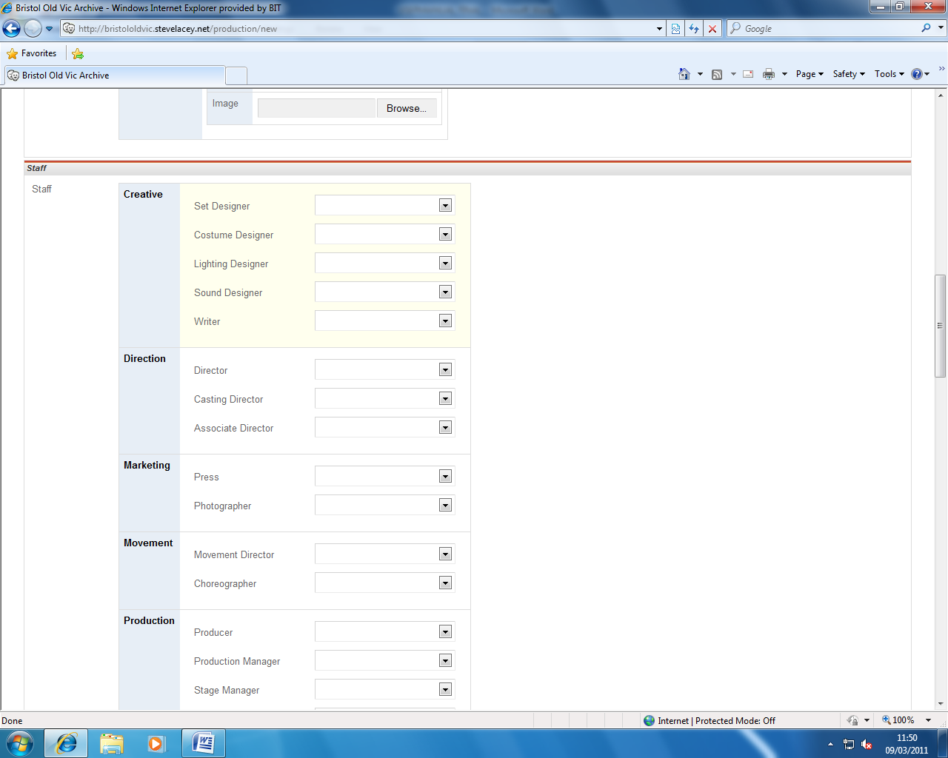

Departments

Roles

When you add new fields in any of the other forms/ tables, the information (title of the fields appear in the productions lists).

## Logo Navigation

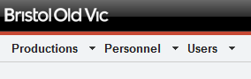

You can return to the ‘home’ page interface by clicking on the Bristol Old Vic logo.

## Dashboard



The dashboard acts as the main interface to the data. Buttons are provided to add/ edit data and assign these to production(s).

## Drop-down Navigation

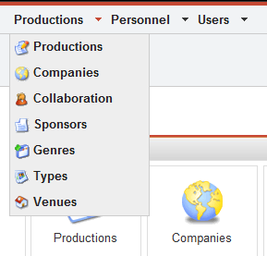

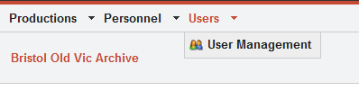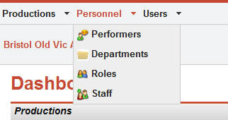

Similarly to how the main interface is grouped – each menu can be accessed via a drop-down navigation. This can be accessed from any screen on the system. There are three groupings: productions, personnel and users.

## Breadcrumb navigation

## 

Home page link – always displayed.

The bread crumb navigation is displayed underneath the drop-down navigation on every page. It allows you to re-trace your “foot-steps” and access pages higher in the hierarchy.

## Log out button

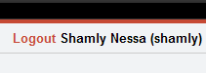

Click on the ‘Logout’ to exit the system safely.

# Adding a New User

1. 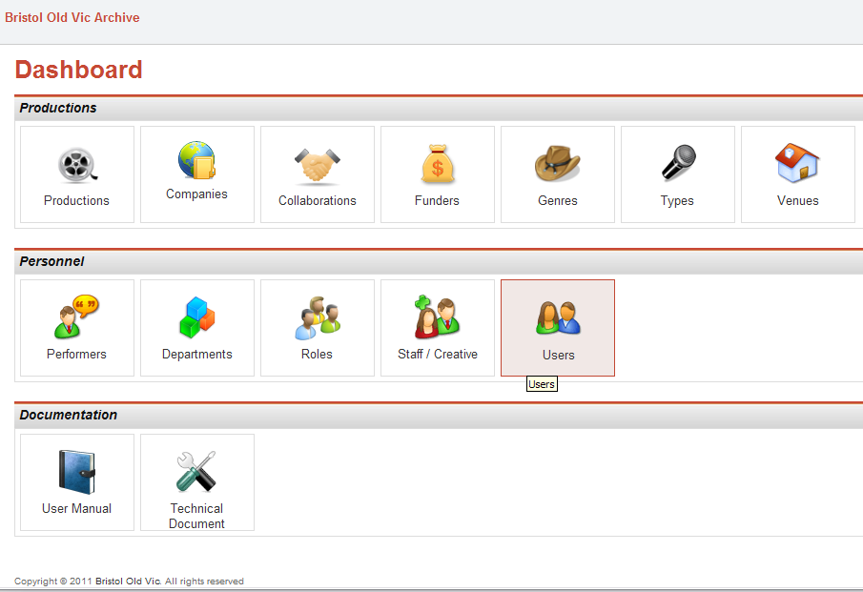

Click on the ‘User’ icon on the main menu.

1. 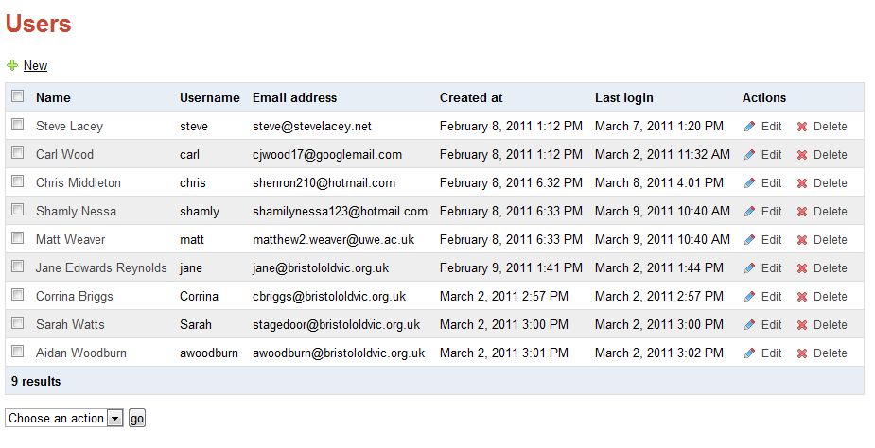

Click on the ‘New’ button.

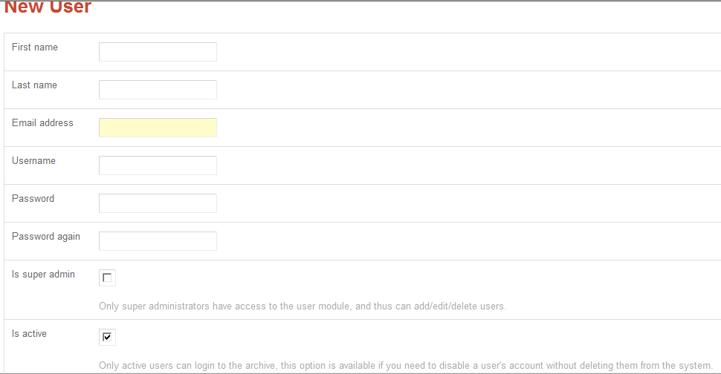

Complete all the fields.

Tick the box if you would like to give the user the privilege of being a ‘Super admin.’

# 

Click the ‘save’ button to save the user. If you wish to add another user click ‘Save and add.’

# 

**Super admin: enables the user to add and edit other users. They can also add, edit or delete other super admin users.**

# Recommended Work Flow for Creating a new Production

***Before creating a new production, it is important to check whether the staff / performers, companies, funders and genres are available for selection. They must be added before creating a new production. If the performers, for example, that starred in a production are already in the archive, they can already be assigned.***

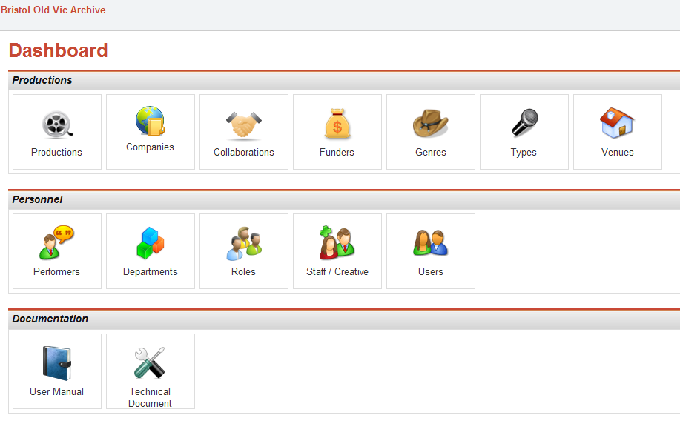

After logging in, the (above) screen will appear. From here, you can add a production; create new companies, collaborations, funders, genres, staff, and performers.

Firstly, we will add a new company / collaboration.

# Companies / Collaborations

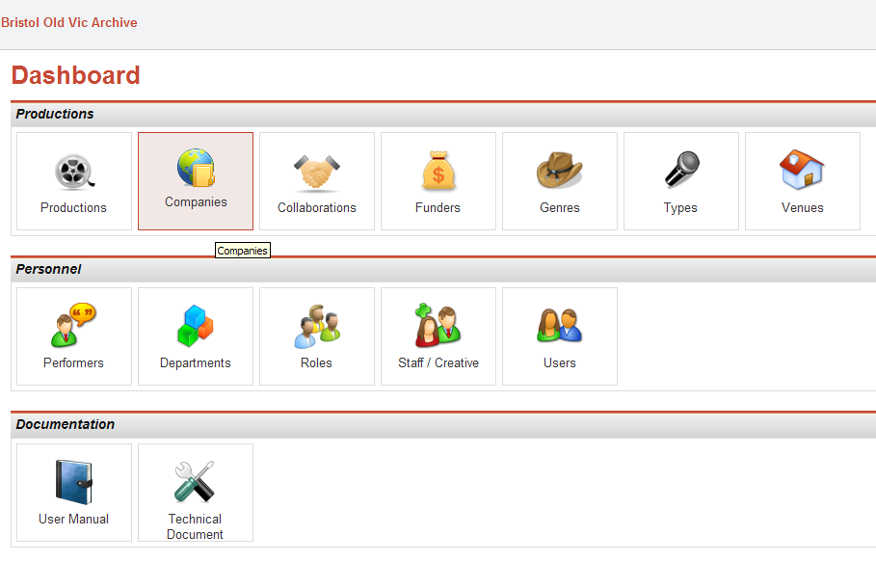

## Adding a new company:

1. Click on the ‘companies’ icon on the main menu.
2. 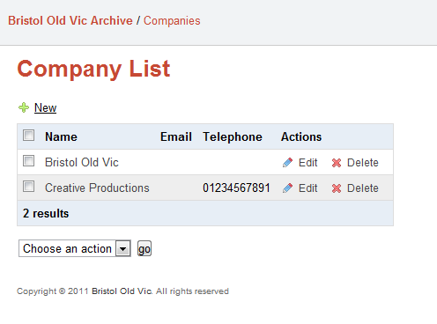

Click on the ‘New’ button.

## 

Once you have filled in all the appropriate details, click ‘save and add’ if you wish to add another record, otherwise click ‘save.’

*Collaborations can be added in the same way.* Performers / Staff

## Adding a new Performer

1. 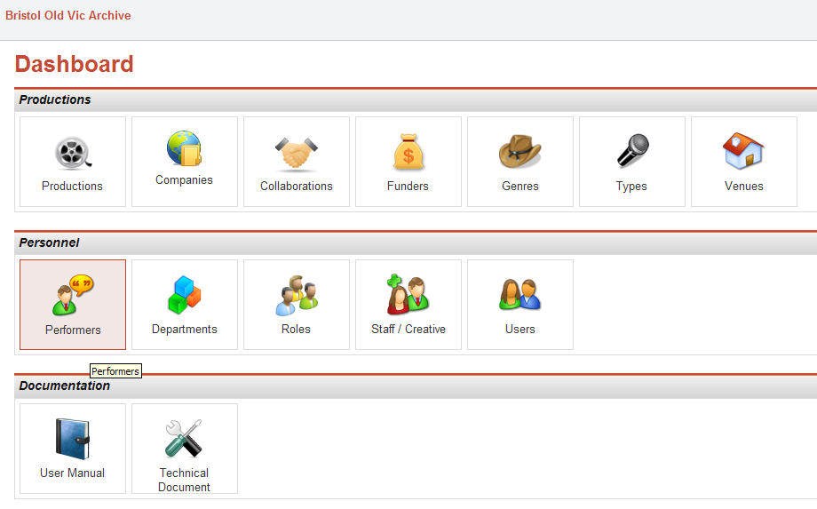

Click on the ‘Performers’ icon.

1. 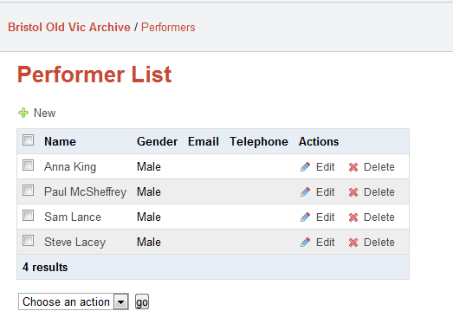

Click on the ‘New’ button.

1. 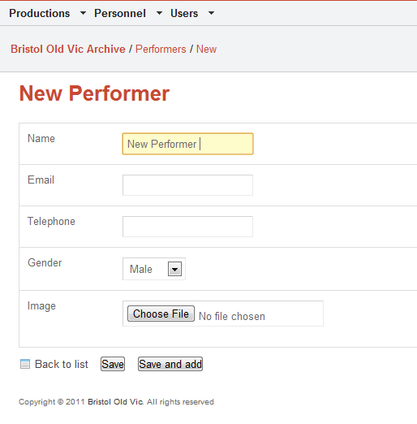

Proceed through the form completing necessary fields.

Upload an image of the performer, if desired.

Once you have filled in all the appropriate details, click ‘save and add’ if you wish to add another record, otherwise click ‘save.’

***If you are adding a new production, please remember to add all the remaining new Performers.***

# Adding a new staff member

1. 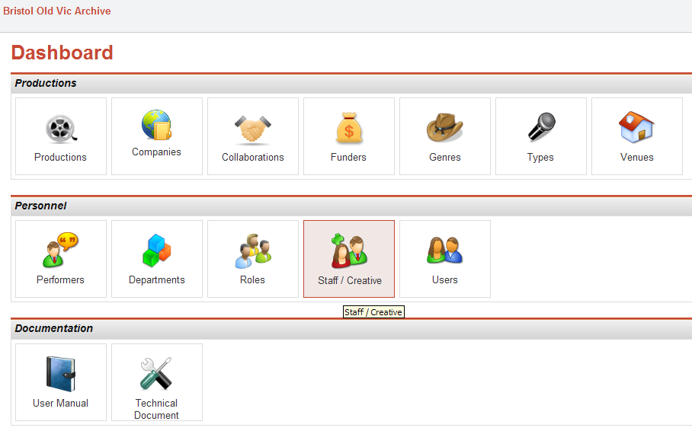

Click on the Staff icon to go to the ‘add new staff’ screen.

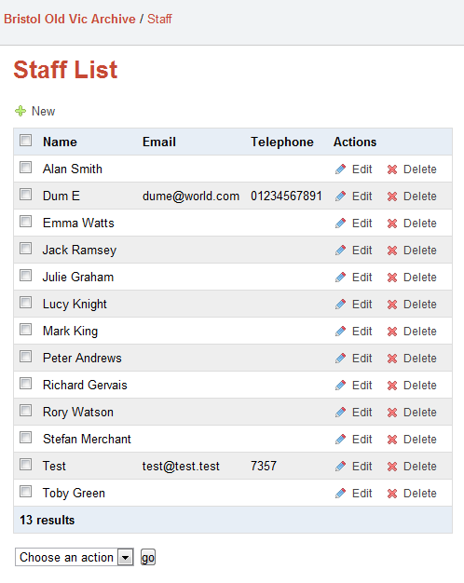

Click here to add a new member of staff.

1. 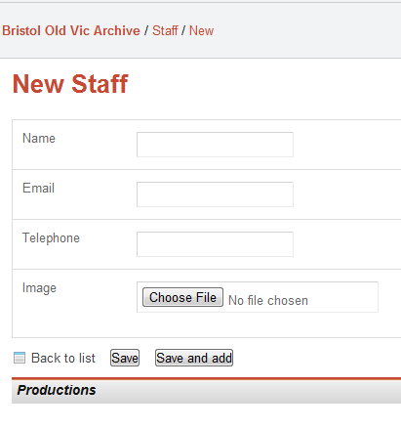

Complete the details and add an image if necessary.

If you plan on adding more than one member of staff then click on the ‘save and add’ button.

1. 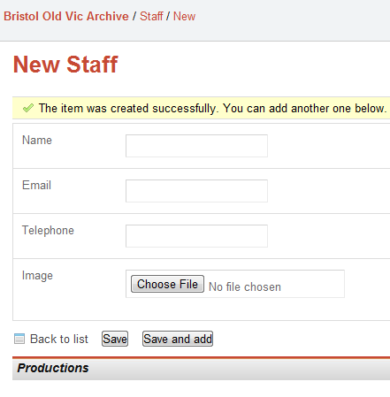

You have added a member of staff successfully. If you wish to add another, complete the form again. Otherwise, to return back to the main screen, click ‘Bristol Old Vic Archive’ on the red breadcrumb trail.

***If you are adding a new production, please remember to add all the relevant remaining new staff.***

# Venues and Layouts:

You can add a new venue and add new layouts to these venues with photos of the seating plans. You may wish to do this *if you have a number of seating arrangements with differing capacities*.

1. 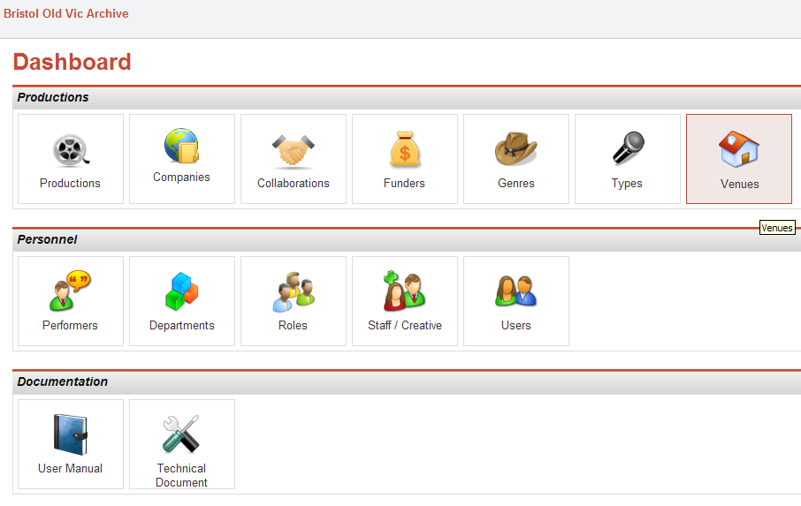

Click on the ‘Venues’ icon.

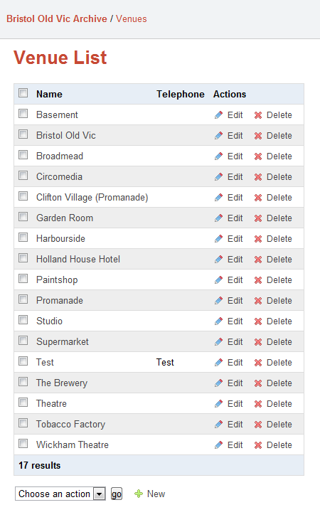

These are the current venues in the database. You can edit and delete any of these.

1. 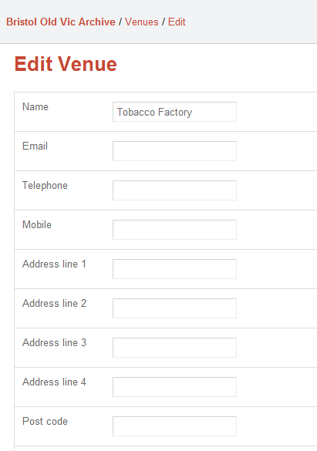When adding or editing a venue, complete the following fields:
2. You can add or edit venue layouts here. This screen is particularly useful for adding seating plans and differing capacities for the venue. The layout will start with a set of blank forms to complete. Once a form is filled out it will appear in the list and will always consist of 2 blank forms in the list ready to be filled out.

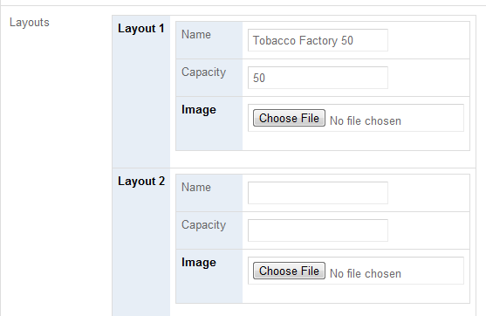

Seating plans can be added in any image format.

# Departments and Roles

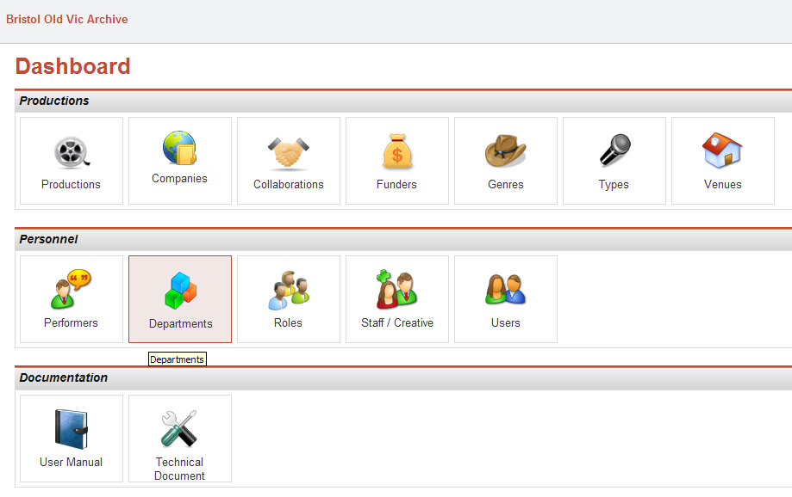A number of roles belong to each department, and staff can be assigned these roles in the production interface. Using the departments and roles menus you can add or edit existing departments and staff roles.

Click on the ‘Departments’ icon.

In order to assign a new role to a department, you need to firstly add a new ‘Department’.

1. 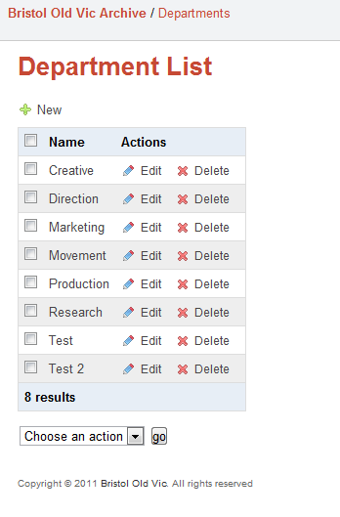

Click on the ‘New’ button.

1. 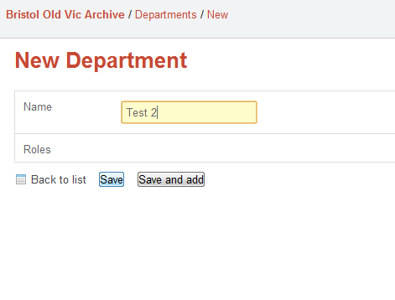

Add a department name. Note that you cannot add a role yet, they must be created *after* creating a department.

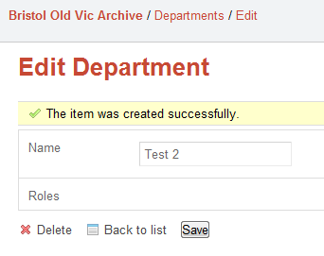

Now you have added a department successfully, you can now create roles for this department.

1. 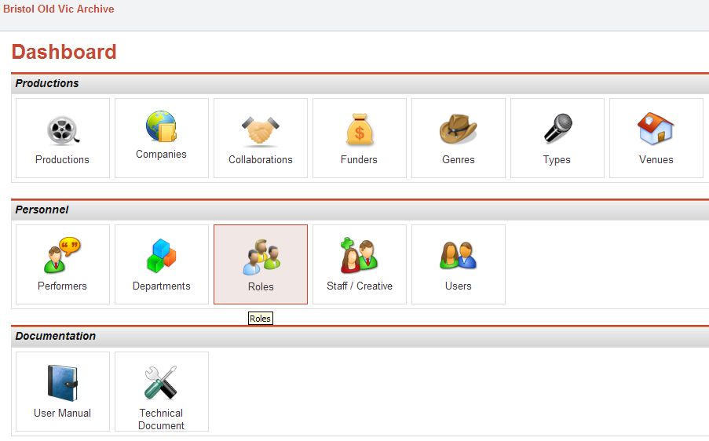

Click on the ‘Roles’ icon.

1. 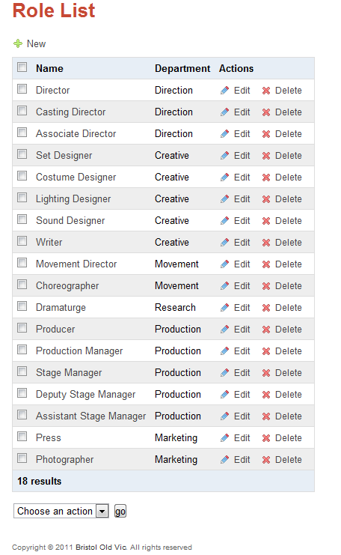

Click ‘New’ to add a new staff role.

1. 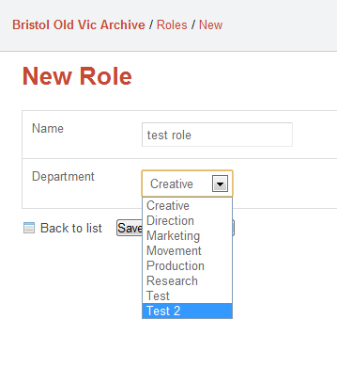Name the new staff role and assign it to your newly created department:

***This new role and department will now be displayed in the productions interface for staff assignment.***

# Production Genres / Types

1. 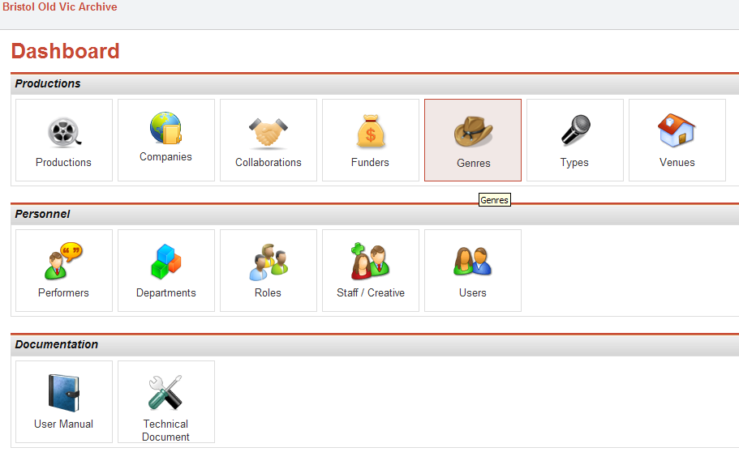

Click ‘Genres’ icon.

1. 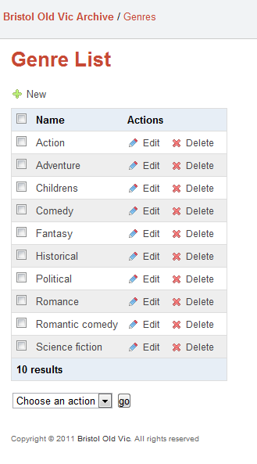

Click ‘New’ to add a new Genre.

1. 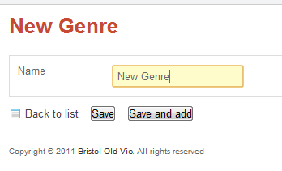

Complete the required field and click ‘Save and add’ to carry on adding Genres, otherwise click ‘Save.’

***Types can be added in the same way.***

# Funders

1. 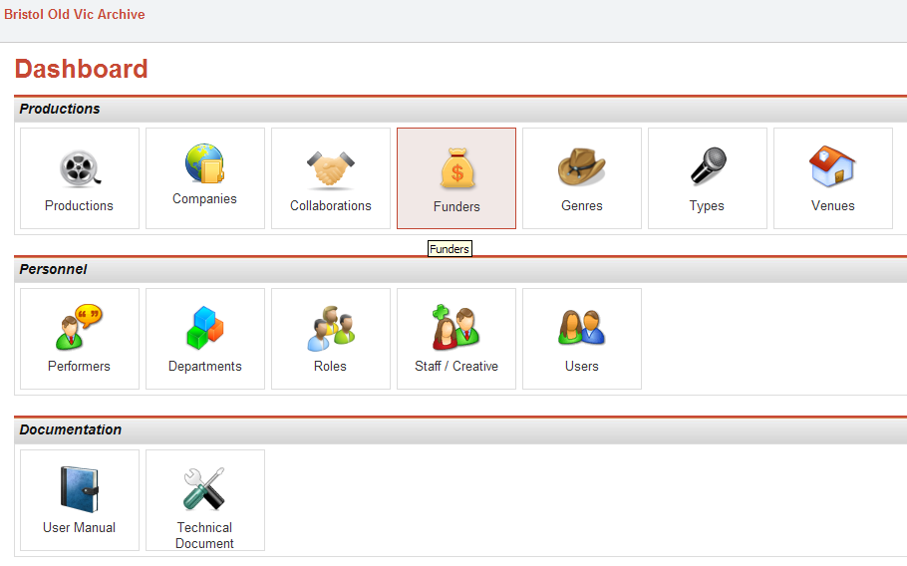

Click on the ‘Funders’ icon.

1. 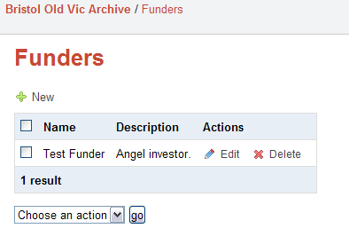

Click ‘New’ to add a new Funder.

1. 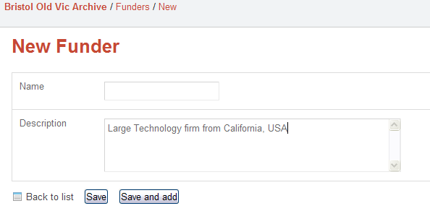

Complete the Funder Name and a relevant description.

Click ‘Save and add’ to add save the details and continue to add more Funders, otherwise click ‘Save.’

# Productions

## Adding a new Production:

1. 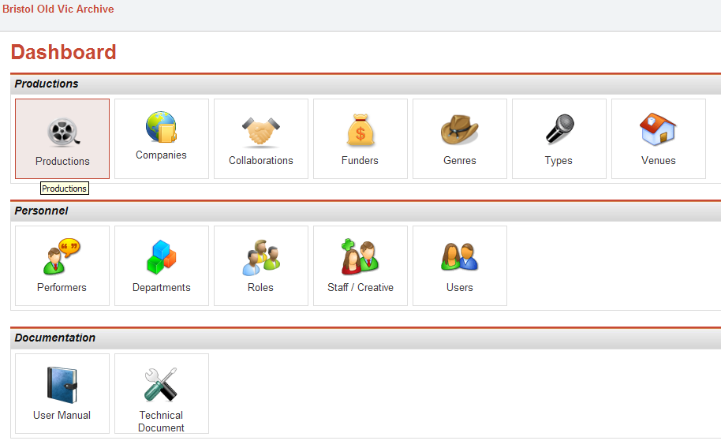
2. 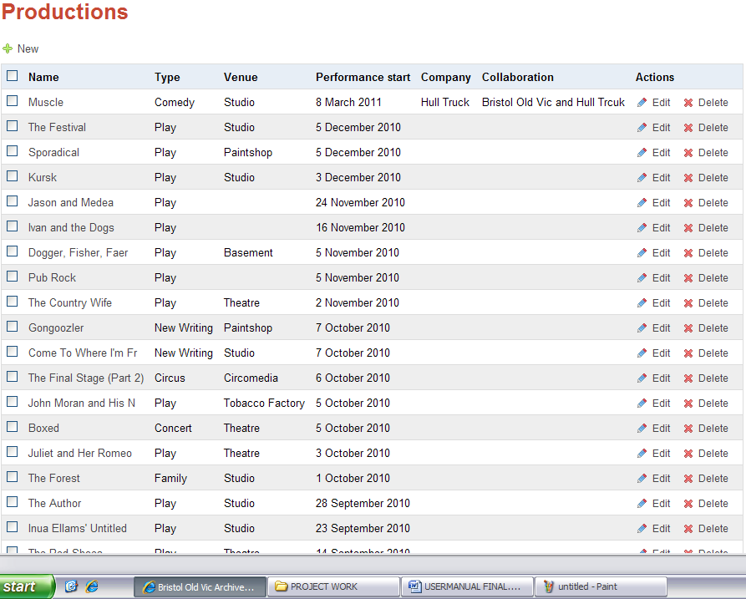

Click on ‘New’ in order to add a new production.

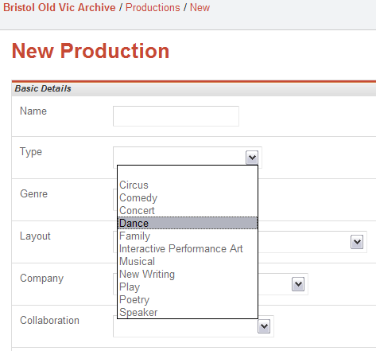

Select a Production type.

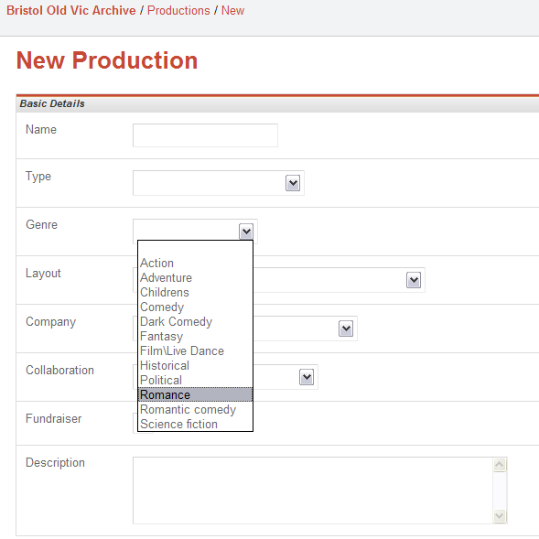

Select a Genre.

1. Complete all the fields up to ‘Staff’

The staff member(s) you added earlier will appear in this list.

1. 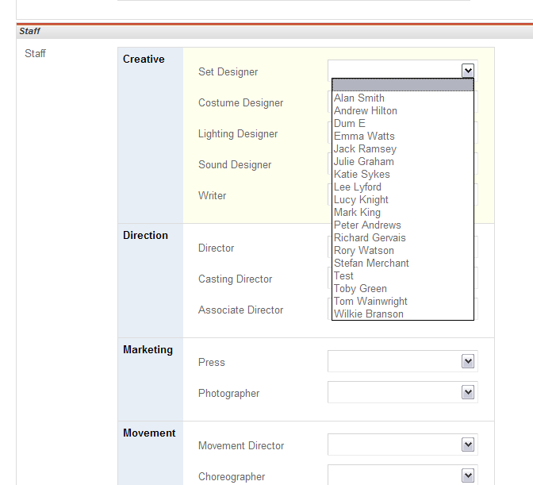

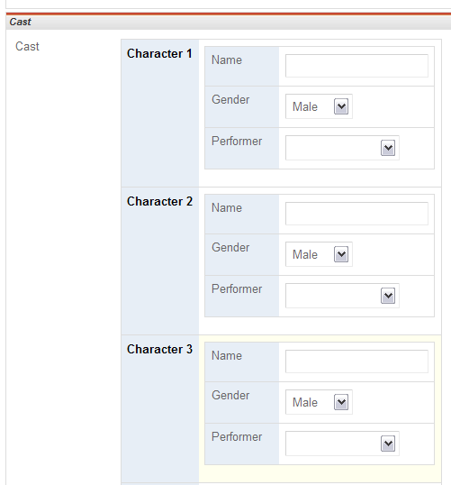Add the correct member of staff and complete all the remaining staff fields.

Similar to adding a member of staff, performers can be selected or, if not present in the list, added in the performer interface. Continue filling in the performer fields.

You can add or edit production characters here. The layout will start with a set of blank forms to complete. Once a form is filled out it will appear in the list and will always consist of 2 blank forms, ready to be filled out.

1. 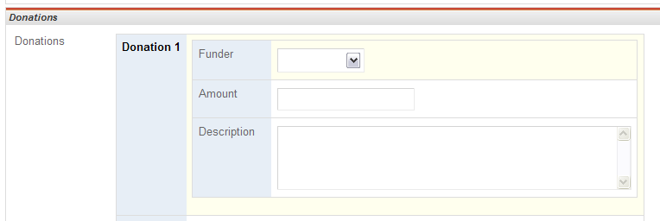

If applicable, add a donation. You can select a funder that has already been added in the ‘Funder’ interface.

1. Click ‘Save’ to save your new production. If you wish to add another production click ‘Save and add’.

# Queries/search

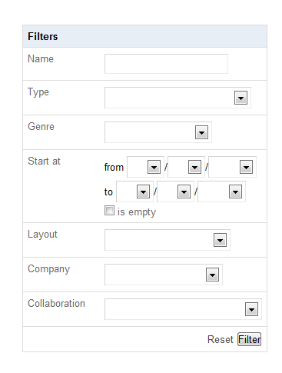In order to query your production data/ records, you can use the ‘filter’ interface on the right of the productions page. It is provided below:

You can query data by production name, type, genre, date range, etc.

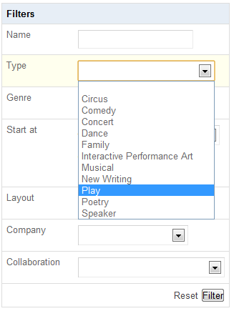

Here, we are filtering (searching by) Production type. In this case: ‘Play’.

When all desired search criteria are set, click ‘Filter’ to search.

1. 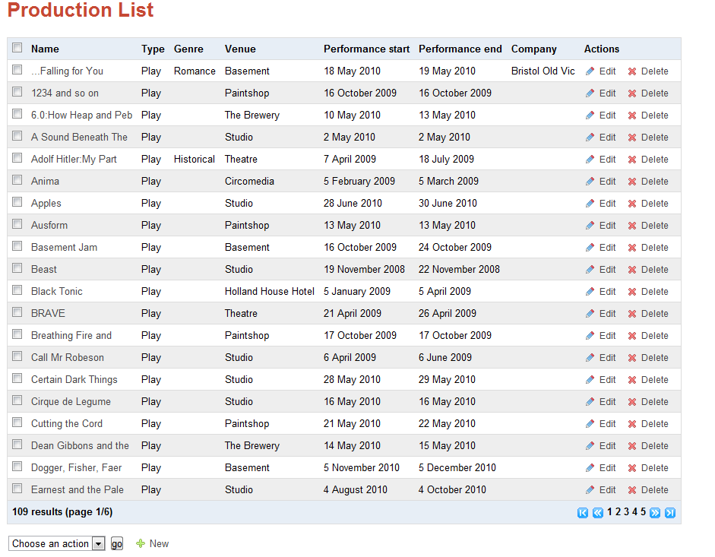

Your results are returned.

***Please note:*** *search criteria are remembered in one session; if you press the ‘****reset’*** *button, it will clear the screen ready for a new search.*

# Printing out reports

In order to print off a report, all you need to do is click the print button on the browser.

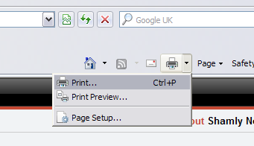

**View in Internet Explorer:**

Towards the top right-hand corner of the server.

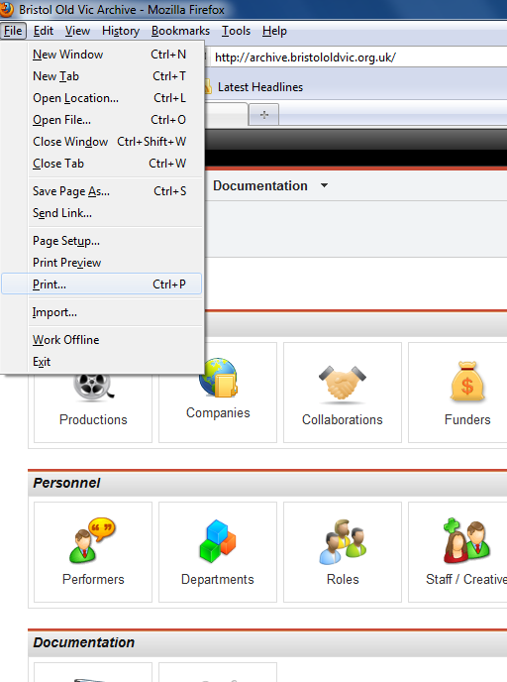

**View in Firefox:**

Top left-hand corner of the server.

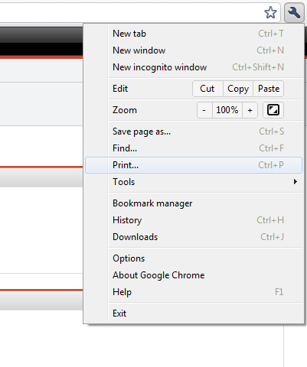

**View in Google Chrome:**

Top right-hand corner of the server.

# Troubleshooting

## Forgotten Password?

1. 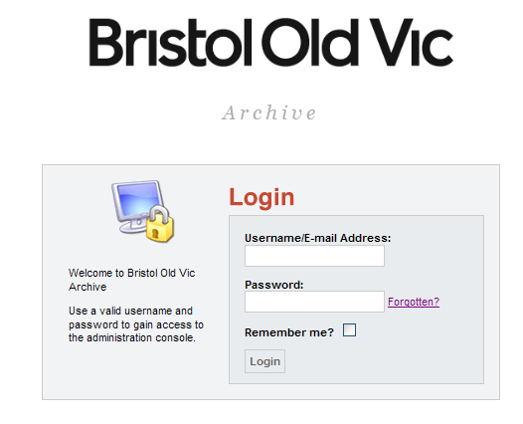

Click on ‘Forgotten’.

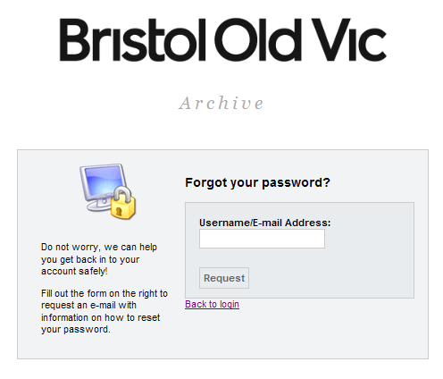

Enter your e-mail address.

Then click Request.

1. This will then display the message below:

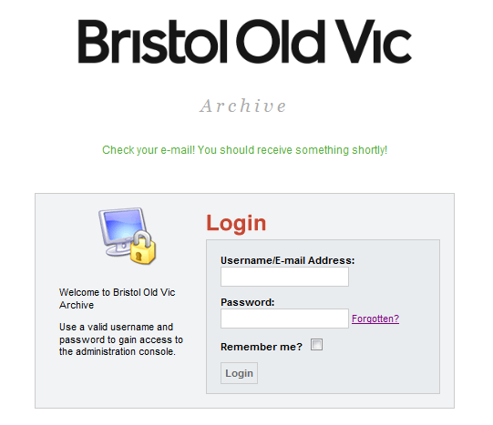

You should then check your e-mail, in which it will state:

*‘This e-mail is being sent because you requested information on how to reset your password.  
  
You can change your password by clicking the below link which is only valid for 24 hours:*[*Click to change password*](http://bristololdvic.stevelacey.net/forgot_password/4c1d8d730b96df94cbb4f5980af99b7b)*’*

1. Once you follow the link, you will be able to change your password:

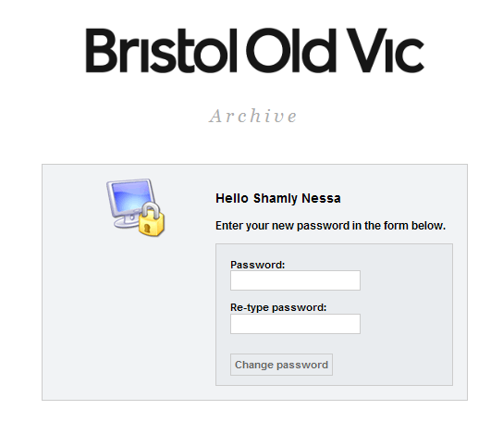

Once you have re-typed your new password twice, click ‘Change password.’

*\* You can also get another existing user on the system to change your password for you or delete you and add you back in.*

# Glossary

**Archive:** Retrieving documents or some sort of file from a stored destination.

**Browser:** A software program that finds any document / information and displays it in a suitable form. E.g. For the purposes of the World Wide Web (WWW).

**Genre:** A class / category of artistic endeavour which has categories such as a particular form, content, technique.

**Interface:** A program that communicates information from one computer or such device to another.

**Navigation:** The direction or the process in which the system is organised to run in.

**Query:** To ask or inquire about a certain aspect of information or topic.

**URL:** Uniform Resource Locator - a protocol used to specify internet addresses.

**WWW:** World Wide Web