Avalanche Repository design
Sanjay Dahiya
(March 30, 2005)

** method and class documentation in javadocs.

Avalanche needs to automate management of different types of data as part of its repository operations. These data include XML based module configuration files, smartfrog description files, code for software to distribute etc. Since all of these data is centered around modules that needs to be deployed and managed on host nodes, avalanche follows a hierarchical storage scheme for all of data. However Avalanche repository is designed to be independent of any particular back end storage. It can work with local file system or an ftp location or a version control using generic interfaces for retrieving and storing modules.

We divide these generic interfaces for operating on modules in two levels.
- Interfaces for working directly with hierarchical repository. Example FTP, Local Disk, XML DB, SVN.
- Interfaces which provide a logical abstraction for a particular type of data, these interfaces are built on top of (a). Example Module configuration, smartfrog descriptions, Code etc.

With proper design patterns as described later we can use any storage system with any data type with a combination of (a) and (b).

Following are the key interfaces for working with hierarchical repositories.
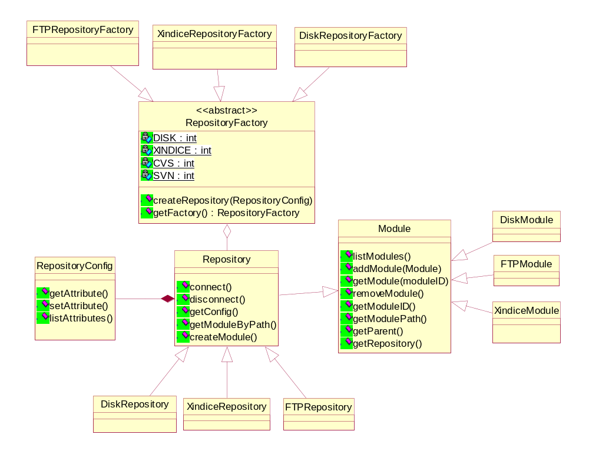

Design pattern note:
- Since we have similar interfaces but multiple implementations for different storage, We can use abstract factory creational pattern for creating these implementations. So when we add another type of repository only class that needs updating is RepositoryFactory. This can actually also be avoided using java Class.forName(“repositoryClass”) for the factory class.
- Creation of new modules may lead to creation of new directories on disk or remote server, or creation of collections in XML database etc. All creation is done through the associated repository. Another example of this pattern is in W3C DOM API where new elements and attributes are created through the associated document. Idea is to centralize creation at defined places so that changes in creation process are easy to implement.
A repository is created by passing RepositoryConfig to the relevant factory. RepositoryConfig contains attributes like type, location, options etc for connecting to repository. RepositoryConfig is a simple attribute value pair which may be different for each type of repository. Details of configuration attributes for different repositories are available in javadocs.
Creation of new modules is done through respective repository object.

As in the class diagram Repository extends Module so we can use this in an hierarchical manner to manage modules.

A simple interaction would look like
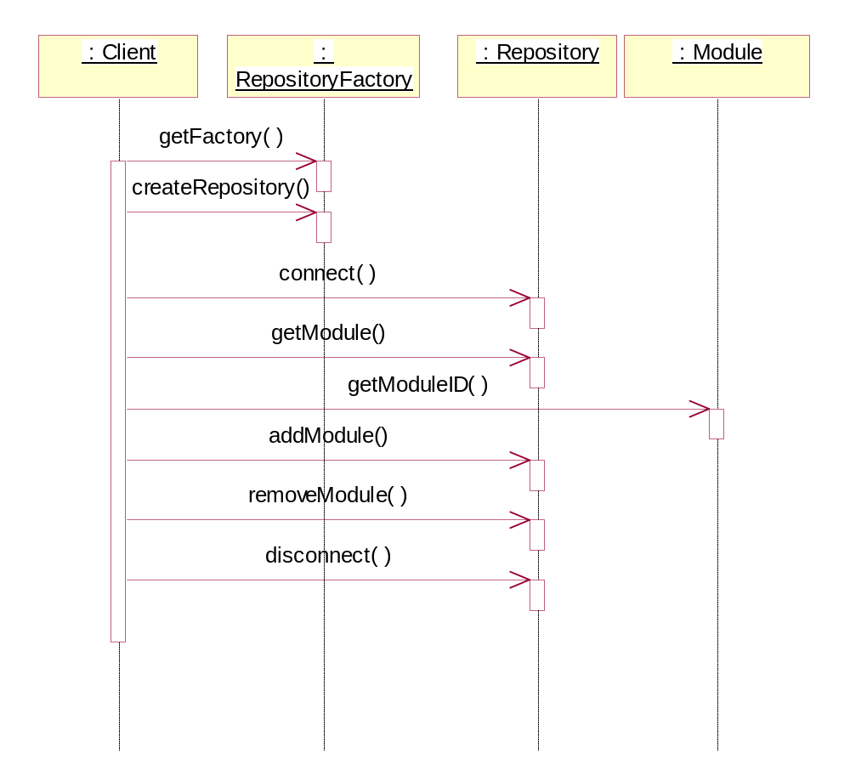

After the base repository implementation for different storage media, next layer is of Avalanche specific data which can go in any of these repositories. Although repository follows hierarchical interfaces, storage may not be hierarchical, so we can still use a RDBMS to implement modules and plug those interfaces with avalanche specific data.

Module configurations
First of this data is Module configurations, these are XML documents which describe a module and its versions. Backend storage for these configurations would be typically an XML database like Xindice.

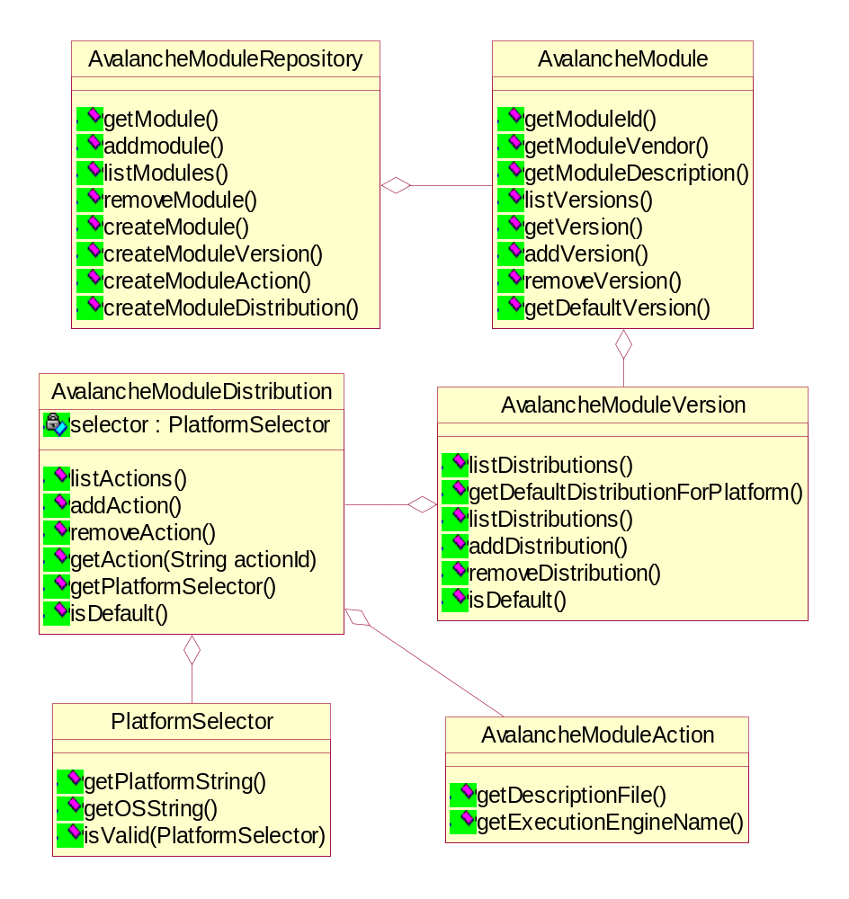
Design pattern note
Creation of avalanche specific data follows builder pattern, where we create the base objects first and using generic interfaces build upon the base objects.

Avalanche Action descriptors
Action descriptors map to a module distribution like an rpm file. Action descriptor files are written in a language understood by the execution engine like smartfrog. We can embed these action descriptors with in the module configuration XML files as CDATA sections but we choose to put them in a separate repository (local disk) so the overhead of extracting this data for submission creating a file for it and then submitting the file to smartfrog daemon can be saved. Also smartfrog daemon would then be able to pick up the file asynchronously from the disk once its submitted. Also it makes it easy to write separate GUI tools for editing action descriptors without overloading the module configuration database.

Action descriptor repository reflect the structure of module configuration. A module configuration XML document contains paths to different action descriptors. Multiple module configurations can point to same action descriptor but it should be taken care of while deleting the descriptor that there are no invalid references are left in the system. Another way is to use a copy of descriptor even if its same. We prefer the later method.
Classes to operate upon action descriptors repository are not exposed to users, these are accessed and updated through module configuration interfaces.

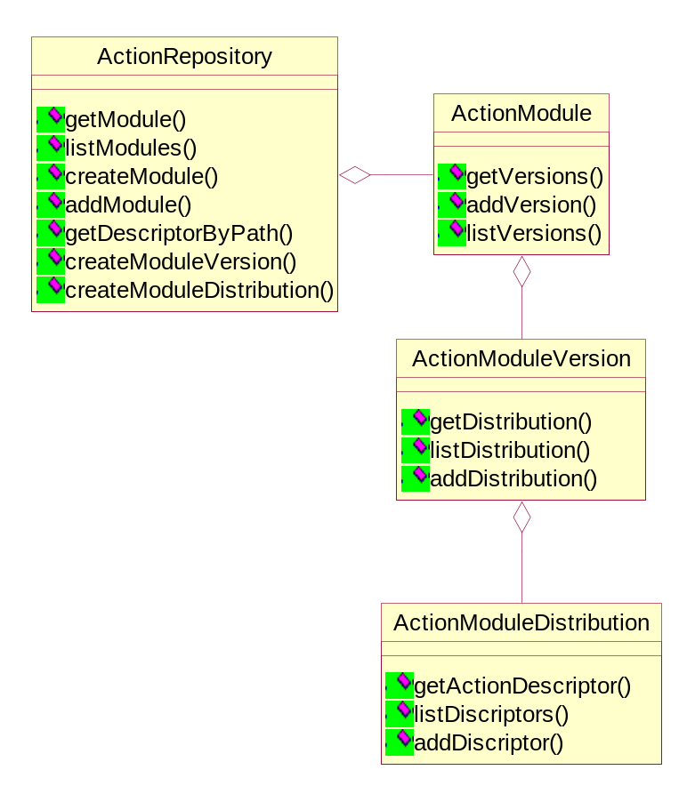

Avalanche code modules

Like action descriptor repository, code repository is also not accessed by users for deployment, this repository is used in cases when users want to add a new software in the repository or do some changes in existing software.
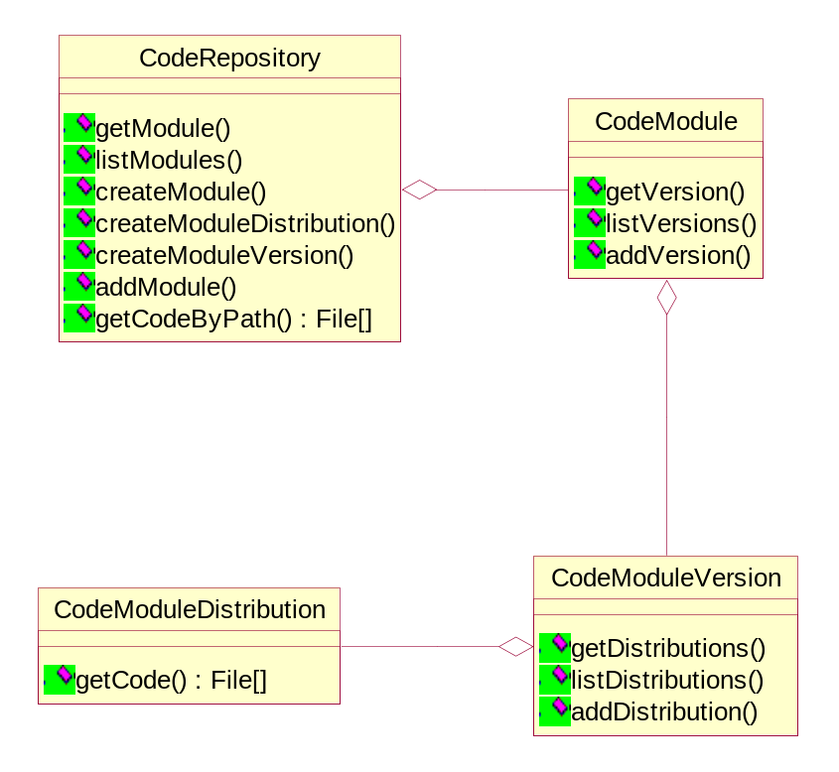

Design pattern note
Both code repository and action descriptor repository follow builder patter for object creation.

Creation of a complete module involves following
- Create a base module repository
- Attach a module configuration repository to base repository
- Create a base module repository and attach a action repository object.
- Create a base module repository and attach a code repository.

Final avalanche module repository will be created by using a builder pattern again and make use of all of above.

Exceptions
RepositoryConnectException
RepositoryConfigException
ModuleConfigException
InvalidModuleException
ModuleNotFoundException

Code samples ( to be changed)
createModuleCfgRep(){

RepositoryFactory factory = RepositoryFactory.getFactory(RepositoryFactory.XINDICE-EMBEDED);

RepositoryConfig config = new RepositoryConfig();
Config.setAttribute(“configFile”, “/db/dbxml/config.xml”);

Return factory.createRepository(config);
}

createActionRep(){
RepositoryFactory factory = RepositoryFactory.getFactory(RepositoryFactory.DISK);

RepositoryConfig config = RepositoryConfig();
Config.setAttribute(“path”, “/db/actionDescriptors”);

Return factory.createRepository(config);
}

createCodeRep(){
RepositoryFactory factory = RepositoryFactory.getFactory(RepositoryFactory.FTP);

RepositoryConfig config = RepositoryConfig();

Config.setAttribute(“server”, “grid1.india.hp.com”);
Config.setAttribute(“username”, “globus”);
Config.setAttribute(“password”, “globus”);
Config.setAttribute(“path”, “/data/grid”);

Return factory.createRepository(config);
}

/**
* Initialize repository and get a action descriptor.
*
**/

Repository moduleBaseRep = createModuleCfgRep();
Repository actionBaseRep = createActionRep();
Repository codeBaseRep = createCodeRep();

ActionRepository actionRepository =
new ActionRepository(actionBaseRep);

CodeRepository codeRepository = new CodeRepository(codeBaseRep);

AvalancheRepository avRep = new AvalancheRepository (moduleRep);

avRep.attachCode(codeReository);
avRep.attachActions(actionRepository);

// Here the repository is initialized
// get a module and deploy it not the network

AvalancheModule module = avRep.getModule("xerces-java");
AvalancheModuleVersion ver = module.getVersion("1.1.1");

Host h = HostManager.getHost("lx9622.india.hp.com");

AvalancheModuleDistribution dist =
ver.getDefaultDistributionForPlatform(h);

AvalancheModuleAction action = dist.getAction(AvalancheActions.SETUP);

// get the execution engine, smartfrog in out case
ExecutionManager execM =
ExecutionManager.getManager(action.getExecutionEgine());

// deploy the action descriptor for the host
execM.deploy(h, action);

