Avalanche Integration guide

Sanjay (dahiya@india.hp.com)

March 18th 2005

1. Integration with information services
Avalanche system consists of two parts –
- Repository server(s) and
- host software.

Repository server is setup with manual intervention whereas host software can be setup and managed automatically on a large number of nodes. Repository server and host software are used to later deploy, upgrade and manager extra software on the grid. As part of repository server setup we also set up monitoring service infrastructure.
Monitoring service provides support for registering information listeners and providers and ensures data flow from providers to listeners. To stay independent of the data format Avalanche defines its own interfaces to encapsulate monitoring data, these interfaces can be implemented by adapters for different monitoring systems like Ganglia, Anubis etc. Listener on the server typically listen on a predefined multicast address for notifications from providers running on remote nodes. Once the repository server is setup properly the listener would be up and running.

Following services on repository server listen for the notifications from host nodes.
- Event logger.
- Active host profile manager.

As part of host software installation we first install basic distribution of smartfrog, bundled with providers for information service. When smartfrog is up and running this provider is used to send a notification of the successful install along with machine properties. On receiving this notification, server locates a default profile for the host type and submits the profile for deployment on host. This causes additional software like grid middleware to be downloaded and installed on the host machine.

Following are interfaces exposed by Avalanche to integrate with external monitoring systems, by default its independent of a transport format, these can be WS-Notification compliant if the implementing classes and monitoring system supports that. This separation of format is of significance in case Avalanche is used in non-grid scenarios.

There are two types of interfaces exposed
- Programmatic interfaces for integrating with monitoring system
- Smartfrog’s SF language based interface for sending notifications from description files directly. This internally utilizes programmatic interfaces.

- Programmatic interfaces for integrating with monitoring system

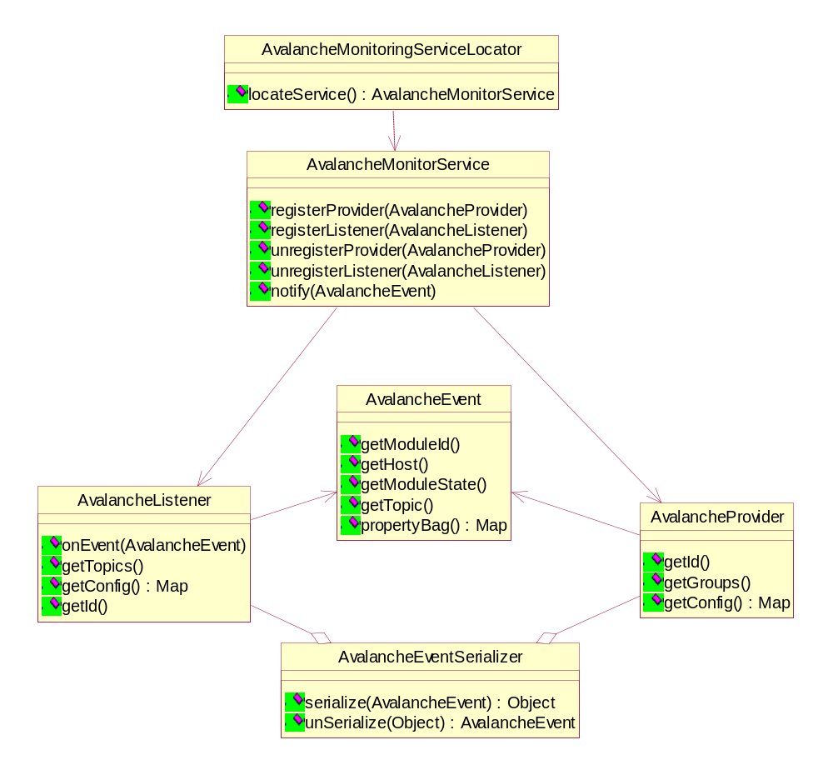

AvalancheMonitorServiceLocator is a part of smartfrog basic distribution and will be available on all nodes. Other smartfrog components use the locator to find service and then register as providers or listeners. Locator creates/returns a reference to the monitor wrapper to the monitoring service daemon on the local node. This wrapper interface is then used to register providers and listeners and for sending and receiving events.
These interfaces provide some open data structures for service specific configuration data like AvalancheProvider.getConfig(), which may contain attributes like updateType [periodic, onEvent] or updateFrequency[ time ] etc.
AvalancheEventSerializer can convert the event into an XML or java serialize format or any other format needed by monitoring service. Info service like ganglia would transmit data in form of XML, whereas Anubis transmit it in form of serialized objects.

Following is an example scenario of how monitoring system are used in Avalanche.

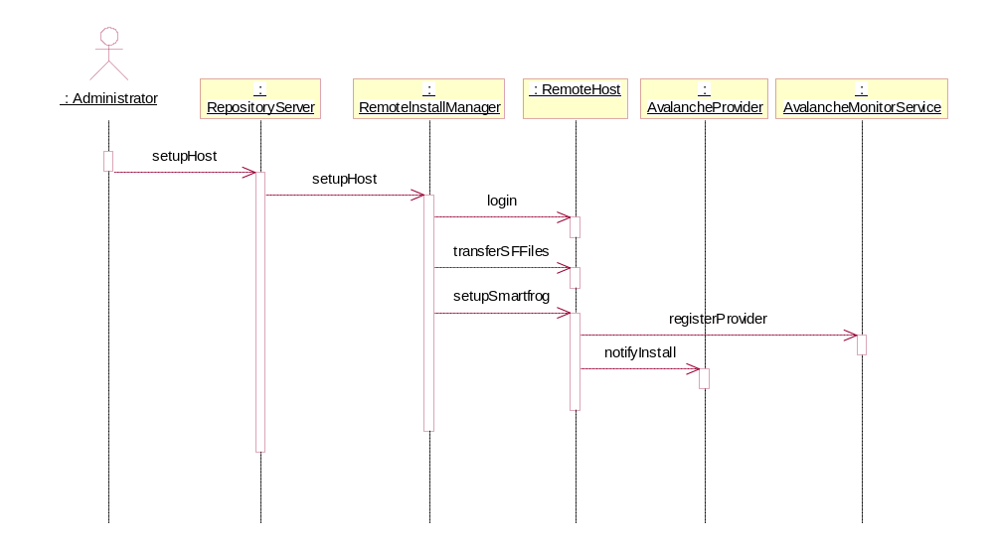
User initiates addition of a new machine on grid.

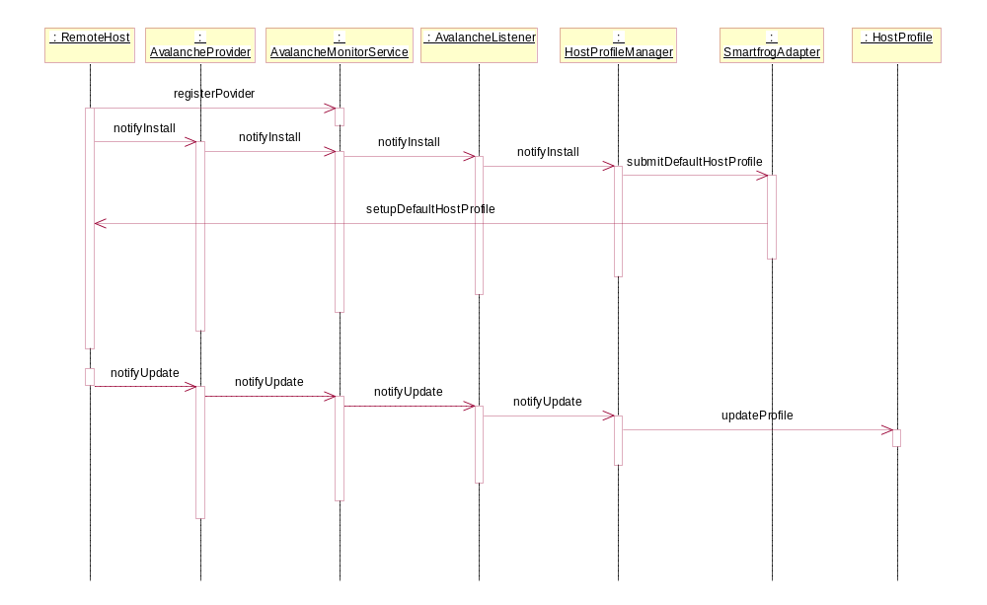
Automated installation default profile on the host and events.

- Smartfrog’s SF language based interface for sending notifications from description files directly.

This is used to send notification on Avalanche without writing any new java code. These notifications can be defined in the smartfrog description files. These notification will use a default instance of provider class.

AvalancheEvent{
moduleID ;
host ;
moduleState ;
topic ;
properties ;
}
AvalancheNotifier{
AvalancheEvent {};
}

2. Requirements for new tools to be deployed on grid.
A new piece of software that needs to be deployed using Avalanche requires following configurations.

1. Module configuration -
This is an XML file which contains information about the software like a
a) unique module Id,
b) description of module,
c) vendor
d) Available versions of the module for different platforms.
e) Actions that can be taken of this module on remote nodes. actions include - downloading, installing, starting, changing configuration, restarting, stopping, uninstalling etc
e) pointers to smartfrog configuration files for each action (described later).
Above values can be entered using Avalanche GUI and these file will be internally created and managed automatically. Also this file can be manually written and uploaded in Avalanche repository using GUI.

2. Smartfrog action descriptions -
To write these descriptions users require knowledge of smartfrog language. For most common packaging formats and executable types users will not need to write any java code. but if there is a new packaging format that Avalanche doesn’t understand a user can write smartfrog description and java code to handle that and it can integrate with Avalanche.
In normal cases writing smartfrog description will involve extending existing smartfrog template provided with Avalanche. User will need to identify following details

- Where the software is placed in the repository, if its an FTP repository select a ftp download description from Avalanche samples, make a copy of it and change the location of download server and other options.
- How to install this software, if it uses a packaging format that smartfrog understands then select appropriate sample descriptions from Avalanche, make a copy of them and change install options like source file, destination, post install configurations etc.
- How to start this software, if this is a library this step can be skipped, otherwise it may be a simple executable or a program that requires a runtime ( java, perl ) or it may require some middleware ( apache, tomcat/jetty/axis ) to be started. Like previous steps for standard type of software templates will be available in Avalanche repository which can be taken and modified to suite new software.
- Similarly configurations for stopping, reconfiguring, uninstalling etc can be specified by extending standard templates.

Follows example of action description that can be extended for new software.

Example of template description provided with Avalanche

FTPSchema extends Schema {
ftpHost extends String;
username extends String;
localFiles extends Vector;
remoteFiles extends Vector;
transferType extends OptionalString;
transferMode extends OptionalString;
shouldTerminate extends Boolean;
}

FTPClient extends Compound {
PasswordProvider extends Password {
}
FTP extends Prim {
/* ========================================================
* Mandatory attributes
*=========================================================
*/
sfClass "org.smartfrog.services.net.FTPClientImpl";
ftpSchema extends FTPSchema;

// change name of FTP server
//ftpHost "grid1.india.hp.com";

// login name in FTP server
//username "sanjay";

// reference to password provider
passwordProvider LAZY PARENT:PasswordProvider;

// list of remote files.
//remoteFiles ["/repository/modules/ganglia/1.0.1/ganglia.tar.gz ",

// list of local files
//localFiles ["/tmp/ganglia/ganglia.tar.gz"]; // if missing use same name

/* ========================================================
* Optional attributes
*=========================================================
*/
// two possible values are "get" and "put"
//transferType "put";
transferType "get";

// two possible values are "ascii" and "binary"
//transferMode "binary";
transferMode "ascii";
shouldTerminate true;
}
}
Extend template for custom application.
XercesDownload extends FTPClient {
ftpHost "grid1.india.hp.com";
username "sanjay";
// list of remote files.
remoteFiles ["/repository/modules/xerces/1.0.1/xerces.jar"]

// list of local files
localFiles ["/opt/grid/libs/xerces.jar"];
transferType "get";
}

// Other properties are inherited from base class FTPClient

