Avalanche
Deployment, change and configuration management system for GRIT

Design document

Sanjay Dahiya
December 2004

System overview

Avalanche is a distributed deployment and change management system for grid. Considering the potential heterogeneity of a grid, it is designed to be independent of any specific packaging scheme, operating system or data transfer mechanism. Avalanche provides a single point of control and management for applications on potentially thousands of heterogeneous nodes in a grid. It comes with a web based user interface for manual operations and a web service based API for automatic provisioning.
Though the system is designed for grid, it contains no dependency on any specific grid infrastructure and can be used easily in any distributed environment. In a grid environment avalanche is primarily targeted for grid administrators, it allows administrators to deploy, upgrade, start, remove or reconfigure applications on a large network from a single user interface.

At a high level avalanche system consists of
- Repository server
- Host software

Repository server is a logical entity and it contains a set of web services to interface with external system and download server(s) where actual software is placed.

Host software is smartfrog based daemon program that takes instructions from repository server and executes these instructions. Repository server may instruct the daemon to download a patch or start a program or even uninstall software. The instructions are described and passed in a language understood by smartfrog (SF, CDDLM).

Administrators can submit deployment requests for a software module using Avalanche’s web based GUI and these requests are distributed to desired target nodes using smartfrog. Special smartfrog components written for avalanche take care of executing deployment requests on target nodes and logging and reporting errors if any.

Use cases
Following section lists primary use cases for avalanche system.
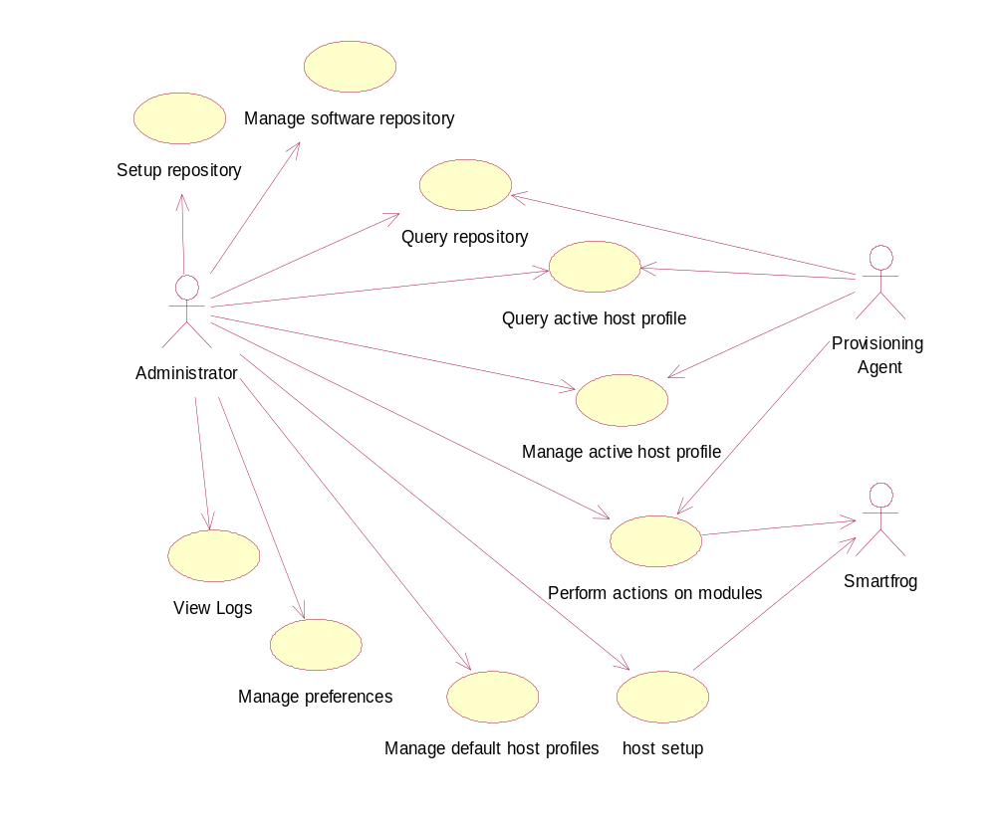

Actors

Administrator
Administrator is a human role and is responsible for maintaining the grid.

Provisioning agent
Provisioning agent is a program which can submit deployment requests to avalanche. Provisioning agents can be a part of job management for grid where applications needed by a job, need to be installed on a node before the job can be executed.

Smartfrog
Smartfrog is external program with which Avalanche interacts to execute commands on remote nodes.

Use case specifications

Set up software repository

Brief description
Administrator sets up the repository server using smartfrog based installer program. Administrator needs to provide some basic information to the system like install location etc. by editing some smartfrog configuration files. Repository server software once setup, provides web based user interface to the administrator to manage and configure nodes and software on the grid. Installation of repository server is done from a locally available installer.

Basic flow
This use case starts when administrator wishes to setup the repository server.
Administrator edits the documented configuration files to provide location of the target repository, source location and install type etc.
Administrator runs the supplied installation scripts to set up the repository server.

Manage Software repository
Brief description
This use case allows an administrator to add/remove/change software and their configurations in the centralized repository. Administrator can maintain multiple versions of the software for different platforms in the centralized repository. Depending on the type of node an appropriate version is selected for a node.

Basic flow
Administrator accesses the user interface to manage repository. Depending on the option selected by administrator one of following sub flow is executed.

Sub flows
Add a new module distribution to repository
- Administrator selects the module ID, if the module (some other distribution) is already present in the repository. Otherwise administrator creates a new unique module ID for the module.
- Administrator enters the basic information for the module like vendor, description, version number, supported platforms etc.
- System creates a directory in repository for this module distribution files.
- Administrator uploads the code files in the repository under the proper directory structure created for this module [1].
- Administrator adds or creates smartfrog configurations for different actions like INSTALL, UNINSTLL described at a later stage. These configurations point to the location of module code in the repository.

Remove a module distribution from repository
- Administrator selects the module distribution or multiple distributions or all distributions to be removed using the user interface.
- System removes the directories containing selected module distributions.
- System removes the configurations from the module configuration database.

Reconfigure a module present in repository
- Administrator selects the module distribution to reconfigure.
- Administrator selects the action to change the configuration or add a new action.
- System displays the smartfrog configuration associated with the action for editing.
- Administrator edits and saves the configuration.

Group modules
- System displays a list of existing module groups.
- Administrator selects to create a new group or edit or delete an existing group.
- If creating system creates a module group with the new name.
- Administrator adds or removes modules with versions to module group.

Query repository
Brief description
This use case allows administrators or provisioning agents to query the repository server for the availability of a particular version of some software for the target platform. It also allows different types of queries like size of download to install a software etc. System exposes a web service based interface for programs to query repository. Administrators use the user interface whereas provisioning agent uses web service interface.

Perform actions on modules
Brief description
This use case starts when the repository server is setup and it contains necessary modules and their configurations. The administrator or provisioning agent may choose to install, uninstall, start, terminate or configure modules on target nodes. This use case becomes applicable only when at least one host machine is associated with the module.

Basic flow
- Administrator access the user interface and selects a host or a host group to perform some action.
- Administrator selects the module or module group.
- If a module is selected all the actions associated with the module are available.
- If the module group is selected only the common actions are available.
- Administrator selects the action to be performed on the module. System takes the smartfrog configuration file associated with the action and submits it to the smartfrog daemon running on the server.
- Smartfrog daemon running on the repository server monitors the progress of action on host nodes and updates the status of the action on repository server.
- Avalanche specific components in smartfrog daemons running on host nodes capture any output from execution of actions and redirect it to the logging component on the repository server.
- Logging component on repository server archives the logs.
- In case of any failures or success a report is made available to administrator using user interface or email etc.

Provisioning agents
- Provisioning agent invokes a web service operation on the repository server providing host details, module details and action to perform.
- System extracts the configurations associated with provided actions and submits them to smartfrog daemon.
- Smartfrog daemon running on the repository server monitors the progress of action on host nodes and updates the status of the action on repository server.
- If the provisioning agent requested for a web service based callback, the smartfrog component invokes a web service operation to update the agent with the status.

Manage default host profiles
Brief description
Default host profiles are stored and managed on repository server. A default host profile is a set of module and version for a type of hosts. Type of host can be specified using host properties. This use case allows users to manage host profiles on the repository server.

Create a new default host profile
- Administrator uses the user interface to access the system and selects create new default host profile option.
- Administrator provides relevant host properties for this profile. Host properties may contain regular expressions.
- Administrator adds modules or module groups to this host profile.
- Administrator saves the new created profile.

Edit a default host profile
- Administrator selects an existing default host profile in the system.
- Administrator can add a new module version.
- Administrator can remove a module version.
- Administrator can change module version.
- Save the changes.

Remove a machine profile
- Administrator selects the machine profile to remove.
- Administrator confirms the removal.

Manage preferences
Brief description
This use case allows administrators to change the preferences related to status notifications like email, size of logs and other system related options.

Basic flow
- Administrator access the manage preference option using user interface.
- Administrator edits the preferences and confirms the changes.

Manage active host profiles
Brief description
Active node profile is the set of modules associated with any node on grid at any point of time. Any action can be taken on a module on a host if it is a part of the active host profile. By default the active profile of a host is same as the default host profile if defined for that host type. Administrator can manually manage the host profile or in some cases provisioning agents can also request for new modules to be set up on hosts.

Edit a host profile - Administrator
- Administrator selects an existing host profile in the system. If administrator is editing the host profile for the first time it would be the default host profile.
- Administrator can add a new module version.
- Administrator can remove a module version.
- Administrator can change module version.
- Save the changes.

Edit a host profile – Provisioning agent
- Provisioning agent invokes a web service operation with the host identification, module and action to be taken for module.
- System performs the action on the module.

Remove a host profile
- Administrator selects the host profile to remove.
- Administrator confirms the removal.

Group hosts
- System displays a list of host groups available.
- Administrator selects to create a new group, edit or remove an existing group.

Query active host profiles
Brief description
A host can be queried at any point for availability of some version of some software and its status. Host profile can be queried by administrator using user interface or by provisioning agent using the web service interface.

View logs
Brief description
System maintains logs for each host and for each module on the host. Administrator can view logs to identify any issues with some action.

Basic flow
Administrator accesses the user interface and passes the host and module details.
System displays the logs for the module on the host.

Host setup
This use case allows adding new machines on the network. System needs to bootstrap the machine with basic software – smartfrog. For this host system should allow remote login capability like ssh/scp.

Basic flow
- Administrator uses the user interface to enter new host details like hostname, operating system, access mode ( ssh, telnet etc. ), use default profile after setup etc.
- System invokes smartfrog self installer with this data.
- Smartfrog self installer verifies availability of JDK etc.
- If JDK is not present self installer transfers and installs JDK.
- Smartfrog self installer installs and starts smartfrog daemon on host.
- Smartfrog self installer notifies the system of successful installation.
- System selects the default host profile for the node if configured by administrator in step 1 and submits the module configurations to smartfrog daemon.

Architectural overview

Following diagram describes a high level overview of the avalanche architecture.

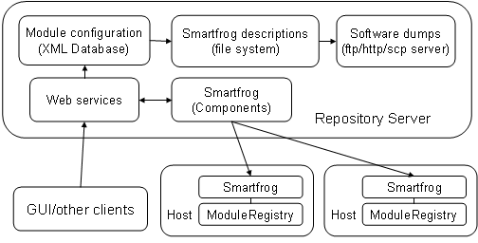

Repository server contains following main parts
- Module dumps
- Configurations
- Smartfrog components
- Web services
- Smartfrog self installer
- Module Locator
- Repository installer

Repository server can be accessed using web service interfaces, but internally it depends on smartfrog to execute the commands. Smartfrog communicates over java RMI with other daemons.

On the host nodes following components are present
- Smartfrog with avalanche components.
- Module registry
- JMX extension for module status. [Removed in favor of monitoring system for module status]

Note:
In next version GUI interface would provide an option to browse through network and select nodes instead of adding machine names manually.

System components

Module dumps
Module dumps reside on an ftp/http server or any other accessible location in a simple directory structure. Different software could be distributed across different download locations. Also, same software can be present on multiple mirror locations, which need to be mentioned in the description for download. Dump should be present in archived form on the server as a set of one or more archive files for efficient downloads. The location of software archives on download servers is referred from software configurations. Any change in location of software must be updated in the configuration otherwise any client trying to download the software will fail.

Directory structure for software dumps looks like
<componentname>
<versionNumber>
<platforms>
<Module archive>
<Module archive>

Configurations:
Configurations contains following information

- Module configurations
Module configurations are XML documents; these are stored in a searchable xml database – Xindice. There is only one module configuration document per-module in the system. This document contains links to smartfrog description files for all actions that can be performed on the module on any platform. The configuration and actions are mapped using selectors in XML document. Module dependencies issues are managed using smartfrog descriptions as described later.
- Smartfrog descriptions
Descriptions for actual work done by smartfrog components on target systems are contained in smartfrog description files. These can be SF language or CDDLM or any other language that smartfrog understands. These files are kept in plain disk files in a well defined directory structure (prefer local) accessible to web services on repository. Smartfrog descriptions are mapped to a particular action in module configuration. There can be different smartfrog descriptions for different platforms for the same version of a module.
Administrator access the system using GUI or any other client program which first locates the XML document containing actions mapped to smartfrog descriptions. GUI provides options to take any action on the software component on the target node.
Modules can be composed of multiple other modules; in such cases actions on these modules include actions on other modules in smartfrog description. For example smartfrog description for DOWNLOAD action on a module can include download of the modules on which it depends. These descriptions can be edited inline using avalanche’s web based interfaces.

- Module groups
A module group is a set of related or un-related modules. These are used to take collective actions like installing a fixed suite of modules on a node.
- Host profiles
Host profiles contain modules and modules groups that are configured on a particular host.
- Host groups
Host group contains a set of hosts on which collective actions can be taken. Host groups are identified by unique IDs, using these IDs system can take action on components, services or service groups with a single command.

Note:
In future versions, host groups can be used to distribute common software using IP multicasting. This is used only for the software that is shared on multiple hosts. Individual software can managed using present methods.

Smartfrog components
Smartfrog components written for deployment system are jar-signed and kept on the repository server (http accessible). These components are loaded dynamically by smartfrog daemons running on target hosts. Some additional smartfrog components are used by smartfrog daemon running on the repository server to support monitoring of distributed deployments. Main components used on server are –

- StreamLogger
Repository server contains a logs directory, which contains sub directories for all hosts. A host sub directory contains individual log files for all modules. Whenever some action is performed on a module on any host the output of that action is captured and sent to stream logger on repository server.
Stream logger creates a centralized log system, but this is in addition to logs maintained locally on each host. This creates a failover system – in case of network failure local logs can be used whereas in case of host machine failure central logs ca be used to find out what went wrong.

- Multi host deployer:
Multi host deployer takes a list of hosts and can deploy the description on all hosts. It’s implemented as a smartfrog function. Also, we may choose to have a smartfrog command-line wrapper program that takes a list of hosts in command line and deploys a description on all those hosts. Smartfrog’s array compound can be used for multi-host deployments.

- sfDispatcher
sfDispatcher component takes descriptions from smartfrog web service and submits them on smartfrog daemon on repository server, which in-turn runs them on target nodes. This component is responsible for monitoring the progress, success or failure of the actions. Smartfrog CDDLM contains an implementation for something similar that can be used if it fits. [Need to explore].

Web services
Web service interfaces are exposed from repository server for GUI or other programs to interact with the server and take actions on software on the distributed network. Main service interfaces are following. See class diagram for details.

- HostProfileManager
- HostGroupConfigManager
- ModuleConfigManager
- ModuleGroupConfigManager
- ModuleStatusManager

HostProfileManager
A host profile is essentially a list of modules and versions. It can also contain module groups, which in-turn contains modules and versions. To take any action on a module on a host it should be present in the host profile. So the first step would be to add the module or module group in host profile and then take some action on it. Modules in host profile can have different status like NOT AVAILABLE, DOWNLOADED, INSTALLED etc.

HostGroupConfigManager
HostGroupConfigManager provides interface to manage host groups to take collections on multiple hosts. A host can reside in multiple hosts groups based on some properties. For example all hosts in a particular project group and with a particular OS can for a host group.

ModuleConfigManager
Module configurations are XML documents that contain information about modules and the actions that can be taken on modules on target nodes. ModuleConfigManager provides a WS interface to manage module configurations. It does not provide any operations to edit fragments of smartfrog configurations associated with any action. These descriptions are taken as links in the XML documents and should be edited using other means and stored in repository. Implication of this is that one can not use WS interface to change the download server in the smartfrog description mapped to DOWNLOAD action for a particular (version + platform) of module.

ModuleGroupConfigManager
ModuleGroupConfigManager provides WS interface to create/manage module groups. Modules can be added or removed from module group. Actions can be defined at module group level. These actions are recursively applied to all modules. If an action is not present in individual module configuration then it can be ignored or error can be raised based on preference.

ModuleStatusManager
Module status manager provides a WS interface to smartfrog components to update the status of any module on any host. Smartfrog component on the server daemon monitor status of components running on hosts and update ModuleStatusManager in case of failures. Module status manager also provides access to the logs for modules.
A reliable notification system using Anubis, or ganglia would be better than exposing a web service interface for this.

Smartfrog self-installer
This deployment system requires all nodes to run smartfrog before it can deploy descriptions on them. For this we provide self-installer mechanism of smartfrog, which can log-in to hosts and install smartfrog. Self-installer is implemented as a smartfrog component. Repository server contains an active smartfrog installation, whenever administrator wants to add nodes to grid, the list of machines and logins are passed to smartfrog self-installer, which bootstraps that machine with smartfrog and starts it.
Smartfrog self installer starts smartfrog with basic smartfrog infrastructure with dynamic class loading enabled. All avalanche related components are loaded dynamically from repository server.
Prerequisites for the self installation is the remote login should be enabled in the machine using – telnet, ssh, ftp, scp etc.

Module Locator
Module locator takes a machine description and a module ID and locates a module distribution i.e. a package and a version applicable for that platform.

Repository Self-installer

Repository self-installer is a set of smartfrog based configurations and components. Self installer is wrapped in a script that first installs smartfrog on the repository server and then uses smartfrog to setup other repository server components.

Smartfrog configuration for repository server needs to be modified for any changes in the actual paths on the server.

Note
Future versions can support a repository installs that installs from a vendor location on internet and keeps the repository software updated with new releases automatically.

Design model

Repository server
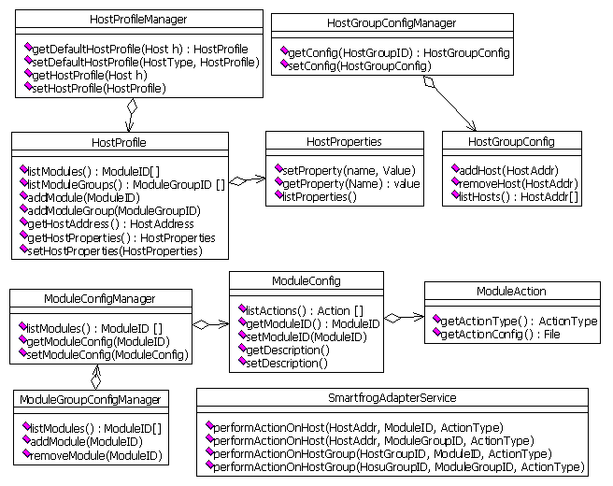

Module configuration

Basic structure of module configuration
Module
    - ModuleID
    - Description
    - Vendor
    - Configurations
      - Version
        - Platform selector
        - Actions
          - Action type
          - Smartfrog file

Module ID is a system wide unique ID. Module IDs can be formed uniquely using a package like naming structure like in Java. Description and Vendor are optional fields to provide additional information about modules. Configurations section provides links to actual smartfrog configurations.
Multiple versions of same module can exist in the system and administrator can choose to use any of these versions on any host. To point to a particular distribution of the module, selectors are used. A platform selector is a regular expression based list of system properties like platform, OS version etc. These properties are mapped against host’s properties and if these match then that particular module distribution is selected for the host.
Also for each distribution there is a list of actions that can be performed on the module. These actions map to some smartfrog description file. Following are some standard actions which can be extended depending on need.

- DOWNLOAD
- INSTALL
- START
- TERMINATE
- UNINSTALL
- UPGRADE
- QUERY

It is not mandatory for all module distributions to implement all actions, for example if a module represents a library then there won’t be any START action associated with it.

Common Actions and descriptions

DOWNLOAD
This action causes downloading of software from a repository on the target node using specified transport. The download server or list of servers and transport is supplied in the smartfrog description. Download actions works if the status of component on the target machine’s ModuleRegistry is not available, if the status is DOWNLOADING, DOWNLOADED, INSTALLED then this action results in success without really downloading anything.

INSTALL
This action assumes the module is already downloaded on the target machine. As described in smartfrog description convention, the downloaded location is shared between installer and downloader using extension mechanism of smartfrog language. This action works if the status is DOWNLOADED or NOT_AVAILABLE. In case of not available it first downloads the module and then installs it. In case status is already INSTALLED or RUNNING it results in success with appropriate code.

UPGRADE
This action forces the description on the target system. The smartfrog components for this module need not check for the status of module in module registry but it must update the status after the upgrade is done. Description for upgrade request can choose to re-download the entire module or just replace some configuration file and restart the module.

UNINSTALL
This action removes the installed module and cleans up the downloaded archives if needed; it shares the location from the INSTALL and DOWNLOAD action’s description using the extension mechanism.

START
This action starts (runs) the software if it’s already installed, otherwise it invokes the INSTALL action and then starts the software.

TERMINATE
This action terminates a running application on the specified host(s). There may not be a separate configuration for terminate in most cases, but some application (like tomcat) require running separate scripts to shutdown the application.

QUERY
This action queries the host for availability or status of a module. This action may not have a per module configuration, some generic configurations could do this work. This is in addition to web service query interface and is not available to external users directly.

5.2.3 Module configuration schema
A module configuration is an XML document conforming to following schema.

<xs:schema targetNamespace="http://avalanche.org/12/2004/module"
xmlns:xs='http://www.w3.org/2001/XMLSchema'
xmlns:av="http://avalanche.org/12/2004/module">

<xs:element name="module" type="av:moduleType"/>

<xs:complexType name="moduleType">
<xs:sequence>
<!-- mendatory attribute. -->
<xs:element name="id" type="av:IDType"
minOccurs="1" maxOccurs="1"/>
<xs:element name="description" type="xs:string"
minOccurs="0" maxOccurs="1"/>
<xs:element name="vendor" type="xs:string"
minOccurs="0" maxOccurs="1"/>

<xs:element name="configurations">
<xs:complexType>
<xs:sequence>
<xs:element name="version" type="av:moduleVersionType"
minOccurs="0" maxOccurs="unbounded"/>
</xs:sequence>
</xs:complexType>
</xs:element>
</xs:sequence>
</xs:complexType>

<xs:simpleType name="IDType">
<!-- should we change this to a http:// format or leave it flexible ?? -->
<xs:restriction base="xs:string"/>
</xs:simpleType>

<xs:simpleType name="versionNumType">
<!-- should we change this to a http:// format or leave it flexible ?? -->
<xs:restriction base="xs:string"/>
</xs:simpleType>
<xs:complexType name="moduleVersionType">
<xs:sequence>
<xs:element name="version" type="av:versionNumberType"
minOccurs="1" maxOccurs="1"/>
<xs:element name="selector"
minOccurs="1" maxOccurs="unbounded">
<xs:complexType>
<xs:sequence>
<!—
platform and operating system can be a regular expression like "*" for all platforms or HP-UX* for all hp unixes. it can also be a set of platforms, appearing seperately. Leaving these attributes empty would be error, if all platform/OSes are supported like in pure Java, "*" should be specified. Versions for operating system/platform/arch should be embedded in the naming scheme itself
-->
<xs:element name="platform" type="xs:string"
minOccus="1" maxOccurs="unbounded"/>
<xs:element name="os" type="xs:string"
minOccurs="1" maxOccurs="unbounded"/>
</xs:sequence>
</xs:complexType>
</xs:element>
<xs:element name="actions" minOccurs="1" maxOccurs="1">
<xs:complexType>
<xs:sequence>
<xs:element name="action" type="av:actionType"
minOccurs="0" maxOccurs="unbounded"/>
</xs:sequence>
</xs:complexType>
</xs:element>
</xs:sequence>
</xs:complexType>

<xs:complexType name="actionType">
<xs:sequence>
<!—
Example action types DOWNLOAD, INSTALL, UNINSTALL, START, TERMINATE, UPGRADE, ALL. New actions like composite action that DOWNLOAD + INSTALL etc may be specified for specific modules and added here.
-->
<xs:element name="type" type="xs:string"
minOccurs="1" maxOccurs="1"/>
<xs:element name="configurationFile" type="xs:string"
minOccurs="1" maxOccurs="1"/>
<!—
default is "smartfrog", if not specified. do we need this ?
-->
<xs:element name="executionEngine" type="xs:string"
minOccurs="0" maxOccurs="1"/>
</xs:sequence>
</xs:complexType>
</xs:schema>

Smartfrog configurations:

Conventions for smartfrog descriptions
All smartfrog descriptions follow some conventions for consistent operation and ease of understanding and writing. Each action is described in a separate file and the actions that share some attribute refer to other component using “#include”. In no case same attribute should be duplicated in different files, it makes updates in consistent.

Example:

/versions/1.1/hp-ux.pa11
download.sf – download as main description, contains attribute download target location.
install.sf – install as main description, includes download and uses attribute download target as install source.
start.sf – starts the module, uses install target as start source.
uninstall.sf – removes the module.

Smartfrog descriptions that need to check for status of a component before taking action should use ModuleRegistry component for this. This component takes a module ID and queries module registry and returns the status. Module registry is available through JMX also.

Dynamic class loading
All smartfrog descriptions in the system use dynamic class loading feature and provide code base in the description as an appropriate location on repository server. Repository server provides a standard http accessible location to place sources for smartfrog components. This makes it easy to maintain changes in smartfrog component’s implementation and distributing new components.

Module Relationships and dependencies
Modules can be composed of other modules; this relationship is established in the smartfrog descriptions. Description for any action on a module is responsible for checking the status of any other module needed to perform the action. If the module is not there it can be automatically downloaded and installed using smartfrog.
Order of module’s actions like parallel downloads; sequential installation is implemented using smartfrog workflows or EventBus. In case any step in the workflow is not needed for example dependent module is already installed, it would be skipped (using module registry).

Removing dependent modules
Should we add reference count to the module registry? Until smartfrog’s XML based language is used we can’t query all modules to see who all depends on some particular module.
Explanation: dependency management at present is done using smartfrog description files. Components refer to each other in smartfrog workflows. Smartfrog files can not be queried in the data store (file system) to find which modules depend on which other modules. Note that these modules may not have an active smartfrog component in daemon all the time and all we have is module IDs and configuration files to figure out dependencies.

Monitoring Parents
Monitoring of distributed components is done over a monitoring infrastructure like ganglia or anubis. In this there are providers and listeners. Any component interested in publishing some information puts it on the monitoring system and its made avaiable to all listeners.

Conventions for smartfrog components

Output streaming
All components that run on target hosts send their output or status back to repository server, in a streaming fashion using smartfrog’s output redirection mechanism. These logs are maintained at server in a well defined directory structure and are accessible to administrators for diagnostics.

ModuleRegistry
ModuleRegistry is implemented as a smartfrog component that connects to a singleton and persistent object. Singleton can be implemented using unique naming of smartfrog components. It provides interface to register a module and its status on the target host. All smartfrog components dealing with modules must use ModuleRegistry to register the status of their module using module ID and version number. Same should be used to check the status of a module for example if module DOWNLOAD action is requested and status of module is already INSTALLED then the module need not be downloaded again.

Host concepts
Smartfrog daemons running on hosts are responsible for executing descriptions, submitted by repository services. All smartfrog daemons start with remote class loading support and all components are loaded from repository server.

Any output generated by running commands is sent back to the parent component on the repository node over an event system. This output is logged in a disk file and is used for diagnosing problems.

Main smartfrog components on target nodes, as mentioned earlier code for these components reside on the repository server on an http location. It is loaded dynamically whenever a description referring to these components is executed.
A version controlled repository for software looks like an overkill since we store multiple versions of software anyways. Having configurations in a version controlled repository sounds like a good idea. We may want to include this in phase 2.

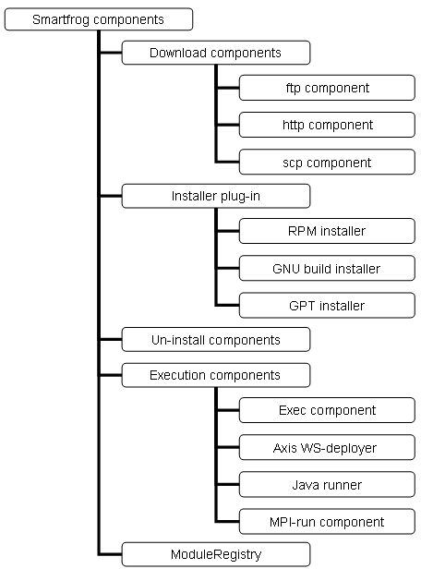

ModuleRegistry
There are two types of descriptions, first are the ones that execute for once and then terminate like downloading or installing. Second, descriptions responsible for running keep active as long as program is running. Second type descriptions are easy to detect if they are active using smartfrog. But we also need a way to determine if a description of first type has executed for a module. For this purpose we introduce a persistent, static, thread-safe component called module registry.
Module registry contains following information for a module on the target node –
    - Module ID
    - Module version
    - Module Status (DOWNLOADING, DOWNLOADED, INSTALLED, NOT_AVAILABLE)

This information is stored in a simple XML file and is updated every time the module status is changed by any of the smartfrog components.
These XML files can be backed up in a XML database on the repository server, which gives an overall view of the status of the modules.

If the host system is rebooted then module registry is reloaded from the file/database.
Note: there is no status for RUNNING etc because the basic idea is to prevent re-installs. Also RUNNING status becomes invalid if the host reboots.

Security
Security is implemented at two places in this phase
- Username/password based access control for administrator through GUI.
- Signed jar files for smartfrog components.

More …
We need to integrate this with grid security in future.

Appendix

Example usage scenario

XML schemas
Module Group

<xs:element name="moduleGroup" type="moduleGroupType"
minOccurs="0" maxOccurs="unbounded"/>

<xs:complexType name="moduleGroupType">
<xs:sequence>
<xs:element name="module" minOccurs="0" maxOccurs="unbounded">
<xs:complexType>
<xs:sequence>
<xs:element name="id" type="av:IDType"
minOccurs="1" maxOccurs="1"/>
<xs:element name="version" type="av:componentVersionType"
minOccurs="1" maxOccurs="1"/>
</xs:sequence>
</xs:complexType>
</xs:element>
</xs:sequence>
</xs:complexType>

<xs:element name="moduleGroup" type="moduleGroupType"
minOccurs="0" maxOccurs="unbounded"/>

<xs:complexType name="moduleGroupType">
<xs:choice>
<xs:element name="module" minOccurs="0" maxOccurs="unbounded">
<xs:complexType>
<xs:sequence>
<xs:element name="id" type="av:IDType"
minOccurs="1" maxOccurs="1"/>
<xs:element name="version" type="av:componentVersionType"
minOccurs="1" maxOccurs="1"/>
</xs:sequence>
</xs:complexType>
</xs:element>
<xs:element name="moduleGroup" type="moduleGroupType"
minOccurs="0" maxOccurs="unbounded"/>
</xs:choice>
</xs:complexType>

Host Profile
<xs:element name="defaultHostProfile"
minOccurs="0" maxOccurs="unbounded">

<xs:complexType>
<xs:sequence>
<xs:element name="hostProperties"
minOccurs="1" maxOccurs="unbounded">
<xs:complexType>
<xs:element name="platform" type="xs:string"
minOccurs="1" maxOccurs="unbounded"/>
<xs:element name="arch" type="xs:string"
minOccurs="0" maxOccurs="unbounded"/>
<xs:element name="os" type="xs:string"
minOccurs="0" maxOccurs="unbounded"/>
</xs:complexType>
</xs:element>
<xs:element name="modulesProfile" type="moduleGroupType"
minOccurs="1" maxOccurs="1"/>
</xs:sequence>
</xs:complexType>

</xs:element>

Default Host Profile
<xs:element name="defaultHostProfile"
minOccurs="0" maxOccurs="unbounded">

<xs:complexType>
<xs:sequence>
<xs:element name="hostSelector"
minOccurs="1" maxOccurs="unbounded">
<xs:complexType>
<xs:element name="platform" type="xs:string"
minOccurs="1" maxOccurs="unbounded"/>
<xs:element name="arch" type="xs:string"
minOccurs="0" maxOccurs="unbounded"/>
<xs:element name="os" type="xs:string"
minOccurs="0" maxOccurs="unbounded"/>
</xs:complexType>
</xs:element>
<xs:element name="modulesProfile" type="moduleGroupType"
minOccurs="1" maxOccurs="1"/>
</xs:sequence>
</xs:complexType>

</xs:element>

Security

Design pattern guide

