Configuration Description, Deployment,
and Lifecycle Management

SmartFrog-Based Language Specification
Revision 0.4

Status of this Memo
This document provides information to the community regarding the specification of the Configuration Description, Deployment, and Lifecycle Management (CDDLM) Language. Distribution of this document is unlimited. This is a DRAFT document and continues to be revised.

Abstract
Successful realization of the Grid vision of a broadly applicable and adopted framework for distributed system integration, virtualization, and management requires the support for configuring Grid services, their deployment, and managing their lifecycle. A major part of this framework is a language in which to describe the components and systems that are required. This document, produced by the CDDLM working group within the Global Grid Forum (GGF), provides a definition of the CDDLM language that is based on the SmartFrog (Smart Framework for Object Groups) and its requirements.


GLOBAL GRID FORUM
office@ggf.org
www.ggf.org

Full Copyright Notice
Copyright © Global Grid Forum (2004). All Rights Reserved.
This document and translations of it may be copied and furnished to others, and derivative works that comment on or otherwise explain it or assist in its implementation may be prepared, copied, published and distributed, in whole or in part, without restriction of any kind, provided that the above copyright notice and this paragraph are included on all such copies and derivative works. However, this document itself may not be modified in any way, such as by removing the copyright notice or references to the GGF or other organizations, except as needed for the purpose of developing Grid Recommendations in which case the procedures for copyrights defined in the GGF Document process must be followed, or as required to translate it into languages other than English.
The limited permissions granted above are perpetual and will not be revoked by the GGF or its successors or assigns.
This document and the information contained herein is provided on an "AS IS" basis and THE GLOBAL GRID FORUM DISCLAIMS ALL WARRANTIES, EXPRESS OR IMPLIED, INCLUDING BUT NOT LIMITED TO ANY WARRANTY THAT THE USE OF THE INFORMATION HEREIN WILL NOT INFRINGE ANY RIGHTS OR ANY IMPLIED WARRANTIES OF MERCHANTABILITY OR FITNESS FOR A PARTICULAR PURPOSE.

Intellectual Property Statement
The GGF takes no position regarding the validity or scope of any intellectual property or other rights that might be claimed to pertain to the implementation or use of the technology described in this document or the extent to which any license under such rights might or might not be available; neither does it represent that it has made any effort to identify any such rights. Copies of claims of rights made available for publication and any assurances of licenses to be made available, or the result of an attempt made to obtain a general license or permission for the use of such proprietary rights by implementers or users of this specification can be obtained from the GGF Secretariat.
The GGF invites any interested party to bring to its attention any copyrights, patents or patent applications, or other proprietary rights which may cover technology that may be required to practice this recommendation. Please address the information to the GGF Executive Director (see contact information at GGF website).

Table of Contents

Table of Contents 3
List of Figures 4
1 Introduction 5
2 CDDLM-WG and the Purpose of this Document 5
3 The CDDLM Notation 5
3.1 Background 5
4 Requirements for the language 6
5 Concrete Syntax 7
5.1 Attributes, Attribute Lists and Streams 7
5.2 Component Descriptions 8
5.3 Types vs. Prototypes 10
5.4 References 10
5.5 Comments 15
6 Parameterization 15
7 Include Files 16
8 Main 17
9 Resolution – Semantics For The CDDLM Notation 18
10 Functions 21
10.1 concat 21
10.2 vector 21
10.3 append 22
10.4 formatString 22
10.5 sum 22
10.6 product 23
10.7 random 23
10.8 next 23
10.9 date 24
10.10 userinput 24
11 Schemas 24
12 Summary of CDDLM Language Processing 27
13 The CDDLM Syntax 27
14 The CDDLM Notation Lexical Rules 28
15 Security Considerations 30
16 Editor Information 30
17 Contributors 30
18 Acknowledgements 30
References 31
A. An Example Configuration 32
A.1 Cross-Application Components 32
A.2 Custom components 35
A.3 Instantiation 38

List of Figures

Figure 1. CDDLM Language Use and Relationship with other Components 6
Figure 2. Use of Inheritance in Templates 9
Figure 3. Scope of References 11

Table of Contents 33
List of Figures 34
List of Figures 34
1 Introduction 55
2 CDDLM-WG and the Purpose of this Document 55
3 The CDDLM Notation 55
3.1 Background 55
4 Requirements for the language 66
5 Concrete Syntax 77
5.1 Attributes, Attribute Lists and Streams 77
5.2 Component Descriptions 88
5.3 Types vs. Prototypes 1010
5.4 References 1010
5.5 Comments 1515
6 Parameterization 1515
7 Include Files 1616
8 Main 1717
9 Resolution – Semantics For The CDDLM Notation 1818
10 Functions 2121
10.1 concat 2121
10.2 vector 2121
10.3 append 2222
10.4 formatString 2222
10.5 sum 2222
10.6 product 2323
10.7 random 2323
10.8 next 2323
10.9 date 2424
10.10 userinput 2424
11 Schemas 2424
12 Summary of CDDLM Language Processing 2727
13 The CDDLM Syntax 2728
14 The CDDLM Notation Lexical Rules 2828
15 Security Considerations 3030
16 Editor Information 3030
17 Contributors 3030
18 Acknowledgements 3031
References 3131

Table of Contents 33
List of Figures 34
List of Figures 34
1 Introduction 56
2 CDDLM-WG and the Purpose of this Document 56
3 The CDDLM Notation 56
3.1 Background 56
4 Requirements for the language 67
5 Concrete Syntax 78
5.1 Attributes, Attribute Lists and Streams 78
5.2 Component Descriptions 89
5.3 Types vs. Prototypes 1011
5.4 References 1011
5.5 Comments 1516
6 Parameterization 1516
7 Include Files 1617
8 Main 1718
9 Resolution – Semantics For The CDDLM Notation 1819
10 Functions 2122
10.1 concat 2122
10.2 vector 2122
10.3 append 2223
10.4 formatString 2223
10.5 sum 2223
10.6 product 2324
10.7 random 2324
10.8 next 2324
10.9 date 2425
10.10 userinput 2425
11 Schemas 2425
12 Summary of CDDLM Language Processing 2728
13 The CDDLM Syntax 2729
14 The CDDLM Notation Lexical Rules 2829
15 Security Considerations 3031
16 Editor Information 3031
17 Contributors 3031
18 Acknowledgements 3032
References 3132

Introduction
Deploying a complex, distributed service presents many challenges related to service configuration and management. These range from how to describe the precise, desired configuration of the service, to how we automatically and repeatably deploy, manage and then remove the service. This document addresses the description challenges, while other challenges are addressed by the follow-up documents . Description challenges include how to represent the full range of service and resource elements, how to support service "templates", service composition, correctness checking, and so on. Addressing these challenges is highly relevant to Grid computing at a number of levels, including configuring and deploying individual Grid Services, as well as composite systems made up of many co-operating Grid Services.

CDDLM-WG and the Purpose of this Document

The CDDLM WG addresses how to: describe configuration of services; deploy them on the Grid; and manage their deployment lifecycle (instantiate, initiate, start, stop, restart, etc.). The intent of the WG is to gather researchers, developers, practitioners, and theoreticians in the areas of services and application configuration, deployment, and deployment life-cycle management and to explore the community need for a broader effort in this area. The target of the CDDLM WG is to come up with the specifications for CDDML a) language, b) component model, and c) basic services. This document represents one of the two CDDLM language specifications. This specification is based on the expertise with SmartFrog language developed at HP Labs. The other language will be entirely XML based. The two language specifications will be compatible.
Both languages will be declarative, i.e. they will support attribute value pairs. They will furthermore support inheritance, references (including lazy), parameterization, predicates and schemas. The rest of the document describes the features supported in the SmartFrog-based CDDLM language.

The CDDLM Notation

Background
The CDDLM notation has been designed to provide users of the CDDLM framework with a simple, yet powerful, attribute description language. The reason that the notation has been developed, rather than merely using XML, is that a number of features are required that are not directly supported by XML, though they could be encoded, and that use of these features requires the use of human-friendly syntax. The syntax is derived from the tried and tested first generation SmartFrog notation [1] and it makes a few minor changes to reflect the core differences between it and CDDLM.
There is an XML binding for the language to go along with this form of the language design, providing support for those who prefer to use that syntax. This syntax is provided in [3].
The CDDLM component model in no way depends on the nature of this notation. Indeed there are relatively few aspects of the notation that are specific to the CDDLM framework. Most of the language is simply for defining collections of attributes. The framework uses these attributes to achieve the desired configuration effect. The details of these attributes and their impact on the framework are left to other CDDLM documents. This document concentrates only on the use of the notation for defining attributes.
The role of the notation is summarized in the diagram below. The descriptions merely define collections of attributes, represented as data structures after parsing, and these may be used either:
- by the CDDLM infrastructure as defining the configuration of some distributed system; though certain well-formedness conditions apply in that specific attributes must be present
- by other programs as the configuration data that they require, though here too, well-formedness criteria might exist - defined on a case by case basis.
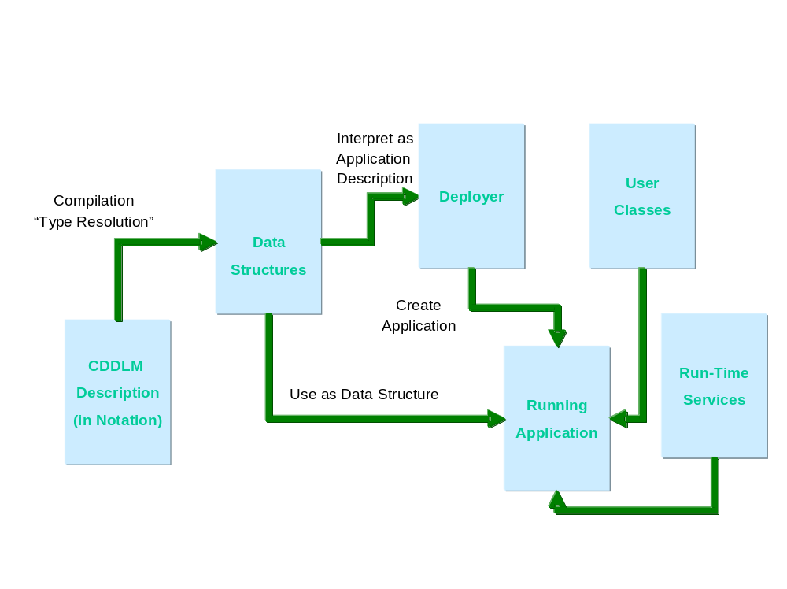
Figure 1. CDDLM Language Use and Relationship with other Components

Requirements for the language
A language designed to support the use of a framework such as CDDLM has a number of core requirements:
- The language is primarily designed to define configuration data for use by the framework services, defining the configuration of the resources and software components that define the Grid service to be deployed.
- The language will be used for such a wide variety of services and resources, and of such complexity, that a language must be both readable and support a number of abstraction mechanisms such as inheritance and parameterization.
- The language must support the notion of templating, the ability to provide patterns of configuration that may be specialized at time of use.
- The language must support a way of checking the use of templates to ensure that they are being applied in an appropriate way.
- The language must support the notion that data is available at different phases of a service deployment – for example some data is available at time of template definition or use, other data is only available at run-time. An example of the former may be data regarding the performance of web servers required for a service whilst an example of the latter may be the specific type of the nodes on which the servers are to run, and hence the precise number of servers required to meet the required performance.

Concrete Syntax

Attributes, Attribute Lists and Streams
A CDDLM description consists of an ordered collection of attributes. The attributes are ordered because several of the operations in the CDDLM framework require an order, for example the order in which the configuration should be instantiated.
Each attribute has a name and a value, this value being either a basic value (integer, string, etc), or an ordered collection of attributes known as a component description. This recursion provides a tree of attributes, the leaves of which are the basic values. A value may also be provided by reference to another attribute. This is described by the following BNF, where Stream indicates the entry point to a CDDLM language parser.
Stream ::= AttributeList

AttributeList ::= AttributeListElement*
AttributeListElement ::= Attribute | #include string (1)
Attribute ::= Name Value (2)
Name ::= BaseReference | -- (3)
Value ::= ; | Basic ; | ComponentDescription | [LAZY] BaseReference ; (4)

Basic ::= Number | String | Boolean | Vector
Vector ::= [ ] | [ Basic (, Basic)* ]
From this, it is clear that the input to the parser is a collection of attributes, each named and having an optional value (2). If the value is not present, (the first alternative in (4)) the value is defined to be the string containing the name of the attribute. Thus, the following two attribute definitions are equivalent.
foo;
foo "foo";
The reason for providing this feature is to enable the use of attributes where the presence of the attribute is what is important, not its value.
The syntax for a name will be covered later, but for now it can be considered to be either a simple sequence of letters and digits, starting with a letter, or the double-hyphen "--" (3). The double hyphen is for use at times when the attribute name is not important (a new unique name is generated and used). This is particularly useful with the function syntax described in Section 10.
Include files (1) are covered in more detail in section 7, but in general they consist of parseable CDDLM text which are parsed as attribute lists and unpacked into place within the container attribute list.
The syntax for the basic values is best given by example.
Integer: 345
Long: 65325L
Float: 34.76
Double: 1534.456D
String: "this is a string"
Multi-line String: ## This is a string
Over many lines #
Boolean: true
Vector: [3.67, [34, 53, 1], ["string", 34], []]
Binary Data: @base64data@

Consequently, an example of a piece of CDDLM text is as follows
portNum 4074;
hostname "ahost.cddlm.org";
isHighPriority false;
validUsers ["fred", "harry", "mike"];
data @234s4Txx@
defining four attributes with the appropriate values.

Component Descriptions
Attributes may have values that are collections of other attributes, known as component descriptions. They obtain their name from the fact that they may be interpreted by the framework as the description of a component, though they may equally be used to describe structured data.
A component description consists of two parts, a reference to another component description to act as a source of attributes, and a collection of attributes that are then added to, or override, the attributes of the referenced collection. The syntax is:
ComponentDescription ::= extends BaseComponent

BaseComponent ::= [Reference | NULL] ( ; | { AttributeList } )
Both the reference and the attribute list are effectively optional. If neither is present, the resultant attribute list is defined to be empty. The syntax is most easily explained through an example:
SFService extends { // an implicit extension of NULL
portNum 4047;
hostname "ahost.Cddlm.org";
administrators ["patrick"];
}

UseableService extends SFService { //an extension of the previous component
portNum 4048; // override the definition of portNum
users ["fred", "harry"]; // add a new attribute
}
The text consists of two attributes, both of which have values that are collections of attributes. The second of these, UseableService, is defined as an extension of the first, SFService, with two attributes added to or overwriting those inherited. The text is semantically identical to the following:
SFService extends {
portNum 4047;
hostname "ahost.Cddlm.org";
administrators ["patrick"];
}

UseableService extends {
portNum 4048;
hostname "ahost.Cddlm.org";
administrators ["patrick"];
users ["fred", "harry"];
}
Note that the attributes in a component description are ordered and that when an attribute is overwritten it maintains its position, but when it is a new attribute it is added to the end. The process of expansion of the inheritance in this way is known as Type Resolution and is explained further below.
Note also that the parsed stream is considered to be in an implicit, anonymous (i.e. not named in an outer component description), component description known as ROOT.
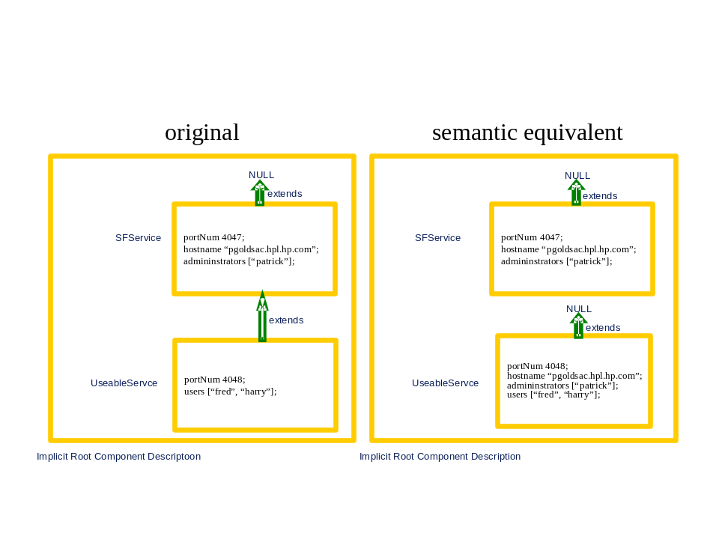
Figure 2. Use of Inheritance in Templates
The example is also shown in the diagram. It clearly shows that there are two kinds of relationship between component descriptions. One is the containment relationship, where a component description contains an attribute that is itself a component description. The second is the inheritance or extension relationship. This second class of relationship is one that can be transformed, by type resolution, to an equivalent one containing no extension (also indicated by the NULL extension).
Whilst the extension relationship is merely a convenient way of defining attributes, the containment hierarchy is a more fundamental construct. It should be noticed that that containment hierarchy effectively provides a naming scheme by which attributes may be referenced. In this it is similar to other such named hierarchies, such as directory hierarchies common in files systems.

Types vs. Prototypes
CDDLM does not define types for attributes and components. Rather it defines the notion of a prototype. Each attribute whose value is a component description may be considered as a prototype for another: it may be taken and modified as appropriate to provide the value for the new attribute. The mechanism for this is the extends construct.
Any attribute whose value is a component description may be, at a later juncture, selected and modified to provide a new component description to be bound to a name. This new attribute may be further modified by subsequent attributes. In this way, it is possible to provide partial definitions, with default values for attributes, to be completed or specialized when used. This provides a simple template mechanism for components.
Consequently, there are no separate spaces of types and instances; every component is logically an instance, but may also be a prototype for another. However, it is clear that in providing descriptions, some components will be defined with the intention that they be used as prototypes for other components, whilst others will be defined without that expectation. Whilst this may appear strange in the first instance, it turns out to be one of the main strengths of the CDDLM notation.

References
References may occur in three places in the syntax: as the name of an attribute – known as a placement, as a reference to the extended component (the prototype) of a component description, and as an attribute value referring to another attribute whose value is to be copied – known as a link.
The primary purpose of a reference is to indicate a path through the containment hierarchy defined by the components. In this, it is similar to the notion of path common in file systems in operating systems such as Linux. A path defines a traversal of the directory hierarchy, a structure similar to the component hierarchy.
The syntax for references is as follows:
BaseReference ::= ReferencePart (: ReferencePart)*
ReferencePart ::= ROOT | PARENT | WORD | ATTRIB WORD | THIS
Thus, a reference is a colon-separated list of parts each of which indicates a step in the path through the containment tree. Examples of references are:
PARENT:PARENT:foo:bar
ATTRIB a:b
ROOT
The general rule for the interpretation of a reference is that the reference is evaluated in a context (a component description somewhere in the description containment tree), and that each step moves the context to a possibly different component for the remainder of the reference to be evaluated. This is equivalent to path evaluation in a Linux file system, the path is evaluated in a current directory, and each part of the path moves the context to another directory.
The semantics of each of the reference parts is as follows: starting at component in which the reference is defined…
- PARENT - move context to the parent (container) component if it exists, fail otherwise (c.f. Linux “..”)
- WORD - look for the attribute named “word” in the current context, fail otherwise
- ATTRIB WORD - look for the attribute named “word” in the current context or anywhere in the containment hierarchy (the closest is chosen), move to the context defined by this attribute, fail if no attribute is found in the containment hierarchy
- ROOT - switch context to the outer-most component (normally the implicit root component - c.f. Linux “/ “)
- THIS – the current context (c.f. Linux “.”)
Some examples of references (in this case link references) are as follows:
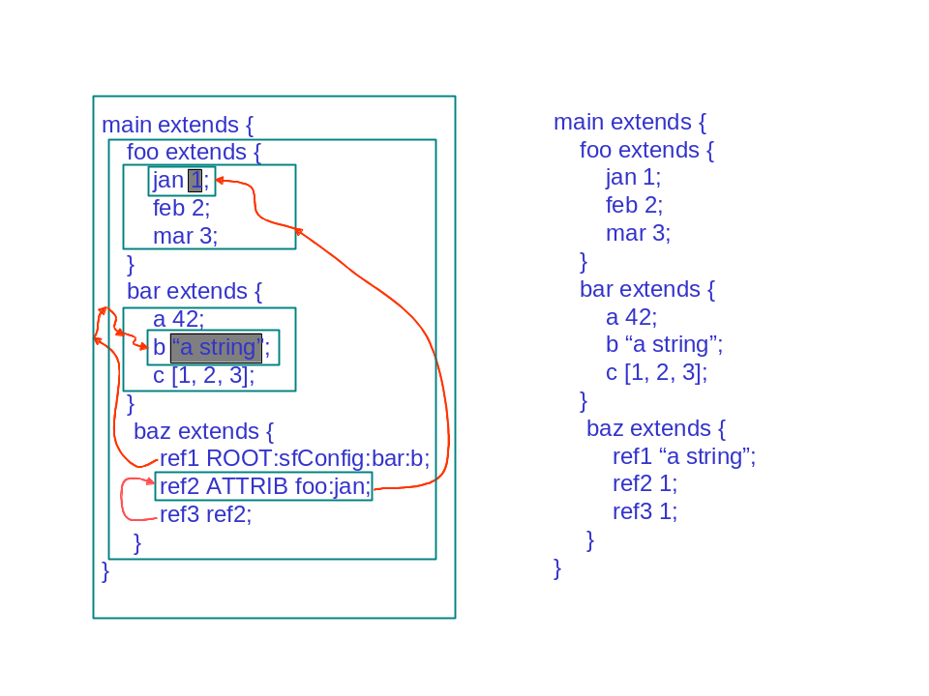
Figure 3. Scope of References
The arrows in the left-hand text show the path followed as the references are resolved to obtain the referenced attribute values, noting that the resolution of ref3 will follow the resolution of ref2. The contexts traversed as the resolutions progress are shown boxed and the right-hand text shows the result of resolving the three links.
The above rules determine the general interpretation of references. However, each of the syntactic contexts has its own slight semantic variation; these variations appear in the detailed definition of the semantics for references.

Reference Elimination – Resolution
The key to the semantics of the CDDLM notation is the process by which references are eliminated. This is necessary for each of the three syntactic locations where references may occur – prototype references, placement references and link references. The process by which references are eliminated is known as reference resolution. However, each type of reference has a different notion of resolution and so each has a specific resolution action – known respectively as type resolution, placement resolution and link resolution. This last name is historically also known as deployment resolution; this old name appears in parts of the API and is kept for backward compatibility. The resolution steps are described in more detail in the next few sub-sections, and then revisited as a whole to examine their interaction with each other.

Prototype References
References to prototypes, as defined in the following syntactic context,
Component ::= extends [LAZY] BaseComponent
BaseComponent ::= [Reference] ( ; | { AttributeList } )
are resolved as described above except in one respect: if the reference to the prototype consists of a single WORD part, it is interpreted as ATTRIB WORD.
Thus, the following are equivalent
Foo extends Bar { …}
Foo extends ATTRIB Bar {…}
This is to provide a greater degree of convenience when referring to a prototype as these are most often defined in the outermost implicit root context, and frequently defined in an included file. Using this re-interpretation using ATTRIB, rather than adding an implicit ROOT reference part to the front, ensures that global definitions of prototypes at the top level may be locally overridden if required.
The following example demonstrates most of the situations:
Foo extends { a 1; }
Bar extends {
foo extends Foo;
}
Baz extends {
Foo extends {
b 2;
}
foo1 extends Foo; // recall - this is equivalent to ATTRIB Foo
foo2 extends ROOT:Foo;
foo3 extends PARENT:Foo;
foo4 extends PARENT:PARENT:Foo;
}
After type resolution, which includes the merging and overwrite of attributes as described in section 5.2, the example is equivalent to:
Foo extends { a 1; }
Bar extends {
foo extends { a 1; } // ATTRIB Foo finds the outermost
}
Baz extends {
Foo extends { b 2; }
foo1 extends { b 2; } // ATTRIB Foo finds the closest enclosing
foo2 extends { a 1; } // ROOT:Foo finds the one in the root
foo3 extends { b 2; } // PARENT:Foo finds that in the parent
foo4 extends { a 1; } // PARENT:PARENT:Foo finds that in the root (in this case)
}

Placement References
An attribute’s name may be a reference, as described in the syntactic clauses
Attribute ::= Name Value
Name ::= BaseReference
This is not completely accurate, as the syntax in fact limits references to being a reference containing WORDS, the other reference parts are considered erroneous.
The resolution of the reference is again largely as described above, with the following modification.
The last reference part of the reference must be a WORD and is treated differently. This word part is not strictly part of the reference, but is used to identify the name of an attribute that is to be created (as opposed to referenced) in the context of the prefix part of the name reference. Thus in the attribute definition
foo:baz:bar 42;
the foo:baz is a reference to a location, bar is the name of the attribute to be created in that context.
In most cases, the name consists only of that final WORD leaving the prefix reference empty, indicating the current context. Thus, the attribute is defined in that current context. Where a non-empty reference prefixes the final word, the reference is used to determine the appropriate context and the attribute with the given name is placed into that context.
Consider the example
Service extends {
portNum 4089;
}

Service:portNum 4074;
Service:hostname "ahost.cddlm.org";
The prefix reference Service: is de-referenced to indicate the Service attribute. The two prefixed attributes are therefore placed within that reference context, overriding or placed at the end of the context as appropriate. Thus, the example is roughly equivalent to the following (there are some differences in their behaviour as prototypes):
Service extends {
portNum 4074;
hostname "ahost.cddlm.org";
}
The act of placing the attributes into a location is known as placement resolution, and it occurs simultaneously with the removal of the reference-prefixed attribute from its defining context.
Placement of attributes can lead to a great deal of confusion if not used properly. It reacts in interesting ways with type resolution; this interaction is explained in the section on resolution.

Link And LAZY Link References
Frequently, attributes need to take on the same values as other attributes. This can be for many reasons:
- to avoid repetition of values at many points in a description making it easier to maintain that description
- to hide the structure of the description to a program; explained further in section Error: Reference source not found.
- to provide a means of simple parameterization; explained further in the section 6.
This association between the value of one attribute and that of another is defined by providing a reference in the place of a value of the attribute. This reference is resolved relative to the context at the point of definition.
Consider the following example, in which a server and a client both need to know the TCP/IP port on which the server will listen.
System extends {
server extends {
portNum 4089;
}
client extends {
portNum ATTRIB server:portNum;
}
}
The system contains a server and a client. The server and client both have an attribute portNum, with that of the client being defined as a link to that of the server.
There is a resolution step, known as link resolution (and occasionally deployment resolution), which replaces references by the values that they reference. During the resolution phase, chains of links are resolved appropriately.
In the above example, the definition of System is equivalent to the following:
System extends {
server extends {
portNum 4089;
}
client extends {
portNum 4089;
}
}
Consequently, both the server and client share the same value and maintenance is eased in that should the port number need be changed, this need happen in only one place in the description.
It is frequently the case that the link itself is required as a value; i.e. the link should not be resolved to the value that it might refer to within the description. This reference may then be used within a CDDLM application after deployment, for resolution at run-time rather than at the time of parsing the description.

In order to provide a reference value, rather than have it resolved to the value of another attribute during link resolution, the keyword LAZY may be prefixed to the link to indicate that the link resolution should not resolve the link. An example of this is:
System extends {
server extends {
foo 42;
}
client extends {
myServer LAZY ATTRIB server;
}
}
In this case, the client’s attribute myServer is a reference to the server, not a copy of the server component. As is, resolution will have no effect, as the link will be left to be the attribute value. If the keyword LAZY had not been present, the following would have been the result of resolution:
System extends {
server extends {
foo 42;
}
client extends {
myServer extends {
foo 42;
}
}
}
The word LAZY is an indication that it will be resolved at run-time – so far as the notation is concerned, this means that the link is the value.

Comments
The CDDLM notation follows most modern languages in providing both end-of-line comments and multi-line bounded comments. The syntax for these is identical to that of Java, namely
// this is a comment to the end of the line
/* this is a comment which is terminated
by */

Parameterization
When extending a prototype, it is normal to override the values of certain attributes to customize the prototype to its actual use. The simplest way is to extend with the replacement attribute – however this only works for a top-level attribute. Modification of attributes deep in the structure requires the placement of the overriding attribute into the correct context, as in the example:
Service extends {
hostname "localhost";
portNum 4567;
}
ServicePair extends {
service1 extends Service ;
service2 extends Service ;
}
main extends ServicePair { // user needs to know structure of ServicePair
service1:hostname "riker.cddlm.org";
service2:hostname "ackbar.cddlm.org";
}
This works adequately, but it has the disadvantage that the use of the ServicePair prototype requires knowledge of its structure, though it does have the advantage that any attribute in the structure may be changed if necessary. However, under normal circumstances, there are attributes whose values are expected to change, and others that are not. Under these circumstances, it would be good if the description could be parameterized on these attributes. However, the normal form of parameterization as provided in programming language functions is not a good fit to the CDDLM notation semantics – so the language provides a way of finding a way of hiding the structure of a description and making it easier to override “deep” attributes.
This technique, more of a pattern for the use of links, is shown in the following example:
Service extends {
hostname "localhost"; // default value
portNum 4567;
}
ServicePair extends {
s1Host "localhost"; // provide default value
s2Host "localhost";
service1 extends Service { hostname ATTRIB s1host; } // lift attribute
service2 extends Service { hostname ATTRIB s2host; } // ditto
}
main extends ServicePair { // user needn’t know structure of ServicePair
s1host "riker.cddlm.org";
s2host "ackbar.cddlm.org";
}
It is clear that the use of ServicePair requires only the extension with top-level attributes to set the attributes deeply defined in the Service prototype. This pattern, of the use of links lifting an attribute value to one provided in the outermost context, is called the parameterization pattern and is very frequently used.
Note that if a default value for a lifted attribute is not given within the description (in this case ServicePair provides defaults for both the lifted attributes s1Host and s2Host), a deploy resolution error will occur if the parameter is not provided at time of use, since the value to resolve the link will not be found.

Include Files
A stream of text may reference include files at certain points in that text. Unlike a C include file, though, the include file is not merely textually embedded into the original stream. Rather the include file is itself parsed (and must be syntactically correct) as a stream in its own right. Every stream must parse as a collection of attribute definitions, and this is equally true of the include files.
Include files may only be used within attribute lists (i.e. at the top level or within a component definition). The collection of attributes from the include file are simply added to the attribute list being parsed in the container stream.
Consider the following example:
- file foo.cddlm contains:
foo extends {
a 42;
}
- the primary stream is:
#include "foo.cddlm"
system extends {
myFoo extends foo;
#include "foo.cddlm"
}
After the parsing is complete (but before type resolution), the following is obtained:
foo extends {
a 42;
}
main extends {
myFoo extends foo;
foo extends {
a 42;
}
}
It should be noted that because includes may occur within other component descriptions, this may be used as a naming mechanism to prevent clashes of attribute name within multiple include files. Consider
- file foo1.cddlm contains
foo extends { a 42; }
- file foo2.cddlm contains
foo extends { b 42; }
- the primary stream contains
foo1 extends { #include "foo1.cddlm" }
foo2 extends { #include "foo2.cddlm" }
main extends {
bar extends ATTRIB foo1:foo;
baz extends ATTRIB foo2:foo;
}
If the includes had not been buried within separately named components, but both had been included into the top level, only the second of the two mentioned foo attributes would have been available for extension. The second would have overridden the first.

Main
A stream contains a whole collection of attributes at the top level. Most are merely there to act as building blocks – prototypes for building others. Typically, there is only a single attribute that is the essence of the description – that which describes the desired configuration and is not merely a building block on the way. By convention in CDDLM, the reserved attribute name main defines this special attribute and all the tools provided respect this convention.
Thus, when a stream is parsed to an attribute set, the top-level attribute main defines the system; the rest are ignored, apart from providing definitions for extensions and other resolutions. This is equivalent to the Java language use of the “special” method main(…) to indicate the entry point to a program. The entry point to a configuration description is main.
Thus in the following example, the attributes def1, def2 and def3 are only present for the purposes of defining main, and it is only this last attribute that represents the actual configuration description.
def1 extends {…}
def2 extends {
foo extends {…}
bar extends {…}
}
def3 extends {…}

main extends {
d1 extends def1;
d2 extends def2;
d3 extends def3;
}

Resolution – Semantics For The CDDLM Notation
Resolution is the process by which the raw CDDLM definitions, with their extensions, placements and links, are turned into the set of attributes that they semantically represent.
There are two ways of representing the semantics, both roughly equivalent.
- By defining how the value of an attribute identified by a reference is obtained from a description; defining the semantics by providing a function from reference to value for all possible references.
- This would be the ideal way of defining the semantics, however for pragmatic reasons the semantics are less “pure” than may be desired and it is hard to define the semantics in this way. Two aspects that are particularly hard to define in this style are the order of type resolution and the placement of attributes.
- By defining a set of transformation rules that eliminate the complexity of the typing (by expansion), placement (by relocation) and linking (by value copy), resulting in a normalized form of a description containing merely a hierarchical set of attribute lists.
Either of these two forms of semantic definition would do, however the definition of the semantics through transformation has a distinct advantage: these transformations are required in practice and hence are implemented within the CDDLM system. Thus, an understanding of these transformations is essential to the use of CDDLM.
The three transformation steps are known in CDDLM as resolution steps. These are respectively type resolution, placement resolution and link resolution. They are carried out in that order: first the types are expanded, then attributes placed into the correct context from the context in which they were defined, and finally links are resolved.
It should be noted that the entire description is type and place resolved, but only the top-level main attribute is normally link resolved. In general if the other top-level attributes are link resolved, errors will occur; they are only present to be available as prototypes. Further, unnecessary work will have been done.
The algorithms defined here for the transformations are the result of much empirical experimentation – other transformation algorithms produce more regular semantics, others are more efficient. However, those presented here are a balance between performance and semantic simplicity. They provide a great deal of control over the semantics of the resolution process.

Type Resolution
Type resolution is the expansion of the prototype reference optionally provided in the extends part of a component description. The syntactic form for a component description is roughly
name extends Reference { AttributeList }
The reference refers to a prototype that is to be extended by the attributes in the provided attribute list. This process of type resolution is a depth-first pass over the root component description, in the order of definition of the attributes.
- Copying the prototype indicated by the reference, creating a new component description
- Replacing the attribute values of the new component description also mentioned in the attribute list (i.e. the value, but not the order, changes)
- Adding the remaining attributes at the end of the new prototype
- Type-resolving each of the component description’s attributes if they are component descriptions
If the prototype reference indicates a component description that is not yet resolved, it resolves it first before copying: i.e. each type resolution is carried out with respect to the location where the prototype is defined. The other point to note is that if the reference is only a word, it is interpreted as ATTRIB word for the purposes of locating the prototype for the component description.
If, at the end of the process, one or more component descriptions have failed to resolve, in that their prototypes cannot be found, the whole resolution process ceases and an exception is thrown indicating the missing prototypes and the locations at which they are referenced.
Note that any references that may be copied as part of the extension process are not modified. Hence, copied placements are now relative to the new location and copied links similarly. Prototype references are never copied since a prototype is always resolved before copy.

Placement Resolution
Placement resolution is the process by which the attributes are placed into the correct location. Attributes are named, and this name may contain a reference to a component description as well as the name by which it is to be known in that component description. If the reference is not present, the attribute is assumed to be in the correct component description as defined.
Thus in the example attribute declaration:
foo:bar:baz 42;
The foo:bar: defines the target component description, and baz defines the name for the attribute in that component description.
Placement resolution is the transformation process that results in the attribute definitions being removed from their point of definition and placed in the target component descriptions. The process is a multi-pass process, for each pass:
- traverse the component description hierarchy
  - depth first
  - visiting the attributes in the order of definition (as determined by type resolution)
- each attribute visited is examined, if it should be placed elsewhere – try to do so, if it fails – leave as is.
The pass is repeated until one of the following occurs:
- there are no placements left to transform
- no placements have been successfully carried out, and at least one placement has failed
In the first instance, the placement resolution has successfully completed, the second it has not and an error is generated.
To see why multiple passes are necessary, consider the following:
foo extends {
a 21;
}
foo:bar:a 42;
foo:bar extends { b 34; }
In the first pass, the attribute foo:bar:a is first to be placed, but it fails since foo does not yet contain foo:bar as a component description. Also in the first pass, but later since it is defined later, foo:bar is placed, giving
foo extends {
a 21;
bar extends { b 34; }
}
foo:bar:a 42;
This leaves a placement incomplete so a second pass is required. This time it succeeds, resulting in
foo extends {
a 21;
bar extends {
b 34;
a 42;
}
}
This order dependency does not have much of an effect, except for when two identically named attributes are placed into the same component description. At this point understanding the order of resolution becomes important.
Since placement resolution is carried out after type resolution, the following consequences should be noted:
- As type resolution is carried out before placement, attributes placed into a prototype will not be inherited by those extending the prototype.
- Again, as type resolution is carried out before placement, do not place an attribute that is to be used as a super-type; it will not be found.
- Wherever possible, placement should be restricted to referencing downwards into a structure from the point of attribute definition. Descriptions can be very hard to understand if PARENT, ROOT or ATTRIB are used in a placement reference; this particularly so within a component description to be used as a type. As a consequence, this release of CDDLM does not permit these reference parts to be used in a placement.
The reason why type resolution is done before placement resolution is that the normal use for placement is to “fill-in” empty “attribute slots” in a prototype. As each instance of the prototype will in general need differently filled slots, placement must be done after the type has been resolved for each instance.
Note that placement of attributes whose values are links do not modify the links to correct for the new location. Thus, links are resolved with respect to where they are placed, not where they are defined.

Link Resolution
Link resolution is the most straightforward of the three forms of resolution; all links are resolved in their location after type and place resolution, and the referenced values copied, replacing the link as the value of the attribute. There are a number of minor points to note:
- Only links that are not LAZY are resolved; those that are LAZY are left unresolved with the link itself being the value.
- In resolving a link, the value of the attribute referenced is copied. If the value of the attribute is a link, this is first resolved and the result copied.
- Links are always resolved in the contexts in which they are located after the type and placement resolution phases are over, not necessarily those in which they were defined.
- Links referring to an attribute whose value is a LAZY link will copy the LAZY link unchanged, this being the attribute’s value.

Functions
CDDLM provides users with a small number of predefined functions to improve the expressiveness of the descriptions.
Functions appear, to the language, as predefined component descriptions that may be extended; the parameters are given as named attributes within the body of that description. For example, a use of the string concatenate function is
#include "/org/cddlm/functions.cddlm" // the standard functions

val 42;
myString extends concat {
-- "the meaning of life is ";
-- ATTRIB val
}
that results in the value of the myString attribute being "the meaning of life is 42". The names of the attributes have no effect in this case, the strings being concatenated in the order of definition, but may be important for some other functions.
Functions are evaluated inner-first, providing for the nesting of function application, and are evaluated after all the other resolutions steps have be completed. The definitions are themselves affected by these resolutions. Thus, a function may be extended with the resultant extension also be a function.
The pre-defined function templates are defined available by including the functions.sf file as follows:
#include "org/cddlm/functions.sf"
This file defines the list of functions that are described below.

concat
The concatenate function takes each of its attribute parameters and concatenates them in the order of definition. These attributes are converted to strings using the toString() Java method. An example of the use of the concatentate function is:
myString extends concat {
a "the meaning of life is ";
b 42;
c extends concat {
a " by ";
b "Douglas Adams";
}
}
which results in the string "the meaning of life is 42 by Douglas Adams".

vector
The vector function takes each of its attribute parameters and puts them together into a vector. An example is
myString extends vector {
-- "the meaning of life is ";
-- 42;
-- extends vector {
-- " by ";
-- "Douglas Adams";
}
}
which results in the vector
[ "the meaning of life is", 42, [ "by", "Douglas Adams"]]

append
The append function is similar to the vector function, except that all parameters must be vectors and these are expanded in-line. The difference can be seen by considering the same example
myString extends vector {
-- ["the meaning of life is "];
-- [42];
-- extends vector {
-- " by ";
-- "Douglas Adams";
}
}
which results in the vector
[ "the meaning of life is", 42, "by", "Douglas Adams"]

formatString
FormatString is a function that takes a format string and a set of parameters and creates a resultant string which has the values of the parameters embedded. The format string attribute itself should be named format and the various paramter strings should be named sx where x is a single digit. The format string should identify the places where the various parameter strings should be embedded using the characters “$x” for a single digit x. An example is
myString extends formatString {
format "the meaning of $2 is $1";
s1 42;
s2 "life";
}
The attributes may of course be links to other values, but not LAZY links as these are not resolved in time for the function phase.

sum
The sum function sums each of its attributes type-caste to integers, failure will result in an exception. The order, of course, is irrelevant. An example of the use of the sum function is:
val1 34;
val2 45;
num extends sum {
a ATTRIB val1;
b 345;
c ATTRIB val2;
}
This will result in num being set to 424.

product
The product function multiplies each of its attributes type-caste to integers, failure will result in an exception. The order is irrelevant. An example of the use of the product function is:
times10 extends product {
ten 10;
}

myNum extends times10 {
val 34;
}
This will result in myNum being set to 340.

random
The random function, which in truth is not really a function since it returns a different value for each invocation, returns a random number as follows:
- if the attribute integer is set to true, an integer between attributes min and max is returned, otherwise a floating point value between 0 and 1. The default values for min and max are 0 and 10 respectively.
- if the attribute seed is provided, and the random number generator has not yet been initialized, that seed is used.
Examples of the use of the random are:
dice extends random {
integer true;
min 1;
max 6;
}

myConfig extends … {
throw1 extends dice;
throw2 extends dice;
}
Each of throw1 and throw2 will be some random integer between 1 and 6. Note that each invocation in myConfig is independent. Each JVM contains a single random number generator for use during function resolution.

next
The next function is one that returns a monotonically increasing value, guaranteed never to return the same number twice within a single description. Again, it is not strictly a function since it never returns the same value for the same parameters. The only parameter attribute is the base attribute, setting a minimum value for the values. If the base is below the next value, it is ignored. If it is above, the next value will be the base. The default base is 0.
An example of the use of next is
unique extends concat {
prefix "xxxyyyqqq";
postfix extends next;
}

myConfig extends … {
name extends unique;
otterAttr 42;
}

date
The date function returns a string representation of the current date. There are no formatting parameters. Again, this is not strictly a function.

userinput
The userinput function asks the user for input. It returns the value entered. The prompting message may be specified in the ‘prompt’ attribute.
anything extends userinput {
prompt "Enter any value";
}
This will result in anything being set to whatever the user enters. A default value may also be set using the attribute “default".

Schemas
It is frequently useful to be able to define a set of well-formedness conditions on the use of a template in order to guarantee that its use is correct. However, this should be done in a way in which all the benefits of template extension are not lost. To this end, an additional phase, similar to that defined for functions, is included which will check schemas defined and attached to a template.
The predefined predicate supplied by the CDDLM framework is the schema, a description that describes the set of attributes a template should contain.

Schemas are best described through the use of an example, in this case of a template for a web server component. The example defines a schema for a web server template, and defines the template linked to the schema.
#include "/org/cddlm/predicates.cddlm" // the definition of schemas

WebServerSchema extends Schema {
port extends Integer;
directory extends OptionalString;
}

WebServerTemplate extends {
schema extends WebServerSchema;
port 80; // default value
}
Note that the name for the attribute linking the template to its schema need not be, as in this case, schema. Indeed, a template may have more than one schema attached as attributes, in which case the uses of the templates are checked against all schemas attached. Schemas must extend the base schema template Schema.
Schemas may be extended in the same way as other templates, and their uses may easily be extended through placement as illustrated in the following examples.
#include "/org/cddlm/predicates.cddlm" // the definition of schemas

ThreadedWebServerSchema extends WebServerSchema {
minimumThreads extends Integer;
}

ThreadedWebServerTemplate extends WebServerTemplate {
//overwrite with extended schema

Schema extends ThreadedWebServerSchema;

minimumThreads 7;
}

AlternativeThreadedWebServerTemplate extends WebServerTemplate {
// add to existing schema
schema:minimumThreads extends Integer;

minimumThreads 7;
}
Note that schemas are entirely optional and need be used only if required.
Schemas are descriptions that may be attached to other descriptions and cause them to be checked against the schema description.
Schemas are defined by extending the predefined template Schema, defined in the file /org/cddlm/predicates.sf:
mySchema extends Schema {
// schema entries
}
Each of the schema entries are attributes whose names are to be found in the template to be validated. Each of these entries must extend a description that defines certain properties about the attribute. The properties are
- optional: a Boolean that states whether the attribute is optional or compulsory
- binding: a string which defines whether the attribute must be lazy ("lazy"), must be eager ("eager"), or may be either ("anyBinding") – this controls whether a link may exist instead of a value of the correct class
- class: a string which defines the name of the class which should be found as the value of the attribute (e.g. "Integer"), or any class ("anyClass"). The interpretation of the string depends on the processing environment.
Thus entries in a schema for a web server component may be
WebServerSchema extends Schema {
port extends {
optional false;
binding "anyBinding";
class "Integer";
}
directory extends {
optional true;
binding "anyBinding";
class "java.lang.String";
}
}
However this is rather cumbersome, so some helper templates are defined in the include file. These are defined as follows, with the obvious meanings.
Compulsory extends {
optional false;
binding "anyBinding";
class "anyClass";
}

Optional extends {
optional true;
binding "anyBinding";
class "anyClass";
}

OptionalBoolean extends Optional {
class "Boolean";
}

Boolean extends Compulsory {
class "Boolean";
}

OptionalInteger extends Optional {
class "Integer";
}

Integer extends Compulsory {
class "Integer";
}

OptionalDouble extends Optional {
class "Double";
}

Double extends Compulsory {
class "Double";
}

OptionalLong extends Optional {
class "Long";
}

Long extends Compulsory {
class "Long";
}

OptionalFloat extends Optional {
class "Float";
}

Float extends Compulsory {
class "Float";
}

OptionalString extends Optional {
class "String";
}

String extends Compulsory {
class "String";
}

OptionalVector extends Optional {
class "Vector";
}

Vector extends Compulsory {
class "Vector";
}

OptionalReference extends Optional {
class "Reference";
}

Reference extends Compulsory {
class "Reference";
}

OptionalCD extends Optional {
class "ComponentDescription";
}

CD extends Compulsory {
class "ComponentDescription";
}

Summary of CDDLM Language Processing
All of the tools provided with the CDDLM system handle a CDDLM text in an identical way to produce a fully resolved deployable description. The process is basically:
- parse the text stream to produce hierarchical data structures
- type resolve the root
- place resolve the root
- extract attribute “main” from the root
- link resolve “main”
- evaluate any functions in “main”
- check schemas in “main”

The CDDLM Syntax
The complete CDDLM language syntax is presented here in its entirety.

Stream ::= AttributeList

AttributeList ::= AttributeListElement*

AttributeListElement ::= Attribute | #include STRING

Attribute ::= Name Value

Name ::= BaseReference // limited to WORD parts only

Value ::= ; | Basic ; | Component | [LAZY] BaseReference ;

Basic ::= NUMBER | STRING | MULTILINESTRING | Vector | BINARY

Vector ::= [ ] | [ Basic (, Basic)* ]

Component ::= extends [LAZY] BaseComponent

BaseComponent ::= [Reference | NULL] ( ; | { AttributeList } )

BaseReference ::= ReferencePart (: ReferencePart)*

ReferencePart ::= ROOT | PARENT | WORD | THIS | ATTRIB WORD

The CDDLM Notation Lexical Rules
In addition to the syntax, we need the rules for the language tokens.

/* White Space */
SKIP : " "| "\t"| "\n"| "\r"| "\f"

/* Comments */
SINGLELINECOMMENT: "//"~["\n"]"\n"
FORMALCOMMENT: "/**" ~["*/"]"*/ "

/* Reserved Tokens */
RESERVED: ";" | "," | "{" | "}" | "[" | "]" | ":" | true | false |
"NULL" | "extends" | "LAZY" | "ROOT" | "ATTRIB" |
"PROPERTY" | "IPROPERTY" | "PARENT" | "HOST" | "PROCESS" |
"THIS" | "#include"

/* Tokens – using Unicode */
WORD: LETTER (LETTER|DIGIT|SPECIAL)*
SPECIAL: [".", "_", "-"]
LETTER:
[
"\u0024",
"\u0041"-"\u005a",
"\u005f",
"\u0061"-"\u007a",
"\u00c0"-"\u00d6",
"\u00d8"-"\u00f6",
"\u00f8"-"\u00ff",
"\u0100"-"\u1fff",
"\u3040"-"\u318f",
"\u3300"-"\u337f",
"\u3400"-"\u3d2d",
"\u4e00"-"\u9fff",
"\uf900"-"\ufaff"
]
DIGIT:
[
"\u0030"-"\u0039",
"\u0660"-"\u0669",
"\u06f0"-"\u06f9",
"\u0966"-"\u096f",
"\u09e6"-"\u09ef",
"\u0a66"-"\u0a6f",
"\u0ae6"-"\u0aef",
"\u0b66"-"\u0b6f",
"\u0be7"-"\u0bef",
"\u0c66"-"\u0c6f",
"\u0ce6"-"\u0cef",
"\u0d66"-"\u0d6f",
"\u0e50"-"\u0e59",
"\u0ed0"-"\u0ed9",
"\u1040"-"\u1049"
]

/* Literals */
STRING: ("\"" (
(~["\"","\\","\n","\r"])
| ("\\"
( ["n","t","b","r","f","\\","'","\""]
| ["0"-"3"] ["0"-"7"] ["0"-"7"]
)
)
)* "\"")

MULTILINESTRING: ("##" (
(~["#","\\"])
| ("\\"
( ["n","t","b","r","f","\\","'","#"]
| ["0"-"3"] ["0"-"7"] ["0"-"7"]
)
)
)* "#")

NUMBER: <INTEGER> | <FLOAT> | <LONG> | <DOUBLE> | <BINARY>

INTEGER: (("-")? ["1"-"9"] (["0"-"9"])*) | "0"

FLOAT_BASE: ("-")?
(
(["0"-"9"])+ "." (["0"-"9"])* (<EXPONENT>)?
| "." (["0"-"9"])+ (<EXPONENT>)?
| (["0"-"9"])+ <EXPONENT>
| (["0"-"9"])+ (<EXPONENT>)?
)

EXPONENT: ["e","E"] (["+","-"])? (["0"-"9"])+ >

DOUBLE: <FLOAT_BASE> (["d", "D"])?

LONG: <INTEGER> (["l", "L"])?

FLOAT: <FLOAT_BASE> ["f", "F"]

BIANRY: "@" ["a"-"z","A"-"Z","0"-"9","+","/"]* "@"
// note whitespace allowed and ignored

Security Considerations
There are few security issues in the design of the language apart from the need to have a canonical representation of the text for signing. This canonical form is generated by the resolution processes.

Editor Information
Patrick Goldsack
Internet Systems and Storage Laboratory
Hewlett-Packard Laboratories
MailStop HPLB
Filton Rd.
Stoke Gifford
Bristol BS34 8QZ
United Kingdom
Phone: +44 117 312 8176
Email: patrick.goldsack@hp.com

Contributors
We gratefully acknowledge the contributions made to this specification by Marc Nijdam.

Acknowledgements
This work was supported in part by Hewlett Packard Labs.

References
- SmartFrog reference manual http://www.hpl.hp.com/research/smartfrog/papers/sfReference.pdf
- Configuration Description, Deployment, and Lifecycle Management (CDDLM) Foundation, http://forge.gridforum.org/projects/cddlm-wg/document/CDDLM_Foundation_Document/en/1
- Configuration Description, Deployment, and Lifecycle Management (CDDLM) XML-Based Language, Document in preparation
- Configuration Description, Deployment, and Lifecycle Management (CDDLM) Basic Services, Document in Preparation.

- An Example Configuration
This is an example of a configuration of a Web Service providing image rendering. It is implemented as system consisting of a front end and a number of back end servers; each back end is implemented as an Apache Tomcat Web Server hosting the rendering web application. The front end is a web server that redirects requests matching predefined patterns to one of a set of back end servers.
The configuration file describes the components used to implement the front and back end servers, and makes selective use of the schema notation to place restrictions on what constitutes a valid configuration. This permits some configuration errors to be detected, diagnosed and corrected far in advance of actual deployment.
  - Cross-Application Components
First come some components that are specific to the technologies being used, but not to the application themselves. One would expect these to be predefined and includable into a system using the #include mechanism.
    - Web Applications
In Java terms, a Web application, a "webapp" is a Zip file with the extension .WAR and a web application descriptor stored in the file WEB-INF/web.xml. This SmartFrog component lets one name the file of the application, and the path that it should be deployed under on the web server. A liveness page lets applications implement a web page whose successful retrieval (HTTP response 200 on a GET request) indicates the system application it is healthy.
The warfile and path attributes are declared in the schema as being required [lines 10 -11 ], so any configuration using the WebApp component must provide values for these attributes. One cannot deploy a web application without knowing the name of the file to deploy, or its mapping within the server.

- /*
- * A webapp requires the warfile and the path to be defined.
- * the web.xml is autoextracted from the warfile unless you choose
- * to override it with a custom one.
- * The liveness page, if defined, is a path relative name of a page
- * that something can use to probe for system happiness.
- */

- WebAppSchema extends Schema {
- warfile extends String;
- path extends String;
- webinf extends OptionalString;
- livenessPage extends OptionalString;
- }

- WebApp extends {
- schema extends WebAppSchema;
- }

The component permits configurations to provide an alternate web.xml descriptor. This is because a common pattern (arguably anti-pattern) of webapp configuration is to store configuration data in the web.xml file; many third party components retrieve some elements of their configuration from this file. While this provides a single configuration point for an application, it does prevent the application to be reconfigured without rebuilding it, and mandates a different WAR archive for each deployment target. Allowing configuration components to name a new web.xml file is a basic mechanism for enabling deployment-time customisation of the webapp's configuration. Of course, a more complete and powerful complete mechanism would be to describe the web application entirely in SmartFrog components, autogenerating the web.xml file at deployment time.

    - Web Server
A Web server has a public hostname (that may not be the same as that determined by local API calls such as getlocalhost()), and a port to which it listens.

- /**
- * a generic web server
- */
- WebServer extends {
- hostname "";
- port 80;
- }

    - Tomcat Web Server
The Apache Tomcat Web server is a web server that listens on port 8080 by default. The options list is a set of parameters to provide to the JVM that runs the application; these can set system properties or control the runtime itself.

- /**
- * tomcat is a web server
- */
- Tomcat extends WebServer {
- port 8080;

- tomcatOpts [];
- }

    - SOAP
The configuration contains the model that a SOAP endpoint has a name and a namespace. The name is combined with the path of any hosting web server/web application to create the full URL to the endpoint. This implementation uses the simpler model of one URL=one endpoint, rather than a single URL supporting multiple endpoints, using an internal WS-Addressing address to determine the ultimate destination. It is therefore "pre-WSRF", but a legitimate Web Service in the eyes of the W3C SOAP working group.

- /**
- * a soap endpoint has a namespace, maybe other things like
- * a rpc/enc versus doc/lit type, WSDL URL.
- * If the declaration was to be used to configure the SOAP runtime
- * then these and more would be needed.
- */

- SoapEndpointSchema extends Schema {
- name extends String;
- namespace extends String;
- }

- SoapEndpoint extends {
- schema extends SoapEndpointSchema;
- }

    - Apache Axis
Apache Axis (http://ws.apache.org/axis) is a SOAP server implemented as a Java Web Application. Its configuration models this by having the Axis component extend the WebApp component [line 62 ]. As well as inheriting the attributes of the WebApp component, we wish to inherit the schema. This happens automatically. We also want to add a new schema, one that contains the extra requirements of Axis –an optional hostname and port, and a mandatory WSDD deployment descriptor. This can be done in two ways.
Firstly, the new schema could be defined as an extension of the existing schema, here: ApacheAxisSchema extends WebAppSchema { … }
The ApacheAxis component would use that schema and all restrictions would be validated:
schema extends ApacheAxisSchema;
The alternate strategy is to declare a separate schema, and assign it as an attribute with a different name than that used in the parent class. This will tell the parser to use both schemas when validating the types of the component. This is what this example does on line 63 .

- ApacheAxisSchema extends Schema {
- //if the hostname is not empty, then it overrides the locally
- //determined hostname in Axis
- hostname extends OptionalString;
- //same for port. Axis normally determines its state
- //from incoming requests, but multi-tier systems force overrides
- port extends OptionalInteger;

- //this is the axis configuration file for a service
- wsddDescriptor extends String;
- }

- ApacheAxis extends WebApp {
- Schema2 extends ApacheAxisSchema;

- path "/axis";

- //sets error code 500 if anything appears wrong
- livenessPage "happyaxis.jsp";

- // standard admin page
- AxisAdmin extends SoapEndpoint {
- name "admin";
- namespace "http://ws.apache.org/axis/admin";
- }
- }

The Axis Web Application provides a status page, happyaxis.jsp that examines the classpath for required libraries and returns a 5XX series error if something important is missing. This is used for the liveness page of the WebApp component. Axis also provides an administration SOAP service by default. Other SOAP services will be published if the WSDD descriptor requests it. This complex and underdocumented XML file could again be replaced by SmartFrog components. This example does not do so not only in the interests of saving space, but because the GT3 toolkit adds its own data to the WSDD file; any component design would need to take this need into account.
  - Custom components
    - Renderer Service
The hypothetical imaging renderings service is implemented as a WebApplication that extends Apache Axis; it is defined as an extension of the ApacheAxis component. It provides a URL to the WAR file containing the application, so unlike the ApacheAxis component, this templact can be used in a system configuration without the schema restrictions raising an error.

- /**
- * a renderer build on apache Axis, adding two new endpoints and a
- WSDD descriptor
- */
- Renderer extends ApacheAxis {
- warfile "http://filestore/files/renderer.war";
- path "/renderer";

- //new liveness page
- livenessPage "happyrenderer.jsp";

- //deployment descriptor
- wsddDescriptor="WEB-INF/renderer.wsdd";

- rendererService extends SoapEndpoint {
- name "render";
- namespace "http://example.org/render/r1.xsd";
- }
- monitor extends SoapEndpoint {
- name "monitor";
- namespace "http://example.org/render/monitor.xsd";
- }
- }

This Web Service declares its deployment descriptor, and identifies the two endpoints that implemented; one for rendering and one for support. It also provides a new liveness page that contains renderer-specific health checks.
    - Back end server
The Renderer Web Service is now defined sufficiently to be deployed onto a web server, so it is time to declare the back end web server. This server is to be an instance of Apache Tomcat, deployed in a named host and running on port 80. The default port of the Web Server is therefore returned to that port number [line 101 ]. The Java Virtual Machine of the application is tuned to have more memory, better garbage collection and less caching of both valid and invalid hostnames. [lines 110 -112 ].
- BackEnd extends Tomcat {
- port 80;
- hostname;

- renderer extends Renderer {
- hostname PARENT:hostname;
- port PARENT:port;
- }

- //tune the JVM
- tomcatOpts ["-Xmx256m","-Xincgc",
- "-Dnetwork.address.cache.ttl=60",
- "-Dnetwork.address.cache.negative.ttl=0"];

- livenessPage renderer:livenessPage;
- }

It does need be told the port and hostname to support, which is done by filling in values from the parent component, the BackEnd component. This is done by assigning them using a relative reference, such as PARENT:hostname, which declares that the hostname should be set to whatever value the hostname attribute of the parent component is set to.
    - Load Balancing Front End
The back end server is matched by a front end that needs to redirect sections of the site to the renderer.
First, the concept of redirection needs to be described, here by providing a pattern for matching and rewriting the paths of requests received by a server, the RedirectPattern, and by providing the component of a redirection target.
- RedirectPattern extends {
- pattern;
- redirectPattern;
- }

- RedirectTargetSchema extends Schema {
- hostname extends Vector;
- port extends Vector;
- livenessPage extends String;
- }

- RedirectTarget extends {
- schema extends RedirectTargetSchema;
- port 80;
- }

The destination of a redirect is described by a vector of hostnames and matching vector of ports.
The redirection pattern is used by the front end server, which is extends a web server with a vector of backend hosts (and ports), and a liveness page and timeout. The server will use liveness pages and timeouts to manage queues of requests to each back end server, and direct incoming requests to whichever functional server it chooses.

- FrontEndSchema extends Schema {
- timeout extends Integer;
- backEndHost extends Vector;
- backEndPort extends Vector;
- backEndLivenessPage extends String;
- }

- FrontEnd extends WebServer {
- schema2 extends FrontEndSchema;
- timeout 60;

- loadBalance extends {
- pattern extends RedirectPattern {
- pattern "/svg/*";
- redirectPattern "/renderer/*";
- }
- dest extends RedirectTarget {
- hostname ATTRIB backEndHost;
- port ATTRIB backEndPort;
- livenessPage LAZY backEndLivenessPage;
- }
- }
- }

There is some complexity here in binding the liveness pages together. At this point in the model of the system, the actual application that runs in the back end is undefined –this component is still highly reusable. Yet the load balancer still needs the liveness page. The schema declares that such a liveness page will be defined [line 135 ], we just need to tell the load balancer component to use that definition when it becomes available. The LAZY option on the attribute delays the evaluation to deployment time, which is exactly what we need.
    - System integration
All the components have been defined in an abstract way; we just need to glue the renderers to the front end.
This is done with a component that declares a base installation with one front end and one back end and binds them together using deployment time evaluation of the attributes (the LAZY reference), of the System component.

It also declares that the backEndLivenessPage attribute of the component is extracted from that of the back end server [line 172 ] and that the liveness page used by the load-balancing front end is bound to that same value [line 164 ]. The combined effect is to tell the load balancer which page the back end offers as a liveness cue, without any need to duplicate the declaration of that page's path.

- System extends {
- frontEndHost;
- frontEndPort 80;
- backEndHost;
- backEndPort 80;

- frontEnd extends FrontEnd {
- //explicitly ask for parent attributes
- backEndHost LAZY PARENT:ATTRIB backEndHost;
- backEndPort LAZY PARENT:ATTRIB backEndPort;
- backEndLivenessPage LAZY PARENT:ATTRIB backEndLivenessPage;
- }

- backEnd extends BackEnd {
- hostname LAZY ATTRIB frontEndHost;
- port LAZY ATTRIB frontEndPort;
- }

- backEndLivenessPage backEnd:livenessPage;
- }
  - Instantiation
Finally, the servers are instantiated by naming the hosts, and, presumably, deploying the system.
- two_servers extends System {
- frontEndHost "front.example.org";
- backEndHost "back.example.org";
- }

- main extends two_servers;

