# Model based Orchestration - Authoring Tool

# User Guide

version: 1.0

1st July 2008

Kumaravel Ganesan

vel@hp.com

# How to Install

Extract the given AuthoringTool.zip in to a folder say *authoringtool_home* folder.

Just Click on *authoringtool_home/ SFAuthoringTool.exe* to launch the tool

Prerequisite:

* Java 1.5

# Model Creation

The following steps should be followed to create a SmartFrog Dependency Model.

1. Create a new Java Project by selecting the following menu: File 🡪 New 🡪 Java Project

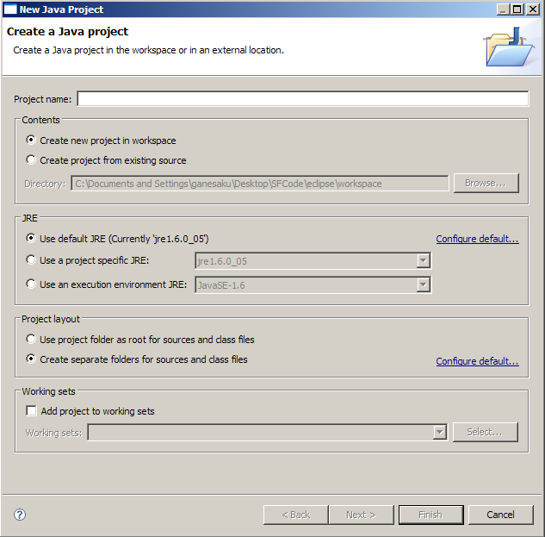

Enter a new name for your project and create it.

1. Create a new SmartFrog model by selecting the manu : *New 🡪 Others 🡪SFAuthoring Tool 🡪 SmartFrog Model* .

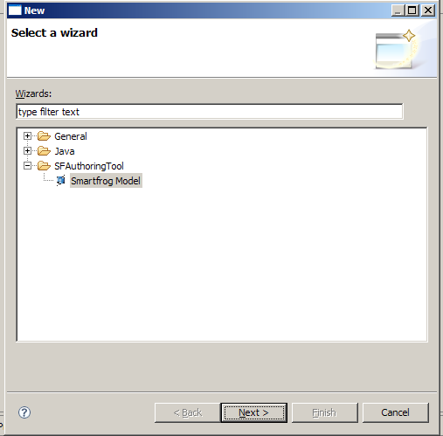

In the Next window, enter the file name for the model as shown in the figure.

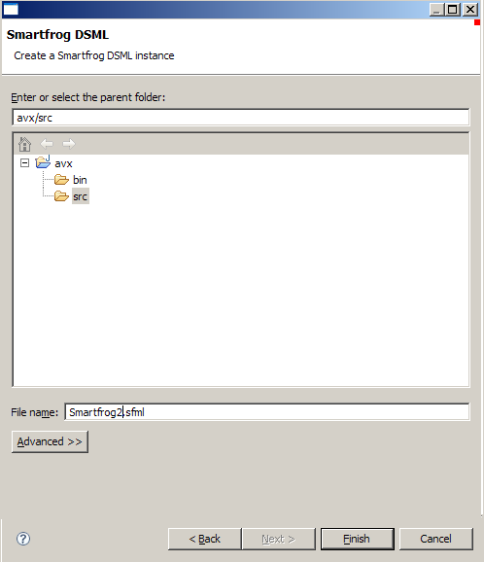

1. Drag and drop the elements from palette

To start modeling, click the model file name in the left “package Explorer” view. Then the canvas will open in the editor as shown in the figure.

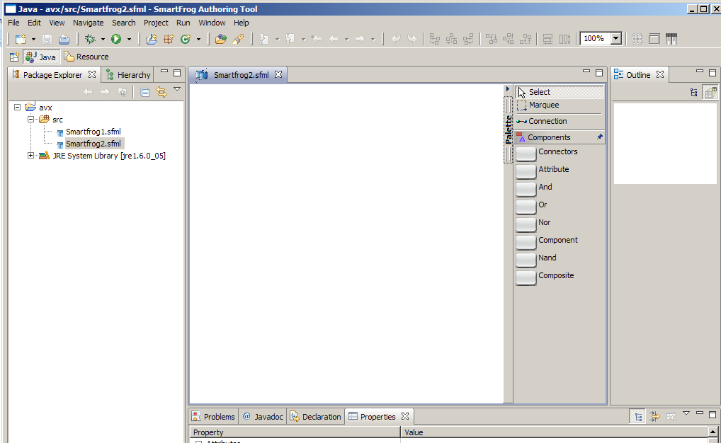

The palette it the editor has all the artifacts which can be used for authoring SmartFrog dependency is available. User can start modeling by clicking the artifacts in the palette and the dropping it in to the canvass.

1. Enter the attributes in property view

User can enter the appropriate property values in the “property” view. It will show the relevant list of property for which user clicked on the canvass.

# SmartFrog Description Generation

Write click on the model and select *Generate🡪 Run Code Generator*

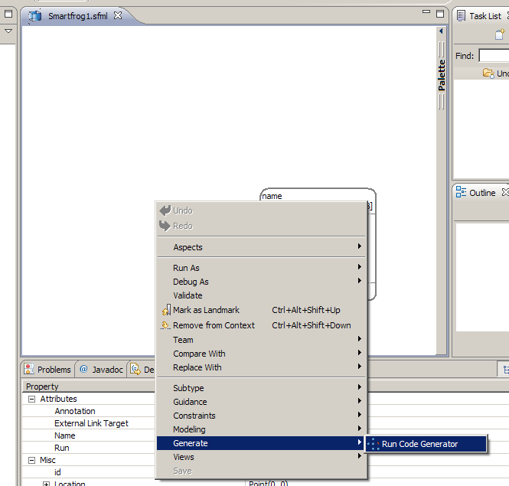

It will pop up a wizard to select the code generator (SF / Java) and the path where the generated files should be placed.

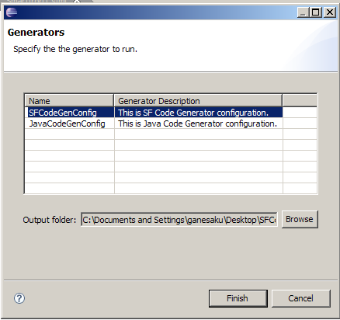

At the successful completion of code generation, it will show the success message as shown in the below diagram.

