***The Necessity of Prayer* by St. Francis de Sales**

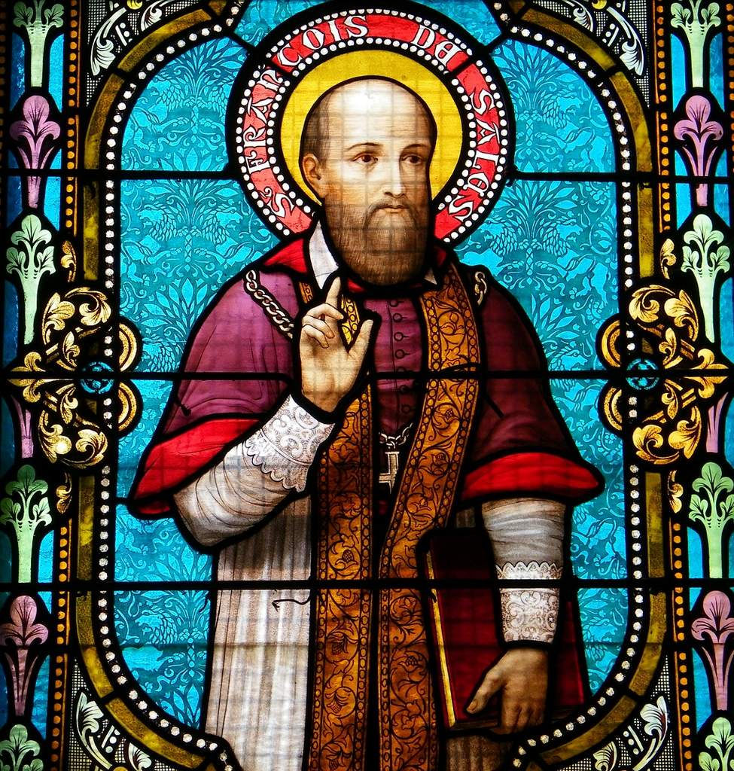

1. PRAYER opens the understanding to the brightness of Divine Light, and the will to the warmth of Heavenly Love--nothing can so effectually purify the mind from its many ignorances, or the will from its perverse affections. It is as a healing water which causes the roots of our good desires to send forth fresh shoots, which washes away the soul's imperfections, and allays the thirst of passion.2. But especially I commend earnest mental prayer to you, more particularly such as bears upon the Life and Passion of our Lord. If you contemplate Him frequently in meditation, your whole soul will be filled with Him, you will grow in His Likeness, and your actions will be moulded on His. He is the Light of the world; therefore in Him, by Him, and for Him we shall be enlightened and illuminated; He is the Tree of Life, beneath the shadow of which we must find rest;--He is the Living Fountain of Jacob's well, wherein we may wash away every stain. Children learn to speak by hearing their mother talk, and stammering forth their childish sounds in imitation; and so if we cleave to the Savior in meditation, listening to His words, watching His actions and intentions, we shall learn in time, through His Grace, to speak, act and will like Himself. Believe me, my daughter, there is no way to God save through this door. Just as the glass of a mirror would give no reflection save for the metal behind it, so neither could we here below contemplate the Godhead, were it not united to the Sacred Humanity of our Saviour, Whose Life and Death are the best, sweetest and most profitable subjects that we can possibly select for meditation. It is not without meaning that the Saviour calls Himself the Bread come down from Heaven;--just as we eat bread with all manner of other food, so we need to meditate and feed upon our Dear Lord in every prayer and action. His Life has been meditated and written about by various authors. I should specially commend to you the writings of S. Bonaventura, Bellintani, Bruno, Capilla, Grenada and Da Ponte. 13. Give an hour every day to meditation before dinner;--if you can, let it be early in the morning, when your mind will be less cumbered, and fresh after the night's rest. Do not spend more than an hour thus, unless specially advised to do so by your spiritual father.4. If you can make your meditation quietly in church, it will be well, and no one, father or mother, husband or wife, can object to an hour spent there, and very probably you could not secure a time so free from interruption at home.5. Begin all prayer, whether mental or vocal, by an act of the Presence of God. If you observe this rule strictly, you will soon see how useful it is.6. **It may help you to say the Creed, Lord's Prayer, etc., in Latin,** but you should also study them diligently in your own language, so as thoroughly to gather up the meaning of these holy words, which must be used fixing your thoughts steadily on their purport, not striving to say many words so much as seeking to say a few with your whole heart. One Our Father said devoutly is worth more than many prayers hurried over.7. The Rosary is a useful devotion when rightly used, and there are various little books to teach this. It is well, too, to say pious Litanies, and the other vocal prayers appointed for the Hours and found in Manuals of devotion,--but if you have a gift for mental prayer, let that always take the chief place, so that if, having made that, you are hindered by business or any other cause from saying your wonted vocal prayers, do not be disturbed, but rest satisfied with saying the Lord's Prayer, the Angelic Salutation, and the Creed after your meditation.8. If, while saying vocal prayers, your heart feels drawn to mental prayer, do not resist it, but calmly let your mind fall into that channel, without troubling because you have not finished your appointed vocal prayers. The mental prayer you have substituted for them is more acceptable to God, and more profitable to your soul. I should make an exception of the Church's Offices, if you are bound to say those by your vocation--in such a case these are your duty.9. If it should happen that your morning goes by without the usual meditation, either owing to a pressure of business, or from any other cause, (which interruptions you should try to prevent as far as possible,) try to repair the loss in the afternoon, but not immediately after a meal, or you will perhaps be drowsy, which is bad both for your meditation and your health. But if you are unable all day to make up for the omission, you must remedy it as far as may be by ejaculatory prayer, and by reading some spiritual book, together with an act of penitence for the neglect, together with a steadfast resolution to do better the next day.

**Sign of the Cross**

**In nomine Patris, et Filii,**

In name of Father, and of Son,

**et Spiritus Sancti. Amen.**  
and of Spirit Holy. Amen.

**Lord’s Prayer**

**Pater noster, qui es in caelis,**

Father our, Who are in Heaven,

**sanctificetur nomen tuum:**

may be sanctified name Your:

**Adveniat regnum tuum:**

May come reign Your:

**Fiat voluntas tua sicut in caelo,**

may will be done Your just as in heaven,

**et in terra.**

and on earth.

**Panem nostrum quotidianum da nobis hodie:**

Bread our daily give to us today:

**Et dimitte nobis debita nostra,**

And forgive us debts our,

**sicut et nos dimittimus debitoribus nostris.**

just as we forgive debtors our.

**Et ne nos inducas in tentationem.**

And do not us lead into temptation.

**Sed libera nos a malo. Amen.**

But free us from evil. Amen.

**Angelic Salutation  
  
Áve María, grátia pléna, Dóminus técum;**  
Hail Mary, full of grace, the Lord is with thee.   
  
**benedícta tu in muliéribus,**    
Blessed art thou amongst women

**et benedíctus frúctus véntris túi, Jésus.**  
and blessed is the fruit thy womb of, Jesus.

**Sáncta María, Máter Déi, óra pro nóbis peccatóribus,**  
Holy Mary, Mother of God, pray for us sinners,

**nunc et in hóra nóstræ. mórtis Amen.**  
now, and in the hour of our death. Amen.

**Doxology**

**Glōria Patrī, et Fīliō,**   
Glory be to the Father and to the Son

**et Spīrituī Sānctō, sīcut erat in prīncipiō,**   
and to the Spirit Holy as it was in the beginning

**et nunc, et semper, et in sæcula sæculōrum. Āmēn.**  
is now and ever shall be, world without end. Amen

**Creed**

**Credo in unum Deum, Patrem omnipotentem,**

I believe in one God, Father almighty,

**factorem caeli et terrae,**

maker of heaven and earth,

**visibilium omnium, et invisibilium.**

visible all, and invisible.

**Et in unum Dominum Jesum Christum,**

And in one Lord Jesus Christ,

**Filium Dei unigenitum.**

Son of God only-begotten.

**Et ex Patre natum ante omnia saecula.**

And from Father born before all ages.

**Deum de Deo, lumen de lumine,**

God from God, light from light,

**Deum verum de Deo vero.**

God true from God true.

**Genitum, non factum, consubstantialem Patris:**

Born, not made, consubstantial with Father:

**per quem omnia facta sunt.**

through Whom all made are.

**Qui propter nos homines, et propter nostram salutem**

Who for us men, and for our salvation

**descendit de caelis.**

descended from Heaven.

**Et incarnatus est de Spiritu Sancto**

And flesh he became by Spirit Holy

**ex Maria Virgine:**

from Mary Virgin:

**et homo factus est. Crucifixus etiam pro nobis:**

and man made he was. Was crucified also for us

**sub Pontio Pilato passus, et sepultus est.**

under Pontius Pilate suffered, and buried was.

**Et resurrexit tertia die, secundum Scripturas.**

And he resurrected on third day, according to Scriptures.

**Et ascendit in caelum: sedet ad dexteram Patris.**

And he ascended to Heaven: he sits at right hand of Father.

**Et iterum venturus est cum gloria**

And again come he will with glory

**judicare vivos et mortuos:**

to judge living and dead:

**Cujus regni non erit finis.**

Whose reign not will end.

**Et in Spiritum Sanctum, Dominum, et vivificantem,**

And in Spirit Holy, Lord, and life-giver,

**qui ex Patre, Filioque procedit.**

Who from Father, and Son proceeds.

**Qui cum Patre, et Filio simul**

Who with Father, and Son at the same time

**adoratur et conglorificatur:**

is adored and is glorified with:

**qui locutus est per Prophetas.**

Who spoke through Prophets.

**Et unam sanctam catholicam et apostolicam Ecclesiam.**

And One, Holy, Catholic, and Apostolic Church.

**Confiteor unum baptisma in remissionem peccatorum.**

I profess one Baptism for remission of sins.

**Et exspecto resurrectionem mortuorum.**

And I expect resurrection of dead.

**Et vitam venturi saeculi.**

And life of coming world.

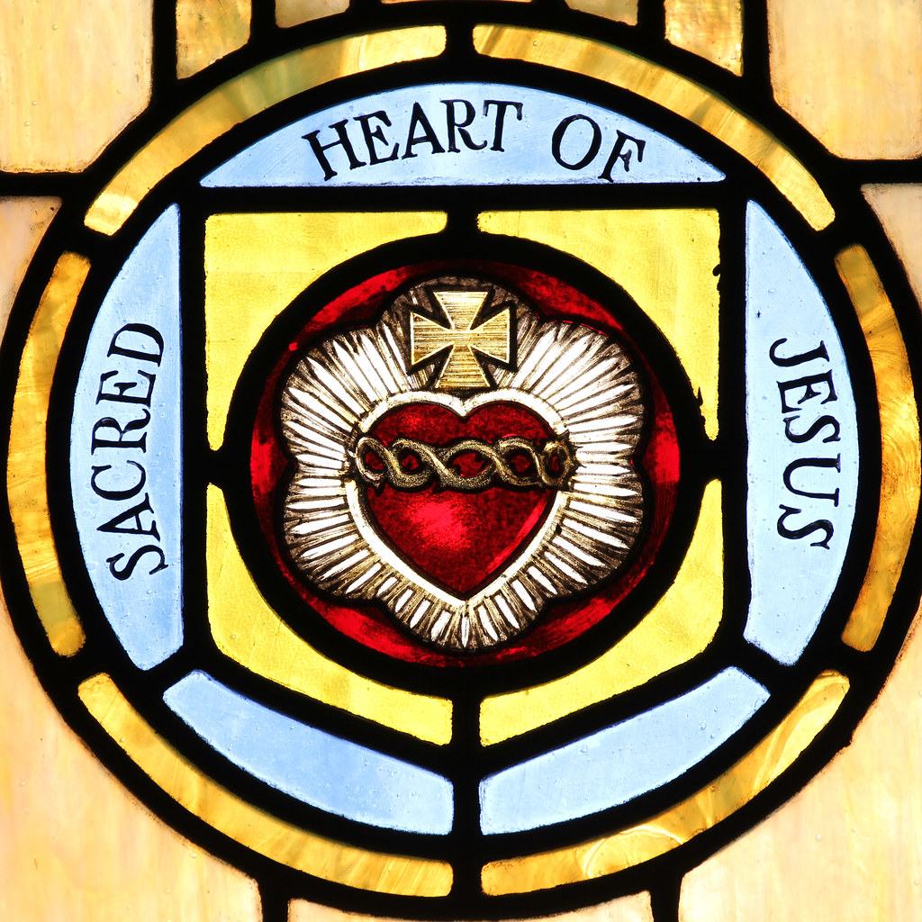

**Instructions on Meditation by St. Francis de Sales**  
**A Short Method of Meditation**  
  
**First, the Presence of God, the First Point of Preparation.**  
  
IT may be, my daughter, that you do not know how to practise mental prayer, for unfortunately it is a thing much neglected now-adays. I will therefore give you a short and easy method for using it, until such time as you may read sundry books written on the subject, and above all till practice teaches you how to use it more perfectly. And first of all, the Preparation, which consists of two points: first, placing yourself in the Presence of God; and second, asking His Aid. And in order to place your self in the Presence of God, I will suggest four chief considerations which you can use at first.  
  
First, a lively earnest realisation that His Presence is universal; that is to say, that He is everywhere, and in all, and that there is no place, nothing in the world, devoid of His Most Holy Presence, so that, even as birds on the wing meet the air continually, we, let us go where we will, meet with that Presence always and everywhere. It is a truth which all are ready to grant, but all are not equally alive to its importance. A blind man when in the presence of his prince will preserve a reverential demeanour if told that the king is there, although unable to see him; but practically, what men do not see they easily forget, and so readily lapse into carelessness and irreverence. Just so, my child, we do not see our God, and although faith warns us that He is present, not beholding Him with our mortal eyes, we are too apt to forget Him, and act as though He were afar: for, while knowing perfectly that He is everywhere, if we do not think about it, it is much as though we knew it not. And therefore, before beginning to pray, it is needful always to rouse the soul to a stedfast remembrance and thought of the Presence of God. This is what David meant when he exclaimed, If I climb up to Heaven, Thou art there, and if I go down to hell, Thou art there also! And in like manner Jacob, who, beholding the ladder which went up to Heaven, cried out: Surely the Lord is in this place and I knew it not meaning thereby that he had not thought of it; for assuredly he could not fail to know that God was everywhere and in all things. Therefore, when you make ready to pray, you must say with your whole heart, God is indeed here.  
  
The second way of placing yourself in this Sacred Presence is to call to mind that God is not only present in the place where you are, but that He is very specially present in your heart and mind, which He kindles and inspires with His Holy Presence, abiding there as Heart of your heart, Spirit of your spirit. Just as the soul animates the whole body, and every member thereof, but abides especially in the heart, so God, while present everywhere, yet makes His special abode with our spirit. Therefore David calls Him the Strength of my heart; and St. Paul said that in Him we live and move and have our being. Dwell upon this thought until you have kindled a great reverence within your heart for God Who is so closely present to you.  
  
The third way is to dwell upon the thought of our Lord, Who in His Ascended Humanity looks down upon all men, but most particularly on all Christians, because they are His children; above all, on those who pray, over whose doings He keeps watch. Nor is this any mere imagination, it is very truth, and although we see Him not, He is looking down upon us. It was given to St. Stephen in the hour of martyrdom thus to behold Him, and we may well say with the Bride of the Canticles, He looketh forth at the windows, showing Himself through the lattice.  
  
The fourth way is simply to exercise your ordinary imagination, picturing the Saviour to yourself in His Sacred Humanity as if He were beside you just as we are wont to think of our friends, and fancy that we see or hear them at our side. But when the Blessed Sacrament of the Altar is there, then this Presence is no longer imaginary, but most real; and the sacred species are but as a veil from behind which the Present Saviour beholds and considers us, although we cannot see Him as He is.  
  
Make use of one or other of these methods for placing yourself in the Presence of God before you begin to pray; do not try to use them all at once, but take one at a time, and that briefly and simply.  
  
**Invocation, the Second Point of Preparation**  
  
INVOCATION is made as follows: your soul, having realised God's Presence, will prostrate itself with the utmost reverence, acknowledging its unworthiness to abide before His Sovereign Majesty; and yet knowing that He of His Goodness would have you come to Him, you must ask of Him grace to serve and worship Him in this your meditation. You may use some such brief and earnest words as those of David: Cast me not away from Thy Presence, and take not Thy Holy Spirit from me. Show me Thy Ways, O Lord, and teach me Thy paths. Give me understanding, and I shall keep Thy Law: yea, I shall keep it with my whole heart. I am Thy servant, O grant me understanding. Dwell too upon the thought of your guardian Angel, and of the Saints connected with the special mystery you are considering, as the Blessed Virgin, St. John, the Magdalene, the good thief, etc., if you are meditating in the Passion, so that you may share in their devout feelings and intention, and in the same way with other subjects.  
  
  
**The Third Point of Preparation, representing the Mystery to be meditated to Your Imagination**  
  
FOLLOWING upon these two ordinary points, there ere is a third, which is not necessary to all meditation, called by some the local representation, and by others the interior picture. It is simply kindling a vivid picture of the mystery to be meditated within your imagination, even as though you were actually beholding it. For instance, if you wish to meditate upon our Lord on His Cross, you will place yourself in imagination on Mount Calvary, as though you saw and heard all that occurred there during the Passion; or you can imagine to yourself all that the Evangelists describe as taking place where you are. In the same way, when you meditate upon death, bring the circumstances that will attend your own vividly to mind, and so of hell, or any subjects which involve visible, tangible circumstances. When it is a question of such mysteries as God's Greatness, His Attributes, the end of our creation, or other invisible things, you cannot make this use of your imagination. At most you may employ certain comparisons and similitudes, but these are not always opportune, and I would have you follow a very simple method, and not weary your mind with striving after new inventions. Still, often this use of the imagination tends to concentrate the mind on the mystery we wish to meditate, and to prevent our thoughts from wandering hither and thither, just as when you shut a bird within a cage, or fasten a hawk by its lures. Some people will tell you that it is better to confine yourself to mere abstract thought, and a simple mental and spiritual consideration of these mysteries, but this is too difficult for beginners; and until God calls you up higher, I would advise you, my daughter, to abide contentedly in the lowly valley I have pointed out.  
  
**Considerations, the Second Part of Meditation**  
  
AFTER this exercise of the imagination, we come to that of the understanding: for meditations, properly so called, are certain considerations by which we raise the affections to God and heavenly things. Now meditation differs therein from study and ordinary methods of thought which have not the Love of God or growth in holiness for their object, but some other end, such as the acquisition of learning or power of argument. So, when you have, as I said, limited the efforts of your mind within due bounds, whether by the imagination, if the subject be material, or by propositions, if it be a spiritual subject, you will begin to form reflections or considerations after the pattern of the meditations I have already sketched for you. And if your mind finds sufficient matter, light and fruit wherein to rest in any one consideration, dwell upon it, even as the bee, which hovers over one flower so long as it affords honey. But if you do not find wherewith to feed your mind, after a certain reasonable effort, then go on to another consideration, only be quiet and simple, and do not be eager or hurried.  
  
**The Third Part of Meditation, Affections and Resolutions**  
  
MEDITATION excites good desires in the will, or sensitive part of the soul, such as love of God and of our neighbour, a craving for the glory of Paradise, zeal for the salvation of others, imitation of our Lord's Example, compassion, thanksgiving, fear of God's wrath and of judgment, hatred of sin, trust in God's Goodness and Mercy, shame for our past life; and in all such affections you should pour out your soul as much as possible. If you want help in this, turn to some simple book of devotions, the Imitation of Christ, the Spiritual Combat, or whatever you find most helpful to your individual wants.  
  
But, my daughter, you must not stop short in general affections, without turning them into special resolutions for your own correction and amendment. For instance, meditating on Our Dear Lord's First Word from the Cross, you will no doubt be roused to the desire of imitating Him in forgiving and loving your enemies. But that is not enough, unless you bring it to some practical resolution, such as, I will not be angered any more by the annoying things said of me by such or such a neighbour, nor by the slights offered me by such an one; but rather I will do such and such things in order to soften and conciliate them. In this way, my daughter, you will soon correct your faults, whereas mere general resolutions would take but a slow and uncertain effect.  
  
**The Conclusion and Spiritual Bouquet**  
  
THE meditation should be concluded by three acts, made with the utmost humility. First, an act of thanksgiving; thanking God for the affections and resolutions with which He has inspired you, and for the Mercy and Goodness He has made known to you in the mystery you have been meditating. Secondly, an act of oblation, by which you offer your affections and resolutions to God, in union with His Own Goodness and Mercy, and the Death and Merits of His Son. The third act is one of petition, in which you ask God to give you a share in the Merits of His Dear Son, and a blessing on your affections and resolutions, to the end that you may be able to put them in practice. You will further pray for the Church, and all her Ministers, your relations, friends, and all others, using the Our Father as the most comprehensive and necessary of prayers.  
  
Besides all this, I bade you gather a little bouquet of devotion, and what I mean is this. When walking in a beautiful garden most people are wont to gather a few flowers as they go, which they keep, and enjoy their scent during the day. So, when the mind explores some mystery in meditation, it is well to pick out one or more points that have specially arrested the attention, and are most likely to be helpful to you through the day, and this should be done at once before quitting the subject of your meditation.  
  
**Some Useful Hints as to Meditation**  
  
ABOVE all things, my daughter, strive when your meditation is ended to retain the thoughts and resolutions you have made as your earnest practice throughout the day. This is the real fruit of meditation, without which it is apt to be unprofitable, if not actually harmful inasmuch as to dwell upon virtues without practising them lends to puff us up with unrealities, until we begin to fancy ourselves all that we have meditated upon and resolved to be; which is all very well if our resolutions are earnest and substantial, but on the contrary hollow and dangerous if they are not put in practice. You must then diligently endeavour to carry out your resolutions, and seek for all opportunities, great or small. For instance, if your resolution was to win over those who oppose you by gentleness, seek through the day any occasion of meeting such persons kindly, and if none offers, strive to speak well of them, and pray for them.  
  
When you leave off this interior prayer, you must be careful to keep your heart in an even balance, lest the balm it has received in meditation be scattered. I mean, try to maintain silence for some brief space, and let your thoughts be transferred gradually from devotion to business, keeping alive the feelings and affections aroused in meditation as long as possible. Supposing some one to have received a precious porcelain vessel, filled with a most costly liquid, which he is going to carry home; how carefully he would go, not looking about, but watching stedfastly lest he trip or stumble, or lest he spill any of the contents of his vessel. Just so, after meditation, do not allow yourself forthwith to be distracted, but look straight before you. Of course, if you meet any one to whom you are bound to attend, you must act according to the circumstances in which you find yourself, but even thus give heed to your heart, so as to lose as little as possible of the precious fruits of your meditation. You should strive, too, to accustom yourself to go easily from prayer to all such occupations as your calling or position lawfully require of you, even although such occupations may seem uncongenial to the affections and thoughts just before forming part of your prayer. Thus the lawyer should be able to go from meditation to his pleading, the tradesman to his business, the mistress of a family to the cares of her household and her wifely duties, so calmly and gently as not to be in any way disturbed by so doing. In both you are fulfilling God's Will, and you should be able to turn from one to the other in a devout and humble spirit.  
  
It may be that sometimes, immediately after your preparation, your affections will be wholly drawn to God, and then, my child, you must let go the reins, and not attempt to follow any given method; since, although as a general rule your considerations should precede your affections and resolutions, when the Holy Spirit gives you those affections at once, it is unnecessary to use the machinery which was intended to bring about the same result. In short, whenever such affections are kindled in your heart, accept them, and give them place in preference to all other considerations. The only object in placing the affections after the points of consideration in meditation, is to make the different parts of meditation clearer, for it is a general rule that when affections arise they are never to be checked, but always encouraged to flow freely. And this applies also to the acts of thanksgiving, of oblation and petition, which must not be restrained either, although it is well to repeat or renew them at the close of your meditation. But your resolutions must be made after the affections, and quite at the end of your meditation, and that all the more because in these you must enter upon ordinary familiar subjects and things which would be liable to cause distractions if they were intruded among your spiritual affections.  
  
Amid your affections and resolutions it is well occasionally to make use of colloquies, and to speak sometimes to your Lord, sometimes to your guardian Angel, or to those persons who are concerned in the mystery you are meditating, to the Saints, to yourself, your own heart, to sinners, and even to the inanimate creation around, as David so often does in the Psalms, as well as other Saints in their meditations and prayers.  
  
**Concerning Dryness in Meditation**  
  
SHOULD it happen sometimes, my daughter, that you have no taste for or consolation in your meditation, I entreat you not to be troubled, but seek relief in vocal prayer, bemoan yourself to our Lord, confess your unworthiness, implore His Aid, kiss His Image, if it be beside you, and say in the words of Jacob, I will not let Thee go, except Thou bless me; or with the Canaanitish woman, Yes, Lord, I am as a dog before Thee, but the dogs eat of the crumbs which fall from their master's table.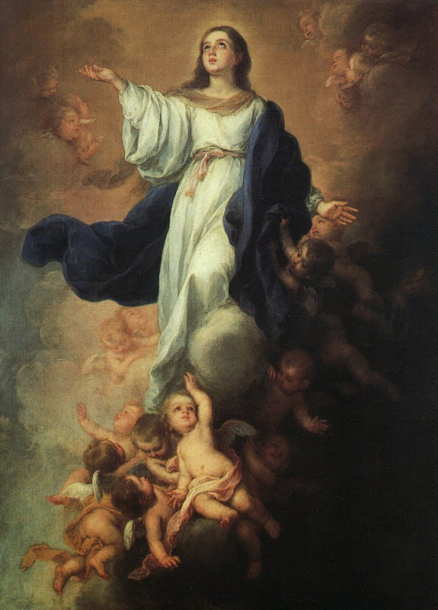  
  
Or you can take a book, and read attentively till such time as your mind is calmed and quickened; or sometimes you may find help from external actions, such as prostrating yourself folding your hands upon your breast, kissing your Crucifix, that is, supposing you are alone. But if, after all this, you are still unrelieved, do not be disturbed at your dryness, however great it be, but continue striving after a devout attitude in God's Sight. What numbers of courtiers appear a hundred times at court without any hope of a word from their king, but merely to pay their homage and be seen of him. Just so, my daughter, we ought to enter upon mental prayer purely to fulfil our duty and testify our loyalty. If it pleases God's Divine Majesty to speak to us, and discourse in our hearts by His Holy Inspirations and inward consolations, it is doubtless a great honour, and very sweet to our soul; but if He does not vouchsafe such favours, but makes as though He saw us not,as though we were not in His Presence,nevertheless we must not quit it, but on the contrary we must remain calmly and devoutly before Him, and He is certain to accept our patient waiting, and give heed to our assiduity and perseverance; so that another time He will impart to us His consolations, and let us taste all the sweetness of holy meditation. But even were it not so, let us, my child, be satisfied with the privilege of being in His Presence and seen of Him.