**UNIVERSITY OF DAR ES SALAAM**

**COLLEGE OF INFORMATION AND COMMUNICATION TECHNOLOGY**

**DEPARTMENT OF COMPUTER SCIENCE AND ENGINEERING**

**FINAL YEAR PROJECT REPORT**

**IS335:** FYP End of Semester One Report

**PROJECT TITLE:** **Prediction System for Agriculture Using a chatbot interface:** Weather Prediction. Using machine learning to account for the effects of climate change module

**Name (Reg. Number) of Candidate:** Stephen Reuben Mbwambo - 2017-04-01542

**Name of Supervisor: Dr.Jimmy Mbelwa**

**Supervisor’s signature: ……………………**

**DECLARATION**

I, the undersigned, MBWAMBO STEPHEN REUBEN declare that this report is my original work, gathered and utilized specifically to fulfill the purpose and objective of the mid-semester progress report on my final year project. I also declare that any publications cited in this work have been personally consulted and no plagiarism has been conducted.

Student Signature Date

________________ ……………………..

This report may proceed for submission for assessment towards the award of BSc. in Computer Science at the University of Dar es Salaam

Supervisor Signature: ……………………………. Date:..................................................

# **ACKNOWLEDGEMENT**

I would like to acknowledge the close and effective assistance obtained from various people on preparing this report and the final year project it documents.

Also, I would like to give my appreciation to Mr. Ally Salim Jr. for his assistance both financially and technologically on researching this final year Project. I would also like to thank my Supervisor Dr. Jimmy Mbelwa for his guidance and support

# **ABSTRACT**

Weather-related disasters account for large losses in the agricultural sector yearly. Weather forecasts are plagued with inaccuracies and a lack of specificity. This inaccuracy leads to farms being not ready to account for sudden changes and losing crops. This report documents an approach to building a system to accurately predict the weather in the face of fluctuations caused by climate change. This system will leverage recent advances in machine learning and computing technologies to develop an accurate model to generate weather forecasts based on specific locations. The creation of such a system will enable governments and individuals to plan appropriately for disasters and food shortages.

The development of this weather forecasting system required the use of Machine learning and Artificial intelligence techniques to process large amounts of data and draw inferences from it. The predominant technique used was the use of neural networks in the prediction of future weather patterns and evaluating the worthiness of data.

The Project will enable its users to get localized and up to date weather forecasts that will enable them to plan effectively while carrying out agricultural processes such as planting or harvesting. This ability to account for weather will prevent loss and improve productivity in agriculture. In conclusion, the ability to accurately inform farmers of weather conditions provides a needed tool for their farming activities. In recommendation, the project should be expanded and implemented on a real basis.

# **TABLE OF CONTENTS**

**ACKNOWLEDGEMENT** **2**

**ABSTRACT** **3**

**TABLE OF CONTENTS** **4**

**LIST OF FIGURES** **6**

**LIST OF ABBREVIATIONS** **7**

**CHAPTER 1. INTRODUCTION** **1**

1.1 General Introduction 1

1.2 General Problem Statement 2

1.3 Objectives 3

1.3.1 Main objective 3

1.3.2 Specific objectives 4

1.4 Significance of the project 4

1.5 Scope and Limitation 4

1.6 Organization of the Report 5

**CHAPTER 2: LITERATURE REVIEW** **6**

2.1 Existing methods 6

2.2 Machine Learning 7

2.2.1 Definitions 7

2.2.2 Existing work (Utilising Artificial Intelligence) 9

**CHAPTER 3: METHODOLOGY** **11**

**3.1 Datasets** **11**

3.2 Data Preprocessing 11

3.3 Requirements gathering method 11

3.4 Software Development Method 12

**CHAPTER 4: SYSTEM ANALYSIS AND DESIGN** **14**

4.1 System Analysis 14

4.2 Requirements Specification 14

4.3 System Modelling 15

4.4 System Design 16

**CHAPTER FIVE** **18**

**IMPLEMENTATION AND TESTING** **18**

5.1 System Implementation 18

5.2 System Testing and Evaluation 20

5.3 Evaluation Results 21

**CHAPTER 6: CONCLUSION** **23**

6.1 Conclusion 23

6.2 Mapping Project Objectives 23

6.3 Recommendations 23

# **LIST OF FIGURES**

Fig1 - Eastern Africa Agro-climatic zones

Fig2 - Classification Report

Fig3 - Scrum Workflow Diagram

Fig 4 - Use case diagram

Fig 5 - Activity Diagram

Fig 6 - System Architecture

Fig 7. System Overview

Fig 8. A generated image of the data for March 15, 1993

# **LIST OF ABBREVIATIONS**

**NWP** - Numerical Weather Prediction

**FD -** Factual Deduction

**GBDT -** Gradient Boosting Decision Trees

**DNN -** Deep Neural Networks

**TMA -** Tanzania Meteorological Association

**CNN -** Convolutional Neural Networks

**MSE -** Mean Squared Error

**MAE -** Mean Average Error

**RMSE -** Root Mean Square Error

# **CHAPTER 1. INTRODUCTION**

## **1.1 General Introduction**

Agriculture is the leading sector in Tanzania contributing up to 28.74% of the National GDP as of 2017(WorldBank). Agriculture engages 85% of the population in it with a majority of the farmers being smallholder farmers. Access to information and expert advice is crucial to improving the productivity and efficiency of the majority of these farmers. Such information includes how to combat specific crop diseases, weather forecasts advisory, and optimal harvesting times. Most rural farmers in Tanzania have limited access to such information. Even when it is available, it is inaccessible to farmers due to illiteracy.

In Tanzania, Mobile phone penetration is up to 85% and internet usage has risen to 40%. In this digital boom, the need for digital solutions to information problems is larger than ever.

This mismatch between Population involved and GDP contribution can be alleviated by improving farmer’s access to information and expert advice on their plants and farms. This information gap can be in diagnosing plant diseases immediately, weather forecasts specific to their area and finely tuned planting, watering, and harvesting schedules.

Weather is defined as the condition of the atmosphere at a particular place over a short period and climate refers to the weather pattern, using statistical data, of a place over a long enough period to yield meaningful averages. [1]Global weather patterns have been changing due to artificial factors. This change in global weather patterns is most commonly referred to as climate change and it affects all the world. Instances of extreme weather such as floods and typhoons happening in places where they never happened before or at the wrong time are causing loss and death on a global scale.“Millions displaced; women, girls hit hardest; crises compounded by conflicts, poverty, and inequality; $700m average climate-related losses; urgent action needed now”(Reliefweb.int). As shown, extreme weather events, especially unpredicted ones, are causing massive damage across the continent and hitting sub-Saharan countries severely impacting their ability to produce enough food for themselves. This disrupts agriculture to a large degree especially small farmers who are a majority in Tanzania's agricultural sector.

Current weather forecasting tools such as Numerical weather prediction and Radar echolocation are resource-intensive and very expensive. This can be evidenced by the fact that Tanzania has only two Weather Radar stations as evidenced by TMA data and 53 weather reporting stations across the country. While these solutions work to a certain degree they do not release personalized data for consumers instead release a wide dataset for regions of the country. This lack of specific weather forecasts is what inspired this project.

Farmers being mostly rural citizens and lacking access or the knowledge of weather forecast channels are deeply affected by current solutions to this problem. They instead rely on local knowledge and observation of the sky to predict the weather forecast. This means that they miss planting seasons by planting too soon or too late and other related mistakes. This project aims to solve that by providing Farmers with up to date weather forecasts enabling them to plan their workflow accordingly.

## **1.2 General Problem Statement**

Access to information and expert advice on Agriculture has been a steady problem in Tanzania. This is due to the rapid improvements in the field of agriculture. New Techniques and treatments for crop diseases driven by research in the field have not been getting to the farmers who most need it. The people affected are the majority of Farmers mostly small scale farmers in rural areas. The Government of Tanzania has tried to address this problem by utilizing a network of Farm Extension officers spread throughout the country's villages. This intervention has met mixed success as very few farmers are engaging and practicing the instructions provided by these officers.

This lack of information leads to Agricultural Farming being carried out using outdated and ineffective methods. This affects the small farmers as they cannot run their farms efficiently and with high productivity. Also, the quality of the goods produced is less than the global standard leading to reduced markets for it globally. Therefore the lack of information leads to misuse of the land and financial stagnation of the agricultural sector.

This project aims to design, implement, and evaluate the efficiency of an automated conversational agent otherwise known as a chatbot. This Agent will provide farming-related information through natural speech interactions offered through a text interface. The use of a chatbot will assist in the provision of this information by using speech a familiar method of interaction that requires limited learning and provides clear and concise information to the user-specific to their queries.

One of the main problems faced by Tanzanian farmers is access to climate information that is location-specific, timely, and easier to interpret for farm-level decision making. (Kahimba. Et al.2015). The availability of climate information is a factor when analyzing the vulnerability of farmers to climate extreme events in Tanzania. The generality and resolution of the information provided by the Tanzania Meteorological Agency make them less useful for farm-level decisions as they are too dense and unspecific.

Due to climate change, there has been a reported decline in crop productivity. In severe drought years, there have been losses as high as 50% due to drought-related stress. Tanzania's rain-fed agriculture is increasingly vulnerable to climate change and its effect on farmers will be increased poverty and food security. The importance of weather forecasts is underlined by the fact that most Tanzanians are rural small farmers and lack the resources to implement irrigation and mechanization tactics that will enable them to adapt to climate change effects on weather.

## **1.3 Objectives**

### **1.3.1 Main objective**

The main objective is to develop and deploy a machine learning model that can accurately predict the weather for a specific region over some time greater than ten days. As this is the current limit for conventional weather prediction systems.

### 

### **1.3.2 Specific objectives**

The specific objectives of the proposed system will be

1. To develop a model to predict the weather
2. To evaluate the model’s performance compared against conventional methods
3. To select and fine-tune the performance of the best performing models
4. To utilize the model to track changes in climate and generate reports on future climate events.

## **1.4 Significance of the project**

The project will offer significant commercial advantages as it will enable farmers to plan accordingly before the rains, help plan tourist activities, air travel, and such. It will also offer causal advantages to the average Tanzanian citizen by warning of impending heavy rains which might cause floods in low lying areas or make roads impassable.

The project will also inform people on future climate trends such as drought assisting in food planning and thus averting a food shortage or similar disaster. Thus the project is significant not only financially but also for the welfare of the average citizen

## **1.5 Scope and Limitation**

The scope of the project: Is limited by two factors

1. Geographically - The Eastern African region and any long-distance weather factors like El Nino and La Nina winds and currents as shown by Fig.1 Below
2. Meteorologically - This study is only focused on predicting rain at the moment or a lack of rain as this is the most important meteorological event.

The geographic region is shown in fig.1 below

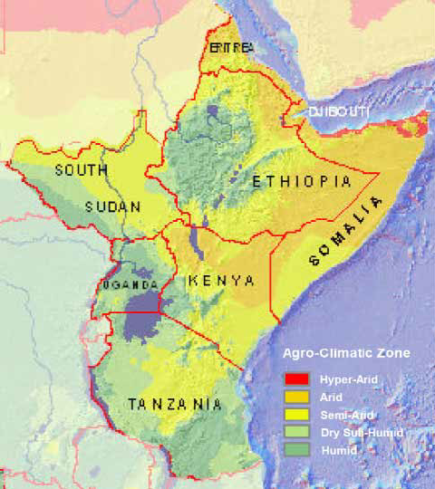

**Fig 1. The Eastern Africa Agro-climatic zones[2]**

## **1.6 Organization of the Report**

This report is organized into 4 chapters, with chapter 1 dealing with the introduction, Chapter 2 dealing with the literature review, and chapter 3 dealing with the Methodology. Chapter 4 is supposed to be involved with system design. Chapter 5 Implementation and Testing. Chapter 6 is the Conclusion.

# **CHAPTER 2:**

# **LITERATURE REVIEW**

Weather forecasts are the main focus of the field of meteorology. There have been multiple methods utilized through the years This literature review will showcase both the traditional linear approach used currently by most weather organizations and machine learning-based approaches attempted by researchers in recent years and the terms they are associated with

## **2.1 Existing methods**

There are mainly two kinds of traditional methods for precipitation forecasting,

**Numerical Weather Prediction**

Numerical Weather Prediction(NWP) models. The NWP model simulates atmosphere movements by physical equations and thus performs predictions by simulating the interaction of different factors build-up of error due to the inability to accurately solve the partial differential equations governing climate interactions.

**Radar Echo Extrapolation**

This method uses radar images to predict precipitation events by tracking clouds. The purpose of radar echo extrapolation is to predict the future position and intensity of radar echoes based on current radar observations. The key to radar echo extrapolation is to obtain a reliable extrapolated radar image. The essence is based on the current and historical moments of radar echo images to predict the next unseen image. (Li et al. 2019)[3].

This method is faced with issues such as a shortened forecast time which cant exceed one hour. Requiring expensive equipment such as weather radars and the processing power to process radar images. But it is a very accurate method for short precipitation forecasting.

## **2.2 Machine Learning**

### **2.2.1 Definitions**

Machine learning is defined as an application of Artificial Intelligence that provides systems with the ability to automatically learn and improve from experience without being explicitly programmed. The process of learning begins with observations or data, to look for patterns in data and make decisions based on trends observed. The primary aim is to allow computers to learn automatically without human intervention or assistance.

**Types of Machine Learning Methods**

1. **Supervised machine learning algorithms**  can apply what has been learned in the past to new data using labeled examples to predict future events
2. **Unsupervised machine learning algorithms** are used when the information used to train is neither classified nor labeled. Unsupervised learning studies how systems can infer a function to describe a hidden structure from unlabeled data. The system explores the data and draws inferences from datasets to describe hidden structures from unlabeled data
3. **Semi-supervised learning algorithms** fall somewhere in between the use of both labeled and unlabeled data. They constantly improve learning accuracy

**Deep learning**

Deep learning is another application of artificial intelligence that is based upon artificial neural networks which are modeled on human brain neurons and how they pass information to each other. Deep learning architectures such as deep neural networks, recurrent neural networks, and convolutional neural networks.[4]

**Convolutional Neural Networks**

Are a deep learning algorithmic approach that excels at capturing spatial context and is responsible for the state of the art results on image classification. Convolutional Neural networks are used to capture temporal patterns in sequential data and predict future events. CNN’s are applied to image, speech, and time-series tasks where the architecture deals with grid-like topology. CNN’s work by scanning input data and extract features located in a small local neighborhood called the receptive field. The receptive field is defined by the kernel size and the stride parameter which is the position at which convolution operations must begin for each element. In the end, neuron outputs are used to form the feature map.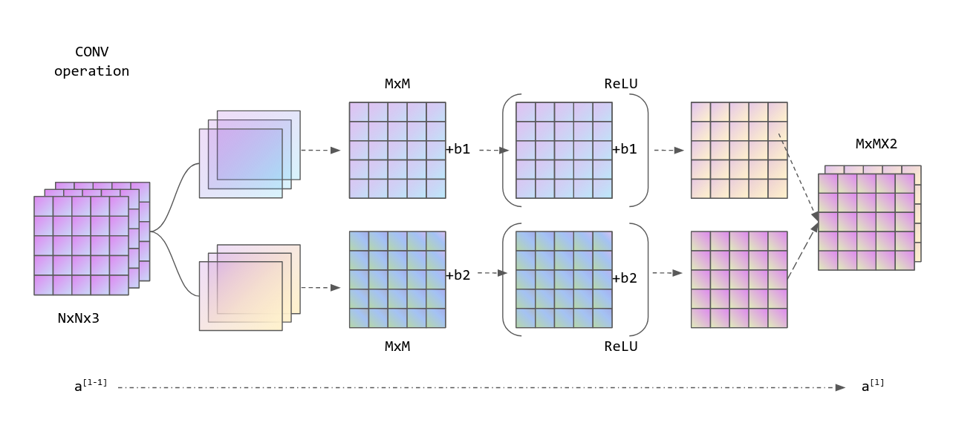

**Fig 2. An illustration of convolutional neural network architecture**

**Causal Convolution**

This is when a model ensures at a step t that no future information from step t+ 1 onward is used by the learning process. This condition is referred to as a causal constraint. For weather forecasting, this constraint is essential as it prevents the model from using future time step information to learn the current state which is unrealistic for a forecast. Implementing a causal constraint can be done as follows: padding input using k-1 elements where k is the kernel size and then removing k-1 elements from the end of the feature map.

**Sequence Modeling**

Is a method to generate models that map input sequences to output sequences where input size is not necessarily equal to output size. A sequence model architecture involves an encoder that reads input and generates a numerical representation of it and a decoder that changes the output sequence into the output format. The most famous encoder-decoder architecture is a Long short-term memory (LSTM) Neural network. This model has a sequential structure where the output of one step is passed to the next step and so forth. This means it follows causal constraint and is suitable for sequential processing.

### **2.2.2 Existing work (Utilising Artificial Intelligence)**

**Non-Linear Machine Learning Approach to Short-Term Precipitation Forecasting(Chen et al).**

Previous methods as found in the paper by Chen et al. to assess the probability of precipitation hours and the amount of rainfall. It used different methodologies for different time frames and the most common methods used were Factual deduction, Gradient Boosting Decision Tree, and Deep Neural Trees. The experimental results showed that the presented methodologies can improve the performance of prediction on the probability of rainfall and the amount of rainfall. The results obtained from this paper are shown below,

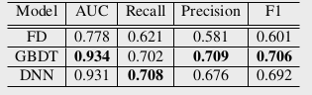

**Fig 3. Classification Report src: Chen et al[5]**

As shown by these Figure 3 Above machine learning-based models performed better than factual deduction across all metrics. This performance improvement is not negligible given this was a research case and not optimized for production.

**Challenges and design choices for global weather and climate models based on machine learning. (Dueben & Bauer)**

Another approach by Dueben & Bauer(2018) used Neural networks at the global and local resolution and showed better performance than conventional methods but lost accuracy over time due to a loss in resolution and a failure to model complex interactions over some time.

**Deep Uncertainty Quantification(Wang, B & Lu. J).**

In this approach carried out in 2019, they used a data-driven approach that learned from historical data by incorporating Numerical Weather prediction. This approach is unique because it implemented single value forecasting and uncertainty quantification for the model. That means for each prediction they knew how uncertain the model was. Their dataset was a publicly available dataset obtained from weather stations in Beijing, China. They reported accuracy of 47.76% above the NWP method which is a state of the art result. They used deep ensemble and clustering methods to train and test their methods.

**Can Machines Learn to Predict Weather? (Weyn et al., 2019).**

In this approach, Elementary weather prediction models are developed using deep convolutional neural networks trained on past weather data to forecast the weather for a lead time of 3 days. This approach succeeded in forecasting significant changes in the intensity of weather systems. This was beyond the capability of fundamental dynamical equations/ methods. This approach did not perform better than operational weather models but it is a good sign that machine learning can be used to generate weather forecasts for a lead time of 14 days.

# 

# **CHAPTER 3:**

# **METHODOLOGY**

# **3.1 Datasets**

The datasets that will be used are open-source datasets. The primary source of data at the moment is provided by the Climate Hazard center of UC Santa Barbara. This dataset is called the CHIRPS: Rainfall estimates from Rain Gauge and satellite observations[6]. It is produced using techniques to generate rainfall maps from areas where surface data is sparse. This is an acute problem for most of the Sub-saharan area. CHIRPS was created to deliver complete, reliable, up-to-date data sets for early warning objectives like trend analysis and seasonal drought monitoring.

CHIRPS is a 35-year global rainfall dataset. Spanning 50S-50N and all longitudes. It ranges from 1981 to the, near present. CHIRPS incorporates satellite imagery and station data to create rainfall time series for trend analysis and seasonal drought monitoring, This makes it the logical choice for our problem case.

## **3.2 Data Preprocessing**

The dataset contains gridded rainfall time series with daily frequency and a spatial resolution of 0.05 degrees. The grid size is reduced to 50x50 using interpolation so as it can fit into Memory. We obtain 13,960 grid sequences and divide the dataset into non-overlapping training, validation and test set following 60%, 20%, 20% ratio in that order.

## **3.3 Requirements gathering method**

The following are requirements gathering techniques used for this project,

**Interview**. Interviews of stakeholders and users are critical to creating great software. Without understanding the goals and expectations of the users and stakeholders, we are very unlikely to satisfy them. We also have to recognize the perspective of each interviewee, so that we can properly weigh and address their inputs. Listening is the skill that helps a great analyst to get more value from an interview than an average analyst.

**Prototyping**. Prototyping is a relatively modern technique for gathering requirements. In this approach, you gather preliminary requirements that you use to build an initial version of the solution - a prototype. You show this to the client, who then gives you additional requirements. You change the application and cycle around with the client again. This repetitive process continues until the product meets the critical mass of business needs or for an agreed number of iterations.

These methods were chosen because this is an attempt to solve a complex problem and the stakeholders need to be closely involved in the development process at each stage.

## **3.4 Software Development Method**

SCRUM is a simple framework for effective team collaboration on complex projects. It is a way for teams to work together to develop a product. But it is not limited to teams only; it works well for individuals also. Personal scrum is an agile methodology that adapts and applies scrum practices to one-person projects. It promotes personal productivity through observation, adaptation, progressive elaboration, prioritizing and sizing work, and time-boxing.

It is implemented through the following points,

1. Short term clearly defined goals
2. Work in sprints
3. Constant Self-reflection

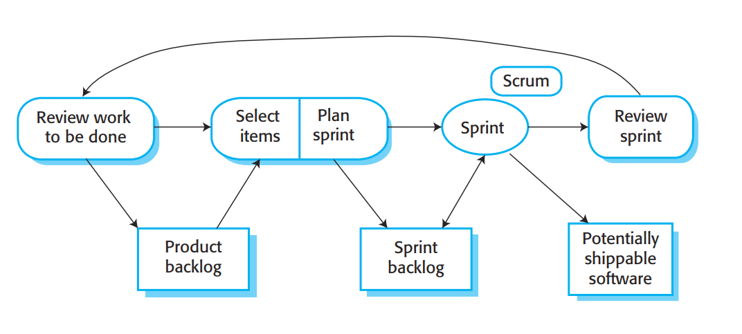

**Fig 4. Scrum workflow diagram src: pmi.org[7]**

The choice to use this development method was because the system requirements are fuzzy and still vague. Working in sprints means features and updates can be reiteratively added to the product until it meets user expectations

# 

# **CHAPTER 4:**

# **SYSTEM ANALYSIS AND DESIGN**

## **4.1 System Analysis**

Current weather forecasting systems work as services. That means they are accessed by other software tools and applications and queried for weather information which they deliver to the requestees app. This Final year project is designed to work in a group of 4 individuals, each one developing an independent component that leads to the building of one application that offers the functionality of these separate components.

The proposed weather prediction module is meant to be integrated into this app hereafter referred to as the agricultural chatbot and deliver weather information based on the user’s location or location specified. To avoid redundancies and streamline implementation after deployment the weather forecasting module of the agricultural chatbot will be implemented as a Cloud API. This avoids the need to process calculations on the user's device.

## **4.2 Requirements Specification**

**Functional Requirements**

|  |  |
| --- | --- |
| R. No  1 | Requirement Description  Predict the weather |
| 1.1 | The system should predict the weather for some time not less than ten days |
| 1.2 | The system should update the user when there are changes to the prediction as soon as they are noticed |
| 1.3 | The system should allow the user to specify the location they want the weather for |
| 2 | Climate Modelling |
| 2.1 | The system should model the climate of the region it is being used |
| 2.2 | The system should predict climate trends and show justification for them |

**Non-Functional Requirements**

|  |  |
| --- | --- |
| R.No  3 | Performance requirements |
| 3.1 | The system should only take 3 seconds to respond |
| 3.2 | The system should always be updating and tracking changes in weather |
| 3.3 | The system should use data from multiple sources to verify its predictions |
| 4 | Availability requirements |
| 4.1 | The system should be fault-tolerant and run from multiple endpoints should one fail |
| 4.2 | The system should be able to respond even when under load from multiple users(Scaling) |

## **4.3 System Modelling**

**Use Case Diagram**

Use case diagrams model the functionality of a system using actors and use cases. It demonstrates the various ways a user can and will interact with the system. The figure shows the use case for the proposed model.

**Fig 5.** Use case diagram

**Activity diagram**

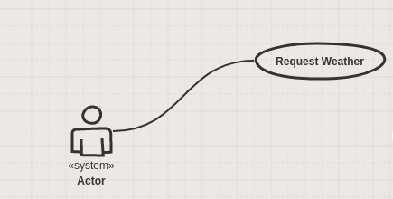This is a diagram showing the end to end activities involved in a weather request 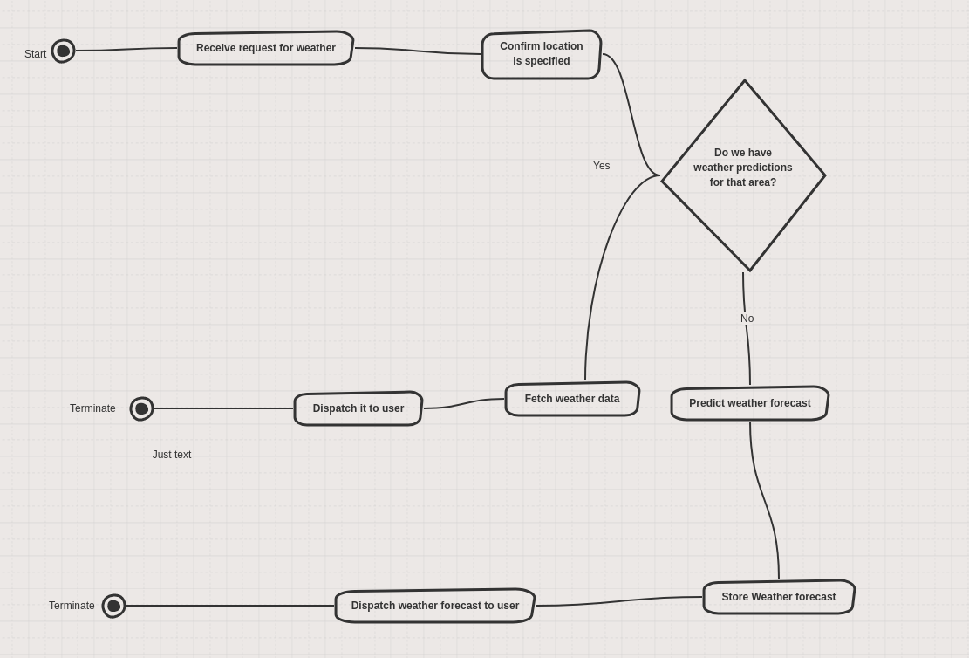

**Fig 6. Activity Diagram**

## **4.4 System Design**

This is the design for the system weather forecast component. It includes all the separate parts that will be required to fulfill the requirements specification. It will require to fetch data from an internet database and retrain the model periodically. This and the hosting service which is still cloud-based as of the mid-semester.

# 

**Fig 7. System Architecture**

Description:

The architecture will consist of the following modules

1. **API gateway.** This will allow users to query the system for data and predictions as they need to through the provided API.
2. **Reactive Code.**  This will respond to users requests as they are made and won't be continuously running thus saving on compute time
3. **Model.** This is the model that will be used to process user requests and return prediction.
4. **Internet Gateway.**  This is the systems access to the internet where it scrapes data from
5. **Weather Forecast DB.**  This is where the system stores made forecasts for verification and analytics

# **CHAPTER FIVE**

# **IMPLEMENTATION AND TESTING**

## **5.1 System Implementation**

The system is designed to be an application interface through which the chatbot will communicate with the user through text. The application will be mobile-based and due to a large majority of users being developed for the Android Operating system. The features/ services offered through the application will be Plant Disease Detection, Weather Forecasts, and Soil condition Analysis.

The component I am responsible for will be the Weather Prediction module. This module is responsible for taking requests from the chatbot and responding with the weather forecast requested.

# 

**Fig 8. System Overview**

**Weather Prediction Model Architecture**

The model architecture implemented is called Spatio Temporal Convolutional Sequence to Sequence Network. It is designed for weather forecasting and uses an encoder-decoder architecture. This model architecture was proposed in Nascimento et al.[2019]. The model replaces convolutional layers with 3D layers to capture spatial and temporal relationships. The model is a stack of 3D convolutional layers with each layer receiving a 4D tensor with dimensions T x H x W x C as input where C is the number of filters used in the previous layer. T is the sequence length(time dimension) H and W represents the size of the spatial coverage. In detail, the encoder is formed by convolutional blocks with batch normalization and the addition of a rectified Linear unit as nonlinearity. The decoder is the same but uses a causal constraint in its first layer to prevent future casting in predictions.

The use of a convolutional neural network imposes the limitation that the length of the output sequence cannot differ from the length of the input sequence. To solve this the addition of a semi-final transposed convolutional layer that is used to generate an output sequence whose length may differ. Using these implementations it is possible to use the previous 5 grids to predict the next 15 grids.

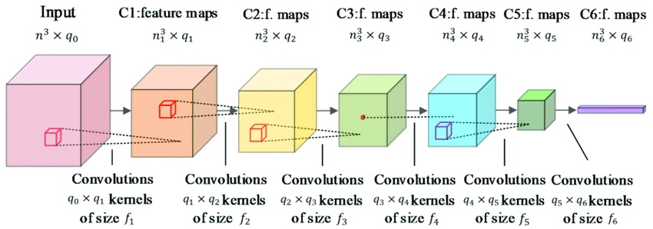

**Fig.** An illustration of a 3D convolutional layer

## **5.2 System Testing and Evaluation**

System testing and Evaluation for machine learning models are a bit different from the convention. The first step is testing using offline data. This is the data used to train the model. Using cross-validation testing data is used to ensure that the model meets the required conditions to be deployed. Offline testing is flawed because it relies on test data which usually fails to fully represent future data. It is also not able to test certain circumstances that may be problematic in real scenarios

After deployment, the model is tested by comparing its predictions with actual real-life weather events. Predictions made by the model are stored in a file and then compared against recorded weather events to provide the performance of the system in real-time.

**Evaluation Metrics**

To evaluate the implemented architecture, results will be compared against traditional statistical models(ARIMA). To accomplish this we use two evaluation metrics

RMSE is denoted as Er which is based on the MSE metric, defined as the average squared difference between real values and predicted values. The MSE square root gives the result in original format as is expressed as

Er(h, w, t) =

With N number of test samples x(h,w,t) and xˆ(h, w, t) are the real and predicted values at the dimensions.

MAE denoted as Em, is the average difference measuring the magnitude of errors in prediction

Em(h,w,t)=)|

## **5.3 Evaluation Results**

The models were run with different hyperparameters tuned to find the best fit. The best fit in this case would be a model with the best metrics and the lowest training time. There were 4 versions run on the same dataset and the results will be shown in Table 1. Below.

The variables between the different model versions are layers(L), Kernels(K), and Filters(F). The models were compared against ARIMA models which are the current state of the art Numerical Weather models.

|  |  |  |  |
| --- | --- | --- | --- |
| **Version** | **Settings** | **RMSE** | **Training time** |
| 1 | L=2, K=3, F=64 | 6.4067 | 0:35:37 |
| 2 | L=3,K=3,F=32 | 6.3905 | 0:25:29 |
| 3 | L=3,K=3, F=64 | 6.3785 | 0:52:01 |
| 4 | L=3,K=5,F=32 | 6.3215 | 0:36:33 |

**Table 1.** Model Versions and their performances.

As seen the model performs better in version 4. That is the version that was used in evaluation against established methods. Its performance is outlined in Table 2.

|  |  |  |
| --- | --- | --- |
| **Metric** | **ARIMA** | **Model** |
| RMSE | 7.4377 | 6.2854 |
| MAE | 6.1694 | 2.3390 |

**Table 2.** Evaluation of Model and conventional (ARIMA) method

The ARIMA measurements were taken for the same area coverage as the model and were used as a point of comparison. The predictions were done through all the 2500 series of the dataset. The results were obtained through iterative running and establishing an average to determine the initial result was not a statistical anomaly.

As shown in Table2 show that the model outperforms conventional models by at least 15% for the same time and area covered.

# 

# **CHAPTER 6: CONCLUSION**

## **6.1 Conclusion**

The current state of the weather prediction model shows a marked increase in performance over conventional models. A 15% accuracy boost is important enough to affect people's livelihoods. The use of the model in weather predictions offers increased accuracy at lower costs proving the point that Artificial intelligence can be used to accurately predict weather events in areas where on-ground equipment is not common.

## **6.2 Mapping Project Objectives**

The Model reaches all specific objectives as it can predict the weather at a better accuracy than conventional methods. The model also shows to perform better when limited to a regional scope as in this project. The use of the project to predict large weather events shows that it can effectively model then and warn of future events

## **6.3 Recommendations**

This project shows that an artificial intelligence approach is appropriate for time series data such as weather forecasting. Future work should be focused on fine-tuning the model, obtaining error-free datasets, and better-preprocessing techniques. Modifications to the architecture may also yield better results.

**REFERENCES**

1. What is Machine Learning? A definition. (2019, November 11). Retrieved December 10, 2019, from <https://expertsystem.com/machine-learning-definition/>.
2. Deep learning. (2019, December 14). Retrieved December 12, 2019, from <https://en.wikipedia.org/wiki/Deep_learning>.
3. Weather and climate. (2019, November 10). Retrieved December 15, 2019, from <https://en.wikipedia.org/wiki/Weather_and_climate>.
4. Shi, E., Li, Q., Gu, D., & Zhao, Z. (2018). A Method of Weather Radar Echo Extrapolation Based on Convolutional Neural Networks. *MultiMedia Modeling Lecture Notes in Computer Science*, 16–28. DOI: 10.1007/978-3-319-73603-7_2
5. Düben, P. (2018). Challenges and design choices for global weather and climate models based on machine learning. DOI: 10.5194/gmd-2018-148-ac1
6. Chen, B., Luo, C., Zhang, K., Shi, X., Wang, X. (2019). Non-Linear Machine Learning Approach to Short-Term Precipitation Forecasting.
7. More than 52 million people across Africa going hungry as weather extremes hit the continent [EN/AR] - World. (n.d.). Retrieved February 1, 2020, from <https://reliefweb.int/report/world/more-52-million-people-across-africa-going-hungry-weather-extremes-hit-continent-enar>
8. How Reliable Are Weather Forecasts? (n.d.). Retrieved February 2, 2020, from <https://scijinks.gov/forecast-reliability/>
9. Wang, B., Lu, J., Yan, Z., Luo, H., Li, T., Zheng, Y., & Zhang, G. (2019). Deep Uncertainty Quantification. *Proceedings of the 25th ACM SIGKDD International Conference on Knowledge Discovery & Data Mining - KDD 19*. DOI: 10.1145/3292500.3330704
10. *Agriculture, forestry, and fishing, value added (% of GDP) - Tanzania*. https://data.worldbank.org/indicator/NV.AGR.TOTL.ZS?locations=TZ.
11. Jain, M., Kumar, P., Bhansali, I., Liao, Q. V., Truong, K., & Patel, S. (2018). FarmChat. *Proceedings of the ACM on Interactive, Mobile, Wearable and Ubiquitous Technologies*, *2*(4), 1–22. https://doi.org/10.1145/3287048
12. Arndt, C., Farmer, W., Strzepek, K., & Thurlow, J. (2012). Climate Change, Agriculture, and Food Security in Tanzania. *Review of Development Economics*, *16*(3), 378–393. https://doi.org/10.1111/j.1467-9361.2012.00669.x
13. Kahimba, F. C., Maliondo, A. S., Mpeta, E. J., & Olson, J. (2015). Climate Change and Food Security in Tanzania: Analysis of Current Knowledge and Research Gaps. *Tanzania Journal Of Agricultural Sciences*, *14*(1), 21–33.
14. Weyn, J. A., Durran, D. R., & Caruana, R. (2019). Can Machines Learn to Predict Weather? Using Deep Learning to Predict Gridded 500‐hPa Geopotential Height From Historical Weather Data. *Journal of Advances in Modeling Earth Systems*, *11*(8), 2680–2693. <https://doi.org/10.1029/2019ms001705>
15. Nascimento,C.R.,Souto,Y.M.,Ogasawara,E.,Porto,F.,Bezerra,E.(2019).STCOVS2S: SpatioTemporal Convolutional Sequence to Sequence Network for Weather Forecasting. Retrieved July 7, 2020, from <https://arxiv.org/pdf/1912.00134v3.pdf>

1. Wikipedia 2019
2. https://www.semanticscholar.org/paper/The-climate-population-nexus-in-the-East-African-in-Pricope-Husak/d9c9e83c50add6d2aa6f49649407308846fc5925
3. A method of Weather Radar Echo Extrapolation Based on COnvolutional Neural networks(2018)
4. Retrieved from <https://en.wikipedia.org/wiki/Weather_and_climate> on November 10 2019
5. Non Linear Machine learning approach to Short-Term Precipitation Forecasting (Chen et al)
6. https://chc.ucsb.edu/data/chirps
7. Retrieved from <https://www.pmi.org/learning/library/agile-project-management-scrum-6269> on January 12 2020