Title
The Economics of Regulated Power Generation: A Cost Analysis Using FERC Form 1 Data
Unlocking the Grid's Financials: A New Look at Power Plant Costs by Linking FERC and EIA Data

Abstract

Introduction
Reliable power sector planning and regulation under decarbonization increasingly depend on the availability of transparent, plant-level cost data. Transparent, accurate, and sufficiently granular cost information provides a foundation for effective economic regulation and ensure public oversight of regulated power plant assets is grounded in empirical reality. The availability of such data helps overcome information asymmetry complications that tend to persist in public utility regulation (Joskow et al., 1989; Wolak, 1994). Regulators and stakeholders can utilize transparent plant cost data in operational prudence reviews and rate cases. Furthermore, optimizing electricity investments depends on accurate, detailed capital and operating cost data across technology options (Anderson, 1972).
This paper focuses on a key source of financial information for electric power plants in the United States: the Federal Energy Regulatory Agency’s (FERC) Form 1 dataset (FERC, 2025). Authority for information collection under Form 1 is provided by the Federal Power Act and mandates the collection of power plant-level capital and operating costs for power plants owned by major rate-regulated electric utilities. Importantly, Form 1 provides the only public power-plant level data on capital and operating expenses in the United States. However, its coverage excludes a significant portion of independently owned plants and currently offers no mandatory reporting for emerging low-carbon technologies like wind, solar, and battery storage. In total, the plant-level financial data in Form 1 is only available for about a third of total U.S. electric capacity. The coverage shortcoming will worsen if conventional rate-regulated ownership structures continue to change and as wind, solar, storage, and emerging technologies grow in deployment. From a policy perspective, the need for transparency in capital and operating costs does not disappear under independent ownership of plants or as new technologies emerge. The limited coverage of Form 1appears to be an artifact of the original reporting requirements under the Federal Power Act implemented in a regulatory framework dominated by vertically integrated utilities, when most generation was from conventional steam, gas combustion, and hydro.
Prior studies have utilized FERC Form 1 data for a variety of applications, including examining trends in generation, transmission, distribution and administrative costs for investor-owned utilities (Fares and King, 2017), as well as changes in plant technical efficiencies associated with market restructuring (Fabrizio et al., 2007; Goto and Tsutsui, 2008; Gultom, 2019). These studies have not directly addressed the implications of Form 1’s limited and evolving coverage for empirical research or policy oversight.
This analysis demonstrates both the value and limitations of publicly available power plant cost data through an empirical analysis, leading to several policy recommendations. It presents a longitudinal, plant-level dataset linking detailed financial data from FERC Form 1 with physical generator characteristics from the U.S. Energy Information Administration. A detailed empirical analysis of capital and operating costs for the U.S. regulated power fleet is then provided, along with a case study estimating the impact of environmental regulations on coal plant capital investment.
The findings highlight several policy-relevant implications for power sector data collection and oversight. As industry ownership has restructured, a growing share of generation has fallen outside the scope of Form 1 reporting, leaving detailed cost data available for only a subset of the U.S. power fleet. At present, Form 1 covers approximately one-third of total installed capacity, including about 61 percent of coal, 41 percent of nuclear, and 35 percent of natural gas capacity, while offering no mandatory plant-level financial reporting for wind, solar, battery storage, and other emerging technologies. As deployment of these resources accelerates, the gap between available cost data and the assets driving system investment decisions will continue to widen absent changes to current reporting frameworks. The empirical results in this paper illustrate the substantial analytical value that even limited expansions in coverage and data quality could unlock, supporting more informed regulatory oversight, investment evaluation, and policy design. While near-term constraints on federal statistical capacity may limit immediate reforms, the analysis underscores the importance of preserving and strengthening plant-level cost data as the sector evolves. In the interim, this research provides a processed, harmonized dataset that improves the usability of existing Form 1 data for future empirical work.

Policy Implications
- Coverage- As industry restructured, many independently owned plants dropped from FERC’s coverage in Form 1. Wind, solar, and other emerging technologies are not covered From table 3:
  - Approx 35% of natural gas plants in the USA are covered, 41% of nuclear plants, and 61% of coal
  - Batteries, wind, and solar, and other low carbon technologies are not covered. (review to see if they are covered by a separate government data form)
- Thus, this provides only partial coverage and there is no other dataset covering the United States with detailed cost information about electric power plants. This coverage shortcoming will worsen as wind, solar, storage, and emerging technologies grow in deployment.
- Current detailed cost information for power plants is provided by Form 1, and only covers a small section of plants, owned by “conventional regulated utilities. Low coverage for independently owned plants and no coverage of detailed financial information for renewables, storage, and other emerging technologies. Thus, cost data coverage gaps can be expected to get worse in the future without changes to current coverage.
- A tiny amount of the potential value from improving the quality and coverage of power plant cost data is demonstrated throughout the paper- discuss some insights from the descriptive and econometric analyses.
- Comment that, under current federal administration, federal statistical efforts are being reduced, and may not be possible to improve and expand. But political pendulum swings, and the future could bring an opportunity to rebuild data collection in better ways for the future.
- This research provides a processed dataset that overcomes these difficulties for future researchers.
- Form 1 data quality, recommend enforcing name persistence, and reporting treatment of jointly owned plants

Data and Methodology
This section describes the data sources, characteristics, and processing steps undertaken to construct the primary analytical dataset used in this study.

Data Sources
The dataset combines power plant financial data from FERC Form 1(FERC, 2025) with generator-level operational and location attributes from the Energy Information Administration Form 860 (“Annual Electric Power Industry Report, Form EIA-860 detailed data with previous form data (EIA-860A/860B) - U.S. Energy Information Administration (EIA),” n.d.). Data from these sources was initially processed and accessed via the Catalyst Cooperative’s Public Utility Data Liberation (PUDL) Project (“The Public Utility Data Liberation (PUDL) Project,” n.d.). Annual power plant financial data is provided by the FERC Form 1 tables, focusing on capital expenditures (CapEx) and operating expenses (OpEx) for electric power plants within the United States. FERC Form 1 filings are mandated for major electric utilities, licensees, and others subject to FERC jurisdiction. FERC’s authority for mandating this data collection derives from the Federal Power Act to collect financial information for rate regulation, market oversight analysis, and financial audits.
The Form 1 dataset used in this study covers large steam plants with a nameplate capacity of 25 MW or more, internal combustion and gas turbine plants with nameplate capacity of 10 MW or more, and utility-owned nuclear plants. Form 1 data for hydroelectric units are collected and reported separately. Hydroelectric plants were excluded from the analysis because of the additional data cleaning effort this would entail along with the fact they were already analyzed extensively and recently in Oladosu and Sasthav (2022) (Oladosu and Sasthav, 2022).
Form 1 cost reporting follows FERC’s Uniform System of Accounts (USofA) (“Accounting Matters | Federal Energy Regulatory Commission,” n.d.). The dataset includes, at the plant level, CapEx information broken out by equipment, land, and structures. It also includes detailed operating expenditure breakouts including costs for boiler maintenance, coolants, production, engineering, supervision, and fuel.
The unit of analysis in the cleaned dataset derived from FERC Form 1 is the individual plant entry as reported annually by a major utility or other required Form 1 respondent. Each row in the dataset represents an individual plant owned or operated by the filing utility for a given reporting year.
Additional data on physical and operational attributes for power generators were sourced from the United States Energy Information Administration (EIA) Form 860, the “Annual Electric Generator Report.” (“Annual Electric Power Industry Report, Form EIA-860 detailed data with previous form data (EIA-860A/860B) - U.S. Energy Information Administration (EIA),” n.d.). EIA requires mandatory reporting based on its information-gathering authority originating in the Federal Energy Administration Act of 1974 section 13(b) (Federal Energy Administration Act, 1974) and transferred to the EIA in The Department of Energy Organization Act of 1977 Section 205 (Department of Energy Organization Act, 1977). The EIA dataset contributes to this analysis the location, technology and fuel, for U.S. electric generators.

Alternative public data sources (and why they fall short)
1. EIA Form 860
What it provides: Generator-level capacity, technology, status, vintage, and environmental controls.
What it does not: Actual capital cost, plant book value, or O&M expense data.
Nature of data: Engineering and inventory, not financial .
2. EIA Form 923
What it provides: Fuel costs, generation, fuel consumption, limited O&M proxies.
What it does not: Capital additions, plant investment, depreciation, or detailed non-fuel O&M.
Costs reported: Operational inputs, not accounting expenses .
3. EIA capital cost studies (e.g., AEO, Sargent & Lundy)
What they provide: Modeled or survey-based overnight capital cost estimates for new builds.
What they do not: Realized plant-level capital or operating expenses.
Purpose: Planning and modeling, not historical accounting .
4. SEC filings (10-Ks)
What they provide: Audited financials at the corporate level.
What they do not: Plant-level or technology-level capital and O&M data.
Limitation: Aggregation obscures generation-specific costs.
5. State commission filings
What they provide: Sometimes highly detailed plant cost data.
Limitation: Not standardized, not national, and not longitudinally consistent.

Data Processing and Linking
A significant data cleaning and linking effort was performed to match cost data from FERC Form 1 with physical generator characteristics data from EIA Form 860. A challenge in this linking step requiring substantial manual intervention arose from inconsistencies in reported plant names over time within FERC Form 1. Specifically, changes in plant names, evolving plant configurations, and shifts in ownership over many plants’ histories across both FERC and EIA data presented a challenge with linking records across time. Frequently, the same power plant appears under varying names in different reporting periods, for instance, “4 Corners” one year and “Four Corners” the next, or “Allen” one year and “Allen E. Kintigh” the next. Such inconsistencies create a barrier to robust analysis of costs at the plant level over time, as plant names are the primary identifying key in FERC Form 1. Ultimately, the matching process for this analysis was anchored by using plants names as of 2023 in the FERC data, with the linkages extending historically when plant names demonstrated persistence over time.
Further complexity arises from Form 1’s treatment of jointly owned or operated facilities. The costs reported by a utility for a jointly owned plant typically represent only the filing utility’s ownership share of that plant’s total costs and statistics. Thus, an entry for a jointly owned plant generally does not reflect the economics of the entire facility but rather often reports costs for the portion of the plant corresponding to the entities’ ownership share. Furthermore, FERC Form 1 plant entries are not fully consistent in their level of physical aggregation. Sometimes entities report individual units, sometimes groups of units aggregated by technology or fuel type, and sometimes an entire plant site.
Further complexity arises from how plant ownership reporting is not enforced nor standardized. Currently, Form 1 data does not directly capture ownership share for plants operating under shared ownership arrangements. Form 1 does report corresponding plant capacity from reporting entities, which was matched to EIA data in this analysis to derive an estimate of ownership share. However, this method is imperfect without clearer and consistent guidance for reporting partially owned plants. Compounding this issue, for plants with multiple owners, some Form 1 entries report partial costs, while others reflect total plant costs. In an apparent workaround for the lack of a dedicated field, a few entities voluntarily include ownership percentages directly in the plant name field. For example, a plant name of “jeffrey energy ctr 8%” in FERC Form 1 refers to an entry by Kansas City Power & Light reporting costs for its 8% share of the Jeffrey Energy Center coal plant.
To address the challenges of inconsistent reporting for jointly-owned facilities and varying levels of unit aggregation, this analysis implements an aggregation step after linking the FERC data with EIA. Specifically, individual plant entries that share identical geographic coordinates and the same technology type are grouped into a single record. During this process, the capacities (MW) and costs reported by each partial owner are summed to create aggregate totals for the full facilities. This approach aggregates all units and partially-owned plant entries to the plant level, providing a more complete plant-level picture to provide a more accurate analysis of plant-level costs.

Descriptive Statistics

Data Coverage
The cleaned dataset for this analysis encompasses 778 unique power plant entries across the United States in 2023, contributing 32,838 plant-year observations, spanning back to 1994. The aggregate installed nameplate capacity represented by these plants in the sample is approximately 394 GW. Figure 1 presents a map of the power plants included in the Form 1 data as of 2023, illustrating their geographic distribution and composition by technology type across the United States. The size of each circle corresponds to the plant's nameplate capacity.
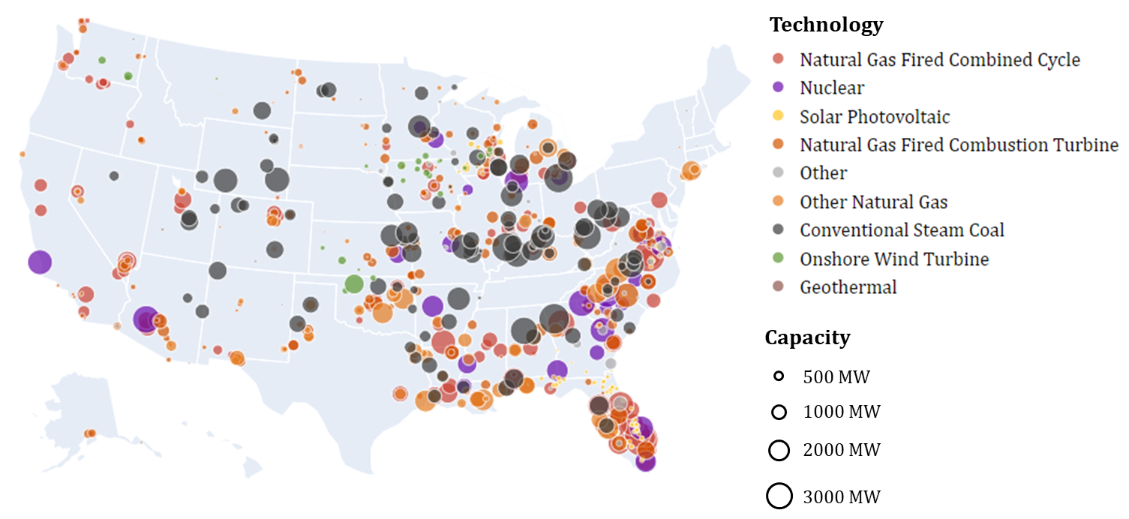
Figure 1 Map of power plants included in this analysis via FERC Form 1 Schedule 402.

Figure 1 shows a concentration of power plants is visible in the eastern half of the United States, particularly throughout the Southeast and the Ohio River Valley. Another significant cluster of facilities, primarily natural gas plants, is in Texas and along the Gulf Coast. The distribution is sparser in the western states, though notable clusters exist in California, Arizona, and the Pacific Northwest. This sparsity in the western U.S. may be partly attributable not only to lower population clusters but also to the significant role of hydroelectric power in serving the region's electricity demand; hydroelectric plants were explicitly excluded from this study's scope as described in section 8.1. The map highlights the prevalence of coal (dark grey) and natural gas combined cycle (red) plants, which are widely distributed across the country. Nuclear plants (purple) are also prominent, though fewer in number, and are generally located in the eastern and southern states.
Another observation from Figure 1 is the inclusion of Onshore Wind Turbine (light green) and Solar Photovoltaic (yellow) facilities. The FERC Form 1 Schedule 402 covers large steam plants (25 MW or more) and internal combustion or gas turbine plants (10 MW or more), but does not mandate cost reporting for wind and solar facilities. The presence of a small number of these renewable energy plants in the dataset, as seen on the map, suggests some utilities have reported them voluntarily, even though most existing wind and solar generation facilities are not included in the FERC Form 1 Schedule 402 data.
Table 1 provides a breakdown of the 2023 sample by technology type, summarizing the number of unique plants, their total capacity, and their share of the sample's aggregate capacity. It shows that conventional steam coal plants represent the largest share of capacity at 30% (117 GW) across 166 plants. Natural Gas Fired Combined Cycle (NGCC) facilities are a close second, accounting for 27% (108 GW) of capacity from 147 plants. If natural gas technologies are considered in aggregate (including combined cycle, combustion turbine, and other), they collectively constitute the majority of the sample’s capacity at 53%. More information on the capacity distributions of plants in the Form 1 sample by technology is provided in Appendix 1.1, and further information on the temporal distributions is provided in Appendix
Table 1 Composition of FERC Form 1 sample by technology type, 2023.
Technology Group | Number of Unique Plants | Total Capacity (MW) | % of Sample's Total Capacity
Conventional Steam Coal | 164 | 116,772 | 30
Natural Gas Fired CC | 147 | 107,514 | 27
Natural Gas Fired CT | 227 | 59,993 | 15
Other Natural Gas | 81 | 44,516 | 11
Nuclear | 34 | 41,442 | 11
Other | 98 | 9,934 | 3
Solar Photovoltaic | 119 | 7,965 | 2
Onshore Wind Turbine | 34 | 5,668 | 1
Geothermal | 1 | 38 | 0

Representativeness of FERC Data Compared to National Totals
As discussed in the Introduction, FERC Form 1 covers a subset of plants in the US. Thus, it is useful to compare its coverage to all power plants in the U.S. as documented by the Energy Information Administration.
Table 2 provides this comparison by technology group, revealing significant variation in coverage. It is notable that overall, the FERC Form 1 large plants dataset covers less than a third (31%) of U.S. powerplants. As noted earlier, hydroelectric plant costs are reported separately to FERC under schedules 406 and 408, and have been analyzed in other research (Oladosu and Sasthav, 2022).
Table 2 Comparison of FERC Sample Capacity to EIA National Totals by Technology, 2023.
Technology Group | FERC Sample: Total Capacity (MW) | EIA National: Total Capacity (MW) | FERC as % of National Capacity
Batteries | 0 | 16,091 | 0%
Coal | 116,772 | 192,602 | 61%
Geothermal | 38 | 4,010 | 1%
Hydroelectric | 0 | 102,140 | 0%
Natural Gas CC | 107,514 | 327,903 | 33%
Natural Gas CT | 59,993 | 156,354 | 38%
Nuclear | 41,442 | 100,675 | 41%
Onshore Wind Turbine | 5,668 | 147,998 | 4%
Other | 9,934 | 51,994 | 19%
Other Natural Gas | 44,516 | 88,002 | 51%
Solar Photovoltaic | 7,965 | 91,219 | 9%
Solar Thermal | 0 | 1,497 | 0%
Total | 393,842 | 1,280,483 | 31%

Even among coal, natural gas, and nuclear, which are the technology groups covered by the Form 1 large plants dataset, coverage is only 43% of plants in the U.S. within those technology categories. The FERC sample captures a higher portion of coal plants at 61%, but only 33% of the country’s natural gas combined cycle and 38% of the natural gas combustion turbine capacity. The small portion of geothermal, wind, and solar plants included in Form 1 come from entities reporting these plants even though they are not required to by FERC.
Figure 2 maps the U.S. power plants that are not included in this sample due to the above-described limits in Form 1 data coverage. This can be compared with Figure 1, which maps the plants in the Form 1 sample. Figure 2 displays the majority of wind, solar, and hydroelectric facilities that are not included in the Form 1 sample for this analysis.

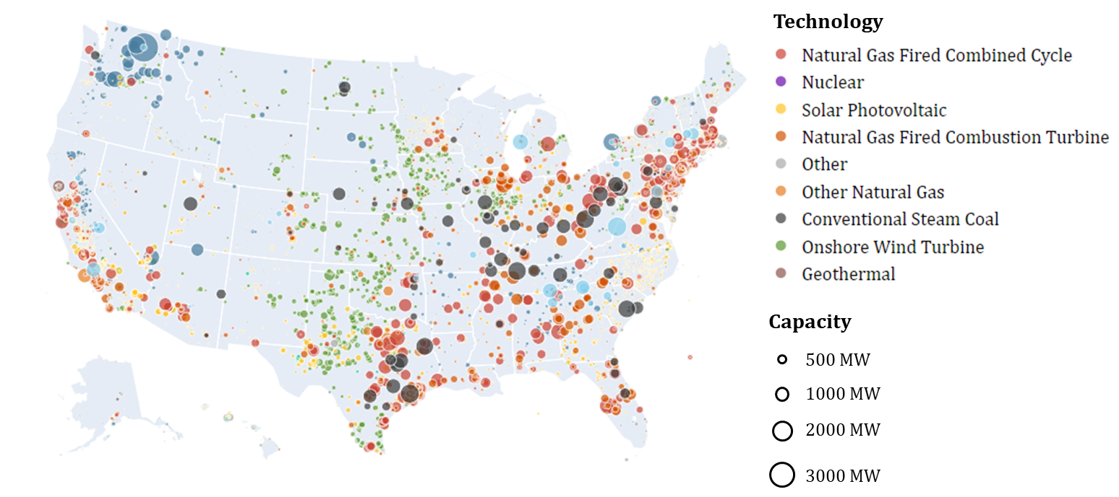
Figure 2 U.S. Powerplants not covered by FERC Form 1, 2023.

Interestingly, Figure 9 also shows the large number of plants across the U.S. that are fueled by natural gas (orange) and coal (black), that are not included in FERC Form 1. It shows many of these are in deregulated regions, including the Northeast and Texas. Additional analysis using EIA plant ownership data (Catalyst Cooperative, n.d.) confirms that the coal, natural gas, and nuclear plants in the U.S. that are not in the FERC Form 1’s cost data are predominantly owned by entities outside of FERC's reporting jurisdiction. Specifically, 59% of these plants are owned by independent power producers. Another 28% belong to municipal utilities, non-profit cooperatives, federal, state, or other political subdivisions, and 6% are owned by commercial or industrial entities. Collectively, these entities, which are generally not considered "major electric utilities" required to file Form 1, account for 93% of the coal, natural gas, and nuclear power plants not in the FERC Form 1 sample. This reinforces that the FERC dataset primarily represents the nation's rate-regulated utility fleet.

Age Profile of Plants by Technology
Table 3 summarizes the capacity-weighted average installation year for each technology group in the sample, highlighting that conventional steam coal and nuclear are among the oldest in the sample with average installation years in 1979 and 1981, respectively. Natural gas combustion turbines and combined cycle are newer, with average installation years of 1995 and 1998. Figure 3 plots the distribution of installation years throughout the sample and shows two distinct investment eras from the sample. The first is a steam plant wave starting in the late 1960’s through mid-1980’s, when most coal and nuclear capacity were built. The second wave began in the late 1990’s when a substantial build out of natural gas capacity began.
Table 3 Average installation year by technology in sample, weighted by capacity.
Technology | Avg Installation Year
Other Natural Gas | 1975
Coal | 1979
Other | 1980
Nuclear | 1981
Natural Gas CT | 1995
Natural Gas CC | 1998
Geothermal | 2002
Solar Photovoltaic | 2007
Onshore Wind Turbine | 2013

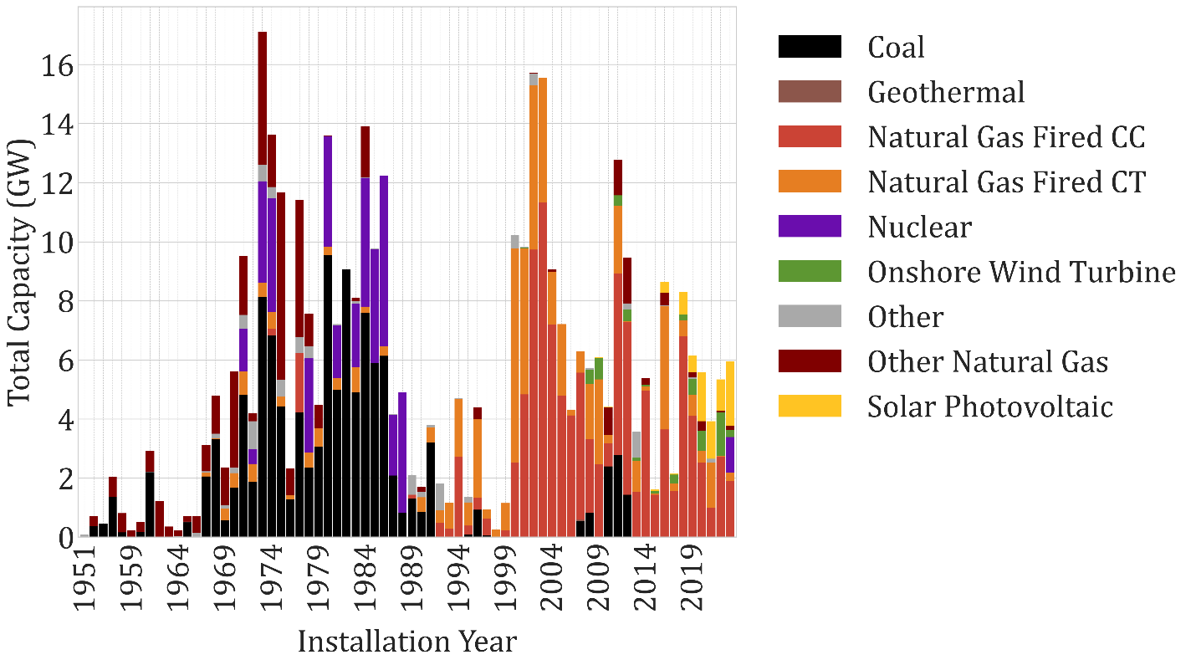
Figure 3 Installation year distribution by technology from sample, 2023.

Operating Expenditures
This section examines operating expenditures (OpEx) patterns across generating technologies from the Form 1 sample, showing how cost composition and labor requirements vary by plant type. Table 4 presents the share of operating expenses by category. “Other” aggregates several reported Opex category including coolants, engineering, electrical, rents, and structural maintenance. “Misc” includes operating expenses not classified in any of the other categories. Fuel costs represent the majority share of operating expenditures for coal and natural gas plants, though the patterns diverge over the sample period. The share of total opex spent on fuel was significantly lower in 2023 compared to 1995 for both coal and nuclear plants on average. Conversely, fuel shares for natural gas technologies’ fuel shares were significantly higher in 2023. Nuclear plants show a distinctly different operating cost structure, with fuel representing only 20% of total OpEx in 2023. Nuclear plants have substantially larger shares of opex allocated to other and miscellaneous categories, which could reflect more intensive needs for regulatory compliance, specialized maintenance, security, and/or waste management.
Table 4 Operating expenditure shares by technology, 1995 and 2023 (% of total OpEx).
Technology | Year | Fuel | Operations | Steam | Boiler | Other | Misc
Coal | 1995 | 77.0 | 1.3 | 2.3 | 6.2 | 9.4 | 3.8
 | 2023 | 68.9 | 1.8 | 4.9 | 7.5 | 12.0 | 4.9
Natural Gas CC | 1995 | 52.7 | 7.0 | 3.4 | 4.2 | 20.6 | 12.0
 | 2023 | 86.6 | 1.0 | 0.6 | 0.2 | 9.2 | 2.4
Natural Gas CT | 1995 | 76.5 | 1.9 | 1.7 | 2.1 | 14.3 | 3.4
 | 2023 | 82.6 | 1.1 | 0.8 | 0.3 | 12.8 | 2.4
Nuclear | 1995 | 27.7 | 6.7 | 5.4 | 7.7 | 33.1 | 19.5
 | 2023 | 20.2 | 7.9 | 4.7 | 5.5 | 36.1 | 25.5

Table 5 compares observed operating expenses in 2023 from Form 1 with an equivalent amount derived from the Annual Technology Baseline (ATB) industry benchmark. ATB provides annually-fixed and variable operational cost components for these technology categories. An comparable annual operating expenditure was constructed from the ATB using the average unit size and capacity factor for each technology group observed in Form 1. The comparison shows that observed operating expenditures for coal and natural gas in 2023 in the FERC dataset are significantly lower than ATB benchmark values for new plants of similar technology. Observed operating expenditures for nuclear plants were slightly higher than the industry benchmark. The ATB benchmark represents forward-looking cost expectations that may include operating-expense assumptions that are different from the existing plants observed in Form 1. The exact causes of these differences are left for future research to determine.
Table 5 Opex for average plant observed in FERC data and a new comparable plant from Annual Technology Baseline data.
Technology Group | Avg Plant Opex, 2023 | ATB Opex, 2023
Coal | 33,888,448 | 79,098,652
Natural Gas CC | 15,370,010 | 26,441,293
Natural Gas CT | 2,301,615 | 8,517,901
Nuclear | 231,306,149 | 219,825,697

FERC also collects employment data in Form 1, which is summarized by technology in Table 6. The data shows nuclear plants being significantly more labor intensive on a capacity-normalized basis than other plant types. Nuclear plants’ more complex systems with additional safety redundancies requires more extensive operational expense for monitoring, testing, and maintenance. Nuclear plants have strict regulatory and compliance requirements that include minimum staffing levels for licensed operators, continuous on-site security, emergency preparedness organizations, and more (Nuclear Energy Agency and International Atomic Energy Agency, 2018; World Nuclear Association, 2024).
Table 6 Average employee counts by technology, 2023.
Technology | Avg Employees per 100 MW
Nuclear | 59.1
Coal | 13.7
Natural Gas CT | 5.6
Natural Gas CC | 4.1

In contrast, coal and natural gas plants face lower staffing requirements, relatively lower regulatory burden, benefiting from simpler designs and greater automation. Coal plants have higher labor intensity than gas due in part to increased operation and maintenance needs for fuel handling, boilers, and emissions control systems. Natural gas plants have more integrated controls systems with more automated operation, leading to less staffing needs (Wagman, 2017).

Capital Costs
The capital costs data in FERC Form 1 consists of running book cost accounts, which is the original, nominal cost of assets invested in the plant, unadjusted for depreciation (Uniform System of Accounts Prescribed for Public Utilities and Licensees Subject to the Provisions of the Federal Power Act, 1947). For any plant constructed prior to 1994, the earliest reporting year in the sample, the data does not show the history of capital transactions and how its capital balance evolved as capital was added for upgrades and retired as equipment was replaced between its construction date and 1994. This limitation prevents inflation adjustments to the capital costs, because the capital balances in 1994 are a composite of investments made throughout prior years in an unknown manner.
Some insight can be gained by examining the relative rates of change in capital account balances across technology categories, summarized in Table 7, which shows that coal plant nominal capital account balances increased at a higher rate on average (3.58% per year) than other technologies during the sample period.
Table 7: Summary of changes in average nominal capital balances ($/MW) by Technology, 1995-2023.
Technology | Avg. Capital Balance in 1995 ($/MW) | Avg. Capital Balance in 2023 ($/MW) | Average Annual Rate of Change (%)
Coal | 466,084 | 1,248,150 | 3.58
Nuclear | 1,112,552 | 2,442,926 | 2.85
Natural Gas CT | 212,377 | 420,238 | 2.47
Natural Gas CC | 379,055 | 686,018 | 2.14

The relative changes in nominal capital cost balances across the sample are further visualized in Figure 4, which shows modest and comparable capital cost increases from 1995 through 2007. In 2008, coal plants capital accounts increased faster on average than other technologies. The notable increase in coal plant capital accounts beginning in the late 2000’s and continuing through the 2010’s is consistent with the timing of U.S. Environmental Protection Agency (EPA) air quality regulations that caused new capital investments in pollution control equipment, analyzed further in section 10.
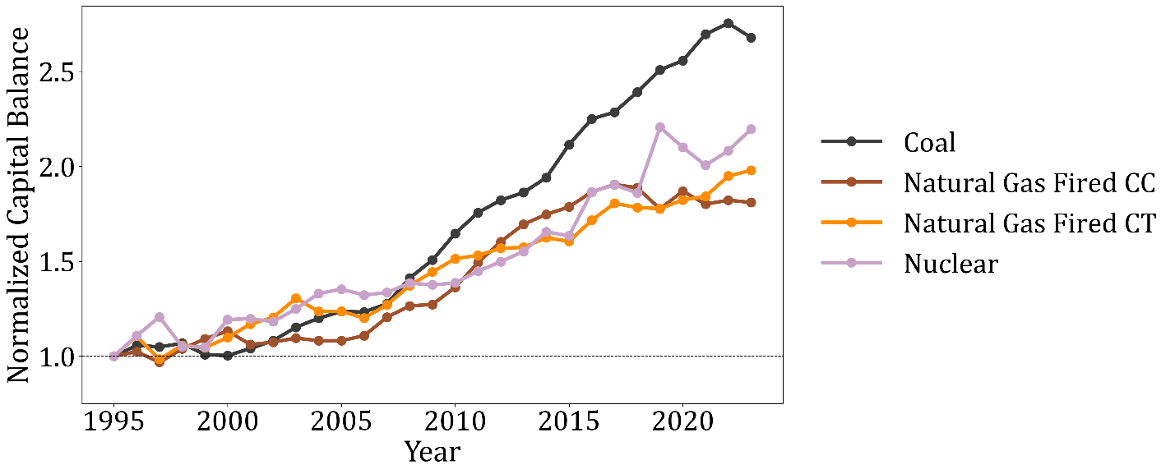
Figure 4 Change in capital accounts during sample period, aggregated by technology type and normalized at 1995=1.
Table 8 presents a breakout of capital accounts by equipment, structures, and land categories across the major technology types in the sample for both 1995 and 2023. Across all technologies, equipment consistently represents the dominant share of total capital costs, ranging from 73% to 90% in 2023. The equipment share of plant capital increased for all technology types between 1995-2023, while structures capital share declined. The capacity-weighted average across all technologies in Table 8 equipment’s share of plant capital increasing from 80% to 86%, while structures declined from 20% to 14%. Land represents a minor share of total capital across plants, consistently below 1% over time and technology groups.
Table 8 Percentages of total capital account by category and technology, 1995 and 2023.
Technology and Year | Equipment | Structures | Land
Coal
1995 | 81.8 | 17.8 | 0.47
2023 | 85.5 | 13.8 | 0.67
Nuclear
1995 | 72.7 | 26.9 | 0.43
2023 | 76.2 | 23.6 | 0.21
Natural Gas CC
1995 | 78.2 | 21.1 | 0.72
2023 | 86.8 | 12.6 | 0.68
Natural Gas CT
1995 | 84.4 | 15.1 | 0.46
2023 | 90.3 | 9.2 | 0.52
Total (Capacity Weighted Average)
1995 | 79.6 | 19.9 | 0.49
2023 | 85.5 | 13.9 | 0.58

The observed increase in equipment’s share of total capital is consistent with new plants new units being more equipment intensive over time, along with existing plants experiencing equipment reinvestment while structural components remain largely unchanged. Coal units added environmental investments during this period with relatively limited structural modification, discussed further in section 10. New natural gas plants during this period incorporated more advanced, higher efficiency turbine equipment, while existing gas plants experienced recurring turbine, generator, and heat recovery module upgrades (Andover Technology Partners, 2018; U.S. Energy Information Administration, 2023). Nuclear plants experienced equipment replacements as well as safety and security upgrades during this period (Hultman et al., 2007; Kessides, 2010).
Given that the capital account data represents running book balances, the original capital expended at installation cannot be observed for plants that were installed prior to the sample period (1994). The data does provide an opportunity to observe initial capital expenditures associated with new plant construction for plants built after 1994. Figure 5 displays capital costs in $/kW for coal and natural gas plants installed between 1995 and 2015. It includes 14 coal units, 64 combined cycle, and 91 combustion turbine units installed during the sample period.
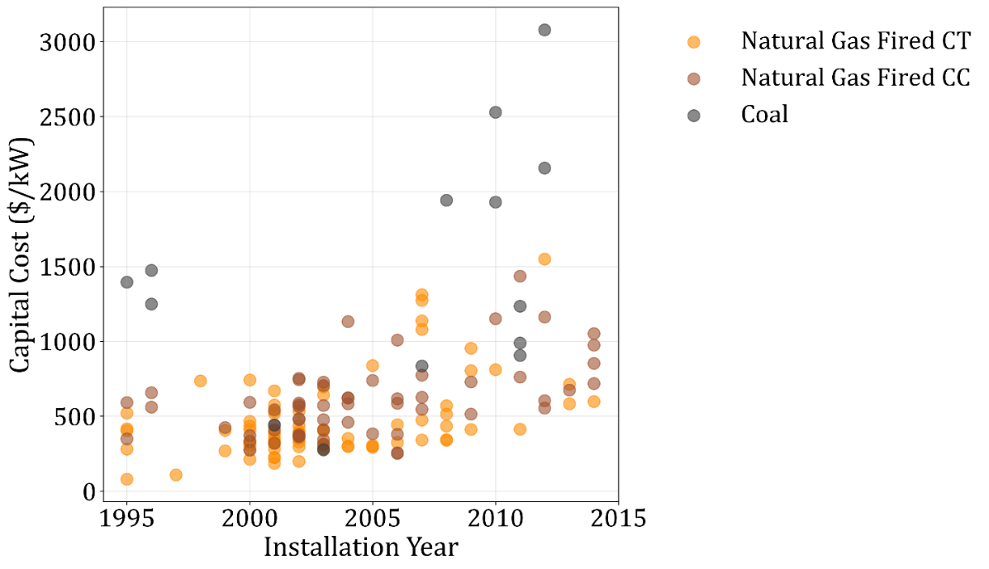
Figure 5 Nominal capital book values at installation for power plants installed during the sample period, by technology type.
Coal plants installed during this period required higher capital costs per kilowatt than the natural gas technologies, with 3 earlier plants installed around 1996 experiencing costs around $1,400/kW, and newer coal plants installed around 2010 ranging between $900-3100/kW. In contrast, natural gas power plants show lower installation capital costs, with installations in the first half of the period generally ranging between $100-700/kW, and in the latter half of the period ranging between $300-1500/kW.
For additional context, the National Renewable Energy Laboratory’s Annual Technology Baseline (ATB) provides benchmark estimates for new generation technologies. NREL’s 2015 ATB reported the total capital expenditures at $867/kW for a new combustion turbine, $1,021/kW for a new combined cycle plant, and $3,446/kW for a new coal plant (National Renewable Energy Laboratory (NREL), 2015). These values are consistent with, albeit on the higher end, the ranges observed near the end of the sample period.

Coal Plant Investment and Environmental Regulation
The descriptive analysis in section 9.5 showed a significant difference in coal capital investment over time compared to other technologies. This section examines in depth the role of environmental regulation in shaping coal plant investment patterns during the 2000-2020 time frame.

Overview of EPA Environmental Regulations (2000s-2010s)
The EPA’s Clean Air Interstate Rule (CAIR), which built on the acid rain program, mandated additional nitrogen oxides (NO_{x}) reductions starting in 2009 and sulfur dioxide (SO₂) reductions beginning in 2010 (U.S. Environmental Protection Agency, 2005a). CAIR required 28 eastern states and the District of Columbia to reduce SO₂ and/or NO_{x} emissions (U.S. Environmental Protection Agency, 2005b). In 2011, in response to legal challenges, the EPA finalized the Cross-State Air Pollution Rule (CSAPR) to replace CAIR, covering the same set of eastern states. After ongoing court challenges and delays, the CSAPR phased deadlines were ultimately set at 2015 and 2017 (U.S. Environmental Protection Agency, 2016). To comply with these successive regulations, the EPA expected in its regulatory impact analyses that coal plants would make capital investments primarily in selective catalytic reduction (SCR) systems to control NO_{x} and flue-gas desulfurization (FGD) systems, or “scrubbers”, for SO₂ (U.S. Environmental Protection Agency, 2015, 2005c).
EPA’s Regional Haze Rule (RHR) was finalized in 1999, focused on protecting visibility in national parks and wilderness areas (U.S. Environmental Protection Agency, 1999). It included a Best Available Retrofit Technology (BART) requirement mandating that states determine and install controls for older large industrial facilities built between 1962-1977 that emit haze-causing pollutants including SO₂, NO_{x}, and particulate matter. For power plants in the eastern U.S., the EPA allowed compliance with CAIR and CSAPR as a “BART-alternative” (U.S. Environmental Protection Agency, 2012). However, for plants in states not covered by CAIR/CSAPR, the RHR remained a regulatory driver for environmental controls on coal plants.
The Clean Air Mercury Rule (CAMR) was finalized by EPA in March 2005 through a cap-and-trade approach on mercury emissions from regulated electric generation units (United States Environmental Protection Agency, 2005). The D.C. Circuit vacated CAMR in 2008 (New Jersey v. EPA, 2008). Concurrently, numerous states established their own mercury regulations for coal-fired power plants, with 18 states enacting or promulgating limits by early 2007 that required 80-90% reductions (Mercury Emissions from Electric Power Plants: States Are Setting Stricter Limits, 2007). Subsequently, the EPA finalized the Mercury and Air Toxics Standards (MATS) in 2012, which set national limits on emissions of mercury and other air pollutants from coal plants. Compliance with MATS was expected by EPA to require another wave of capital projects, including the installation of activated carbon injection (ACI) for mercury control, as well as fabric filters, (baghouses), new or upgraded scrubbers, dry sorbent injection (DSI) systems, and electrostatic precipitator upgrades (U.S. Environmental Protection Agency, 2011). The compliance deadline for MATS was in 2015, with a possible one-year extension to 2016.
The Coal Combustion Residuals (CCR) Rule was finalized by EPA in 2015 and originally required coal ash ponds to begin closing in 2018 (United States Environmental Protection Agency, 2015), a deadline later extended to 2020 and 2021 (United States Environmental Protection Agency, 2020). Capital projects involved significant costs for excavating or capping coal ash ponds and building new dry disposal sites with liners and leachate control systems.
Collectively, these regulations created overlapping compliance obligations for requiring significant capital expenditures specifically for coal plants, with staggered and uncertainty timelines throughout the 2000s and 2010s. From the perspective of capital accounts in the Form 1 data, accounting for the one-year lag where capital expenditures in year t appear in the data at year t+1, it is reasonable to expect compliance-related investments to span roughly 2007- 2021, with the possibility of earlier anticipatory investments.

Plant-Level Investment Patterns
Figure 6 plots capital balance time series to display the timing and scale of environmental control investments for a few large coal plant examples. Boswell, a 960 MW coal plant owned by Minnesota Power, announced completion in 2015 of a major environmental project for controlling mercury sulfur dioxide, and other particulates (Minnesota Power, n.d.), and it reported an increase in its capital balance of approximately $760 million from 2008 through 2015. The observed 2018 decrease in Boswell’s capital balance occurred when it retired two older small units in 2018 at which time the plant’s capacity decreased to 810 MW (Global Energy Monitor, n.d.).

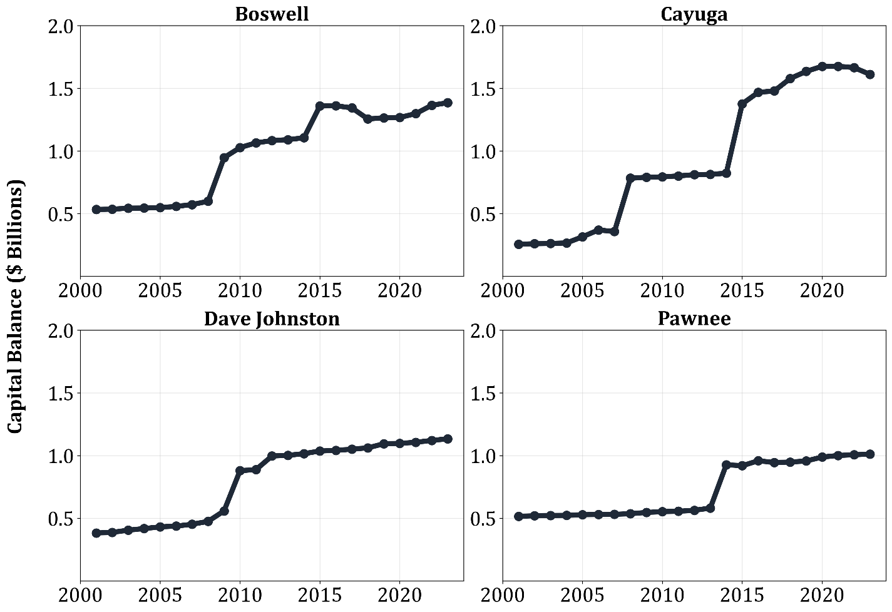
Figure 6 Capital account balances over time for select coal plants, 2000-2023

Cayuga, a 1062 MW plant owned by Duke Indiana, reported an increase in capital investment of over $1 billion from 2007-2015. It received regulatory approval in 2006 to perform a series of investments to comply with sulfur dioxide, nitrogen oxide, and mercury reduction requirements for CAIR and CAMR, and further regulatory approval in late 2012 to perform additional investment for MATS compliance (Indiana Office of Utility Consumer Counselor, 2020).
Dave Johnston, an 817 MW coal plant in Wyoming owned by PacifiCorp, reported a 240 million capital balance increase from 2009-2010. It testified that EPA’s Regional Haze Rules required the installation of a dry flue gas desulfurization system and baghouse by 2010 to reduce sulfur dioxide and particular matter emissions (Direct Testimony of Chad A. Teply, In the Matter of the Application of Rocky Mountain Power for Authority to Increase its Retail Electric Utility Service Rates in Utah and for Approval of its Proposed Electric Servive Schedules and Electric Service Regulations, 2010).
Finally, Pawnee, a 550 MW coal plant owned by Xcel in Colorado, installed new environmental controls in 2014 at which point its capital balance increased by approximately $317 million. Pawnee, built in 1981, was not directly subject to EPA’s Regional Haze Requirements, and this investment was instead a result of coal plant emissions reductions required by state legislation (Colorado Clean Air-Clean Jobs Act, 2010; Xcel Energy Pawnee Generating Station Fact Sheet, n.d.).
Figure 6 shows a two-wave investment pattern for the two plants in the eastern United States (Boswell and Cayuga): a first wave in 2008-09 aligning with the CAIR/CSAPR compliance, and a second wave in 2015, aligned with MATS compliance. The other two plants, both in the Western U.S. and not subject to CAIR/CSAPR, show examples of single-wave investment in response to regional haze rules for Dave Johnston and a state-level requirement for Pawnee. These two plants did not show notable additional investment during MATS compliance time, suggesting their earlier investments may have been sufficient to meet these later federal mercury standards.

Econometric Analysis of Coal Investment Premium

Model Specification
An econometric panel model was implemented that specifies more robustly the additional capital expenditures in coal plants relative to the rest of the natural gas and nuclear plants in the sample. The model employs an event study design that tracks year-by-year differences in capital investment flows between coal plants and their gas and nuclear counterparts from 1995 through 2023. Rather than assuming a single "treatment effect" at a specific point in time, this approach allows the data to reveal the full dynamic evolution of investment patterns across a range of compliance requirements during this sample period. The model captures in a descriptive sense both anticipatory spending in advance of regulatory deadlines and extended timelines of compliance-related investments.
The econometric specification compares coal plants to gas and nuclear plants within each year, effectively using the non-coal plants as a control group that absorbs common economic shocks and market-wide investment trends. This design isolates the coal-specific investment premium – the additional amount that coal plants invested beyond what would have been expected based on the investment behavior of comparable gas and nuclear facilities facing similar market conditions but different regulatory requirements. The model estimates separate coefficients for each year relative to a 1995 baseline, providing a granular view of how the coal investment premium evolved over nearly three decades of changing environmental policy and industry evolution.
The econometric specific takes the form in equation (1),
 | $$∆CapEx_{i,t}=α+\sum_{s=1}^{28}{β_{s}∙\left(Coal_{i}×I_{s,t}\right)+γ∆Capacity_{i,t}+ϵ_{i,t}}$$  $∀i, t∈\{1996:2023\}$ | (1)

where $∆CapEx_{i,t}$ represents the annual change in capital expenditures for plant $i$ in year $t$, and $Coal_{i}$ is an indicator variable equal to one for coal plants with capacity $≥$ 25 MW that were installed prior to 2001. This definition aligns with EPA’s regulatory thresholds that apply to coal units above 25 MW, and plants built after 2001 already incorporate the environmental control technologies targeted by EPA over this time. $I_{s,t}$ are year-specific indicator variables that equal one when $t=1995+s$, creating separate interaction terms for each year from 1996 through 2003. The specification omits 1995 as the baseline reference year, making all coefficients interpretable relative to that initial period.
The coefficients $β_{s}$ capture the coal-specific investment premium in each year $s$ relative to comparable non-coal plants in the same year. Thus, $β_{s}$ represents the differential investment between coal and non-coal plants in the sample after controlling for macro factors that affected all plant types similarly within each year. Each coefficient represents a per-plant differential, indicating how much more the average coal plant invested compared to the average non-coal plant in that specific year. For example, $β_{13}$ (corresponding to 2008) measures the differential in coal-plant investment in 2008 relative to all other natural gas and nuclear plants in the sample in 2008.
The model includes $∆Capacity_{i,t}$ to control for capacity expansions or reductions during the period that impact the plant’s capital balance and expenditure levels. The intercept $α$ captures the average investment change for non-coal plants in the baseline year (1995). Heteroskedasticity-robust standard errors clustered at the plant level to account for serial correlation in individual plants’ investment decisions over time. This model design inherently performs the essential functions of traditional plant and year fixed effects, because the first-differenced dependent variable removes time-invariant plant heterogeneity, and the separate year-specific event indicators capture year-to-year variation investment conditions that affect all plants.
Coal plants in the sample require more capital expense than the plants in the comparison group, independent of the environmental controls mandated during this period. Appendix 2 shows a simple difference in differences calculation on capital account levels yields an average annual premium of $15.6 billion per year from 1995-2023, an order of magnitude larger than the corresponding premium described in the econometric results below. This is likely due to the relative age and/or complexity of the coal plant technology relative to the control group, and illustrates the necessity of differencing out plant-level effects in the dependent variable.

Results
The event study model results provide additional insight into the additional capital expenditure for coal plants that overlap with the EPA compliance timelines described above. Figure 7 displays the model results, showing the annual coal investment premium across the sample period. Each point represents the additional average capital expenditure for a coal plant compared to gas and nuclear plants in the same year, after controlling for capacity changes, with shaded areas indicating 95% confidence intervals based on the plant-level clustered robust standard errors. Numeric tables with the detailed model results are provided in Appendix 2.
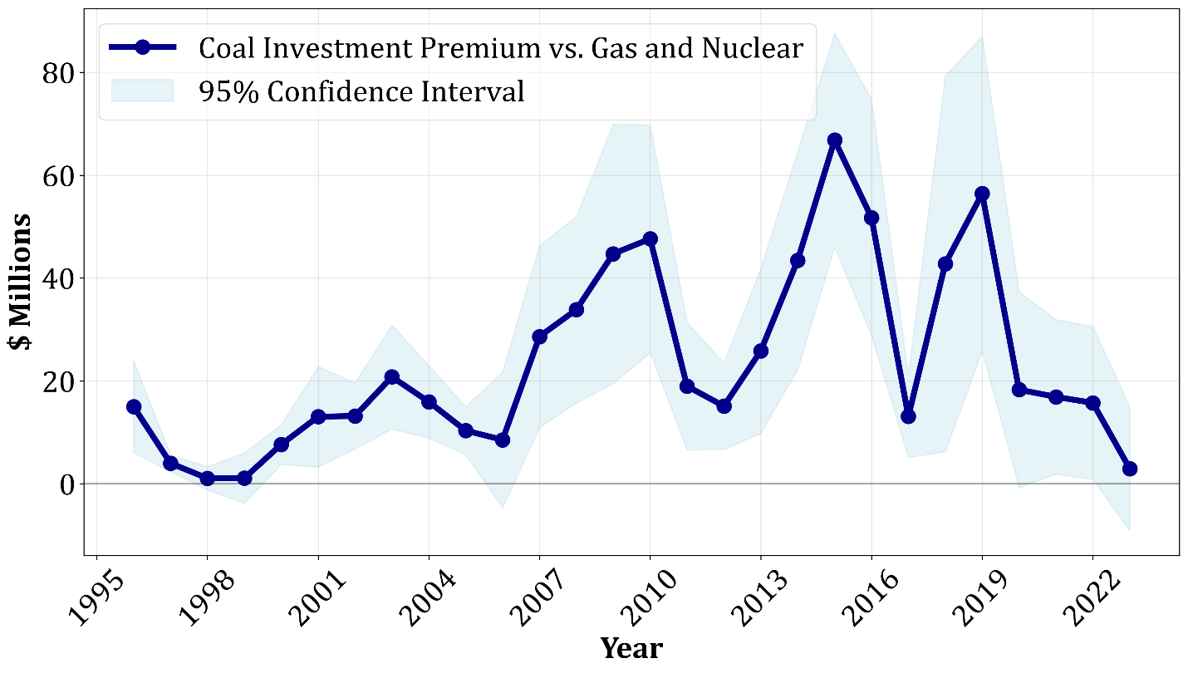
Figure 7 Annual Coal Plant Investment Premium from Event-Study Model.

The estimated coal investment premium exhibits multiple phases that align the EPA’s regulatory timeline described above, including three distinct waves of investment premiums that peak in 2010, 2015, and 2019. During the pre-compliance period (1996-2000), coal plants exhibited investment premiums ranging between $0-$18 million per year. These earlier, smaller premiums could be explained by compliance with earlier EPA requirements on coal plants under the acid rain program which led to smaller amounts of scrubber investment (Clean Air Act Amendments of 1990, 1990; Frey, 2013), anticipatory investment in advance of the upcoming EPA regulations, and baseline differences in capital investment for coal and other technologies.
The first wave of coal investment peaks at $47.6 million in 2010, coinciding with the CAIR compliance deadline. The second wave peaks at $66.8 million in 2015, coinciding with the MATS deadline. The third wave peaks at $56.4 million in 2019, overlapping with the CCR Rule compliance date. The coal investment premium declines after 2019 to the earlier baseline levels. These results show that from 2007-2019, the average coal plant experienced a cumulative investment premium of $489 million. There were 101 coal plants online during this period on average, yielding a total investment premium to coal plants of $49 billion from 2007-2019, or $3.8 billion per year during this period. These results cover the coal plants from the data sample, which as of 2023 included 61% of all coal power plants in the United States, previously shown in
Table 2.
To assess the sensitivity of the event-study model results to the choice of comparison groups, Appendix 2.3 presents two robustness checks that re-estimate the model using, 1) only natural gas plants, and 2) only nuclear plants as the control sample. Despite the more restrictive comparison groups, the resulting coal investment premiums closely track the main model, with the cumulative premiums estimated during 2007-2019 differs by only a few million dollars across specifications. The consistency of these alternative estimates indicates the coal investment premium is not driven by the composition of the control group.

Comparison to Literature
The estimated coal investment premium averaging $3.8 billion per year across the sample can be contextualized against existing studies. The EPA’s projected in its regulatory impact assessment (RIA) for the Clean Air Interstate Rule additional annual costs of $3.6 billion in 2015, encompassing capital expenditures for pollution controls as well as incremental operating and fuel costs (U.S. Environmental Protection Agency, 2005c). The EPA’s RIA for MATS projected an annualized cost of $9.6 billion (in 2007 dollars) for MATS compliance in 2020 (U.S. Environmental Protection Agency, 2011). Another study by Burtraw et al. (2013) estimated MATS compliance costs at $5.1 billion annually (in 2009 dollars) (Burtraw et al., 2013). Gowrisankaran et al. (2025) developed an ex post model which predicted that generators subject to MATS would spend a total of $11.8 billion on technology adoption, in 2012 dollars (Gowrisankaran et al., 2025). The empirical results in this stud are order-of-magnitude consistent with this literature, particularly given that the data sample in this study includes 61% of the U.S. coal fleet and the $3.8 billion number is an annual average over a 13 year period, while the referenced studies estimate national impacts for a projected reference year.
The results from the referenced studies provide relevant context but not a direct comparison to the econometric results presented in this study. First, the EPA RIA’s and Burtraw estimates are ex ante projections from models based on compliance scenarios prior to actual implementation, whereas the econometric results reflect ex post empirical observations of investment. Second, the referenced studies focus on individual rules and specific compliance years, while the econometric model captures the aggregate investment pattern across multiple overlapping regulations over an extended period. From this study, the annual average premium of $3.8 billion across thirteen years (2007-2019) covers the compliance periods of CAIR, CSAPR, MATS, and CCR rules.
Notably, there is limited empirical analysis on coal plant capital investment in response to this period of EPA environmental regulations in the existing literature. For example, Dorsey (2019) examined how legal challenges to CAIR delayed investment and increased compliance costs at a subset of plants affected by additional uncertainty, but did not attempt to quantify aggregate capital expenditures associated with environmental compliance during this period. (Dorsey, 2019).

Conclusion
* Summarize the main findings of the study regarding power plant costs and data characteristics.
* Reiterate the value and challenges of using FERC Form 1 data.
* Restate key recommendations for data improvement.
* Concluding thoughts on the contribution of the research.

References
Accounting Matters | Federal Energy Regulatory Commission [WWW Document], n.d. URL https://www.ferc.gov/accounting-matters-1 (accessed 5.12.25).
Anderson, D., 1972. Models for determining least-cost investments in electricity supply. The Bell Journal of Economics and Management Science 267–299.
Andover Technology Partners, 2018. Improving Heat Rate on Combined Cycle Power Plants.
Annual Electric Power Industry Report, Form EIA-860 detailed data with previous form data (EIA-860A/860B) - U.S. Energy Information Administration (EIA) [WWW Document], n.d. URL https://www.eia.gov/electricity/data/eia860/ (accessed 5.12.25a).
Annual Electric Power Industry Report, Form EIA-860 detailed data with previous form data (EIA-860A/860B) - U.S. Energy Information Administration (EIA) [WWW Document], n.d. URL https://www.eia.gov/electricity/data/eia860/ (accessed 5.13.25b).
Bond, K., Butler-Sloss, S., Walter, D., Speelman, L., 2024. The Great Reallocation. RMI.
Burtraw, D., Palmer, K., Paul, A., Beasley, B., Woerman, M., 2013. Reliability in the U.S. electricity industry under new environmental regulations. Energy Policy 62, 1078–1091. https://doi.org/10.1016/j.enpol.2013.06.070
Catalyst Cooperative, n.d. PUDL Data Dictionary.
Clean Air Act Title IV - Acid Deposition Control, 1990. , U.S.C.
Colorado Clean Air-Clean Jobs Act, 2010. , Colo. Rev. Stat. § 40-2-125.5.
Department of Energy Organization Act, 1977.
Direct Testimony of Chad A. Teply, In the Matter of the Application of Rocky Mountain Power for Authority to Increase its Retail Electric Utility Service Rates in Utah and for Approval of its Proposed Electric Servive Schedules and Electric Service Regulations, 2010. , Docket 10-035-124. Utah Public Service Commission.
Dorsey, J., 2019. Waiting for the Courts: Effects of Policy Uncertainty on Pollution and Investment. Environ Resource Econ 74, 1453–1496. https://doi.org/10.1007/s10640-019-00375-2
Fabrizio, K.R., Rose, N.L., Wolfram, C.D., 2007. Do Markets Reduce Costs? Assessing the Impact of Regulatory Restructuring on US Electric Generation Efficiency. American Economic Review 97, 1250–1277. https://doi.org/10.1257/aer.97.4.1250
Fares, R.L., King, C.W., 2017. Trends in transmission, distribution, and administration costs for U.S. investor-owned electric utilities. Energy Policy 105, 354–362. https://doi.org/10.1016/j.enpol.2017.02.036
Federal Energy Administration Act, 1974.
FERC, 2025. Electric Industry Forms: Form No. 1 - Annual Report of Major Electric Utility.
Frey, E.F., 2013. Technology Diffusion and Environmental Regulation: The Adoption of Scrubbers by Coal-Fired Power Plants. The Energy Journal 34, 177–205. https://doi.org/10.5547/01956574.34.1.8
Global Energy Monitor, n.d. Boswell Energy Center [WWW Document]. URL https://www.gem.wiki/Boswell_Energy_Center (accessed 10.28.25).
Goto, M., Tsutsui, M., 2008. Technical efficiency and impacts of deregulation: An analysis of three functions in U.S. electric power utilities during the period from 1992 through 2000. Energy Economics 30, 15–38. https://doi.org/10.1016/j.eneco.2006.05.020
Gowrisankaran, G., Langer, A., Zhang, W., 2025. Policy Uncertainty in the Market for Coal Electricity: The Case of Air Toxics Standards. Journal of Political Economy 133, 1757–1795. https://doi.org/10.1086/734779
Gultom, Y.M.L., 2019. Governance structures and efficiency in the U.S. electricity sector after the market restructuring and deregulation. Energy Policy 129, 1008–1019. https://doi.org/10.1016/j.enpol.2019.02.005
Hultman, N.E., Koomey, J.G., Kammen, D.M., 2007. What History Can Teach Us About the Future Costs of U.S. Nuclear Power. Environ. Sci. Technol. 41, 2087–2094. https://doi.org/10.1021/es0725089
Indiana Office of Utility Consumer Counselor, 2020. Duke Energy Environmental Compliance Cases [WWW Document]. URL https://www.in.gov/oucc/electric/key-cases-by-utility/duke-energy-environmental-compliance-cases/ (accessed 10.28.25).
Joskow, P.L., Bohi, D.R., Gollop, F.M., 1989. Regulatory failure, regulatory reform, and structural change in the electrical power industry. Brookings papers on economic activity. Microeconomics 1989, 125–208.
Kessides, I.N., 2010. Nuclear power: Understanding the economic risks and uncertainties. Energy Policy 38, 3849–3864. https://doi.org/10.1016/j.enpol.2010.03.005
Mercury Emissions from Electric Power Plants: States Are Setting Stricter Limits (CRS Report for Congress No. RL33535), 2007. . Congressional Research Service, Washington, DC.
Minnesota Power, n.d. Reducing Emissions [WWW Document]. URL https://www.mnpower.com/Environment/ReducingEmissions (accessed 10.28.25).
National Renewable Energy Laboratory (NREL), 2015. Annual Technology Baseline.
New Jersey v. Environmental Protection Agency, 2008. , Federal Reporter, Third Series.
Nuclear Energy Agency, International Atomic Energy Agency, 2018. Measuring Employment Generated by the Nuclear Power Sector. OECD. https://doi.org/10.1787/9789264305960-en
Oladosu, G.A., Sasthav, C.M., 2022. Hydropower Capital and O&M Costs: An Exploration of the FERC Form 1 Data (No. ORNL/TM-2021/2297). Oak Ridge National Laboratory (ORNL), Oak Ridge, TN (United States). https://doi.org/10.2172/1845786
The Public Utility Data Liberation (PUDL) Project, n.d. . Catalyst Cooperative. URL https://catalyst.coop/pudl/ (accessed 5.12.25).
Uniform System of Accounts Prescribed for Public Utilities and Licensees Subject to the Provisions of the Federal Power Act, 1947. , U.S. Code of Federal Regulations.
United States Environmental Protection Agency, 2020. Hazardous and Solid Waste Management System; Disposal of Coal Combustion Residuals from Electric Utilities; A Holistic Approach to Closure Part A: Deadline To Initiate Closure (Final Rule), 40 C.F.R. Part 257.
United States Environmental Protection Agency, 2015. Hazardous and Solid Waste Management System; Disposal of Coal Combustion Residuals from Electric Utilities (Final Rule), 40 C.F.R. Parts 257 and 261.
United States Environmental Protection Agency, 2005. Standards of Performance for New and Existing Stationary Sources: Electric Utility Steam Generating Units, Federal Register.
U.S. Energy Information Administration, 2023. Natural gas combined-cycle power plants increased utilization with improved technology - U.S. Energy Information Administration (EIA).
U.S. Environmental Protection Agency, 2016. Rulemaking To Affirm Interim Amendments to Dates in Federal Implementation Plans Addressing Interstate Transport of Ozone and Fine Particulate Matter, 40 CFR Parts 51, 52, 97.
U.S. Environmental Protection Agency, 2015. Regulatory Impact Analysis for the Proposed Cross-State Air Pollution Rule (CSAPR) Update for the 2008 National Ambient Air Quality Standards (NAAQS) (No. EPA-452/R-15-009).
U.S. Environmental Protection Agency, 2012. Regional Haze: Revisions to Provisions Governing Alternatives to Source-Specific Best Available Retrofit Technology (BART) Determinations, Limited SIP Disapprovals, and Federal Implementation Plans, Federal Register.
U.S. Environmental Protection Agency, 2011. Regulatory Impact Analysis for the Final Mercury and Air Toxics Standards (No. EPA-452/R-11-011).
U.S. Environmental Protection Agency, 2005a. Rule to Reduce Interstate Transport of Fine Particulate Matter and Ozone (Clean Air Interstate Rule).
U.S. Environmental Protection Agency, 2005b. Rule to Reduce Interstate Transport of Fine Particulate Matter and Ozone (Clean Air Interstate Rule); Revisions to Acid Rain Program; Revisions to the NOₓ SIP Call, Federal Register.
U.S. Environmental Protection Agency, 2005c. Regulatory Impact Analysis for the Final Clean Air Interstate Rule (No. EPA-452/R-05-002).
U.S. Environmental Protection Agency, 1999. Regional Haze Regulations: Final Rule, Federal Register.
Wagman, D., 2017. Automation Is Engineering the Jobs Out of Power Plants (IEEE Spectrum).
Wolak, F.A., 1994. An econometric analysis of the asymmetric information, regulator-utility interaction. Annales d’Economie et de Statistique 13–69.
World Nuclear Association, 2024. Nuclear Power Economics and Structuring.
Xcel Energy Pawnee Generating Station Fact Sheet, n.d.
- Additional Descriptive Analysis of Form 1 Sample
- Capacity Distributions
Table 9 presents statistics showing the distribution of plants by technology type Nuclear plants are on average the largest among technologies in the analysis, with a mean capacity of 1,218 MW and a median of 1,148 MW. The largest nuclear plant in the dataset is Duke Energy’s Oconee plant, at 2,667 MW. NGCC and coal technologies have comparable mean capacities of 731 and 732 MW, respectively. The largest NGCC plant in the data is Florida Power and Light’s 4100 MW West County Energy Center and the largest coal plant is Georgia Power’s 3,499 MW Bowen facility.
Table 9 Descriptive statistics for plant capacity (MW) by technology from Form 1(2023).
Technology Group | Mean | Median | Min | Max | Std. Dev. | IQR
Nuclear | 1218 | 1148 | 219 | 2667 | 702 | 1068
Natural Gas Fired CC | 731 | 603 | 25 | 4100 | 594 | 631
Conventional Steam Coal | 712 | 532 | 14 | 3499 | 678 | 713
Other Natural Gas | 549 | 317 | 13 | 2491 | 558 | 659
Natural Gas Fired CT | 264 | 151 | 13 | 2245 | 299 | 293
Onshore Wind Turbine | 166 | 137 | 9 | 816 | 171 | 136
Other | 101 | 41 | 2 | 805 | 163 | 68
Solar Photovoltaic | 66 | 74 | 10 | 161 | 28 | 24
Geothermal | 38 | 38 | 38 | 38 | N/A | 0
Other natural gas plants, which include steam turbines and internal combustion engines, along with natural gas combustion turbines, have smaller average capacities. The largest among “Other Natural Gas” plants is Duke Energy’s Belews Creek natural gas steam turbine, while the largest combustion turbine is the Duke Energy’s Smith Energy Center. The largest plant in the “Other” category is Duke’s Energy’s Edwardsport integrated coal gasification combined cycle plant in Indiana. Other technologies in the “Other” category include plants using fuel oil, petroleum coke, woody biomass, and solid waste.
The distribution of plant capacities by technology is visualized as a series of boxplots in Figure 8. Because plant capacities span orders of magnitude across technologies, a logarithmic scale is displayed on the y-axis in Figure 8 to enable a better visual comparison. A linear scale would visually obscure details of the smaller-capacity technologies by compressing their distributions. To avoid improper interpretation, it is important to emphasize that the logarithmic scaling of the y-axis displays the proportional, rather than absolute, differences in capacity across the technology ranges. So, for example, while the range for Onshore Wind capacities visually appears taller than for Nuclear in Figure 8, that is not the case in absolute terms. The interquartile range for nuclear capacity in the sample is 1,068 MW for Nuclear, but only 136 MW for wind.
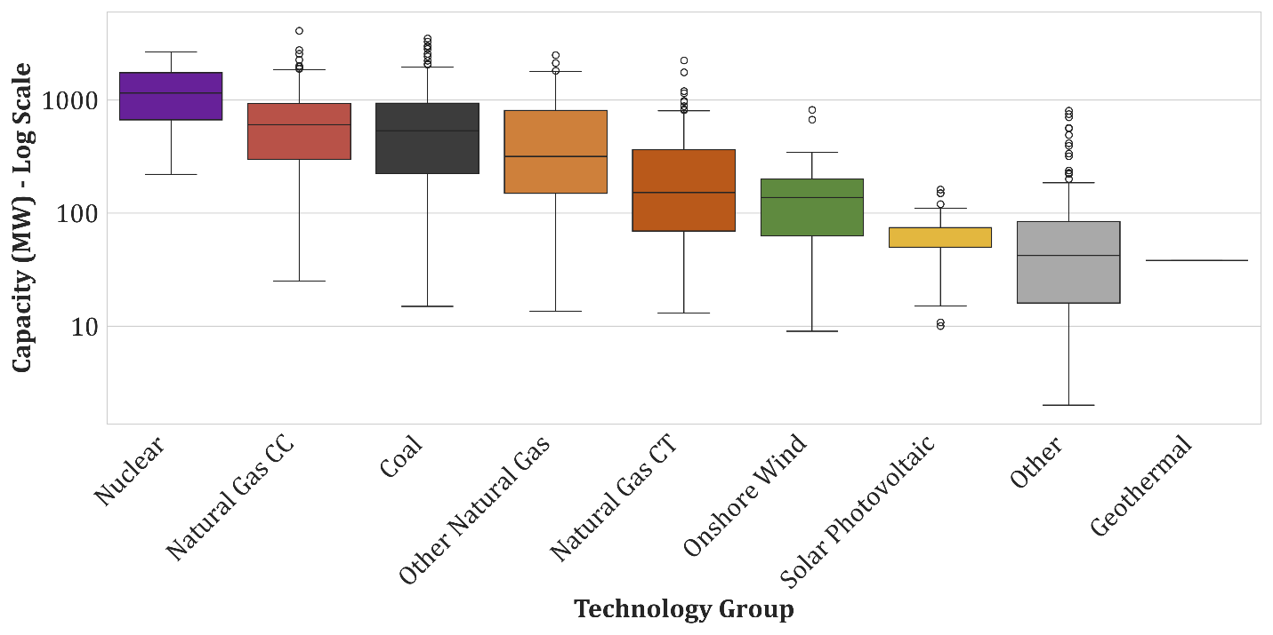
Figure 8 Boxplot of capacity distribution among technologies in data sample (2023).

- Temporal Distributions
Figure 9 illustrates the temporal distribution of electric generating capacity within the cleaned FERC Form 1 sample, broken out by technology. Significant growth in aggregate capacity over time is displayed in the clean sample, increasing from approximately 150 GW in 1994 to nearly 400 GW in 2023.
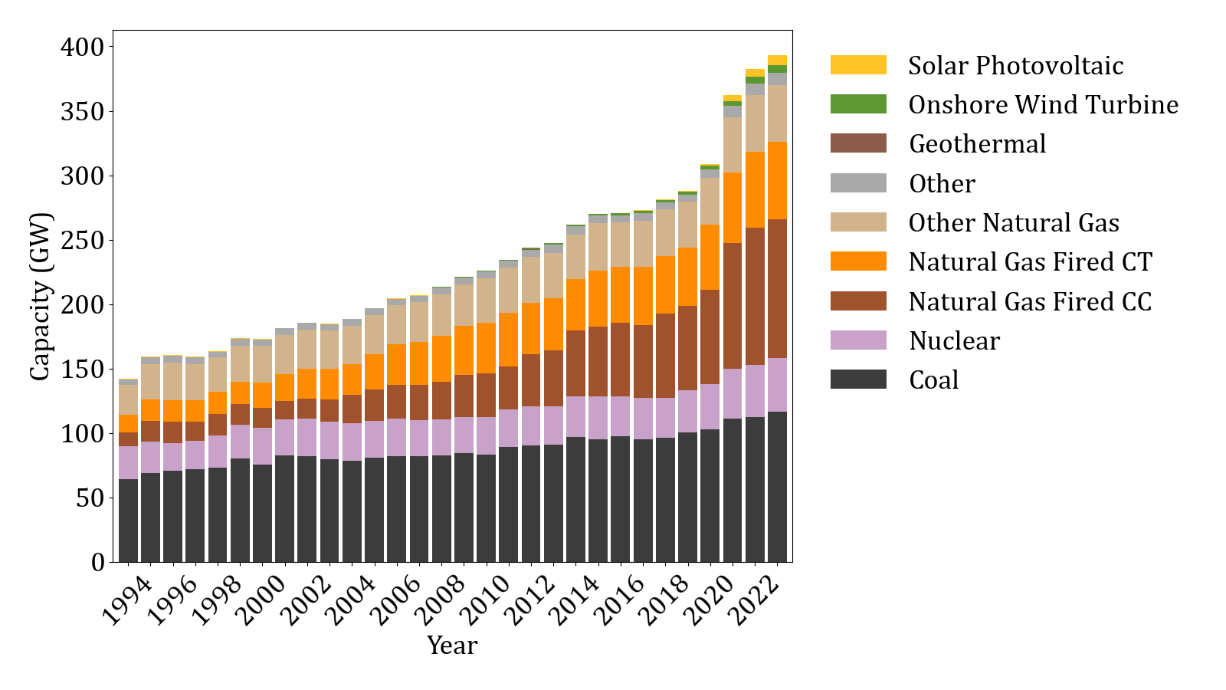
Figure 9 Plant capacity by technology over time in the analysis data sample.
Figure 9 shows that most of the capacity growth over time in the sample is from natural gas-fired generation. While natural gas technologies constituted a minority of the sample’s capacity in the mid-1990’s, they have collectively become the largest component by 2023. Coal and nuclear capacity in the sample increased slightly over time, while its relative share of total capacity decreased significantly. Figure 9 further displays the limited scope of Form 1 regarding renewable energy technologies. As noted previously, cost reporting is not mandated by FERC Form 1 for wind and solar facilities. Consequently, wind, solar, and geothermal appear as minor additions late in the sample period, likely representing voluntary filings rather than mandatory reporting by jurisdictional respondents.
Some capacity growth in Figure 9 is from real-world growth in capacity, but much of the displayed growth is an artifact of the data linking process. As already discussed, inconsistencies in plant names over time make it difficult to link Form 1 plants to the power plant characteristics in EIA. The issue is exacerbated as you go farther back in time, resulting in lower successfully matched plants in the 1990’s compared to more recent years.
Additional national context is provided in Figure 10, which plots total U.S. generating capacity using national EIA data. It shows that while natural gas capacity did grow in the U.S. after 2010, it was not at the rate in the FERC 1 sample. Figure 10 shows the U.S. from 2010-2024 experienced a steady decline in coal capacity, and most growth occurring from wind, solar, and more recently, batteries. As noted previously, wind, solar, and storage are largely outside the reporting scope of FERC Form 1. Consequently, plant-level cost data for these growing segments of U.S. power generation is unavailable for this analysis.
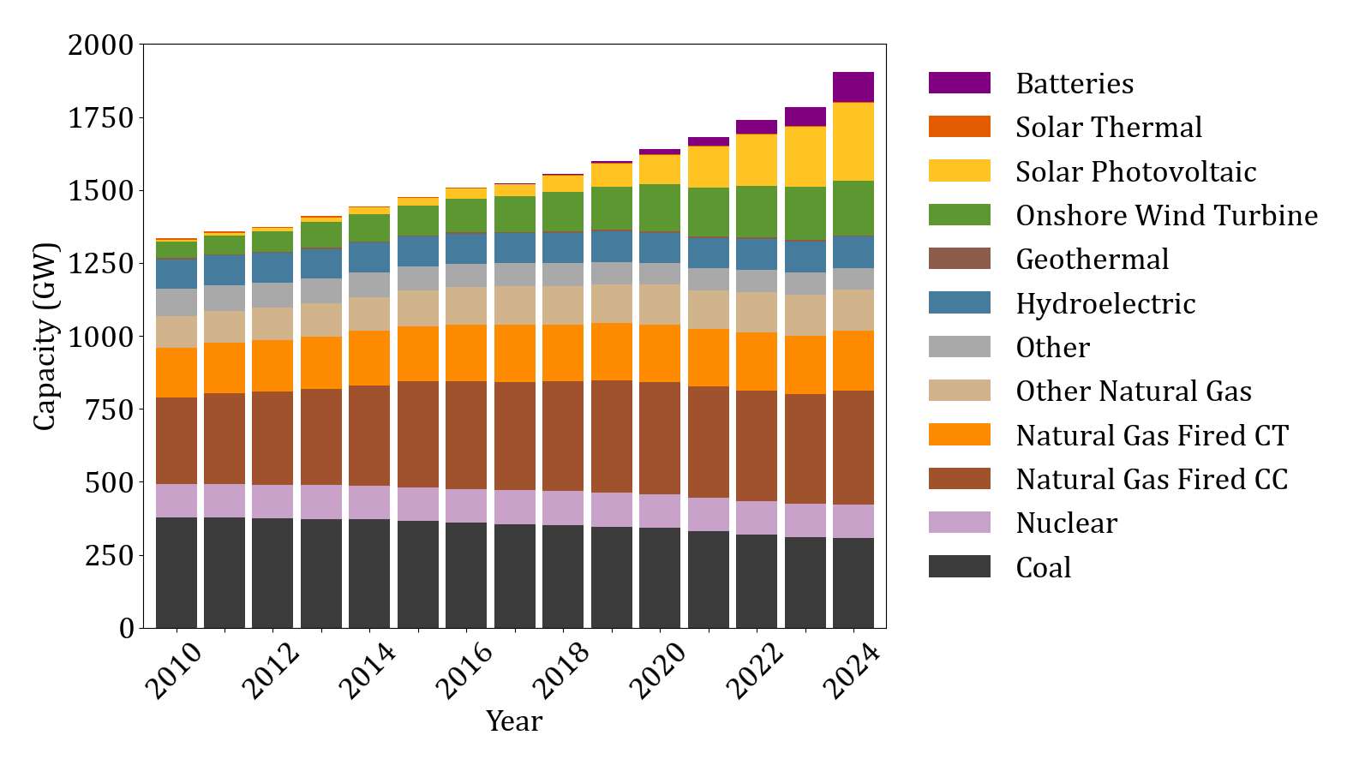
Figure 10 Total U.S. Electric Generating Capacity by Technology, 2010-2024.

- Supplemental Capital Cost Analysis

- Detailed Coal Premium Econometric Results
Statistic | Value
Observations | 7,668
Entities | 405.0
Time Periods | 29.0
R-squared | 0.0765
R-squared (Within) | 0.0565
R-squared (Between) | 0.2221
R-squared (Overall) | 0.0765
F-statistic | 21.8342
F-statistic p-value | 0.000000
Log-likelihood | -1.51e+05
Average Obs per Entity | 18.9
Average Obs per Time | 264.4

Year | Event_t | Coefficient ($M) | Std Error ($M) | t-stat | P-value | CI Lower ($M) | CI Upper ($M)
1996 | 1 | 15.0 | 4.5 | 3.303 | 0.0010 | 6.1 | 23.9
1997 | 2 | 4.0 | 0.8 | 4.736 | 0.0000 | 2.3 | 5.7
1998 | 3 | 1.1 | 1.2 | 0.921 | 0.3572 | -1.2 | 3.4
1999 | 4 | 1.1 | 2.5 | 0.448 | 0.6541 | -3.8 | 6.0
2000 | 5 | 7.7 | 2.0 | 3.885 | 0.0001 | 3.8 | 11.5
2001 | 6 | 13.0 | 5.0 | 2.611 | 0.0090 | 3.3 | 22.8
2002 | 7 | 13.2 | 3.3 | 4.026 | 0.0001 | 6.8 | 19.6
2003 | 8 | 20.8 | 5.2 | 4.034 | 0.0001 | 10.7 | 30.9
2004 | 9 | 15.9 | 3.6 | 4.441 | 0.0000 | 8.9 | 23.0
2005 | 10 | 10.3 | 2.4 | 4.327 | 0.0000 | 5.7 | 15.0
2006 | 11 | 8.6 | 6.7 | 1.267 | 0.2051 | -4.7 | 21.8
2007 | 12 | 28.6 | 9.0 | 3.169 | 0.0015 | 10.9 | 46.4
2008 | 13 | 33.9 | 9.3 | 3.658 | 0.0003 | 15.7 | 52.0
2009 | 14 | 44.7 | 12.9 | 3.474 | 0.0005 | 19.5 | 70.0
2010 | 15 | 47.6 | 11.3 | 4.217 | 0.0000 | 25.5 | 69.8
2011 | 16 | 19.0 | 6.3 | 3.008 | 0.0026 | 6.6 | 31.4
2012 | 17 | 15.1 | 4.3 | 3.499 | 0.0005 | 6.6 | 23.6
2013 | 18 | 25.9 | 8.2 | 3.163 | 0.0016 | 9.8 | 41.9
2014 | 19 | 43.5 | 10.8 | 4.013 | 0.0001 | 22.2 | 64.7
2015 | 20 | 66.8 | 10.6 | 6.304 | 0.0000 | 46.0 | 87.6
2016 | 21 | 51.8 | 11.7 | 4.412 | 0.0000 | 28.8 | 74.8
2017 | 22 | 13.1 | 4.1 | 3.229 | 0.0012 | 5.2 | 21.1
2018 | 23 | 42.8 | 18.6 | 2.295 | 0.0217 | 6.2 | 79.3
2019 | 24 | 56.4 | 15.6 | 3.613 | 0.0003 | 25.8 | 87.0
2020 | 25 | 18.3 | 9.7 | 1.886 | 0.0594 | -0.7 | 37.3
2021 | 26 | 16.9 | 7.7 | 2.206 | 0.0274 | 1.9 | 31.9
2022 | 27 | 15.7 | 7.6 | 2.072 | 0.0383 | 0.8 | 30.6
2023 | 28 | 3.0 | 6.1 | 0.482 | 0.6297 | -9.1 | 15.0

- Coal Premium Difference in Differences
Figure 11 plots the average capital balance over time for coal plants as well as a series of a weighted-average capital balance for gas and nuclear plants. It shows that coal plants’ nominal capital accounts, on a per MW basis, increased from $0.47 million in 1995 to $1.25 million in 2023, whereas the weighted average of gas and nuclear capital accounts increased from $0.64 million to $0.92 million. The difference in differences between these two series over the period is $0.5 million per MW, which, after multiplying $0.5 million per MW by average of total coal capacity across the sample period (281 GW), translates to $141 billion ($15.6 billion per year) of additional nominal capital spend on coal plants in the sample relative to the other three technologies on average from 1995-2023.
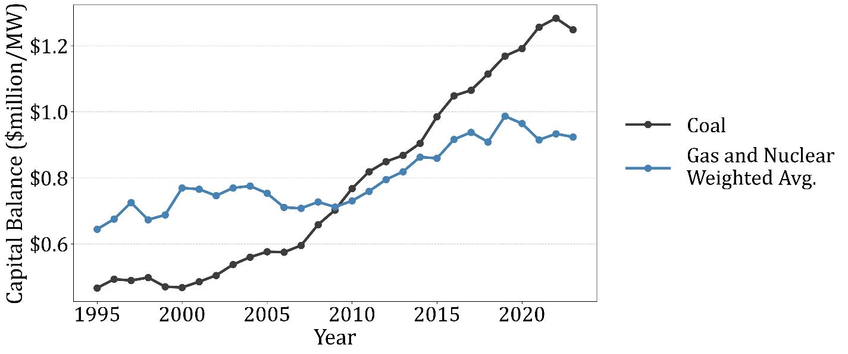
Figure 11 Average capital account balances for coal plants and a weighted average of natural gas combined cycle, combustion turbine, and nuclear plants.
- Econometric Control Sample Robustness Checks
Two alternative models were estimated that restricted the control group to specific technology types, to test whether the coal investment premium patterns depend on the composition of the comparison group. The first robustness check restricted the control group to natural gas plants (including 7087 observations across 380 plants), while the second used only nuclear plants (3422 observations across 164 plants).
The results for each control group specification, displayed in Figure 12 and Figure 13, appear nearly identical to the main model’s results. As already reported, the cumulative coal investment premium for the average coal plant from 2007-2019 in the main model results was $489.2 million. The corresponding cumulative premium for the natural gas control group specification is $484.9 million, and for the nuclear control group it is 491.6 million. Because each robustness specification restricts the comparison group to a single fuel type, the number of observations decrease relative to the main model, from 7,668 observations to 7,087 for the natural-gas-only sample and 3,422 for the nuclear-only sample.
The consistency in results across different control groups suggests that both gas and nuclear plants followed similar underlying investment trends relative to the coal plants. Any macro economic and industry wide factors a well-captured by year-specific indicator variables, and there is not a systematic difference in how gas vs. nuclear plants responded to these general market conditions across the sample period.
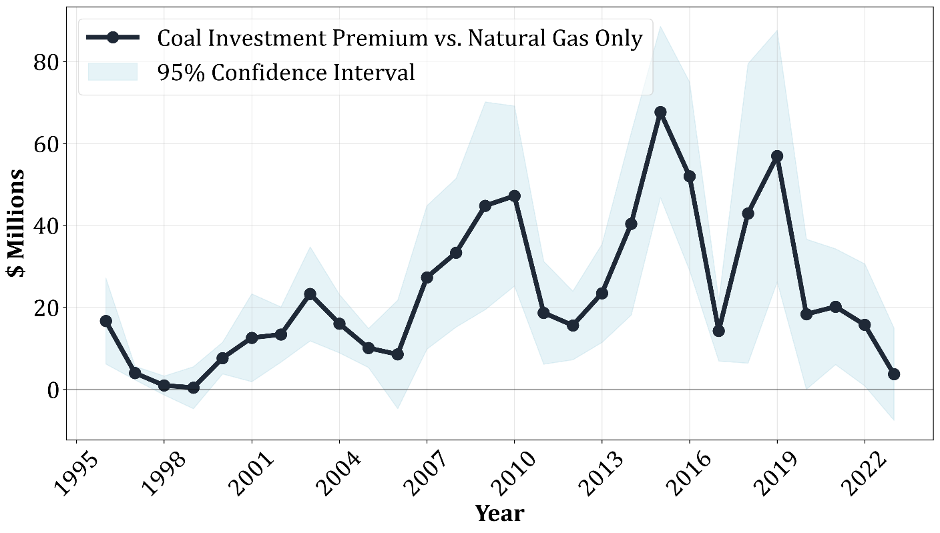
Figure 12 Annual coal plant investment premium from event study model that restricted the control group to natural gas plants.
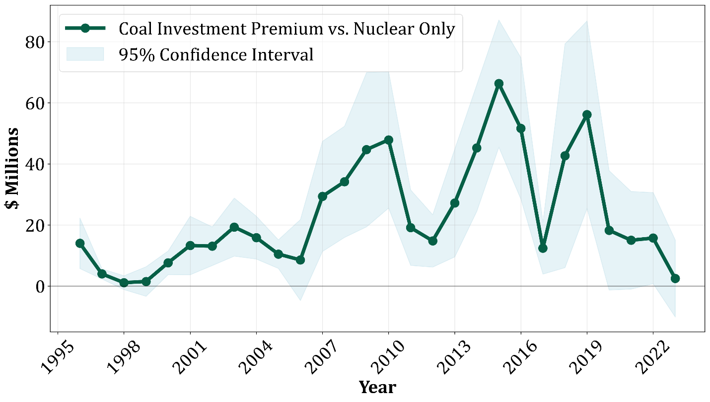
Figure 13 Annual coal plant investment premium from event study model that restricted the control group to nuclear plants.

Detailed Results for Natural Gas Control Group Model
Statistic | Value
Observations | 7,087
Entities | 380.0
Time Periods | 29.0
R-squared | 0.1998
R-squared (Within) | 0.1710
R-squared (Between) | 0.3421
R-squared (Overall) | 0.1998
F-statistic | 60.7792
F-statistic p-value | 0.000000
Log-likelihood | -1.37e+05
Average Obs per Entity | 18.6
Average Obs per Time | 244.4

Year | Event_t | Coefficient ($M) | Std Error ($M) | t-stat | P-value | CI Lower ($M) | CI Upper ($M)
1996 | 1 | 16.7 | 5.3 | 3.124 | 0.0018 | 6.2 | 27.2
1997 | 2 | 4.0 | 0.8 | 4.735 | 0.0000 | 2.3 | 5.7
1998 | 3 | 1.0 | 1.2 | 0.816 | 0.4145 | -1.3 | 3.3
1999 | 4 | 0.4 | 2.6 | 0.162 | 0.8715 | -4.7 | 5.5
2000 | 5 | 7.7 | 2.0 | 3.884 | 0.0001 | 3.8 | 11.5
2001 | 6 | 12.6 | 5.5 | 2.307 | 0.0211 | 1.9 | 23.3
2002 | 7 | 13.4 | 3.4 | 3.900 | 0.0001 | 6.7 | 20.1
2003 | 8 | 23.3 | 5.9 | 3.985 | 0.0001 | 11.8 | 34.8
2004 | 9 | 16.1 | 3.6 | 4.420 | 0.0000 | 8.9 | 23.2
2005 | 10 | 10.1 | 2.4 | 4.166 | 0.0000 | 5.4 | 14.9
2006 | 11 | 8.5 | 6.7 | 1.265 | 0.2057 | -4.7 | 21.8
2007 | 12 | 27.3 | 8.9 | 3.062 | 0.0022 | 9.8 | 44.8
2008 | 13 | 33.4 | 9.3 | 3.605 | 0.0003 | 15.2 | 51.5
2009 | 14 | 44.8 | 12.9 | 3.468 | 0.0005 | 19.5 | 70.2
2010 | 15 | 47.2 | 11.2 | 4.213 | 0.0000 | 25.2 | 69.2
2011 | 16 | 18.7 | 6.4 | 2.925 | 0.0035 | 6.2 | 31.3
2012 | 17 | 15.6 | 4.3 | 3.656 | 0.0003 | 7.2 | 24.0
2013 | 18 | 23.5 | 6.1 | 3.839 | 0.0001 | 11.5 | 35.5
2014 | 19 | 40.4 | 11.4 | 3.558 | 0.0004 | 18.2 | 62.7
2015 | 20 | 67.7 | 10.7 | 6.357 | 0.0000 | 46.8 | 88.6
2016 | 21 | 52.0 | 11.7 | 4.432 | 0.0000 | 29.0 | 75.0
2017 | 22 | 14.3 | 3.8 | 3.804 | 0.0001 | 6.9 | 21.7
2018 | 23 | 43.0 | 18.6 | 2.304 | 0.0212 | 6.4 | 79.5
2019 | 24 | 57.0 | 15.7 | 3.637 | 0.0003 | 26.3 | 87.7
2020 | 25 | 18.4 | 9.3 | 1.964 | 0.0496 | 0.0 | 36.7
2021 | 26 | 20.2 | 7.2 | 2.802 | 0.0051 | 6.1 | 34.3
2022 | 27 | 15.8 | 7.6 | 2.074 | 0.0381 | 0.9 | 30.6
2023 | 28 | 3.7 | 5.7 | 0.650 | 0.5158 | -7.5 | 15.0

Detailed Results for Nuclear Control Group Model
Statistic | Value
Observations | 3,422
Entities | 164.0
Time Periods | 29.0
R-squared | 0.0585
R-squared (Within) | 0.0354
R-squared (Between) | 0.2242
R-squared (Overall) | 0.0585
F-statistic | 7.2634
F-statistic p-value | 0.000000
Log-likelihood | -6.86e+04
Average Obs per Entity | 20.9
Average Obs per Time | 118.0

Year | Event_t | Coefficient ($M) | Std Error ($M) | t-stat | P-value | CI Lower ($M) | CI Upper ($M)
1996 | 1 | 14.0 | 4.2 | 3.323 | 0.0009 | 5.7 | 22.3
1997 | 2 | 4.0 | 0.8 | 4.724 | 0.0000 | 2.3 | 5.7
1998 | 3 | 1.1 | 1.2 | 0.977 | 0.3286 | -1.1 | 3.4
1999 | 4 | 1.5 | 2.5 | 0.617 | 0.5371 | -3.3 | 6.4
2000 | 5 | 7.7 | 2.0 | 3.876 | 0.0001 | 3.8 | 11.5
2001 | 6 | 13.3 | 4.9 | 2.725 | 0.0065 | 3.7 | 22.9
2002 | 7 | 13.1 | 3.2 | 4.050 | 0.0001 | 6.7 | 19.4
2003 | 8 | 19.3 | 4.8 | 3.989 | 0.0001 | 9.8 | 28.8
2004 | 9 | 15.9 | 3.6 | 4.438 | 0.0000 | 8.9 | 22.9
2005 | 10 | 10.5 | 2.4 | 4.394 | 0.0000 | 5.8 | 15.2
2006 | 11 | 8.6 | 6.8 | 1.265 | 0.2059 | -4.7 | 21.8
2007 | 12 | 29.4 | 9.2 | 3.195 | 0.0014 | 11.4 | 47.4
2008 | 13 | 34.2 | 9.3 | 3.678 | 0.0002 | 15.9 | 52.4
2009 | 14 | 44.7 | 12.9 | 3.467 | 0.0005 | 19.4 | 69.9
2010 | 15 | 47.9 | 11.4 | 4.207 | 0.0000 | 25.6 | 70.2
2011 | 16 | 19.1 | 6.3 | 3.037 | 0.0024 | 6.8 | 31.5
2012 | 17 | 14.8 | 4.4 | 3.390 | 0.0007 | 6.2 | 23.4
2013 | 18 | 27.2 | 9.0 | 3.025 | 0.0025 | 9.6 | 44.9
2014 | 19 | 45.2 | 10.6 | 4.277 | 0.0000 | 24.5 | 66.0
2015 | 20 | 66.3 | 10.6 | 6.238 | 0.0000 | 45.5 | 87.1
2016 | 21 | 51.6 | 11.8 | 4.369 | 0.0000 | 28.5 | 74.8
2017 | 22 | 12.4 | 4.3 | 2.872 | 0.0041 | 3.9 | 20.9
2018 | 23 | 42.7 | 18.7 | 2.284 | 0.0224 | 6.1 | 79.3
2019 | 24 | 56.1 | 15.6 | 3.586 | 0.0003 | 25.4 | 86.8
2020 | 25 | 18.3 | 10.0 | 1.833 | 0.0668 | -1.3 | 37.8
2021 | 26 | 15.0 | 8.1 | 1.843 | 0.0653 | -1.0 | 31.0
2022 | 27 | 15.7 | 7.6 | 2.066 | 0.0389 | 0.8 | 30.7
2023 | 28 | 2.5 | 6.4 | 0.392 | 0.6948 | -10.1 | 15.1

Specifically, the PUDL table Core FERC1 Yearly Steam Plants Sched402 provides the plant-level cost data, while the PUDL table Core EIA860 SCD Generators provided additional technology details. Plant and utility entity tables were also used in constructing the data analyzed for this study.
The “Other” technology category includes power plants primarily using fuel oil, petroleum coke, coal gasification, woody biomass, and solid waste.
Via Catalyst Cooperative’s Public Utility Data Liberation Project (Catalyst Cooperative, n.d.), specifically the table titled “out_eia__yearly_generators.”

