Analysis - San Francisco Fire Department Calls For Service

Steven De La Fuente

12/10/2018

Introduction

This exploritory analysis is the first step toward achieving a larger project goal of improving theoretical availability and utilization rates of San Francisco Fire Department services. San Francisco faces many social challenges similar to other rapidly devoloping cities. Today socio-economic disparity has become evident in nearly every neighborhood of the city. Maintaing and improving departmental services may lead to future quality of life and resiliancy improvements among the cities most vulnerable populations.

Objective

* Conduct spatiotemporal analysis of San Francisco Fire Department calls for service occuring within the year of 2016.
* Discover and understand common statistics such as, incident type, response time and fequency related to unique units, stations and neighborhoods within the city.
* Manipulate derivitive values from the established dataset, leading to interesting and informative geospatial insights.
* Establish a baseline, aimed at improving project scope and direction.

Data

-Data Repository: <https://datasf.org/opendata/>

* Fire Department Calls for Service

<https://data.sfgov.org/Public-Safety/Fire-Department-Calls-for-Service/nuek-vuh3>

* Analysis Neighborhoods Shapefile

<https://data.sfgov.org/Geographic-Locations-and-Boundaries/Analysis-Neighborhoods/p5b7-5n3h>

Packages used

* library(tidyr, ggplot2, dplyr, lubridate, stringr, sf)

San Francisco Fire Department, Calls for Service dataset.

data <- read.csv(file= "/Users/Steve/Dropbox/ucsc/data_analysis/project/Fire_Department_Calls_for_Service_2016.csv")

Shapefile delineating neighborhood boundaries.

sfn_shp <- st_read('/Users/steve/Downloads/sf_nhoods/geo_export_b43d0be8-0ef5-421a-8fa0-204489a90d6b.shp')

## Reading layer `geo_export_b43d0be8-0ef5-421a-8fa0-204489a90d6b' from data source `/Users/Steve/Downloads/sf_nhoods/geo_export_b43d0be8-0ef5-421a-8fa0-204489a90d6b.shp' using driver `ESRI Shapefile'  
## Simple feature collection with 41 features and 1 field  
## geometry type: MULTIPOLYGON  
## dimension: XY  
## bbox: xmin: -122.5149 ymin: 37.70813 xmax: -122.357 ymax: 37.8333  
## epsg (SRID): 4326  
## proj4string: +proj=longlat +ellps=WGS84 +no_defs

-Analysis

str(data)

## 'data.frame': 303967 obs. of 35 variables:  
## $ X : int 1 2 3 4 5 6 7 8 9 10 ...  
## $ Call.Number : int 160010009 160010009 160010013 160010015 160010018 160010018 160010018 160010038 160010038 160010040 ...  
## $ Unit.ID : Factor w/ 266 levels "50","52","53",..: 174 179 13 108 82 117 264 24 102 27 ...  
## $ Incident.Number : int 16000001 16000001 16000002 16000003 16000004 16000004 16000004 16000005 16000005 16000006 ...  
## $ Call.Type : Factor w/ 28 levels "Administrative",..: 16 16 16 21 3 3 3 16 16 16 ...  
## $ Call.Date : Factor w/ 366 levels "2016-01-01","2016-01-02",..: 1 1 1 1 1 1 1 1 1 1 ...  
## $ Watch.Date : Factor w/ 367 levels "01/01/2016","01/02/2016",..: 366 366 366 366 366 366 366 366 366 366 ...  
## $ Received.DtTm : Factor w/ 141713 levels "01/01/2016 01:00:34 AM",..: 478 478 482 480 481 481 481 484 484 483 ...  
## $ Entry.DtTm : Factor w/ 141626 levels "01/01/2016 01:00:47 AM",..: 481 481 483 484 485 485 485 486 486 487 ...  
## $ Dispatch.DtTm : Factor w/ 169079 levels "01/01/2016 01:00:25 AM",..: 623 632 628 625 627 627 627 630 630 631 ...  
## $ Response.DtTm : Factor w/ 292074 levels "","01/01/2016 01:00:24 AM",..: 1036 1045 1 1037 1040 1038 1037 1042 1043 1044 ...  
## $ On.Scene.DtTm : Factor w/ 239272 levels "","01/01/2016 01:00:08 AM",..: 1 868 1 854 1 857 855 859 858 863 ...  
## $ Transport.DtTm : Factor w/ 85187 levels "","01/01/2016 01:00:45 AM",..: 1 287 1 1 1 1 1 279 1 281 ...  
## $ Hospital.DtTm : Factor w/ 83056 levels "","01/01/2016 01:01:23 AM",..: 1 278 1 1 1 1 1 275 1 276 ...  
## $ Call.Final.Disposition : Factor w/ 15 levels "Against Medical Advice",..: 4 4 12 11 7 7 7 4 4 4 ...  
## $ Available.DtTm : Factor w/ 289745 levels "","01/01/2016 01:00:18 AM",..: 1064 47 1060 1062 1065 1065 1063 33 1066 61 ...  
## $ Address : Factor w/ 17677 levels "0 Block of 0EB 1ST ST ON",..: 10515 10515 15264 16327 4165 4165 4165 14602 14602 566 ...  
## $ City : Factor w/ 9 levels "","Brisbane",..: 7 7 7 7 7 7 7 7 7 7 ...  
## $ Zipcode.of.Incident : int 94102 94102 94105 94110 94132 94132 94132 94102 94102 94102 ...  
## $ Battalion : Factor w/ 11 levels "B01","B02","B03",..: 2 2 11 6 8 8 8 3 3 2 ...  
## $ Station.Area : int 36 36 13 9 19 19 19 1 1 36 ...  
## $ Box : Factor w/ 2089 levels "","0123","0126",..: 662 662 193 1182 2061 2061 2061 304 304 335 ...  
## $ Original.Priority : Factor w/ 8 levels "","1","2","3",..: 3 3 3 4 4 4 4 4 4 4 ...  
## $ Priority : Factor w/ 8 levels "1","2","3","A",..: 2 2 2 3 3 3 3 3 3 7 ...  
## $ Final.Priority : int 2 2 2 3 3 3 3 3 3 3 ...  
## $ ALS.Unit : Factor w/ 2 levels "false","true": 1 1 2 2 1 2 1 2 2 2 ...  
## $ Call.Type.Group : Factor w/ 5 levels "","Alarm","Fire",..: 5 5 4 3 2 2 2 5 5 4 ...  
## $ Number.of.Alarms : int 1 1 1 1 1 1 1 1 1 1 ...  
## $ Unit.Type : Factor w/ 10 levels "AIRPORT","CHIEF",..: 6 6 5 3 2 3 10 5 3 5 ...  
## $ Unit.sequence.in.call.dispatch : int 2 1 1 1 3 2 1 2 1 2 ...  
## $ Fire.Prevention.District : Factor w/ 11 levels "1","10","2","3",..: 3 3 1 7 9 9 9 3 3 3 ...  
## $ Supervisor.District : Factor w/ 12 levels "1","10","11",..: 7 7 5 11 9 9 9 8 8 8 ...  
## $ Neighborhooods...Analysis.Boundaries: Factor w/ 42 levels "Bayview Hunters Point",..: 10 10 6 2 36 36 36 37 37 37 ...  
## $ Location : Factor w/ 22947 levels "(37.6168823239251, -122.384094238098)",..: 15152 15152 20421 7686 4202 4202 4202 17578 17578 15806 ...  
## $ RowID : Factor w/ 303967 levels "160010009-KM06",..: 1 2 3 4 5 6 7 8 9 10 ...

summary(data)

## X Call.Number Unit.ID Incident.Number   
## Min. : 1 Min. :160010009 E03 : 10833 Min. :16000001   
## 1st Qu.: 75992 1st Qu.:160930074 E01 : 9063 1st Qu.:16036672   
## Median :151984 Median :161863224 E36 : 7284 Median :16073626   
## Mean :151984 Mean :161854530 T03 : 5272 Mean :16073547   
## 3rd Qu.:227976 3rd Qu.:162783805 E07 : 4712 3rd Qu.:16110440   
## Max. :303967 Max. :163664050 E13 : 4408 Max. :16146990   
## (Other):262395   
## Call.Type Call.Date   
## Medical Incident :208609 2016-01-01: 1194   
## Alarms : 32410 2016-12-10: 1152   
## Structure Fire : 29665 2016-12-02: 1071   
## Traffic Collision : 13366 2016-12-08: 1060   
## Other : 4555 2016-09-24: 1053   
## Citizen Assist / Service Call: 3912 2016-09-25: 1053   
## (Other) : 11450 (Other) :297384   
## Watch.Date Received.DtTm   
## 12/02/2016: 1100 06/18/2016 02:19:13 PM: 83   
## 12/08/2016: 1095 10/20/2016 12:11:54 AM: 51   
## 12/10/2016: 1078 04/21/2016 08:27:44 AM: 42   
## 09/23/2016: 1075 03/13/2016 11:22:23 PM: 39   
## 10/07/2016: 1066 10/08/2016 04:07:48 PM: 37   
## 12/16/2016: 1066 02/13/2016 08:13:09 PM: 36   
## (Other) :297487 (Other) :303679   
## Entry.DtTm Dispatch.DtTm   
## 06/18/2016 02:19:40 PM: 83 02/27/2016 10:16:20 AM: 18   
## 10/20/2016 12:13:12 AM: 51 03/21/2016 04:11:43 PM: 18   
## 04/21/2016 08:30:50 AM: 42 04/30/2016 03:51:05 PM: 18   
## 03/13/2016 11:23:12 PM: 39 08/10/2016 05:52:39 PM: 18   
## 10/08/2016 04:07:48 PM: 37 11/17/2016 01:52:50 PM: 17   
## 02/13/2016 08:14:43 PM: 36 02/08/2016 09:32:05 AM: 15   
## (Other) :303679 (Other) :303863   
## Response.DtTm On.Scene.DtTm   
## : 8359 : 62690   
## 01/24/2016 05:47:06 AM: 9 01/24/2016 05:47:15 AM: 9   
## 06/19/2016 03:44:37 AM: 7 04/23/2016 04:27:16 PM: 8   
## 06/26/2016 09:13:08 AM: 7 06/26/2016 09:13:08 AM: 7   
## 08/15/2016 10:09:33 AM: 7 08/15/2016 10:09:33 AM: 7   
## 02/26/2016 08:04:56 AM: 6 08/25/2016 11:39:23 PM: 7   
## (Other) :295572 (Other) :241239   
## Transport.DtTm Hospital.DtTm   
## :218605 :220663   
## 04/18/2016 03:32:14 PM: 3 10/16/2016 04:02:09 AM: 4   
## 04/30/2016 02:46:32 PM: 3 05/09/2016 12:08:23 PM: 3   
## 05/13/2016 05:55:58 PM: 3 08/10/2016 11:38:00 PM: 3   
## 06/14/2016 04:21:46 AM: 3 08/23/2016 05:51:48 AM: 3   
## 07/24/2016 07:01:59 PM: 3 09/14/2016 12:39:09 PM: 3   
## (Other) : 85347 (Other) : 83288   
## Call.Final.Disposition Available.DtTm   
## Code 2 Transport :151521 : 58   
## Fire : 77620 11/04/2016 03:59:06 AM: 14   
## No Merit : 15350 04/30/2016 03:57:49 PM: 13   
## Patient Declined Transport: 14369 10/24/2016 10:25:30 AM: 13   
## Code 3 Transport : 14053 01/24/2016 05:45:20 AM: 12   
## Cancelled : 6911 03/15/2016 05:59:57 AM: 11   
## (Other) : 24143 (Other) :303846   
## Address City   
## 800 Block of MARKET ST: 2657 San Francisco:299634   
## 0 Block of 6TH ST : 2060 Treasure Isla: 1572   
## 1000 Block of POLK ST : 1792 Presidio : 1329   
## 300 Block of EDDY ST : 1469 : 771   
## 500 Block of 5TH ST : 1362 Yerba Buena : 226   
## 300 Block of ELLIS ST : 1301 Fort Mason : 185   
## (Other) :293326 (Other) : 250   
## Zipcode.of.Incident Battalion Station.Area Box   
## Min. :94102 B03 :55742 Min. : 1.00 2251 : 3536   
## 1st Qu.:94103 B02 :55248 1st Qu.: 4.00 1453 : 3032   
## Median :94110 B01 :34001 Median :15.00 1461 : 2768   
## Mean :94113 B04 :29326 Mean :18.06 1546 : 2417   
## 3rd Qu.:94121 B10 :23828 3rd Qu.:32.00 3121 : 2386   
## Max. :94158 B08 :22578 Max. :51.00 1545 : 2242   
## NA's :501 (Other):83244 NA's :132 (Other):287586   
## Original.Priority Priority Final.Priority ALS.Unit   
## 3 :197442 3 :201231 Min. :2.000 false:108704   
## 2 : 98276 2 : 88670 1st Qu.:2.000 true :195263   
## E : 6231 E : 13157 Median :3.000   
## A : 1774 A : 798 Mean :2.705   
## : 98 B : 82 3rd Qu.:3.000   
## B : 94 I : 23 Max. :3.000   
## (Other): 52 (Other): 6   
## Call.Type.Group Number.of.Alarms  
## : 359 Min. :1.000   
## Alarm : 71377 1st Qu.:1.000   
## Fire : 9542 Median :1.000   
## Non Life-threatening : 73024 Mean :1.003   
## Potentially Life-Threatening:149665 3rd Qu.:1.000   
## Max. :5.000   
##   
## Unit.Type Unit.sequence.in.call.dispatch  
## ENGINE :115546 Min. : 1.000   
## MEDIC : 91392 1st Qu.: 1.000   
## PRIVATE : 32204 Median : 2.000   
## TRUCK : 29885 Mean : 2.078   
## CHIEF : 20796 3rd Qu.: 2.000   
## RESCUE CAPTAIN: 7606 Max. :83.000   
## (Other) : 6538   
## Fire.Prevention.District Supervisor.District  
## 2 :60322 6 :89551   
## 3 :50192 3 :40891   
## 1 :34845 5 :28688   
## 4 :27837 10 :26640   
## 10 :23243 9 :25432   
## 9 :22451 8 :20086   
## (Other):85077 (Other):72679   
## Neighborhooods...Analysis.Boundaries  
## Tenderloin : 41815   
## South of Market : 31293   
## Mission : 26897   
## Financial District/South Beach: 22538   
## Bayview Hunters Point : 15383   
## Sunset/Parkside : 10789   
## (Other) :155252   
## Location RowID   
## (37.7861172118379, -122.419854245692): 1744 160010009-KM06: 1   
## (37.7776242389287, -122.39998111124) : 1359 160010009-KM11: 1   
## (37.7811458612596, -122.409026046516): 985 160010013-63 : 1   
## (37.7843455364627, -122.407785146121): 982 160010015-E09 : 1   
## (37.7850246606887, -122.411971890566): 932 160010018-B08 : 1   
## (37.7818654473304, -122.414285346421): 910 160010018-E18 : 1   
## (Other) :297055 (Other) :303961

call_type_distribution <- data %>%  
 group_by(Call.Type) %>%  
 summarise(Percent =((n_distinct(Incident.Number)/  
 n_distinct(data$Incident.Number)*100)))  
  
ggplot(data=call_type_distribution , aes(x=Call.Type, y=Percent)) +  
 geom_bar(stat="identity")+theme(axis.text.x = element_text(angle = 45,   
 hjust = 1)) +  
 ggtitle("Call Type Distribution")

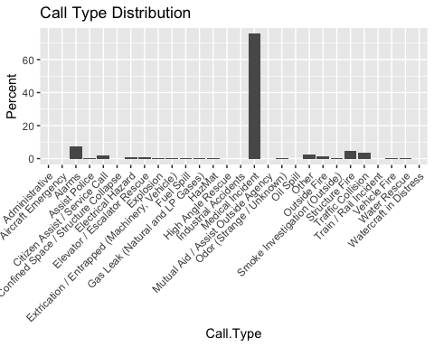

Medical incidents accounted for over 75% of responses in 2016. This is consistant with national fire department response statistics. Below is a table that more accurattly displays San Francisco Fire Department response type distrabution.

head(call_type_distribution%>%arrange(desc(Percent)),10)

## # A tibble: 10 x 2  
## Call.Type Percent  
## <fct> <dbl>  
## 1 Medical Incident 75.6   
## 2 Alarms 7.44   
## 3 Structure Fire 4.75   
## 4 Traffic Collision 3.46   
## 5 Other 2.33   
## 6 Citizen Assist / Service Call 2.17   
## 7 Outside Fire 1.64   
## 8 Elevator / Escalator Rescue 0.584  
## 9 Electrical Hazard 0.579  
## 10 Gas Leak (Natural and LP Gases) 0.447

Summary of total coll volume by neighborhood, decsending order. Neighborhoods near the city center experiance relativly higher call volumes when compaired to other areas of the city.

Neiborhood_call_volume <- data%>%group_by(Neighborhooods...Analysis.Boundaries) %>%  
 rename(nhood = Neighborhooods...Analysis.Boundaries) %>%  
 summarise(count = n_distinct(Incident.Number))  
  
Neiborhood_call_volume %>% arrange(desc(Neiborhood_call_volume$count)) %>% print(n=Inf)

## # A tibble: 42 x 2  
## nhood count  
## <fct> <int>  
## 1 Tenderloin 20440  
## 2 South of Market 15507  
## 3 Mission 13310  
## 4 Financial District/South Beach 10305  
## 5 Bayview Hunters Point 7167  
## 6 Sunset/Parkside 5161  
## 7 Western Addition 5108  
## 8 Nob Hill 4426  
## 9 Castro/Upper Market 3688  
## 10 Hayes Valley 3398  
## 11 Outer Richmond 3347  
## 12 North Beach 3121  
## 13 West of Twin Peaks 2933  
## 14 Excelsior 2825

Neiborhood_call_volume <- data%>%group_by(Neighborhooods...Analysis.Boundaries) %>%  
 rename(nhood = Neighborhooods...Analysis.Boundaries) %>%  
 summarise(count = n_distinct(Incident.Number))  
  
ggplot(data=Neiborhood_call_volume ,   
 aes(x=nhood , y=count)) +  
 geom_bar(stat="identity")+theme(axis.text.x = element_text(angle = 45,   
 hjust = 1)) +  
 ggtitle('Neighborhood Call Volume') +  
 labs(x='Neighborhood', y = 'Count')

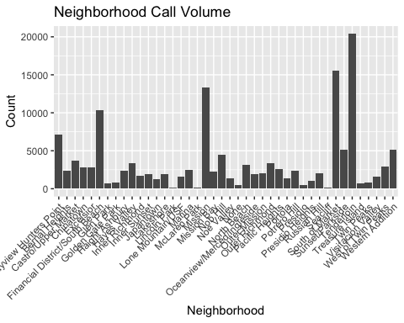

neighborhood_call_shp <- inner_join(sfn_shp,Neiborhood_call_volume)  
ggplot(neighborhood_call_shp) + geom_sf(aes(fill=count)) +  
 scale_fill_gradient(low = 'green',high = 'red' )+  
 ggtitle('Neighborhood Call Volume')

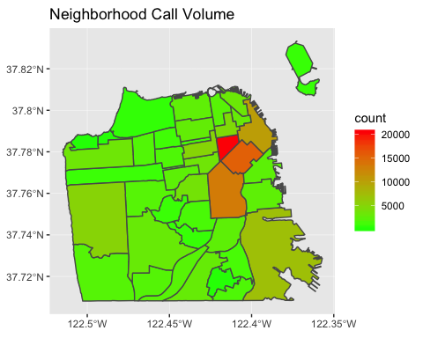

Downtown companies have consistently ranked among the busiest in the nation.

station_call_volume <- data %>%  
 group_by(Station.Area) %>%  
 summarise(count = n_distinct(Incident.Number))  
  
ggplot(data=station_call_volume , aes(x=Station.Area, y=count)) +  
 geom_bar(stat="identity")+theme(axis.text.x = element_text(angle = 45,   
 hjust = 1)) +  
 ggtitle('Station Call Volume') + labs(x = 'Station',y='Count')

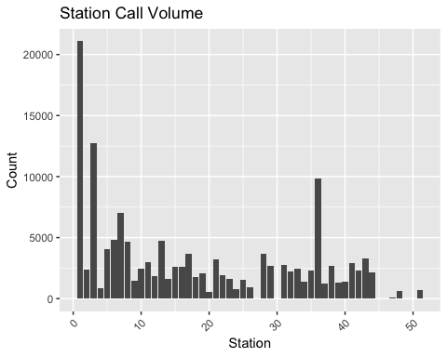

Engine, Truck and Ambulance companies form the main response contingency of the department. These units contain a diverse set of tools and capabilities, requiring specialized training. Many departmental members are cross trained and are capable of preforming essential duties on any unit.

Engine companies respond to almost every type of emergency, provide basic and advanced medical care and are typicly assisgned to fire attack operations.

Truck companies are the largest fire department apparatus, cary a vast array of specialised forcible entry tools and a large assortment of ladders needed to preform search and rescue operations.

Ambulance or “Medic” companies are staffed with Paramedics, provide medical care and transport.

engine_call_volume <- data %>% filter(Unit.Type == 'ENGINE') %>%  
 group_by(Unit.ID) %>%  
 summarise(count = n_distinct(Incident.Number))  
  
ggplot(data=engine_call_volume , aes(x=Unit.ID, y=count)) +  
 geom_bar(stat="identity")+theme(axis.text.x = element_text(angle = 45,   
 hjust = 1)) +  
 ggtitle('Engine Call Volume') + labs(x= 'Unit ID', y='Count')

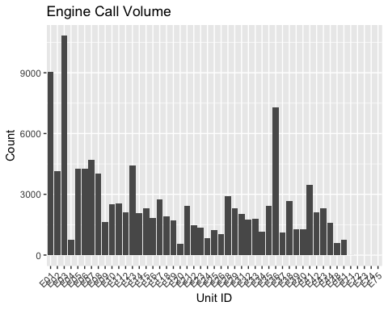

truck_call_volume <- data %>% filter(Unit.Type == 'TRUCK') %>%  
 group_by(Unit.ID) %>%  
 summarise(count = n_distinct(Incident.Number))  
  
ggplot(data=truck_call_volume , aes(x=Unit.ID, y=count)) +  
 geom_bar(stat="identity")+theme(axis.text.x = element_text(angle = 45,   
 hjust = 1)) +  
 ggtitle("Truck Call Volume") + labs(x= 'Unit ID', y='Count')

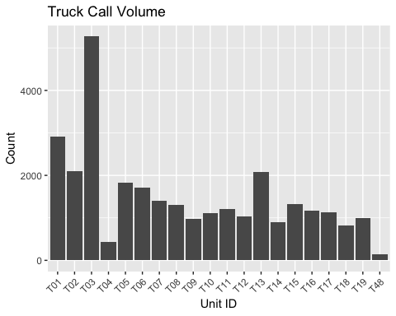

medic_call_volume <- data %>% filter(Unit.Type == 'MEDIC') %>%  
 group_by(Unit.ID) %>%  
 summarise(count = n_distinct(Incident.Number))  
  
ggplot(data=medic_call_volume , aes(x=Unit.ID, y=count)) +  
 geom_bar(stat="identity")+theme(axis.text.x = element_text(angle = 45,   
 hjust = 1)) +  
 ggtitle("Ambulance Call Volume") + labs(x= 'Unit ID', y='Count')

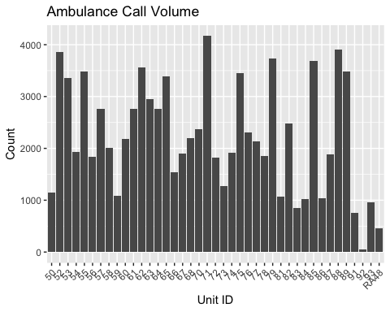

fire_volume <- data %>% rename(nhood = Neighborhooods...Analysis.Boundaries) %>%   
 filter(data$Call.Type == 'Structure Fire') %>% group_by(nhood) %>%  
 summarise(count = n_distinct(Incident.Number))  
  
  
fire_volume_shp <- inner_join(sfn_shp,fire_volume)

## Joining, by = "nhood"

## Warning: Column `nhood` joining factors with different levels, coercing to  
## character vector

ggplot(fire_volume_shp) + geom_sf(aes(fill=count)) +  
 scale_fill_gradient(low = 'green',high = 'red' )+  
 ggtitle('Fire Incidents')

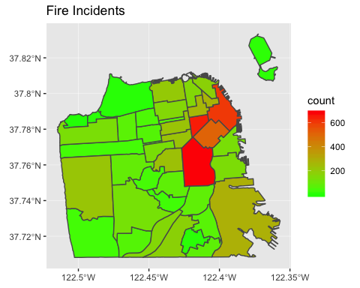

medical_volume <- data %>% rename(nhood = Neighborhooods...Analysis.Boundaries) %>%   
 filter(data$Call.Type == 'Medical Incident') %>% group_by(nhood) %>%  
 summarise(count = n_distinct(Incident.Number))  
  
medical_volume_shp <- inner_join(sfn_shp,medical_volume)

## Joining, by = "nhood"

## Warning: Column `nhood` joining factors with different levels, coercing to  
## character vector

ggplot(medical_volume_shp) + geom_sf(aes(fill=count)) +  
 scale_fill_gradient(low = 'green',high = 'red' )+  
 ggtitle('Medical Incidents')

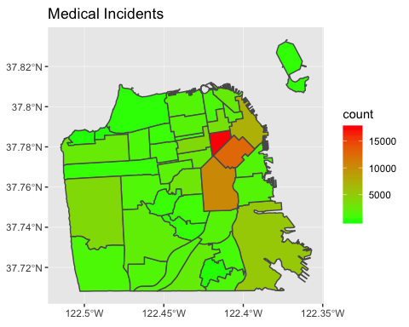

data <- separate(data, Location, into = c("long", "lat"), sep = ",")  
  
data$lat <- str_remove_all(data$lat,'[)]') %>% as.numeric(data$lat)  
data$long <- str_remove_all(data$long,'[(]') %>% as.numeric(data$long)  
data$Received.DtTm <- parse_date_time(data$Received.DtTm, '%m/%d/%Y %I:%M:%S %p')  
data$Entry.DtTm <- parse_date_time(data$Entry.DtTm, '%m/%d/%Y %I:%M:%S %p')  
data$Dispatch.DtTm <- parse_date_time(data$Dispatch.DtTm, '%m/%d/%Y %I:%M:%S %p')  
data$Response.DtTm <- parse_date_time(data$Response.DtTm, '%m/%d/%Y %I:%M:%S %p')  
data$On.Scene.DtTm <- parse_date_time(data$On.Scene.DtTm, '%m/%d/%Y %I:%M:%S %p')  
data$Transport.DtTm <- parse_date_time(data$Transport.DtTm, '%m/%d/%Y %I:%M:%S %p')  
data$Hospital.DtTm <- parse_date_time(data$Hospital.DtTm, '%m/%d/%Y %I:%M:%S %p')  
data$Available.DtTm <- parse_date_time(data$Available.DtTm, '%m/%d/%Y %I:%M:%S %p')  
data$disp_response_delta <- as.difftime(data$Response.DtTm - data$Dispatch.DtTm)  
  
code3_response_time <- data %>%   
 rename(nhood = Neighborhooods...Analysis.Boundaries) %>%   
 filter(data$Priority == '3') %>% na.omit(code3_response_time$On.Scene.DtTm)  
  
code3_response_time$response_time <- as.numeric(difftime(code3_response_time$On.Scene.DtTm,   
 code3_response_time$Response.DtTm),  
 units = 'mins')  
  
code3_response_time$hour <- hour(code3_response_time$Dispatch.DtTm)  
  
calls_by_hour <- code3_response_time %>% group_by(hour)%>%  
 summarise(count = n_distinct(Incident.Number))

Call volume increases during the dayight hours and is consistant with an increased daytime population, comprised of many outside workers.

ggplot(data=calls_by_hour , aes(x=hour, y=count)) +  
 geom_bar(stat="identity")+  
 theme(axis.text.x = element_text(angle = 45, hjust = 1)) +  
 ggtitle("Call Volume by Time of Day") + labs(x= 'Time of Day', y='Count')

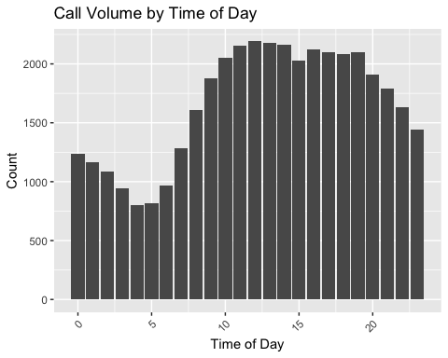

Response times also increase during the daylight hours. More investigation is required to determine weather this increase is caused by increased system demand or heavy traffic patterns during business hours.

TOD_response_time <- code3_response_time %>%  
 mutate(TOD = hour(code3_response_time$Dispatch.DtTm)) %>%   
 group_by(TOD) %>%  
 summarise(count = mean(response_time))  
scatter.smooth(TOD_response_time$TOD,TOD_response_time$count,   
main ='Average Response Time', ylab= 'Response Time (Minutes)', xlab= 'Time of Day')

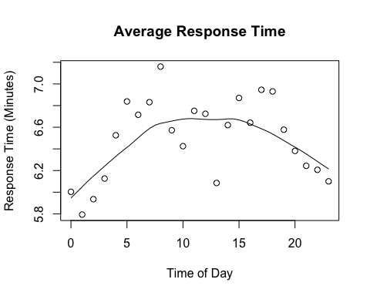

All engine companies in San Francisco can provide Basic Life Support (BLS) services and selected companies are staffed with Paramedics, providing Advanced Life Support (ALS) services.

As we can see below, average BLS response times are extremely low, averaging around 2.5 minutes. ALS engine companies are dynamicly staffed throughout the city, on a daily basis. This allows fast response from a designated location. ALS engine companies are generally assisgned a greater coverage area, which may be explain increased average response times.

Through this dynamic coverage system the department is able to provide much needed medical services while awaiting the arrival of a transport ambulance.

engine_ALS_medical_response_time <- code3_response_time %>%   
 filter(code3_response_time$Call.Type == 'Medical Incident' &   
 code3_response_time$Unit.Type == 'ENGINE' &  
 code3_response_time$ALS.Unit == 'true') %>%  
 group_by(Station.Area) %>%  
 summarise(count = mean(response_time))  
  
engine_ALS_outliers <- boxplot(engine_ALS_medical_response_time, plot=FALSE)$out  
  
engine_ALS_medical_response_time_clean <-  
 engine_ALS_medical_response_time[-which(engine_ALS_medical_response_time$count  
 %in% engine_ALS_outliers),]  
  
engine_BLS_medical_response_time <- code3_response_time %>%   
 filter(code3_response_time$Call.Type == 'Medical Incident' &   
 code3_response_time$Unit.Type == 'ENGINE' &  
 code3_response_time$ALS.Unit == 'false') %>%  
 group_by(Station.Area) %>%  
 summarise(count = mean(response_time))  
  
medic_response_time <- code3_response_time %>%   
 filter(code3_response_time$Unit.Type == 'MEDIC' &  
 code3_response_time$Call.Type == 'Medical Incident') %>%  
 group_by(Unit.ID) %>%  
 summarise(count = mean(response_time))  
  
  
boxplot(engine_BLS_medical_response_time$count,  
 engine_ALS_medical_response_time_clean$count,  
 medic_response_time$count,   
 names = c('BLS','ALS','AMBULANCE'),  
 main = 'Response Time by Unit Type',  
 ylab = 'Response (Minuets)')

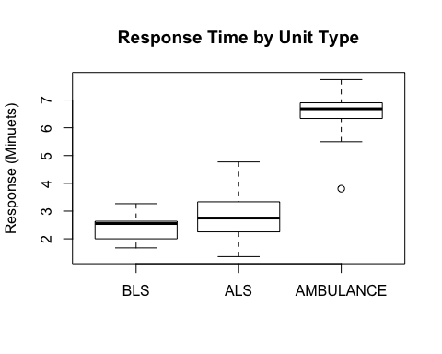

As we can see below, ambulance response times are shortest in the geographic regions where requests for service are generated more frequently.

medic_response_time_shape_prep <- code3_response_time %>%   
 filter(code3_response_time$Unit.Type == 'MEDIC' &  
 code3_response_time$Call.Type == 'Medical Incident') %>%  
 group_by(nhood) %>%  
 summarise(Minutes = mean(response_time))  
  
  
medic_response_shp <- inner_join(sfn_shp,medic_response_time_shape_prep)

## Joining, by = "nhood"

## Warning: Column `nhood` joining factors with different levels, coercing to  
## character vector

ggplot(medic_response_shp) + geom_sf(aes(fill=Minutes)) +  
 scale_fill_gradient(low = 'green',high = 'red' )+  
 ggtitle('Ambulance Response Time')

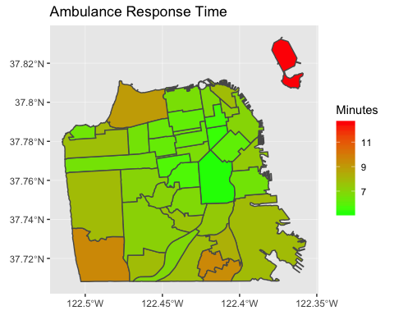

Conclusion

San Francisco Fire Deparments has built a system that can easily adapt to the required system load; The amazing men and women that comprise the department will continue to make advances toward improving departmental services.

Rasterizing the dataset may prove useful in preforming predictive analytics over space and time; Anticipating frequency and neighborhood’s where incidents are likely to occur.

Socio-economic factors should also be used in futher analysis. Finding locations that would most benifit from improved community clinics and social services, may decrease system load while providing, local neighborhood medical care. A reduction in ambulance utilization rates may cause a reduction in overall ambulance response times.