Name: Steven R. Ferrer | CS ELEC 4- Linux Essentials
Yr.&Sec: BSCS-4A

TERM-MIGHT – A User Friendly Way to Use the Terminal
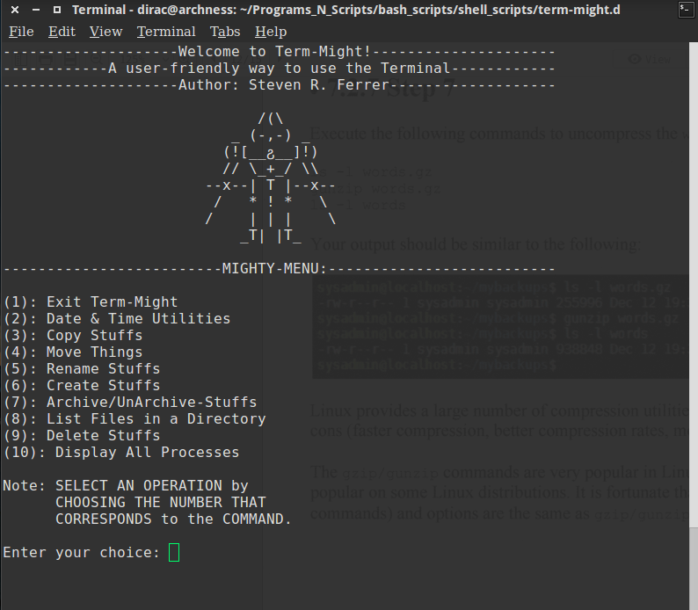

FILE STRUCTURE:
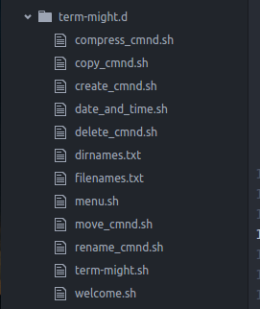

SOURCE CODE:

menu.sh

#!/bin/bash
#Displays the Menu
dispMenu(){
echo "-------------------------MIGHTY-MENU:--------------------------"
echo
echo "(1): Exit Term-Might"
echo "(2): Date & Time Utilities"
echo "(3): Copy Stuffs"
echo "(4): Move Things"
echo "(5): Rename Stuffs"
echo "(6): Create Stuffs"
echo "(7): Archive/UnArchive-Stuffs"
#echo "(8): Print Working Directory"
echo "(8): List Files in a Directory"
echo "(9): Delete Stuffs"
echo "(10): Display All Processes"
echo
echo "Note: SELECT AN OPERATION by
CHOOSING THE NUMBER THAT
CORRESPONDS to the COMMAND."
echo
}
dispMenu

welcome.sh

#!/bin/bash
#Displays the Welcome Message
dispWelcome(){
echo "--------------------Welcome to Term-Might!---------------------"
echo "------------A user-friendly way to use the Terminal------------"
echo "--------------------Author: Steven R. Ferrer-------------------"
echo
echo " /(\ "
echo " _ (-,-) _"
echo " (![__ჷ__]!) "
echo " // \_+_/ \\\\"
echo " --x--| T |--x--"
echo " / * ! * \ "
echo " / | | | \ "
echo " _T| |T_ "
echo
}
dispWelcome

rename_cmnd.sh

#!/bin/bash
clear
./welcome.sh
echo "-------------------------Rename-Stuffs-------------------------"
echo
echo " (1): Rename a directory"
echo " (2): Rename a file"
echo
echo -n "Enter your choice: "
read CHOICE
echo
if test "$CHOICE" = "1"
then
echo "Note: You must use the absolute/relative path as a complete name."
echo
echo -n "Enter the path of the directory to rename: "
read SOURCEPATH
echo -n "Enter the new name of the directory: "
read DESTPATH
mv -v $SOURCEPATH $DESTPATH
elif test "$CHOICE" = "2"
then
echo "Note: You must use the absolute/relative path as a complete name."
echo
echo -n "Enter the path of the file to rename: "
read SOURCEPATH
echo -n "Enter the new name of the file: "
read DESTPATH
mv -v $SOURCEPATH $DESTPATH
else
echo "It's not clear to me!"
fi

create_cmnd.sh

#!/bin/bash
clear
./welcome.sh
echo "-------------------------Create-Stuffs-------------------------"
echo
echo " (1): Create a directory"
echo " (2): Create directories"
echo " (3): Create an empty file"
echo " (4): Create empty files"
echo
echo -n "Enter your choice: "
read CHOICE
createDirs(){
DIRLIST=$(< $DIRNAMELIST)
for DIRNAME in $DIRLIST ; do
mkdir -v $DIRPATH/$DIRNAME
done
}
createFiles(){
FILELIST=$(< $FILENAMELIST)
for FILENAME in $FILELIST; do
touch $FILESPATH/$FILENAME.$FILEXTENTION
done
}
echo
if test "$CHOICE" = "1"
then
echo "Note: You must use the absolute/relative path as a complete name."
echo " You can pass multiple arguments."
echo
echo -n "Enter the name of the directory: "
read DIRNAME
mkdir -v $DIRNAME
echo
ls -lshd $DIRNAME
elif test "$CHOICE" = "2"
then
echo "Note: You must use the absolute/relative path as a complete name."
echo
echo -n "Enter the path to put the newly created directories: "
read DIRPATH
echo "Enter the path of a text-file that contains directory names: "
read DIRNAMELIST
createDirs $DIRPATH $DIRNAMELIST
echo
ls -lsh $DIRPATH
elif test "$CHOICE" = "3"
then
echo "Note: You must use the absolute/relative path as a complete name."
echo " You can pass multiple arguments."
echo
echo "Enter the file name of the empty file with extention: "
read FILENAME
touch $FILENAME && ls -lsh $FILENAME
elif test "$CHOICE" = "4"
then
echo "Note: You must use the absolute/relative path as a complete name."
echo
echo -n "Enter the path to put the newly created empty files: "
read FILESPATH
echo -n "Enter the path of a text-file that contains filenames: "
read FILENAMELIST
echo -n "Enter the file extention: "
read FILEXTENTION
createFiles $FILESPATH $FILENAMELIST $FILEXTENTION
echo
ls -lsh $FILESPATH
else
echo "It's not clear to me!"
fi

copy_cmnd.sh

#!/bin/bash
clear
./welcome.sh
echo "--------------------------Copy-Stuffs--------------------------"
echo
echo " (1): Copy a directory"
echo " (2): Copy a file"
echo " (3): Copy files in a directory"
echo
echo -n "Enter your choice: "
read CHOICE
echo
if test "$CHOICE" = "1"
then
echo -n "Enter the path of the directory to copy: "
read SOURCEPATH
echo -n "Enter the destination directory: "
read DESTPATH
cp -vR $SOURCEPATH $DESTPATH
elif test "$CHOICE" = "2"
then
echo -n "Enter the path of the file to copy: "
read SOURCEPATH
echo -n "Enter the destination directory: "
read DESTPATH
cp -v $SOURCEPATH $DESTPATH
elif test "$CHOICE" = "3"
then
echo -n "Enter path of files to copy: "
read SOURCEPATH
echo -n "Enter the destination directory: "
read DESTPATH
cp -v $SOURCEPATH* $DESTPATH
else
echo "It's not clear to me!"
fi
move_cmnd.sh

#!/bin/bash
clear
./welcome.sh
echo "-------------------------Move-Things---------------------------"
echo
echo " (1): Move a directory"
echo " (2): Move a file"
echo " (3): Move files"
echo
echo -n "Enter your choice: "
read CHOICE
echo
if test "$CHOICE" = "1"
then
echo -n "Enter the path of the directory to move: "
read SOURCEPATH
echo -n "Enter the destination directory: "
read DESTPATH
mv -v $SOURCEPATH $DESTPATH
elif test "$CHOICE" = "2"
then
echo "Note: You can pass multiple arguments to the command."
echo
echo -n "Enter the path of the file to move: "
read SOURCEPATH
echo -n "Enter the destination directory: "
read DESTPATH
mv -v $SOURCEPATH $DESTPATH
elif test "$CHOICE" = "3"
then
echo "Note: You can pass multiple arguments to the command."
echo
echo -n "Enter the path of files to move: "
read SOURCEPATH
echo -n "Enter the destination directory: "
read DESTPATH
mv -v $SOURCEPATH* $DESTPATH
else
echo "It's not clear to me!"
fi

term-might.sh

#!/bin/bash
readChoice(){
if test $CHOICE -eq 1 &> /dev/null
then
echo
echo "THANK YOU FOR USING TERM-MIGHT!"
echo 'GOODBYE! HAVE A NICE DAY!'
echo
exit
elif test $CHOICE -eq 2 &> /dev/null
then
#echo "You choose Date & Time"
./date_and_time.sh
elif test $CHOICE -eq 3 &> /dev/null
then
#echo "You choose Copy"
./copy_cmnd.sh
elif test $CHOICE -eq 4 &> /dev/null
then
#echo "You choose Move"
./move_cmnd.sh
elif test $CHOICE -eq 5 &> /dev/null
then
#echo "You choose Rename"
./rename_cmnd.sh
elif test $CHOICE -eq 6 &> /dev/null
then
#echo "You choose Create"
./create_cmnd.sh
elif test $CHOICE -eq 7 &> /dev/null
then
#echo "You choose Compress/Archive"
./compress_cmnd.sh
elif test $CHOICE -eq 8 &> /dev/null
then
#echo "You choose List Files in Current Directory"
clear
./welcome.sh
echo "--------------------List-Files-in-a-Directory------------------"
echo
echo -n "Enter the path of the directory: "
read LISTDIR
ls -lsh $LISTDIR
elif test $CHOICE -eq 9 &> /dev/null
then
clear
./delete_cmnd.sh
elif test $CHOICE -eq 10 &> /dev/null
then
#echo "You choose Display All Processes"
top #displays processes
else
#cathes any garbage inputs
echo "I think that's is not in the list of choices."
CHOICE=0 #sets the CHOICE back to 0 to continue the program
fi
}
CHOICE=0; #will contain the choice of the user
while [ $CHOICE -ge 0 -a $CHOICE -le 10 ] ;
do
clear #clears the screen to remove clutters
./welcome.sh
./menu.sh #runs the ter-might-menu.sh script which displays menu
#get the number of choice
echo -n "Enter your choice: "
read CHOICE

echo
readChoice $CHOICE;
echo
echo "Press ENTER to continue or type CTRL-C to exit"
read NOTHING
done

compress_cmnd.sh

#!/bin/bash
clear
./welcome.sh
echo "-------------------Archive/UnArchive-Stuffs------------------"
echo
echo " (1): Archive a directory using tar utility"
echo " (2): Archive a directory using zip utility"
echo " (3): Archive lists of files using zip utility"
echo " (4): UnArchive using tar utility"
echo " (5): UnArchive using unzip utility"
echo
echo -n "Enter your choice: "
read CHOICE
echo
if test "$CHOICE" = "1"
then
echo "Note: You must use the absolute/relative path as a complete name."
echo
echo -n "Enter the name of the directory to archive: "
read DIRNAME
echo -n "Enter the name of the tar file: "
read TARFILE
echo
tar cvfz "$TARFILE.tgz" $DIRNAME
echo
echo "Your archive file: " && ls -lsh $TARFILE.tgz
elif test "$CHOICE" = "2"
then
echo "Note: You must use the absolute/relative path as a complete name."
echo " This will preserve the structure of the director passed."
echo
echo -n "Enter the name of the directory to archive: "
read DIRPATH
echo -n "Enter the name of the zip file: "
read ZIPFILE
echo
zip -r "$ZIPFILE.zip" $DIRPATH
echo
echo "Your compressed file: " && ls -lsh $ZIPFILE.zip
elif test "$CHOICE" = "3"
then
echo "Note: You must use the absolute/relative path as a complete name."
echo " This will preserve the structure of the director passed."
echo
echo -n "Enter the list of files to archive: "
read FILELIST
echo -n "Enter the name of the zip file: "
read ZIPFILE
echo
zip -r "$ZIPFILE.zip" $FILELIST
echo
echo "Your compressed file: " && ls -lsh $ZIPFILE.zip
elif test "$CHOICE" = "4"
then
echo "Note: You must use the absolute/relative path as a complete name."
echo
echo -n "Enter the filename of the tar file: "
read TARFILE
echo -n "Enter the path to put the extrated files: "
read EXTRACTDIR
tar xzvf $TARFILE -C $EXTRACTDIR
echo
ls -lsh $EXTRACTDIR
elif test "$CHOICE" = "5"
then
echo "Note: You must use the absolute/relative path as a complete name."
echo
echo -n "Enter the filename of the zip file: "
read ZIPFILE
echo -n "Enter the path to put the extrated files: "
read EXTRACTDIR
echo
unzip $ZIPFILE -d $EXTRACTDIR
echo
ls -lsh $EXTRACTDIR
else
echo "It's not clear to me!"
fi

delete_cmnd.sh

#!/bin/bash
clear
./welcome.sh
echo "-------------------------Delete-Stuffs-------------------------"
echo
echo " (1): Delete a directory"
echo " (2): Delete file/s"
echo
echo -n "Enter your choice: "
read CHOICE
echo
if test "$CHOICE" = "1"
then
echo "Note: You must use the absolute/relative path as a complete name."
echo "Warning: Pass a star (*) at your own risk."
echo " This will delete all the files under the specified directory"
echo
echo -n "Enter the path of the directory to delete: "
read DIRPATH
rm -vR $DIRPATH
elif test "$CHOICE" = "2"
then
echo "Note: You must use the absolute/relative path as a complete name."
echo "Warning: Pass a star (*) at your own risk."
echo " You can pass multiple arguments."
echo
echo -n "Enter the path of the file/s to delete: "
read FILES
rm -v $FILES
else
echo "It's not clear to me!"
fi

date_and_time.sh

#!/bin/bash
clear
./welcome.sh
echo "---------------------Date-and-Time-Utilities-------------------"
echo
echo " (1): Display this month's calendar, date and time"
echo " (2): Display this year's calendar"
echo
echo -n "Enter your choice: "
read CHOICE
echo
if test "$CHOICE" = "1"
then
cal
echo "Today is $(date +%A), $(date +%B%e,\ %G)"
echo "It is now $(date +%H:%M:%S)"
elif test "$CHOICE" = "2"
then
cal -y
else
echo "It's not clear to me!"
fi

