ACPOS
WB-01 儀表板
Mother Basic Design / 科技紫 UI 重建
workspace:WB-01
Design Candidate • Current Authority Bound • Real-Data-Only

交付狀態
本文件為 Basic Design + Visual Candidate。尚未取得 Human Visual Approval，因此 DESIGN_FROZEN = FALSE；不得把本文件視為已施工或已升格為 Current Canonical Visual。
GitHub Current 基準：new @ 165c6440cb53b1b45ec96905241fb4d56dc3b867
Page Authority：ACPOS_WB-01_FINAL_LOCKED_ENCODING.yaml @ 49239a0af6cbee94b2b3f8821c0110859f372458

1. Current Truth / Authority Provenance
層級 | Current Owner / Ref | 本文件用途
Repository | steven-gold/orange-one-ai-viedo-v1.0 / branch new / HEAD 165c644… | 頁面與 Authority 的 Current Truth 基準
Authority Manifest | ACPOS_CURRENT_AUTHORITY_MANIFEST_FINAL_LOCKED @ V1.8 | 只允許 manifest 列出的 Current Authority
Page Authority | workspace:WB-01 / ACPOS_WB-01_FINAL_LOCKED_ENCODING | WB-01 實際內容、14 sections、14 controls、layout、state、render schema
Global Shell | GLOBAL_HOME_SHELL_TEMPLATE_AUTHORITY @ V1.9 | 58px 全寬 Header、64/221px 自動伸縮左側導覽、workspace origin x=78px
Global Visual | GLOBAL_WEB_VISUAL_SYSTEM_AUTHORITY @ V1.0 | 科技紫 tokens、button/input/panel/state semantics
Mother Basic Design | 01_BLUEPRINT_DESIGN_GOVERNANCE：S012–S039、S040C、S040E、S071–S072 | Basic Design artifact denominator、Visual Preview/Review/Freeze、Workbench/Topology
Current-only 規則
Supplemental concept 不得反向覆蓋 GitHub Current Authority；任何新增設計若超出 Current Authority，必須以 Change Set / Authority Gap 明確標示，不能偽裝成現有功能。

2. Mother Basic Design Compliance Matrix
Mother Gate | 必填內容 | 落點
S012 Requirement Gate | Project Scope / Goal / User / Functional & Non-functional / Role / OOS / Glossary | 本文件 §3
S013 Architecture Gate | Architecture / Module / Dependency / Navigation / User Flow / State / Data / FE-BE boundary | 本文件 §4, §5
S015 Page Registry | Page UID / Name / Route / Purpose / Permission / Owners / Visual & Implementation Status | 本文件 §4
S016–S018 Design/Layout/Grid | Tokens / Header / Nav / Grid / Span / Responsive / Collapse | 本文件 §6
S020 Page Design | Sections / Components / Controls / Fields / Assets / Dimensions / States / i18n / Anchors | 本文件 §6–§12
S021–S023 Section/Control/Field | Exact UID / geometry / state / permission / action / data binding | 本文件 §8–§10
S027–S033 Visual Governance | Generation Manifest / Preview / Candidate / Anchor / Drift | 本文件 §7, §13
S034–S037 Audit / Freeze | Audit Baseline / Acceptance / DoD / Freeze Package | 本文件 §14–§16
S040C Functional Chain | Intent → Trigger → Gate → Permission → Action → API → Response → UI/Recovery | 本文件 §5, §11
S040E Visual Geometry | Exact width/height/grid/anchor/locked region | 本文件 §6, §13
S071 Entity × Operation | Entity lifecycle applicability with explicit N/A evidence | 本文件 §4
S072 Workbench / Topology | Functional Workbench Contract + Interaction Topology Matrix | 本文件 §5

3. Requirement Definition
項目 | WB-01 定義
Project Scope | 全公司首頁總覽 / CompanyDashboardProjection；唯讀，不承擔各部門深層操作。
Business Goal | 讓授權使用者以一頁取得公司專案、進度、待處理/待審、生產、通知、公告、AI/產業新聞、系統狀態、近期完成之摘要。
Target User | 具 workspace.dashboard.view 且通過 page/section/control/scope/classification gate 的帳戶。
Functional Requirement | 14 個 canonical sections；每 section 唯一可見觸發面為卡片 Header 右側「查看」；Drawer 只顯示該 section render schema。
Non-functional | Desktop-first；>=1440 12-column；1280–1439 固定重排；<1280 保持 min-width=1280 horizontal scroll；Real-data-only。
Role / Permission | Account-permission assignment only；禁止 role-name authorization。
Out of Scope | 新增/編輯/刪除/批准/鎖定/發布、Provider Health、Correction Rate、財務/成本、搜尋/篩選/排序/分頁、自動輪詢、外部新聞連結。
Glossary | Section Open = 同一 registered READ_ONLY operation；Drawer = 對應 section 的 read projection；Missing value = —。

4. Architecture / Page Registry / Entity × Operation
欄位 | 值
Page UID | workspace:WB-01
Canonical Name | WB-01 / Dashboard
Display Name | 儀表板
Surface | WORKSPACE
Owner | CompanyDashboardProjection
Layout | dashboard_shell
Permission | workspace.dashboard.view
Business Write Actions | 0
Implementation Status | Current implementation exists; this document is redesign candidate only
Visual Status | VISUAL_CANDIDATE / PENDING HUMAN REVIEW
Business Entity Applicability（Mother S071）
Entity | Operation | Applicability | Authority Evidence
CompanyDashboardProjection | DISCOVER_OR_LIST | REQUIRED | READ_ONLY dashboard projection / SECTION_OPEN / audited UI interaction / same control re-invocation / return to destination page
CompanyDashboardProjection | SELECT_OR_OPEN | REQUIRED | READ_ONLY dashboard projection / SECTION_OPEN / audited UI interaction / same control re-invocation / return to destination page
CompanyDashboardProjection | CREATE | NOT_APPLICABLE | WB-01 Authority: workflow=READ_ONLY, state_transition=NONE, expected_business_write_actions=0
CompanyDashboardProjection | EDIT | NOT_APPLICABLE | WB-01 Authority: workflow=READ_ONLY, state_transition=NONE, expected_business_write_actions=0
CompanyDashboardProjection | SAVE | NOT_APPLICABLE | WB-01 Authority: workflow=READ_ONLY, state_transition=NONE, expected_business_write_actions=0
CompanyDashboardProjection | VALIDATE | NOT_APPLICABLE | WB-01 Authority: workflow=READ_ONLY, state_transition=NONE, expected_business_write_actions=0
CompanyDashboardProjection | CONFIRM_OR_APPROVE | NOT_APPLICABLE | WB-01 Authority: workflow=READ_ONLY, state_transition=NONE, expected_business_write_actions=0
CompanyDashboardProjection | VERSION | NOT_APPLICABLE | WB-01 Authority: workflow=READ_ONLY, state_transition=NONE, expected_business_write_actions=0
CompanyDashboardProjection | LOCK_OR_UNLOCK | NOT_APPLICABLE | WB-01 Authority: workflow=READ_ONLY, state_transition=NONE, expected_business_write_actions=0
CompanyDashboardProjection | ARCHIVE_OR_DELETE | NOT_APPLICABLE | WB-01 Authority: workflow=READ_ONLY, state_transition=NONE, expected_business_write_actions=0
CompanyDashboardProjection | RESTORE | NOT_APPLICABLE | WB-01 Authority: workflow=READ_ONLY, state_transition=NONE, expected_business_write_actions=0
CompanyDashboardProjection | AUDIT | REQUIRED | READ_ONLY dashboard projection / SECTION_OPEN / audited UI interaction / same control re-invocation / return to destination page
CompanyDashboardProjection | ERROR_RECOVERY | REQUIRED | READ_ONLY dashboard projection / SECTION_OPEN / audited UI interaction / same control re-invocation / return to destination page
CompanyDashboardProjection | NEXT_STEP | REQUIRED | READ_ONLY dashboard projection / SECTION_OPEN / audited UI interaction / same control re-invocation / return to destination page

5. Functional Workbench / Interaction Topology / Functional Chain
Contract Item | Definition
Functional Cluster UID | WB-01-FWC-DASHBOARD-READ-01
Business Journey | 進入儀表板 → 讀取授權 Projection → 掃描 14 個摘要 → 需要細節時按該 section「查看」→ Drawer 檢視 → 關閉 / 導向對應部門頁
Workbench Class | ATOMIC_WORKBENCH（單一 Dashboard Main Workspace）；Drawer = SAME_SURFACE_CLUSTER
Shared Context Identity | account/session + page_uid=workspace:WB-01 + read_model_version + correlation_id
Required Operation Order | Page read → render visible sections → section open → drawer read/refresh → close
Adjacency Rule | 同 group sections 必須維持 canonical row group；不得插入無關 panel 破壞 6 KPI / 8+4 / 8+4 / 4+4+4 / 12 topology。
Forbidden Interruptions | 新增 quick action、analytics chart、Provider card、搜索/篩選、AI chat、approval block。
Responsive Reflow | 僅依 Authority 的 1440 / 1280–1439 / <1280 規則；不得重新定義 mobile workflow。
Interaction Topology Matrix
Seq | Operation | Surface | Context Continuity | Recovery
1 | GET /v1/dashboard/read-model | Main Workspace | session + page + permission + scope | ERROR → same registered read re-invocation
2 | Render authorized 14 sections | Main Workspace | read_model_version | permission denied → hidden; missing → —
3 | SECTION_OPEN | Card header trailing 查看 | section UID + same page context | LOADING / ERROR preserves geometry
4 | Drawer projection | Right Drawer | section schema + correlation_id | Close / Escape / backdrop; no new retry control
5 | Next destination | Registered navigation only | explicit destination context handoff | No external link / no invented route
Functional Chain
READ_ONLY Chain
Business Intent → identity/page permission → page entry → GET read model → section/field visibility gate → render schema validation → response → card projection → optional SECTION_OPEN → Drawer projection → audit/correlation → close / registered next destination。沒有 API write、runtime mutation 或 business state transition。

6. Page Design System / Layout / Geometry
Token / Geometry | Current Definition
Theme | Dark purple enterprise AI production workstation
Page BG | #050816 / #080C20
Surface | #0C1026 / #111936
Primary Purple | #8B5CFF
Secondary Purple | #6E35FF
Highlight | #B38CFF
Header | 58px fixed / full width / 0 radius
Sidebar | 64px transparent hit rail collapsed; 221px overlay expanded; no workspace reflow
Workspace | origin x=78px / y=68px / right=16px / bottom=16px
Grid | 12 columns / 16px gap / 16px content padding
Panel | 12px radius / 16px padding / 40px header / 40px view control
Breakpoints | >=1440 exact 6×KPI row; 1280–1439 3+3 KPI; <1280 fixed min-width=1280 horizontal scroll
User-confirmed visual direction
本次視覺不改變 Current topology，只把既有 Global Visual 紫色 Token 完整落地：全寬頂部 Header、左側 Auto-collapse/overlay 導覽、工作區高資訊密度卡片。

7. Actual UI Visual Candidate — Collapsed Main State
主畫面只顯示 9 個 canonical nav icons；221px expanded surface 不得同時存在。所有 business values 未取得 Current data 時顯示 — / 目前無資料。
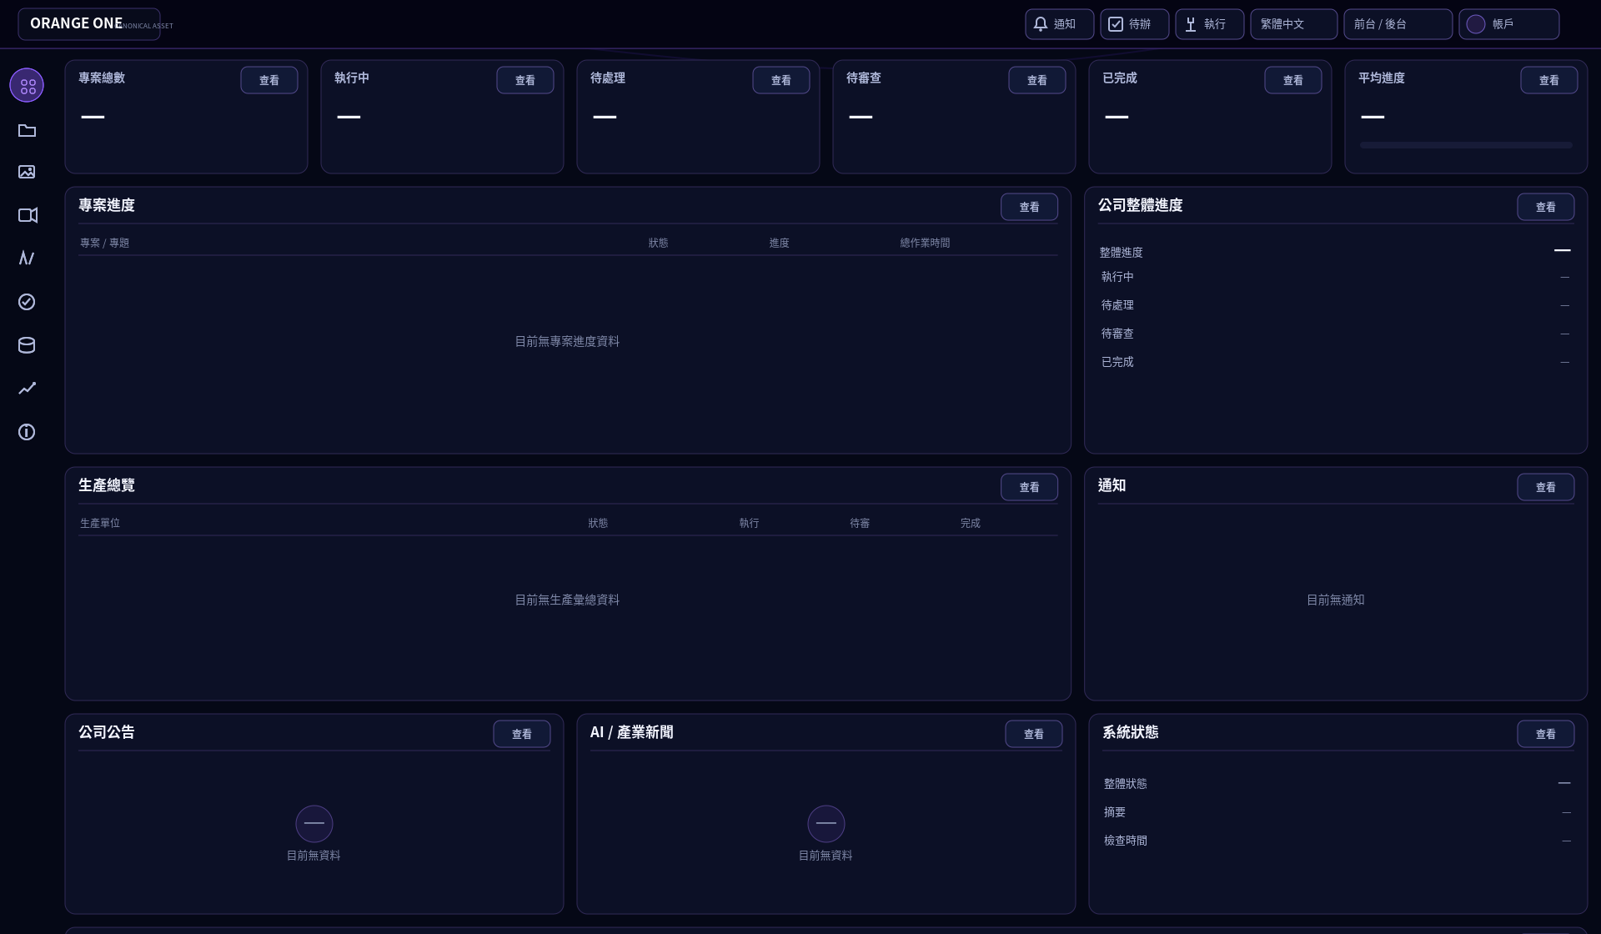
Figure WB01-VIS-CANDIDATE-A • 1920px reference viewport • Collapsed sidebar

7.1 Actual UI Visual Candidate — Expanded Navigation Overlay
Pointer enter / keyboard focusin 時才出現 221px overlay；workspace x=78px 不變，不縮排、不 reflow。
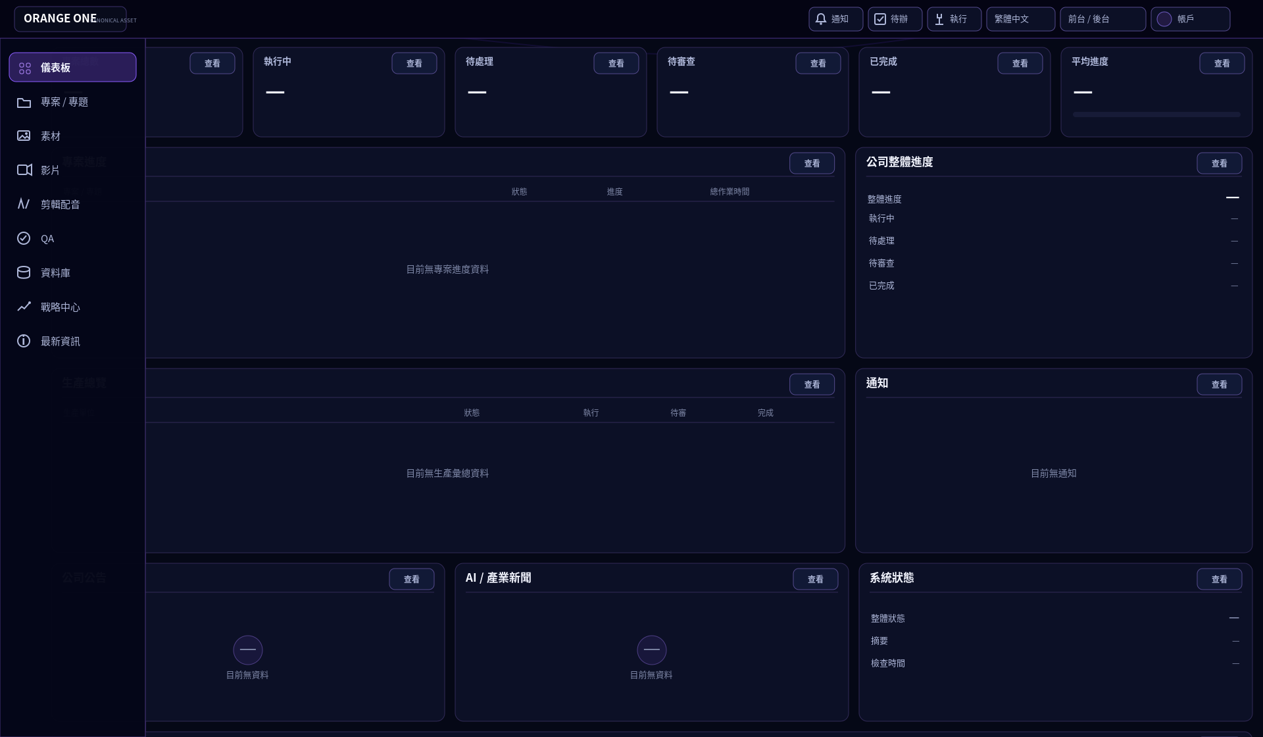
Figure WB01-VIS-CANDIDATE-B • Expanded overlay state

7.2 Actual UI Visual Candidate — Lower Workspace
向下捲動後仍保留 fixed Header / collapsed icon rail；資訊區與近期完成依 canonical row group 呈現。
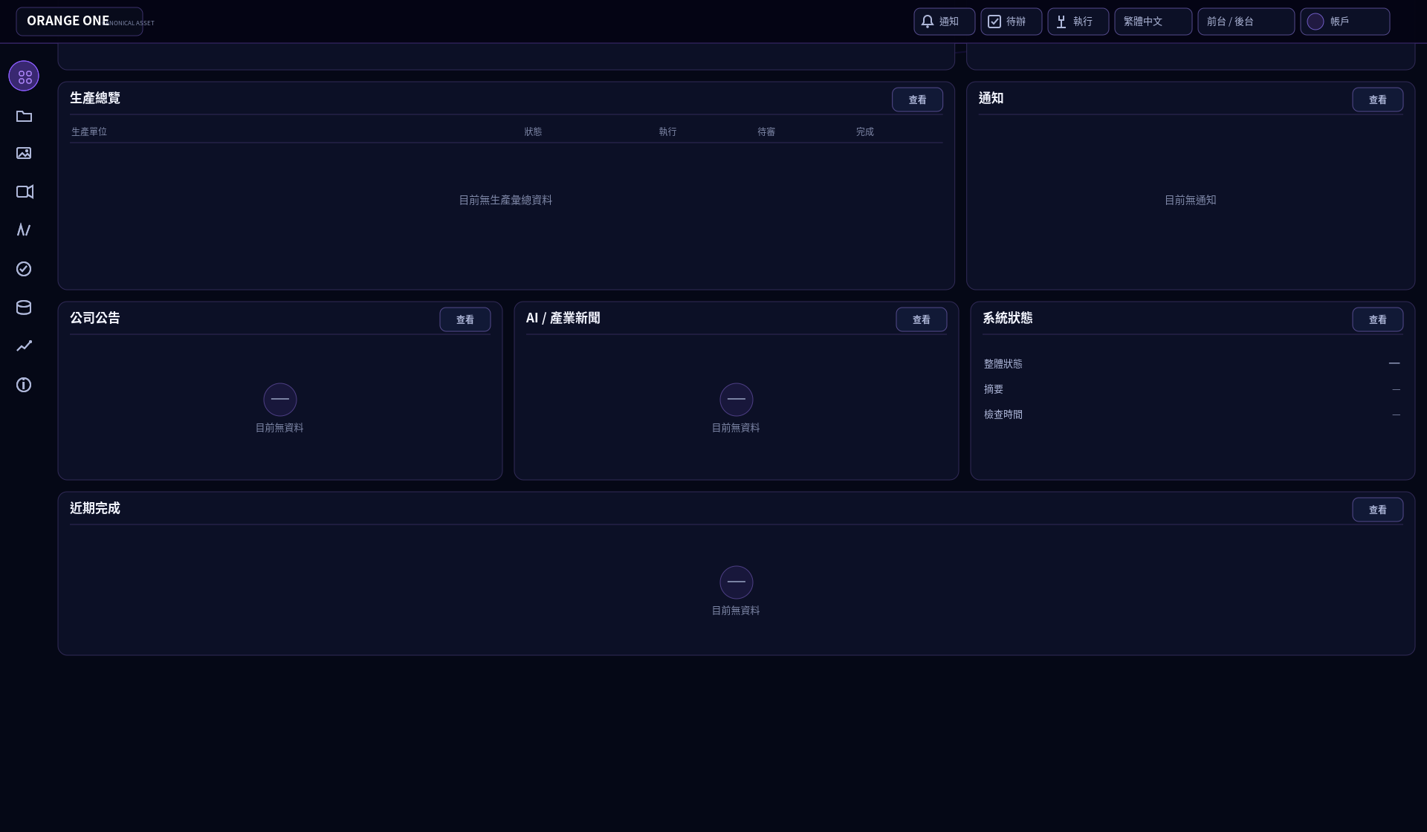
Figure WB01-VIS-CANDIDATE-C • Scroll continuation

7.3 Actual UI Visual Candidate — Drawer Interaction
每個 section 唯一觸發點為 Header 右側「查看」；Drawer 只呈現對應 render schema 與 read-model metadata，不暴露其他 department payload。
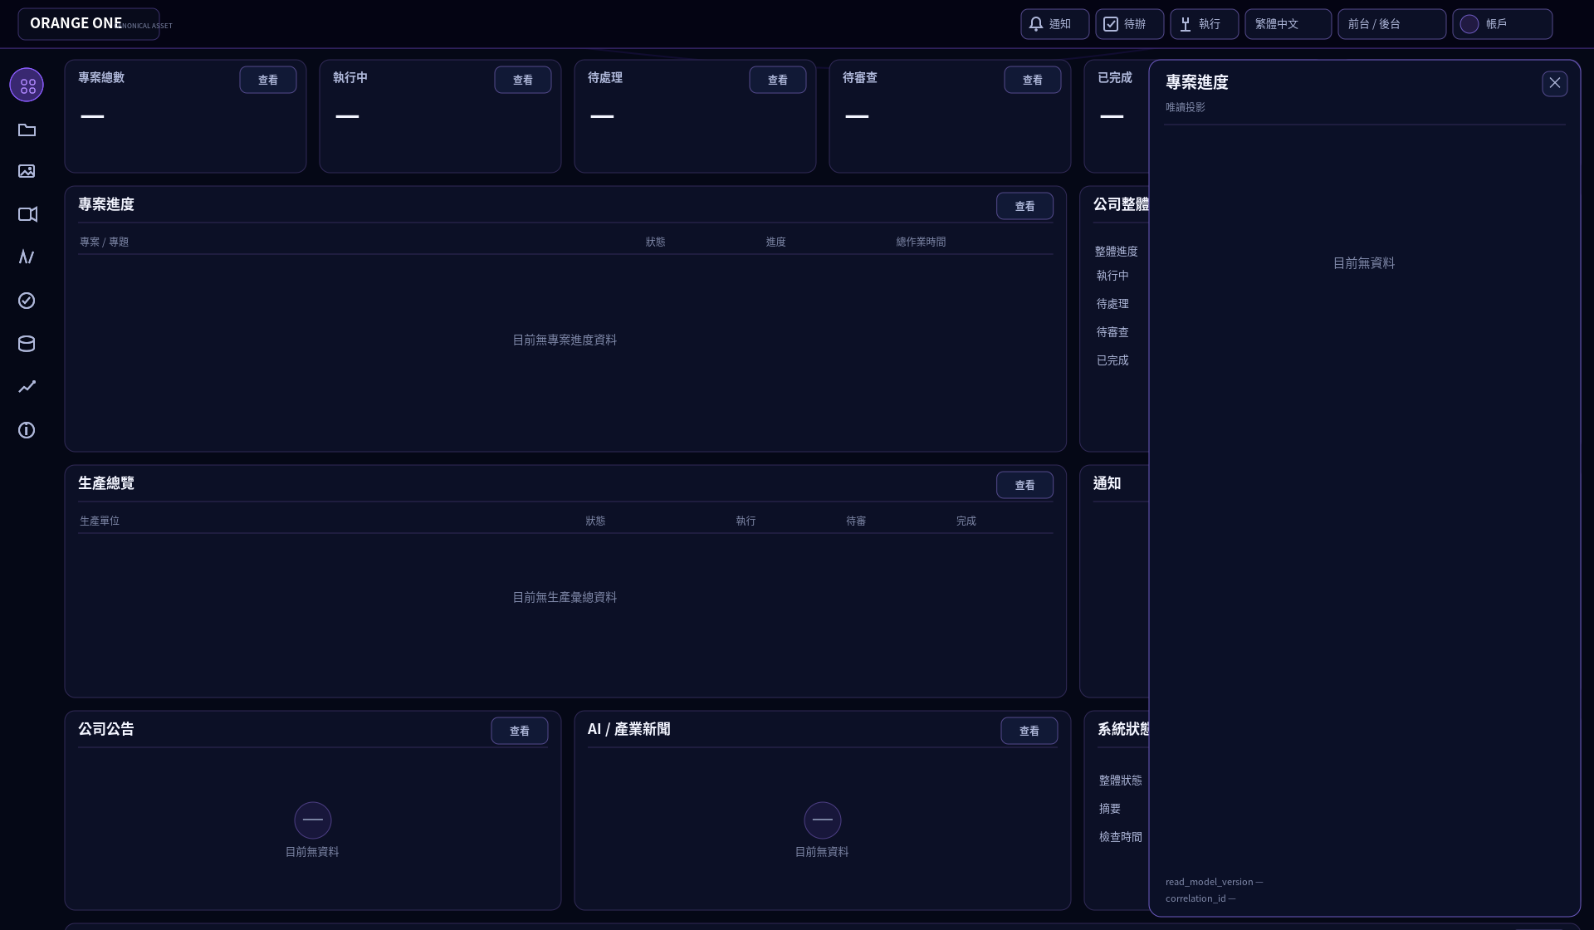
Figure WB01-VIS-CANDIDATE-D • Section projection drawer

8. Section / Component / Geometry Mapping
# | Section | Component UID | Row Group | >=1440 | Height
1 | 專案總數 | WB-01-CMP-KPI-PROJECT-COUNT | kpi | span 2 | 136px
2 | 執行中 | WB-01-CMP-KPI-RUNNING | kpi | span 2 | 136px
3 | 待處理 | WB-01-CMP-KPI-PENDING-ACTION | kpi | span 2 | 136px
4 | 待審查 | WB-01-CMP-KPI-PENDING-REVIEW | kpi | span 2 | 136px
5 | 已完成 | WB-01-CMP-KPI-COMPLETED | kpi | span 2 | 136px
6 | 平均進度 | WB-01-CMP-KPI-AVERAGE-PROGRESS | kpi | span 2 | 136px
7 | 專案進度 | WB-01-CMP-PROJECT-PROGRESS | progress | span 8 | 320px
8 | 公司整體進度 | WB-01-CMP-COMPANY-PROGRESS | progress | span 4 | 320px
9 | 生產總覽 | WB-01-CMP-PRODUCTION-SUMMARY | production | span 8 | 280px
10 | 通知 | WB-01-CMP-NOTIFICATIONS | production | span 4 | 280px
11 | 公司公告 | WB-01-CMP-ANNOUNCEMENTS | information | span 4 | 240px
12 | AI / 產業新聞 | WB-01-CMP-INDUSTRY-NEWS | information | span 4 | 240px
13 | 系統狀態 | WB-01-CMP-SYSTEM-STATUS | information | span 4 | 240px
14 | 近期完成 | WB-01-CMP-RECENT-COMPLETIONS | recent | span 12 | 220px
Canonical order 不得因視覺方便重排；同 row group 的 visible authorized sections 左到右 pack，但不得跨 group 或拉伸填補 denied sibling。

9. Control / Field / Action / Gate / Permission Mapping
Section | Field UID | Compact Alias (Non-Control) | Action / Operation | Permission
專案總數 | FIELD-…COMPANY-PROJECT-COUNT | CTRL-…COMPANY-PROJECT-COUNT-OPEN | getDashboardReadModel | workspace.dashboard.view
執行中 | FIELD-…COMPANY-RUNNING-PROJECT-COUNT | CTRL-…COMPANY-RUNNING-PROJECT-COUNT-OPEN | getDashboardReadModel | workspace.dashboard.view
待處理 | FIELD-…COMPANY-PENDING-ACTION-COUNT | CTRL-…COMPANY-PENDING-ACTION-COUNT-OPEN | getDashboardReadModel | workspace.dashboard.view
待審查 | FIELD-…COMPANY-PENDING-REVIEW-COUNT | CTRL-…COMPANY-PENDING-REVIEW-COUNT-OPEN | getDashboardReadModel | workspace.dashboard.view
已完成 | FIELD-…COMPANY-COMPLETED-PROJECT-COUNT | CTRL-…COMPANY-COMPLETED-PROJECT-COUNT-OPEN | getDashboardReadModel | workspace.dashboard.view
平均進度 | FIELD-…COMPANY-AVERAGE-PROGRESS | CTRL-…COMPANY-AVERAGE-PROGRESS-OPEN | getDashboardReadModel | workspace.dashboard.view
專案進度 | FIELD-…PROJECT-PROGRESS-OVERVIEW | CTRL-…PROJECT-PROGRESS-OVERVIEW-OPEN | getDashboardReadModel | workspace.dashboard.view
公司整體進度 | FIELD-…COMPANY-PROGRESS-SUMMARY | CTRL-…COMPANY-PROGRESS-SUMMARY-OPEN | getDashboardReadModel | workspace.dashboard.view
生產總覽 | FIELD-…PRODUCTION-SUMMARY | CTRL-…PRODUCTION-SUMMARY-OPEN | getDashboardReadModel | workspace.dashboard.view
通知 | FIELD-…NOTIFICATIONS | CTRL-…NOTIFICATIONS-OPEN | getDashboardReadModel | workspace.dashboard.view
公司公告 | FIELD-…COMPANY-ANNOUNCEMENTS | CTRL-…COMPANY-ANNOUNCEMENTS-OPEN | getDashboardReadModel | workspace.dashboard.view
AI / 產業新聞 | FIELD-…INDUSTRY-NEWS | CTRL-…INDUSTRY-NEWS-OPEN | getDashboardReadModel | workspace.dashboard.view
系統狀態 | FIELD-…SYSTEM-STATUS-SUMMARY | CTRL-…SYSTEM-STATUS-SUMMARY-OPEN | getDashboardReadModel | workspace.dashboard.view
近期完成 | FIELD-…RECENT-COMPLETIONS | CTRL-…RECENT-COMPLETIONS-OPEN | getDashboardReadModel | workspace.dashboard.view
Control exactness
14/14 controls 全部都是 SECTION_OPEN / READ_ONLY；visible trigger = 卡片 Header trailing「查看」。Card body 與 list rows 不可 clickable。不存在 Create / Edit / Delete / Approve / Publish control。

10. Data Binding / Render Schema
Section | Type | Data Binding | Render Schema UID
專案總數 | integer | company_project_count.company_project_count | WB-01-SCHEMA-KPI-INTEGER-01
執行中 | integer | company_running_project_count.company_running_project_count | WB-01-SCHEMA-KPI-INTEGER-02
待處理 | integer | company_pending_action_count.company_pending_action_count | WB-01-SCHEMA-KPI-INTEGER-03
待審查 | integer | company_pending_review_count.company_pending_review_count | WB-01-SCHEMA-KPI-INTEGER-04
已完成 | integer | company_completed_project_count.company_completed_project_count | WB-01-SCHEMA-KPI-INTEGER-05
平均進度 | percentage | company_average_progress.company_average_progress | WB-01-SCHEMA-KPI-PERCENT-01
專案進度 | read_model_object | project_progress_overview.project_progress_overview | WB-01-SCHEMA-PROJECT-TOPIC-TASK-01
公司整體進度 | read_model_object | company_progress_summary.company_progress_summary | WB-01-SCHEMA-COMPANY-PROGRESS-01
生產總覽 | read_model_object | production_summary.production_summary | WB-01-SCHEMA-PRODUCTION-SUMMARY-01
通知 | read_model_object | notifications.notifications | WB-01-SCHEMA-NOTIFICATIONS-01
公司公告 | read_model_object | company_announcements.company_announcements | WB-01-SCHEMA-ANNOUNCEMENTS-01
AI / 產業新聞 | read_model_object | industry_news.industry_news | WB-01-SCHEMA-INDUSTRY-NEWS-01
系統狀態 | read_model_object | system_status_summary.system_status_summary | WB-01-SCHEMA-SYSTEM-STATUS-01
近期完成 | read_model_object | recent_completions.recent_completions | WB-01-SCHEMA-RECENT-COMPLETIONS-01
- Missing value = —；Loading 不得暫時顯示 0。
- Project Progress：API response order only；Topic total_operation_time_seconds → HHH:MM:SS；null → —；不得 client-side 計算。
- Production Summary：只顯示 company-level aggregate；不得顯示 provider/model/secret/job payload。
- Industry News：沒有 registered external-navigation action，所以 row 不可直接開外部連結。
- System Status：只顯示 overall_status / summary / checked_at；不得擴充 health percentage、provider health、finance 或 secret。

11. State / Recovery / Error Contract
State | UI Behavior | Recovery
LOADING | exact card geometry skeleton；不顯示 fake value | read 成功→READ_ONLY / EMPTY；失敗→ERROR
EMPTY | 保留 geometry；— / 目前無資料；無 mock rows | 使用既有「查看」重新讀取或重新進入 page
ERROR | 保留 geometry；顯示實際允許 reason | 不得建立 Retry button；只能 re-invoke same SECTION_OPEN
POLICY_BLOCKED | permission denied = HIDDEN；可揭露 policy block 才顯示 reason | 重新授權後重新進入 / registered read
VERSION_CONFLICT | stale/conflict read-only status | same read control 再讀取
REVIEW_REQUIRED | 只顯示後端返回的 review status/count | 不得 approve
EXTERNAL_PENDING | 只顯示 Pending | 不得 local promote Completed
READ_ONLY | 正常 loaded mode | 無 write control
ARCHIVED | 只有 read model 返回 Archived 才顯示 | 不得當 current

12. Function ↔ Visual Traceability
Visual Unit | Function | Geometry | Authority
Global Header | Shell: Notification / To-do / Running / Language / Surface Switch / Account | 58px full-width fixed header | GHS Shell V1.9
Collapsed Nav | 9 L1 icons only | 64px transparent interaction rail | GHS Shell V1.9
Expanded Nav | same 9 L1 + labels | 221px overlay, no reflow | GHS Shell V1.9
KPI 1–6 | 6 canonical read-only KPI | single row >=1440; 3+3 at 1280–1439 | WB-01 layout + schema
Progress row | Project Progress + Company Progress | 8/4 span | WB-01 canonical sections 7–8
Production row | Production Summary + Notifications | 8/4 span | WB-01 canonical sections 9–10
Information row | Announcements + AI/Industry News + System Status | 4/4/4 span | WB-01 canonical sections 11–13
Recent row | Recent Completions | 12 span | WB-01 canonical section 14
Drawer | section projection only | 520px right drawer default | Global Visual + WB-01 Drawer contract

13. Visual Anchors / Locked Regions / Generation Manifest
Anchor UID | Position / Dimension Rule | Lock
WB-01-ANCHOR-HEADER | top=0; h=58; width=100% | LOCKED
WB-01-ANCHOR-NAV-RAIL | left=0; top=58; collapsed hit rail=64; expanded overlay=221 | LOCKED
WB-01-ANCHOR-WORKSPACE | x=78; y=68; right=16; bottom=16; no reflow | LOCKED
WB-01-ANCHOR-KPI-GROUP | first row group; 6×span2 >=1440 | LOCKED
WB-01-ANCHOR-PROGRESS | row 2; 8/4 | LOCKED
WB-01-ANCHOR-PRODUCTION | row 3; 8/4 | LOCKED
WB-01-ANCHOR-INFORMATION | row 4; 4/4/4 | LOCKED
WB-01-ANCHOR-RECENT | row 5; span12 | LOCKED
Visual Generation Manifest
Field | Value
Generation UID | WB-01-GEN-20260920-TECHPURPLE-01
Page UID | workspace:WB-01
Design Version | DESIGN-CANDIDATE-2026-09-20.1
Reference Visual UID | Current WB-01 Authority / no candidate promoted
Design System | GLOBAL_WEB_VISUAL_SYSTEM_AUTHORITY@V1.0
Layout UID | dashboard_shell / Global Shell V1.9
Viewport | 1920 reference; exact layout contracts >=1440 / 1280–1439 / <1280
Language | zh-TW
Theme | dark-purple / Current token set
Change Level | LEVEL_4_PAGE_REDESIGN visual candidate
Locked Areas | Header geometry, nav topology, grid group order, 14 canonical sections/controls, real-data-only semantics
Editable Areas | Presentation micro-detail inside Current token + geometry boundaries only

14. Audit Baseline / Acceptance Matrix
UID | Audit Item | PASS Condition | Req
ACC-01 | Canonical Registry | 14/14 Section + Field + Control exact identities; no add/delete/reorder | REQUIRED
ACC-02 | Component Binding | 15/15 components resolved (14 cards + 1 drawer) | REQUIRED
ACC-03 | Visual Binding | 15/15 visuals + Global Visual inheritance | REQUIRED
ACC-04 | Render Schema | 14/14 explicit | REQUIRED
ACC-05 | KPI Exactness | exactly six KPI; no correction rate / legacy mock KPI | REQUIRED
ACC-06 | Trigger Uniqueness | one Header trailing 查看 per section; body/rows non-clickable | REQUIRED
ACC-07 | Permission Semantics | denied=hidden; state disabled only for authorized control | REQUIRED
ACC-08 | Exact Geometry | 1440 / 1280–1439 / <1280 behavior exact | REQUIRED
ACC-09 | No AI UI Inference | no charts/icons/trends/polling/search/filter/pagination/external link additions | REQUIRED
ACC-10 | Real Data Only | missing=—; no sample/mock/fake business values | REQUIRED
ACC-11 | Global Shell | full-width 58px header + auto-collapse 64/221 nav; no page-local shell duplication | REQUIRED
ACC-12 | Visual Review | Human review approves candidate or issues Change Set | REQUIRED

15. Hard Prohibitions / Authority Gap Rules
- 禁止 Correction Rate KPI、Provider Health main card、System Health main KPI、Monthly Spend、Raw Cost Trend、素材總數/影片產出 legacy KPI。
- 禁止 Quick Create / Upload / Generate / Voice、搜尋、篩選、排序、分頁、Refresh、新 Retry、自動輪詢、timer。
- 禁止 line/bar/area/pie/donut/radar/sparkline、trend arrow、較上週/較上月等未註冊資訊。
- 禁止 fake KPI / project / topic / task / user / provider / version / status / time / date。
- 禁止 page-specific header/sidebar/nav、clickable card body、clickable rows、外部新聞連結、直接 provider call。
- 遇到 undefined field/control/chart/action/navigation：BLOCK + REPORT_AUTHORITY_GAP；不得自行補齊。

16. Visual Review / Design Freeze Status / Definition of Done
Gate | Status | Evidence / Next
Requirement Gate | PASS | Current Authority + Mother Basic Design mapped
Architecture / Page Registry | PASS | Current Page Authority resolved
Design System / Layout / Grid | PASS | Global Visual V1.0 + Shell V1.9
Page Design Gate | PASS | 14 sections / 15 components / 14 controls / 14 fields mapped
Visual Generation Gate | PASS | 4 governed visual candidates generated in this Word
Visual Review Gate | PENDING HUMAN REVIEW | User review required
Visual Approval Gate | PENDING | No VISUAL_APPROVED claim
Audit Baseline Gate | PASS | §14 acceptance matrix established before implementation
Design Freeze Gate | BLOCKED | Requires Visual Review + Visual Approval
Definition of Done for this Word
這份 Word 完成 = Mother Basic Design 所需規劃資訊齊全 + UI Visual Candidate 可供施工參考 + Render QA 無版面缺陷。這不等於網站已施工，也不等於 DESIGN_FROZEN。
DESIGN_FROZEN = FALSE
Visual Candidate UID：WB-01-VIS-CANDIDATE-TECHPURPLE-20260920-01

2026-09-21 Machine Authority Construction Closure / 機器權威施工綁定封板
[ACPOS-20260921-SOURCE-GROUNDED-CONSTRUCTION-CLOSURE-V2] Source-grounded only. Existing Current source wins; missing source values remain blocked/decision-required. This closure supersedes the prior generic 2026-09-21 V1/V3 annex only, not the original domain logic or human visual review gates.

WB-01 · Exact Construction Binding
Authority | Value
Source Commit | 165c6440cb53b1b45ec96905241fb4d56dc3b867
Machine Authority | authority/pages/workspace/WB-01/ACPOS_WB-01_FINAL_LOCKED_ENCODING.yaml
Authority SHA-256 | 4acd7bd76a0248c0247c2418287d3878d6f7158699f9368c1a753b722b983e2f
Expected Control Denominator | 14
Unique Control Rows | 14
Denominator Gate | PASS
Control UID | UID Status | Label | Type | Action UID | Gate | Permission / Auth Resource | Payload / Schema | Operation | Method / Path | Runtime Owner | Persistence Owner | Runtime Status
CTRL-WORKSPACE-WB-01-COMPANY-PROJECT-COUNT-OPEN | EXISTING_SOURCE_UID | 查看專案總數 | SECTION_OPEN | — | PAGE_READ | workspace.dashboard.view | N/A_READ_PROJECTION | getDashboardReadModel | GET /v1/dashboard/read-model | DASHBOARD_READ_MODEL | company_project_count.company_project_count | READ_EXACT
CTRL-WORKSPACE-WB-01-COMPANY-RUNNING-PROJECT-COUNT-OPEN | EXISTING_SOURCE_UID | 查看執行中 | SECTION_OPEN | — | PAGE_READ | workspace.dashboard.view | N/A_READ_PROJECTION | getDashboardReadModel | GET /v1/dashboard/read-model | DASHBOARD_READ_MODEL | company_running_project_count.company_running_project_count | READ_EXACT
CTRL-WORKSPACE-WB-01-COMPANY-PENDING-ACTION-COUNT-OPEN | EXISTING_SOURCE_UID | 查看待處理 | SECTION_OPEN | — | PAGE_READ | workspace.dashboard.view | N/A_READ_PROJECTION | getDashboardReadModel | GET /v1/dashboard/read-model | DASHBOARD_READ_MODEL | company_pending_action_count.company_pending_action_count | READ_EXACT
CTRL-WORKSPACE-WB-01-COMPANY-PENDING-REVIEW-COUNT-OPEN | EXISTING_SOURCE_UID | 查看待審查 | SECTION_OPEN | — | PAGE_READ | workspace.dashboard.view | N/A_READ_PROJECTION | getDashboardReadModel | GET /v1/dashboard/read-model | DASHBOARD_READ_MODEL | company_pending_review_count.company_pending_review_count | READ_EXACT
CTRL-WORKSPACE-WB-01-COMPANY-COMPLETED-PROJECT-COUNT-OPEN | EXISTING_SOURCE_UID | 查看已完成 | SECTION_OPEN | — | PAGE_READ | workspace.dashboard.view | N/A_READ_PROJECTION | getDashboardReadModel | GET /v1/dashboard/read-model | DASHBOARD_READ_MODEL | company_completed_project_count.company_completed_project_count | READ_EXACT
CTRL-WORKSPACE-WB-01-COMPANY-AVERAGE-PROGRESS-OPEN | EXISTING_SOURCE_UID | 查看平均進度 | SECTION_OPEN | — | PAGE_READ | workspace.dashboard.view | N/A_READ_PROJECTION | getDashboardReadModel | GET /v1/dashboard/read-model | DASHBOARD_READ_MODEL | company_average_progress.company_average_progress | READ_EXACT
CTRL-WORKSPACE-WB-01-PROJECT-PROGRESS-OVERVIEW-OPEN | EXISTING_SOURCE_UID | 查看專案進度 | SECTION_OPEN | — | PAGE_READ | workspace.dashboard.view | N/A_READ_PROJECTION | getDashboardReadModel | GET /v1/dashboard/read-model | DASHBOARD_READ_MODEL | project_progress_overview.project_progress_overview | READ_EXACT
CTRL-WORKSPACE-WB-01-COMPANY-PROGRESS-SUMMARY-OPEN | EXISTING_SOURCE_UID | 查看公司整體進度 | SECTION_OPEN | — | PAGE_READ | workspace.dashboard.view | N/A_READ_PROJECTION | getDashboardReadModel | GET /v1/dashboard/read-model | DASHBOARD_READ_MODEL | company_progress_summary.company_progress_summary | READ_EXACT
CTRL-WORKSPACE-WB-01-PRODUCTION-SUMMARY-OPEN | EXISTING_SOURCE_UID | 查看生產總覽 | SECTION_OPEN | — | PAGE_READ | workspace.dashboard.view | N/A_READ_PROJECTION | getDashboardReadModel | GET /v1/dashboard/read-model | DASHBOARD_READ_MODEL | production_summary.production_summary | READ_EXACT
CTRL-WORKSPACE-WB-01-NOTIFICATIONS-OPEN | EXISTING_SOURCE_UID | 查看通知 | SECTION_OPEN | — | PAGE_READ | workspace.dashboard.view | N/A_READ_PROJECTION | getDashboardReadModel | GET /v1/dashboard/read-model | DASHBOARD_READ_MODEL | notifications.notifications | READ_EXACT
CTRL-WORKSPACE-WB-01-COMPANY-ANNOUNCEMENTS-OPEN | EXISTING_SOURCE_UID | 查看公司公告 | SECTION_OPEN | — | PAGE_READ | workspace.dashboard.view | N/A_READ_PROJECTION | getDashboardReadModel | GET /v1/dashboard/read-model | DASHBOARD_READ_MODEL | company_announcements.company_announcements | READ_EXACT
CTRL-WORKSPACE-WB-01-INDUSTRY-NEWS-OPEN | EXISTING_SOURCE_UID | 查看 AI / 產業新聞 | SECTION_OPEN | — | PAGE_READ | workspace.dashboard.view | N/A_READ_PROJECTION | getDashboardReadModel | GET /v1/dashboard/read-model | DASHBOARD_READ_MODEL | industry_news.industry_news | READ_EXACT
CTRL-WORKSPACE-WB-01-SYSTEM-STATUS-SUMMARY-OPEN | EXISTING_SOURCE_UID | 查看系統狀態 | SECTION_OPEN | — | PAGE_READ | workspace.dashboard.view | N/A_READ_PROJECTION | getDashboardReadModel | GET /v1/dashboard/read-model | DASHBOARD_READ_MODEL | system_status_summary.system_status_summary | READ_EXACT
CTRL-WORKSPACE-WB-01-RECENT-COMPLETIONS-OPEN | EXISTING_SOURCE_UID | 查看近期完成 | SECTION_OPEN | — | PAGE_READ | workspace.dashboard.view | N/A_READ_PROJECTION | getDashboardReadModel | GET /v1/dashboard/read-model | DASHBOARD_READ_MODEL | recent_completions.recent_completions | READ_EXACT

Page Construction Invariant
The exact control denominator above is the only construction denominator for this page. Components/fields/visual IDs are not counted as additional controls. Existing source UIDs are preserved. A control classified UI_LOCAL_EXACT MUST NOT create a server write. A control classified SPEC_EXACT_RUNTIME_BLOCKED / NOT_EXECUTED MUST remain disabled or fail-closed until its runtime evidence exists.

Batch 05 · Exact UID Runtime Owner Binding Addendum
[ACPOS-20260921-BATCH-05-WB-RUNTIME-OWNER-ADDENDUM] This addendum is part of the page definition. It supplies Runtime Owner only for the exact Control UID rows listed below. It does not create new Actions, Gates, Permissions, Operations, APIs, or Runtime implementation evidence.
Compact Alias (Non-Control) | Runtime Owner | Authority Basis
CTRL-…COMPANY-ANNOUNCEMENTS-OPEN | DASHBOARD_READ_MODEL | Exact operation getDashboardReadModel -> DASHBOARD_READ_MODEL in Current System Authority
CTRL-…COMPANY-AVERAGE-PROGRESS-OPEN | DASHBOARD_READ_MODEL | Exact operation getDashboardReadModel -> DASHBOARD_READ_MODEL in Current System Authority
CTRL-…COMPANY-COMPLETED-PROJECT-COUNT-OPEN | DASHBOARD_READ_MODEL | Exact operation getDashboardReadModel -> DASHBOARD_READ_MODEL in Current System Authority
CTRL-…COMPANY-PENDING-ACTION-COUNT-OPEN | DASHBOARD_READ_MODEL | Exact operation getDashboardReadModel -> DASHBOARD_READ_MODEL in Current System Authority
CTRL-…COMPANY-PENDING-REVIEW-COUNT-OPEN | DASHBOARD_READ_MODEL | Exact operation getDashboardReadModel -> DASHBOARD_READ_MODEL in Current System Authority
CTRL-…COMPANY-PROGRESS-SUMMARY-OPEN | DASHBOARD_READ_MODEL | Exact operation getDashboardReadModel -> DASHBOARD_READ_MODEL in Current System Authority
CTRL-…COMPANY-PROJECT-COUNT-OPEN | DASHBOARD_READ_MODEL | Exact operation getDashboardReadModel -> DASHBOARD_READ_MODEL in Current System Authority
CTRL-…COMPANY-RUNNING-PROJECT-COUNT-OPEN | DASHBOARD_READ_MODEL | Exact operation getDashboardReadModel -> DASHBOARD_READ_MODEL in Current System Authority
CTRL-…INDUSTRY-NEWS-OPEN | DASHBOARD_READ_MODEL | Exact operation getDashboardReadModel -> DASHBOARD_READ_MODEL in Current System Authority
CTRL-…NOTIFICATIONS-OPEN | DASHBOARD_READ_MODEL | Exact operation getDashboardReadModel -> DASHBOARD_READ_MODEL in Current System Authority
CTRL-…PRODUCTION-SUMMARY-OPEN | DASHBOARD_READ_MODEL | Exact operation getDashboardReadModel -> DASHBOARD_READ_MODEL in Current System Authority
CTRL-…PROJECT-PROGRESS-OVERVIEW-OPEN | DASHBOARD_READ_MODEL | Exact operation getDashboardReadModel -> DASHBOARD_READ_MODEL in Current System Authority
CTRL-…RECENT-COMPLETIONS-OPEN | DASHBOARD_READ_MODEL | Exact operation getDashboardReadModel -> DASHBOARD_READ_MODEL in Current System Authority
CTRL-…SYSTEM-STATUS-SUMMARY-OPEN | DASHBOARD_READ_MODEL | Exact operation getDashboardReadModel -> DASHBOARD_READ_MODEL in Current System Authority

Batch 08 · WB Compact Alias / Owner Mapping Register (superseded by Batch 11 denominator correction)
[ACPOS-20260921-BATCH-08-WB-CANONICAL-OWNER-MAPPING-V1] The 14 WB compact/synthetic control UIDs below account for 28 unresolved fields (Action + Gate). They already carry exact Permission / Operation / Runtime Owner anchors in the page design, but no exact Control UID owner row exists in System 01–09. Action and Gate MUST remain unbound until a canonical owner mapping is established.
Compact Alias (Non-Control) | Missing Fields | Existing Permission | Existing Operation | Existing Runtime Owner | Runtime Status | Mapping State
CTRL-…COMPANY-ANNOUNCEMENTS-OPEN | ACTION + GATE | workspace.dashboard.view | getDashboardReadModel | DASHBOARD_READ_MODEL |  | CANONICAL_CONTROL_UID_OWNER_MAPPING_REQUIRED
CTRL-…COMPANY-AVERAGE-PROGRESS-OPEN | ACTION + GATE | workspace.dashboard.view | getDashboardReadModel | DASHBOARD_READ_MODEL |  | CANONICAL_CONTROL_UID_OWNER_MAPPING_REQUIRED
CTRL-…COMPANY-COMPLETED-PROJECT-COUNT-OPEN | ACTION + GATE | workspace.dashboard.view | getDashboardReadModel | DASHBOARD_READ_MODEL |  | CANONICAL_CONTROL_UID_OWNER_MAPPING_REQUIRED
CTRL-…COMPANY-PENDING-ACTION-COUNT-OPEN | ACTION + GATE | workspace.dashboard.view | getDashboardReadModel | DASHBOARD_READ_MODEL |  | CANONICAL_CONTROL_UID_OWNER_MAPPING_REQUIRED
CTRL-…COMPANY-PENDING-REVIEW-COUNT-OPEN | ACTION + GATE | workspace.dashboard.view | getDashboardReadModel | DASHBOARD_READ_MODEL |  | CANONICAL_CONTROL_UID_OWNER_MAPPING_REQUIRED
CTRL-…COMPANY-PROGRESS-SUMMARY-OPEN | ACTION + GATE | workspace.dashboard.view | getDashboardReadModel | DASHBOARD_READ_MODEL |  | CANONICAL_CONTROL_UID_OWNER_MAPPING_REQUIRED
CTRL-…COMPANY-PROJECT-COUNT-OPEN | ACTION + GATE | workspace.dashboard.view | getDashboardReadModel | DASHBOARD_READ_MODEL |  | CANONICAL_CONTROL_UID_OWNER_MAPPING_REQUIRED
CTRL-…COMPANY-RUNNING-PROJECT-COUNT-OPEN | ACTION + GATE | workspace.dashboard.view | getDashboardReadModel | DASHBOARD_READ_MODEL |  | CANONICAL_CONTROL_UID_OWNER_MAPPING_REQUIRED
CTRL-…INDUSTRY-NEWS-OPEN | ACTION + GATE | workspace.dashboard.view | getDashboardReadModel | DASHBOARD_READ_MODEL |  | CANONICAL_CONTROL_UID_OWNER_MAPPING_REQUIRED
CTRL-…NOTIFICATIONS-OPEN | ACTION + GATE | workspace.dashboard.view | getDashboardReadModel | DASHBOARD_READ_MODEL |  | CANONICAL_CONTROL_UID_OWNER_MAPPING_REQUIRED
CTRL-…PRODUCTION-SUMMARY-OPEN | ACTION + GATE | workspace.dashboard.view | getDashboardReadModel | DASHBOARD_READ_MODEL |  | CANONICAL_CONTROL_UID_OWNER_MAPPING_REQUIRED
CTRL-…PROJECT-PROGRESS-OVERVIEW-OPEN | ACTION + GATE | workspace.dashboard.view | getDashboardReadModel | DASHBOARD_READ_MODEL |  | CANONICAL_CONTROL_UID_OWNER_MAPPING_REQUIRED
CTRL-…RECENT-COMPLETIONS-OPEN | ACTION + GATE | workspace.dashboard.view | getDashboardReadModel | DASHBOARD_READ_MODEL |  | CANONICAL_CONTROL_UID_OWNER_MAPPING_REQUIRED
CTRL-…SYSTEM-STATUS-SUMMARY-OPEN | ACTION + GATE | workspace.dashboard.view | getDashboardReadModel | DASHBOARD_READ_MODEL |  | CANONICAL_CONTROL_UID_OWNER_MAPPING_REQUIRED

Batch 11 · WB Compact Alias → Canonical UID Resolution
[ACPOS-20260921-BATCH-11-WB-SYNTHETIC-DENOMINATOR-CLEANUP-V1] The 14 compact aliases below are governance aliases only. They are not product controls and MUST NOT enter the Control denominator. Each resolves one-to-one to an already-existing WB product registry row and the same System 01 canonical owner row. No Action/Gate/Permission/Operation/Runtime Owner business value is created or changed by this batch.
Compact Alias | Canonical UID | Canonical Owner | WB Registry | System 01 Registry | Existing Gate | Disposition
CTRL-…COMPANY-ANNOUNCEMENTS-OPEN | CTRL-WORKSPACE-WB-01-COMPANY-ANNOUNCEMENTS-OPEN | 01_ACPOS_Global_Intelligent_Brain_Information_Lifecycle_Mother_Basic_Logic_Design_Normative_Contract_v4.docx | table 26 / row 12 | table 73 / row 2 | PAGE_READ | ALIAS_ONLY / EXCLUDE_FROM_CONTROL_DENOMINATOR
CTRL-…COMPANY-AVERAGE-PROGRESS-OPEN | CTRL-WORKSPACE-WB-01-COMPANY-AVERAGE-PROGRESS-OPEN | 01_ACPOS_Global_Intelligent_Brain_Information_Lifecycle_Mother_Basic_Logic_Design_Normative_Contract_v4.docx | table 26 / row 7 | table 73 / row 3 | PAGE_READ | ALIAS_ONLY / EXCLUDE_FROM_CONTROL_DENOMINATOR
CTRL-…COMPANY-COMPLETED-PROJECT-COUNT-OPEN | CTRL-WORKSPACE-WB-01-COMPANY-COMPLETED-PROJECT-COUNT-OPEN | 01_ACPOS_Global_Intelligent_Brain_Information_Lifecycle_Mother_Basic_Logic_Design_Normative_Contract_v4.docx | table 26 / row 6 | table 73 / row 4 | PAGE_READ | ALIAS_ONLY / EXCLUDE_FROM_CONTROL_DENOMINATOR
CTRL-…COMPANY-PENDING-ACTION-COUNT-OPEN | CTRL-WORKSPACE-WB-01-COMPANY-PENDING-ACTION-COUNT-OPEN | 01_ACPOS_Global_Intelligent_Brain_Information_Lifecycle_Mother_Basic_Logic_Design_Normative_Contract_v4.docx | table 26 / row 4 | table 73 / row 5 | PAGE_READ | ALIAS_ONLY / EXCLUDE_FROM_CONTROL_DENOMINATOR
CTRL-…COMPANY-PENDING-REVIEW-COUNT-OPEN | CTRL-WORKSPACE-WB-01-COMPANY-PENDING-REVIEW-COUNT-OPEN | 01_ACPOS_Global_Intelligent_Brain_Information_Lifecycle_Mother_Basic_Logic_Design_Normative_Contract_v4.docx | table 26 / row 5 | table 73 / row 6 | PAGE_READ | ALIAS_ONLY / EXCLUDE_FROM_CONTROL_DENOMINATOR
CTRL-…COMPANY-PROGRESS-SUMMARY-OPEN | CTRL-WORKSPACE-WB-01-COMPANY-PROGRESS-SUMMARY-OPEN | 01_ACPOS_Global_Intelligent_Brain_Information_Lifecycle_Mother_Basic_Logic_Design_Normative_Contract_v4.docx | table 26 / row 9 | table 73 / row 7 | PAGE_READ | ALIAS_ONLY / EXCLUDE_FROM_CONTROL_DENOMINATOR
CTRL-…COMPANY-PROJECT-COUNT-OPEN | CTRL-WORKSPACE-WB-01-COMPANY-PROJECT-COUNT-OPEN | 01_ACPOS_Global_Intelligent_Brain_Information_Lifecycle_Mother_Basic_Logic_Design_Normative_Contract_v4.docx | table 26 / row 2 | table 73 / row 8 | PAGE_READ | ALIAS_ONLY / EXCLUDE_FROM_CONTROL_DENOMINATOR
CTRL-…COMPANY-RUNNING-PROJECT-COUNT-OPEN | CTRL-WORKSPACE-WB-01-COMPANY-RUNNING-PROJECT-COUNT-OPEN | 01_ACPOS_Global_Intelligent_Brain_Information_Lifecycle_Mother_Basic_Logic_Design_Normative_Contract_v4.docx | table 26 / row 3 | table 73 / row 9 | PAGE_READ | ALIAS_ONLY / EXCLUDE_FROM_CONTROL_DENOMINATOR
CTRL-…INDUSTRY-NEWS-OPEN | CTRL-WORKSPACE-WB-01-INDUSTRY-NEWS-OPEN | 01_ACPOS_Global_Intelligent_Brain_Information_Lifecycle_Mother_Basic_Logic_Design_Normative_Contract_v4.docx | table 26 / row 13 | table 73 / row 10 | PAGE_READ | ALIAS_ONLY / EXCLUDE_FROM_CONTROL_DENOMINATOR
CTRL-…NOTIFICATIONS-OPEN | CTRL-WORKSPACE-WB-01-NOTIFICATIONS-OPEN | 01_ACPOS_Global_Intelligent_Brain_Information_Lifecycle_Mother_Basic_Logic_Design_Normative_Contract_v4.docx | table 26 / row 11 | table 73 / row 11 | PAGE_READ | ALIAS_ONLY / EXCLUDE_FROM_CONTROL_DENOMINATOR
CTRL-…PRODUCTION-SUMMARY-OPEN | CTRL-WORKSPACE-WB-01-PRODUCTION-SUMMARY-OPEN | 01_ACPOS_Global_Intelligent_Brain_Information_Lifecycle_Mother_Basic_Logic_Design_Normative_Contract_v4.docx | table 26 / row 10 | table 73 / row 12 | PAGE_READ | ALIAS_ONLY / EXCLUDE_FROM_CONTROL_DENOMINATOR
CTRL-…PROJECT-PROGRESS-OVERVIEW-OPEN | CTRL-WORKSPACE-WB-01-PROJECT-PROGRESS-OVERVIEW-OPEN | 01_ACPOS_Global_Intelligent_Brain_Information_Lifecycle_Mother_Basic_Logic_Design_Normative_Contract_v4.docx | table 26 / row 8 | table 73 / row 13 | PAGE_READ | ALIAS_ONLY / EXCLUDE_FROM_CONTROL_DENOMINATOR
CTRL-…RECENT-COMPLETIONS-OPEN | CTRL-WORKSPACE-WB-01-RECENT-COMPLETIONS-OPEN | 01_ACPOS_Global_Intelligent_Brain_Information_Lifecycle_Mother_Basic_Logic_Design_Normative_Contract_v4.docx | table 26 / row 15 | table 73 / row 14 | PAGE_READ | ALIAS_ONLY / EXCLUDE_FROM_CONTROL_DENOMINATOR
CTRL-…SYSTEM-STATUS-SUMMARY-OPEN | CTRL-WORKSPACE-WB-01-SYSTEM-STATUS-SUMMARY-OPEN | 01_ACPOS_Global_Intelligent_Brain_Information_Lifecycle_Mother_Basic_Logic_Design_Normative_Contract_v4.docx | table 26 / row 14 | table 73 / row 15 | PAGE_READ | ALIAS_ONLY / EXCLUDE_FROM_CONTROL_DENOMINATOR
Action UID remains '—' on the actual canonical product rows and is not remediated in Batch 11. Those canonical rows remain part of the separate unique-owner specification-remediation denominator.

Batch 13 · Action UID Applicability Ledger
[ACPOS-20260921-BATCH-13-EXPLICIT-NA-ACTION-SEMANTICS-V1::PAGE::WB-01] This ledger records applicability only. Product Control Registry rows remain unchanged; Action UID stays '—'. These rows MUST NOT be parsed as additional product controls.
Target UID | Field | Current Cell | Applicability Class | Required Handling
CTRL-WORKSPACE-WB-01-COMPANY-ANNOUNCEMENTS-OPEN | Action UID | — | LEGITIMATE_NA_READ_PROJECTION_ACTION | DO_NOT_INVENT_ACTION_UID
CTRL-WORKSPACE-WB-01-COMPANY-AVERAGE-PROGRESS-OPEN | Action UID | — | LEGITIMATE_NA_READ_PROJECTION_ACTION | DO_NOT_INVENT_ACTION_UID
CTRL-WORKSPACE-WB-01-COMPANY-COMPLETED-PROJECT-COUNT-OPEN | Action UID | — | LEGITIMATE_NA_READ_PROJECTION_ACTION | DO_NOT_INVENT_ACTION_UID
CTRL-WORKSPACE-WB-01-COMPANY-PENDING-ACTION-COUNT-OPEN | Action UID | — | LEGITIMATE_NA_READ_PROJECTION_ACTION | DO_NOT_INVENT_ACTION_UID
CTRL-WORKSPACE-WB-01-COMPANY-PENDING-REVIEW-COUNT-OPEN | Action UID | — | LEGITIMATE_NA_READ_PROJECTION_ACTION | DO_NOT_INVENT_ACTION_UID
CTRL-WORKSPACE-WB-01-COMPANY-PROGRESS-SUMMARY-OPEN | Action UID | — | LEGITIMATE_NA_READ_PROJECTION_ACTION | DO_NOT_INVENT_ACTION_UID
CTRL-WORKSPACE-WB-01-COMPANY-PROJECT-COUNT-OPEN | Action UID | — | LEGITIMATE_NA_READ_PROJECTION_ACTION | DO_NOT_INVENT_ACTION_UID
CTRL-WORKSPACE-WB-01-COMPANY-RUNNING-PROJECT-COUNT-OPEN | Action UID | — | LEGITIMATE_NA_READ_PROJECTION_ACTION | DO_NOT_INVENT_ACTION_UID
CTRL-WORKSPACE-WB-01-INDUSTRY-NEWS-OPEN | Action UID | — | LEGITIMATE_NA_READ_PROJECTION_ACTION | DO_NOT_INVENT_ACTION_UID
CTRL-WORKSPACE-WB-01-NOTIFICATIONS-OPEN | Action UID | — | LEGITIMATE_NA_READ_PROJECTION_ACTION | DO_NOT_INVENT_ACTION_UID
CTRL-WORKSPACE-WB-01-PRODUCTION-SUMMARY-OPEN | Action UID | — | LEGITIMATE_NA_READ_PROJECTION_ACTION | DO_NOT_INVENT_ACTION_UID
CTRL-WORKSPACE-WB-01-PROJECT-PROGRESS-OVERVIEW-OPEN | Action UID | — | LEGITIMATE_NA_READ_PROJECTION_ACTION | DO_NOT_INVENT_ACTION_UID
CTRL-WORKSPACE-WB-01-RECENT-COMPLETIONS-OPEN | Action UID | — | LEGITIMATE_NA_READ_PROJECTION_ACTION | DO_NOT_INVENT_ACTION_UID
CTRL-WORKSPACE-WB-01-SYSTEM-STATUS-SUMMARY-OPEN | Action UID | — | LEGITIMATE_NA_READ_PROJECTION_ACTION | DO_NOT_INVENT_ACTION_UID

