ACPOS · DB-01
資料模型與追溯工作區
Mother-Compliant Basic Design · Tech Purple
Current Authority 基準：GitHub new · 165c6440cb53…
UI Candidate，不代表 Current Canonical Visual 已更新

項目 | Current
Page UID | admin:DB-01
Canonical Name | 資料模型與追溯工作區 / Data Model & Traceability Workspace
Page Authority SHA | 8074187716f40d4a31704ed6212fe40ffd66fc0e
Manifest SHA | 465329b6fb19b8e44c3083a9f280015ee95cc55c
Authority Status | FINAL_LOCKED / current_only
Design Status | VISUAL_CANDIDATE / PENDING HUMAN REVIEW
Design Freeze | FALSE

0. Current Truth / 文件邊界與來源優先序
本文件是 DB-01 的 Basic Design / Construction Blueprint。Current Page Authority、Global Shell、Global Visual 為上位來源；本文件不得反向修改 Current Authority。
優先序 | 來源 | 作用範圍
1 | ACPOS_CURRENT_AUTHORITY_MANIFEST | 決定 Current authority set
2 | GLOBAL_HOME_SHELL_TEMPLATE_AUTHORITY V1.9 | 58px fixed Header、64px collapsed sidebar、221px overlay
3 | GLOBAL_WEB_VISUAL_SYSTEM_AUTHORITY V1.0 | 科技紫 token / control state / accessibility
4 | authority/pages/admin/DB-01/ACPOS_DB-01_FINAL_LOCKED_ENCODING.yaml | DB-01 page UX/business/registry authority
5 | 本 Word | UI candidate + Mother Basic Design construction reference

Current Authority Denominator
Artifact | Count
Sections | 10
Visual Regions | 10
Components | 12
Controls | 49
Actions | 15
Gates | 9
Permissions | 5
Objects/Refs | 8
Errors | 10
Page States | 8
Stages / Transitions | 5 / 4
Integration Ports | 7

1. Requirement / Problem Definition
- DB-01 是 ACPOS canonical data model、exact version lineage、relationships、traceability、schema/migration history、integrity findings 與 audit 的管理／Debug Viewer。
- 核心不是 CRUD，而是「看清楚 exact entity、version、reference、checksum 與 lineage」；任何 production mutation 由 Domain Service 或 System Lifecycle / Change Management 處理。
- Formal execution 嚴禁 latest/current/default、filename guessing、silent repair。Broken/orphan/mismatch 必須成為 explicit integrity finding。
- 資料顯示 Real Data Only；沒有 Current business value 時顯示「—」，不得以假 table count、row count、migration status、checksum 或 health 填充畫面。

2. Business Entity / Data Object Inventory
Object UID | Entity | Required Content
DB-01-OBJ-ENTITY | DatabaseEntityRef | entity_id/name + owner_service + aggregate/table + classification + current schema ref
DB-01-OBJ-SCHEMA | SchemaMetadata | table/aggregate + columns + PK/FK + constraints + indexes + version rules
DB-01-OBJ-RELATION | RelationRef | source entity/ref + relation type + exact target entity/ref + FK/typed ref metadata
DB-01-OBJ-VERSION | VersionLineageRef | version_id/status + source_version_ref + hash/checksum + actor/reason/review/audit
DB-01-OBJ-TRACE | TraceabilityPath | Project/Mother/Topic/Child/Boundary/Bridge/source/task/job/output/QA/release exact refs
DB-01-OBJ-MIGRATION | SchemaMigrationHistory | migration_id + checksum + approval_ref + dependency/bootstrap + applied_by/at + status
DB-01-OBJ-INTEGRITY | DatabaseIntegrityFinding | check_id/type + affected exact refs + severity/status + reason + evidence + owner route
DB-01-OBJ-AUDIT | AuditCorrelationTrace | actor + event + correlation/causation + entity/version + before/after ref + timestamp

2.1 Canonical Data Groups
Group | Current Entities
CANON | Project; ProjectStructureVersion / Mother Structure Version; StoryCoreVersion; WorldBibleVersion; ChapterArchitectureVersion; DNAVersion
TOPIC_PRODUCTION | ProductionTopic; TopicBlueprintVersion / Child Blueprint Version; Boundary; ContinuityBridge; CanonicalScriptVersion
RUNTIME | WorkPackage; DepartmentTask; ProviderJob; AssetOutputVersion; VideoOutputVersion; EditingOutputVersion; QAReviewRun
GOVERNANCE | DecisionAtom; Scorecard; Finding; CorrectionRequest; ManualReviewCase; QAGateDecision; ReleasePackage; AuditEvent
SYSTEM | AccountPermissionAssignment; SchemaMigrationHistory; Outbox/Inbox; Experience / Strategic Context refs

3. Entity Hierarchy / Traceability Authority
Canonical positioning：Project → Mother Structure Versions → Production Topics → Child Blueprint Versions；Task/Job/Asset/Review/Decision/Release 均須透過 explicit exact refs 可追溯。
- Project
- Mother Structure Version
- Production Topic
- Child Blueprint Version
- Boundary
- Continuity Bridge
- Script / DNA / Input
- Department Task / Provider Job
- Output Version
- QA Review / Decision / Release

Required Trace Keys
Key | Rule
project_id | Explicit exact ref; missing = trace blocker
mother_structure_version_id | Explicit exact ref; missing = trace blocker
topic_id | Explicit exact ref; missing = trace blocker
child_blueprint_version_id | Explicit exact ref; missing = trace blocker
boundary_id | Explicit exact ref; missing = trace blocker
continuity_bridge_id | Explicit exact ref; missing = trace blocker

4. User Journey Registry
Journey | User Intent | Required Gate / Boundary
Inspect Schema | 選擇 registered Entity/Table，查看 metadata / columns / constraints / indexes | DB-01-GATE-ENTITY + DB-01-GATE-SCHEMA
Open Relation | 從 exact relation graph/list 打開 typed target ref | DB-01-GATE-RELATION
Trace Lineage | 以 source_type + exact source_id/version 追溯 canonical path | DB-01-GATE-TRACE
Inspect Migration | 查看 migration ID/checksum/approval/dependency/status | DB-01-GATE-MIGRATION
Inspect Integrity | 查看 FK/ref/orphan/version/scope/checksum finding | DB-01-GATE-INTEGRITY
Audit Trace | 以 correlation/entity/version ref 讀取 actor/event/causation | DB-01-GATE-AUDIT
Request Change | 由 DB-01 導向 System Lifecycle / Change Management | UI navigation only; NO DB mutation

5. Functional Workbench Contract
區域 | 責任 | Hard Boundary
Context / Schema Head | Environment / schema head / migration head / scope / integrity | Read-only; exact authorized context
Entity Explorer | Search/filter/select registered domain/entity/table | No database-name guessing
Schema Inspector | Metadata + columns + constraints + indexes | No Row Editor / no DDL
Relation Graph | Typed FK/ref relation nodes | No relation inference from naming
Traceability Path | Exact canonical lineage | No latest/current/default
Integrity Status | Integrity summary | No silent repair
Migration History | Read migration history/checksum/dependency/status | No execute/rollback
Findings | Broken/orphan/mismatch detail + repair owner route | No direct production repair
Audit | Actor/event/correlation/causation lineage | Read permitted trace only
Status / Boundary | Disabled reason + System Lifecycle route | All mutations leave DB-01

6. Interaction Topology / Stage Flow
Stage UID | Stage | Flow
DB-01-STAGE-01-CONTEXT | Resolve Context | Resolve environment/schema head/authorized scope
DB-01-STAGE-02-INSPECT | Inspect Schema | Select registered entity -> schema/columns/constraints/indexes/relations
DB-01-STAGE-03-TRACE | Trace Lineage | Exact source -> Mother/Topic/Child/Boundary/Bridge/Input/Output/QA/Audit path
DB-01-STAGE-04-INTEGRITY | Integrity / Migration | Read integrity finding + migration history/checksum/dependencies
DB-01-STAGE-05-AUDIT | Audit / Route Change | Read audit/correlation; mutation requests route to System Lifecycle / Change Management

6.1 Stage Transitions
Transition | From | To | Trigger | Gate
DB-01-STTR-01 | DB-01-STAGE-01-CONTEXT | DB-01-STAGE-02-INSPECT | select registered entity | DB-01-GATE-ENTITY
DB-01-STTR-02 | DB-01-STAGE-02-INSPECT | DB-01-STAGE-03-TRACE | trace source selected | DB-01-GATE-TRACE
DB-01-STTR-03 | DB-01-STAGE-03-TRACE | DB-01-STAGE-04-INTEGRITY | trace/integrity context resolved | DB-01-GATE-INTEGRITY
DB-01-STTR-04 | DB-01-STAGE-04-INTEGRITY | DB-01-STAGE-05-AUDIT | audit/correlation ref selected | DB-01-GATE-AUDIT

7. Complete Operation Contract
Action UID | Label | Permission | Gate | Effect | Query / Route
DB-01-ACT-NOOP | Read display | DB_READ | DB-01-GATE-PAGE | UI_ONLY | —
DB-01-ACT-CONTEXT | Set DB context | DB_READ | DB-01-GATE-PAGE | CONTEXT_STATE | —
DB-01-ACT-SEARCH | Search entity/table | DB_READ | DB-01-GATE-PAGE | READ_MODEL_QUERY | DatabaseReadModel.list_entities
DB-01-ACT-FILTER | Filter domain/type/state | DB_READ | DB-01-GATE-PAGE | UI_ONLY | —
DB-01-ACT-ENTITY-SELECT | Open entity schema | DB_READ | DB-01-GATE-ENTITY | CONTEXT_STATE | —
DB-01-ACT-SCHEMA-REFRESH | Refresh schema metadata | DB_READ | DB-01-GATE-SCHEMA | READ_MODEL_QUERY | DatabaseReadModel.get_entity_schema
DB-01-ACT-RELATION-OPEN | Open exact relation | DB_TRACE | DB-01-GATE-RELATION | CONTEXT_STATE | —
DB-01-ACT-RELATION-MODE | Graph / List view | DB_READ | DB-01-GATE-SCHEMA | UI_ONLY | —
DB-01-ACT-TRACE | Trace exact lineage | DB_TRACE | DB-01-GATE-TRACE | READ_MODEL_QUERY | TraceabilityReadModel.trace_entity_lineage
DB-01-ACT-MIGRATION-SELECT | Open migration detail | DB_MIGRATION_READ | DB-01-GATE-MIGRATION | CONTEXT_STATE | —
DB-01-ACT-MIGRATION-REFRESH | Refresh migration history | DB_MIGRATION_READ | DB-01-GATE-MIGRATION | READ_MODEL_QUERY | MigrationReadModel.list_history
DB-01-ACT-FINDING-SELECT | Open integrity finding | DB_INTEGRITY_READ | DB-01-GATE-INTEGRITY | CONTEXT_STATE | —
DB-01-ACT-INTEGRITY-REFRESH | Refresh integrity status | DB_INTEGRITY_READ | DB-01-GATE-INTEGRITY | READ_MODEL_QUERY | DatabaseIntegrityReadModel.list_findings
DB-01-ACT-AUDIT-OPEN | Open audit/correlation trace | DB_AUDIT_READ | DB-01-GATE-AUDIT | READ_MODEL_QUERY | AuditReadModel.trace
DB-01-ACT-SYSTEM-LIFECYCLE | Open System Lifecycle change route | DB_READ | DB-01-GATE-PAGE | UI_ONLY | UI_NAVIGATION_ONLY

8. Page / Section / Component Registry

8.1 Sections · 10/10
Section UID | Name | Responsibility | Visual
DB-01-SEC-01 | Context / Schema Head | Environment, schema/migration head, selected scope and data health | DB-01-VIS-CONTEXT
DB-01-SEC-02 | Entity Explorer | Domain/Entity/Table search, filter and exact selection | DB-01-VIS-LEFT
DB-01-SEC-03 | Schema Inspector | Entity/table/aggregate metadata, columns, constraints and indexes | DB-01-VIS-SCHEMA
DB-01-SEC-04 | Relation Graph | FK/typed refs, parent-child/version relations and exact clickable nodes | DB-01-VIS-RELATION
DB-01-SEC-05 | Traceability Path | Mother/Child/Topic/Boundary/Bridge/Source lineage from any registered object | DB-01-VIS-TRACE
DB-01-SEC-06 | Integrity Status | Reference/version/orphan/scope/checksum integrity summary | DB-01-VIS-RIGHT
DB-01-SEC-07 | Migration History | Migration ID/checksum/approval/dependency/status; read-only | DB-01-VIS-MIGRATION
DB-01-SEC-08 | Integrity Findings | Broken/orphan/mismatch findings and affected exact refs | DB-01-VIS-FINDING
DB-01-SEC-09 | Audit / Correlation | Actor/event/correlation/causation/change lineage | DB-01-VIS-AUDIT
DB-01-SEC-10 | Status / Boundary | Page state, disabled reason, source sync, System Lifecycle route | DB-01-VIS-STATUS

8.2 Components · 12/12
Component UID | Section | Name
DB-01-CMP-CONTEXT | DB-01-SEC-01 | Database Context / Schema Head
DB-01-CMP-EXPLORER | DB-01-SEC-02 | Domain / Entity Explorer
DB-01-CMP-SCHEMA | DB-01-SEC-03 | Schema Metadata Inspector
DB-01-CMP-COLUMNS | DB-01-SEC-03 | Columns / Constraints / Indexes
DB-01-CMP-RELATIONS | DB-01-SEC-04 | Relations / Reference Graph
DB-01-CMP-TRACE-INPUT | DB-01-SEC-05 | Trace Source Selector
DB-01-CMP-TRACE-PATH | DB-01-SEC-05 | Exact Lineage Path Viewer
DB-01-CMP-INTEGRITY | DB-01-SEC-06 | Integrity / Version Summary
DB-01-CMP-MIGRATION | DB-01-SEC-07 | Migration History
DB-01-CMP-FINDINGS | DB-01-SEC-08 | Integrity Finding List / Detail
DB-01-CMP-AUDIT | DB-01-SEC-09 | Audit / Correlation Trace
DB-01-CMP-STATUS | DB-01-SEC-10 | Page Status / System Lifecycle Boundary

9. Visual Architecture / Tech Purple UI Candidate
Global Shell 固定：Header 58px 全寬；Sidebar resting 64px icon-only；hover/focus 221px overlay，不 reflow workspace。DB-01 Page Authority：Primary Grid 20% / 60% / 20%，center viewer/inspector priority highest。

9.1 Visual A — Main Schema Inspector
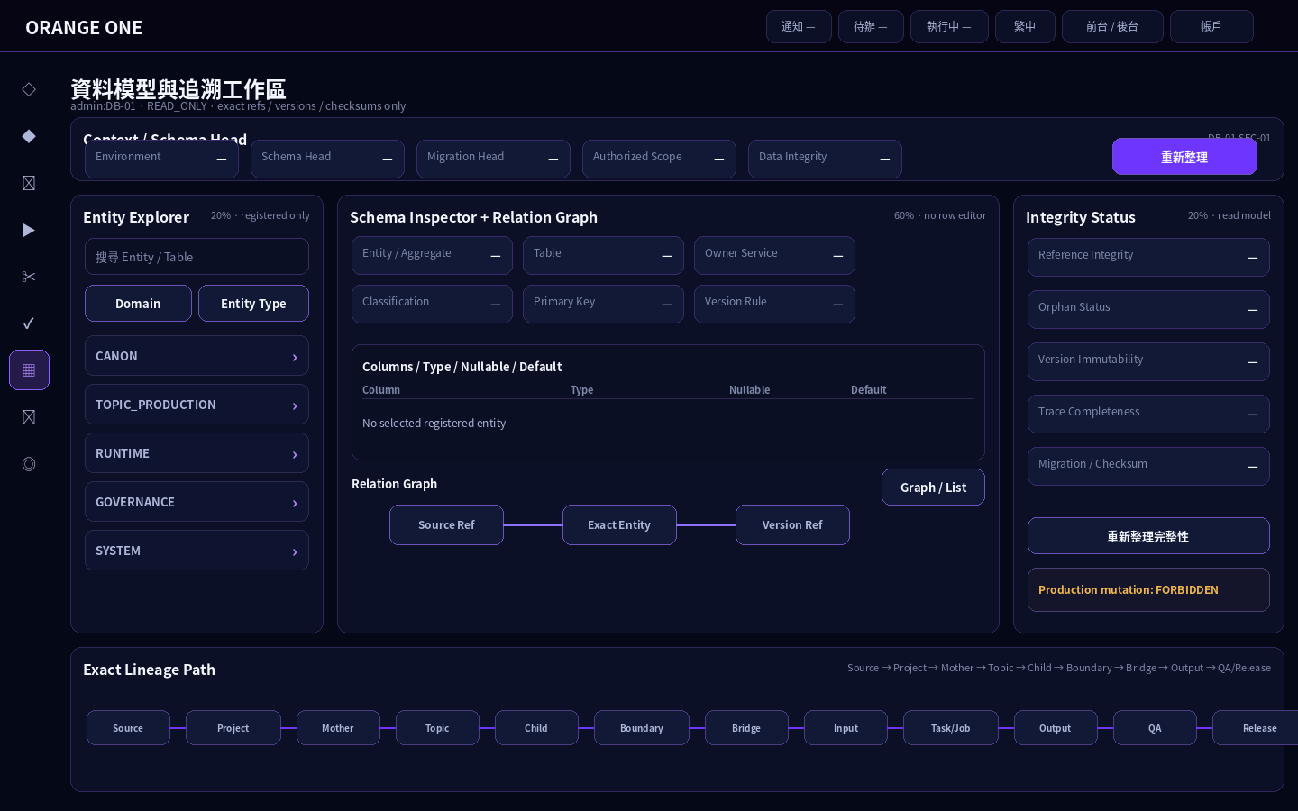
Collapsed Sidebar · Context / Explorer / Schema / Relation / Integrity / Exact Lineage

9.2 Visual B — Expanded Sidebar Overlay
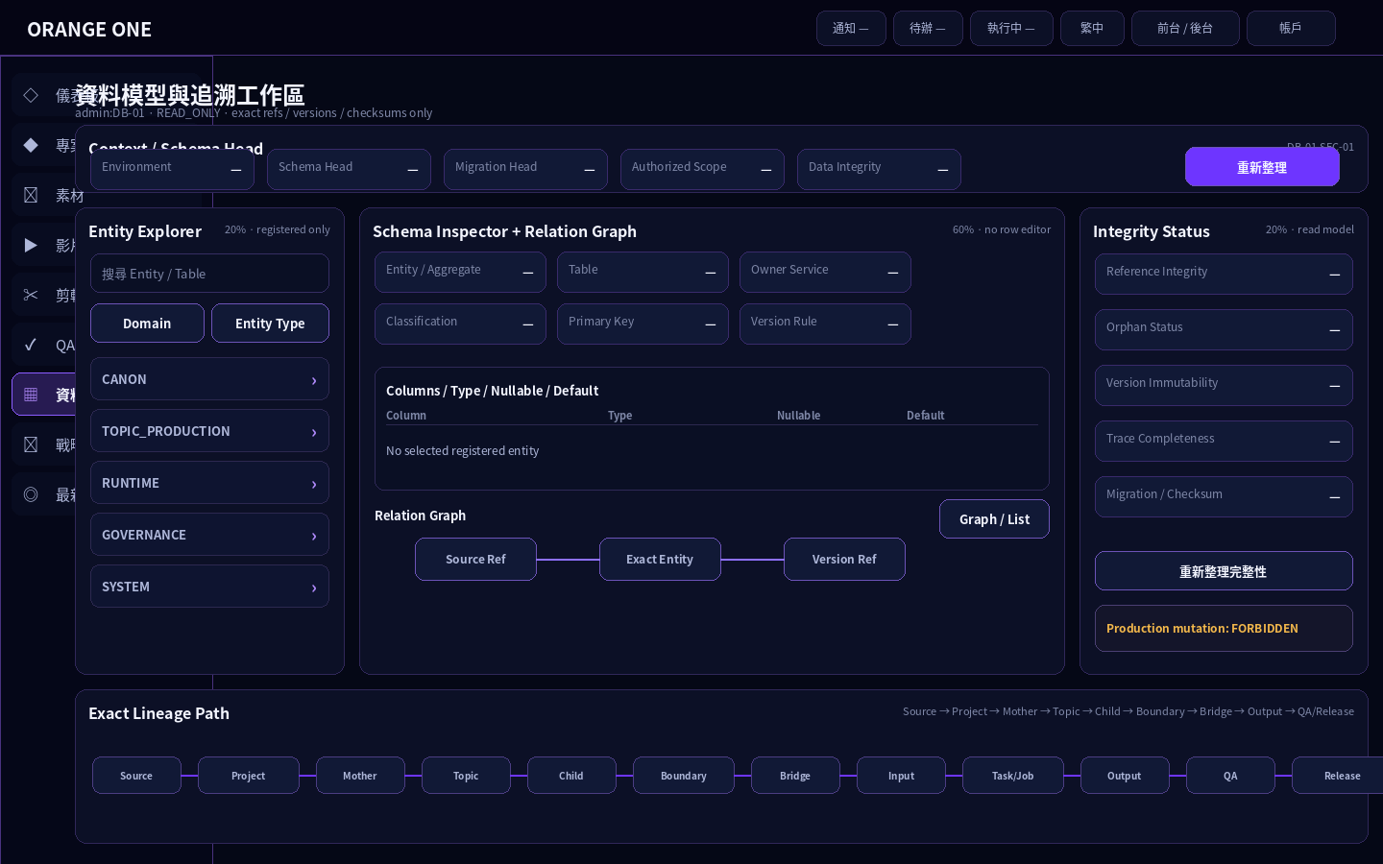
221px Global Sidebar overlay；workspace x=78px 不 reflow。

10. Visual State Set / Real Workbench States

10.1 Visual C — Exact Traceability
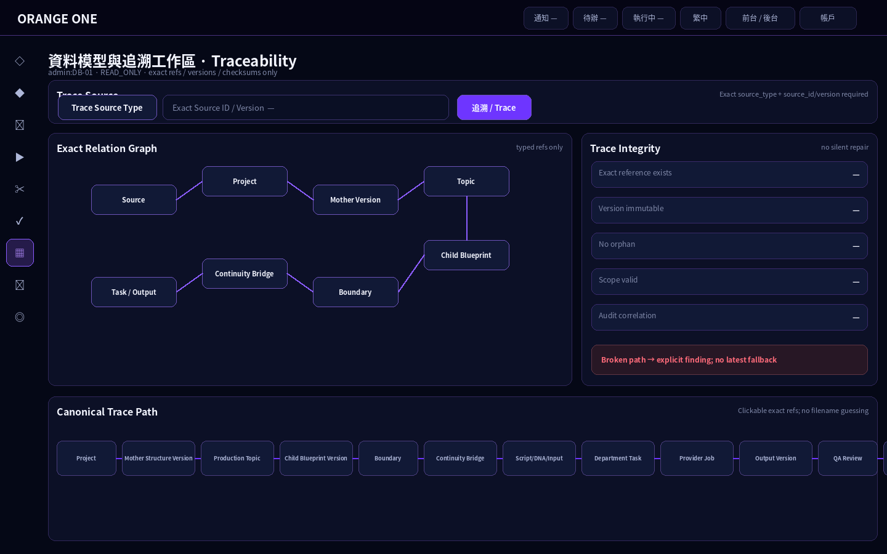
Trace Source → typed relation graph → canonical lineage path；所有節點為 exact ref。

10.2 Visual D — Integrity + Migration + Audit
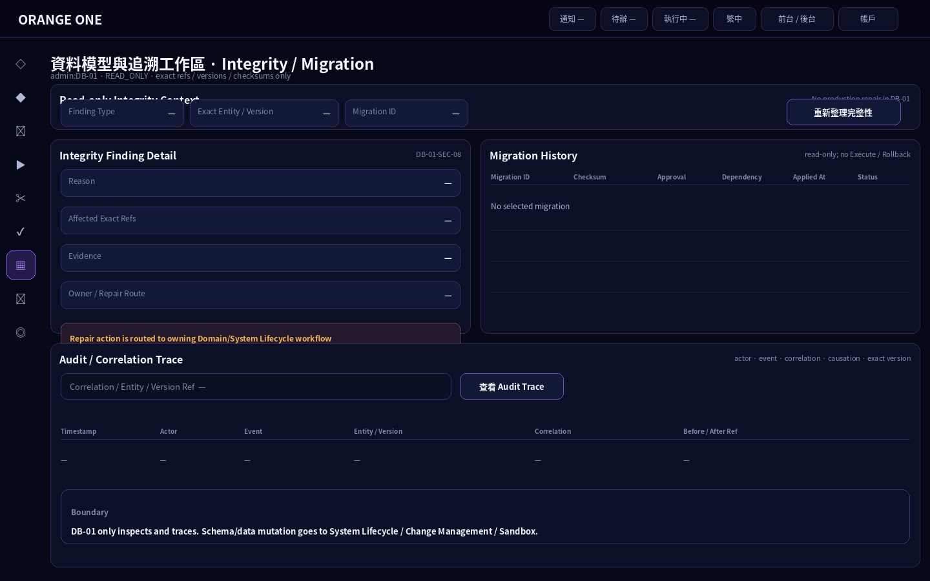
Finding、Migration、Audit 均為 read-only projection；修正由 owner workflow 處理。

11. Boundary / Recovery Visual

11.1 Visual E — Version Conflict / Change Route
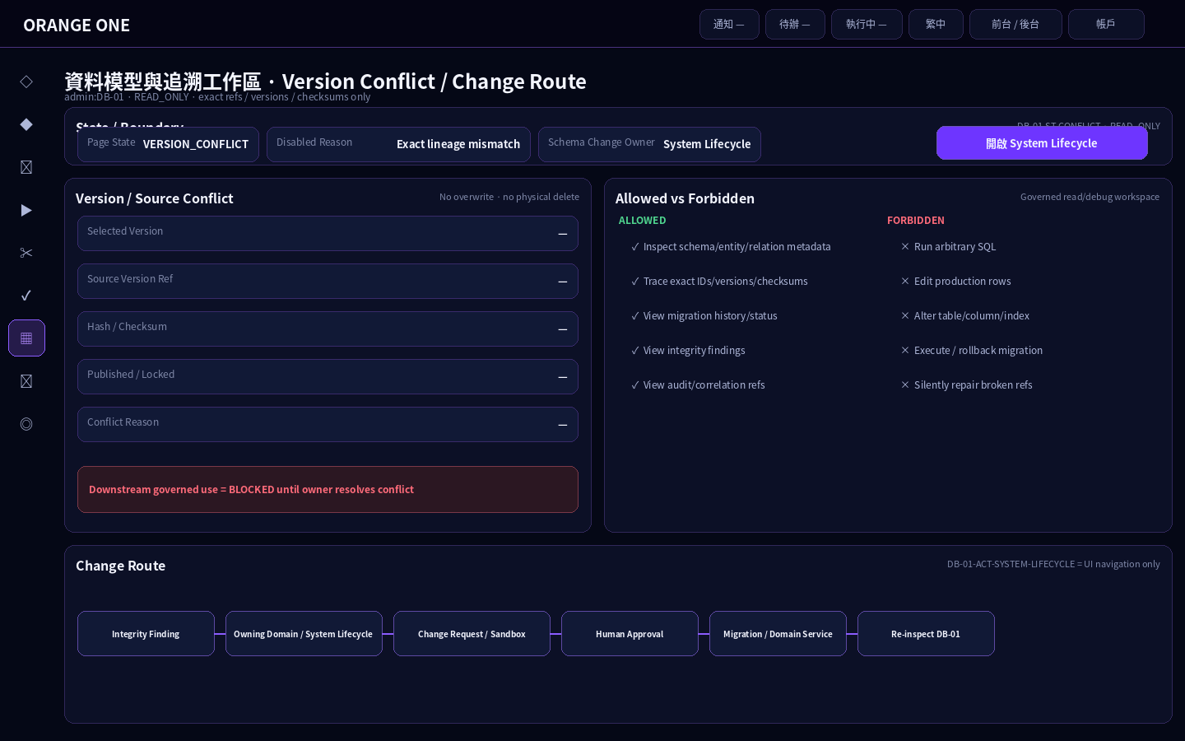
VERSION_CONFLICT：不覆寫、不 physical delete；DB-01 只導向 System Lifecycle / Change Management。

11.2 Visual Hard Locks
- No manual SQL console
- No raw row editor
- No direct DDL / Production write
- No migration execute / rollback
- No filename-based authority
- No latest/current/default fallback
- No fake database metrics
- No silent orphan/ref repair

12. Control / Field / Action / Gate / Permission Binding
49/49 Current Controls。所有可見 control 必須 resolve Section / Component / Action / Gate / Permission；unlisted = BLOCK。
Control UID | Sec/Cmp | Type / Label | Action | Gate | Permission
DB-01-FLD-ENV | SEC-01/CONTEXT | READONLY / Environment | DB-01-ACT-NOOP | DB-01-GATE-PAGE | DB_READ
DB-01-FLD-SCHEMA-HEAD | SEC-01/CONTEXT | READONLY / Schema Head | DB-01-ACT-NOOP | DB-01-GATE-PAGE | DB_READ
DB-01-FLD-MIGRATION-HEAD | SEC-01/CONTEXT | READONLY / Migration Head | DB-01-ACT-NOOP | DB-01-GATE-PAGE | DB_READ
DB-01-FLD-SCOPE | SEC-01/CONTEXT | READONLY / Authorized Scope | DB-01-ACT-NOOP | DB-01-GATE-PAGE | DB_READ
DB-01-FLD-HEALTH | SEC-01/CONTEXT | READONLY / Data Integrity | DB-01-ACT-NOOP | DB-01-GATE-PAGE | DB_READ
DB-01-BTN-REFRESH | SEC-01/CONTEXT | BUTTON / 重新整理 / Refresh | DB-01-ACT-SCHEMA-REFRESH | DB-01-GATE-CONTEXT | DB_READ
DB-01-INP-SEARCH | SEC-02/EXPLORER | SEARCH / 搜尋 Entity / Table | DB-01-ACT-SEARCH | DB-01-GATE-PAGE | DB_READ
DB-01-SEL-DOMAIN | SEC-02/EXPLORER | SELECT / Domain | DB-01-ACT-FILTER | DB-01-GATE-PAGE | DB_READ
DB-01-SEL-ENTITY-TYPE | SEC-02/EXPLORER | SELECT / Entity Type | DB-01-ACT-FILTER | DB-01-GATE-PAGE | DB_READ
DB-01-LIST-ENTITIES | SEC-02/EXPLORER | LIST / Entity / Table Explorer | DB-01-ACT-ENTITY-SELECT | DB-01-GATE-ENTITY | DB_READ
DB-01-FLD-ENTITY | SEC-03/SCHEMA | READONLY / Entity / Aggregate | DB-01-ACT-NOOP | DB-01-GATE-SCHEMA | DB_READ
DB-01-FLD-TABLE | SEC-03/SCHEMA | READONLY / Table | DB-01-ACT-NOOP | DB-01-GATE-SCHEMA | DB_READ
DB-01-FLD-OWNER | SEC-03/SCHEMA | READONLY / Owner Service | DB-01-ACT-NOOP | DB-01-GATE-SCHEMA | DB_READ
DB-01-FLD-CLASSIFICATION | SEC-03/SCHEMA | READONLY / Data Classification | DB-01-ACT-NOOP | DB-01-GATE-SCHEMA | DB_READ
DB-01-FLD-PK | SEC-03/SCHEMA | READONLY / Primary Key | DB-01-ACT-NOOP | DB-01-GATE-SCHEMA | DB_READ
DB-01-FLD-VERSION-RULE | SEC-03/SCHEMA | READONLY / Version Rule | DB-01-ACT-NOOP | DB-01-GATE-SCHEMA | DB_READ
DB-01-TBL-COLUMNS | SEC-03/COLUMNS | TABLE / Columns / Type / Nullable / Default | DB-01-ACT-NOOP | DB-01-GATE-SCHEMA | DB_READ
DB-01-TBL-CONSTRAINTS | SEC-03/COLUMNS | TABLE / Constraints / Indexes | DB-01-ACT-NOOP | DB-01-GATE-SCHEMA | DB_READ
DB-01-BTN-SCHEMA-REFRESH | SEC-03/SCHEMA | BUTTON / 重新讀取 Schema | DB-01-ACT-SCHEMA-REFRESH | DB-01-GATE-SCHEMA | DB_READ
DB-01-TOGGLE-RELATION-VIEW | SEC-04/RELATIONS | TOGGLE / Graph / List | DB-01-ACT-RELATION-MODE | DB-01-GATE-SCHEMA | DB_READ
DB-01-GRAPH-RELATIONS | SEC-04/RELATIONS | GRAPH / Exact Relation Graph | DB-01-ACT-RELATION-OPEN | DB-01-GATE-RELATION | DB_TRACE
DB-01-LIST-RELATIONS | SEC-04/RELATIONS | LIST / Relation List | DB-01-ACT-RELATION-OPEN | DB-01-GATE-RELATION | DB_TRACE
DB-01-SEL-TRACE-TYPE | SEC-05/TRACE | SELECT / Trace Source Type | DB-01-ACT-CONTEXT | DB-01-GATE-PAGE | DB_TRACE
DB-01-INP-TRACE-ID | SEC-05/TRACE | REFERENCE / Exact Source ID / Version | DB-01-ACT-CONTEXT | DB-01-GATE-PAGE | DB_TRACE
DB-01-BTN-TRACE | SEC-05/TRACE | PRIMARY_BUTTON / 追溯 / Trace | DB-01-ACT-TRACE | DB-01-GATE-TRACE | DB_TRACE
DB-01-VIEW-TRACE-PATH | SEC-05/TRACE | TRACE_VIEW / Exact Lineage Path | DB-01-ACT-RELATION-OPEN | DB-01-GATE-TRACE | DB_TRACE
DB-01-FLD-REF-INTEGRITY | SEC-06/INTEGRITY | READONLY / Reference Integrity | DB-01-ACT-NOOP | DB-01-GATE-INTEGRITY | DB_INTEGRITY_READ
DB-01-FLD-ORPHAN | SEC-06/INTEGRITY | READONLY / Orphan Status | DB-01-ACT-NOOP | DB-01-GATE-INTEGRITY | DB_INTEGRITY_READ
DB-01-FLD-IMMUTABLE | SEC-06/INTEGRITY | READONLY / Version Immutability | DB-01-ACT-NOOP | DB-01-GATE-INTEGRITY | DB_INTEGRITY_READ
DB-01-FLD-TRACE-COMPLETE | SEC-06/INTEGRITY | READONLY / Trace Completeness | DB-01-ACT-NOOP | DB-01-GATE-INTEGRITY | DB_INTEGRITY_READ
DB-01-FLD-MIGRATION-INTEGRITY | SEC-06/INTEGRITY | READONLY / Migration / Checksum | DB-01-ACT-NOOP | DB-01-GATE-INTEGRITY | DB_INTEGRITY_READ
DB-01-BTN-INTEGRITY-REFRESH | SEC-06/INTEGRITY | BUTTON / 重新整理完整性 | DB-01-ACT-INTEGRITY-REFRESH | DB-01-GATE-INTEGRITY | DB_INTEGRITY_READ
DB-01-INP-MIGRATION-SEARCH | SEC-07/MIGRATION | SEARCH / Migration ID | DB-01-ACT-MIGRATION-REFRESH | DB-01-GATE-MIGRATION | DB_MIGRATION_READ
DB-01-TBL-MIGRATIONS | SEC-07/MIGRATION | TABLE / Migration History | DB-01-ACT-MIGRATION-SELECT | DB-01-GATE-MIGRATION | DB_MIGRATION_READ
DB-01-BTN-MIGRATION-REFRESH | SEC-07/MIGRATION | BUTTON / 重新整理 Migration | DB-01-ACT-MIGRATION-REFRESH | DB-01-GATE-MIGRATION | DB_MIGRATION_READ
DB-01-SEL-FINDING-TYPE | SEC-08/FINDINGS | SELECT / Integrity Finding Type | DB-01-ACT-FILTER | DB-01-GATE-INTEGRITY | DB_INTEGRITY_READ
DB-01-LIST-FINDINGS | SEC-08/FINDINGS | LIST / Integrity Findings | DB-01-ACT-FINDING-SELECT | DB-01-GATE-INTEGRITY | DB_INTEGRITY_READ
DB-01-FLD-FINDING-REASON | SEC-08/FINDINGS | READONLY / Reason | DB-01-ACT-NOOP | DB-01-GATE-INTEGRITY | DB_INTEGRITY_READ
DB-01-FLD-FINDING-AFFECTED | SEC-08/FINDINGS | READONLY / Affected Exact Refs | DB-01-ACT-NOOP | DB-01-GATE-INTEGRITY | DB_INTEGRITY_READ
DB-01-FLD-FINDING-EVIDENCE | SEC-08/FINDINGS | READONLY / Evidence | DB-01-ACT-NOOP | DB-01-GATE-INTEGRITY | DB_INTEGRITY_READ
DB-01-FLD-FINDING-OWNER | SEC-08/FINDINGS | READONLY / Owner / Repair Route | DB-01-ACT-NOOP | DB-01-GATE-INTEGRITY | DB_INTEGRITY_READ
DB-01-INP-AUDIT-ID | SEC-09/AUDIT | REFERENCE / Correlation / Entity / Version Ref | DB-01-ACT-CONTEXT | DB-01-GATE-AUDIT | DB_AUDIT_READ
DB-01-BTN-AUDIT | SEC-09/AUDIT | BUTTON / 查看 Audit Trace | DB-01-ACT-AUDIT-OPEN | DB-01-GATE-AUDIT | DB_AUDIT_READ
DB-01-VIEW-AUDIT | SEC-09/AUDIT | TRACE_VIEW / Audit / Correlation | DB-01-ACT-NOOP | DB-01-GATE-AUDIT | DB_AUDIT_READ
DB-01-FLD-PAGE-STATE | SEC-10/STATUS | READONLY / Page State | DB-01-ACT-NOOP | DB-01-GATE-PAGE | DB_READ
DB-01-FLD-SOURCE-SYNC | SEC-10/STATUS | READONLY / Source / Last Sync | DB-01-ACT-NOOP | DB-01-GATE-PAGE | DB_READ
DB-01-FLD-DISABLED | SEC-10/STATUS | READONLY / Disabled Reason | DB-01-ACT-NOOP | DB-01-GATE-PAGE | DB_READ
DB-01-FLD-CHANGE-OWNER | SEC-10/STATUS | READONLY / Schema Change Owner | DB-01-ACT-NOOP | DB-01-GATE-PAGE | DB_READ
DB-01-BTN-SYSTEM-LIFECYCLE | SEC-10/STATUS | BUTTON / 開啟 System Lifecycle / Change Management | DB-01-ACT-SYSTEM-LIFECYCLE | DB-01-GATE-PAGE | DB_READ

13. Gate / Permission Contract

13.1 Gates · 9/9
Gate UID | Condition
DB-01-GATE-PAGE | explicit account page permission + scope + condition + audit
DB-01-GATE-CONTEXT | environment/schema head resolved + authorized scope; no implicit tenant/project fallback
DB-01-GATE-ENTITY | selected entity/table is registered and permitted for current scope
DB-01-GATE-SCHEMA | selected entity has authoritative schema/entity/column/relation metadata
DB-01-GATE-RELATION | selected exact entity/ref has registered typed relations; no inferred relation from naming
DB-01-GATE-TRACE | source_type + exact source_id/version are present and authorized
DB-01-GATE-MIGRATION | migration history permission + registered migration/checksum manifest available
DB-01-GATE-INTEGRITY | integrity read source available for selected scope/entity/version
DB-01-GATE-AUDIT | audit read permission + exact correlation/entity/version scope

13.2 Permissions · 5/5
Permission UID | Backend Scope | Purpose
DB_READ | database.metadata.read | Read database/entity/schema/relation/version metadata
DB_TRACE | database.trace.read | Resolve exact registered lineage and relation trace
DB_MIGRATION_READ | database.migration.read | Read migration/checksum/dependency/status history
DB_INTEGRITY_READ | database.integrity.read | Read integrity checks/findings
DB_AUDIT_READ | audit.read | Read permitted audit/correlation trace

14. State / Error / Recovery

14.1 Page States · 8/8
State UID | Display | Definition
DB-01-ST-LOADING | LOADING | Loading authorized Database Read Model
DB-01-ST-READY | READY | Database metadata/read model ready
DB-01-ST-EMPTY | EMPTY | Authorized query has no registered result
DB-01-ST-ERROR | ERROR | Real read/contract/integrity error
DB-01-ST-POLICY | POLICY_BLOCKED | Permission/data classification/scope blocks read
DB-01-ST-CONFLICT | VERSION_CONFLICT | Schema/version/source lineage mismatch
DB-01-ST-READONLY | READ_ONLY | Normal DB-01 operating mode; no production mutation
DB-01-ST-ARCHIVED | ARCHIVED | Historical schema/entity/migration/version context

14.2 Error / Recovery · 10/10
Error UID | Context | Recovery
DB-01-ERR-CONTEXT-001 | Database context/environment/schema head unavailable or scope mismatch | BLOCK data panels; resolve authorized context
DB-01-ERR-ENTITY-001 | Entity/table not registered or outside allowed scope | BLOCK selection; no database-name guessing
DB-01-ERR-SCHEMA-001 | Schema/column/relation metadata missing or inconsistent | Show explicit authority gap/integrity finding; do not synthesize schema
DB-01-ERR-TRACE-001 | Trace source ref missing/orphan/mismatched | Show broken path; do not silently repair or jump to latest
DB-01-ERR-VERSION-001 | Version/source snapshot immutable lineage conflict | BLOCK any governed downstream use and surface exact conflict
DB-01-ERR-MIGRATION-001 | Migration/checksum/dependency history invalid or incomplete | Show migration integrity blocker; route change to System Lifecycle
DB-01-ERR-INTEGRITY-001 | FK/reference/orphan/scope/checksum integrity failure | Show finding and affected exact refs; no direct production repair
DB-01-ERR-AUDIT-001 | Audit/correlation trace unavailable or unauthorized | Show read restriction / missing audit evidence
DB-01-ERR-PERM-001 | Permission/scope denied | Disable access/action and show actual reason
DB-01-ERR-UNDEFINED-001 | Unlisted control/action/relation/mutation requested | BLOCK + REPORT_AUTHORITY_GAP

15. Data Binding / Read Model Contract
Port UID | Boundary | Operation | Method | Permission | Exposure
DB-01-PORT-ENTITY-LIST | Database metadata read model | DatabaseReadModel.list_entities | READ_MODEL_QUERY | database.metadata.read | DB-01-ACT-SEARCH
DB-01-PORT-SCHEMA | Entity schema projection | DatabaseReadModel.get_entity_schema | READ_MODEL_QUERY | database.metadata.read | DB-01-ACT-SCHEMA-REFRESH
DB-01-PORT-TRACE | Traceability read model | TraceabilityReadModel.trace_entity_lineage | READ_MODEL_QUERY | database.trace.read | DB-01-ACT-TRACE
DB-01-PORT-MIGRATION | Migration history read model | MigrationReadModel.list_history | READ_MODEL_QUERY | database.migration.read | DB-01-ACT-MIGRATION-REFRESH / SELECT
DB-01-PORT-INTEGRITY | Database integrity read model | DatabaseIntegrityReadModel.list_findings | READ_MODEL_QUERY | database.integrity.read | DB-01-ACT-INTEGRITY-REFRESH / FINDING-SELECT
DB-01-PORT-AUDIT | Audit trace read model | AuditReadModel.trace | READ_MODEL_QUERY | audit.read | DB-01-ACT-AUDIT-OPEN
DB-01-PORT-SYSTEM-LIFECYCLE | Schema mutation/change route | NAVIGATE_TO_SYSTEM_LIFECYCLE | UI_NAVIGATION_ONLY | database.metadata.read | DB-01-ACT-SYSTEM-LIFECYCLE

15.1 Read-model Rules
- Schema direct write = FORBIDDEN
- Manual SQL = FORBIDDEN
- Row data editor = FORBIDDEN
- Migration page scope = READ_ONLY_MIGRATION_HISTORY_AND_STATUS
- Trace uses canonical IDs/refs/checksums only
- Broken/orphan refs become findings, not auto-repair

16. Function ↔ Visual Traceability
Function | Visual Region | Primary Controls
Context | DB-01-VIS-CONTEXT | Environment / Schema Head / Migration Head / Scope / Integrity / Refresh
Explore | DB-01-VIS-LEFT | Search / Domain / Entity Type / Entity list
Schema | DB-01-VIS-SCHEMA | Entity / Table / Owner / Classification / PK / Version Rule / Columns / Constraints
Relations | DB-01-VIS-RELATION | Graph/List toggle + exact relation open
Trace | DB-01-VIS-TRACE | Source Type / Exact ID-Version / Trace / Path
Integrity | DB-01-VIS-RIGHT | Reference / Orphan / Immutable / Trace Complete / Migration Integrity
Migration | DB-01-VIS-MIGRATION | Migration search/history/refresh
Findings | DB-01-VIS-FINDING | Finding type/list/detail/owner route
Audit | DB-01-VIS-AUDIT | Correlation ref / Audit trace
Boundary | DB-01-VIS-STATUS | Page State / Source Sync / Disabled / Change Owner / System Lifecycle

17. Visual Anchor Registry / Geometry
Anchor | Geometry / Behavior
Global Header | 58px fixed top; full width; ORANGE ONE left; quick status/language/surface/account right
Collapsed Sidebar | 64px invisible interaction rail; icons only; no panel/background/frame
Expanded Sidebar | 221px fixed overlay under Header; no workspace reflow
Workspace Origin | x=78px / y=68px; right inset 16px
Context Bar | 100% width; h=56px
Primary Grid | minmax(280px,1fr) / minmax(760px,3fr) / minmax(300px,1fr); gap 16px
Center | Schema Inspector upper + Relation Graph lower; highest priority
Lower Rows | Trace / Migration / Finding / Audit / Status full width; page vertical scroll
Control | 40px; radius 10px; missing business value = —
Panel | radius 12px; violet border; no page-local palette

18. Visual Generation Manifest
Visual | Purpose | Status
A Main | Primary read/debug workbench | CANDIDATE
B Expanded Overlay | Global Sidebar behavior | CANDIDATE
C Traceability | Exact lineage / relations | CANDIDATE
D Integrity | Finding / Migration / Audit | CANDIDATE
E Boundary | Version conflict / System Lifecycle route | CANDIDATE

所有圖均使用 Authority-defined labels、roles、flows；沒有 Current 真值的欄位一律顯示「—」，不以 sample business data 填圖。

19. Pre-Implementation Guards
- Current Authority must remain FINAL_LOCKED source; this Word is candidate only.
- No second database page / database authority / CRUD editor.
- All refs explicit ID/version/hash/checksum; latest/current/default forbidden.
- No schema or data mutation action is added inside DB-01.
- Any unknown entity/relation/control/action => BLOCK + REPORT_AUTHORITY_GAP.
- Visual must preserve 58px Header + 64/221 Sidebar behavior + 20/60/20 DB grid.
- i18n labels use zh-TW / zh-CN / en; database/API/schema code remains English.

20. Acceptance Matrix
UID | Item | Condition
ACC-01 | Single Page / Global Visual | Only admin:DB-01 current database page; inherits Global Shell/Visual
ACC-02 | Read-only Data Model Viewer | No raw SQL, row editor, DDL or production mutation
ACC-03 | Exact Traceability | Task/Job/Asset/Review/Decision/Release trace exact canonical path
ACC-04 | Clickable Versions | Exact selectable refs, not display-only aliases
ACC-05 | Immutable History | Prior locked/published snapshots not overwritten/deleted
ACC-06 | Integrity | Ref/orphan/version/trace/scope checks visible
ACC-07 | Migration | ID/checksum/approval/dependency/status inspectable; no execute/rollback
ACC-08 | System Lifecycle Boundary | Mutations route to governed change workflow
ACC-09 | No Silent Repair | Broken refs explicit; no fallback latest
ACC-10 | Permission / Classification | Explicit account permission/scope/classification
ACC-11 | Scrollable Page | Main Workspace height:auto; independent of sidebar height
ACC-12 | Machine Binding | Every control resolves registry bindings; unlisted=BLOCK

21. Audit Baseline / Evidence Contract
Evidence | Required
Authority Identity | authority/pages/admin/DB-01/ACPOS_DB-01_FINAL_LOCKED_ENCODING.yaml @ 8074187716f40d4a31704ed6212fe40ffd66fc0e
Branch / HEAD | new @ 165c6440cb53b1b45ec96905241fb4d56dc3b867
Current Manifest | 465329b6fb19b8e44c3083a9f280015ee95cc55c
Registry denominator | 10 sections / 12 components / 49 controls / 15 actions / 7 ports
Visual evidence | 5 candidate UI PNGs embedded in this Word
Real data policy | Missing values = —; invented business values forbidden
Boundary | Read-only; mutation route only to System Lifecycle

22. Definition of Done / Basic Design Freeze Gate
Gate | Current Status
Current Authority resolved | PASS
Mother Basic Design artifacts present | PASS
Controls / Actions / Gates / Permissions enumerated | PASS
Five UI candidate states embedded | PASS
No fake business data in UI candidate | PASS
No CRUD/SQL/migration mutation introduced | PASS
Human visual / functional review | PENDING
DESIGN_FROZEN | FALSE

23. Resume / Next Step
- Human review DB-01 visual proportions, information density, relation/trace presentation and System Lifecycle boundary.
- If approved: set Design Freeze through governed review; only then use this Word as implementation construction input.
- If rejected: revise this Word/UI candidate only; do not mutate Current Authority without a governed change request.

Appendix A. Hard Prohibitions
- FORBIDDEN — Generic CRUD table editor
- FORBIDDEN — Manual SQL console
- FORBIDDEN — Direct production row edit
- FORBIDDEN — Direct DDL
- FORBIDDEN — Migration execute / rollback / restore backup
- FORBIDDEN — Permission/scope bypass
- FORBIDDEN — latest/current/default ref inference
- FORBIDDEN — filename parsing as identity
- FORBIDDEN — physical delete of locked history
- FORBIDDEN — silent repair of broken refs
- FORBIDDEN — fake table/row/migration/integrity metrics
- FORBIDDEN — unlisted control/action/relation/mutation

2026-09-21 Machine Authority Construction Closure / 機器權威施工綁定封板
[ACPOS-20260921-SOURCE-GROUNDED-CONSTRUCTION-CLOSURE-V2] Source-grounded only. Existing Current source wins; missing source values remain blocked/decision-required. This closure supersedes the prior generic 2026-09-21 V1/V3 annex only, not the original domain logic or human visual review gates.

DB-01 · Exact Construction Binding
Authority | Value
Source Commit | 165c6440cb53b1b45ec96905241fb4d56dc3b867
Machine Authority | authority/pages/admin/DB-01/ACPOS_DB-01_FINAL_LOCKED_ENCODING.yaml
Authority SHA-256 | 051595b3819a6bbd39b92ecc95ca04c7c1a2c050c0a8139b652300d237958f9c
Expected Control Denominator | 49
Unique Control Rows | 49
Denominator Gate | PASS
Control UID | UID Status | Label | Type | Action UID | Gate | Permission / Auth Resource | Payload / Schema | Operation | Method / Path | Runtime Owner | Persistence Owner | Runtime Status
DB-01-BTN-AUDIT | EXISTING_SOURCE_UID | 查看 Audit Trace | BUTTON | DB-01-ACT-AUDIT-OPEN | DB-01-GATE-AUDIT | DB_AUDIT_READ | — | — | — | Database Read Model / DB-01 | — | UI_LOCAL_OR_READ_SOURCE
DB-01-BTN-INTEGRITY-REFRESH | EXISTING_SOURCE_UID | 重新整理完整性 | BUTTON | DB-01-ACT-INTEGRITY-REFRESH | DB-01-GATE-INTEGRITY | DB_INTEGRITY_READ | — | — | — | Database Read Model / DB-01 | — | UI_LOCAL_OR_READ_SOURCE
DB-01-BTN-MIGRATION-REFRESH | EXISTING_SOURCE_UID | 重新整理 Migration | BUTTON | DB-01-ACT-MIGRATION-REFRESH | DB-01-GATE-MIGRATION | DB_MIGRATION_READ | — | — | — | Database Read Model / DB-01 | — | UI_LOCAL_OR_READ_SOURCE
DB-01-BTN-REFRESH | EXISTING_SOURCE_UID | 重新整理 / Refresh | BUTTON | DB-01-ACT-SCHEMA-REFRESH | DB-01-GATE-CONTEXT | DB_READ | — | — | — | Database Read Model / DB-01 | — | UI_LOCAL_OR_READ_SOURCE
DB-01-BTN-SCHEMA-REFRESH | EXISTING_SOURCE_UID | 重新讀取 Schema | BUTTON | DB-01-ACT-SCHEMA-REFRESH | DB-01-GATE-SCHEMA | DB_READ | — | — | — | Database Read Model / DB-01 | — | UI_LOCAL_OR_READ_SOURCE
DB-01-BTN-SYSTEM-LIFECYCLE | EXISTING_SOURCE_UID | 開啟 System Lifecycle / Change Management | BUTTON | DB-01-ACT-SYSTEM-LIFECYCLE | DB-01-GATE-PAGE | DB_READ | — | — | — | Database Read Model / DB-01 | — | UI_LOCAL_EXACT
DB-01-BTN-TRACE | EXISTING_SOURCE_UID | 追溯 / Trace | PRIMARY_BUTTON | DB-01-ACT-TRACE | DB-01-GATE-TRACE | DB_TRACE | — | — | — | Database Read Model / DB-01 | — | UI_LOCAL_OR_READ_SOURCE
DB-01-FLD-CHANGE-OWNER | EXISTING_SOURCE_UID | Schema Change Owner | READONLY | DB-01-ACT-NOOP | DB-01-GATE-PAGE | DB_READ | — | — | — | Database Read Model / DB-01 | — | UI_LOCAL_EXACT
DB-01-FLD-CLASSIFICATION | EXISTING_SOURCE_UID | Data Classification | READONLY | DB-01-ACT-NOOP | DB-01-GATE-SCHEMA | DB_READ | — | — | — | Database Read Model / DB-01 | — | UI_LOCAL_EXACT
DB-01-FLD-DISABLED | EXISTING_SOURCE_UID | Disabled Reason | READONLY | DB-01-ACT-NOOP | DB-01-GATE-PAGE | DB_READ | — | — | — | Database Read Model / DB-01 | — | UI_LOCAL_EXACT
DB-01-FLD-ENTITY | EXISTING_SOURCE_UID | Entity / Aggregate | READONLY | DB-01-ACT-NOOP | DB-01-GATE-SCHEMA | DB_READ | — | — | — | Database Read Model / DB-01 | — | UI_LOCAL_EXACT
DB-01-FLD-ENV | EXISTING_SOURCE_UID | Environment | READONLY | DB-01-ACT-NOOP | DB-01-GATE-PAGE | DB_READ | — | — | — | Database Read Model / DB-01 | — | UI_LOCAL_EXACT
DB-01-FLD-FINDING-AFFECTED | EXISTING_SOURCE_UID | Affected Exact Refs | READONLY | DB-01-ACT-NOOP | DB-01-GATE-INTEGRITY | DB_INTEGRITY_READ | — | — | — | Database Read Model / DB-01 | — | UI_LOCAL_EXACT
DB-01-FLD-FINDING-EVIDENCE | EXISTING_SOURCE_UID | Evidence | READONLY | DB-01-ACT-NOOP | DB-01-GATE-INTEGRITY | DB_INTEGRITY_READ | — | — | — | Database Read Model / DB-01 | — | UI_LOCAL_EXACT
DB-01-FLD-FINDING-OWNER | EXISTING_SOURCE_UID | Owner / Repair Route | READONLY | DB-01-ACT-NOOP | DB-01-GATE-INTEGRITY | DB_INTEGRITY_READ | — | — | — | Database Read Model / DB-01 | — | UI_LOCAL_EXACT
DB-01-FLD-FINDING-REASON | EXISTING_SOURCE_UID | Reason | READONLY | DB-01-ACT-NOOP | DB-01-GATE-INTEGRITY | DB_INTEGRITY_READ | — | — | — | Database Read Model / DB-01 | — | UI_LOCAL_EXACT
DB-01-FLD-HEALTH | EXISTING_SOURCE_UID | Data Integrity | READONLY | DB-01-ACT-NOOP | DB-01-GATE-PAGE | DB_READ | — | — | — | Database Read Model / DB-01 | — | UI_LOCAL_EXACT
DB-01-FLD-IMMUTABLE | EXISTING_SOURCE_UID | Version Immutability | READONLY | DB-01-ACT-NOOP | DB-01-GATE-INTEGRITY | DB_INTEGRITY_READ | — | — | — | Database Read Model / DB-01 | — | UI_LOCAL_EXACT
DB-01-FLD-MIGRATION-HEAD | EXISTING_SOURCE_UID | Migration Head | READONLY | DB-01-ACT-NOOP | DB-01-GATE-PAGE | DB_READ | — | — | — | Database Read Model / DB-01 | — | UI_LOCAL_EXACT
DB-01-FLD-MIGRATION-INTEGRITY | EXISTING_SOURCE_UID | Migration / Checksum | READONLY | DB-01-ACT-NOOP | DB-01-GATE-INTEGRITY | DB_INTEGRITY_READ | — | — | — | Database Read Model / DB-01 | — | UI_LOCAL_EXACT
DB-01-FLD-ORPHAN | EXISTING_SOURCE_UID | Orphan Status | READONLY | DB-01-ACT-NOOP | DB-01-GATE-INTEGRITY | DB_INTEGRITY_READ | — | — | — | Database Read Model / DB-01 | — | UI_LOCAL_EXACT
DB-01-FLD-OWNER | EXISTING_SOURCE_UID | Owner Service | READONLY | DB-01-ACT-NOOP | DB-01-GATE-SCHEMA | DB_READ | — | — | — | Database Read Model / DB-01 | — | UI_LOCAL_EXACT
DB-01-FLD-PAGE-STATE | EXISTING_SOURCE_UID | Page State | READONLY | DB-01-ACT-NOOP | DB-01-GATE-PAGE | DB_READ | — | — | — | Database Read Model / DB-01 | — | UI_LOCAL_EXACT
DB-01-FLD-PK | EXISTING_SOURCE_UID | Primary Key | READONLY | DB-01-ACT-NOOP | DB-01-GATE-SCHEMA | DB_READ | — | — | — | Database Read Model / DB-01 | — | UI_LOCAL_EXACT
DB-01-FLD-REF-INTEGRITY | EXISTING_SOURCE_UID | Reference Integrity | READONLY | DB-01-ACT-NOOP | DB-01-GATE-INTEGRITY | DB_INTEGRITY_READ | — | — | — | Database Read Model / DB-01 | — | UI_LOCAL_EXACT
DB-01-FLD-SCHEMA-HEAD | EXISTING_SOURCE_UID | Schema Head | READONLY | DB-01-ACT-NOOP | DB-01-GATE-PAGE | DB_READ | — | — | — | Database Read Model / DB-01 | — | UI_LOCAL_EXACT
DB-01-FLD-SCOPE | EXISTING_SOURCE_UID | Authorized Scope | READONLY | DB-01-ACT-NOOP | DB-01-GATE-PAGE | DB_READ | — | — | — | Database Read Model / DB-01 | — | UI_LOCAL_EXACT
DB-01-FLD-SOURCE-SYNC | EXISTING_SOURCE_UID | Source / Last Sync | READONLY | DB-01-ACT-NOOP | DB-01-GATE-PAGE | DB_READ | — | — | — | Database Read Model / DB-01 | — | UI_LOCAL_EXACT
DB-01-FLD-TABLE | EXISTING_SOURCE_UID | Table | READONLY | DB-01-ACT-NOOP | DB-01-GATE-SCHEMA | DB_READ | — | — | — | Database Read Model / DB-01 | — | UI_LOCAL_EXACT
DB-01-FLD-TRACE-COMPLETE | EXISTING_SOURCE_UID | Trace Completeness | READONLY | DB-01-ACT-NOOP | DB-01-GATE-INTEGRITY | DB_INTEGRITY_READ | — | — | — | Database Read Model / DB-01 | — | UI_LOCAL_EXACT
DB-01-FLD-VERSION-RULE | EXISTING_SOURCE_UID | Version Rule | READONLY | DB-01-ACT-NOOP | DB-01-GATE-SCHEMA | DB_READ | — | — | — | Database Read Model / DB-01 | — | UI_LOCAL_EXACT
DB-01-GRAPH-RELATIONS | EXISTING_SOURCE_UID | Exact Relation Graph | GRAPH | DB-01-ACT-RELATION-OPEN | DB-01-GATE-RELATION | DB_TRACE | — | — | — | Database Read Model / DB-01 | — | UI_LOCAL_EXACT
DB-01-INP-AUDIT-ID | EXISTING_SOURCE_UID | Correlation / Entity / Version Ref | REFERENCE | DB-01-ACT-CONTEXT | DB-01-GATE-AUDIT | DB_AUDIT_READ | — | — | — | Database Read Model / DB-01 | — | UI_LOCAL_EXACT
DB-01-INP-MIGRATION-SEARCH | EXISTING_SOURCE_UID | Migration ID | SEARCH | DB-01-ACT-MIGRATION-REFRESH | DB-01-GATE-MIGRATION | DB_MIGRATION_READ | — | — | — | Database Read Model / DB-01 | — | UI_LOCAL_OR_READ_SOURCE
DB-01-INP-SEARCH | EXISTING_SOURCE_UID | 搜尋 Entity / Table | SEARCH | DB-01-ACT-SEARCH | DB-01-GATE-PAGE | DB_READ | — | — | — | Database Read Model / DB-01 | — | UI_LOCAL_OR_READ_SOURCE
DB-01-INP-TRACE-ID | EXISTING_SOURCE_UID | Exact Source ID / Version | REFERENCE | DB-01-ACT-CONTEXT | DB-01-GATE-PAGE | DB_TRACE | — | — | — | Database Read Model / DB-01 | — | UI_LOCAL_EXACT
DB-01-LIST-ENTITIES | EXISTING_SOURCE_UID | Entity / Table Explorer | LIST | DB-01-ACT-ENTITY-SELECT | DB-01-GATE-ENTITY | DB_READ | — | — | — | Database Read Model / DB-01 | — | UI_LOCAL_EXACT
DB-01-LIST-FINDINGS | EXISTING_SOURCE_UID | Integrity Findings | LIST | DB-01-ACT-FINDING-SELECT | DB-01-GATE-INTEGRITY | DB_INTEGRITY_READ | — | — | — | Database Read Model / DB-01 | — | UI_LOCAL_EXACT
DB-01-LIST-RELATIONS | EXISTING_SOURCE_UID | Relation List | LIST | DB-01-ACT-RELATION-OPEN | DB-01-GATE-RELATION | DB_TRACE | — | — | — | Database Read Model / DB-01 | — | UI_LOCAL_EXACT
DB-01-SEL-DOMAIN | EXISTING_SOURCE_UID | Domain | SELECT | DB-01-ACT-FILTER | DB-01-GATE-PAGE | DB_READ | — | — | — | Database Read Model / DB-01 | — | UI_LOCAL_EXACT
DB-01-SEL-ENTITY-TYPE | EXISTING_SOURCE_UID | Entity Type | SELECT | DB-01-ACT-FILTER | DB-01-GATE-PAGE | DB_READ | — | — | — | Database Read Model / DB-01 | — | UI_LOCAL_EXACT
DB-01-SEL-FINDING-TYPE | EXISTING_SOURCE_UID | Integrity Finding Type | SELECT | DB-01-ACT-FILTER | DB-01-GATE-INTEGRITY | DB_INTEGRITY_READ | — | — | — | Database Read Model / DB-01 | — | UI_LOCAL_EXACT
DB-01-SEL-TRACE-TYPE | EXISTING_SOURCE_UID | Trace Source Type | SELECT | DB-01-ACT-CONTEXT | DB-01-GATE-PAGE | DB_TRACE | — | — | — | Database Read Model / DB-01 | — | UI_LOCAL_EXACT
DB-01-TBL-COLUMNS | EXISTING_SOURCE_UID | Columns / Type / Nullable / Default | TABLE | DB-01-ACT-NOOP | DB-01-GATE-SCHEMA | DB_READ | — | — | — | Database Read Model / DB-01 | — | UI_LOCAL_EXACT
DB-01-TBL-CONSTRAINTS | EXISTING_SOURCE_UID | Constraints / Indexes | TABLE | DB-01-ACT-NOOP | DB-01-GATE-SCHEMA | DB_READ | — | — | — | Database Read Model / DB-01 | — | UI_LOCAL_EXACT
DB-01-TBL-MIGRATIONS | EXISTING_SOURCE_UID | Migration History | TABLE | DB-01-ACT-MIGRATION-SELECT | DB-01-GATE-MIGRATION | DB_MIGRATION_READ | — | — | — | Database Read Model / DB-01 | — | UI_LOCAL_EXACT
DB-01-TOGGLE-RELATION-VIEW | EXISTING_SOURCE_UID | Graph / List | TOGGLE | DB-01-ACT-RELATION-MODE | DB-01-GATE-SCHEMA | DB_READ | — | — | — | Database Read Model / DB-01 | — | UI_LOCAL_EXACT
DB-01-VIEW-AUDIT | EXISTING_SOURCE_UID | Audit / Correlation | TRACE_VIEW | DB-01-ACT-NOOP | DB-01-GATE-AUDIT | DB_AUDIT_READ | — | — | — | Database Read Model / DB-01 | — | UI_LOCAL_EXACT
DB-01-VIEW-TRACE-PATH | EXISTING_SOURCE_UID | Exact Lineage Path | TRACE_VIEW | DB-01-ACT-RELATION-OPEN | DB-01-GATE-TRACE | DB_TRACE | — | — | — | Database Read Model / DB-01 | — | UI_LOCAL_EXACT

Page Construction Invariant
The exact control denominator above is the only construction denominator for this page. Components/fields/visual IDs are not counted as additional controls. Existing source UIDs are preserved. A control classified UI_LOCAL_EXACT MUST NOT create a server write. A control classified SPEC_EXACT_RUNTIME_BLOCKED / NOT_EXECUTED MUST remain disabled or fail-closed until its runtime evidence exists.

Batch 15 · DB Read-Model Operation Applicability Ledger
[ACPOS-20260921-BATCH-15-OWNER-SPECIFIC-READ-PROJECTION-CLOSURE-V1::PAGE::DB-01] Applicability-only ledger. Product Control Registry rows remain unchanged; Operation stays '—'. Target UID is used so this evidence table is not a second product-control denominator.
Target UID | Field | Current Cell | Owner | Handling
DB-01-BTN-AUDIT | Operation | — | Database Read Model / DB-01 | DO_NOT_INVENT_REGISTERED_OPERATION
DB-01-BTN-INTEGRITY-REFRESH | Operation | — | Database Read Model / DB-01 | DO_NOT_INVENT_REGISTERED_OPERATION
DB-01-BTN-MIGRATION-REFRESH | Operation | — | Database Read Model / DB-01 | DO_NOT_INVENT_REGISTERED_OPERATION
DB-01-BTN-REFRESH | Operation | — | Database Read Model / DB-01 | DO_NOT_INVENT_REGISTERED_OPERATION
DB-01-BTN-SCHEMA-REFRESH | Operation | — | Database Read Model / DB-01 | DO_NOT_INVENT_REGISTERED_OPERATION
DB-01-BTN-TRACE | Operation | — | Database Read Model / DB-01 | DO_NOT_INVENT_REGISTERED_OPERATION
DB-01-INP-MIGRATION-SEARCH | Operation | — | Database Read Model / DB-01 | DO_NOT_INVENT_REGISTERED_OPERATION
DB-01-INP-SEARCH | Operation | — | Database Read Model / DB-01 | DO_NOT_INVENT_REGISTERED_OPERATION

Canonical Business Entity Operation Applicability Matrix / 業務實體操作適用性矩陣
Authority: Current Word design + Mother §71 bounded completion. 本矩陣只正規化既有行為與目前未授權行為；不得據此新增 Business Entity、Operation、Runtime 或 API。 Current tree: b2f81b20322dd9e9268001126b07931b437e27df.
Entity | Operation | Applicability | Authority Evidence
DatabaseIntegrityFinding | ARCHIVE_OR_DELETE | NOT_APPLICABLE | Current Word tree: RESOLVE_FRESH_AT_AUDIT_TIME: zero entity-bound operation evidence for this entity/operation. Mother §71 forbids speculative CRUD/sibling-feature expansion; current revision authorizes no new behavior.
DatabaseIntegrityFinding | AUDIT | NOT_APPLICABLE | Current Word tree: RESOLVE_FRESH_AT_AUDIT_TIME: zero entity-bound operation evidence for this entity/operation. Mother §71 forbids speculative CRUD/sibling-feature expansion; current revision authorizes no new behavior.
DatabaseIntegrityFinding | CATEGORY_OR_GROUP_BIND | NOT_APPLICABLE | Current Word tree: RESOLVE_FRESH_AT_AUDIT_TIME: zero entity-bound operation evidence for this entity/operation. Mother §71 forbids speculative CRUD/sibling-feature expansion; current revision authorizes no new behavior.
DatabaseIntegrityFinding | CONFIRM_OR_APPROVE | NOT_APPLICABLE | Current Word tree: RESOLVE_FRESH_AT_AUDIT_TIME: zero entity-bound operation evidence for this entity/operation. Mother §71 forbids speculative CRUD/sibling-feature expansion; current revision authorizes no new behavior.
DatabaseIntegrityFinding | CREATE | NOT_APPLICABLE | Current Word tree: RESOLVE_FRESH_AT_AUDIT_TIME: zero entity-bound operation evidence for this entity/operation. Mother §71 forbids speculative CRUD/sibling-feature expansion; current revision authorizes no new behavior.
DatabaseIntegrityFinding | CREATION_MODE | NOT_APPLICABLE | Current Word tree: RESOLVE_FRESH_AT_AUDIT_TIME: zero entity-bound operation evidence for this entity/operation. Mother §71 forbids speculative CRUD/sibling-feature expansion; current revision authorizes no new behavior.
DatabaseIntegrityFinding | DEPENDENCY_IMPACT | NOT_APPLICABLE | Current Word tree: RESOLVE_FRESH_AT_AUDIT_TIME: zero entity-bound operation evidence for this entity/operation. Mother §71 forbids speculative CRUD/sibling-feature expansion; current revision authorizes no new behavior.
DatabaseIntegrityFinding | DISCOVER_OR_LIST | NOT_APPLICABLE | Current Word tree: RESOLVE_FRESH_AT_AUDIT_TIME: zero entity-bound operation evidence for this entity/operation. Mother §71 forbids speculative CRUD/sibling-feature expansion; current revision authorizes no new behavior.
DatabaseIntegrityFinding | DRAFT | NOT_APPLICABLE | Current Word tree: RESOLVE_FRESH_AT_AUDIT_TIME: zero entity-bound operation evidence for this entity/operation. Mother §71 forbids speculative CRUD/sibling-feature expansion; current revision authorizes no new behavior.
DatabaseIntegrityFinding | EDIT | NOT_APPLICABLE | Current Word tree: RESOLVE_FRESH_AT_AUDIT_TIME: zero entity-bound operation evidence for this entity/operation. Mother §71 forbids speculative CRUD/sibling-feature expansion; current revision authorizes no new behavior.
DatabaseIntegrityFinding | ERROR_RECOVERY | NOT_APPLICABLE | Current Word tree: RESOLVE_FRESH_AT_AUDIT_TIME: zero entity-bound operation evidence for this entity/operation. Mother §71 forbids speculative CRUD/sibling-feature expansion; current revision authorizes no new behavior.
DatabaseIntegrityFinding | LOCK_OR_UNLOCK | NOT_APPLICABLE | Current Word tree: RESOLVE_FRESH_AT_AUDIT_TIME: zero entity-bound operation evidence for this entity/operation. Mother §71 forbids speculative CRUD/sibling-feature expansion; current revision authorizes no new behavior.
DatabaseIntegrityFinding | MOVE_OR_REPARENT | NOT_APPLICABLE | Current Word tree: RESOLVE_FRESH_AT_AUDIT_TIME: zero entity-bound operation evidence for this entity/operation. Mother §71 forbids speculative CRUD/sibling-feature expansion; current revision authorizes no new behavior.
DatabaseIntegrityFinding | NEXT_STEP | NOT_APPLICABLE | Current Word tree: RESOLVE_FRESH_AT_AUDIT_TIME: zero entity-bound operation evidence for this entity/operation. Mother §71 forbids speculative CRUD/sibling-feature expansion; current revision authorizes no new behavior.
DatabaseIntegrityFinding | PARENT_BIND | NOT_APPLICABLE | Current Word tree: RESOLVE_FRESH_AT_AUDIT_TIME: zero entity-bound operation evidence for this entity/operation. Mother §71 forbids speculative CRUD/sibling-feature expansion; current revision authorizes no new behavior.
DatabaseIntegrityFinding | REORDER | NOT_APPLICABLE | Current Word tree: RESOLVE_FRESH_AT_AUDIT_TIME: zero entity-bound operation evidence for this entity/operation. Mother §71 forbids speculative CRUD/sibling-feature expansion; current revision authorizes no new behavior.
DatabaseIntegrityFinding | RESTORE | NOT_APPLICABLE | Current Word tree: RESOLVE_FRESH_AT_AUDIT_TIME: zero entity-bound operation evidence for this entity/operation. Mother §71 forbids speculative CRUD/sibling-feature expansion; current revision authorizes no new behavior.
DatabaseIntegrityFinding | RESUME | NOT_APPLICABLE | Current Word tree: RESOLVE_FRESH_AT_AUDIT_TIME: zero entity-bound operation evidence for this entity/operation. Mother §71 forbids speculative CRUD/sibling-feature expansion; current revision authorizes no new behavior.
DatabaseIntegrityFinding | REVISE | NOT_APPLICABLE | Current Word tree: RESOLVE_FRESH_AT_AUDIT_TIME: zero entity-bound operation evidence for this entity/operation. Mother §71 forbids speculative CRUD/sibling-feature expansion; current revision authorizes no new behavior.
DatabaseIntegrityFinding | SAVE | NOT_APPLICABLE | Current Word tree: RESOLVE_FRESH_AT_AUDIT_TIME: zero entity-bound operation evidence for this entity/operation. Mother §71 forbids speculative CRUD/sibling-feature expansion; current revision authorizes no new behavior.
DatabaseIntegrityFinding | SELECT_OR_OPEN | NOT_APPLICABLE | Current Word tree: RESOLVE_FRESH_AT_AUDIT_TIME: zero entity-bound operation evidence for this entity/operation. Mother §71 forbids speculative CRUD/sibling-feature expansion; current revision authorizes no new behavior.
DatabaseIntegrityFinding | VALIDATE | NOT_APPLICABLE | Current Word tree: RESOLVE_FRESH_AT_AUDIT_TIME: zero entity-bound operation evidence for this entity/operation. Mother §71 forbids speculative CRUD/sibling-feature expansion; current revision authorizes no new behavior.
DatabaseIntegrityFinding | VERSION | NOT_APPLICABLE | Current Word tree: RESOLVE_FRESH_AT_AUDIT_TIME: zero entity-bound operation evidence for this entity/operation. Mother §71 forbids speculative CRUD/sibling-feature expansion; current revision authorizes no new behavior.
SchemaMigrationHistory | ARCHIVE_OR_DELETE | NOT_APPLICABLE | Current Word tree: RESOLVE_FRESH_AT_AUDIT_TIME: zero entity-bound operation evidence for this entity/operation. Mother §71 forbids speculative CRUD/sibling-feature expansion; current revision authorizes no new behavior.
SchemaMigrationHistory | AUDIT | NOT_APPLICABLE | Current Word tree: RESOLVE_FRESH_AT_AUDIT_TIME: zero entity-bound operation evidence for this entity/operation. Mother §71 forbids speculative CRUD/sibling-feature expansion; current revision authorizes no new behavior.
SchemaMigrationHistory | CATEGORY_OR_GROUP_BIND | NOT_APPLICABLE | Current Word tree: RESOLVE_FRESH_AT_AUDIT_TIME: zero entity-bound operation evidence for this entity/operation. Mother §71 forbids speculative CRUD/sibling-feature expansion; current revision authorizes no new behavior.
SchemaMigrationHistory | CONFIRM_OR_APPROVE | NOT_APPLICABLE | Current Word tree: RESOLVE_FRESH_AT_AUDIT_TIME: zero entity-bound operation evidence for this entity/operation. Mother §71 forbids speculative CRUD/sibling-feature expansion; current revision authorizes no new behavior.
SchemaMigrationHistory | CREATE | NOT_APPLICABLE | Current Word tree: RESOLVE_FRESH_AT_AUDIT_TIME: zero entity-bound operation evidence for this entity/operation. Mother §71 forbids speculative CRUD/sibling-feature expansion; current revision authorizes no new behavior.
SchemaMigrationHistory | CREATION_MODE | NOT_APPLICABLE | Current Word tree: RESOLVE_FRESH_AT_AUDIT_TIME: zero entity-bound operation evidence for this entity/operation. Mother §71 forbids speculative CRUD/sibling-feature expansion; current revision authorizes no new behavior.
SchemaMigrationHistory | DEPENDENCY_IMPACT | NOT_APPLICABLE | Current Word tree: RESOLVE_FRESH_AT_AUDIT_TIME: zero entity-bound operation evidence for this entity/operation. Mother §71 forbids speculative CRUD/sibling-feature expansion; current revision authorizes no new behavior.
SchemaMigrationHistory | DISCOVER_OR_LIST | NOT_APPLICABLE | Current Word tree: RESOLVE_FRESH_AT_AUDIT_TIME: zero entity-bound operation evidence for this entity/operation. Mother §71 forbids speculative CRUD/sibling-feature expansion; current revision authorizes no new behavior.
SchemaMigrationHistory | DRAFT | NOT_APPLICABLE | Current Word tree: RESOLVE_FRESH_AT_AUDIT_TIME: zero entity-bound operation evidence for this entity/operation. Mother §71 forbids speculative CRUD/sibling-feature expansion; current revision authorizes no new behavior.
SchemaMigrationHistory | EDIT | NOT_APPLICABLE | Current Word tree: RESOLVE_FRESH_AT_AUDIT_TIME: zero entity-bound operation evidence for this entity/operation. Mother §71 forbids speculative CRUD/sibling-feature expansion; current revision authorizes no new behavior.
SchemaMigrationHistory | ERROR_RECOVERY | NOT_APPLICABLE | Current Word tree: RESOLVE_FRESH_AT_AUDIT_TIME: zero entity-bound operation evidence for this entity/operation. Mother §71 forbids speculative CRUD/sibling-feature expansion; current revision authorizes no new behavior.
SchemaMigrationHistory | LOCK_OR_UNLOCK | NOT_APPLICABLE | Current Word tree: RESOLVE_FRESH_AT_AUDIT_TIME: zero entity-bound operation evidence for this entity/operation. Mother §71 forbids speculative CRUD/sibling-feature expansion; current revision authorizes no new behavior.
SchemaMigrationHistory | MOVE_OR_REPARENT | NOT_APPLICABLE | Current Word tree: RESOLVE_FRESH_AT_AUDIT_TIME: zero entity-bound operation evidence for this entity/operation. Mother §71 forbids speculative CRUD/sibling-feature expansion; current revision authorizes no new behavior.
SchemaMigrationHistory | NEXT_STEP | NOT_APPLICABLE | Current Word tree: RESOLVE_FRESH_AT_AUDIT_TIME: zero entity-bound operation evidence for this entity/operation. Mother §71 forbids speculative CRUD/sibling-feature expansion; current revision authorizes no new behavior.
SchemaMigrationHistory | PARENT_BIND | NOT_APPLICABLE | Current Word tree: RESOLVE_FRESH_AT_AUDIT_TIME: zero entity-bound operation evidence for this entity/operation. Mother §71 forbids speculative CRUD/sibling-feature expansion; current revision authorizes no new behavior.
SchemaMigrationHistory | REORDER | NOT_APPLICABLE | Current Word tree: RESOLVE_FRESH_AT_AUDIT_TIME: zero entity-bound operation evidence for this entity/operation. Mother §71 forbids speculative CRUD/sibling-feature expansion; current revision authorizes no new behavior.
SchemaMigrationHistory | RESTORE | NOT_APPLICABLE | Current Word tree: RESOLVE_FRESH_AT_AUDIT_TIME: zero entity-bound operation evidence for this entity/operation. Mother §71 forbids speculative CRUD/sibling-feature expansion; current revision authorizes no new behavior.
SchemaMigrationHistory | RESUME | NOT_APPLICABLE | Current Word tree: RESOLVE_FRESH_AT_AUDIT_TIME: zero entity-bound operation evidence for this entity/operation. Mother §71 forbids speculative CRUD/sibling-feature expansion; current revision authorizes no new behavior.
SchemaMigrationHistory | REVISE | NOT_APPLICABLE | Current Word tree: RESOLVE_FRESH_AT_AUDIT_TIME: zero entity-bound operation evidence for this entity/operation. Mother §71 forbids speculative CRUD/sibling-feature expansion; current revision authorizes no new behavior.
SchemaMigrationHistory | SAVE | NOT_APPLICABLE | Current Word tree: RESOLVE_FRESH_AT_AUDIT_TIME: zero entity-bound operation evidence for this entity/operation. Mother §71 forbids speculative CRUD/sibling-feature expansion; current revision authorizes no new behavior.
SchemaMigrationHistory | SELECT_OR_OPEN | NOT_APPLICABLE | Current Word tree: RESOLVE_FRESH_AT_AUDIT_TIME: zero entity-bound operation evidence for this entity/operation. Mother §71 forbids speculative CRUD/sibling-feature expansion; current revision authorizes no new behavior.
SchemaMigrationHistory | VALIDATE | NOT_APPLICABLE | Current Word tree: RESOLVE_FRESH_AT_AUDIT_TIME: zero entity-bound operation evidence for this entity/operation. Mother §71 forbids speculative CRUD/sibling-feature expansion; current revision authorizes no new behavior.
SchemaMigrationHistory | VERSION | NOT_APPLICABLE | Current Word tree: RESOLVE_FRESH_AT_AUDIT_TIME: zero entity-bound operation evidence for this entity/operation. Mother §71 forbids speculative CRUD/sibling-feature expansion; current revision authorizes no new behavior.

Mother Planning / Basic Design Closure Annex｜規劃設計規範閉環補充
[ACPOS-20260922-PLANNING-DESIGN-CLOSURE-ANNEX-V1] 本附錄只補規劃／基本設計規範缺口；原頁面既有功能、Owner、Operation、Permission、Entity、Visual 與跨頁 Authority 仍為同一 Canonical Owner。不得由本附錄發明 Runtime/API/DB/Provider 行為，也不得建立第二套平行規範。

Requirement Definition Gate Closure｜需求定義補齊
[ACPOS-DESIGN-CLOSURE:DB-01:REQUIREMENTS]
Design Item / 設計項目 | Canonical Planning Design Contract / 正式規劃設計契約
Project Scope | DB-01／資料模型／資料庫治理 current Word planning/basic-design scope；僅補設計規範，不改變已存在產品 Authority。
Business Goal | 以單一治理視角呈現 ACPOS canonical data model、exact version lineage、relationships、schema/migration history、integrity findings 與 audit，供受權限限制的管理／Debug Viewer 使用。
Target User / Role Definition | 具 DB-01 read/debug/governance 權限的內部管理者、系統工程或資料治理人員。
Functional Requirements | 查看 canonical model、relationship、version lineage、schema/migration history、integrity finding、audit/traceability；任何 effectful 行為仍只可使用既有 exact Operation。
Non-functional Requirements | Read-first、Fail Closed、Real Data Only、Exact Version、Traceability；缺 Authority 時顯示 gap，不合成 schema。
Out-of-Scope Definition | 禁止建立第二套 DB owner、禁止由 Viewer 猜測 schema/relationship、禁止以文件補寫未授權資料 mutation。
Glossary | DB-01 使用本文既有 Entity / Operation / State / Owner / Evidence / Version 名詞；同義詞不得建立第二 identity。
Naming Registry Initial State | Page UID=DB-01；Owner File=ACPOS_DB-01_MOTHER_BASIC_DESIGN_TECH_PURPLE_v1.0.docx；Current canonical filename only；禁止 copy/backup/alternate owner。
Authority | Current DB-01 Word + Mother 01→04；缺產品選擇時 BLOCK，不由本附錄猜測。

Design System / Layout Closure｜設計系統與版面補齊
[ACPOS-DESIGN-CLOSURE:DB-01:DESIGN-SYSTEM]
Design Item / 設計項目 | Canonical Planning Design Contract / 正式規劃設計契約
Color Tokens | SHARED_OWNER_REFERENCE → current Global Home / Shell Design System tech-purple token set; existing page-local approved override, if any, remains authoritative.
Typography Tokens | SHARED_OWNER_REFERENCE → current Global Design System typography; page-local text hierarchy may only use registered heading/body/label/technical text roles.
Spacing Tokens | Use registered gap/padding/spacing tokens; existing exact page gaps remain authoritative; no ad-hoc pixel drift.
Component States | Default / Hover / Focus / Active / Loading / Disabled / Success / Error MUST NOT change the approved component footprint unless the current component contract explicitly allows it.
Primary Layout | Use this Word's existing Primary Grid / Section / Workspace layout as the page-local authority; this annex introduces no second grid.
Navigation Region | Global Header and collapsible/overlay Sidebar remain shared shell regions; page Workspace starts in the registered content region.
Responsive Behavior | Use the current page responsive rule and shared shell breakpoint owner; semantic order and functional topology MUST remain stable across reflow.
Design Ownership | Page owns page-local layout/components; Global Shell owns shared header/sidebar/tokens; references only, no duplicated shared payload.

Visual Geometry Contract Closure｜視覺幾何補齊
[ACPOS-DESIGN-CLOSURE:DB-01:GEOMETRY]
Design Item / 設計項目 | Canonical Planning Design Contract / 正式規劃設計契約
Viewport / Breakpoint UID | SHARED_OWNER_REFERENCE → current Global Home breakpoint contract; page-specific breakpoint/reflow rules in this Word override only where explicitly registered.
Container Width / Min / Max | Retain current Global Shell + page Primary Grid width contract. No page-local implicit width may override an existing exact dimension.
Grid Columns / Span / Gutter / Outer Margin | Use the existing page Primary Grid / section mapping and current gap/margin values; any structural grid change requires Change Set.
Section Bounding Rules | Every registered Section remains within its current Workspace region; sticky/fixed/overlay areas MUST NOT occlude required controls.
Component / Control / Field Width / Height Rules | Use current Control/Field Dimensions or shared component token. State transitions MUST NOT cause layout jump.
Min / Max Width / Height | Inherit current exact values where present; otherwise shared component minimums apply. Required input/button content may not compress below its registered usable size.
Gap / Padding / Alignment | Use current page spacing/grid tokens; alignment changes outside token tolerance require Visual Review.
Aspect Ratio | NOT_APPLICABLE unless the current page declares an image/video/preview ratio; when declared, the exact current ratio remains authoritative.
Overflow / Scroll Rule | No hidden overflow for actionable content. Long technical values use existing ellipsis + tooltip/drawer rule; large tables may use the current controlled horizontal-scroll rule.
Collapse / Stack / Wrap Rule | Reflow may stack/collapse only within the current responsive contract; semantic order, required adjacency and operation order MUST NOT change.
Z-order / Overlay Rule | Global Header / Sidebar overlay / Dialog / Drawer layers remain above Workspace without blocking required content; overlay expansion MUST NOT reflow the primary Workspace unless explicitly specified.
Text Capacity / Truncation / Wrap Rule | Required labels/status/error text may not be clipped. Long IDs/technical values use controlled ellipsis with recoverable full value; no silent semantic truncation.
Asset Object-fit / Object-position | REFERENCE_ONLY → current Asset Binding owner when a formal visual asset exists; otherwise NOT_APPLICABLE.
Locked Visual Anchors | Bound to the Visual Anchor Registry in this annex; unlisted regions are not implicitly editable.
Allowed Tolerance / Diff Threshold | Locked anchors and structural grid: zero unapproved drift. Token-level micro adjustment is allowed only inside current Design Token/Layout rules; structural changes require Change Set + re-review.
Geometry Failure Set | Detect overlap, clipping, horizontal overflow, unapproved scroll, control compression, unexpected wrap/stack, aspect drift, misalignment, sticky/fixed occlusion and header/sidebar/workspace collision.

