ACPOS · admin STR-01
戰略中心後台｜Mother Basic Design
Strategy Administration · Intelligence / Fact · Playbook · Opportunity · Decision
頁面定位｜後台單一 Strategy Administration 工作區。治理情報來源、Fact、Playbook、趨勢與機會候選、決策候選與受控 Handoff；不是前台 AI 對話工作區，也不是 Project / Budget / Publish 的直接執行頁。

頁面身份 | 定義
Page UID | admin:STR-01
頁面名稱 | 戰略中心後台 / Strategy Center Administration
Surface | ADMIN
Current UX | Single-page / 5 same-page views
Owner Boundary | StrategyService + StrategyFactPackService；禁止 merge/rebuild 第二套服務
Route | 由 Current Navigation Authority 解譯；本頁禁止自行推導
Data Truth | Real projection only；缺值 = —；Inference 不得冒充 Fact
Runtime Status | 此設計只定義施工規格；Effectful runtime 需 exact operation/permission materialization 後才能啟用

1. Page Role / 前台與後台責任邊界
面向 | admin STR-01 戰略中心後台 | workspace STR-01 戰略中心工作區
主要角色 | 治理 Source / Fact / Playbook / Opportunity / Decision Candidate、審批與可追溯性 | 策略 AI 對話、分析、方案比較、Human Review 與決策輔助
AI Conversation | 不作為主工作面；不得複製前台 Conversation Core | 正式 Strategic AI Conversation 使用面
資料管理 | 管理治理物件、品質、版本、Scope、Retention、Citation、Fact Registry | 消費受治理的 Strategic Context
決策 | Decision Lab 比較候選、記錄理由、建立 governed handoff/context | 人類審查策略建議並形成決策紀錄
禁止 | 直接寫 Canon Lock / Task / Budget / Publish、建立第二套 Strategy Service | 取代 Finance / Workflow / Governance / Production owner 執行權

核心裁決｜前台負責「分析與決策輔助」，後台負責「策略資料與候選治理」。兩者可共享 StrategyService / StrategyFactPackService 與受治理資料，但不得互相複製 UI、Runtime 或 Authority。

2. Business Entity Inventory
Business Entity | 責任 | 唯一 Owner 邊界
StrategicSource | 外部/內部情報來源、Scope、Quality、Retention、Health | StrategyFactPackService / shared acquisition
StrategicFact | 可追溯 Fact、Citation、Completeness、Confidence/Quality state | StrategyFactPackService
Watchlist | 受治理觀察範圍與追蹤項目 | StrategyService / projection
PlatformPlaybook | 平台 Profile、Account Scope、Playbook、Hypothesis、Evidence、Version | StrategyService
OpportunityCandidate | Trend/Momentum/Forecast 產生的策略機會候選；非正式決策 | StrategyService
StrategyCandidate | 可比較/拒絕/採納為 Context 的決策候選 | StrategyService
DecisionContext | 候選、Evidence、Risk/Cost/Capacity、Gate、Human Reason | StrategyService
ContextCandidate | 受治理的跨模組 Context handoff；不是執行命令 | StrategyService / downstream owner
AuditEvidence | Source/version/citation/correlation/approval/decision lineage | Audit / existing owners

3. Business Entity × Operation Matrix
Entity | Discover/List | Open | Create/Edit | Approve/Decide | Search | Export | Version | Audit
StrategicSource | R | R | Configure* | Approve* | Search | Export* | — | Audit
StrategicFact | R | R | Configure* | Approve* | Search | Export* | — | Audit
Watchlist | R | R | Configure* | Approve* | Search | — | — | Audit
PlatformPlaybook | R | R | Draft Save* | Approve* | — | — | Version | Audit
OpportunityCandidate | R | R | Create Candidate* | Approve* | — | — | Version | Audit
StrategyCandidate | R | R | — | Reject/Decide* | — | — | Version | Audit
DecisionContext | R | R | Compare | Human reason | — | — | Version | Audit
ContextCandidate | R | R | Adopt* | — | — | — | Immutable lineage | Audit

* 表示 Effectful 動作：只有 exact Operation Registry + Page Permission + State/Version/Idempotency/Audit 綁定 materialize 後才可 Enable；否則保持 Disabled / BLOCK。

4. Entity Hierarchy / Lineage
上游 | 關係 | 下游 | 不可破壞規則
StrategicSource | evidence/source | StrategicFact | 來源、版本、時間、Scope、Quality 必須可追溯；外部資料不得覆蓋 Current internal truth
StrategicFact | supports | Playbook / Opportunity / Strategy Candidate | Fact 與 inference 分離；Confidence 不得由前端生成
PlatformPlaybook | versioned hypothesis/evidence | OpportunityCandidate | Playbook 不是 Publish Command；版本 append-only
OpportunityCandidate | reviewed candidate | StrategyCandidate / DecisionContext | Opportunity 不得自動改 Project / Budget
StrategyCandidate | compare / decide / adopt | ContextCandidate | 候選 ≠ 正式下游執行；採納只產生受治理 Context
ContextCandidate | handoff ref | Owner Module | Budget→ERP/Finance；Production→Workflow/Department；Publish→Publishing owner

5. Five-View Functional Workbench
Current View | 主要責任 | 允許 Action | 拓撲分類
1 戰略總覽 | Intelligence Summary、Source Health、Fact Quality、Watchlist、Risk Alert、Candidate Queue | Search / Refresh / Detail | READ/SEARCH/REFRESH
2 情報與 Fact | Source Registry、Scope Policy、Quality、Retention、Fact Registry、Cohort、Market Map、Citation | Configure / Approve / Search / Export / Detail | GOVERNANCE + READ
3 平台 Playbook | Platform Profile、Account Scope、Playbook、Hypothesis、Evidence、Version、Approval | Draft Save / Approve / Detail | DRAFT + APPROVAL
4 趨勢與機會 | Trend、Momentum、Forecast、Opportunity Queue、Confidence、Evidence、Review | Create Candidate / Approve / Detail | CANDIDATE
5 決策實驗室 | Decision Context、Option Compare、Evidence、Risk/Cost/Capacity、Decision Gate、Handoff、Audit | Compare / Reject-Decide / Adopt Context / Detail | DECISION + HANDOFF

Interaction Topology｜五個 View 都是 SAME_SURFACE_CLUSTER；View switch 僅改 UI Context，不新增 route、不改 business state、不自動 submit。Selected scope / selected object / query / unsubmitted form state 必須持續保留。

6. Layout / Visual Geometry
- Global Shell：Header 58px；workspace slot 從 x=78 / y=68 開始；Sidebar 預設只顯示 icon，展開為 overlay，不得讓本頁 reflow。
- 本頁：Top Context + 5 View Tabs + Main Work Area + Right Information Panel；Detail 使用 480–560px Drawer，Effectful action 使用 Modal。
- 桌面優先；同頁 reflow。不得建立 Mobile-only 第二頁。長值採 ellipsis + Drawer；隱藏 row click 禁止。
- 一個 context 最多一個 dominant Primary CTA；其餘 Secondary。Disabled effectful control 必須顯示可存取 disabled reason。
- 表格／卡片只顯示 real projection。禁止 sample strategy data、假 confidence、假 health、假 cost/capacity。
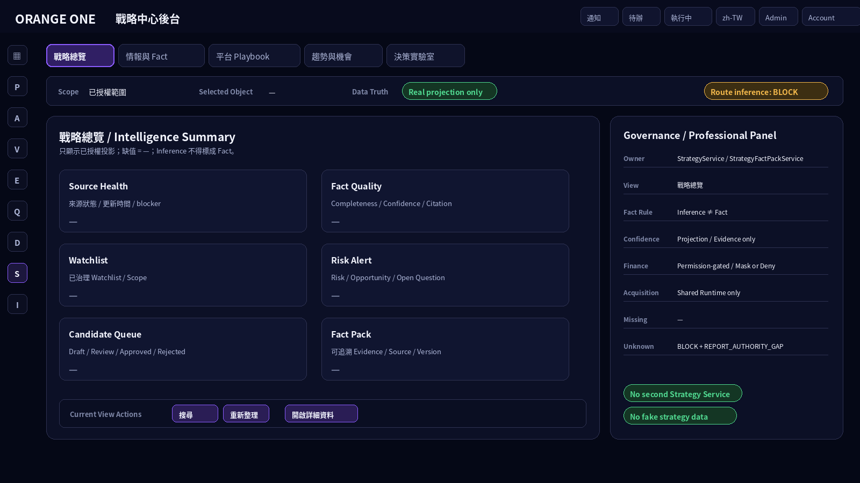
圖 A｜戰略總覽：五個 View 同頁切換；左側主工作區呈現真實 Strategy Projection，右側固定顯示 Owner、Truth、Permission 與 Runtime Boundary。

7. Functional Chain / 端到端功能鏈
Flow | Functional Chain
Overview Search | Authorized scope → query/scope → Search control → page/account/scope gate → searchProjection binding → projection owner → results → same-page table → Detail Drawer
Intelligence Configure | Selected exact governed resource → Config Modal → schema validation → configureGovernedResource → expected version/idempotency/audit → Strategy owner → updated projection → REVIEW/READY
Fact Approval | Exact resource/version → rationale → approveGovernedResource → approval gate → immutable lineage → approved projection → downstream consumers may read
Playbook Draft | Selected platform/account scope → content + refs → saveDraft → draft owner → new version → no auto publish → explicit later approval
Opportunity Candidate | Trend/Forecast projection + evidence → Create Candidate → candidate owner → DRAFT/REVIEW → explicit approval only
Decision Compare | Selected Strategy candidates → compareCandidates READ → normalized comparison projection → Human review → no mutation
Decision Reject/Adopt | Exact candidate/version + reason/evidence → Reject or Adopt Context → operation/permission/state gate → audit → ContextCandidate or rejected state → governed downstream handoff

8. Operation / Runtime Binding & Current Blockers
Operation | Method / Path | Owner | Effect | 施工 Gate
getUiProjection | GET /v1/ui-projections/{pageUid} | Read projection owner | READ | Page projection route must resolve
searchProjection | POST /v1/search | INFO_COMMAND_RUNTIME | SEARCH | admin STR-01 exact authorization context must resolve
refreshProjection | POST /v1/projections/refresh | INFO_COMMAND_RUNTIME | REFRESH | Source registry currently INFO-owned; STR binding must be exact
configureGovernedResource | PATCH /v1/governance/resources/{id} | IAM_RUNTIME / governance | CONFIGURE | Operation exists; admin STR-01 auth context must be materialized
approveGovernedResource | POST /v1/governance/resources/{id}/approve | IAM_RUNTIME / governance | APPROVE | Operation exists; admin STR-01 auth context must be materialized
saveDraft | POST /v1/drafts | IAM_RUNTIME / draft owner | DRAFT | Reused source operation; exact STR source binding required
exportProjection | POST /v1/exports | INFO_COMMAND_RUNTIME | EXPORT | Registry reports canonical export persistence owner blocker
createCandidate | POST /v1/candidates | Strategy candidate owner | CREATE CANDIDATE | Payload registered; exact current Operation Registry binding unresolved → BLOCK
compareCandidates | GET /v1/candidates/compare | Strategy comparison owner | READ COMPARE | No-form read contract exists; exact current Operation Registry binding unresolved → BLOCK
rejectStrategyCandidate | POST /v1/ai/strategy/candidates/{strategyCandidateId}/reject | Strategy candidate owner | DECIDE | Payload registered; exact current Operation Registry binding unresolved → BLOCK
adoptAsContextCandidate | POST /v1/state-commands/strategycandidate/adoptascontextcandidate | Strategy context owner | ADOPT | Payload registered; exact current Operation Registry binding unresolved → BLOCK

Current Runtime Truth｜UI Spec 可完整施工，但 Effectful controls 不能因頁面 Authority 已列出 Action 就視為可執行。只要 exact Operation Registry / authorization context / persistence owner 尚未閉合，控制必須 Disabled，並回報 Authority Gap。

9. Form / Input Contracts
Contract | Business Fields | View | Rule
SearchProjectionRequest | query*；scope_ref*；filters_json? | Overview / Intelligence | 不得用前端自行衍生 unauthorized filter
RefreshProjectionRequest | projection_type*；scope_ref* | Overview | 只刷新 exact projection/scope
ConfigureGovernedResourceRequest | resource_type*；resource_id*；config_patch_json*；reason* | Intelligence / Fact | 禁止跨 domain union payload
ApproveGovernedResourceRequest | resource_type*；resource_id*；rationale*；expected_resource_version? | Intelligence / Playbook / Opportunity | Approval 綁 exact resource/version
SaveDraftRequest | resource_type*；target_ref*；content*；reference_ids? | Playbook | Draft 不等於 Approved / Published
ExportProjectionRequest | projection_type*；scope_ref*；format* | Intelligence / Fact | Persistence owner 未閉合時不可假下載成功
CreateCandidateRequest | resource_type*；title?；source_ref?；content?；reference_ids? | Opportunity | Candidate ≠ Decision；需保留 evidence lineage
RejectStrategyCandidateRequest | path strategyCandidateId；decision_reason*；evidence_refs? | Decision | Body ID 若存在必須等於 path canonical ID
AdoptAsContextCandidateRequest | strategy_candidate_id*；decision_reason*；evidence_refs? | Decision | 只建立 Context Candidate，不執行 downstream owner action
Compare Candidates | No-form GET；selected candidates supplied by registered query contract | Decision | READ_ONLY；不得改 candidate state

10. Permission / Gate / Security Boundary
Gate | 條件
Page Gate | Identity + exact account page permission + admin Strategy target + scope + condition + audit
Read Gate | Page Gate + exact section/control/field read permission + classification/mask
Configure Gate | Read Gate + configure action permission + exact resource/version + state guard + idempotency + audit
Approve Gate | Page Gate + approve permission + REVIEW/eligible state + exact version + rationale + audit
Candidate Gate | Page Gate + candidate action permission + evidence/source scope + state/version + idempotency + audit
Decision Gate | Exact candidate + compare/decide/adopt permission + Human reason + evidence refs + state/version + audit
Finance Guardrail | Risk/Cost/Capacity 僅在 authorized finance projection 下顯示；否則 MASK/DENY，不得用推估填值
Acquisition Gate | Strategic intelligence acquisition 只能走 shared acquisition runtime；raw acquisition 不可直接成為 governed Fact

11. State Model / Truthful Status
State | UI / Runtime semantics
LOADING | 保留 geometry；effectful controls disabled
READY | 依 permission/state 顯示與 enable
EMPTY | 顯示空狀態；不造 sample
ERROR | 顯示 actual error / permitted reason
POLICY_BLOCKED | Authorized 但政策阻擋 → disabled + reason
VERSION_CONFLICT | 停止寫入；reload exact version；force overwrite 禁止
REVIEW_REQUIRED | 等待 Human/Governance review；不得自動 approve
EXTERNAL_PENDING | 外部情報或 acquisition pending；不得標示成功
READ_ONLY | 只讀；Effectful controls 隱藏/disabled
ARCHIVED | 只讀歷史；不可覆寫 lineage

12. Data Truth / Fact Quality / Lineage
- 任何 Fact 必須可回溯 source_ref、source_type、source_time_or_version、scope、confidence_or_quality_state。
- External Intelligence 只能成為 P4 輸入；不得覆蓋 Confirmed Decision / Current governed internal truth。
- Confidence、Completeness、Source Health 必須由 registered projection/evidence logic 提供，前端不可計分或手動改綠。
- Candidate / Opportunity / Playbook 是版本化治理物件；revision 建立新版本，歷史不覆蓋。
- Decision Context 必須同時呈現 Evidence、Assumption、Risk、Cost/Capacity Boundary、Uncertainty 與 Human reason；不能只顯示推薦結論。

13. Shared Acquisition Boundary
項目 | 規格
Runtime | ACPOS_SHARED_EXTERNAL_DATA_ACQUISITION_RUNTIME；admin STR-01 不擁有第二套 crawler/search runtime
Mode | STRATEGIC_INTELLIGENCE_ACQUISITION
Allowed | SEARCH_DISCOVERY / WEB_CRAWL / WEB_FETCH / SCHEDULED_RECRAWL
Raw Result | 僅為 acquisition evidence；必須經 Fact quality / source / citation / governance 才能成為 governed Fact
Failure | 保留 exact source/error/pending；不得用 AI 摘要偽裝成成功抓取

14. Decision Lab / Governed Handoff Design
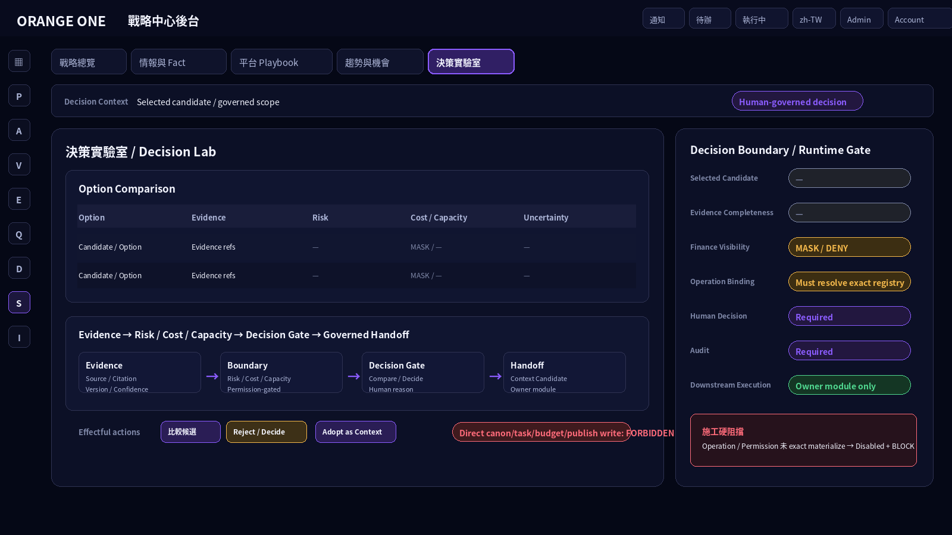
圖 B｜決策實驗室：比較候選、Evidence、Risk/Cost/Capacity 與 Human Gate 同屏；Adopt 僅建立 Context Candidate，禁止直接修改 Canon、Task、Budget 或 Publish state。

15. Error / Recovery / Partial Failure
Error | Recovery
AUTH_DENIED | Hide/deny protected control/value；server 仍拒絕 direct call；不得以角色名或部門作 allow
SOURCE_STALE | 標示 stale / actual timestamp；保留上一可驗證 projection；提供 registered refresh only
FACT_INCOMPLETE | 顯示 missing / incomplete / confidence state；不得補 0、補假 Fact 或 AI 猜值
VERSION_CONFLICT | 阻止 effectful write；reload exact object/version；保留未提交表單供人工比較
OPERATION_UNMATERIALIZED | Disabled + reason + REPORT_AUTHORITY_GAP；不得自行創 endpoint / permission / runtime
EXPORT_BLOCKED | 不顯示假下載；顯示 persistence owner 未閉合或 actual backend reason
ACQUISITION_PARTIAL | 保留已取得 evidence；缺失來源仍 pending/error；只重試合法缺失工作
DOWNSTREAM_OWNER_BLOCKED | 保留 Context Candidate / handoff ref；由 owner module 處理；Strategy page 不越權執行

16. i18n / Accessibility / Responsive
項目 | 要求
i18n | zh-TW / zh-CN / en；ORANGE ONE、ACPOS、AI、API、QA 等固定詞依 Global 規則處理
Keyboard | Tabs / Table actions / Drawer / Modal 全可鍵盤到達；Focus visible，不可只靠色彩
Drawer/Modal | Focus trap；Escape/Close；Effectful Modal 關閉前保留/提示未提交內容
Status | Success/Warning/Error/Processing 不只用顏色；必須有文字或 icon 語義
Responsive | Desktop-first，同頁 reflow；不得建立 mobile-only 第二頁；長表格允許受控 horizontal scroll
Text capacity | 長 title/source/citation 採 ellipsis + Detail Drawer；按鈕文字不得壓框/破框

17. Acceptance Matrix / Definition of Done
ID | Acceptance | Pass Condition
STR-A-01 | Single Current Page | 只存在 admin:STR-01 Current Strategy admin page；不得重建舊多頁 Strategy admin
STR-A-02 | Five Views | 總覽 / 情報與 Fact / Playbook / 趨勢與機會 / 決策實驗室皆為同頁 View
STR-A-03 | Owner Reuse | 只使用 StrategyService + StrategyFactPackService + shared owners；無第二套服務
STR-A-04 | Action Isolation | 每個 View 只使用其 registered action family；payload 不跨 source union
STR-A-05 | Fact Truth | Inference 不得標 Fact；Confidence/Health/Cost/Capacity 不得偽造
STR-A-06 | Version Lineage | Playbook/Opportunity/Candidate/Context 變更保留版本與 evidence lineage
STR-A-07 | Decision Boundary | Decision Lab 不直接寫 Canon/Task/Budget/Publish；handoff 到 owner
STR-A-08 | Acquisition Boundary | 只走 shared acquisition runtime；raw result 不直接成 Fact
STR-A-09 | Permission | Account assignment + scope/condition/state/version/idempotency/audit server-side gate
STR-A-10 | Runtime Honesty | 未 materialized Operation/Permission/Persistence → Disabled/BLOCK；不得以文件宣告 runtime complete
STR-A-11 | Visual Geometry | 無壓邊/破框/重疊；Drawer/Modal/Tab/Table 遵守 Global geometry
STR-A-12 | A11y / i18n | Keyboard/Focus/Status/i18n 三語施工條件完整

18. Hard Locks / 施工不可破壞規則
- 只允許一個 admin:STR-01 Current Strategy Administration；禁止平行 Strategy admin pages。
- 本頁不得定義 Global Sidebar sibling order；只宣告自己的 active menu key / page identity。
- StrategyService 與 StrategyFactPackService 不得 merge/rebuild；shared acquisition runtime 不得複製。
- Inference ≠ Fact；Candidate ≠ Decision；Playbook ≠ Publish；Opportunity ≠ Project/Budget mutation。
- Decision Lab 不得直接寫 Canon Lock、Task、Budget、Publish state。
- 外部情報不得覆蓋 Current governed internal truth；缺值顯示 —，不得 AI-fill。
- Effectful action 必須 exact Operation + Permission + State + Version + Idempotency + Audit；缺任一項即 BLOCK。
- Export、Candidate、Decision 等若 runtime owner/persistence/authorization 未 current materialize，不得假接、不得 fake success。

19. Construction Mapping / 實作順序
Phase | 施工與驗收
1 Shell / Page Mount | 掛載 admin:STR-01；只消費 Global navigation，不改 menu order
2 Five-view Context | 建立同頁 tabs + preserve scope/object/query/form state；無 route split
3 Projection Layer | Overview / Fact / Playbook / Opportunity / Decision read projections；缺值與 masking 正確
4 Drawer / Modal | Read Detail Drawer + schema-driven Effectful Modal；focus/a11y 完整
5 Operation Binding | 逐 Action 對 exact operation/schema/runtime/permission；未 materialized 控制維持 disabled
6 Data Lineage | Source → Fact → Evidence → Candidate → Context / Approval / Audit exact refs
7 Acquisition | 接 shared strategic intelligence acquisition；raw→fact governance boundary
8 Decision Boundary | Compare / Reject / Adopt Context；確認無 downstream direct mutation
9 Regression / E2E | 五 View、所有可見控制、權限、state/version/idempotency、error/recovery、restart persistence
10 Production Acceptance | 只有 exact deployed SHA + production evidence 成立後，才可把 Runtime status 改為完成

