ACPOS · STR-01
戰略中心工作區
Mother-Compliant Basic Design · Tech Purple
Current Authority 基準：GitHub new · 165c6440cb53…
UI Candidate，不代表 Current Canonical Visual 已更新
項目 | Current
Page UID | workspace:STR-01
Canonical Name | 戰略中心工作區 / Strategic Center Workspace
Page Authority SHA | 618e56f2f993bc818d943cb14db6ce455d68a1c5
Manifest SHA | 465329b6fb19b8e44c3083a9f280015ee95cc55c
Authority Status | FINAL_LOCKED / current_only
Design Status | VISUAL_CANDIDATE / PENDING HUMAN REVIEW
Design Freeze | FALSE

0. Current Truth / Authority Basis
本文件只作 STR-01 Basic Design / Construction Blueprint。Current Authority、Global Shell、Global Visual 為上位來源；本 Word 不反向修改 Authority。
優先序 | 來源 | 作用
1 | ACPOS_CURRENT_AUTHORITY_MANIFEST | Current authority set
2 | GLOBAL_HOME_SHELL_TEMPLATE_AUTHORITY V1.9 | 58px Header / 64px collapsed / 221px overlay
3 | GLOBAL_WEB_VISUAL_SYSTEM_AUTHORITY V1.0 | 科技紫 tokens / component states
4 | authority/pages/workspace/STR-01/ACPOS_STR-01_FINAL_LOCKED_ENCODING_PROVIDER_BOUND.yaml | STR-01 UX/business/registry
5 | 本 Word | UI candidate / construction reference

Current Registry Denominator
Artifact | Count
Sections / Visuals | 12 / 12
Components | 16
Controls | 57
Actions | 11
Gates / Permissions | 11 / 5
Objects / Errors / States | 12 / 9 / 9
Stages | 6
Integration Ports | 6

Governance Consistency Note
Current Manifest、authority header 與 shared_provider_adapter_binding 都指向 ACPOS_PRODUCTION_SCRIPT_CONTENT_AND_PROVIDER_ADAPTER_CONTRACT@V1.3；同檔 legacy validation/hard-lock 文字仍殘留 V1.2。本文依 Current Manifest + formal binding 使用 V1.3，並保留此差異作治理修正事項，不宣稱 Authority 已被改寫。

1. Purpose / Hard Boundary
- STR-01 用於企業策略情報整理、趨勢分析、方案比較、風險評估、資源建議與人工決策輔助。
- AI only provides analysis/proposals. Formal strategy decision is human-governed.
- Finance / Workflow / Governance / Production execution remains in owning modules.
- External intelligence cannot overwrite confirmed decisions/current governed internal truth.
- Missing source/finance/resource/risk/KPI/evidence values remain —; AI must not invent them.

2. Strategic Context Contract
Priority | Meaning
P0 | Current Human Instruction
P1 | Confirmed Decision
P2 | Current Valid Internal Data
P3 | Historical Strategic Analysis / Baseline / Experience
P4 | External Intelligence

Required Context Metadata
Field | Rule
source_ref | REQUIRED / exact source metadata
source_type | REQUIRED / exact source metadata
source_time_or_version | REQUIRED / exact source metadata
scope | REQUIRED / exact source metadata
confidence_or_quality_state | REQUIRED / exact source metadata

Supported Source Types
Type
市場情報
產業資料
競爭資訊
企業內部資料
資源能力
成本資訊
風險資訊
Governance 條件

3. Business Object Inventory · 12/12
Object UID | Entity | Required Content
STR-01-OBJ-TOPIC | StrategyTopicRef | strategy_topic_id + title + scope + objective + status + conversation/thread refs
STR-01-OBJ-CONTEXT | StrategicContextBundle | market/industry/competition/internal/resource/cost/risk/governance refs + priority + source_time/version + confidence
STR-01-OBJ-CONVERSATION | StrategicConversationRef | conversation_id + topic ref + mode + message refs + context fingerprint + audit
STR-01-OBJ-ANALYSIS | StrategyAnalysisResult | basis + assumptions + opportunity + risk + uncertainty + pattern/baseline/forecast + evidence
STR-01-OBJ-CANDIDATE | StrategyCandidate | candidate_id/version + output type + proposal + analysis refs + risk + uncertainty + evidence + state
STR-01-OBJ-RECOMMENDATION | StrategyRecommendation | summary + basis + recommended path + reason + risk + uncertainty + evidence
STR-01-OBJ-ALERT | StrategyAlert | alert type + scope + reason + evidence + urgency/priority + recommended response
STR-01-OBJ-RESOURCE | ResourceProposal | target + need + reason + expected effect + cost/capacity impact + risk + dependency
STR-01-OBJ-BRIEF | DecisionBrief | issue + context + options + recommendation + alternatives + risks + unknowns + decision needed
STR-01-OBJ-LEDGER | StrategyDecisionLedgerEntry | decision_id + candidate + sources + risk + approval level + result + reason + actor/time + execution status/ref
STR-01-OBJ-MEMORY | StrategicExperienceRef | pattern/case/experiment/baseline/result/KPI/expected-vs-actual/learning + immutable history
STR-01-OBJ-FEEDBACK | StrategyExecutionFeedback | execution ref + actual result + KPI/revenue/cost/performance + expected-vs-actual + learning

4. Conversation / AI Continuity Contract
- Shared Core = ACPOS AI Conversation Core; strategy extension only.
- Modes = SINGLE_AI / MULTI_AI. Assistant always exists and is not a mode.
- MULTI_AI = same original question + same Strategic Context + same evidence basis → independent complete viewpoints → Assistant synthesis after responses.
- Provider/Model picker is FORBIDDEN. Provider brand may display on response; technical details belong to AIAPI-01.
- Input supports zh-TW instruction, file/image refs, @Strategy/@Alert/@Knowledge/@Decision, quoted message/response refs.
- Raw AI response never becomes formal Strategy Decision automatically.

Visible Record
Record
User instruction
AI viewpoints
Assistant summary
analysis basis
assumptions
risks
uncertainty
human decision record

5. Strategy Analysis / Output Contract
Analysis Mandatory Field
analysis_basis
assumptions
opportunities
risks
uncertainties
option_comparison
recommendation_reason
evidence_refs

Four Structured Outputs
Type | Meaning
STRATEGY_RECOMMENDATION | Strategy Recommendation / 策略建議
STRATEGY_ALERT | Strategy Alert / 風險與機會提醒
RESOURCE_PROPOSAL | Resource Proposal / 資源配置建議；approval belongs to owner module
DECISION_BRIEF | Decision Brief / 決策摘要

6. Page / Section / Component Registry

6.1 Sections · 12/12
Section UID | Name | Responsibility | Visual
STR-01-SEC-01 | Strategy Context Bar | Strategy Topic, scope, horizon, mode, state, current decision status | STR-01-VIS-CONTEXT
STR-01-SEC-02 | Strategy Topics / History | Strategy topic list, search, current topic selection, previous discussions | STR-01-VIS-LEFT-TOPIC
STR-01-SEC-03 | Strategic Context | Market/industry/competition/internal/resource/cost/risk/governance sources and confidence | STR-01-VIS-LEFT-CONTEXT
STR-01-SEC-04 | Strategic Alerts / Open Questions | Relevant opportunity/risk alerts and missing-information questions | STR-01-VIS-LEFT-ALERT
STR-01-SEC-05 | Strategic AI Conversation | Single/Multi AI conversation, attachment/image/reference, assistant summary | STR-01-VIS-CONVERSATION
STR-01-SEC-06 | Strategy Analysis | Basis, assumptions, opportunity, risk, uncertainty, pattern/baseline/forecast | STR-01-VIS-ANALYSIS
STR-01-SEC-07 | Option Comparison | Compare strategy candidates/options without deleting prior versions | STR-01-VIS-COMPARE
STR-01-SEC-08 | Strategy Outputs | Recommendation, Alert, Resource Proposal, Decision Brief | STR-01-VIS-RIGHT-OUTPUT
STR-01-SEC-09 | Human Review / Decision Ledger | Review status, candidate status, human decision record, execution status | STR-01-VIS-RIGHT-DECISION
STR-01-SEC-10 | Strategic Memory / Experience | Patterns, cases, experiments, baselines, KPI changes and learning | STR-01-VIS-MEMORY
STR-01-SEC-11 | Feedback Loop | Expected vs Actual, difference, learning, owner execution feedback | STR-01-VIS-FEEDBACK
STR-01-SEC-12 | Audit / Boundary | Source trace, provider brand, correlation, permission, owner handoff boundary | STR-01-VIS-STATUS

6.2 Components · 16/16
Component UID | Section | Name
STR-01-CMP-CONTEXT | STR-01-SEC-01 | Strategic Context Bar
STR-01-CMP-TOPICS | STR-01-SEC-02 | Strategy Topic List / History
STR-01-CMP-SOURCE-STACK | STR-01-SEC-03 | Strategic Context Source Stack
STR-01-CMP-ALERTS | STR-01-SEC-04 | Strategy Alerts / Open Questions
STR-01-CMP-CONVERSATION | STR-01-SEC-05 | AI Conversation Workspace
STR-01-CMP-MODE | STR-01-SEC-05 | Single / Multi AI Mode
STR-01-CMP-COMPOSER | STR-01-SEC-05 | Conversation Composer
STR-01-CMP-ASSISTANT | STR-01-SEC-05 | Assistant Summary / Meeting Record
STR-01-CMP-ANALYSIS | STR-01-SEC-06 | Strategy Analysis Result
STR-01-CMP-COMPARE | STR-01-SEC-07 | Option Comparison
STR-01-CMP-OUTPUTS | STR-01-SEC-08 | Strategic Output Cards
STR-01-CMP-REVIEW | STR-01-SEC-09 | Human Review
STR-01-CMP-LEDGER | STR-01-SEC-09 | Decision Ledger
STR-01-CMP-MEMORY | STR-01-SEC-10 | Strategic Memory / Experience
STR-01-CMP-FEEDBACK | STR-01-SEC-11 | Expected vs Actual / Learning
STR-01-CMP-STATUS | STR-01-SEC-12 | Audit / Boundary / Handoff Status

7. Interaction / Stage Flow
Stage UID | Stage | Flow
STR-01-STAGE-01-CONTEXT | Resolve Strategic Context | Topic + sources + confirmed decisions + current internal data + historical experience + external intelligence
STR-01-STAGE-02-CONVERSE | Strategic Conversation | Single/Multi AI same issue/context -> independent views -> Assistant record
STR-01-STAGE-03-ANALYZE | Analyze / Compare | Pattern/Baseline/Forecast -> Need/Opportunity/Risk/Priority -> Option comparison
STR-01-STAGE-04-OUTPUT | Strategic Outputs | Recommendation / Alert / Resource Proposal / Decision Brief candidate outputs
STR-01-STAGE-05-HUMAN | Human Review / Decision | Submit strategy review -> human decision -> governed strategy context adoption when approved
STR-01-STAGE-06-FEEDBACK | Execution Feedback / Learning | Owner execution result -> Expected vs Actual -> Learning -> Strategic Experience

Functional Flow
Resolve Context → Strategic Conversation → Analyze/Compare → Structured Outputs → Human Review/Decision → Owner Execution Feedback/Learning。STR-01 不跨界執行 owner-module action。

8. Action / Operation Contract · 11/11
Action UID | Label | Permission | Gate | Effect | Operation
STR-01-ACT-NOOP | Read display | STR_VIEW | STR-01-GATE-PAGE | READ_ONLY | —
STR-01-ACT-TOPIC-SELECT | Select Strategy Topic | STR_VIEW | STR-01-GATE-PAGE | CONTEXT_STATE | —
STR-01-ACT-FILTER | Filter current strategic projection | STR_VIEW | STR-01-GATE-PAGE | UI_ONLY | —
STR-01-ACT-MODE | Single / Multi AI mode | STR_VIEW | STR-01-GATE-TOPIC | UI_ONLY | —
STR-01-ACT-SEND | Send Strategic Message | STR_CONVERSATION | STR-01-GATE-MESSAGE | CONVERSATION_WRITE | sendConversationMessage
STR-01-ACT-STOP | Stop Current Generation | STR_CONVERSATION | STR-01-GATE-MESSAGE | CONVERSATION_CONTROL | stopConversationGeneration
STR-01-ACT-COMPARE | Compare Strategy Candidates | STR_COMPARE | STR-01-GATE-COMPARE | READ_MODEL_QUERY | compareCandidates
STR-01-ACT-REVIEW | Submit Strategy Review | STR_REVIEW | STR-01-GATE-REVIEW | STRATEGY_REVIEW_REQUEST | submitStrategyReview
STR-01-ACT-ADOPT | Adopt Reviewed Strategy Context | STR_ADOPT | STR-01-GATE-ADOPT | STRATEGY_CONTEXT_ADOPTION | adoptAsContextCandidate
STR-01-ACT-OPEN-OWNER | Open Execution Owner Module | STR_VIEW | STR-01-GATE-PAGE | UI_NAVIGATION | —
STR-01-ACT-AUDIT | Open Audit / Trace | STR_VIEW | STR-01-GATE-PAGE | UI_ONLY | —

9. Visual Architecture / Tech Purple UI Candidate
Global Shell: 58px fixed Header；64px icon-only collapsed sidebar；221px hover/focus overlay，不造成 workspace reflow。STR-01 Primary Grid ≈ 19% / 59% / 22%，Conversation 是中心 dominant region。

9.1 Visual A — Single AI Main Workspace
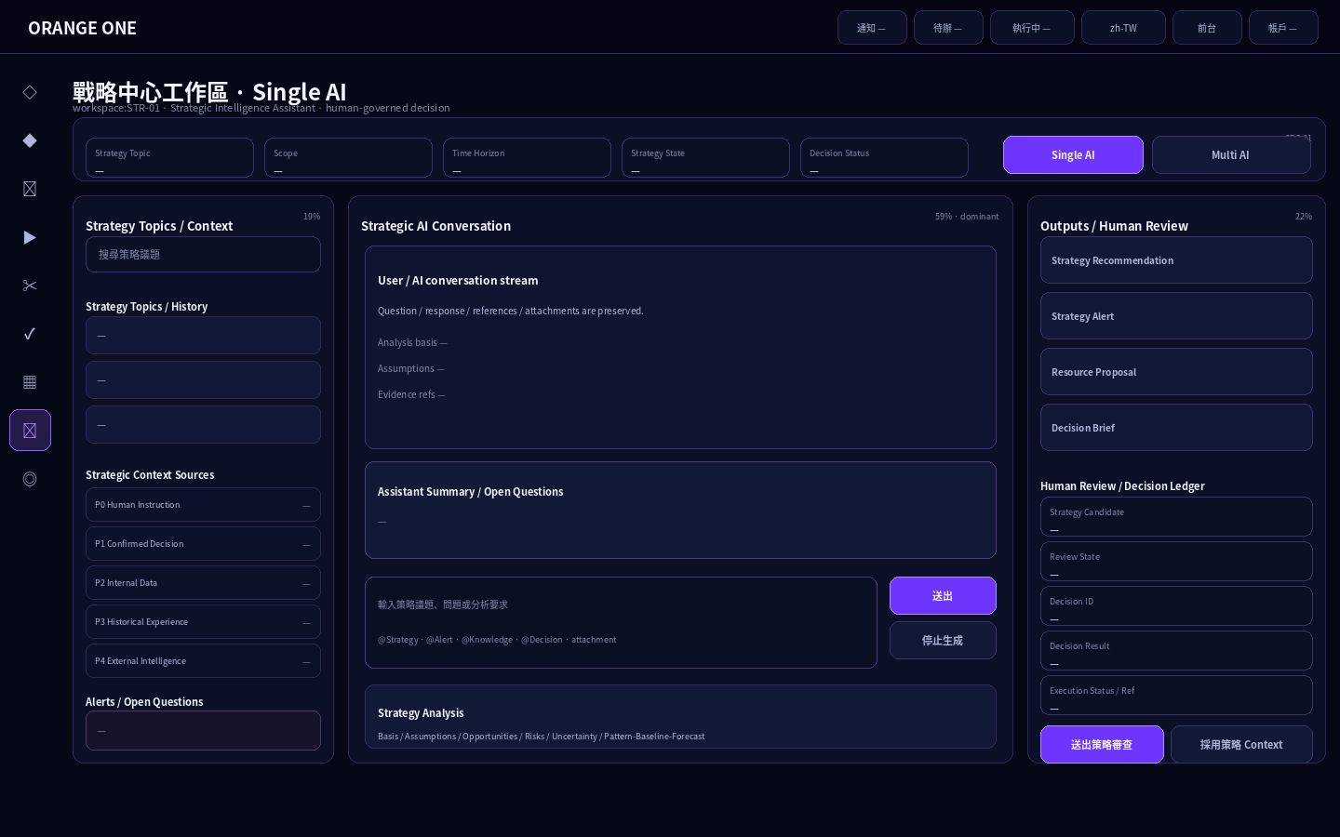
Strategy Topics / Context / Alerts + Strategic AI Conversation + Outputs / Human Review。所有 business values = —。

9.2 Visual B — Multi AI Same-Context Workspace
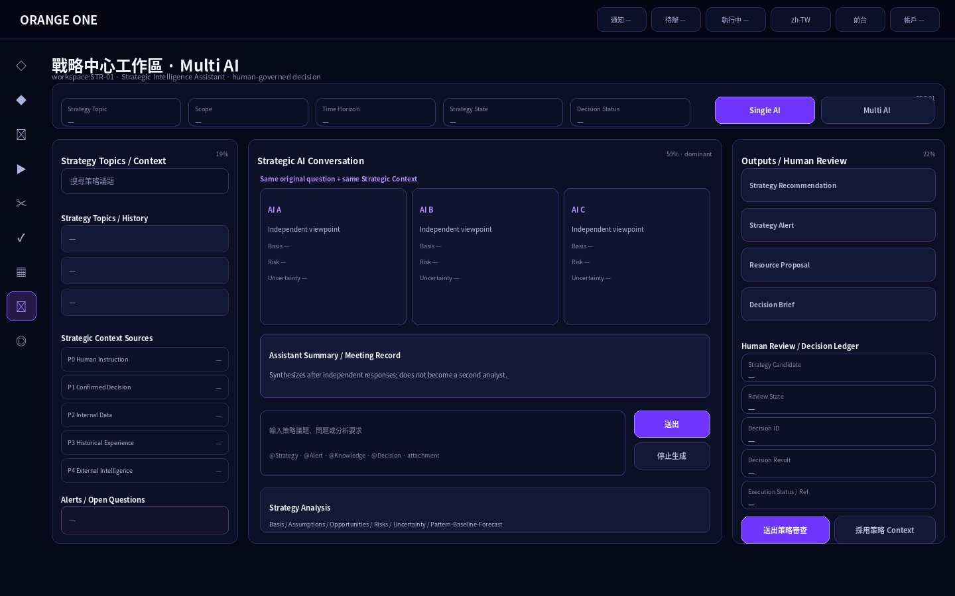
三個獨立 viewpoints 使用同一 original question + Strategic Context；Assistant 只在回應後綜整。

10. Visual State Set

10.1 Visual C — Option Comparison
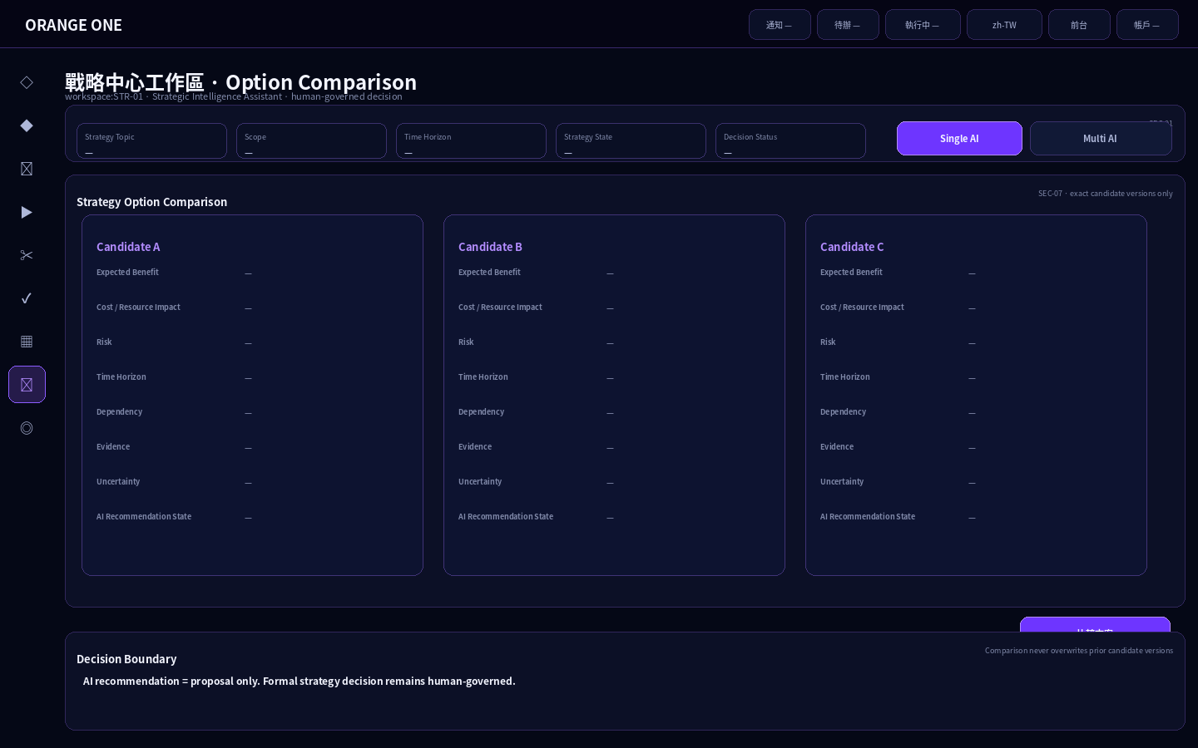
Exact strategy candidate/version refs only；比較欄位包含 benefit / cost / risk / horizon / dependency / evidence / uncertainty。

10.2 Visual D — Human Review / Decision Ledger
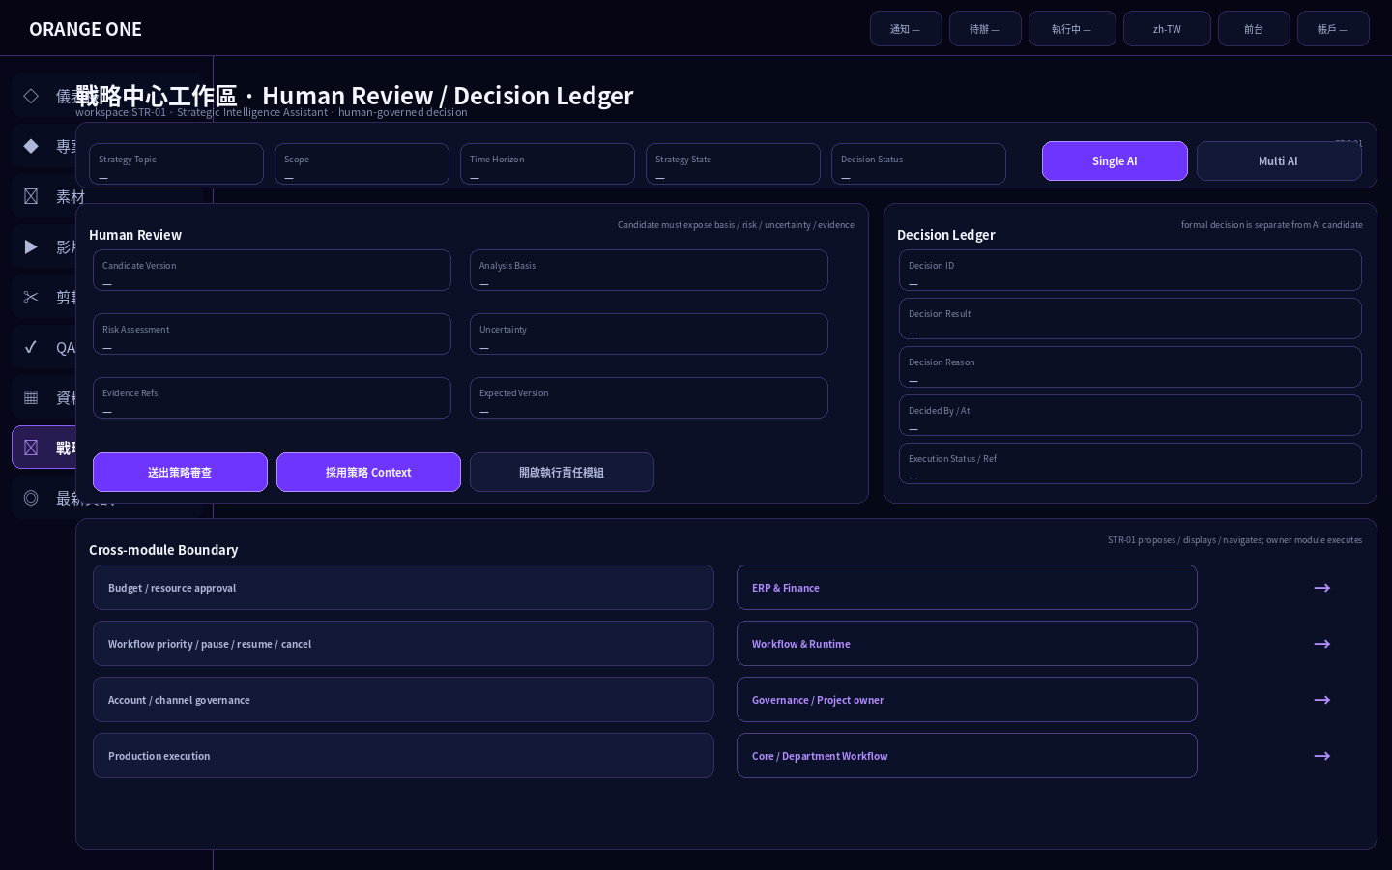
221px Sidebar Overlay + Human Review + Decision Ledger + Cross-module owner boundaries。

11. Memory / Feedback / Audit Visual

11.1 Visual E — Strategic Memory / Feedback Loop
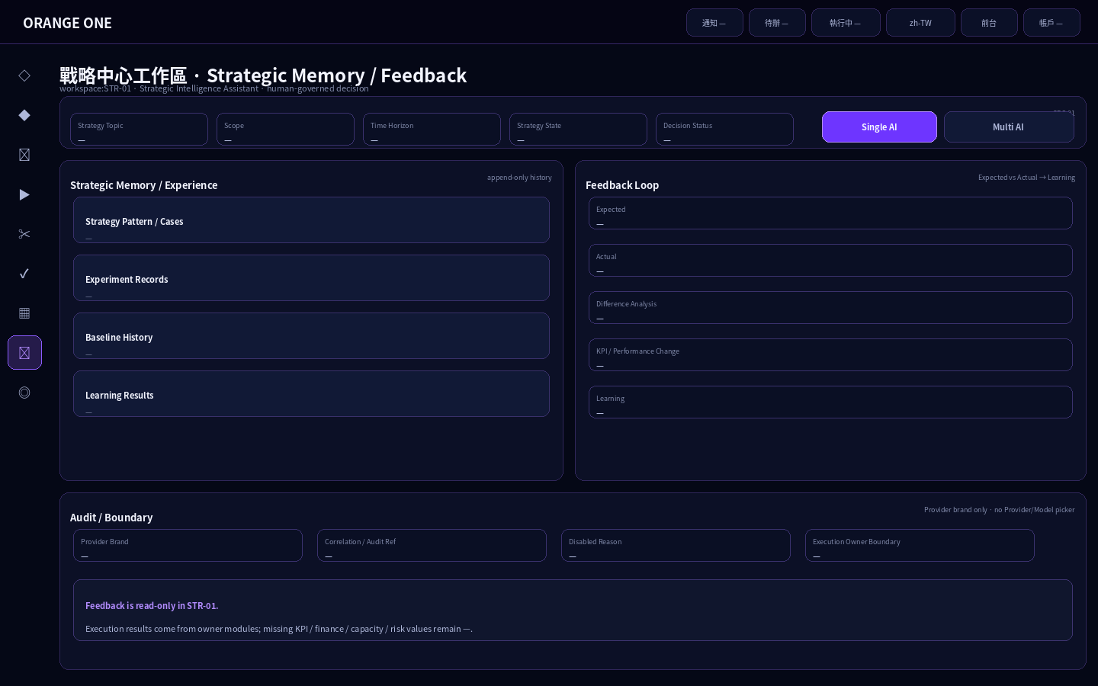
Strategic Memory append-only；Execution result / KPI / Expected-vs-Actual 從 owner module 回流；Provider brand only。

12. Geometry / Workbench Ratio
Region | Geometry / Behavior
Global Header | 58px fixed top, full width
Collapsed Sidebar | 64px interaction rail; icons only; no visible panel
Expanded Sidebar | 221px fixed overlay; no page reflow
Workspace Origin | x=78px / y=68px
Context Bar | 100% width; h=56px
Primary Grid | minmax(280px,1fr) / minmax(720px,3fr) / minmax(320px,1.12fr); ≈19/59/22; gap 16px
Conversation | center upper; dominant
Analysis | center lower; stacked/collapsible
Option Compare | lower full-width
Memory / Feedback | lower full-width / 2-column
Controls | h40; radius10; missing data = —
Panels | radius12; global tech-purple only

13. Control / Field / Action / Gate / Permission Binding · 57/57
Control UID | Section | Type / Label | Action | Gate | Permission
STR-01-FLD-TOPIC | STR-01-SEC-01 | READONLY / Strategy Topic | STR-01-ACT-NOOP | STR-01-GATE-PAGE | STR_VIEW
STR-01-FLD-SCOPE | STR-01-SEC-01 | READONLY / Strategy Scope | STR-01-ACT-NOOP | STR-01-GATE-PAGE | STR_VIEW
STR-01-FLD-HORIZON | STR-01-SEC-01 | READONLY / Time Horizon | STR-01-ACT-NOOP | STR-01-GATE-PAGE | STR_VIEW
STR-01-FLD-STATE | STR-01-SEC-01 | READONLY / Strategy State | STR-01-ACT-NOOP | STR-01-GATE-PAGE | STR_VIEW
STR-01-FLD-DECISION-STATE | STR-01-SEC-01 | READONLY / Decision Status | STR-01-ACT-NOOP | STR-01-GATE-PAGE | STR_VIEW
STR-01-TGL-MODE | STR-01-SEC-01 | TOGGLE / Single AI / Multi AI | STR-01-ACT-MODE | STR-01-GATE-TOPIC | STR_VIEW
STR-01-INP-TOPIC-SEARCH | STR-01-SEC-02 | SEARCH / 搜尋策略議題 | STR-01-ACT-FILTER | STR-01-GATE-PAGE | STR_VIEW
STR-01-LST-TOPICS | STR-01-SEC-02 | LIST / Strategy Topics / History | STR-01-ACT-TOPIC-SELECT | STR-01-GATE-PAGE | STR_VIEW
STR-01-LST-CONTEXT | STR-01-SEC-03 | LIST / Strategic Context Sources | STR-01-ACT-NOOP | STR-01-GATE-CONTEXT | STR_VIEW
STR-01-FLD-CONTEXT-PRIORITY | STR-01-SEC-03 | READONLY / Context Priority | STR-01-ACT-NOOP | STR-01-GATE-CONTEXT | STR_VIEW
STR-01-FLD-CONTEXT-SOURCE | STR-01-SEC-03 | READONLY / Source / Ref | STR-01-ACT-NOOP | STR-01-GATE-CONTEXT | STR_VIEW
STR-01-FLD-CONTEXT-TIME | STR-01-SEC-03 | READONLY / Source Time / Version | STR-01-ACT-NOOP | STR-01-GATE-CONTEXT | STR_VIEW
STR-01-FLD-CONTEXT-CONFIDENCE | STR-01-SEC-03 | READONLY / Confidence / Quality | STR-01-ACT-NOOP | STR-01-GATE-CONTEXT | STR_VIEW
STR-01-LST-ALERTS | STR-01-SEC-04 | LIST / Strategy Alerts / Open Questions | STR-01-ACT-NOOP | STR-01-GATE-PAGE | STR_VIEW
STR-01-VIEW-CONVERSATION | STR-01-SEC-05 | CONVERSATION / Strategic AI Conversation | STR-01-ACT-NOOP | STR-01-GATE-TOPIC | STR_VIEW
STR-01-BTN-ATTACH | STR-01-SEC-05 | ATTACHMENT / 附件 / 圖片 | STR-01-ACT-NOOP | STR-01-GATE-TOPIC | STR_VIEW
STR-01-INP-MESSAGE | STR-01-SEC-05 | TEXTAREA / 輸入策略議題、問題或分析要求 | STR-01-ACT-SEND | STR-01-GATE-MESSAGE | STR_CONVERSATION
STR-01-BTN-SEND | STR-01-SEC-05 | PRIMARY_BUTTON / 送出 | STR-01-ACT-SEND | STR-01-GATE-MESSAGE | STR_CONVERSATION
STR-01-BTN-STOP | STR-01-SEC-05 | BUTTON / 停止生成 | STR-01-ACT-STOP | STR-01-GATE-MESSAGE | STR_CONVERSATION
STR-01-FLD-ASSISTANT-SUMMARY | STR-01-SEC-05 | READONLY / Assistant Summary | STR-01-ACT-NOOP | STR-01-GATE-ANALYSIS | STR_VIEW
STR-01-FLD-OPEN-QUESTIONS | STR-01-SEC-05 | READONLY / Open Questions | STR-01-ACT-NOOP | STR-01-GATE-ANALYSIS | STR_VIEW
STR-01-FLD-MEETING-RECORD | STR-01-SEC-05 | READONLY / Meeting / Discussion Record | STR-01-ACT-NOOP | STR-01-GATE-ANALYSIS | STR_VIEW
STR-01-FLD-BASIS | STR-01-SEC-06 | READONLY / 分析依據 / Basis | STR-01-ACT-NOOP | STR-01-GATE-ANALYSIS | STR_VIEW
STR-01-FLD-ASSUMPTIONS | STR-01-SEC-06 | READONLY / 假設 / Assumptions | STR-01-ACT-NOOP | STR-01-GATE-ANALYSIS | STR_VIEW
STR-01-FLD-OPPORTUNITIES | STR-01-SEC-06 | READONLY / 機會 / Opportunities | STR-01-ACT-NOOP | STR-01-GATE-ANALYSIS | STR_VIEW
STR-01-FLD-RISKS | STR-01-SEC-06 | READONLY / 風險 / Risks | STR-01-ACT-NOOP | STR-01-GATE-ANALYSIS | STR_VIEW
STR-01-FLD-UNCERTAINTY | STR-01-SEC-06 | READONLY / 不確定性 / Uncertainty | STR-01-ACT-NOOP | STR-01-GATE-ANALYSIS | STR_VIEW
STR-01-FLD-PATTERN | STR-01-SEC-06 | READONLY / Pattern / Baseline / Forecast | STR-01-ACT-NOOP | STR-01-GATE-ANALYSIS | STR_VIEW
STR-01-TBL-COMPARE | STR-01-SEC-07 | TABLE / Strategy Option Comparison | STR-01-ACT-COMPARE | STR-01-GATE-COMPARE | STR_COMPARE
STR-01-BTN-COMPARE | STR-01-SEC-07 | BUTTON / 比較方案 | STR-01-ACT-COMPARE | STR-01-GATE-COMPARE | STR_COMPARE
STR-01-CARD-RECOMMENDATION | STR-01-SEC-08 | READONLY_CARD / Strategy Recommendation | STR-01-ACT-NOOP | STR-01-GATE-ANALYSIS | STR_VIEW
STR-01-CARD-ALERT | STR-01-SEC-08 | READONLY_CARD / Strategy Alert | STR-01-ACT-NOOP | STR-01-GATE-ANALYSIS | STR_VIEW
STR-01-CARD-RESOURCE | STR-01-SEC-08 | READONLY_CARD / Resource Proposal | STR-01-ACT-NOOP | STR-01-GATE-ANALYSIS | STR_VIEW
STR-01-CARD-BRIEF | STR-01-SEC-08 | READONLY_CARD / Decision Brief | STR-01-ACT-NOOP | STR-01-GATE-ANALYSIS | STR_VIEW
STR-01-FLD-CANDIDATE-REF | STR-01-SEC-09 | READONLY / Strategy Candidate | STR-01-ACT-NOOP | STR-01-GATE-PAGE | STR_VIEW
STR-01-FLD-REVIEW-STATE | STR-01-SEC-09 | READONLY / Review State | STR-01-ACT-NOOP | STR-01-GATE-PAGE | STR_VIEW
STR-01-FLD-DECISION-ID | STR-01-SEC-09 | READONLY / Decision ID | STR-01-ACT-NOOP | STR-01-GATE-PAGE | STR_VIEW
STR-01-FLD-DECISION-RESULT | STR-01-SEC-09 | READONLY / Decision Result | STR-01-ACT-NOOP | STR-01-GATE-PAGE | STR_VIEW
STR-01-FLD-DECISION-REASON | STR-01-SEC-09 | READONLY / Decision Reason | STR-01-ACT-NOOP | STR-01-GATE-PAGE | STR_VIEW
STR-01-FLD-EXECUTION-STATE | STR-01-SEC-09 | READONLY / Execution Status / Ref | STR-01-ACT-NOOP | STR-01-GATE-PAGE | STR_VIEW
STR-01-BTN-SUBMIT-REVIEW | STR-01-SEC-09 | PRIMARY_BUTTON / 送出策略審查 | STR-01-ACT-REVIEW | STR-01-GATE-REVIEW | STR_REVIEW
STR-01-BTN-ADOPT | STR-01-SEC-09 | PRIMARY_BUTTON / 採用策略 Context | STR-01-ACT-ADOPT | STR-01-GATE-ADOPT | STR_ADOPT
STR-01-BTN-OPEN-OWNER | STR-01-SEC-09 | BUTTON / 開啟執行責任模組 | STR-01-ACT-OPEN-OWNER | STR-01-GATE-PAGE | STR_VIEW
STR-01-LST-PATTERNS | STR-01-SEC-10 | LIST / Strategy Pattern / Cases | STR-01-ACT-NOOP | STR-01-GATE-MEMORY | STR_VIEW
STR-01-LST-EXPERIMENTS | STR-01-SEC-10 | LIST / Experiment Records | STR-01-ACT-NOOP | STR-01-GATE-MEMORY | STR_VIEW
STR-01-LST-BASELINES | STR-01-SEC-10 | LIST / Baseline History | STR-01-ACT-NOOP | STR-01-GATE-MEMORY | STR_VIEW
STR-01-LST-LEARNING | STR-01-SEC-10 | LIST / Learning Results | STR-01-ACT-NOOP | STR-01-GATE-MEMORY | STR_VIEW
STR-01-FLD-EXPECTED | STR-01-SEC-11 | READONLY / Expected | STR-01-ACT-NOOP | STR-01-GATE-FEEDBACK | STR_VIEW
STR-01-FLD-ACTUAL | STR-01-SEC-11 | READONLY / Actual | STR-01-ACT-NOOP | STR-01-GATE-FEEDBACK | STR_VIEW
STR-01-FLD-DIFFERENCE | STR-01-SEC-11 | READONLY / Difference Analysis | STR-01-ACT-NOOP | STR-01-GATE-FEEDBACK | STR_VIEW
STR-01-FLD-KPI | STR-01-SEC-11 | READONLY / KPI / Performance Change | STR-01-ACT-NOOP | STR-01-GATE-FEEDBACK | STR_VIEW
STR-01-FLD-LEARNING | STR-01-SEC-11 | READONLY / Learning | STR-01-ACT-NOOP | STR-01-GATE-FEEDBACK | STR_VIEW
STR-01-FLD-PROVIDER-BRAND | STR-01-SEC-12 | READONLY / Provider Brand | STR-01-ACT-NOOP | STR-01-GATE-PAGE | STR_VIEW
STR-01-FLD-CORRELATION | STR-01-SEC-12 | READONLY / Correlation / Audit Ref | STR-01-ACT-NOOP | STR-01-GATE-PAGE | STR_VIEW
STR-01-FLD-DISABLED | STR-01-SEC-12 | READONLY / Disabled Reason | STR-01-ACT-NOOP | STR-01-GATE-PAGE | STR_VIEW
STR-01-FLD-OWNER-BOUNDARY | STR-01-SEC-12 | READONLY / Execution Owner Boundary | STR-01-ACT-NOOP | STR-01-GATE-PAGE | STR_VIEW
STR-01-BTN-AUDIT | STR-01-SEC-12 | BUTTON / 查看 Audit / Trace | STR-01-ACT-AUDIT | STR-01-GATE-PAGE | STR_VIEW

14. Gate / Permission Contract

14.1 Gates · 11/11
Gate UID | Condition
STR-01-GATE-PAGE | explicit Account Permission Assignment + scope + condition + audit
STR-01-GATE-TOPIC | exact Strategy Topic / discussion context is selected and active
STR-01-GATE-CONTEXT | Strategic Context sources have exact refs/version/time + authorization + confidence/quality state
STR-01-GATE-MESSAGE | active conversation + strategy topic + context ready + non-empty message + conversation.write
STR-01-GATE-MULTI | mode=MULTI_AI + assigned AI route/group available from shared ACPOS Router; no manual Provider/Model picker
STR-01-GATE-ANALYSIS | AI response(s) + Assistant Summary + source/evidence refs available
STR-01-GATE-COMPARE | at least 2 exact strategy candidate refs/version refs available
STR-01-GATE-REVIEW | exact Strategy Candidate state=CANDIDATE + analysis basis/risk/uncertainty/evidence + expected version + strategy.decision.propose
STR-01-GATE-ADOPT | exact Strategy Candidate state=REVIEW_REQUIRED + human review decision/reason + evidence refs + strategy.decision.approve
STR-01-GATE-MEMORY | authorized strategic memory/experience projection available
STR-01-GATE-FEEDBACK | execution/performance result refs available; read-only in STR-01

14.2 Permissions · 5/5
Permission UID | Backend Scope | Purpose
STR_VIEW | strategy.read | Read Strategic Center projection/context/output/decision/memory
STR_CONVERSATION | conversation.write | Send Strategic Center conversation message
STR_COMPARE | candidate.read | Compare strategy candidates/options
STR_REVIEW | strategy.decision.propose | Submit strategy candidate for human review
STR_ADOPT | strategy.decision.approve | Adopt reviewed strategy candidate as governed context

15. State / Error / Recovery

15.1 Page States · 9/9
State UID | Display | Definition
STR-01-ST-EMPTY | EMPTY | No Strategy Topic/discussion selected
STR-01-ST-READY | READY | Strategy Topic + context ready
STR-01-ST-RESPONDING | RESPONDING | Single/Multi AI response active
STR-01-ST-ANALYZING | ANALYZING | Assistant synthesis / strategy analysis active
STR-01-ST-CANDIDATE | CANDIDATE_READY | Strategy candidate/output ready
STR-01-ST-REVIEW | REVIEW_REQUIRED | Human strategy review required
STR-01-ST-ADOPTED | ADOPTED_CONTEXT | Human-reviewed strategy context adopted; owner execution still separate
STR-01-ST-FEEDBACK | FEEDBACK_AVAILABLE | Execution/performance feedback available
STR-01-ST-ERROR | ERROR/BLOCKED | Real permission/context/runtime/error blocker

15.2 Errors · 9/9
Error UID | Context | Recovery
STR-01-ERR-CONTEXT-001 | Strategic Context source/ref/time/version unavailable or stale | BLOCK dependent analysis; show exact missing source; do not AI-fill
STR-01-ERR-CONVERSATION-001 | Conversation/session/message/attachment/mode invalid | Preserve topic/context; show registered error/retry eligibility
STR-01-ERR-CANDIDATE-001 | Strategy candidate/version/evidence invalid or stale | BLOCK compare/review/adoption
STR-01-ERR-REVIEW-001 | Review prerequisites/permission/expected version invalid | BLOCK submit review; preserve candidate
STR-01-ERR-ADOPT-001 | Adoption prerequisites/human decision/evidence/version invalid | BLOCK adoption; no auto-approval
STR-01-ERR-MEMORY-001 | Strategic Memory/Experience projection unavailable | Show unavailable state; do not substitute unvalidated conversation
STR-01-ERR-FEEDBACK-001 | Execution result / KPI / Expected-vs-Actual refs missing | Show pending/incomplete feedback; do not fabricate performance
STR-01-ERR-PERM-001 | Permission/scope denied | Hide/disable according to actual server result
STR-01-ERR-UNDEFINED-001 | Unlisted Section/Component/Control/Action/Gate/Permission/Port requested | BLOCK + REPORT_AUTHORITY_GAP

16. Integration Ports · 6/6
Port UID | Boundary | Operation | Method | Permission | Exposure
STR-01-PORT-PROJECTION | Strategic Center Projection | getUiProjection | GET /v1/ui-projections/{pageUid} | page/strategy read | all read-only strategic page data
STR-01-PORT-CONVERSATION | Strategic Conversation | sendConversationMessage | POST /v1/conversations/{conversationId}/messages | conversation.write | Single/Multi AI through shared conversation core; provider routing system-owned
STR-01-PORT-STOP | Conversation Control | stopConversationGeneration | POST /v1/conversations/{conversationId}/generation/stop | conversation.write | current conversation only
STR-01-PORT-COMPARE | Strategy Candidate Compare | compareCandidates | GET /v1/candidates/compare | candidate.read | exact candidate refs only
STR-01-PORT-REVIEW | Strategy Review | submitStrategyReview | POST /v1/state-commands/strategycandidate/submitstrategyreview | strategy.decision.propose | human review request; no auto approval
STR-01-PORT-ADOPT | Strategy Context Adoption | adoptAsContextCandidate | POST /v1/state-commands/strategycandidate/adoptascontextcandidate | strategy.decision.approve | governed context adoption only; owner module executes later

Provider Adapter Boundary
- Required capability = TEXT_CHAT.
- Profile owner = admin:AIAPI-01#provider_model_profiles.
- No page-local provider registry or prompt compiler.
- No manual Provider/Model picker.
- Provider-specific prompt syntax / request JSON / endpoint / secrets are forbidden in STR-01.
- Fallback must recompile from canonical strategic meaning for the fallback profile; cross-provider compiled-prompt reuse is forbidden.

17. Decision Ledger / Human Gate
Requirement | Rule
Candidate vs Decision | Strategy recommendation/candidate is not formal Decision Ledger result.
Human Gate | Required before governed context adoption.
Budget reallocation | ERP & Finance owner
Production priority / pause / resume / cancel | Workflow & Runtime owner
Account / channel governance | Governance / Project owner
Production execution | Core / Department Workflow owner

18. Function ↔ Visual Traceability
Function | Visual Region | Controls / Output
Context | STR-01-VIS-CONTEXT | Topic / Scope / Horizon / State / Decision / Single-Multi
Topics | STR-01-VIS-LEFT-TOPIC | Search / History / Select
Strategic Context | STR-01-VIS-LEFT-CONTEXT | Priority / Source / Time-Version / Confidence
Alerts | STR-01-VIS-LEFT-ALERT | Opportunity/Risk Alerts / Open Questions
Conversation | STR-01-VIS-CONVERSATION | Conversation / Attach / Message / Send / Stop / Assistant
Analysis | STR-01-VIS-ANALYSIS | Basis / Assumptions / Opportunity / Risk / Uncertainty / Forecast
Compare | STR-01-VIS-COMPARE | Candidate comparison
Outputs | STR-01-VIS-RIGHT-OUTPUT | Recommendation / Alert / Resource / Brief
Decision | STR-01-VIS-RIGHT-DECISION | Candidate / Review / Decision Ledger / Owner link
Memory | STR-01-VIS-MEMORY | Patterns / Experiments / Baselines / Learning
Feedback | STR-01-VIS-FEEDBACK | Expected / Actual / Difference / KPI / Learning
Audit | STR-01-VIS-STATUS | Provider Brand / Correlation / Disabled / Owner Boundary

19. Visual Generation Manifest
Visual | Purpose | Status
A | Single AI main workbench | CANDIDATE
B | Multi AI same-context independent viewpoints | CANDIDATE
C | Option comparison | CANDIDATE
D | Human review / Decision Ledger / owner boundary | CANDIDATE
E | Strategic Memory / Feedback / Audit | CANDIDATE

20. Hard Locks / Pre-Implementation Guards
- Only workspace:STR-01 is Current executable Strategic Center workspace.
- AI cannot directly create formal decision, budget approval, workflow change, production action, release or publish.
- External intelligence cannot overwrite confirmed decisions/current internal truth.
- Single/Multi AI share the same Conversation Core; Multi AI uses same question/context/evidence.
- No Provider/Model picker; routing is system-owned.
- Four output types remain distinct.
- Candidate/output/memory/history revisions append new versions; no overwrite.
- Missing source/confidence/finance/capacity/KPI/risk/evidence/execution values remain —.
- No unlisted Section/Component/Control/Action/State/Gate/Permission/Port/business sample data.

21. Acceptance Matrix
UID | Item | Condition
STR-01-ACC-01 | Single Page / Global Visual | Only workspace:STR-01; Global Shell/Visual inherited
STR-01-ACC-02 | Strategic Context | Exact ref/time/version/confidence; no AI fill
STR-01-ACC-03 | Single / Multi AI | Same context; no provider picker; Assistant always exists
STR-01-ACC-04 | Analysis Transparency | Basis/assumptions/opportunity/risk/uncertainty/evidence visible
STR-01-ACC-05 | Four Outputs | Recommendation / Alert / Resource / Decision Brief remain distinct
STR-01-ACC-06 | Human Decision | AI result never formal decision; review then human adoption
STR-01-ACC-07 | Cross-module Boundary | Execution remains owner module
STR-01-ACC-08 | Decision Ledger | Decision/candidate/source/risk/result/actor/execution/audit traceable
STR-01-ACC-09 | Immutable History | Candidate/output/memory/history not overwritten
STR-01-ACC-10 | Feedback Loop | Execution → Expected vs Actual → Learning → Strategic Experience
STR-01-ACC-11 | Scrollable Page | height:auto + overflow-y:auto
STR-01-ACC-12 | Machine Binding | Every control resolves registry binding; unlisted=BLOCK
STR-01-ACC-13 | Shared Provider Adapter | TEXT_CHAT through shared AIAPI-01 ProviderModelProfile / Adapter; no local picker/router/compiler

22. Audit Baseline / Evidence Contract
Evidence | Required
Authority Identity | authority/pages/workspace/STR-01/ACPOS_STR-01_FINAL_LOCKED_ENCODING_PROVIDER_BOUND.yaml @ 618e56f2f993bc818d943cb14db6ce455d68a1c5
Branch / HEAD | new @ 165c6440cb53b1b45ec96905241fb4d56dc3b867
Current Manifest | 465329b6fb19b8e44c3083a9f280015ee95cc55c
Registry denominator | 12 sections / 16 components / 57 controls / 11 actions / 6 ports
UI evidence | 5 candidate UI PNGs embedded
Real data policy | Missing business values = —; invented data forbidden
Provider binding | Current construction basis = V1.3; source file V1.2 residual noted
Boundary | Proposal/analysis only; owner module executes

23. Definition of Done / Design Freeze Gate
Gate | Status
Current Authority resolved | PASS
Mother Basic Design artifacts present | PASS
57 Control bindings enumerated | PASS
11 Action / 11 Gate / 5 Permission enumerated | PASS
5 UI candidate states embedded | PASS
No fake business data | PASS
No cross-module execution controls introduced | PASS
Human visual / functional review | PENDING
DESIGN_FROZEN | FALSE

24. Resume / Next Step
- Human review STR-01 visual proportions, information density, conversation dominance and decision boundary.
- If approved, complete governed Design Freeze before construction.
- If rejected, revise this Word/UI candidate only; Current Authority changes require governed change request.
- Separate governance maintenance should resolve V1.2 residual wording without changing STR-01 page logic.

2026-09-21 Machine Authority Construction Closure / 機器權威施工綁定封板
[ACPOS-20260921-SOURCE-GROUNDED-CONSTRUCTION-CLOSURE-V1] Source-grounded only. Existing Current source wins; missing source values remain blocked/decision-required. This closure supersedes the prior generic 2026-09-21 V1/V3 annex only, not the original domain logic or human visual review gates.

STR-01 · Exact Construction Binding
Authority | Value
Source Commit | 165c6440cb53b1b45ec96905241fb4d56dc3b867
Machine Authority | authority/pages/workspace/STR-01/ACPOS_STR-01_FINAL_LOCKED_ENCODING_PROVIDER_BOUND.yaml
Authority SHA-256 | ce709e58e09b635f23aa0fa1ef85b11ba313550c6235f48003e68d0a43ac2f7d
Expected Control Denominator | 57
Unique Control Rows | 57
Denominator Gate | PASS
Control UID | UID Status | Label | Type | Action UID | Gate | Permission / Auth Resource | Payload / Schema | Operation | Method / Path | Runtime Owner | Persistence Owner | Runtime Status
STR-01-BTN-ADOPT | EXISTING_SOURCE_UID | 採用策略 Context | PRIMARY_BUTTON | STR-01-ACT-ADOPT | STR-01-GATE-ADOPT | STR_ADOPT | — | adoptAsContextCandidate | — | STR-01 / shared registered service | — | EFFECTFUL_EXACT
STR-01-BTN-ATTACH | EXISTING_SOURCE_UID | 附件 / 圖片 | ATTACHMENT | STR-01-ACT-NOOP | STR-01-GATE-TOPIC | STR_VIEW | — | — | — | STR-01 / shared registered service | — | READ_EXACT
STR-01-BTN-AUDIT | EXISTING_SOURCE_UID | 查看 Audit / Trace | BUTTON | STR-01-ACT-AUDIT | STR-01-GATE-PAGE | STR_VIEW | — | — | — | STR-01 / shared registered service | — | UI_LOCAL_EXACT
STR-01-BTN-COMPARE | EXISTING_SOURCE_UID | 比較方案 | BUTTON | STR-01-ACT-COMPARE | STR-01-GATE-COMPARE | STR_COMPARE | — | compareCandidates | — | STR-01 / shared registered service | — | EFFECTFUL_EXACT
STR-01-BTN-OPEN-OWNER | EXISTING_SOURCE_UID | 開啟執行責任模組 | BUTTON | STR-01-ACT-OPEN-OWNER | STR-01-GATE-PAGE | STR_VIEW | — | — | — | STR-01 / shared registered service | — | UI_LOCAL_EXACT
STR-01-BTN-SEND | EXISTING_SOURCE_UID | 送出 | PRIMARY_BUTTON | STR-01-ACT-SEND | STR-01-GATE-MESSAGE | STR_CONVERSATION | — | sendConversationMessage | — | STR-01 / shared registered service | — | EFFECTFUL_EXACT
STR-01-BTN-STOP | EXISTING_SOURCE_UID | 停止生成 | BUTTON | STR-01-ACT-STOP | STR-01-GATE-MESSAGE | STR_CONVERSATION | — | stopConversationGeneration | — | STR-01 / shared registered service | — | EFFECTFUL_EXACT
STR-01-BTN-SUBMIT-REVIEW | EXISTING_SOURCE_UID | 送出策略審查 | PRIMARY_BUTTON | STR-01-ACT-REVIEW | STR-01-GATE-REVIEW | STR_REVIEW | — | submitStrategyReview | — | STR-01 / shared registered service | — | EFFECTFUL_EXACT
STR-01-CARD-ALERT | EXISTING_SOURCE_UID | Strategy Alert | READONLY_CARD | STR-01-ACT-NOOP | STR-01-GATE-ANALYSIS | STR_VIEW | — | — | — | STR-01 / shared registered service | — | READ_EXACT
STR-01-CARD-BRIEF | EXISTING_SOURCE_UID | Decision Brief | READONLY_CARD | STR-01-ACT-NOOP | STR-01-GATE-ANALYSIS | STR_VIEW | — | — | — | STR-01 / shared registered service | — | READ_EXACT
STR-01-CARD-RECOMMENDATION | EXISTING_SOURCE_UID | Strategy Recommendation | READONLY_CARD | STR-01-ACT-NOOP | STR-01-GATE-ANALYSIS | STR_VIEW | — | — | — | STR-01 / shared registered service | — | READ_EXACT
STR-01-CARD-RESOURCE | EXISTING_SOURCE_UID | Resource Proposal | READONLY_CARD | STR-01-ACT-NOOP | STR-01-GATE-ANALYSIS | STR_VIEW | — | — | — | STR-01 / shared registered service | — | READ_EXACT
STR-01-FLD-ACTUAL | EXISTING_SOURCE_UID | Actual | READONLY | STR-01-ACT-NOOP | STR-01-GATE-FEEDBACK | STR_VIEW | — | — | — | STR-01 / shared registered service | — | READ_EXACT
STR-01-FLD-ASSISTANT-SUMMARY | EXISTING_SOURCE_UID | Assistant Summary | READONLY | STR-01-ACT-NOOP | STR-01-GATE-ANALYSIS | STR_VIEW | — | — | — | STR-01 / shared registered service | — | READ_EXACT
STR-01-FLD-ASSUMPTIONS | EXISTING_SOURCE_UID | 假設 / Assumptions | READONLY | STR-01-ACT-NOOP | STR-01-GATE-ANALYSIS | STR_VIEW | — | — | — | STR-01 / shared registered service | — | READ_EXACT
STR-01-FLD-BASIS | EXISTING_SOURCE_UID | 分析依據 / Basis | READONLY | STR-01-ACT-NOOP | STR-01-GATE-ANALYSIS | STR_VIEW | — | — | — | STR-01 / shared registered service | — | READ_EXACT
STR-01-FLD-CANDIDATE-REF | EXISTING_SOURCE_UID | Strategy Candidate | READONLY | STR-01-ACT-NOOP | STR-01-GATE-PAGE | STR_VIEW | — | — | — | STR-01 / shared registered service | — | READ_EXACT
STR-01-FLD-CONTEXT-CONFIDENCE | EXISTING_SOURCE_UID | Confidence / Quality | READONLY | STR-01-ACT-NOOP | STR-01-GATE-CONTEXT | STR_VIEW | — | — | — | STR-01 / shared registered service | — | READ_EXACT
STR-01-FLD-CONTEXT-PRIORITY | EXISTING_SOURCE_UID | Context Priority | READONLY | STR-01-ACT-NOOP | STR-01-GATE-CONTEXT | STR_VIEW | — | — | — | STR-01 / shared registered service | — | READ_EXACT
STR-01-FLD-CONTEXT-SOURCE | EXISTING_SOURCE_UID | Source / Ref | READONLY | STR-01-ACT-NOOP | STR-01-GATE-CONTEXT | STR_VIEW | — | — | — | STR-01 / shared registered service | — | READ_EXACT
STR-01-FLD-CONTEXT-TIME | EXISTING_SOURCE_UID | Source Time / Version | READONLY | STR-01-ACT-NOOP | STR-01-GATE-CONTEXT | STR_VIEW | — | — | — | STR-01 / shared registered service | — | READ_EXACT
STR-01-FLD-CORRELATION | EXISTING_SOURCE_UID | Correlation / Audit Ref | READONLY | STR-01-ACT-NOOP | STR-01-GATE-PAGE | STR_VIEW | — | — | — | STR-01 / shared registered service | — | READ_EXACT
STR-01-FLD-DECISION-ID | EXISTING_SOURCE_UID | Decision ID | READONLY | STR-01-ACT-NOOP | STR-01-GATE-PAGE | STR_VIEW | — | — | — | STR-01 / shared registered service | — | READ_EXACT
STR-01-FLD-DECISION-REASON | EXISTING_SOURCE_UID | Decision Reason | READONLY | STR-01-ACT-NOOP | STR-01-GATE-PAGE | STR_VIEW | — | — | — | STR-01 / shared registered service | — | READ_EXACT
STR-01-FLD-DECISION-RESULT | EXISTING_SOURCE_UID | Decision Result | READONLY | STR-01-ACT-NOOP | STR-01-GATE-PAGE | STR_VIEW | — | — | — | STR-01 / shared registered service | — | READ_EXACT
STR-01-FLD-DECISION-STATE | EXISTING_SOURCE_UID | Decision Status | READONLY | STR-01-ACT-NOOP | STR-01-GATE-PAGE | STR_VIEW | — | — | — | STR-01 / shared registered service | — | READ_EXACT
STR-01-FLD-DIFFERENCE | EXISTING_SOURCE_UID | Difference Analysis | READONLY | STR-01-ACT-NOOP | STR-01-GATE-FEEDBACK | STR_VIEW | — | — | — | STR-01 / shared registered service | — | READ_EXACT
STR-01-FLD-DISABLED | EXISTING_SOURCE_UID | Disabled Reason | READONLY | STR-01-ACT-NOOP | STR-01-GATE-PAGE | STR_VIEW | — | — | — | STR-01 / shared registered service | — | READ_EXACT
STR-01-FLD-EXECUTION-STATE | EXISTING_SOURCE_UID | Execution Status / Ref | READONLY | STR-01-ACT-NOOP | STR-01-GATE-PAGE | STR_VIEW | — | — | — | STR-01 / shared registered service | — | READ_EXACT
STR-01-FLD-EXPECTED | EXISTING_SOURCE_UID | Expected | READONLY | STR-01-ACT-NOOP | STR-01-GATE-FEEDBACK | STR_VIEW | — | — | — | STR-01 / shared registered service | — | READ_EXACT
STR-01-FLD-HORIZON | EXISTING_SOURCE_UID | Time Horizon | READONLY | STR-01-ACT-NOOP | STR-01-GATE-PAGE | STR_VIEW | — | — | — | STR-01 / shared registered service | — | READ_EXACT
STR-01-FLD-KPI | EXISTING_SOURCE_UID | KPI / Performance Change | READONLY | STR-01-ACT-NOOP | STR-01-GATE-FEEDBACK | STR_VIEW | — | — | — | STR-01 / shared registered service | — | READ_EXACT
STR-01-FLD-LEARNING | EXISTING_SOURCE_UID | Learning | READONLY | STR-01-ACT-NOOP | STR-01-GATE-FEEDBACK | STR_VIEW | — | — | — | STR-01 / shared registered service | — | READ_EXACT
STR-01-FLD-MEETING-RECORD | EXISTING_SOURCE_UID | Meeting / Discussion Record | READONLY | STR-01-ACT-NOOP | STR-01-GATE-ANALYSIS | STR_VIEW | — | — | — | STR-01 / shared registered service | — | READ_EXACT
STR-01-FLD-OPEN-QUESTIONS | EXISTING_SOURCE_UID | Open Questions | READONLY | STR-01-ACT-NOOP | STR-01-GATE-ANALYSIS | STR_VIEW | — | — | — | STR-01 / shared registered service | — | READ_EXACT
STR-01-FLD-OPPORTUNITIES | EXISTING_SOURCE_UID | 機會 / Opportunities | READONLY | STR-01-ACT-NOOP | STR-01-GATE-ANALYSIS | STR_VIEW | — | — | — | STR-01 / shared registered service | — | READ_EXACT
STR-01-FLD-OWNER-BOUNDARY | EXISTING_SOURCE_UID | Execution Owner Boundary | READONLY | STR-01-ACT-NOOP | STR-01-GATE-PAGE | STR_VIEW | — | — | — | STR-01 / shared registered service | — | READ_EXACT
STR-01-FLD-PATTERN | EXISTING_SOURCE_UID | Pattern / Baseline / Forecast | READONLY | STR-01-ACT-NOOP | STR-01-GATE-ANALYSIS | STR_VIEW | — | — | — | STR-01 / shared registered service | — | READ_EXACT
STR-01-FLD-PROVIDER-BRAND | EXISTING_SOURCE_UID | Provider Brand | READONLY | STR-01-ACT-NOOP | STR-01-GATE-PAGE | STR_VIEW | — | — | — | STR-01 / shared registered service | — | READ_EXACT
STR-01-FLD-REVIEW-STATE | EXISTING_SOURCE_UID | Review State | READONLY | STR-01-ACT-NOOP | STR-01-GATE-PAGE | STR_VIEW | — | — | — | STR-01 / shared registered service | — | READ_EXACT
STR-01-FLD-RISKS | EXISTING_SOURCE_UID | 風險 / Risks | READONLY | STR-01-ACT-NOOP | STR-01-GATE-ANALYSIS | STR_VIEW | — | — | — | STR-01 / shared registered service | — | READ_EXACT
STR-01-FLD-SCOPE | EXISTING_SOURCE_UID | Strategy Scope | READONLY | STR-01-ACT-NOOP | STR-01-GATE-PAGE | STR_VIEW | — | — | — | STR-01 / shared registered service | — | READ_EXACT
STR-01-FLD-STATE | EXISTING_SOURCE_UID | Strategy State | READONLY | STR-01-ACT-NOOP | STR-01-GATE-PAGE | STR_VIEW | — | — | — | STR-01 / shared registered service | — | READ_EXACT
STR-01-FLD-TOPIC | EXISTING_SOURCE_UID | Strategy Topic | READONLY | STR-01-ACT-NOOP | STR-01-GATE-PAGE | STR_VIEW | — | — | — | STR-01 / shared registered service | — | READ_EXACT
STR-01-FLD-UNCERTAINTY | EXISTING_SOURCE_UID | 不確定性 / Uncertainty | READONLY | STR-01-ACT-NOOP | STR-01-GATE-ANALYSIS | STR_VIEW | — | — | — | STR-01 / shared registered service | — | READ_EXACT
STR-01-INP-MESSAGE | EXISTING_SOURCE_UID | 輸入策略議題、問題或分析要求 | TEXTAREA | STR-01-ACT-SEND | STR-01-GATE-MESSAGE | STR_CONVERSATION | — | sendConversationMessage | — | STR-01 / shared registered service | — | EFFECTFUL_EXACT
STR-01-INP-TOPIC-SEARCH | EXISTING_SOURCE_UID | 搜尋策略議題 | SEARCH | STR-01-ACT-FILTER | STR-01-GATE-PAGE | STR_VIEW | — | — | — | STR-01 / shared registered service | — | UI_LOCAL_EXACT
STR-01-LST-ALERTS | EXISTING_SOURCE_UID | Strategy Alerts / Open Questions | LIST | STR-01-ACT-NOOP | STR-01-GATE-PAGE | STR_VIEW | — | — | — | STR-01 / shared registered service | — | READ_EXACT
STR-01-LST-BASELINES | EXISTING_SOURCE_UID | Baseline History | LIST | STR-01-ACT-NOOP | STR-01-GATE-MEMORY | STR_VIEW | — | — | — | STR-01 / shared registered service | — | READ_EXACT
STR-01-LST-CONTEXT | EXISTING_SOURCE_UID | Strategic Context Sources | LIST | STR-01-ACT-NOOP | STR-01-GATE-CONTEXT | STR_VIEW | — | — | — | STR-01 / shared registered service | — | READ_EXACT
STR-01-LST-EXPERIMENTS | EXISTING_SOURCE_UID | Experiment Records | LIST | STR-01-ACT-NOOP | STR-01-GATE-MEMORY | STR_VIEW | — | — | — | STR-01 / shared registered service | — | READ_EXACT
STR-01-LST-LEARNING | EXISTING_SOURCE_UID | Learning Results | LIST | STR-01-ACT-NOOP | STR-01-GATE-MEMORY | STR_VIEW | — | — | — | STR-01 / shared registered service | — | READ_EXACT
STR-01-LST-PATTERNS | EXISTING_SOURCE_UID | Strategy Pattern / Cases | LIST | STR-01-ACT-NOOP | STR-01-GATE-MEMORY | STR_VIEW | — | — | — | STR-01 / shared registered service | — | READ_EXACT
STR-01-LST-TOPICS | EXISTING_SOURCE_UID | Strategy Topics / History | LIST | STR-01-ACT-TOPIC-SELECT | STR-01-GATE-PAGE | STR_VIEW | — | — | — | STR-01 / shared registered service | — | UI_LOCAL_EXACT
STR-01-TBL-COMPARE | EXISTING_SOURCE_UID | Strategy Option Comparison | TABLE | STR-01-ACT-COMPARE | STR-01-GATE-COMPARE | STR_COMPARE | — | compareCandidates | — | STR-01 / shared registered service | — | EFFECTFUL_EXACT
STR-01-TGL-MODE | EXISTING_SOURCE_UID | Single AI / Multi AI | TOGGLE | STR-01-ACT-MODE | STR-01-GATE-TOPIC | STR_VIEW | — | — | — | STR-01 / shared registered service | — | UI_LOCAL_EXACT
STR-01-VIEW-CONVERSATION | EXISTING_SOURCE_UID | Strategic AI Conversation | CONVERSATION | STR-01-ACT-NOOP | STR-01-GATE-TOPIC | STR_VIEW | — | — | — | STR-01 / shared registered service | — | READ_EXACT

Page Construction Invariant
The exact control denominator above is the only construction denominator for this page. Components/fields/visual IDs are not counted as additional controls. Existing source UIDs are preserved. A control classified UI_LOCAL_EXACT MUST NOT create a server write. A control classified SPEC_EXACT_RUNTIME_BLOCKED / NOT_EXECUTED MUST remain disabled or fail-closed until its runtime evidence exists.

