ACPOS · INFO-01
最新資訊工作區
Mother-Compliant Basic Design · Tech Purple
Current Authority 基準：GitHub new · 165c6440cb53…
UI Candidate，不代表 Current Canonical Visual 已更新
項目 | Current
Page UID | workspace:INFO-01
Canonical Name | 最新資訊工作區 / Latest Information Workspace
Page Authority SHA | 749d152aef9bc4365374f9265081d3382e1bdc5a
Manifest SHA | 465329b6fb19b8e44c3083a9f280015ee95cc55c
Authority Status | FINAL_LOCKED / current_only
Design Status | VISUAL_CANDIDATE / PENDING HUMAN REVIEW
Design Freeze | FALSE

0. Current Truth / Authority Basis
本文件只作 INFO-01 Basic Design / Construction Blueprint。Current Authority、Global Shell、Global Visual 為上位來源；本 Word 不反向修改 Authority。
優先序 | 來源 | 作用
1 | ACPOS_CURRENT_AUTHORITY_MANIFEST | Current authority set
2 | GLOBAL_HOME_SHELL_TEMPLATE_AUTHORITY V1.9 | 58px Header / 64px collapsed / 221px overlay
3 | GLOBAL_WEB_VISUAL_SYSTEM_AUTHORITY V1.0 | 科技紫 tokens / component states
4 | authority/pages/workspace/INFO-01/ACPOS_INFO-01_FINAL_LOCKED_ENCODING.yaml | INFO-01 UX/business/registry
5 | 本 Word | UI candidate / construction reference

Current Registry Denominator
Artifact | Count
Sections / Visuals | 12 / 12
Components | 20
Controls | 66
Actions | 17
Gates / Permissions | 10 / 7
Objects / Errors / States | 10 / 12 / 8
Knowledge Firewall Workflow States | 9
Integration Ports | 6

1. Purpose / Hard Boundary
- INFO-01 顯示 authorized source health、freshness、alerts、research runs、fact packs、evidence、Fact/Inference separation、source metadata、completeness、confidence、citations 與 governed Context Candidate review。
- Owner boundary = FactPackService + KnowledgeExperienceService through registered operations only.
- FACT / INFERENCE / RECOMMENDATION may create Context / Alert / Candidate / Review Request only.
- INFO-01 must never directly modify Canon, Lock, Priority, Budget, Task, Release or Publish.
- All business values are real-data-only; missing = —.

2. Information / Knowledge Firewall Contract

2.1 Fact Minimum Contract
Required field
source
source_time
scope
completeness
confidence
classification

2.2 Fact / Inference Rules
- FACT and INFERENCE must be visibly separated.
- Inference/recommendation never renders as FACT.
- Validated Fact requires traceable source/evidence + source time.
- STALE stays visibly STALE; never relabeled current.
- Missing/incomplete source data remains incomplete; AI does not fabricate.
- No page-local numeric freshness/confidence/completeness thresholds.

2.3 Research Boundary
- Research Queue / Research Run is read-model status only.
- No Start Research / Cancel Research action without registered operation.
- Research result enters evidence/fact/context-candidate governance path before adoption.

3. Object Inventory · 10/10
Object UID | Entity | Owner | Required Content
INFO-01-OBJ-SOURCE-HEALTH | SourceHealthProjection | FactPackService | authorized source ref + health/readiness/status + audit/version binding
INFO-01-OBJ-ALERT | InformationAlert | FactPackService | alert exact ref + target/scope + source/evidence + status when present
INFO-01-OBJ-RESEARCH | ResearchRunProjection | FactPackService | research run exact ref + state/status + source/result refs when present
INFO-01-OBJ-FACTPACK | FactPack | FactPackService | exact ref/version + facts/inferences + evidence + source metadata + freshness/completeness/confidence
INFO-01-OBJ-FACT | Fact | FactPackService | source + source_time + scope + completeness + confidence + classification + evidence refs
INFO-01-OBJ-INFERENCE | Inference / Recommendation | FactPackService | Entity Role=SUPPORTING_ARTIFACT；explicit non-FACT classification + supporting fact/evidence refs + scope；read/context selection only。
INFO-01-OBJ-EVIDENCE | EvidenceRef | Source / FactPack authority | exact evidence/source ref + metadata/time/classification/citation when available
INFO-01-OBJ-CITATION | CitationRef | FactPackService | exact source/evidence binding; never fabricated
INFO-01-OBJ-CONTEXT-CANDIDATE | ContextCandidate | KnowledgeExperienceService | context_candidate_id + target scope + facts + citations + adoption-review projection + exact evidence
INFO-01-OBJ-AUDIT | Audit/Correlation | Governance | actor + operation/event + correlation/idempotency + scope + timestamp/result

4. Page / Section / Component Registry

4.1 Sections · 12/12
Section UID | Name | Responsibility | Visual
INFO-01-SEC-01 | Context / Projection Control | Authorized scope, projection version, page status, refresh/search | INFO-01-VIS-CONTEXT
INFO-01-SEC-02 | Scope / Source Health | Scope filter, authorized sources, source-health projection | INFO-01-VIS-LEFT-SOURCE
INFO-01-SEC-03 | Alert Feed | Authorized alert feed and exact alert selection | INFO-01-VIS-LEFT-ALERT
INFO-01-SEC-04 | Fact Pack Explorer | Recent Fact Packs and exact in-page selection | INFO-01-VIS-FACTPACK
INFO-01-SEC-05 | Fact / Inference Detail | Explicit FACT versus INFERENCE / Recommendation separation | INFO-01-VIS-FACT
INFO-01-SEC-06 | Evidence / Source Metadata | Evidence refs, source metadata, source time, scope/classification | INFO-01-VIS-EVIDENCE
INFO-01-SEC-07 | Freshness / Completeness / Confidence | Governed read-model quality/freshness indicators; no local threshold | INFO-01-VIS-RIGHT-QUALITY
INFO-01-SEC-08 | Research Queue / Runs | Read-only research queue/run status | INFO-01-VIS-RIGHT-RESEARCH
INFO-01-SEC-09 | Context Candidate Review | Context scope, fact selection, citation check, preview, adoption review | INFO-01-VIS-CANDIDATE
INFO-01-SEC-10 | Citation Drawer | Exact citation/evidence/source references | INFO-01-VIS-CITATION
INFO-01-SEC-11 | Action Dock | Export, Adopt Context, Candidate Decision; only registered operations | INFO-01-VIS-ACTION
INFO-01-SEC-12 | Audit / Status | Correlation, source sync, errors, disabled reason, firewall status | INFO-01-VIS-STATUS

4.2 Components · 20/20
Component UID | Section | Name
INFO-01-CMP-CONTEXT | INFO-01-SEC-01 | Projection Context Bar
INFO-01-CMP-SCOPE | INFO-01-SEC-02 | Scope Filter
INFO-01-CMP-SOURCE-HEALTH | INFO-01-SEC-02 | Source Health List / Detail
INFO-01-CMP-ALERT | INFO-01-SEC-03 | Alert Feed / Detail
INFO-01-CMP-FACTPACK-LIST | INFO-01-SEC-04 | Recent Fact Pack List
INFO-01-CMP-FACTPACK-HEADER | INFO-01-SEC-04 | Selected Fact Pack Header
INFO-01-CMP-FACT | INFO-01-SEC-05 | FACT List / Detail
INFO-01-CMP-INFERENCE | INFO-01-SEC-05 | INFERENCE / Recommendation List / Detail
INFO-01-CMP-EVIDENCE | INFO-01-SEC-06 | Evidence List
INFO-01-CMP-SOURCE-META | INFO-01-SEC-06 | Source Metadata
INFO-01-CMP-QUALITY | INFO-01-SEC-07 | Freshness / Completeness / Confidence
INFO-01-CMP-RESEARCH | INFO-01-SEC-08 | Research Queue / Runs
INFO-01-CMP-CANDIDATE-SCOPE | INFO-01-SEC-09 | Context Scope
INFO-01-CMP-CANDIDATE-FACTS | INFO-01-SEC-09 | Fact Selection
INFO-01-CMP-CANDIDATE-CITATION | INFO-01-SEC-09 | Citation Check
INFO-01-CMP-CANDIDATE-PREVIEW | INFO-01-SEC-09 | Context Candidate Preview
INFO-01-CMP-ADOPTION-REVIEW | INFO-01-SEC-09 | Adoption Review
INFO-01-CMP-CITATION | INFO-01-SEC-10 | Citation Drawer
INFO-01-CMP-ACTIONS | INFO-01-SEC-11 | Latest Information Action Dock
INFO-01-CMP-STATUS | INFO-01-SEC-12 | Audit / Status / Firewall

5. Functional Workbench / Interaction Topology
Primary Grid ≈ 20% / 60% / 20%。Left = Scope / Source Health / Alert；Center = Fact Pack / Fact-Inference / Evidence；Right = Quality / Research；lower rows = Candidate / Citation / Action / Audit。
Zone | Primary Function | Mutation Boundary
Top Context | Scope / Projection Version / Page State / Refresh / Search | Only registered refresh/search commands
Left Rail | Scope / Source Health / Alert Feed | Selection/filter only
Center | Fact Pack + FACT/INFERENCE + Evidence / Source Metadata | Read/context selection only
Right Rail | Freshness / Completeness / Confidence / Research Queue | Read-only; no research execution
Lower Candidate | Context Candidate review / citation / preview | Candidate actions only when server gates allow
Action Dock | Export / Adopt Context / Candidate Decision | Only registered operations
Audit | Correlation / Source Sync / Firewall / Disabled Reason | Read-only trace

6. Knowledge Firewall State Flow
Workflow State | Owner
SOURCE_REGISTERED | WF-KNOW-01 / server authority
INGESTION_PENDING | WF-KNOW-01 / server authority
NORMALIZED | WF-KNOW-01 / server authority
FACT_PACK | WF-KNOW-01 / server authority
CONTEXT_CANDIDATE | WF-KNOW-01 / server authority
REVIEW_REQUIRED | WF-KNOW-01 / server authority
ADOPTED | WF-KNOW-01 / server authority
REJECTED | WF-KNOW-01 / server authority
RETIRED | WF-KNOW-01 / server authority

WF-KNOW-01 state machine is server-authority-owned. INFO-01 renders/acts only through the registered page contracts and must not merge or invent server transitions.

7. Visual Architecture / Tech Purple UI Candidate

7.1 Visual A — Main Fact Pack Workspace
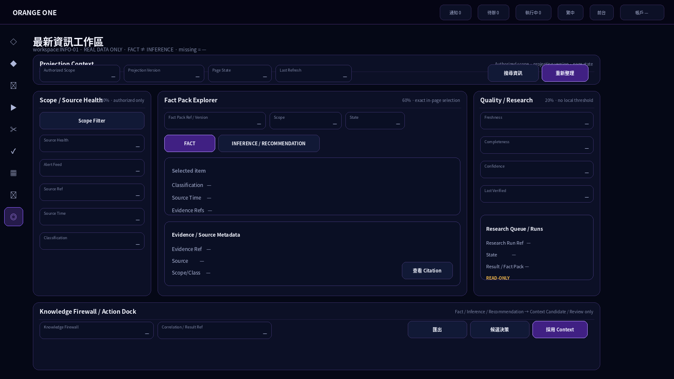
20/60/20 main workbench：Source/Alert → Fact Pack/Fact-Inference/Evidence → Quality/Research；所有未取得的 business values = —。

7.2 Visual B — FACT / INFERENCE + Citation
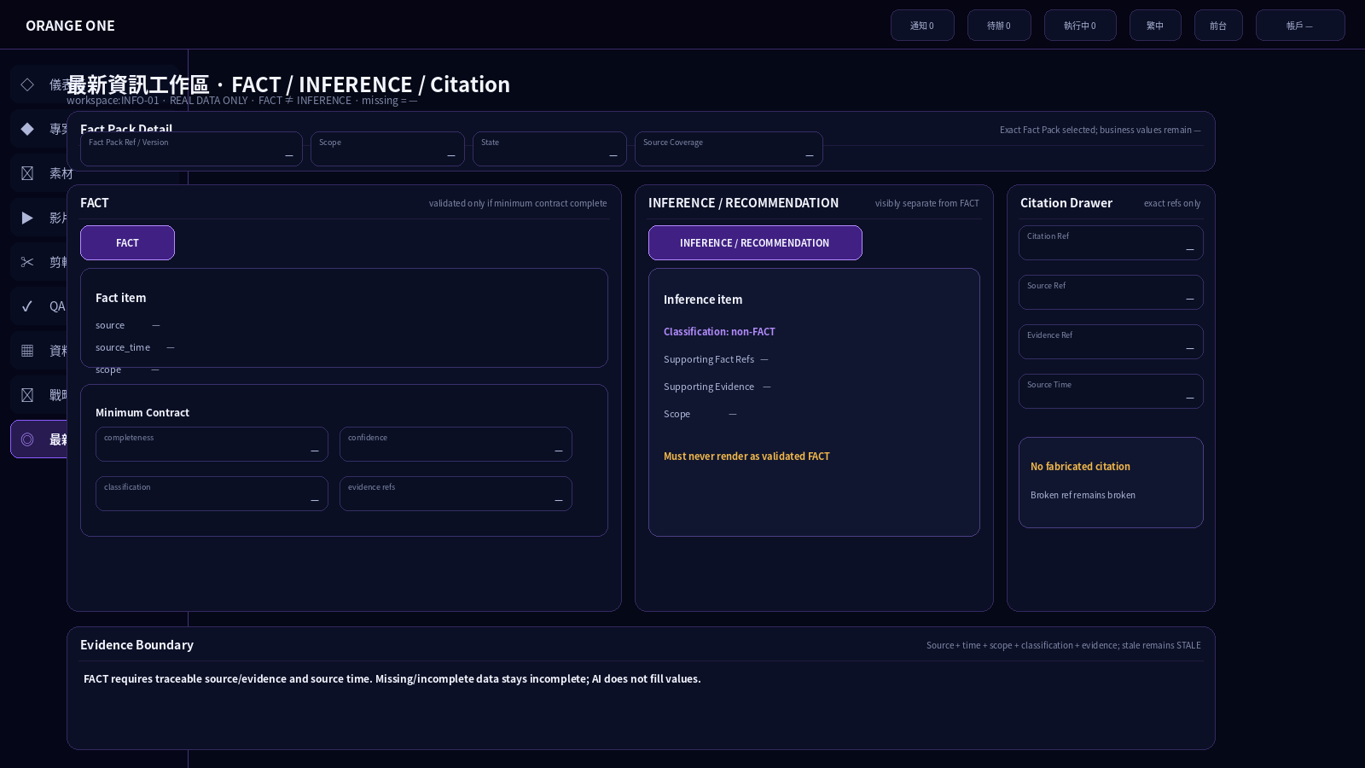
FACT 與 INFERENCE / RECOMMENDATION 明確分離；Citation Drawer 只顯示 exact source/evidence refs，不製造引用。

8. Visual State Set

8.1 Visual C — STALE / INCOMPLETE + Research Queue
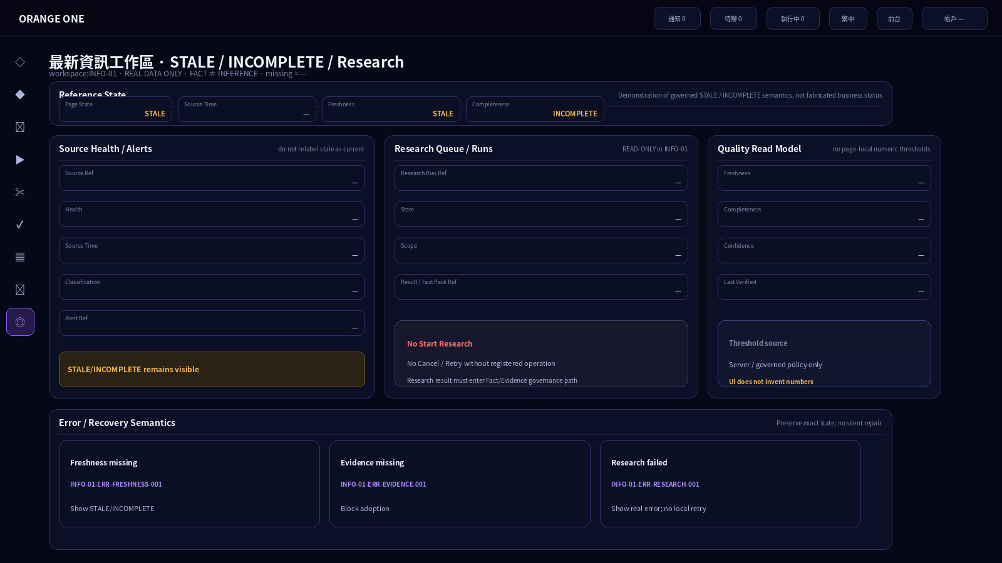
Reference state demonstrates governed STALE/INCOMPLETE semantics；Research Queue remains read-only and has no Start/Cancel/Retry button。

8.2 Visual D — Context Candidate Review
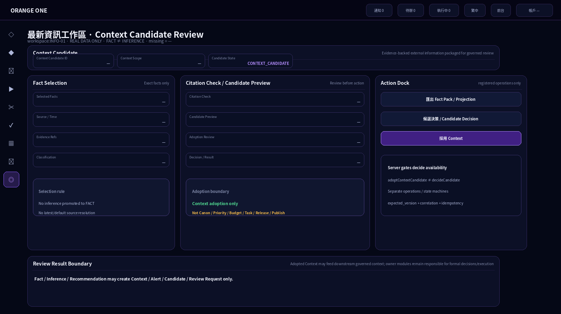
Context scope / selected facts / citation check / candidate preview / adoption review + separate Adopt and Decide actions。

9. Knowledge Firewall / Audit Visual

9.1 Visual E — Knowledge Firewall / Action Dock / Audit
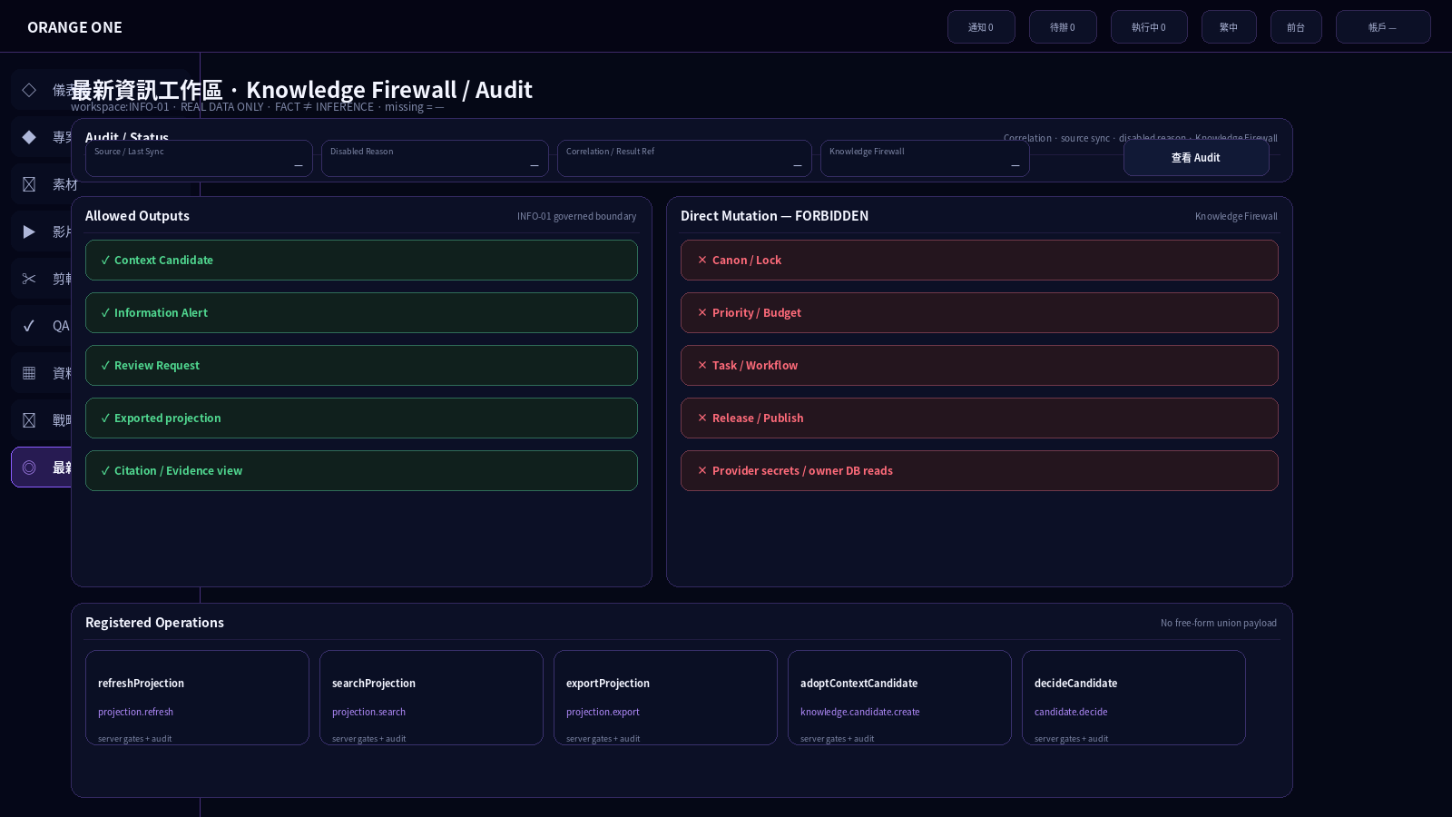
221px Sidebar Overlay + allowed candidate/review outputs versus forbidden direct Canon/Lock/Priority/Budget/Task/Release/Publish mutations。

10. Geometry / Design Tokens
Region | Geometry / Rule
Global Header | 58px fixed full width
Collapsed Sidebar | 64px icon-only transparent interaction rail
Expanded Sidebar | 221px overlay; no workspace reflow
Workspace Origin | x=78px / y=68px
Context Bar | 100% width; h=56px
Primary Grid | minmax(280px,1fr) / minmax(720px,3fr) / minmax(300px,1fr); ≈20/60/20
Left Rail | min 280px
Center | min 720px; highest priority
Right Rail | min 300px
Controls | 40px; radius 10
Panels | radius 12; large container radius 24
Missing values | —
Palette | Global Tech Purple only; page visual override forbidden

11. Action / Operation Contract · 17/17
Action UID | Label | Permission | Gate | Effect | Operation
INFO-01-ACT-NOOP | Read display | INFO_READ | INFO-01-GATE-READ | READ_ONLY | —
INFO-01-ACT-FILTER | Filter current projection | INFO_READ | INFO-01-GATE-READ | UI_ONLY | —
INFO-01-ACT-SOURCE-SELECT | Select source | INFO_READ | INFO-01-GATE-READ | CONTEXT_STATE | —
INFO-01-ACT-ALERT-SELECT | Select alert | INFO_READ | INFO-01-GATE-READ | CONTEXT_STATE | —
INFO-01-ACT-FACTPACK-SELECT | Select Fact Pack | INFO_READ | INFO-01-GATE-FACTPACK | CONTEXT_STATE | —
INFO-01-ACT-FACT-TYPE | FACT / INFERENCE view | INFO_READ | INFO-01-GATE-FACTPACK | UI_ONLY | —
INFO-01-ACT-EVIDENCE-SELECT | Open evidence | INFO_READ | INFO-01-GATE-EVIDENCE | CONTEXT_STATE | —
INFO-01-ACT-RESEARCH-SELECT | Open research run | INFO_READ | INFO-01-GATE-READ | CONTEXT_STATE | —
INFO-01-ACT-CANDIDATE-SELECT | Open Context Candidate | INFO_READ | INFO-01-GATE-CANDIDATE | CONTEXT_STATE | —
INFO-01-ACT-CITATION-OPEN | Open Citation | INFO_READ | INFO-01-GATE-EVIDENCE | UI_ONLY | —
INFO-01-ACT-REFRESH | 重新整理 / Refresh | INFO_REFRESH | INFO-01-GATE-REFRESH | REGISTERED_COMMAND | refreshProjection
INFO-01-ACT-SEARCH | 搜尋資訊 / Search | INFO_SEARCH | INFO-01-GATE-SEARCH | REGISTERED_COMMAND | searchProjection
INFO-01-ACT-PROJECTION-READ | Read UI projection | INFO_PAGE_VIEW | INFO-01-GATE-PAGE | READ_MODEL_QUERY | getUiProjection
INFO-01-ACT-EXPORT | 匯出 Fact Pack / Projection | INFO_EXPORT | INFO-01-GATE-EXPORT | REGISTERED_COMMAND | exportProjection
INFO-01-ACT-ADOPT-CONTEXT | 採用 Context | INFO_CONTEXT_ADOPT | INFO-01-GATE-ADOPT | CANDIDATE_ADOPTION | adoptContextCandidate
INFO-01-ACT-CANDIDATE-DECIDE | 候選決策 / Candidate Decision | INFO_CANDIDATE_DECIDE | INFO-01-GATE-DECIDE | CANDIDATE_DECISION | decideCandidate
INFO-01-ACT-AUDIT-OPEN | 查看 Audit / Correlation | INFO_PAGE_VIEW | INFO-01-GATE-PAGE | UI_ONLY | —

Effectful Registered Operations
Operation | Method / Boundary
refreshProjection | POST /v1/projections/refresh
searchProjection | POST /v1/search
exportProjection | POST /v1/exports
adoptContextCandidate | POST /v1/context-candidates/{id}/adopt
decideCandidate | POST /v1/candidates/{id}/decision

adoptContextCandidate 與 decideCandidate 為分離 operation；INFO-01 不自行合併 state machine，server/state gates 決定可用性。

12. Control / Field / Action / Gate / Permission Binding · 66/66
Control UID | Section | Type / Label | Action | Gate | Permission
INFO-01-FLD-SCOPE | INFO-01-SEC-01 | READONLY / Authorized Scope | INFO-01-ACT-NOOP | INFO-01-GATE-READ | INFO_READ
INFO-01-FLD-PROJECTION-VERSION | INFO-01-SEC-01 | READONLY / Projection Version | INFO-01-ACT-NOOP | INFO-01-GATE-READ | INFO_READ
INFO-01-FLD-PAGE-STATE | INFO-01-SEC-01 | READONLY / Page State | INFO-01-ACT-NOOP | INFO-01-GATE-READ | INFO_READ
INFO-01-FLD-LAST-REFRESH | INFO-01-SEC-01 | READONLY / Last Refresh | INFO-01-ACT-NOOP | INFO-01-GATE-READ | INFO_READ
INFO-01-BTN-REFRESH | INFO-01-SEC-01 | PRIMARY_BUTTON / 重新整理 / Refresh | INFO-01-ACT-REFRESH | INFO-01-GATE-REFRESH | INFO_REFRESH
INFO-01-BTN-SEARCH | INFO-01-SEC-01 | BUTTON / 搜尋資訊 / Search | INFO-01-ACT-SEARCH | INFO-01-GATE-SEARCH | INFO_SEARCH
INFO-01-SEL-SCOPE | INFO-01-SEC-02 | FILTER / 範圍篩選 / Scope Filter | INFO-01-ACT-FILTER | INFO-01-GATE-READ | INFO_READ
INFO-01-LST-SOURCES | INFO-01-SEC-02 | LIST / 來源健康狀態 / Source Health | INFO-01-ACT-SOURCE-SELECT | INFO-01-GATE-READ | INFO_READ
INFO-01-FLD-SOURCE-REF | INFO-01-SEC-02 | READONLY / Source Ref | INFO-01-ACT-NOOP | INFO-01-GATE-READ | INFO_READ
INFO-01-FLD-SOURCE-HEALTH | INFO-01-SEC-02 | READONLY / Health | INFO-01-ACT-NOOP | INFO-01-GATE-READ | INFO_READ
INFO-01-FLD-SOURCE-TIME | INFO-01-SEC-02 | READONLY / Source Time | INFO-01-ACT-NOOP | INFO-01-GATE-READ | INFO_READ
INFO-01-FLD-SOURCE-CLASS | INFO-01-SEC-02 | READONLY / Classification | INFO-01-ACT-NOOP | INFO-01-GATE-READ | INFO_READ
INFO-01-LST-ALERTS | INFO-01-SEC-03 | LIST / 警示資訊流 / Alert Feed | INFO-01-ACT-ALERT-SELECT | INFO-01-GATE-READ | INFO_READ
INFO-01-FLD-ALERT-REF | INFO-01-SEC-03 | READONLY / Alert Ref | INFO-01-ACT-NOOP | INFO-01-GATE-READ | INFO_READ
INFO-01-FLD-ALERT-SCOPE | INFO-01-SEC-03 | READONLY / Target Scope | INFO-01-ACT-NOOP | INFO-01-GATE-READ | INFO_READ
INFO-01-FLD-ALERT-SOURCE | INFO-01-SEC-03 | READONLY / Source / Evidence | INFO-01-ACT-NOOP | INFO-01-GATE-READ | INFO_READ
INFO-01-FLD-ALERT-STATUS | INFO-01-SEC-03 | READONLY / Status | INFO-01-ACT-NOOP | INFO-01-GATE-READ | INFO_READ
INFO-01-LST-FACTPACKS | INFO-01-SEC-04 | LIST / 最近 Fact Packs | INFO-01-ACT-FACTPACK-SELECT | INFO-01-GATE-FACTPACK | INFO_READ
INFO-01-FLD-FACTPACK-REF | INFO-01-SEC-04 | READONLY / Fact Pack Ref / Version | INFO-01-ACT-NOOP | INFO-01-GATE-FACTPACK | INFO_READ
INFO-01-FLD-FACTPACK-SCOPE | INFO-01-SEC-04 | READONLY / Scope | INFO-01-ACT-NOOP | INFO-01-GATE-FACTPACK | INFO_READ
INFO-01-FLD-FACTPACK-STATE | INFO-01-SEC-04 | READONLY / State | INFO-01-ACT-NOOP | INFO-01-GATE-FACTPACK | INFO_READ
INFO-01-FLD-FACTPACK-SOURCE-COUNT | INFO-01-SEC-04 | READONLY / Source Coverage | INFO-01-ACT-NOOP | INFO-01-GATE-FACTPACK | INFO_READ
INFO-01-TAB-FACT | INFO-01-SEC-05 | TAB / FACT | INFO-01-ACT-FACT-TYPE | INFO-01-GATE-FACTPACK | INFO_READ
INFO-01-TAB-INFERENCE | INFO-01-SEC-05 | TAB / INFERENCE / RECOMMENDATION | INFO-01-ACT-FACT-TYPE | INFO-01-GATE-FACTPACK | INFO_READ
INFO-01-LST-FACTS | INFO-01-SEC-05 | LIST / Facts | INFO-01-ACT-EVIDENCE-SELECT | INFO-01-GATE-EVIDENCE | INFO_READ
INFO-01-LST-INFERENCES | INFO-01-SEC-05 | LIST / Inferences / Recommendations | INFO-01-ACT-EVIDENCE-SELECT | INFO-01-GATE-EVIDENCE | INFO_READ
INFO-01-FLD-ITEM-CLASS | INFO-01-SEC-05 | READONLY / Classification | INFO-01-ACT-NOOP | INFO-01-GATE-FACTPACK | INFO_READ
INFO-01-FLD-ITEM-SCOPE | INFO-01-SEC-05 | READONLY / Scope | INFO-01-ACT-NOOP | INFO-01-GATE-FACTPACK | INFO_READ
INFO-01-FLD-ITEM-SOURCE-TIME | INFO-01-SEC-05 | READONLY / Source Time | INFO-01-ACT-NOOP | INFO-01-GATE-FACTPACK | INFO_READ
INFO-01-FLD-ITEM-EVIDENCE | INFO-01-SEC-05 | READONLY / Evidence Refs | INFO-01-ACT-NOOP | INFO-01-GATE-FACTPACK | INFO_READ
INFO-01-LST-EVIDENCE | INFO-01-SEC-06 | LIST / Evidence List | INFO-01-ACT-EVIDENCE-SELECT | INFO-01-GATE-EVIDENCE | INFO_READ
INFO-01-FLD-EVIDENCE-REF | INFO-01-SEC-06 | READONLY / Evidence Ref | INFO-01-ACT-NOOP | INFO-01-GATE-EVIDENCE | INFO_READ
INFO-01-FLD-EVIDENCE-SOURCE | INFO-01-SEC-06 | READONLY / Source | INFO-01-ACT-NOOP | INFO-01-GATE-EVIDENCE | INFO_READ
INFO-01-FLD-EVIDENCE-TIME | INFO-01-SEC-06 | READONLY / Source / Collected Time | INFO-01-ACT-NOOP | INFO-01-GATE-EVIDENCE | INFO_READ
INFO-01-FLD-EVIDENCE-SCOPE | INFO-01-SEC-06 | READONLY / Scope | INFO-01-ACT-NOOP | INFO-01-GATE-EVIDENCE | INFO_READ
INFO-01-FLD-EVIDENCE-CLASS | INFO-01-SEC-06 | READONLY / Classification | INFO-01-ACT-NOOP | INFO-01-GATE-EVIDENCE | INFO_READ
INFO-01-BTN-CITATION | INFO-01-SEC-06 | BUTTON / 查看 Citation | INFO-01-ACT-CITATION-OPEN | INFO-01-GATE-EVIDENCE | INFO_READ
INFO-01-FLD-FRESHNESS | INFO-01-SEC-07 | READONLY / Freshness | INFO-01-ACT-NOOP | INFO-01-GATE-READ | INFO_READ
INFO-01-FLD-COMPLETENESS | INFO-01-SEC-07 | READONLY / Completeness | INFO-01-ACT-NOOP | INFO-01-GATE-READ | INFO_READ
INFO-01-FLD-CONFIDENCE | INFO-01-SEC-07 | READONLY / Confidence | INFO-01-ACT-NOOP | INFO-01-GATE-READ | INFO_READ
INFO-01-FLD-VERIFICATION-TIME | INFO-01-SEC-07 | READONLY / Last Verified | INFO-01-ACT-NOOP | INFO-01-GATE-READ | INFO_READ
INFO-01-LST-RESEARCH | INFO-01-SEC-08 | LIST / 研究佇列 / Research Queue | INFO-01-ACT-RESEARCH-SELECT | INFO-01-GATE-READ | INFO_READ
INFO-01-FLD-RESEARCH-REF | INFO-01-SEC-08 | READONLY / Research Run Ref | INFO-01-ACT-NOOP | INFO-01-GATE-READ | INFO_READ
INFO-01-FLD-RESEARCH-STATE | INFO-01-SEC-08 | READONLY / State | INFO-01-ACT-NOOP | INFO-01-GATE-READ | INFO_READ
INFO-01-FLD-RESEARCH-SCOPE | INFO-01-SEC-08 | READONLY / Scope | INFO-01-ACT-NOOP | INFO-01-GATE-READ | INFO_READ
INFO-01-FLD-RESEARCH-RESULT | INFO-01-SEC-08 | READONLY / Result / Fact Pack Ref | INFO-01-ACT-NOOP | INFO-01-GATE-READ | INFO_READ
INFO-01-FLD-CANDIDATE-ID | INFO-01-SEC-09 | READONLY / Context Candidate ID | INFO-01-ACT-NOOP | INFO-01-GATE-CANDIDATE | INFO_READ
INFO-01-FLD-CANDIDATE-SCOPE | INFO-01-SEC-09 | READONLY / Context Scope | INFO-01-ACT-NOOP | INFO-01-GATE-CANDIDATE | INFO_READ
INFO-01-FLD-CANDIDATE-FACTS | INFO-01-SEC-09 | READONLY / Selected Facts | INFO-01-ACT-NOOP | INFO-01-GATE-CANDIDATE | INFO_READ
INFO-01-FLD-CANDIDATE-CITATIONS | INFO-01-SEC-09 | READONLY / Citation Check | INFO-01-ACT-NOOP | INFO-01-GATE-CANDIDATE | INFO_READ
INFO-01-FLD-CANDIDATE-PREVIEW | INFO-01-SEC-09 | READONLY / Candidate Preview | INFO-01-ACT-NOOP | INFO-01-GATE-CANDIDATE | INFO_READ
INFO-01-FLD-ADOPTION-REVIEW | INFO-01-SEC-09 | READONLY / Adoption Review | INFO-01-ACT-NOOP | INFO-01-GATE-CANDIDATE | INFO_READ
INFO-01-FLD-CANDIDATE-STATE | INFO-01-SEC-09 | READONLY / Candidate State | INFO-01-ACT-NOOP | INFO-01-GATE-CANDIDATE | INFO_READ
INFO-01-LST-CANDIDATES | INFO-01-SEC-09 | LIST / Context Candidates | INFO-01-ACT-CANDIDATE-SELECT | INFO-01-GATE-CANDIDATE | INFO_READ
INFO-01-FLD-CITATION-REF | INFO-01-SEC-10 | READONLY / Citation Ref | INFO-01-ACT-NOOP | INFO-01-GATE-EVIDENCE | INFO_READ
INFO-01-FLD-CITATION-SOURCE | INFO-01-SEC-10 | READONLY / Source Ref | INFO-01-ACT-NOOP | INFO-01-GATE-EVIDENCE | INFO_READ
INFO-01-FLD-CITATION-EVIDENCE | INFO-01-SEC-10 | READONLY / Evidence Ref | INFO-01-ACT-NOOP | INFO-01-GATE-EVIDENCE | INFO_READ
INFO-01-FLD-CITATION-TIME | INFO-01-SEC-10 | READONLY / Source Time | INFO-01-ACT-NOOP | INFO-01-GATE-EVIDENCE | INFO_READ
INFO-01-BTN-EXPORT | INFO-01-SEC-11 | BUTTON / 匯出 Fact Pack / Projection | INFO-01-ACT-EXPORT | INFO-01-GATE-EXPORT | INFO_EXPORT
INFO-01-BTN-ADOPT-CONTEXT | INFO-01-SEC-11 | PRIMARY_BUTTON / 採用 Context | INFO-01-ACT-ADOPT-CONTEXT | INFO-01-GATE-ADOPT | INFO_CONTEXT_ADOPT
INFO-01-BTN-CANDIDATE-DECIDE | INFO-01-SEC-11 | BUTTON / 候選決策 / Candidate Decision | INFO-01-ACT-CANDIDATE-DECIDE | INFO-01-GATE-DECIDE | INFO_CANDIDATE_DECIDE
INFO-01-FLD-SOURCE-SYNC | INFO-01-SEC-12 | READONLY / Source / Last Sync | INFO-01-ACT-NOOP | INFO-01-GATE-READ | INFO_READ
INFO-01-FLD-DISABLED | INFO-01-SEC-12 | READONLY / Disabled Reason | INFO-01-ACT-NOOP | INFO-01-GATE-READ | INFO_READ
INFO-01-FLD-CORRELATION | INFO-01-SEC-12 | READONLY / Correlation / Result Ref | INFO-01-ACT-NOOP | INFO-01-GATE-READ | INFO_READ
INFO-01-FLD-FIREWALL | INFO-01-SEC-12 | READONLY / Knowledge Firewall | INFO-01-ACT-NOOP | INFO-01-GATE-READ | INFO_READ
INFO-01-BTN-AUDIT | INFO-01-SEC-12 | BUTTON / 查看 Audit / Correlation | INFO-01-ACT-AUDIT-OPEN | INFO-01-GATE-PAGE | INFO_PAGE_VIEW

13. Gate / Permission Contract

13.1 Gates · 10/10
Gate UID | Condition
INFO-01-GATE-PAGE | explicit account page permission + scope + condition + classification mask + audit
INFO-01-GATE-READ | authorized scope + information.read + read_model_version available
INFO-01-GATE-FACTPACK | selected exact Fact Pack exists in authorized projection
INFO-01-GATE-EVIDENCE | selected exact Fact/Evidence/Citation ref exists and is authorized
INFO-01-GATE-REFRESH | projection.refresh permission + registered RefreshProjectionRequest + server state/idempotency/audit gates
INFO-01-GATE-SEARCH | projection.search permission + registered SearchProjectionRequest + server state/idempotency/audit gates
INFO-01-GATE-EXPORT | projection.export permission + exact scope/projection + ExportProjectionRequest + server gates
INFO-01-GATE-CANDIDATE | exact evidence-backed Context Candidate + authorized target scope + citation/adoption-review projection
INFO-01-GATE-ADOPT | knowledge.candidate.create + exact context_candidate_id + decision_reason + server state/version/idempotency/audit gates
INFO-01-GATE-DECIDE | candidate.decide + exact candidate_id + registered decision + server state/version/idempotency/audit gates

13.2 Permissions · 7/7
Permission UID | Backend Scope | Purpose
INFO_PAGE_VIEW | page.view | View authorized latest-information page/sections
INFO_READ | information.read | Read authorized source/fact/evidence/research projection
INFO_REFRESH | projection.refresh | Refresh registered projection
INFO_SEARCH | projection.search | Search registered projection
INFO_EXPORT | projection.export | Export authorized projection
INFO_CONTEXT_ADOPT | knowledge.candidate.create | Adopt governed Context Candidate
INFO_CANDIDATE_DECIDE | candidate.decide | Decide registered Candidate

14. State / Error / Recovery

14.1 Page States · 8/8
State UID | Display | Definition
INFO-01-ST-LOADING | LOADING | Loading authorized projection
INFO-01-ST-READY | READY | Authorized information projection ready
INFO-01-ST-EMPTY | EMPTY | Authorized projection has no result
INFO-01-ST-STALE | STALE | Source/fact projection is stale according to governed freshness data
INFO-01-ST-INCOMPLETE | INCOMPLETE | Required source/evidence/completeness data is missing
INFO-01-ST-ERROR | ERROR | Registered read/action error
INFO-01-ST-POLICY | POLICY_BLOCKED | Permission/classification/scope policy blocks access/action
INFO-01-ST-CANDIDATE | CONTEXT_CANDIDATE | Evidence-backed Context Candidate available for governed review

14.2 Errors · 12/12
Error UID | Context | Recovery
INFO-01-ERR-CONTEXT-001 | Authorized scope/read model unavailable or version mismatch | BLOCK dependent panels; show actual server reason
INFO-01-ERR-SOURCE-001 | Source health/source metadata unavailable or unauthorized | Show unavailable/masked state; never fabricate source
INFO-01-ERR-FRESHNESS-001 | Freshness/source_time missing, stale or inconsistent | Show STALE/INCOMPLETE as returned; never relabel current
INFO-01-ERR-FACTPACK-001 | Fact Pack missing, inaccessible or invalid exact ref | BLOCK detail; preserve list/context
INFO-01-ERR-FACT-001 | FACT lacks required source/source_time/scope/completeness/confidence/classification | Do not present as validated FACT; surface missing contract
INFO-01-ERR-EVIDENCE-001 | Evidence/citation ref missing or invalid | Show broken evidence state; block evidence-dependent adoption
INFO-01-ERR-RESEARCH-001 | Research run/queue projection missing or failed | Show actual status/error; do not create local retry/start action
INFO-01-ERR-SEARCH-001 | Search request invalid/denied/stale | Show registered error + retry eligibility
INFO-01-ERR-EXPORT-001 | Export request invalid/denied/stale | Show registered error; no local file fabrication
INFO-01-ERR-CANDIDATE-001 | Context Candidate scope/evidence/citation/adoption-review invalid | BLOCK candidate action; preserve candidate projection
INFO-01-ERR-PERM-001 | Permission/scope/classification denied | Hide/disable/mask according to registered permission result
INFO-01-ERR-UNDEFINED-001 | Unlisted Section/Component/Control/Action/Gate/Permission/Port requested | BLOCK + REPORT_AUTHORITY_GAP

15. Integration Ports · 6/6
Port UID | Boundary | Operation | Method | Permission | Exposure
INFO-01-PORT-PROJECTION | Latest Information UI Projection | getUiProjection | GET /v1/ui-projections/{pageUid} | page.view | INFO-01-ACT-PROJECTION-READ
INFO-01-PORT-REFRESH | Projection Refresh | refreshProjection | POST /v1/projections/refresh | projection.refresh | INFO-01-ACT-REFRESH
INFO-01-PORT-SEARCH | Projection Search | searchProjection | POST /v1/search | projection.search | INFO-01-ACT-SEARCH
INFO-01-PORT-EXPORT | Fact Pack / Projection Export | exportProjection | POST /v1/exports | projection.export | INFO-01-ACT-EXPORT
INFO-01-PORT-CONTEXT-ADOPT | Context Candidate Adoption | adoptContextCandidate | POST /v1/context-candidates/{id}/adopt | knowledge.candidate.create | INFO-01-ACT-ADOPT-CONTEXT
INFO-01-PORT-CANDIDATE-DECIDE | Candidate Decision | decideCandidate | POST /v1/candidates/{id}/decision | candidate.decide | INFO-01-ACT-CANDIDATE-DECIDE

Shared Acquisition Boundary
- Raw crawl/research runtime is NOT owned by INFO-01.
- INFO-01 consumes governed source/fact/evidence projections.
- Research and fact acquisition use shared external-data acquisition runtime only when registered.
- No provider secrets or unregistered owner database reads are rendered.

16. Data Binding / Fact Pack Contract
Block | Required
Fact Pack identity | exact ref/version
FACT list | source + source_time + scope + completeness + confidence + classification + evidence refs
INFERENCE / Recommendation | explicit non-FACT classification + supporting facts/evidence
Evidence | exact source/evidence refs + metadata/time/classification
Quality | governed Freshness / Completeness / Confidence values; no local threshold
Citation | exact source/evidence binding; never fabricated
Research | read-model status only
Selection | in-page exact selection; no second Fact Pack page

17. Context Candidate / Adoption Contract
Block | Rule
Context Scope | exact authorized target scope
Fact Selection | evidence-backed FACT refs only
Citation Check | exact citation/evidence/source refs
Candidate Preview | governed read model
Adoption Review | server-owned governed review state
Adopt Context | records governed Context adoption only
Candidate Decision | separate registered decideCandidate operation
Forbidden | no direct Canon / Lock / Priority / Budget / Task / Release / Publish mutation

18. Function ↔ Visual Traceability
Function | Visual Region | Controls / Output
Projection Control | INFO-01-VIS-CONTEXT | Scope / version / state / refresh / search
Source Health | INFO-01-VIS-LEFT-SOURCE | Scope filter / source health / metadata
Alerts | INFO-01-VIS-LEFT-ALERT | Alert feed / exact alert detail
Fact Pack | INFO-01-VIS-FACTPACK | Recent packs / exact ref / scope / state
Fact-Inference | INFO-01-VIS-FACT | FACT tab / INFERENCE tab / item metadata
Evidence | INFO-01-VIS-EVIDENCE | Evidence list / source / time / class / citation
Quality | INFO-01-VIS-RIGHT-QUALITY | Freshness / Completeness / Confidence / Verified
Research | INFO-01-VIS-RIGHT-RESEARCH | Queue/run status only
Candidate | INFO-01-VIS-CANDIDATE | Scope / facts / citations / preview / review
Citation | INFO-01-VIS-CITATION | Exact citation detail
Action | INFO-01-VIS-ACTION | Export / Adopt / Decide
Audit | INFO-01-VIS-STATUS | Sync / disabled / correlation / firewall / audit

19. Visual Generation Manifest
Visual | Purpose | Status
A | Main Fact Pack workbench | CANDIDATE
B | FACT vs INFERENCE + Citation Drawer | CANDIDATE
C | STALE / INCOMPLETE + Research read-only | CANDIDATE
D | Context Candidate Review / Action Dock | CANDIDATE
E | Knowledge Firewall / Audit / Sidebar Overlay | CANDIDATE

20. Hard Locks / Pre-Implementation Guards
- Only workspace:INFO-01 is the Current latest-information workspace.
- Global Header/Sidebar/Visual inherited; no page-local global visual system.
- Real business data only; missing = —; no fake source, alert, fact, score, confidence, freshness, research state, candidate or citation.
- FACT and INFERENCE / RECOMMENDATION remain visibly distinct.
- Validated Fact requires source + source_time + scope + completeness + confidence + classification.
- No page-local numeric quality/freshness thresholds.
- Research Queue / Run is read-only; no unregistered Start/Cancel/Retry.
- Knowledge Firewall prevents direct Canon/Lock/Priority/Budget/Task/Release/Publish mutation.
- Adopt Context is governed context adoption, not Canon adoption or production execution.
- Refresh/Search/Export/Adopt/Decide use registered request schema + exact scope/version/correlation/idempotency + permission/audit gates.
- No unlisted Section/Component/Control/Action/State/Gate/Permission/Port/business sample data.

21. Acceptance Matrix
UID | Item | Condition
INFO-01-ACC-01 | Single Page / Global Visual | Only workspace:INFO-01; inherit Global Shell/Visual
INFO-01-ACC-02 | Real Data | Missing = —; no fabricated source/fact/quality/research/candidate data
INFO-01-ACC-03 | FACT / INFERENCE | Visibly separated; no inference rendered as fact
INFO-01-ACC-04 | Fact Minimum Contract | source/source_time/scope/completeness/confidence/classification required
INFO-01-ACC-05 | Evidence / Citation | Exact evidence/source/citation refs; broken refs remain explicit
INFO-01-ACC-06 | Research Boundary | Research Queue/Run read-only; no Start/Cancel action
INFO-01-ACC-07 | Knowledge Firewall | No direct Canon/Lock/Priority/Budget/Task/Release/Publish mutation
INFO-01-ACC-08 | Context Candidate | Scope/facts/citations/review visible; Adopt Context = context adoption only
INFO-01-ACC-09 | Registered Actions | Refresh/Search/Export/Adopt/Decide bind only canonical operations/schemas/gates
INFO-01-ACC-10 | Authorization | Account Permission + scope + condition + classification + audit
INFO-01-ACC-11 | Scrollable Page | height:auto + overflow-y:auto
INFO-01-ACC-12 | Machine Binding | Every visible control resolves Section/Component/Visual/Action/Gate/Permission; unlisted=BLOCK

22. Audit Baseline / Evidence Contract
Evidence | Required
Authority Identity | authority/pages/workspace/INFO-01/ACPOS_INFO-01_FINAL_LOCKED_ENCODING.yaml @ 749d152aef9bc4365374f9265081d3382e1bdc5a
Branch / HEAD | new @ 165c6440cb53b1b45ec96905241fb4d56dc3b867
Current Manifest | 465329b6fb19b8e44c3083a9f280015ee95cc55c
Registry denominator | 12 sections / 20 components / 66 controls / 17 actions / 6 ports
UI evidence | 5 candidate UI PNGs embedded
Real data policy | Missing values = —; invented values forbidden
Fact firewall | FACT ≠ INFERENCE; Research read-only; direct owner mutation forbidden
Action boundary | Registered Refresh/Search/Export/Adopt/Decide only

23. Definition of Done / Design Freeze Gate
Gate | Status
Current Authority resolved | PASS
Mother Basic Design artifacts present | PASS
66 Control bindings enumerated | PASS
17 Action / 10 Gate / 7 Permission enumerated | PASS
5 UI candidate states embedded | PASS
FACT / INFERENCE visual separation | PASS
Research execution controls absent | PASS
No fake business data | PASS
Knowledge Firewall boundary explicit | PASS
Human visual / functional review | PENDING
DESIGN_FROZEN | FALSE

24. Resume / Next Step
- Human review INFO-01 proportions, information density, FACT/INFERENCE separation and Context Candidate action boundary.
- If approved, complete governed Design Freeze before construction.
- If rejected, revise this Word/UI candidate only; Current Authority changes require governed change request.
- Construction must not introduce research execution or direct Canon/Task/Release/Publish mutations.

2026-09-21 Machine Authority Construction Closure / 機器權威施工綁定封板
[ACPOS-20260921-SOURCE-GROUNDED-CONSTRUCTION-CLOSURE-V2] Source-grounded only. Existing Current source wins; missing source values remain blocked/decision-required. This closure supersedes the prior generic 2026-09-21 V1/V3 annex only, not the original domain logic or human visual review gates.

INFO-01 · Exact Construction Binding
Authority | Value
Source Commit | 165c6440cb53b1b45ec96905241fb4d56dc3b867
Machine Authority | authority/pages/workspace/INFO-01/ACPOS_INFO-01_FINAL_LOCKED_ENCODING.yaml
Authority SHA-256 | 5544858e3e3a7a2833d5a98c36da201f15d63d16b6a71b995ec6eb7c99e309c1
Expected Control Denominator | 66
Unique Control Rows | 66
Denominator Gate | PASS
Control UID | UID Status | Label | Type | Action UID | Gate | Permission / Auth Resource | Payload / Schema | Operation | Method / Path | Runtime Owner | Persistence Owner | Runtime Status
INFO-01-BTN-ADOPT-CONTEXT | EXISTING_SOURCE_UID | 採用 Context | PRIMARY_BUTTON | INFO-01-ACT-ADOPT-CONTEXT | INFO-01-GATE-ADOPT | INFO_CONTEXT_ADOPT | AdoptContextCandidateRequest | adoptContextCandidate | POST /v1/context-candidates/{id}/adopt | INFO-01 registered information/knowledge boundary | public.context_candidates | EFFECTFUL_EXACT
INFO-01-BTN-AUDIT | EXISTING_SOURCE_UID | 查看 Audit / Correlation | BUTTON | INFO-01-ACT-AUDIT-OPEN | INFO-01-GATE-PAGE | INFO_PAGE_VIEW | — | — | — | INFO-01 registered information/knowledge boundary | — | UI_LOCAL_EXACT
INFO-01-BTN-CANDIDATE-DECIDE | EXISTING_SOURCE_UID | 候選決策 / Candidate Decision | BUTTON | INFO-01-ACT-CANDIDATE-DECIDE | INFO-01-GATE-DECIDE | INFO_CANDIDATE_DECIDE | DecideCandidateRequest | decideCandidate | POST /v1/candidates/{id}/decision | INFO-01 registered information/knowledge boundary | public.context_candidates | EFFECTFUL_EXACT
INFO-01-BTN-CITATION | EXISTING_SOURCE_UID | 查看 Citation | BUTTON | INFO-01-ACT-CITATION-OPEN | INFO-01-GATE-EVIDENCE | INFO_READ | — | — | — | INFO-01 registered information/knowledge boundary | — | UI_LOCAL_EXACT
INFO-01-BTN-EXPORT | EXISTING_SOURCE_UID | 匯出 Fact Pack / Projection | BUTTON | INFO-01-ACT-EXPORT | INFO-01-GATE-EXPORT | INFO_EXPORT | ExportProjectionRequest | exportProjection | POST /v1/exports | INFO-01 registered information/knowledge boundary | Global Brain / Export Artifact + Export Audit | EFFECTFUL_EXACT
INFO-01-BTN-REFRESH | EXISTING_SOURCE_UID | 重新整理 / Refresh | PRIMARY_BUTTON | INFO-01-ACT-REFRESH | INFO-01-GATE-REFRESH | INFO_REFRESH | RefreshProjectionRequest | refreshProjection | POST /v1/projections/refresh | INFO-01 registered information/knowledge boundary | Global Brain / ACPOSStateProjection + Projection Audit | EFFECTFUL_EXACT
INFO-01-BTN-SEARCH | EXISTING_SOURCE_UID | 搜尋資訊 / Search | BUTTON | INFO-01-ACT-SEARCH | INFO-01-GATE-SEARCH | INFO_SEARCH | SearchProjectionRequest | searchProjection | POST /v1/search | INFO-01 registered information/knowledge boundary | Global Brain / SemanticIndexResult + Search Audit | EFFECTFUL_EXACT
INFO-01-FLD-ADOPTION-REVIEW | EXISTING_SOURCE_UID | Adoption Review | READONLY | INFO-01-ACT-NOOP | INFO-01-GATE-CANDIDATE | INFO_READ | — | — | — | INFO-01 registered information/knowledge boundary | — | READ_EXACT
INFO-01-FLD-ALERT-REF | EXISTING_SOURCE_UID | Alert Ref | READONLY | INFO-01-ACT-NOOP | INFO-01-GATE-READ | INFO_READ | — | — | — | INFO-01 registered information/knowledge boundary | — | READ_EXACT
INFO-01-FLD-ALERT-SCOPE | EXISTING_SOURCE_UID | Target Scope | READONLY | INFO-01-ACT-NOOP | INFO-01-GATE-READ | INFO_READ | — | — | — | INFO-01 registered information/knowledge boundary | — | READ_EXACT
INFO-01-FLD-ALERT-SOURCE | EXISTING_SOURCE_UID | Source / Evidence | READONLY | INFO-01-ACT-NOOP | INFO-01-GATE-READ | INFO_READ | — | — | — | INFO-01 registered information/knowledge boundary | — | READ_EXACT
INFO-01-FLD-ALERT-STATUS | EXISTING_SOURCE_UID | Status | READONLY | INFO-01-ACT-NOOP | INFO-01-GATE-READ | INFO_READ | — | — | — | INFO-01 registered information/knowledge boundary | — | READ_EXACT
INFO-01-FLD-CANDIDATE-CITATIONS | EXISTING_SOURCE_UID | Citation Check | READONLY | INFO-01-ACT-NOOP | INFO-01-GATE-CANDIDATE | INFO_READ | — | — | — | INFO-01 registered information/knowledge boundary | — | READ_EXACT
INFO-01-FLD-CANDIDATE-FACTS | EXISTING_SOURCE_UID | Selected Facts | READONLY | INFO-01-ACT-NOOP | INFO-01-GATE-CANDIDATE | INFO_READ | — | — | — | INFO-01 registered information/knowledge boundary | — | READ_EXACT
INFO-01-FLD-CANDIDATE-ID | EXISTING_SOURCE_UID | Context Candidate ID | READONLY | INFO-01-ACT-NOOP | INFO-01-GATE-CANDIDATE | INFO_READ | — | — | — | INFO-01 registered information/knowledge boundary | — | READ_EXACT
INFO-01-FLD-CANDIDATE-PREVIEW | EXISTING_SOURCE_UID | Candidate Preview | READONLY | INFO-01-ACT-NOOP | INFO-01-GATE-CANDIDATE | INFO_READ | — | — | — | INFO-01 registered information/knowledge boundary | — | READ_EXACT
INFO-01-FLD-CANDIDATE-SCOPE | EXISTING_SOURCE_UID | Context Scope | READONLY | INFO-01-ACT-NOOP | INFO-01-GATE-CANDIDATE | INFO_READ | — | — | — | INFO-01 registered information/knowledge boundary | — | READ_EXACT
INFO-01-FLD-CANDIDATE-STATE | EXISTING_SOURCE_UID | Candidate State | READONLY | INFO-01-ACT-NOOP | INFO-01-GATE-CANDIDATE | INFO_READ | — | — | — | INFO-01 registered information/knowledge boundary | — | READ_EXACT
INFO-01-FLD-CITATION-EVIDENCE | EXISTING_SOURCE_UID | Evidence Ref | READONLY | INFO-01-ACT-NOOP | INFO-01-GATE-EVIDENCE | INFO_READ | — | — | — | INFO-01 registered information/knowledge boundary | — | READ_EXACT
INFO-01-FLD-CITATION-REF | EXISTING_SOURCE_UID | Citation Ref | READONLY | INFO-01-ACT-NOOP | INFO-01-GATE-EVIDENCE | INFO_READ | — | — | — | INFO-01 registered information/knowledge boundary | — | READ_EXACT
INFO-01-FLD-CITATION-SOURCE | EXISTING_SOURCE_UID | Source Ref | READONLY | INFO-01-ACT-NOOP | INFO-01-GATE-EVIDENCE | INFO_READ | — | — | — | INFO-01 registered information/knowledge boundary | — | READ_EXACT
INFO-01-FLD-CITATION-TIME | EXISTING_SOURCE_UID | Source Time | READONLY | INFO-01-ACT-NOOP | INFO-01-GATE-EVIDENCE | INFO_READ | — | — | — | INFO-01 registered information/knowledge boundary | — | READ_EXACT
INFO-01-FLD-COMPLETENESS | EXISTING_SOURCE_UID | Completeness | READONLY | INFO-01-ACT-NOOP | INFO-01-GATE-READ | INFO_READ | — | — | — | INFO-01 registered information/knowledge boundary | — | READ_EXACT
INFO-01-FLD-CONFIDENCE | EXISTING_SOURCE_UID | Confidence | READONLY | INFO-01-ACT-NOOP | INFO-01-GATE-READ | INFO_READ | — | — | — | INFO-01 registered information/knowledge boundary | — | READ_EXACT
INFO-01-FLD-CORRELATION | EXISTING_SOURCE_UID | Correlation / Result Ref | READONLY | INFO-01-ACT-NOOP | INFO-01-GATE-READ | INFO_READ | — | — | — | INFO-01 registered information/knowledge boundary | — | READ_EXACT
INFO-01-FLD-DISABLED | EXISTING_SOURCE_UID | Disabled Reason | READONLY | INFO-01-ACT-NOOP | INFO-01-GATE-READ | INFO_READ | — | — | — | INFO-01 registered information/knowledge boundary | — | READ_EXACT
INFO-01-FLD-EVIDENCE-CLASS | EXISTING_SOURCE_UID | Classification | READONLY | INFO-01-ACT-NOOP | INFO-01-GATE-EVIDENCE | INFO_READ | — | — | — | INFO-01 registered information/knowledge boundary | — | READ_EXACT
INFO-01-FLD-EVIDENCE-REF | EXISTING_SOURCE_UID | Evidence Ref | READONLY | INFO-01-ACT-NOOP | INFO-01-GATE-EVIDENCE | INFO_READ | — | — | — | INFO-01 registered information/knowledge boundary | — | READ_EXACT
INFO-01-FLD-EVIDENCE-SCOPE | EXISTING_SOURCE_UID | Scope | READONLY | INFO-01-ACT-NOOP | INFO-01-GATE-EVIDENCE | INFO_READ | — | — | — | INFO-01 registered information/knowledge boundary | — | READ_EXACT
INFO-01-FLD-EVIDENCE-SOURCE | EXISTING_SOURCE_UID | Source | READONLY | INFO-01-ACT-NOOP | INFO-01-GATE-EVIDENCE | INFO_READ | — | — | — | INFO-01 registered information/knowledge boundary | — | READ_EXACT
INFO-01-FLD-EVIDENCE-TIME | EXISTING_SOURCE_UID | Source / Collected Time | READONLY | INFO-01-ACT-NOOP | INFO-01-GATE-EVIDENCE | INFO_READ | — | — | — | INFO-01 registered information/knowledge boundary | — | READ_EXACT
INFO-01-FLD-FACTPACK-REF | EXISTING_SOURCE_UID | Fact Pack Ref / Version | READONLY | INFO-01-ACT-NOOP | INFO-01-GATE-FACTPACK | INFO_READ | — | — | — | INFO-01 registered information/knowledge boundary | — | READ_EXACT
INFO-01-FLD-FACTPACK-SCOPE | EXISTING_SOURCE_UID | Scope | READONLY | INFO-01-ACT-NOOP | INFO-01-GATE-FACTPACK | INFO_READ | — | — | — | INFO-01 registered information/knowledge boundary | — | READ_EXACT
INFO-01-FLD-FACTPACK-SOURCE-COUNT | EXISTING_SOURCE_UID | Source Coverage | READONLY | INFO-01-ACT-NOOP | INFO-01-GATE-FACTPACK | INFO_READ | — | — | — | INFO-01 registered information/knowledge boundary | — | READ_EXACT
INFO-01-FLD-FACTPACK-STATE | EXISTING_SOURCE_UID | State | READONLY | INFO-01-ACT-NOOP | INFO-01-GATE-FACTPACK | INFO_READ | — | — | — | INFO-01 registered information/knowledge boundary | — | READ_EXACT
INFO-01-FLD-FIREWALL | EXISTING_SOURCE_UID | Knowledge Firewall | READONLY | INFO-01-ACT-NOOP | INFO-01-GATE-READ | INFO_READ | — | — | — | INFO-01 registered information/knowledge boundary | — | READ_EXACT
INFO-01-FLD-FRESHNESS | EXISTING_SOURCE_UID | Freshness | READONLY | INFO-01-ACT-NOOP | INFO-01-GATE-READ | INFO_READ | — | — | — | INFO-01 registered information/knowledge boundary | — | READ_EXACT
INFO-01-FLD-ITEM-CLASS | EXISTING_SOURCE_UID | Classification | READONLY | INFO-01-ACT-NOOP | INFO-01-GATE-FACTPACK | INFO_READ | — | — | — | INFO-01 registered information/knowledge boundary | — | READ_EXACT
INFO-01-FLD-ITEM-EVIDENCE | EXISTING_SOURCE_UID | Evidence Refs | READONLY | INFO-01-ACT-NOOP | INFO-01-GATE-FACTPACK | INFO_READ | — | — | — | INFO-01 registered information/knowledge boundary | — | READ_EXACT
INFO-01-FLD-ITEM-SCOPE | EXISTING_SOURCE_UID | Scope | READONLY | INFO-01-ACT-NOOP | INFO-01-GATE-FACTPACK | INFO_READ | — | — | — | INFO-01 registered information/knowledge boundary | — | READ_EXACT
INFO-01-FLD-ITEM-SOURCE-TIME | EXISTING_SOURCE_UID | Source Time | READONLY | INFO-01-ACT-NOOP | INFO-01-GATE-FACTPACK | INFO_READ | — | — | — | INFO-01 registered information/knowledge boundary | — | READ_EXACT
INFO-01-FLD-LAST-REFRESH | EXISTING_SOURCE_UID | Last Refresh | READONLY | INFO-01-ACT-NOOP | INFO-01-GATE-READ | INFO_READ | — | — | — | INFO-01 registered information/knowledge boundary | — | READ_EXACT
INFO-01-FLD-PAGE-STATE | EXISTING_SOURCE_UID | Page State | READONLY | INFO-01-ACT-NOOP | INFO-01-GATE-READ | INFO_READ | — | — | — | INFO-01 registered information/knowledge boundary | — | READ_EXACT
INFO-01-FLD-PROJECTION-VERSION | EXISTING_SOURCE_UID | Projection Version | READONLY | INFO-01-ACT-NOOP | INFO-01-GATE-READ | INFO_READ | — | — | — | INFO-01 registered information/knowledge boundary | — | READ_EXACT
INFO-01-FLD-RESEARCH-REF | EXISTING_SOURCE_UID | Research Run Ref | READONLY | INFO-01-ACT-NOOP | INFO-01-GATE-READ | INFO_READ | — | — | — | INFO-01 registered information/knowledge boundary | — | READ_EXACT
INFO-01-FLD-RESEARCH-RESULT | EXISTING_SOURCE_UID | Result / Fact Pack Ref | READONLY | INFO-01-ACT-NOOP | INFO-01-GATE-READ | INFO_READ | — | — | — | INFO-01 registered information/knowledge boundary | — | READ_EXACT
INFO-01-FLD-RESEARCH-SCOPE | EXISTING_SOURCE_UID | Scope | READONLY | INFO-01-ACT-NOOP | INFO-01-GATE-READ | INFO_READ | — | — | — | INFO-01 registered information/knowledge boundary | — | READ_EXACT
INFO-01-FLD-RESEARCH-STATE | EXISTING_SOURCE_UID | State | READONLY | INFO-01-ACT-NOOP | INFO-01-GATE-READ | INFO_READ | — | — | — | INFO-01 registered information/knowledge boundary | — | READ_EXACT
INFO-01-FLD-SCOPE | EXISTING_SOURCE_UID | Authorized Scope | READONLY | INFO-01-ACT-NOOP | INFO-01-GATE-READ | INFO_READ | — | — | — | INFO-01 registered information/knowledge boundary | — | READ_EXACT
INFO-01-FLD-SOURCE-CLASS | EXISTING_SOURCE_UID | Classification | READONLY | INFO-01-ACT-NOOP | INFO-01-GATE-READ | INFO_READ | — | — | — | INFO-01 registered information/knowledge boundary | — | READ_EXACT
INFO-01-FLD-SOURCE-HEALTH | EXISTING_SOURCE_UID | Health | READONLY | INFO-01-ACT-NOOP | INFO-01-GATE-READ | INFO_READ | — | — | — | INFO-01 registered information/knowledge boundary | — | READ_EXACT
INFO-01-FLD-SOURCE-REF | EXISTING_SOURCE_UID | Source Ref | READONLY | INFO-01-ACT-NOOP | INFO-01-GATE-READ | INFO_READ | — | — | — | INFO-01 registered information/knowledge boundary | — | READ_EXACT
INFO-01-FLD-SOURCE-SYNC | EXISTING_SOURCE_UID | Source / Last Sync | READONLY | INFO-01-ACT-NOOP | INFO-01-GATE-READ | INFO_READ | — | — | — | INFO-01 registered information/knowledge boundary | — | READ_EXACT
INFO-01-FLD-SOURCE-TIME | EXISTING_SOURCE_UID | Source Time | READONLY | INFO-01-ACT-NOOP | INFO-01-GATE-READ | INFO_READ | — | — | — | INFO-01 registered information/knowledge boundary | — | READ_EXACT
INFO-01-FLD-VERIFICATION-TIME | EXISTING_SOURCE_UID | Last Verified | READONLY | INFO-01-ACT-NOOP | INFO-01-GATE-READ | INFO_READ | — | — | — | INFO-01 registered information/knowledge boundary | — | READ_EXACT
INFO-01-LST-ALERTS | EXISTING_SOURCE_UID | 警示資訊流 / Alert Feed | LIST | INFO-01-ACT-ALERT-SELECT | INFO-01-GATE-READ | INFO_READ | — | — | — | INFO-01 registered information/knowledge boundary | — | UI_LOCAL_EXACT
INFO-01-LST-CANDIDATES | EXISTING_SOURCE_UID | Context Candidates | LIST | INFO-01-ACT-CANDIDATE-SELECT | INFO-01-GATE-CANDIDATE | INFO_READ | — | — | — | INFO-01 registered information/knowledge boundary | — | UI_LOCAL_EXACT
INFO-01-LST-EVIDENCE | EXISTING_SOURCE_UID | Evidence List | LIST | INFO-01-ACT-EVIDENCE-SELECT | INFO-01-GATE-EVIDENCE | INFO_READ | — | — | — | INFO-01 registered information/knowledge boundary | — | UI_LOCAL_EXACT
INFO-01-LST-FACTPACKS | EXISTING_SOURCE_UID | 最近 Fact Packs | LIST | INFO-01-ACT-FACTPACK-SELECT | INFO-01-GATE-FACTPACK | INFO_READ | — | — | — | INFO-01 registered information/knowledge boundary | — | UI_LOCAL_EXACT
INFO-01-LST-FACTS | EXISTING_SOURCE_UID | Facts | LIST | INFO-01-ACT-EVIDENCE-SELECT | INFO-01-GATE-EVIDENCE | INFO_READ | — | — | — | INFO-01 registered information/knowledge boundary | — | UI_LOCAL_EXACT
INFO-01-LST-INFERENCES | EXISTING_SOURCE_UID | Inferences / Recommendations | LIST | INFO-01-ACT-EVIDENCE-SELECT | INFO-01-GATE-EVIDENCE | INFO_READ | — | — | — | INFO-01 registered information/knowledge boundary | — | UI_LOCAL_EXACT
INFO-01-LST-RESEARCH | EXISTING_SOURCE_UID | 研究佇列 / Research Queue | LIST | INFO-01-ACT-RESEARCH-SELECT | INFO-01-GATE-READ | INFO_READ | — | — | — | INFO-01 registered information/knowledge boundary | — | UI_LOCAL_EXACT
INFO-01-LST-SOURCES | EXISTING_SOURCE_UID | 來源健康狀態 / Source Health | LIST | INFO-01-ACT-SOURCE-SELECT | INFO-01-GATE-READ | INFO_READ | — | — | — | INFO-01 registered information/knowledge boundary | — | UI_LOCAL_EXACT
INFO-01-SEL-SCOPE | EXISTING_SOURCE_UID | 範圍篩選 / Scope Filter | FILTER | INFO-01-ACT-FILTER | INFO-01-GATE-READ | INFO_READ | — | — | — | INFO-01 registered information/knowledge boundary | — | UI_LOCAL_EXACT
INFO-01-TAB-FACT | EXISTING_SOURCE_UID | FACT | TAB | INFO-01-ACT-FACT-TYPE | INFO-01-GATE-FACTPACK | INFO_READ | — | — | — | INFO-01 registered information/knowledge boundary | — | UI_LOCAL_EXACT
INFO-01-TAB-INFERENCE | EXISTING_SOURCE_UID | INFERENCE / RECOMMENDATION | TAB | INFO-01-ACT-FACT-TYPE | INFO-01-GATE-FACTPACK | INFO_READ | — | — | — | INFO-01 registered information/knowledge boundary | — | UI_LOCAL_EXACT

Page Construction Invariant
The exact control denominator above is the only construction denominator for this page. Components/fields/visual IDs are not counted as additional controls. Existing source UIDs are preserved. A control classified UI_LOCAL_EXACT MUST NOT create a server write. A control classified SPEC_EXACT_RUNTIME_BLOCKED / NOT_EXECUTED MUST remain disabled or fail-closed until its runtime evidence exists.

Batch 41 · INFO-01 Projection Persistence Binding Ledger
[ACPOS-20260922-BATCH-41-SYSTEM01-INFO-PERSISTENCE-REMEDIATION-V1::PAGE::INFO-01] Projection/search/export persistence is derived/audit state only. Domain canonical business rows remain under their original owners. No physical table names are invented and no exported/search result is promoted to canonical truth.
Control UID | Operation | Persistence Owner | Required Semantics
INFO-01-BTN-REFRESH | refreshProjection | Global Brain / ACPOSStateProjection + Projection Audit | Refresh rematerializes a derived projection for an exact domain version. It must not create a second canonical domain row; projection state/version and audit lineage remain reconstructable.
INFO-01-BTN-SEARCH | searchProjection | Global Brain / SemanticIndexResult + Search Audit | Search persists only search/index result pointers, scope and audit/evidence needed to dereference exact source/version/evidence. Search score/result is not canonical truth.
INFO-01-BTN-EXPORT | exportProjection | Global Brain / Export Artifact + Export Audit | Export persists an authorized derived export artifact and audit lineage for the exact projection/scope. Export output does not become a second canonical owner for domain data.

Canonical Business Entity Operation Applicability Matrix / 業務實體操作適用性矩陣
Authority: Current Word design + Mother §71 bounded completion. 本矩陣只正規化既有行為與目前未授權行為；不得據此新增 Business Entity、Operation、Runtime 或 API。 Current tree: b2f81b20322dd9e9268001126b07931b437e27df.
Entity | Operation | Applicability | Authority Evidence
InformationAlert | ARCHIVE_OR_DELETE | NOT_APPLICABLE | Current exact tree b2f81b20322dd9e9268001126b07931b437e27df: zero entity-bound operation evidence for this entity/operation. Mother §71 forbids speculative CRUD/sibling-feature expansion; current revision authorizes no new behavior.
InformationAlert | AUDIT | NOT_APPLICABLE | Current exact tree b2f81b20322dd9e9268001126b07931b437e27df: zero entity-bound operation evidence for this entity/operation. Mother §71 forbids speculative CRUD/sibling-feature expansion; current revision authorizes no new behavior.
InformationAlert | CATEGORY_OR_GROUP_BIND | NOT_APPLICABLE | Current exact tree b2f81b20322dd9e9268001126b07931b437e27df: zero entity-bound operation evidence for this entity/operation. Mother §71 forbids speculative CRUD/sibling-feature expansion; current revision authorizes no new behavior.
InformationAlert | CONFIRM_OR_APPROVE | NOT_APPLICABLE | Current exact tree b2f81b20322dd9e9268001126b07931b437e27df: zero entity-bound operation evidence for this entity/operation. Mother §71 forbids speculative CRUD/sibling-feature expansion; current revision authorizes no new behavior.
InformationAlert | CREATE | NOT_APPLICABLE | Current exact tree b2f81b20322dd9e9268001126b07931b437e27df: zero entity-bound operation evidence for this entity/operation. Mother §71 forbids speculative CRUD/sibling-feature expansion; current revision authorizes no new behavior.
InformationAlert | CREATION_MODE | NOT_APPLICABLE | Current exact tree b2f81b20322dd9e9268001126b07931b437e27df: zero entity-bound operation evidence for this entity/operation. Mother §71 forbids speculative CRUD/sibling-feature expansion; current revision authorizes no new behavior.
InformationAlert | DEPENDENCY_IMPACT | NOT_APPLICABLE | Current exact tree b2f81b20322dd9e9268001126b07931b437e27df: zero entity-bound operation evidence for this entity/operation. Mother §71 forbids speculative CRUD/sibling-feature expansion; current revision authorizes no new behavior.
InformationAlert | DISCOVER_OR_LIST | NOT_APPLICABLE | Current exact tree b2f81b20322dd9e9268001126b07931b437e27df: zero entity-bound operation evidence for this entity/operation. Mother §71 forbids speculative CRUD/sibling-feature expansion; current revision authorizes no new behavior.
InformationAlert | DRAFT | NOT_APPLICABLE | Current exact tree b2f81b20322dd9e9268001126b07931b437e27df: zero entity-bound operation evidence for this entity/operation. Mother §71 forbids speculative CRUD/sibling-feature expansion; current revision authorizes no new behavior.
InformationAlert | EDIT | NOT_APPLICABLE | Current exact tree b2f81b20322dd9e9268001126b07931b437e27df: zero entity-bound operation evidence for this entity/operation. Mother §71 forbids speculative CRUD/sibling-feature expansion; current revision authorizes no new behavior.
InformationAlert | ERROR_RECOVERY | NOT_APPLICABLE | Current exact tree b2f81b20322dd9e9268001126b07931b437e27df: zero entity-bound operation evidence for this entity/operation. Mother §71 forbids speculative CRUD/sibling-feature expansion; current revision authorizes no new behavior.
InformationAlert | LOCK_OR_UNLOCK | NOT_APPLICABLE | Current exact tree b2f81b20322dd9e9268001126b07931b437e27df: zero entity-bound operation evidence for this entity/operation. Mother §71 forbids speculative CRUD/sibling-feature expansion; current revision authorizes no new behavior.
InformationAlert | MOVE_OR_REPARENT | NOT_APPLICABLE | Current exact tree b2f81b20322dd9e9268001126b07931b437e27df: zero entity-bound operation evidence for this entity/operation. Mother §71 forbids speculative CRUD/sibling-feature expansion; current revision authorizes no new behavior.
InformationAlert | NEXT_STEP | NOT_APPLICABLE | Current exact tree b2f81b20322dd9e9268001126b07931b437e27df: zero entity-bound operation evidence for this entity/operation. Mother §71 forbids speculative CRUD/sibling-feature expansion; current revision authorizes no new behavior.
InformationAlert | PARENT_BIND | NOT_APPLICABLE | Current exact tree b2f81b20322dd9e9268001126b07931b437e27df: zero entity-bound operation evidence for this entity/operation. Mother §71 forbids speculative CRUD/sibling-feature expansion; current revision authorizes no new behavior.
InformationAlert | REORDER | NOT_APPLICABLE | Current exact tree b2f81b20322dd9e9268001126b07931b437e27df: zero entity-bound operation evidence for this entity/operation. Mother §71 forbids speculative CRUD/sibling-feature expansion; current revision authorizes no new behavior.
InformationAlert | RESTORE | NOT_APPLICABLE | Current exact tree b2f81b20322dd9e9268001126b07931b437e27df: zero entity-bound operation evidence for this entity/operation. Mother §71 forbids speculative CRUD/sibling-feature expansion; current revision authorizes no new behavior.
InformationAlert | RESUME | NOT_APPLICABLE | Current exact tree b2f81b20322dd9e9268001126b07931b437e27df: zero entity-bound operation evidence for this entity/operation. Mother §71 forbids speculative CRUD/sibling-feature expansion; current revision authorizes no new behavior.
InformationAlert | REVISE | NOT_APPLICABLE | Current exact tree b2f81b20322dd9e9268001126b07931b437e27df: zero entity-bound operation evidence for this entity/operation. Mother §71 forbids speculative CRUD/sibling-feature expansion; current revision authorizes no new behavior.
InformationAlert | SAVE | NOT_APPLICABLE | Current exact tree b2f81b20322dd9e9268001126b07931b437e27df: zero entity-bound operation evidence for this entity/operation. Mother §71 forbids speculative CRUD/sibling-feature expansion; current revision authorizes no new behavior.
InformationAlert | SELECT_OR_OPEN | NOT_APPLICABLE | Current exact tree b2f81b20322dd9e9268001126b07931b437e27df: zero entity-bound operation evidence for this entity/operation. Mother §71 forbids speculative CRUD/sibling-feature expansion; current revision authorizes no new behavior.
InformationAlert | VALIDATE | NOT_APPLICABLE | Current exact tree b2f81b20322dd9e9268001126b07931b437e27df: zero entity-bound operation evidence for this entity/operation. Mother §71 forbids speculative CRUD/sibling-feature expansion; current revision authorizes no new behavior.
InformationAlert | VERSION | NOT_APPLICABLE | Current exact tree b2f81b20322dd9e9268001126b07931b437e27df: zero entity-bound operation evidence for this entity/operation. Mother §71 forbids speculative CRUD/sibling-feature expansion; current revision authorizes no new behavior.

Mother Planning / Basic Design Closure Annex｜規劃設計規範閉環補充
[ACPOS-20260922-PLANNING-DESIGN-CLOSURE-ANNEX-V1] 本附錄只補規劃／基本設計規範缺口；原頁面既有功能、Owner、Operation、Permission、Entity、Visual 與跨頁 Authority 仍為同一 Canonical Owner。不得由本附錄發明 Runtime/API/DB/Provider 行為，也不得建立第二套平行規範。

Requirement Definition Gate Closure｜需求定義補齊
[ACPOS-DESIGN-CLOSURE:INFO-01:REQUIREMENTS]
Design Item / 設計項目 | Canonical Planning Design Contract / 正式規劃設計契約
Project Scope | INFO-01／資訊／研究工作區 current Word planning/basic-design scope；僅補設計規範，不改變已存在產品 Authority。
Business Goal | 在受治理來源與 exact evidence 下管理 Source Health、Fact Pack、Fact/Inference、Evidence/Citation、Research/Quality 與候選資訊，維持 source/version/audit 可追溯。
Target User / Role Definition | 具 INFO-01 資訊、研究、查證或治理權限的內部使用者。
Functional Requirements | 選擇 authorized source/scope、檢視 readiness/health/status、組合 Fact Pack、查看 Evidence/Citation、形成受治理的 inference/recommendation supporting artifact 與後續 handoff。
Non-functional Requirements | Real Data Only、Evidence-first、Fail Closed、Exact source/version、Audit、不可把 inference 當 verified fact。
Out-of-Scope Definition | 禁止建立第二 Source Registry、禁止憑空生成 Fact/Evidence、禁止把 supporting artifact 升格成未授權 Business Entity。
Glossary | INFO-01 使用本文既有 Entity / Operation / State / Owner / Evidence / Version 名詞；同義詞不得建立第二 identity。
Naming Registry Initial State | Page UID=INFO-01；Owner File=ACPOS_INFO-01_MOTHER_BASIC_DESIGN_TECH_PURPLE_v1.0.docx；Current canonical filename only；禁止 copy/backup/alternate owner。
Authority | Current INFO-01 Word + Mother 01→04；缺產品選擇時 BLOCK，不由本附錄猜測。

