Teensy TouchDAW

Hello and welcome to the Teensy TouchDAW
Functions:
16step long clips (8 of them for each of the 8 Tracks) can be arranged to a complete arrangment of a song.
The 8 Tracks will also be able to send their Notes to internal Audio-Plugins. So you can make your music without the need of any external musical gear.

As this is still a project under Development, things may change over time.
Please refer to Github https://github.com/steven-law/Teensy-DAW for the latest releases and informations.

Many Thanks to Tristan Rowley, without his immense efforts and time to explain things to me, this project would have never reached this amount of functions and still have a more or less readable code. For more Informations on him, please take a look at www.github.com/doctea and www.doctea.co.uk!! Very Interesting stuff to find and try out!!!

1) Overview:

This is the Startupscreen after powering up the module.

On the top Row you have some general Settings and Views: from left to right

Gridcoordinates, shows what coordinates you have touched the last time
Barcounter, counts the played bars
Record, not implemented yet.
Playbutton, to start playback
Stopbutton, to stop playback
Tempo, shows the selected Tempo (Touch the rectangle and turn poti to change tempo)
Savebutton, to store the clip information on an SD card.
Loadbutton, to load the clip information from an SD card.
Scale Select Greys out the notes if they are not within the selected scale.
Arrangmentselect Not implemented yet, but you will be able to select from 8 different arrangments.

On the left side you can select between the different Tabs:
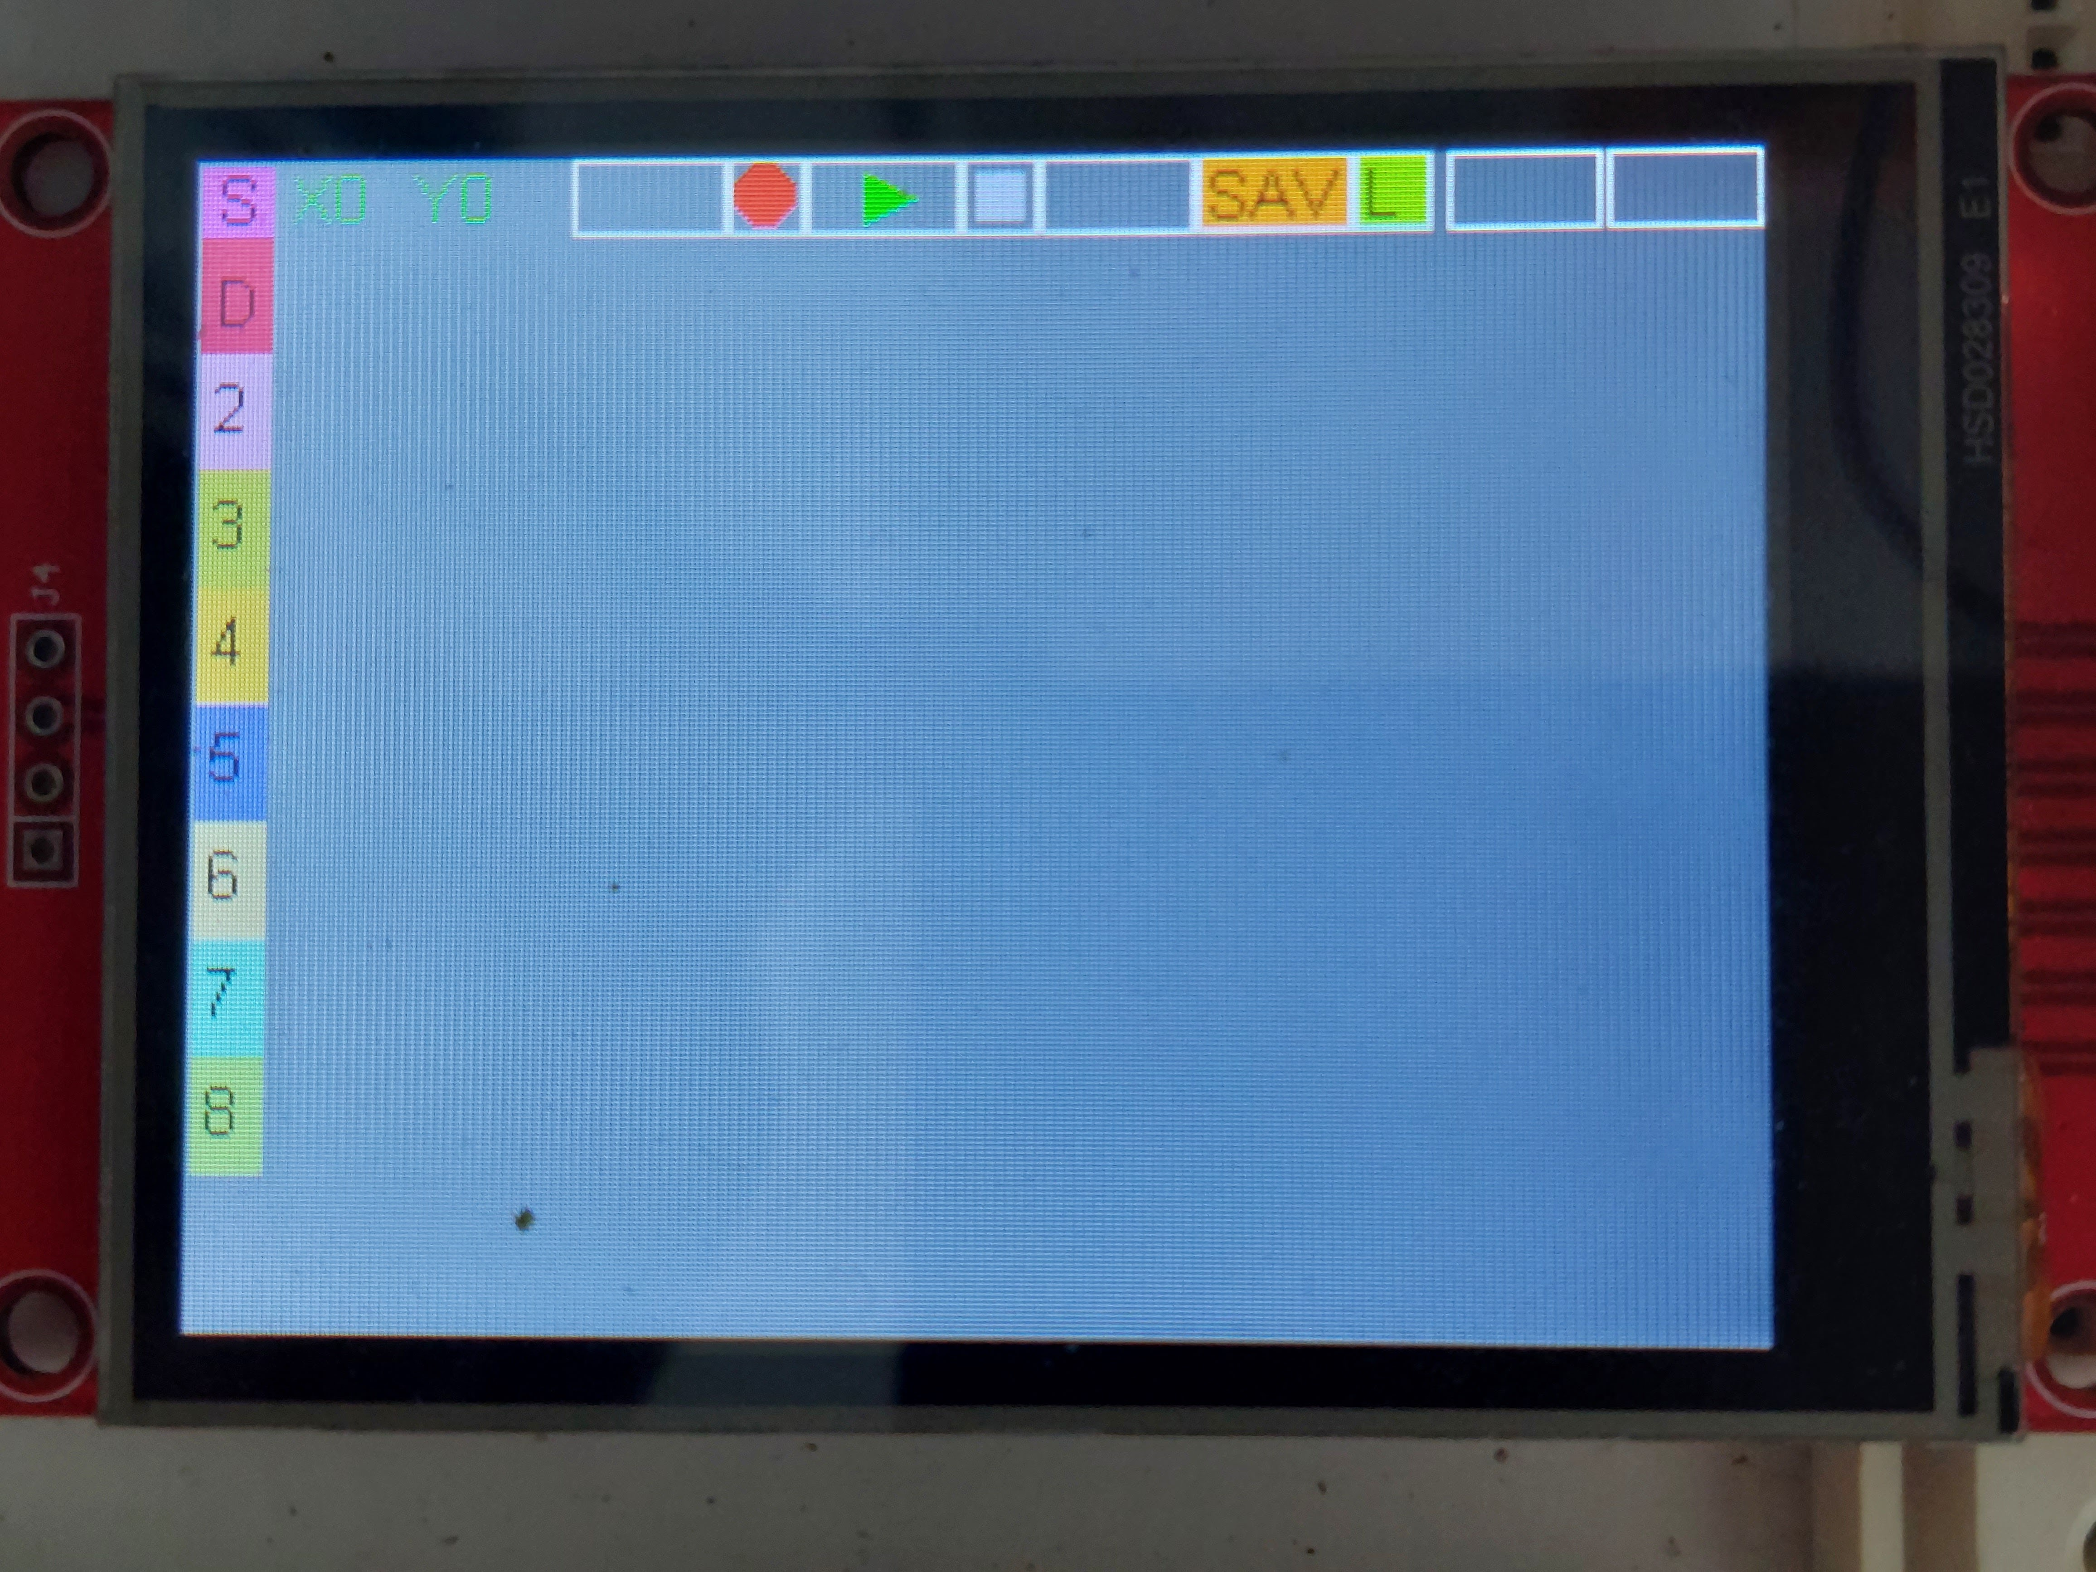

„S“ Song arrangment
„D“ Drumtrack (Poly)
„2“ Melodic track (Mono)
„3“ Melodic track (Mono)
„4“ Melodic track (Mono)
„5“ Melodic track (Mono)
„6“ Melodic track (Mono)
„7“ Melodic track (Mono)
„8“ Melodic track (Mono)

3x Position pointer, see pics below

2) Songmode

In this view you will be able to arrange your complete song.
An arrangment consist of the 8 tracks, that are filled with different clips.
Each clip in the arrangment runs for 16 bars ( = 1 phrase) before it can switch to the next clip. The next clip can be the same as before or any of the other 7 clips that are provided within a track.

Clips from Tracks A cannot be played at Track B!

In Songmode you also can loop a region of your song.

If you click on „S“ this window will open up. This is the arrangment of the first 16 phrases.
On the right side, you will find Settings for this page:

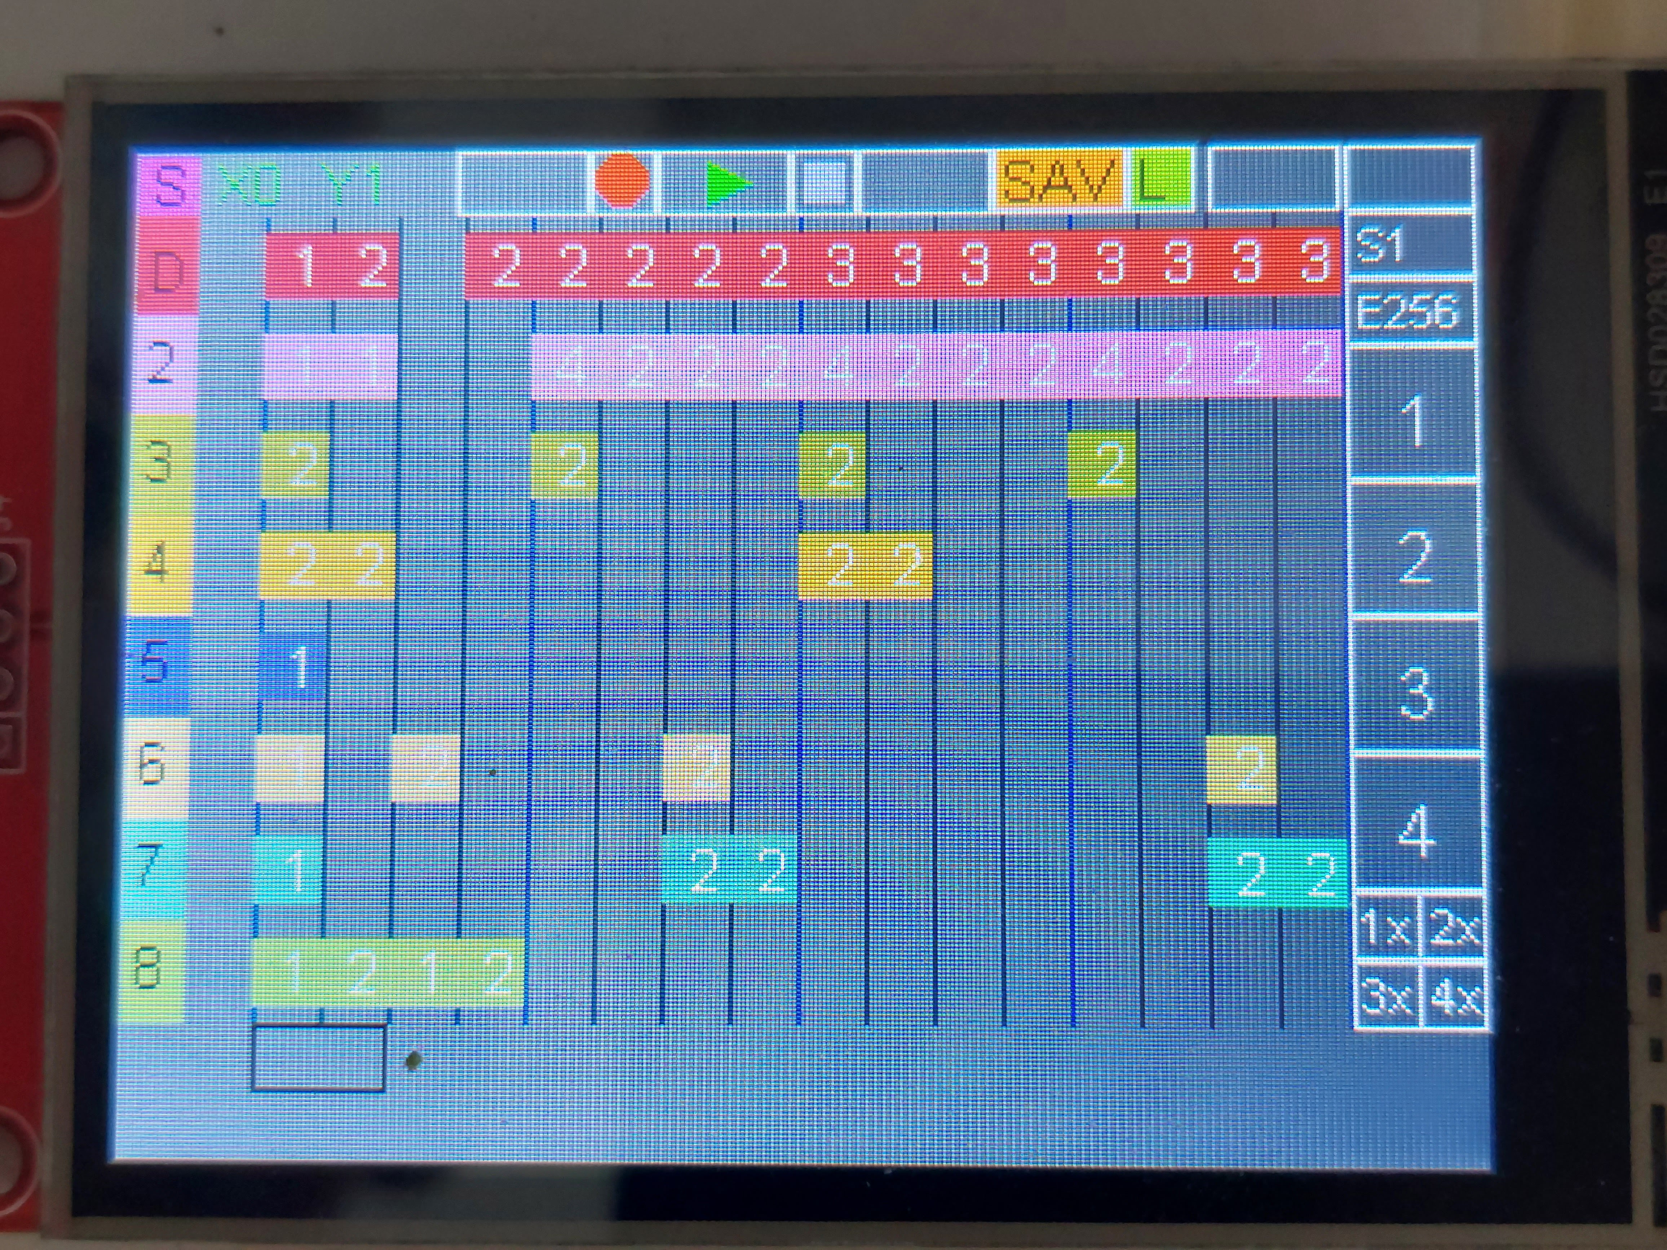
csdc

Loop start (in bars)
Loop end (in bars)
View Page 1

View Page 2
View Page 3

View Page 4
Zoom: from whole arrangment to 16 Phrases

Tap a tracks Phrase. On the buttom (black rectangular) the Track and assigned clip is shown. Tap the phrase and turn poti to change the desired clipnumber.

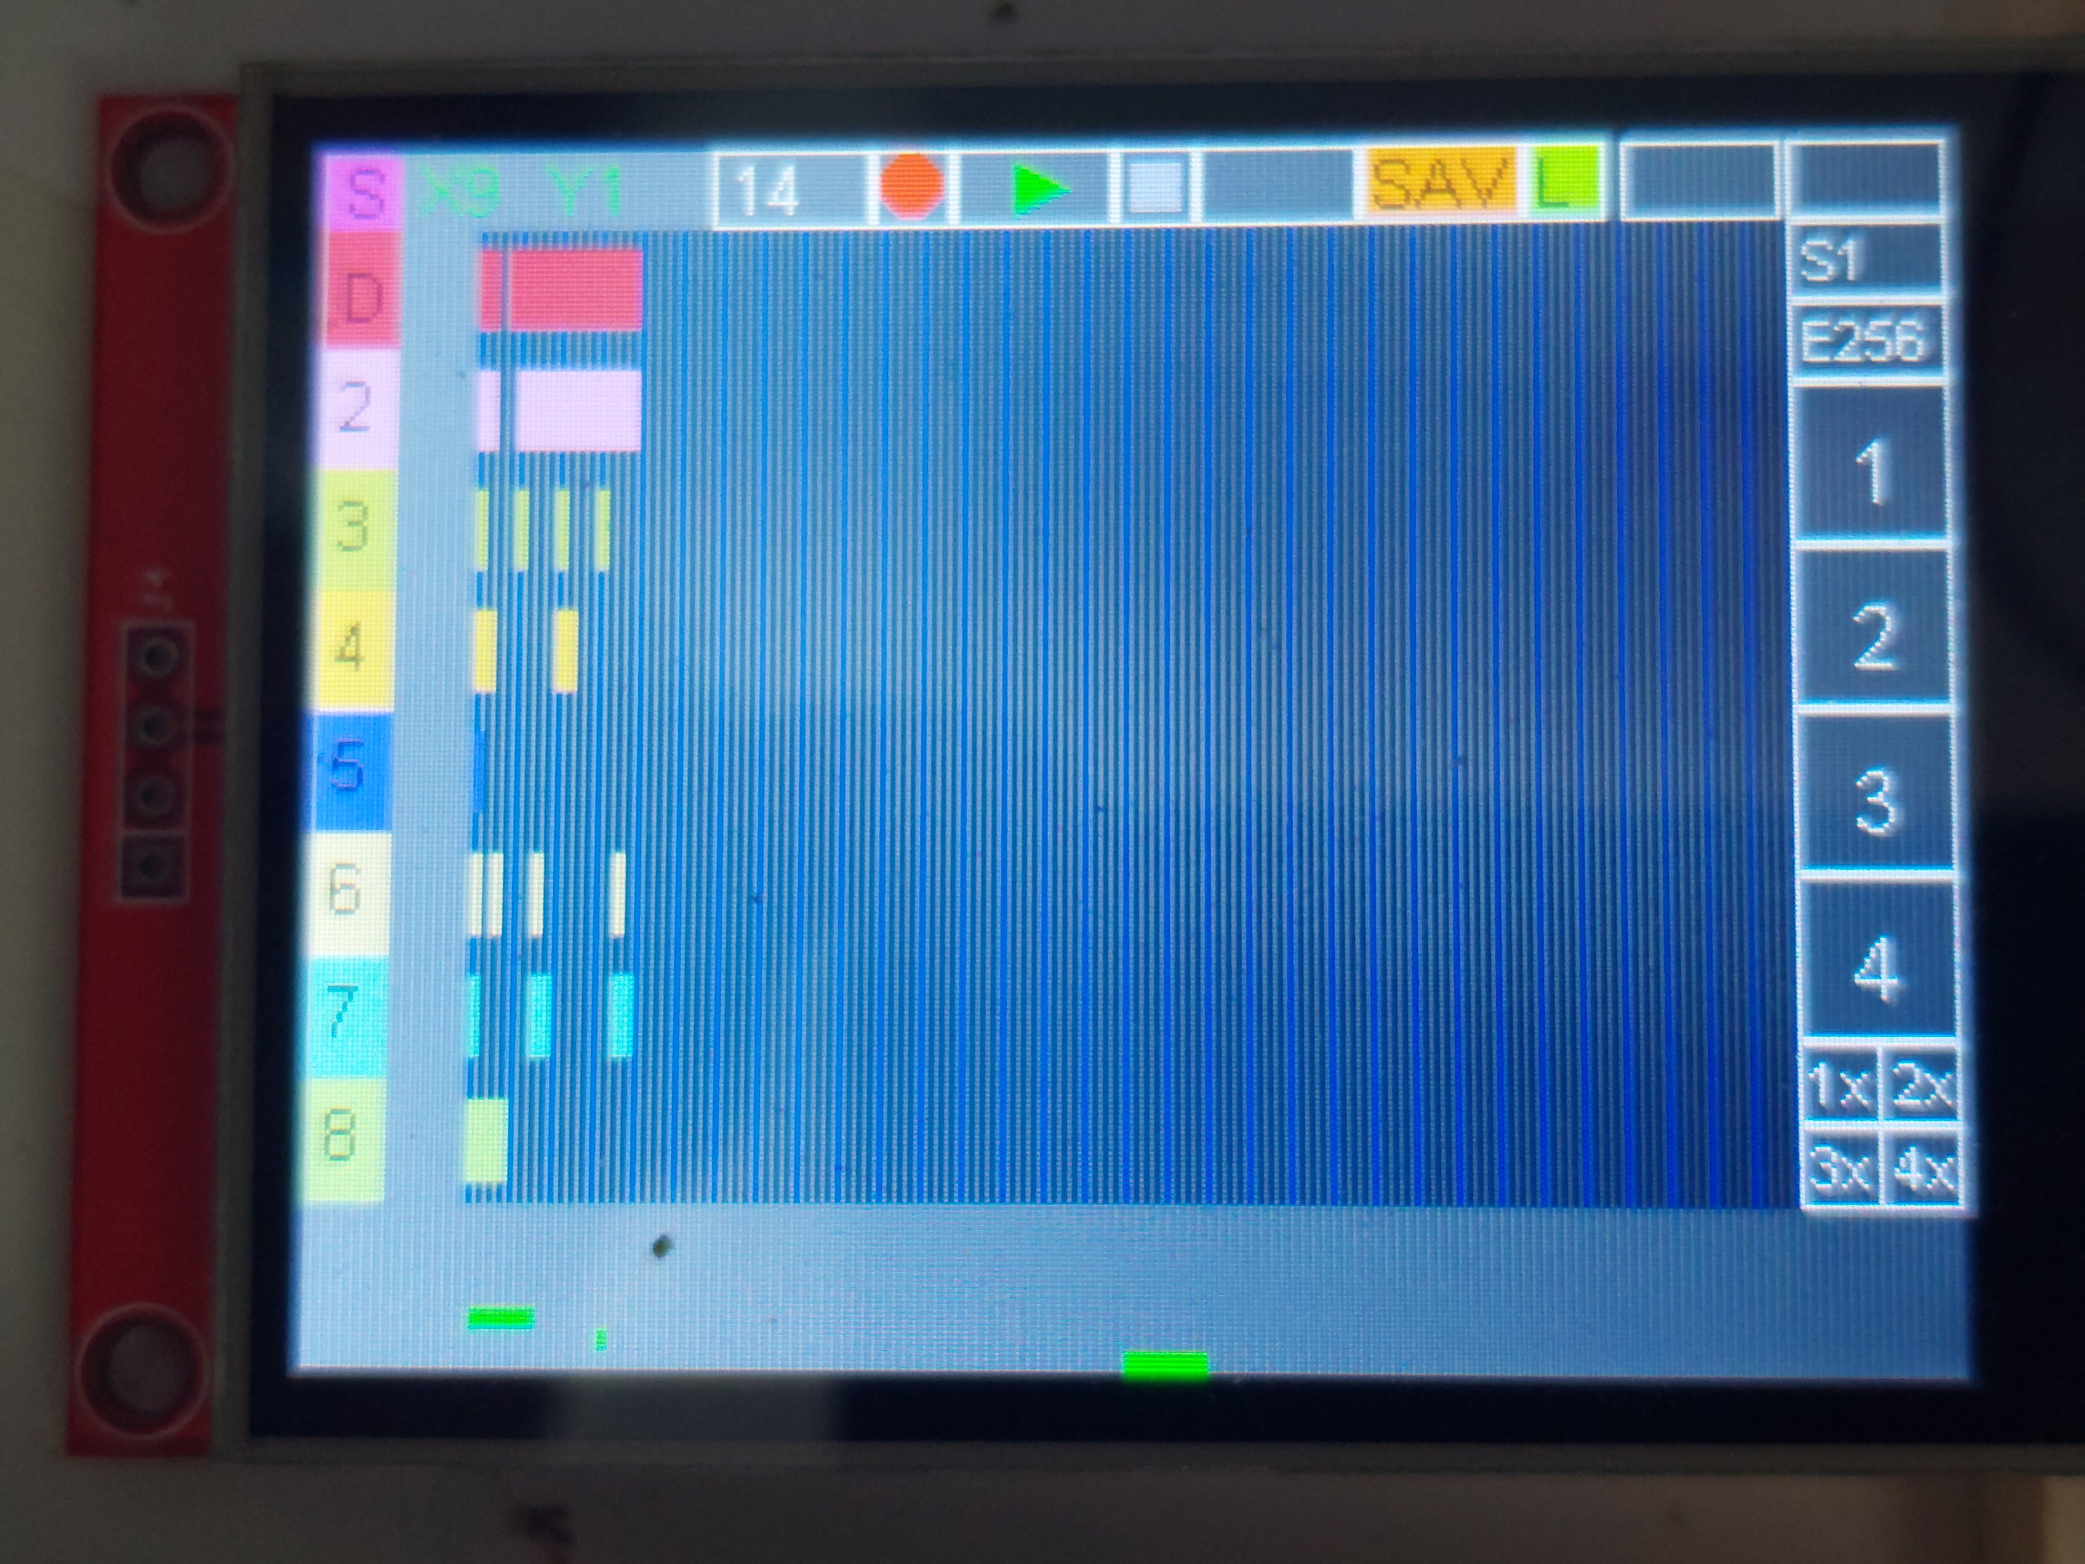

Songposition pointer
1) complete songlenght
2) actual view lenght
3) 16 Step sequence

3) Drumtrack
In this View you can set the active steps for your drumtrack.

For now, this is the only polyphonic track in the DAW.
With the octave switches on the right you can set your „root C“ for different drummaschines (thinking of Bitwigs-Drumtrack, or the force´s/mpc´s drumtrack) of course you may set your notes from the general MIDI Percussion Key map.

Under the octave selection you can set your MIDI-channel for this track. Just tap the coloured rectangular and turn the poti. Channel 1-16 will be sent out to your DAW/Instruments, Channel 17 and above will select one of the internal plugins.
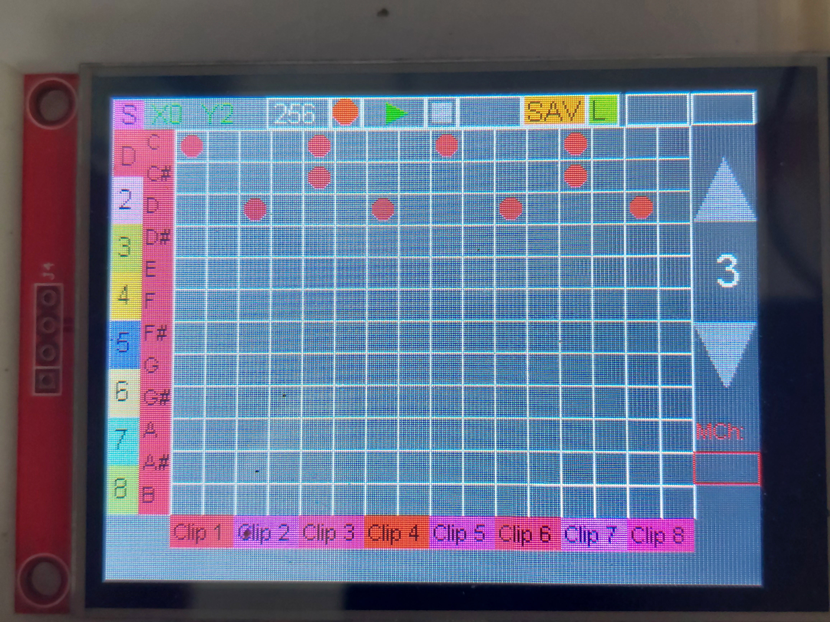

4) Melodictracks 2-8
In this View you can set the active steps for your melodic tracks.

This Tracks only work Monophonic for now!
With the octave switches on the right you can set your Octaves

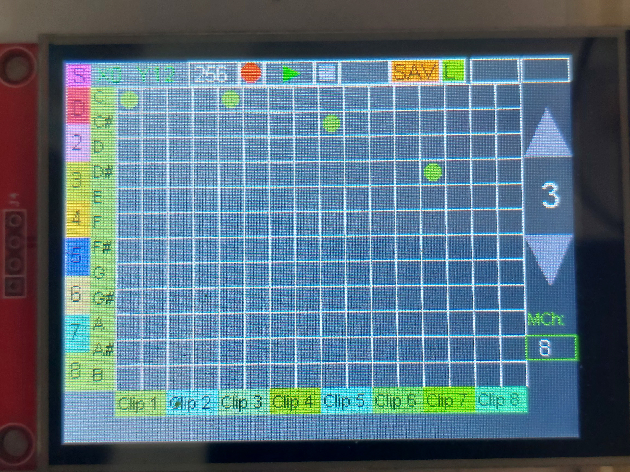
Under the octave selection you can set your MIDI-channel for this track. Just tap the coloured rectangular and turn the poti. Channel 1-16 will be sent out to your DAW/Instruments, Channel 17 and above will select one of the internal plugins.

