# HW1b Written

Steven Liu (xl2948)

1. **What is a database management system? What are 5 reasons people use DBMS?**

Answer: DBMS is a software system that contains information about a particular enterprise and is used to manage a large, complex collection of data. People use DBMS to solve data inconsistency, retrieve data more easily, ensure atomicity, enable concurrent access by multiple users, and solve data isolations problems, integrity problems, and security problems. (Source: Class slides, Page 5, Book, Page 1)

1. **How do DBMS ensure atomicity?**

Answer: DBMS has a recovery manager to ensure atomicity. If there’s no failure, all transactions are carried out successfully and atomicity is achieved. If a failure occurs, recovery manager must perform failure recovery to recover the database to the state before the problematic transaction took place. (Source: Book, Page 21)

1. **What is an ER model? Draw an example ER model for Columbia classes including Students, Professors, and Course IDs. In this example, explicitly show an example of a one-to-many, and many-to-many relationship. *(There are many correct answers here)***

Answer: The ER model is a model developed to represent the logical structure of a database by modelling an enterprise as a collection of entities and relationships. (Source: Lecture 2 Slide, Page 8 & 10, Book, Page 244)

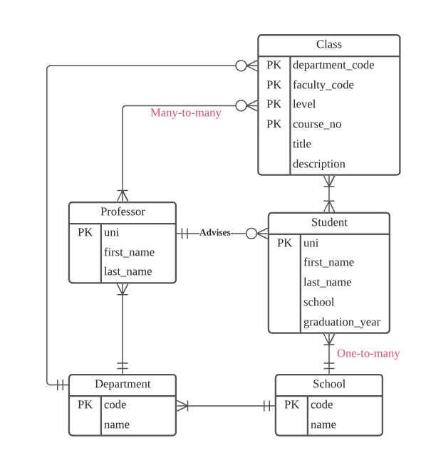

1. **Insert a table that might occur in the relational database version of your ER diagram. What is an example of a key-constraint in this instance?**

Answer: This is an example table of Student

|  |  |  |  |  |
| --- | --- | --- | --- | --- |
| uni | first_name | last_name | school | graduation_year |
| xl2948 | Steven | Liu | SEAS | 2022 |

Key-constraint: UNI is a primary key of Student. Each student has one unique UNI, and no two students can have the same UNIs.

1. **What is the difference between a query language and a programming language?**

Answer: A query language is a language for finding things, creating things and modifying things in databases, and a means for the user to interacts with the SQL user interfaces. It is not a Turing machine equivalent language, and is usually embedded in a higher-level language to be able to compute complex functions.

A programming language, on the other hand, is a language consists of instructions that produce various output. It is accepted by the Turing machine. (Source: lecture, Google)