THA Homework Assignment #2

ME 397 ASBR, Sp 23, Dr. Farshid Alambeigi

Jared Rosenbaum and Steven Swanbeck

1. **Exercise 4.8**: The spatial RRRRPR open chain of Figure **4.14** is shown in its zero position, with fixed and end-effector frames chosen as indicated. Determine the end-effector zero position configuration *M*, the screw axes *Si* in {0}, and the screw axes *Bi* in {b}.

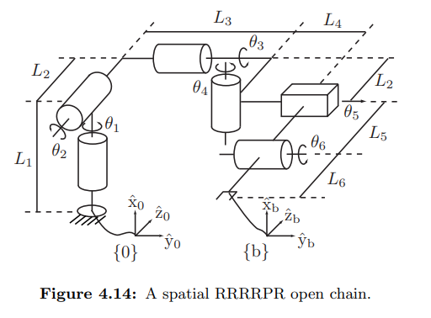

M = [1, 0, 0, L1;

0, 1, 0, L3+L4;

0, 0, 1, -(L5+L6);

0, 0, 0, 1]

Fixed Frame:

| i | wi | vi |
| --- | --- | --- |
| 1 | ( 1, 0, 0 ) | ( 0, 0, 0 ) |
| 2 | ( 0, 0, -1 ) | ( 0, L1, 0 ) |
| 3 | ( 0, 1, 0 ) | ( -L2, 0, L1 ) |
| 4 | ( 1, 0, 0 ) | ( 0, 0, -L3 ) |
| 5 | ( 0, 0, 0 ) | ( 0, 1, 0 ) |
| 6 | ( 0, 1, 0 ) | ( L5, 0, L1 ) |

Body Frame: (assuming L4 = 5)

| i | wi | vi |
| --- | --- | --- |
| 1 | ( 1, 0, 0 ) | ( 0, L5+L6, L4+L3 ) |
| 2 | ( 0, 0, -1 ) | ( L4+L3, 0, 0 ) |
| 3 | ( 0, 1, 0 ) | ( -L2-L5-L6. 0, 0 ) |
| 4 | ( 1, 0, 0 ) | ( 0, L5+L6, L4 ) |
| 5 | ( 0, 0, 0 ) | ( 0, 1, 0 ) |
| 6 | ( 0, 1, 0 ) | ( -L6, 0 0 ) |

1. **Exercise 4.11**: The spatial RPRRR open chain of Figure **4.17** is shown in its zero position. Determine the end-effector zero position configuration *M,* the screw axes *Si* in {0}, and the screw axes *Bi* in {b}.

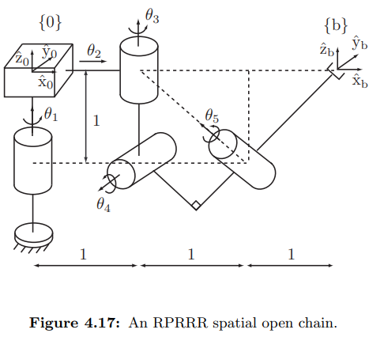

M = [1, 0, 0, 3;

0, 1, 0, 0;

0, 0, 1, 0;

0, 0, 0, 1]

Fixed Frame:

| i | wi | vi |
| --- | --- | --- |
| 1 | ( 0, 0, 1 ) | ( 0, 0, 0 ) |
| 2 | ( 0, 0, 0 ) | ( 1, 0, 0 ) |
| 3 | ( 0, 0, 1 ) | ( 0, -1, 0 ) |
| 4 | ( 0, -1, 0 ) | ( -1, 0, -1 ) |
| 5 | ( -, 0, ) | ( 0, -, 0 ) |

Body Frame:

| i | wi | vi |
| --- | --- | --- |
| 1 | ( 0, 0, 1 ) | ( 0, 3, 0 ) |
| 2 | ( 0, 0, 0 ) | ( 1, 0, 0 ) |
| 3 | ( 0, 0, 1 ) | ( 0, 2, 0 ) |
| 4 | ( 0, -1, 0 ) | ( -1, 0, 2 ) |
| 5 | ( -, 0, ) | ( 0,, 0 ) |

1. **Exercise 5.12**: The RRRP chain of Figure **5.22** is shown in its zero position. Let *p* be the coordinates of the origin of {b} expressed in {s}.

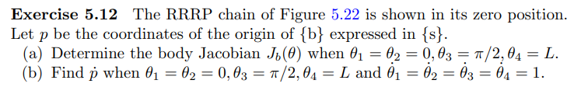

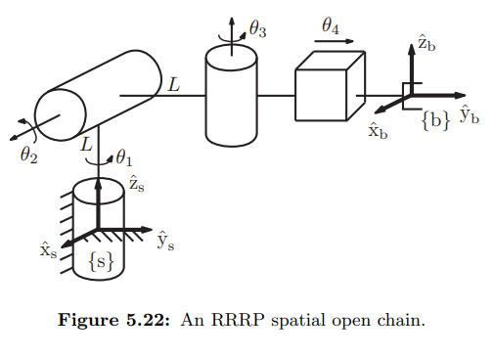

To solve this problem, the screw axes were first defined analogous to the first two problems of this assignment. These were then implemented first into a longform script used to calculate the symbolic form of the Jacobian, then later confirmed using the symbolic options within the functions we developed for the programming portion of this assignment.

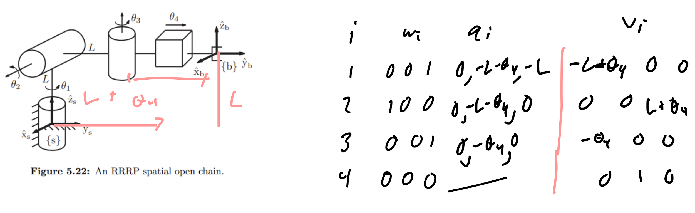

1. The body Jacobian here was calculated using the shown script and later verified using the symbolic version of our *body_jacobian.m* function with these screw axes using the formula:



Script:

syms L t1 t2 t3 t4

L = sym('L', 'real');

t1 = sym('t1', 'real');

t2 = sym('t2', 'real');

t3 = sym('t3', 'real');

t4 = sym('t4', 'real');

Screws = [0 0 1 -L 0 0; 1 0 0 0 0 L; 0 0 1 0 0 0; 0 0 0 0 1 0];

Thetas = [0; 0; pi/2; L];

T1 = S2T(-transpose(Screws(1,:)),Thetas(1));

T2 = S2T(-transpose(Screws(2,:)),Thetas(2));

T3 = S2T(-transpose(Screws(3,:)),Thetas(3));

T4 = S2T(-transpose(Screws(4,:)),Thetas(4));

Adj3 = Adjoint_Matrix(T4);

Adj2 = Adjoint_Matrix(T4*T3);

Adj1 = Adjoint_Matrix(T4*T3*T2);

J4 = transpose(Screws(4,:));

J3 = Adj3*transpose(Screws(3,:));

J2 = Adj2*transpose(Screws(2,:));

J1 = Adj1*transpose(Screws(1,:));

answer = simplify([J1 J2 J3 J4])

qdot = answer*[1;1;1;1]

The body jacobian at this configuration is

J_b =

[ 0, 0, 0, 0]

[ 0, -1, 0, 0]

[ 1, 0, 1, 0]

[-2L, 0, -2L, 0]

[ -3L, 0, 0, 1]

[ 0, L, 0, 0]

Where the last column is indeed the screw axis of the first joint, as expected for the space Jacobian.

1. Using  (as shown in the above script)



Pdot =

0

-1

2

-4*L

1 - 3L

L

1. **Exercise 5.13**: For the 6R spatial open chain of Figure **5.23**,

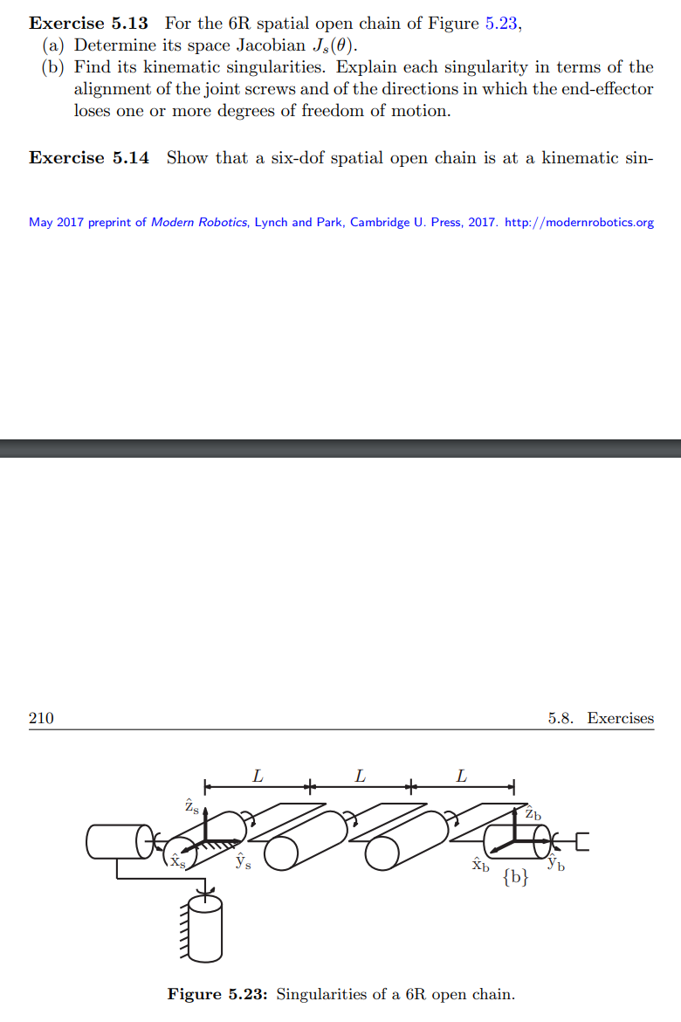

To solve this problem, the screw axes were first defined analogous to the first two problems of this assignment. These were then implemented first into a longform script used to calculate the symbolic form of the Jacobian, then later confirmed using the symbolic options within the functions we developed for the programming portion of this assignment.

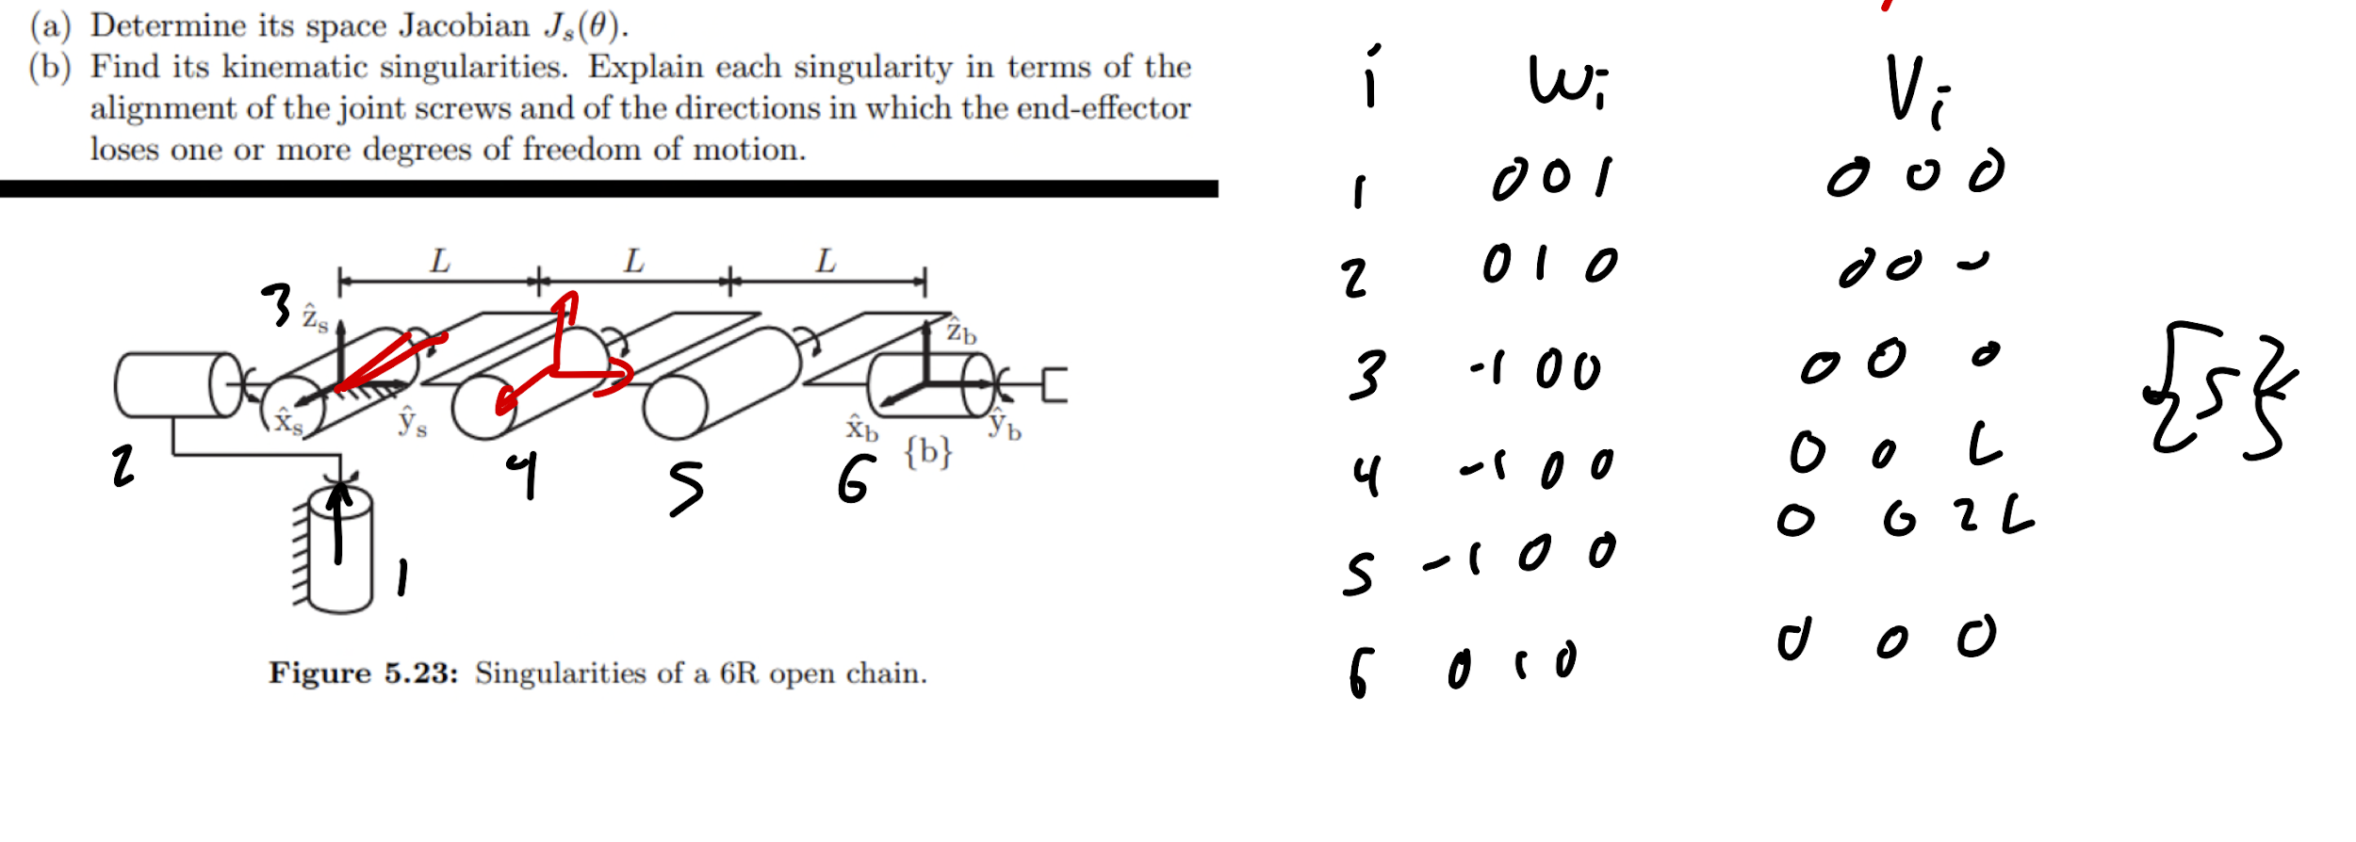

1. The space Jacobian here was calculated using the shown script and later verified using the symbolic version of our *space_jacobian.m* function with these screw axes using the formula

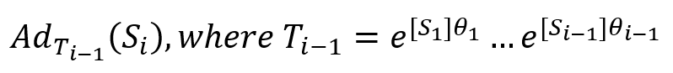

Script:

syms L t1 t2 t3 t4 t5 t6

L = sym('L', 'real');

t1 = sym('t1', 'real');

t2 = sym('t2', 'real');

t3 = sym('t3', 'real');

t4 = sym('t4', 'real');

t5 = sym('t5', 'real');

t6 = sym('t6', 'real');

Screws = [0 0 1 0 0 0; 0 1 0 0 0 0; -1 0 0 0 0 0; -1 0 0 0 0 L; -1 0 0 0 0 2*L; 0 1 0 0 0 0];

Thetas = [t1; t2; t3; t4; t5; t6];

T1 = S2T(transpose(Screws(1,:)),Thetas(1));

T2 = S2T(transpose(Screws(2,:)),Thetas(2));

T3 = S2T(transpose(Screws(3,:)),Thetas(3));

T4 = S2T(transpose(Screws(4,:)),Thetas(4));

T5 = S2T(transpose(Screws(5,:)),Thetas(5));

T6 = S2T(transpose(Screws(6,:)),Thetas(6));

Adj2 = Adjoint_Matrix(T1);

Adj3 = Adjoint_Matrix(T1*T2);

Adj4 = Adjoint_Matrix(T1*T2*T3);

Adj5 = Adjoint_Matrix(T1*T2*T3*T4);

Adj6 = Adjoint_Matrix(T1*T2*T3*T4*T5);

J1 = transpose(Screws(1,:));

J2 = Adj2*transpose(Screws(2,:));

J3 = Adj3*transpose(Screws(3,:));

J4 = Adj4*transpose(Screws(4,:));

J5 = Adj5*transpose(Screws(5,:));

J6 = Adj6*transpose(Screws(6,:));

answer = simplify([J1 J2 J3 J4 J5 J6])

detans = simplify((det(answer)))

This produces the symbolic Jacobian:

J_s =

[0, -sin(t1), -cos(t1)*cos(t2), -cos(t1)*cos(t2), -cos(t1)*cos(t2), sin(t5)*(cos(t4)*(sin(t1)*sin(t3) - cos(t1)*cos(t3)*sin(t2)) + sin(t4)*(cos(t3)*sin(t1) + cos(t1)*sin(t2)*sin(t3))) - cos(t5)*(cos(t4)*(cos(t3)*sin(t1) + cos(t1)*sin(t2)*sin(t3)) - sin(t4)*(sin(t1)*sin(t3) - cos(t1)*cos(t3)*sin(t2)))]

[0, cos(t1), -cos(t2)*sin(t1), -cos(t2)*sin(t1), -cos(t2)*sin(t1), cos(t5)*(cos(t4)*(cos(t1)*cos(t3) - sin(t1)*sin(t2)*sin(t3)) - sin(t4)*(cos(t1)*sin(t3) + cos(t3)*sin(t1)*sin(t2))) - sin(t5)*(cos(t4)*(cos(t1)*sin(t3) + cos(t3)*sin(t1)*sin(t2)) + sin(t4)*(cos(t1)*cos(t3) - sin(t1)*sin(t2)*sin(t3)))]

[1, 0, sin(t2), sin(t2), sin(t2), -sin(t3 + t4 + t5)*cos(t2)]

[0, 0, 0, L*cos(t1)*cos(t3)*sin(t2) - L*sin(t1)*sin(t3), L*cos(t1)*cos(t3)*sin(t2) - L*sin(t1)*sin(t3) - L*cos(t3)*sin(t1)*sin(t4) - L*cos(t4)*sin(t1)*sin(t3) + L*cos(t1)*cos(t3)*cos(t4)*sin(t2) - L*cos(t1)*sin(t2)*sin(t3)*sin(t4), -L*cos(t1)*cos(t2)*(sin(t4 + t5) + sin(t5))]

[0, 0, 0, L*(cos(t1)*sin(t3) + cos(t3)*sin(t1)*sin(t2)), L*cos(t1)*sin(t3) + L*cos(t1)*cos(t3)*sin(t4) + L*cos(t1)*cos(t4)*sin(t3) + L*cos(t3)*sin(t1)*sin(t2) +

L*cos(t3)*cos(t4)*sin(t1)*sin(t2) - L*sin(t1)*sin(t2)*sin(t3)*sin(t4), -L*cos(t2)*sin(t1)*(sin(t4 + t5) + sin(t5))]

[0, 0, 0, L*cos(t2)*cos(t3), L*cos(t2)*(cos(t3 + t4) + cos(t3)), L*sin(t2)*(sin(t4 + t5) + sin(t5))]

Where the first column is indeed the screw axis of the first joint, as expected for the space Jacobian.

1. The robot is at singularity when the determinant of the Jacobian is equal to zero (works because the Jacobian is square).



As calculated using the above script, the determinant of the Jacobian is:

Which is equal to zero when:

-> Joints 1 and 3 are collinear

-> Joints 3 4 and 5 are coplanar and parallel (the joint axes are coplanar)

= -> Joints 2 and 6 are collinear

**By definition**:

This robot should be at singularity when joints 2 and 6 are collinear, when joints 1 and 3 are collinear

This robot should be at singularity when joints 3, 4, and 5 are coplanar and parallel