Pl@ntation: The manual

Introduction

In this manual, you will learn how to install, configure and use a plant aid system correctly with an arduino 8266.

Component list

### ESP8266 (NodeMCU ESP-12E) Arduino

* DHT11 humidity sensor
* Light sensor flying fish
* 2x Resistors minimum 100 ohm
* 2x LED lamp (red/green)
* SRD-05VDC-SL-C relay
* Velleman VMA421 water pump
* Ohmeron 1000mA compact switch power supply
* One or two breadboards (amount depends on density of setup)
* about 10 to 15 connection cables (insulated copper) (amount depends on setup)

Installation

#### Installing the Arduino

1. Place the Arduino on a breadboard.

#### Installing the temperature / air humidity sensor

1. Place the sensor on a breadboard.
2. Connect pin G on the sensor to one of the GND pins on the Arduino.
3. Connect pin N on the sensor to one of the 3V3 pins on the Arduino.
4. Connect pin D on the sensor to pin D4 on the Arduino.

#### Installing the light sensor

1. Place the sensor on a breadboard.
2. Connect pin VCC on the sensor to one of the 3V3 pins on the Arduino.
3. Connect pin GND on the sensor to one of the GND pins on the Arduino.
4. Connect pin A0 on the sensor to pin A0 on the Arduino.
5. (In case the light sensor isn’t working properly, the screw can be turned clockwise and counter-clockwise to increase and decrease the sensitivity of the sensor, respectively.)

#### Installing the water pump

1. Place the relay on the breadboard.
2. Connect pin “-” on the relay to one of the GND pins on the Arduino.
3. Connect pin “+” on the relay to pin Vin on the Arduino.
4. Connect pin S on the relay to pin D7 on the Arduino.
5. Take the power adapter of the pump, make sure it has 2 cables and detach the cables from one another for about 5 - 10 cm’s.
6. Cut one of the detached cables in half and remove about a half to 1 cm on each side of the cut.
7. Take the exposed copper cables and insert them into the right side (above the “-” pin) and the middle part of the top side of the relay.
8. Attach a tube to the pump and connect the adapter cable to the pump.
9. Point the end of the tube towards the plant and make sure it can’t move around because the pressure might make it spray water everywhere.
10. Place the pump at the bottom of a water tank and make sure it sits below the height of where the tube goes so the water doesn’t keep flowing once the pump did it’s job.

#### Installing the indicator lights

1. Place both indicator lights on the breadboard.
2. Connect the negative side of the each light to a resistor.
3. Connect both resistors to one of the GND pins on the Arduino.
4. Connect the positive side of the red LED to the D5 pin on the Arduino.
5. Connect the positive side of the green LED to the D6 pin on the Arduino.

#### The link to our code on GitHub

#### <https://github.com/steven-zegers/Pl-ntation>

Configuration

Different plant species may require different needs in order to survive. Luckily there is a way to configure different boundaries of the plant so you can get a notification that something is wrong or let the system take action on its own.

There are 4 different boundaries the system takes into account:

* Temperature: You can configure how hot or cold it should be for optimal growth.
* Light: You can configure the intensity of the light in order for the plant to have an optimal light exposure.
* Air humidity: You can configure how high and low the percentage of air humidity should be.

Most house plants grow best when the air humidity is between 40 and 60 percent, therefore these are the default values. The temperature default is 21-26 degrees Celsius.

We used Node-RED to generate a flow between our ESP8266 Arduino and the IBM cloud using the MQTT protocol. The sensors data are read by the arduino software and consequently sent to the IBM cloud, we use our Node-RED flow on the cloud to respond to the data reactively. For example if there is not enough light for the plant a message will be sent back to the arduino to turn on the LED light to provide extra light for the plant.

To prevent sending too many messages back to our arduino we used rbe nodes to send messages back when the status of one of the parameters changes.

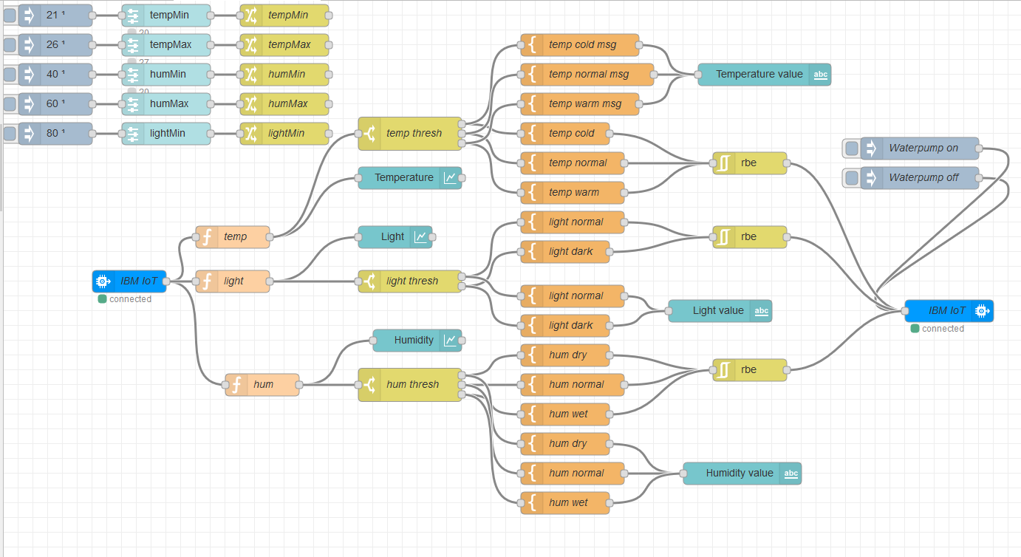

Usage

The device is going to gather data from the different components and send it to the IBM cloud. This data will be shown on an interface that the user can view. In this interface you will find charts containing information on the plant’s current conditions.

As mentioned in the installation section, there are some indicator LED’s installed on the breadboard. The red LED indicates there is too much or too little light near the plant, while the green LED indicates the temperature is too high or too low near the plant.

The water pump can be turned on and off by pressing on the inject nodes in the Node-RED flowchart.