**Report**

1. **Chip Layout View :**

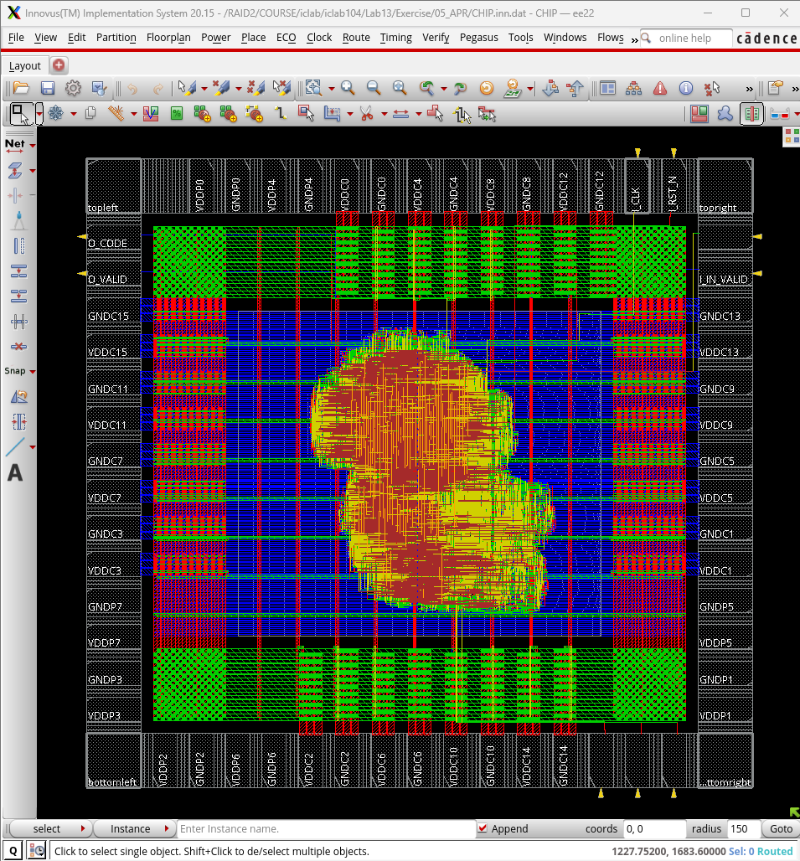

1. **Core to IO boundary :**

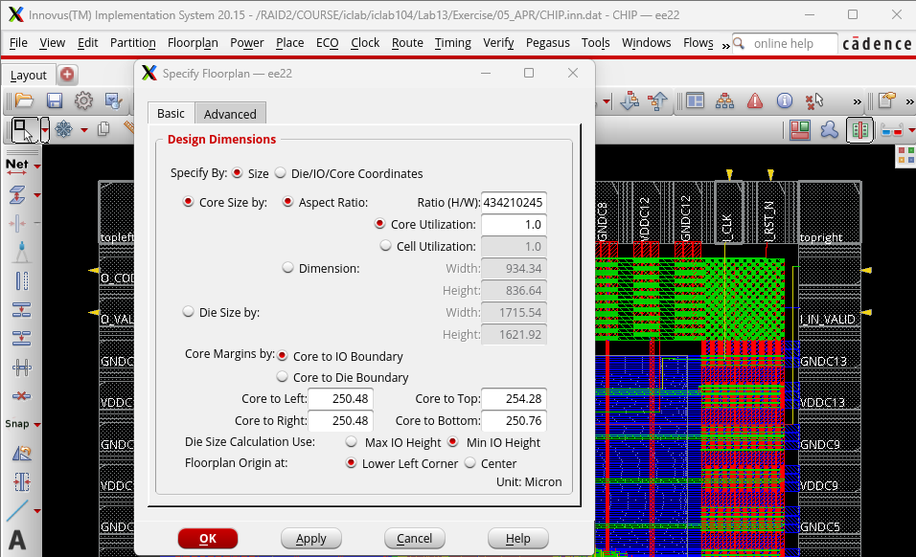

1. **Core Ring :**

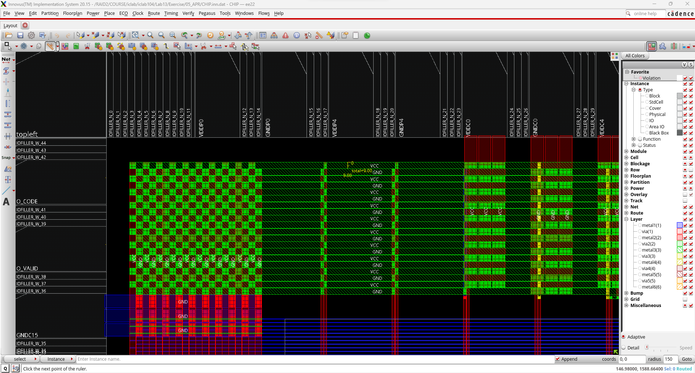

**(top)**

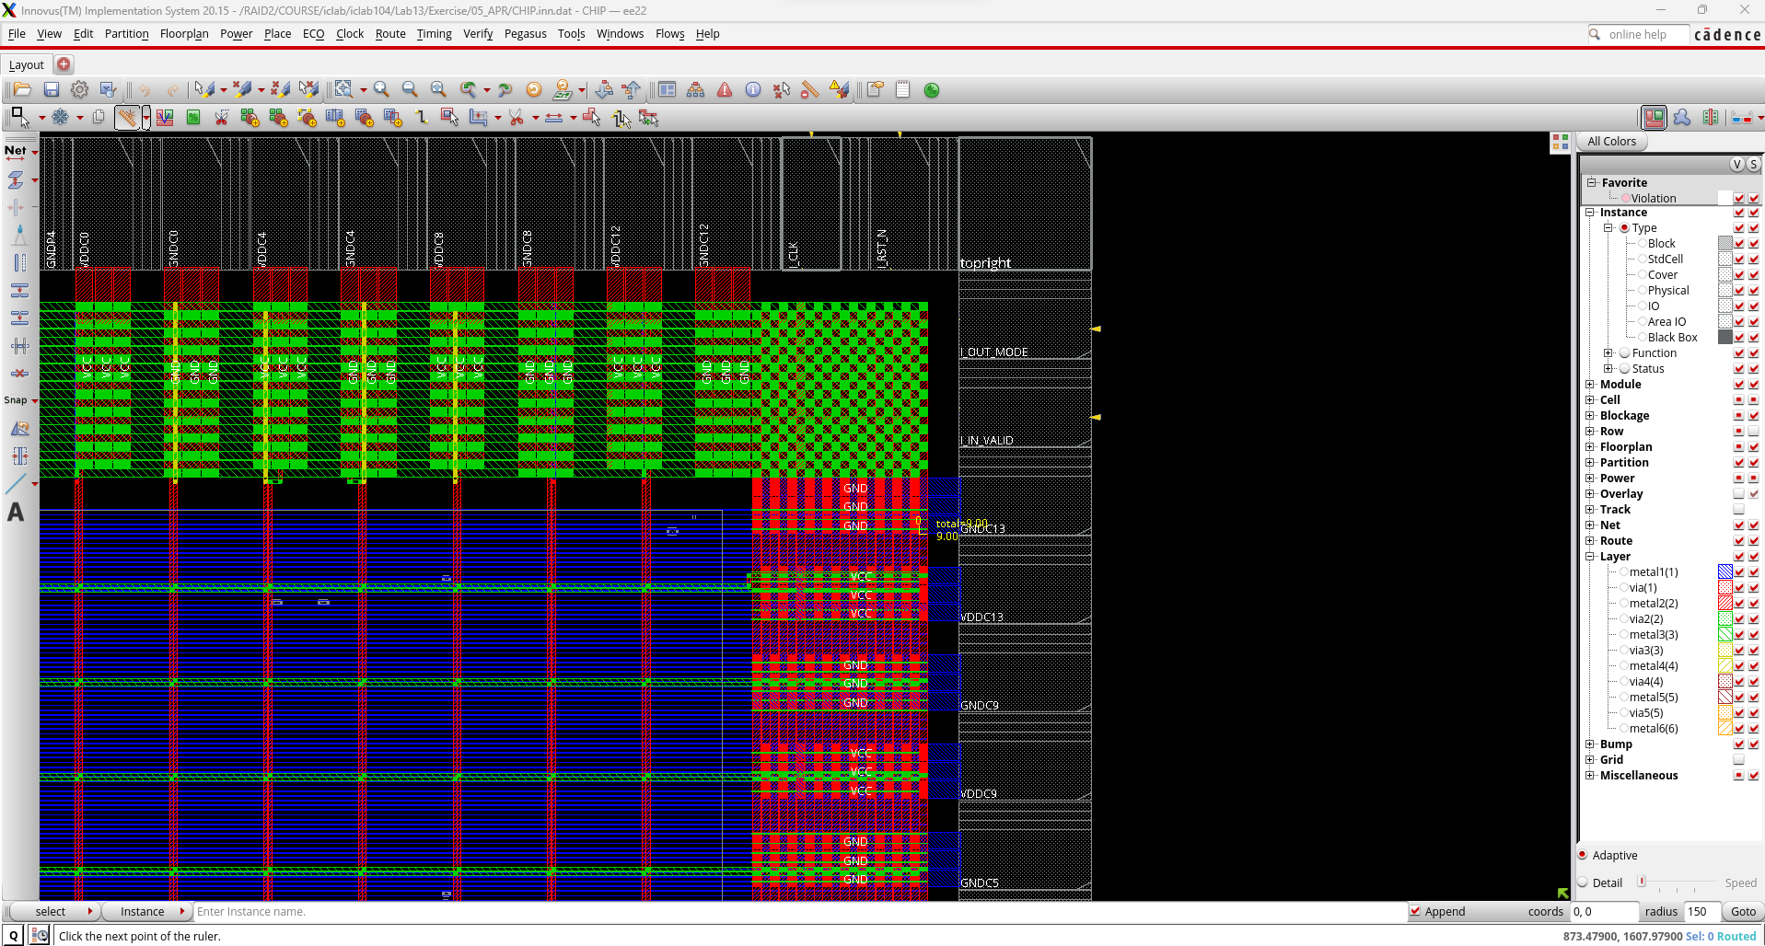

**(right)**

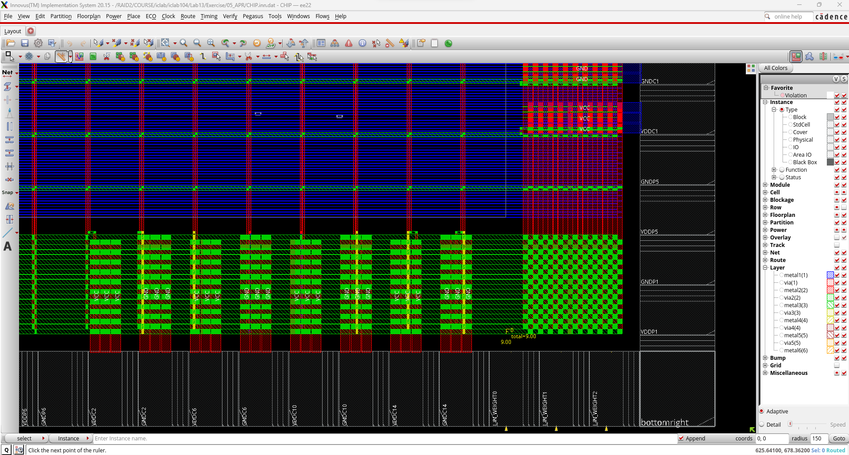

**(bottom)**

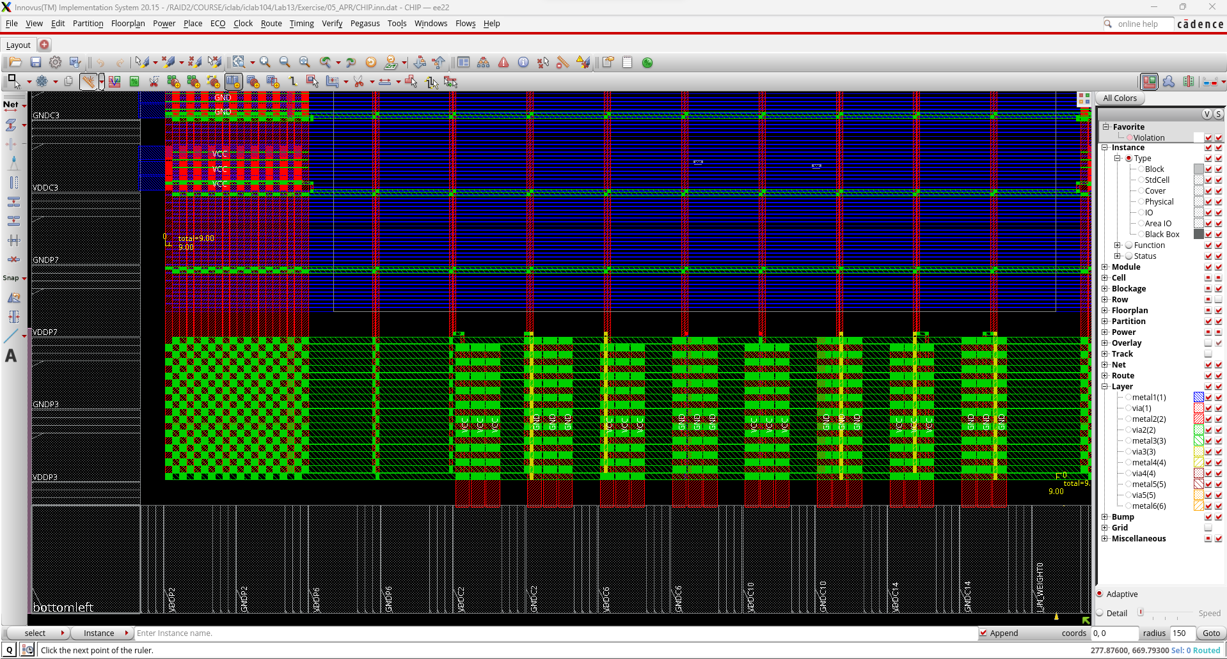

**(left)**

1. **Post-Route se**t**up time analysis :**

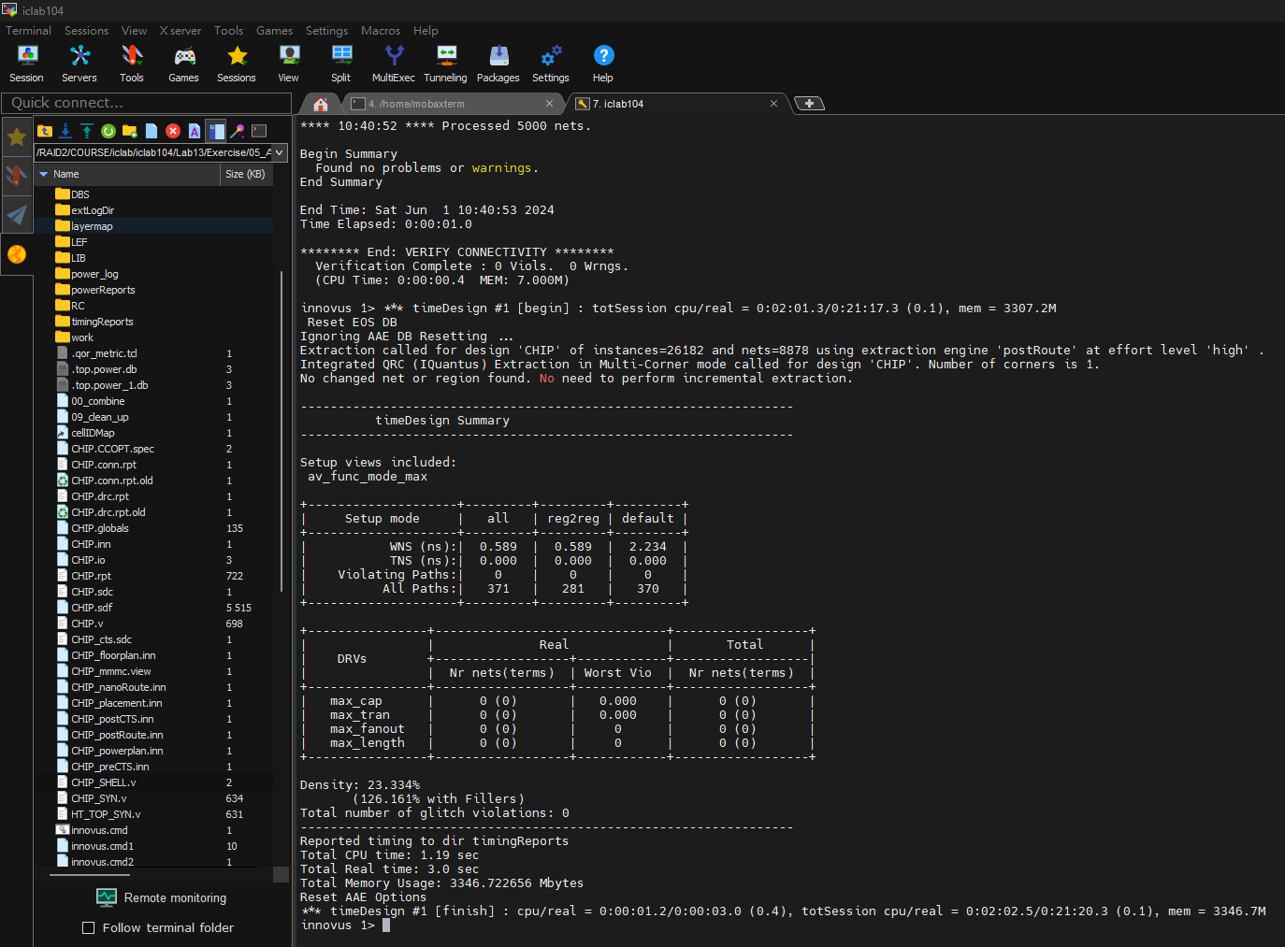

1. **Post-Route hold time analysis :**

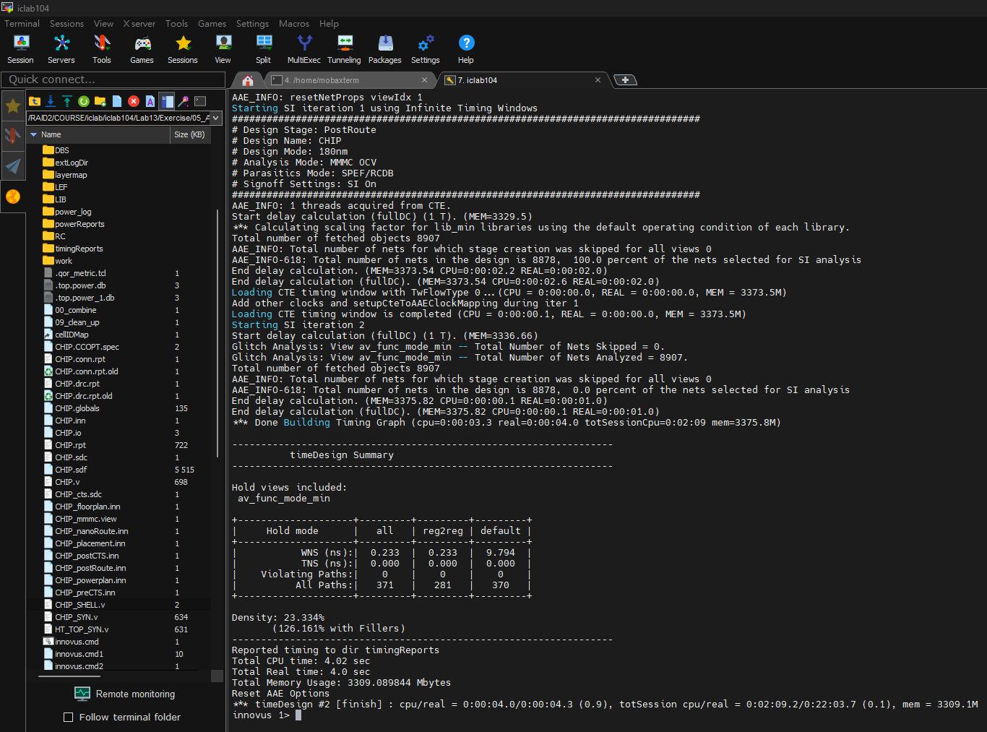

1. **DRC result :**

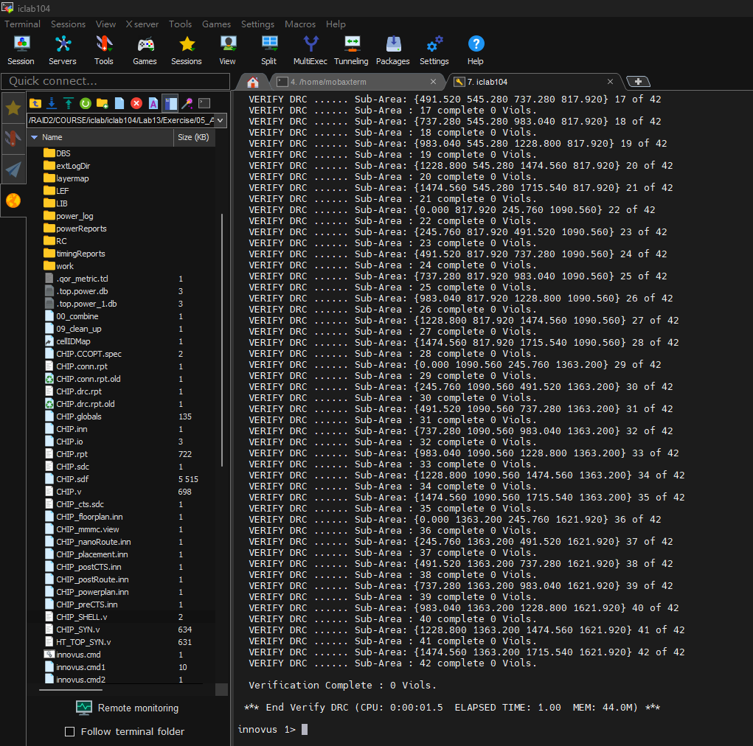

1. **LVS result :**

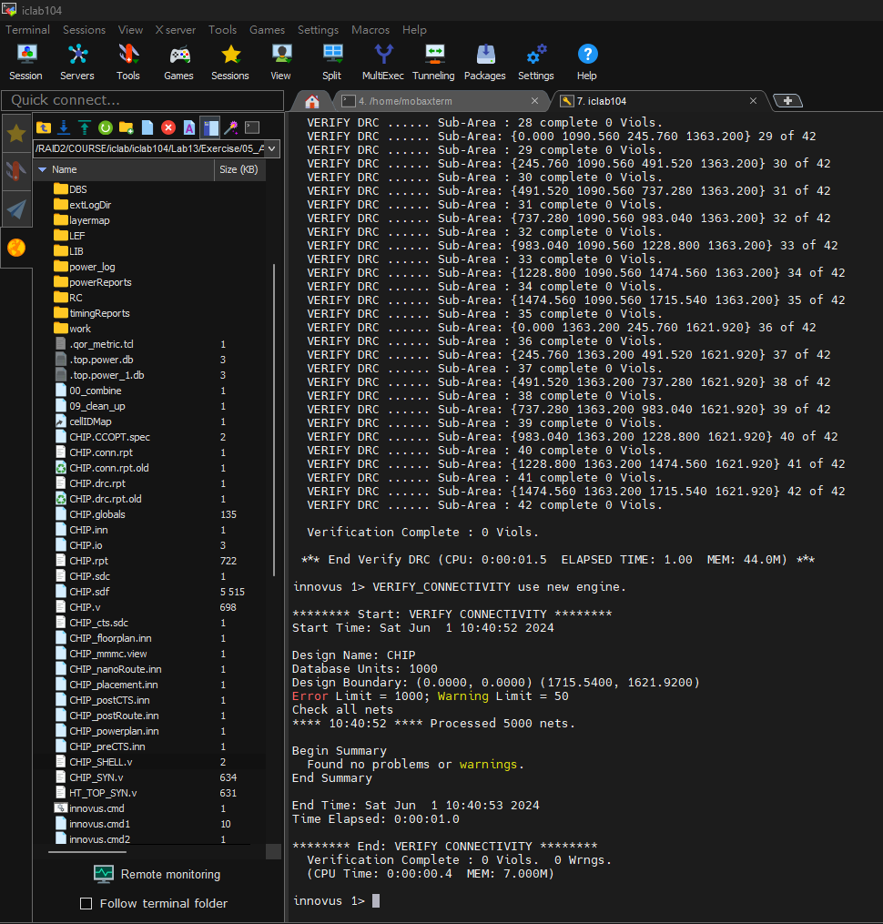

1. **Post Layout simulation result :**

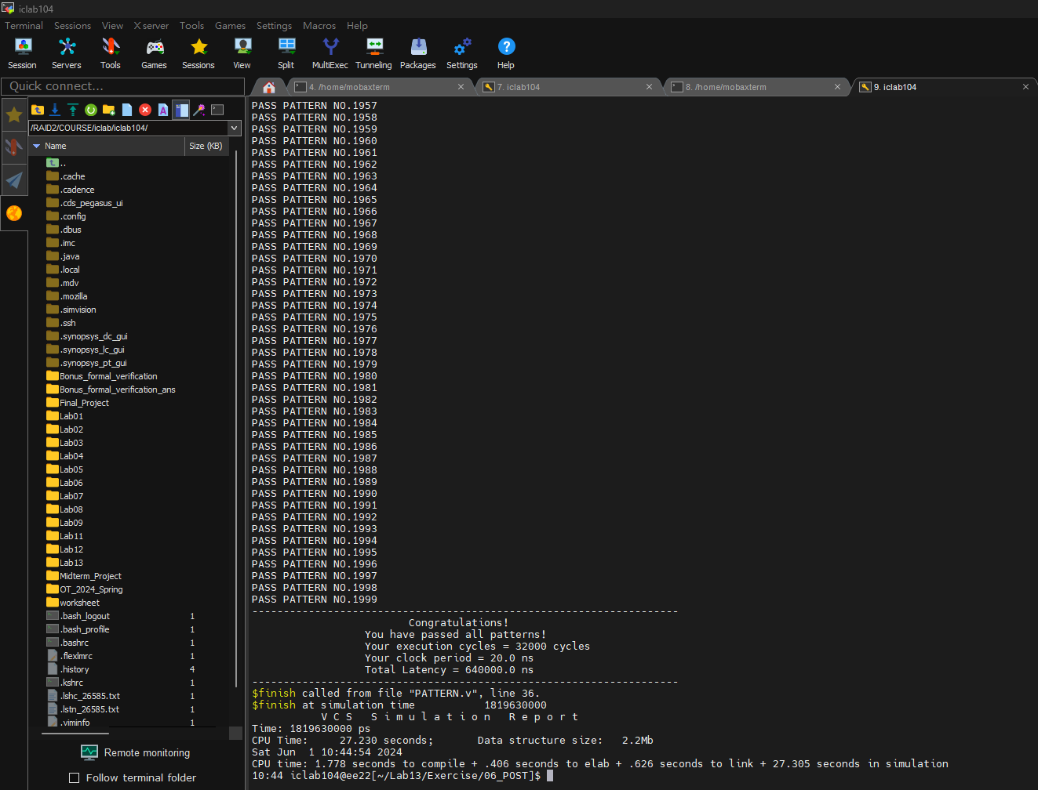

1. **Power result :**

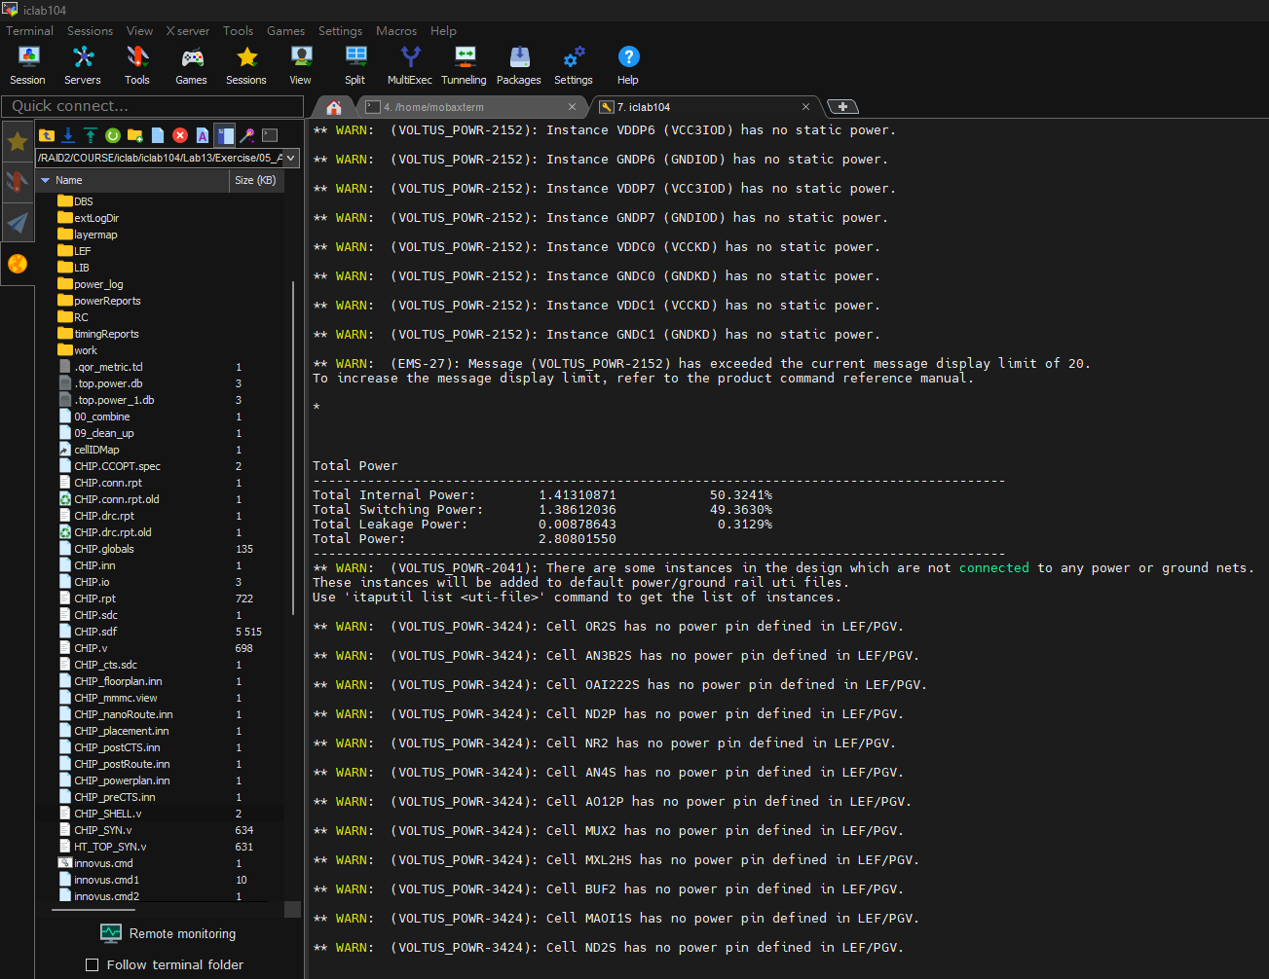

1. **IR Drop Results :**

In Lab12, I set utilization at 75%. This time, I set 70%. Additionally, I add more core power pads. There are 4 pairs in each side, 16 pairs in total.

