Introduction to Artificial Intelligence

Homework 2

0510002

袁鈺勛

1. Tic-tac-toe game
2. 如下圖

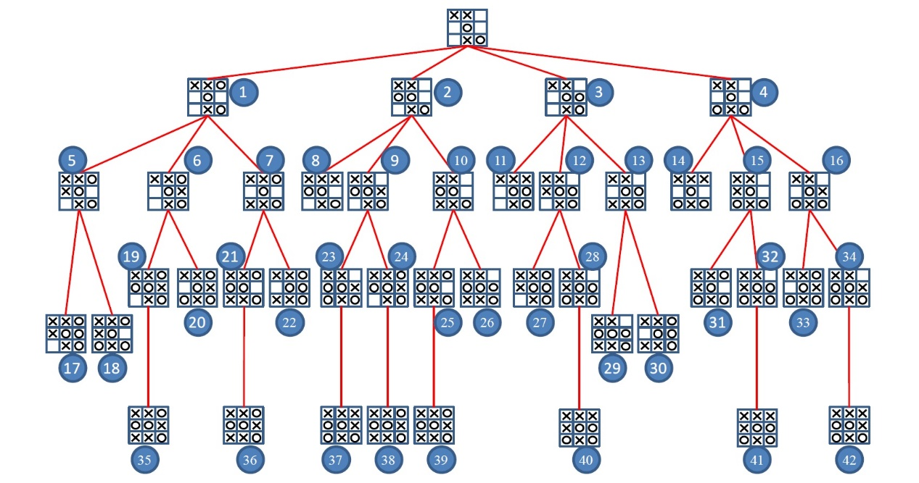

-1

-1

-1

1

1

1

1

1

1

1

1

-1

-1

-1

-1

0

0

0

0

1

1

1. 如下圖，MAX會走最左邊的1 node



-1

-1

-1

0

-1

0

0

1

1

1

-1

0

1

-1

1

1

-1

1

1

0

-1

-1

-1

-1

-1

-1

-1

1

1

1

1

1

1

1

1

1

0

0

0

1

0

1

1

1. 如下圖



圖中的9, 10, 12, 13, 15, 16, 23, 24, 25, 26, 27, 28, 29, 30, 31, 32, 33, 34, 37, 38, 39, 40, 41, 42這些node不會被check

1. Tic-tac-toe game, evaluation function
2. 如果圖中”O”有三個連成一列就+9，有三個”X”連成一列就-9(用以保證下面兩個計算不會超過他)

在所有空格中填入”O”，有幾條三個連線就+幾

在所有空格中填入”X”，有幾條三個連線就-幾

將上述的三個數字相加，得到minimax value

1. 如下圖，會走最左邊的1 node

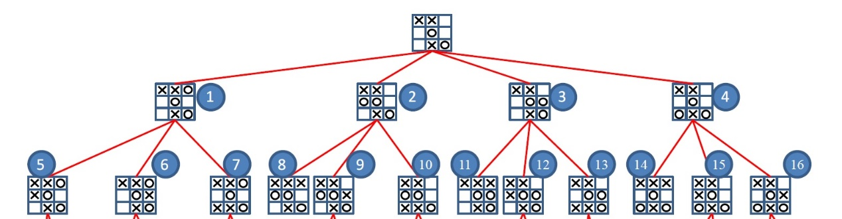

0

-8

-8

-8

0

-8

0

1

0

0

-8

0

1

-8

1

0

1

1. Hsinchu area
2. 如下圖

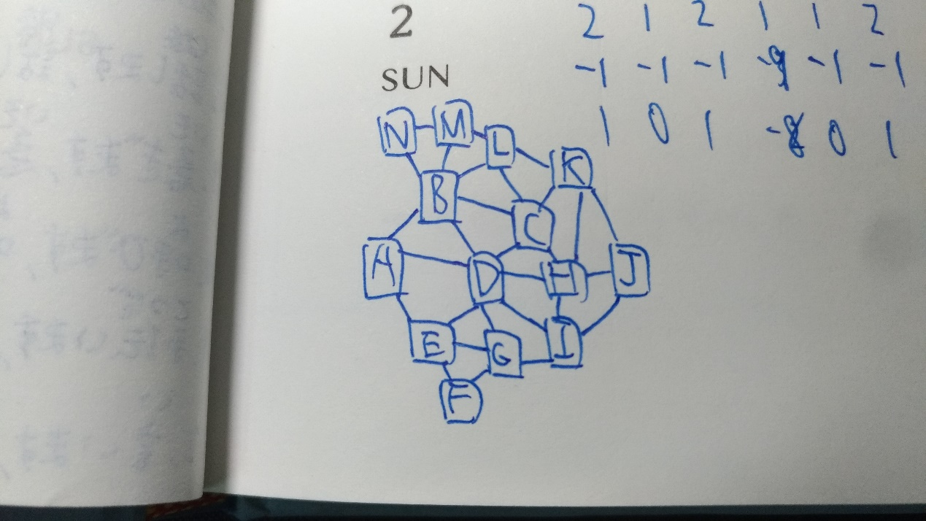

1. 如下表

|  |  |  |  |  |  |  |  |  |  |  |  |  |  |  |  |
| --- | --- | --- | --- | --- | --- | --- | --- | --- | --- | --- | --- | --- | --- | --- | --- |
| Assigned  region | Assigned  Value | A | B | C | D | E | F | G | H | I | J | K | L | M | N |
| D | 1 | 234 | 234 | 234 | 1 | 234 | 1234 | 234 | 234 | 234 | 1234 | 1234 | 1234 | 1234 | 1234 |
| B | 2 | 34 | 2 | 34 | 1 | 234 | 1234 | 234 | 234 | 234 | 1234 | 1234 | 134 | 134 | 134 |
| C | 3 | 34 | 2 | 3 | 1 | 234 | 1234 | 234 | 24 | 234 | 1234 | 124 | 14 | 134 | 134 |
| H | 2 | 34 | 2 | 3 | 1 | 234 | 1234 | 234 | 2 | 34 | 134 | 14 | 14 | 134 | 134 |
| I | 3 | 34 | 2 | 3 | 1 | 234 | 1234 | 24 | 2 | 3 | 14 | 14 | 14 | 134 | 134 |
| G | 2 | 34 | 2 | 3 | 1 | 34 | 134 | 2 | 2 | 3 | 14 | 14 | 14 | 134 | 134 |
| E | 3 | 4 | 2 | 3 | 1 | 3 | 14 | 2 | 2 | 3 | 14 | 14 | 14 | 134 | 134 |
| A | 4 | 4 | 2 | 3 | 1 | 3 | 14 | 2 | 2 | 3 | 14 | 14 | 14 | 134 | 134 |
| K | 1 | 4 | 2 | 3 | 1 | 3 | 14 | 2 | 2 | 3 | 4 | 1 | 4 | 134 | 134 |
| L | 4 | 4 | 2 | 3 | 1 | 3 | 14 | 2 | 2 | 3 | 4 | 1 | 4 | 13 | 134 |
| J | 4 | 4 | 2 | 3 | 1 | 3 | 14 | 2 | 2 | 3 | 4 | 1 | 4 | 13 | 134 |
| M | 1 | 4 | 2 | 3 | 1 | 3 | 14 | 2 | 2 | 3 | 4 | 1 | 4 | 1 | 34 |
| F | 1 | 4 | 2 | 3 | 1 | 3 | 1 | 2 | 2 | 3 | 4 | 1 | 4 | 1 | 34 |
| N | 3 | 4 | 2 | 3 | 1 | 3 | 1 | 2 | 2 | 3 | 4 | 1 | 4 | 1 | 3 |

1. Decision tree

