**Notes**

I think this is how Stochastic universal sampling and Deterministic sampling works. I think I did the performance right. I only did Stochastic universal sampling and Deterministic sampling on the individual run. I didn’t do with Stochastic universal sampling and Deterministic sampling on the 30 independent runs.

Stochastic universal sampling

Normalize the f values(f/n). Then generate a uniformly randomly generated probe. This probe is the first probe to be generated(u(0,1)) and all other probes are all equidistant from each other. When hitting boundaries, wrap around back to 0. The distance between each probe is 1/n.

Deterministic sampling

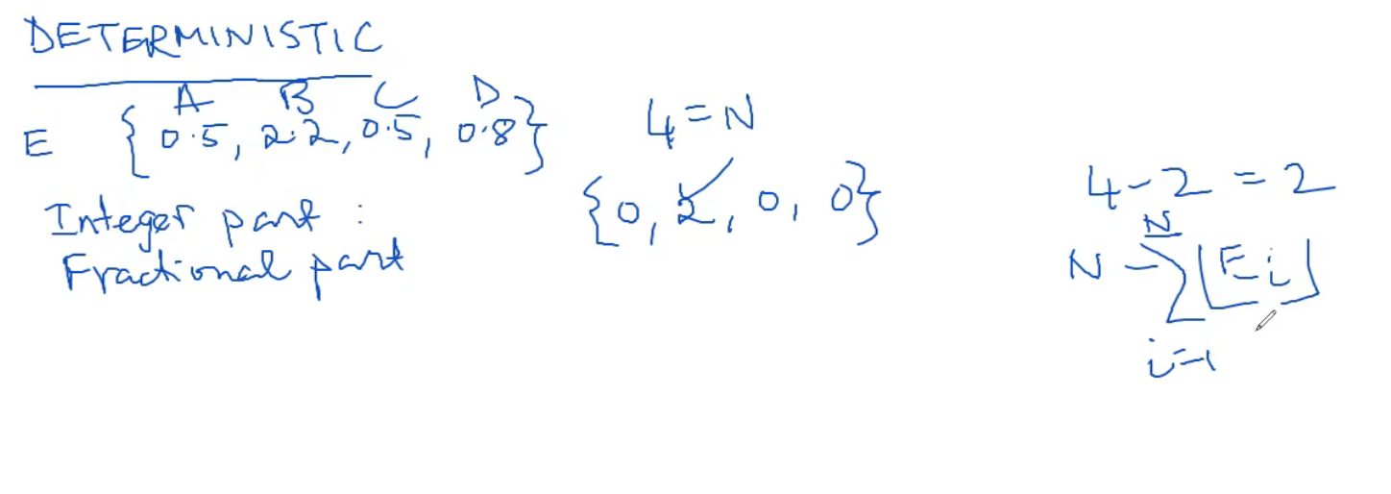

Ei = pi*n. Take all integer parts of Ei, add them up and subtract total from n. This gives you the number of individuals that need to be filled(r).

Sort the population. Find the highest numbers (r) times. If one of those numbers have multiple instances, choose one randomly.

