1.

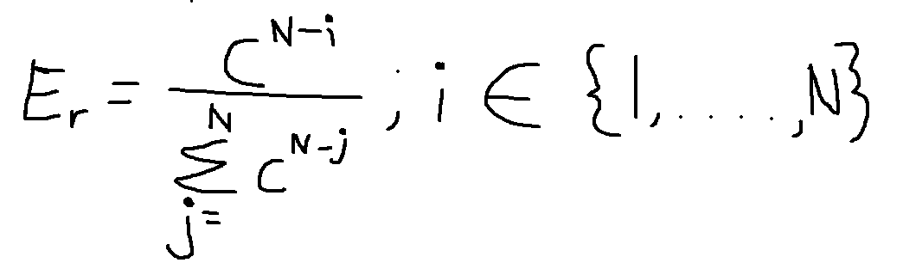

c is 0<c<1

this permits higher selective pressures than the linear ranking method.

Non-linear ranking assigns selection probabilities that are based on each individual’s rank but are not proportional to the rank. Therefore there’s no suffering of premature convergence.

2. min is the expected number of copies that the worst individual receives at the end of the selection process. For there to be no parameters for linear ranking, min and max will have to be predetermined. We can say

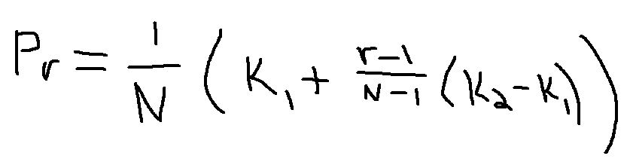

K1 =1

K2 =10

3a. 1

3b. no, because min+max is always = 2

3c. r=2

Each tournament takes 2 individuals from the population uniformly randomly and picks the better individual out of the two. If the population is 100 and the selection population we need is 100, then the average individual should be chosen about half the time so it is about 50. This is because the average of the population is the median of the population. And therefore the average individual is chosen if it is better than anything after the average. Which is about 49% of the population. Ex: population is from 1-10. The average will be 5. Therefore it is a 50% chance that it is bigger than it’s competitor.

3d. the expected count for the average individual using the new linear ranking selection is 60. Say the N is 100 that means the average would be 50

