How to run

1. Extract files from Release.Zip to a folder.
2. Open command prompt window as administrator.
3. Type in “MYOB.exe” and press enter.

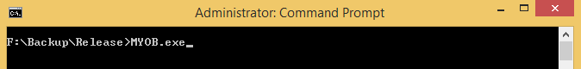

1. Enter input data path. This is the path to input CSV file. You can leave this blank and press enter. The default input CSV file is located in your unzipped folder, such as Data\InputData.csv
2. Enter output data path. This is the path to output CSV file. You can leave this blank and press enter. The default output CSV file is located in your unzipped folder, such as Data\OutputData.csv
3. Enter tax table path. This is the path to tax table. You can leave this blank and press enter. The default tax CSV file is located in your unzipped folder, such as Tax\TaxTable.csv

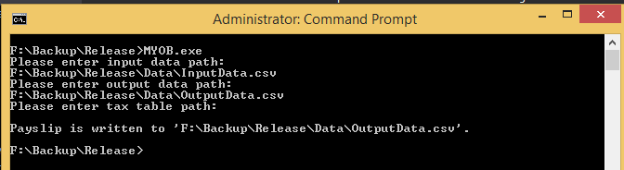

Technical Details

1. Created using VS 2015, .Net framework 4.5.2 and C#.
2. MYOB project is the single startup project using console application template.
3. Calculator project contains all the business logic.
4. UnitTest Project (TDD) contains sample tests for functions.
5. UnitTestBDD Project (BDD) contains sample tests for the whole workflow.

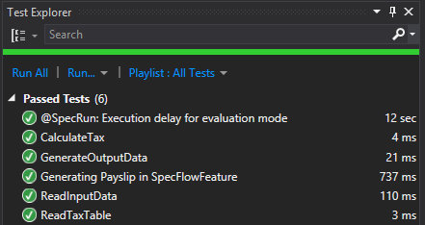

1. This application can handle large CSV files. It reads, calculates and writes one record at a time.