**Features**

Group 23

**Feature Introduction:**

The base version of Covey.Town lacks an invitation system that allows users to both invite and accept invitations from their friends. To increase the interactivity between users, we added such a system. To invite a user, a user can direct the invite tab at the bottom of the app. Under this tab, he/she can either click the invite button next to his/her friend or copy the invitation link and send it to the friend via social media. On the one hand, to accept invitations for a user currently on the town list page (the user has already created a username), he/she can view all invitations sent by others from the town invitation box and choose to accept or deny any invitation. On the other hand, for a user who hasn't created a username, he/she can use an invitation link to join the Covey.Town: the link will direct him/her to a page asking for a username and display the town name that he/she is entering.

**Identifier of a user: username**

1. Since the invitation system needs something to keep track of user identification, we will always ask for a username before a user enters a town.

**The first page of the app:**

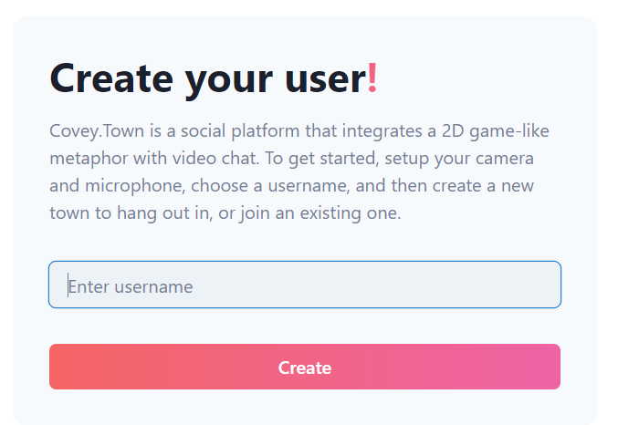

**The landing page when user use a invitation link to join:**

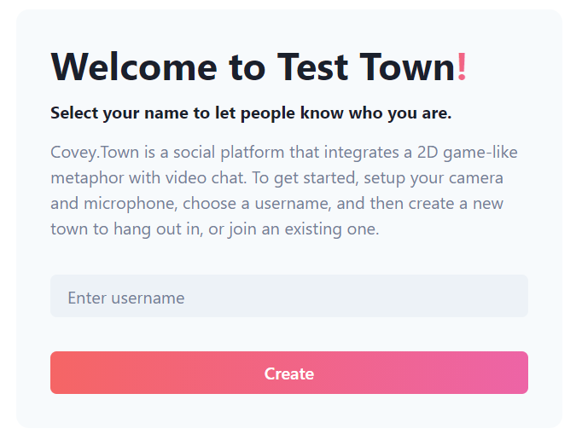

**Navigation Bar:**

Once the user logged in with a username, he/she will see a navigation bar at the top of the page.

1. **Town List Button:** This button is unclickable unless a user has already joined a town. Clicking this button will make the user quit the room and navigate him/her to the town list page.
2. **Logout Button:** If a user clicks this button, he/she will go back to the first page of the app, which is the page asking for a username. He/she will no longer be visible to other users that are already in a town.
3. **Town Invitations Dropdown:** A user can view all invitations and choose to accept or deny any of them in this dropdown menu.

**Navigation Bar:**

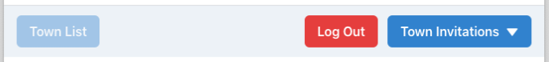

**Inviting Users:**

After a user joins a town, he/she will see an invite button at the bottom right of the app page:

Clicking the button will make an invitation window prompt out as following:

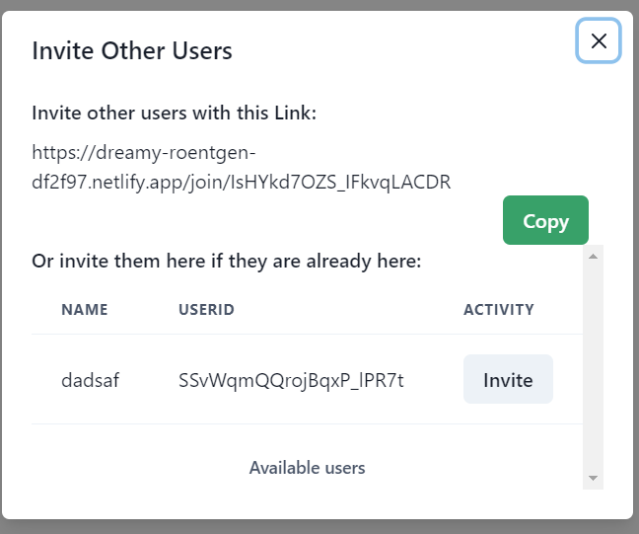

1. **Invite IN-SYSTEM Users:**

IN-SYSTEM users are considered as those who have already created their usernames. On this window, a user can view all IN-SYSTEM users. He/she can invite by simply clicking the invite button next to a user.

**To invite IN-SYSTEM user:**

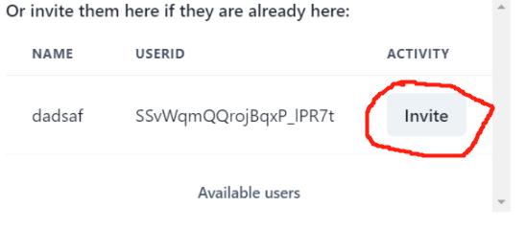

1. **Invite OUT-SYSTEM**

OUT-SYSTEM users are considered as those who have not created their usernames yet. Again, on this window, a user can copy the invitation link and send it to others via social media.

**To invite OUT-SYSTEM user:**

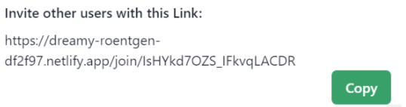

**Accepting Invitations:**

1. **Join as IN-SYSTEM User:**

As stated above, IN-SYSTEM users are able to view all invitations from the **Town Invitation** dropdown menu.

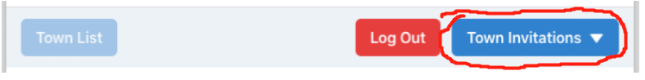

He/She can take actions by simply clicking the accept or deny button.

**Invitation List:**

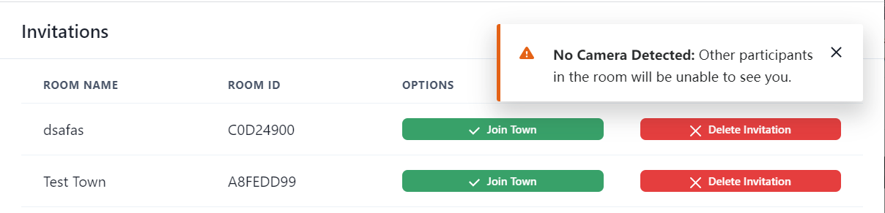

1. **Join as OUT-SYSTEM User:**

Once received an invitation link, an OUT-SYSTEM user can copy the link and paste it into a browser. This link will navigate him/her to a page asking for a username to enter, displaying the town name that the user is currently joining, as stated above. After creating the username, the user will directly get into the town.