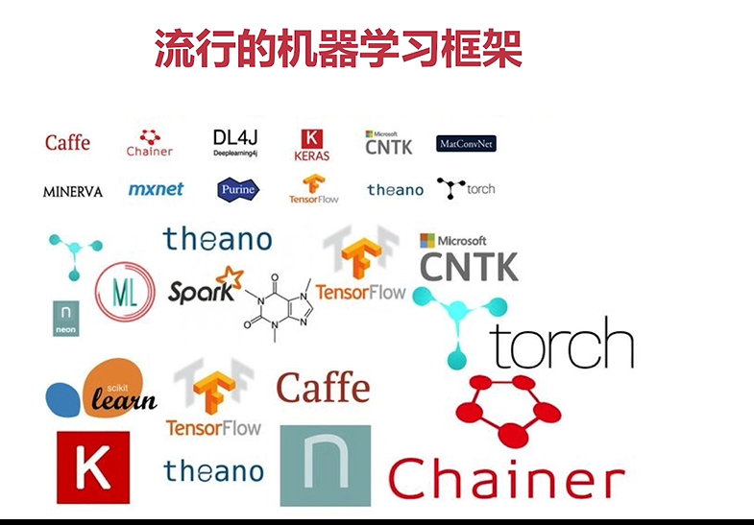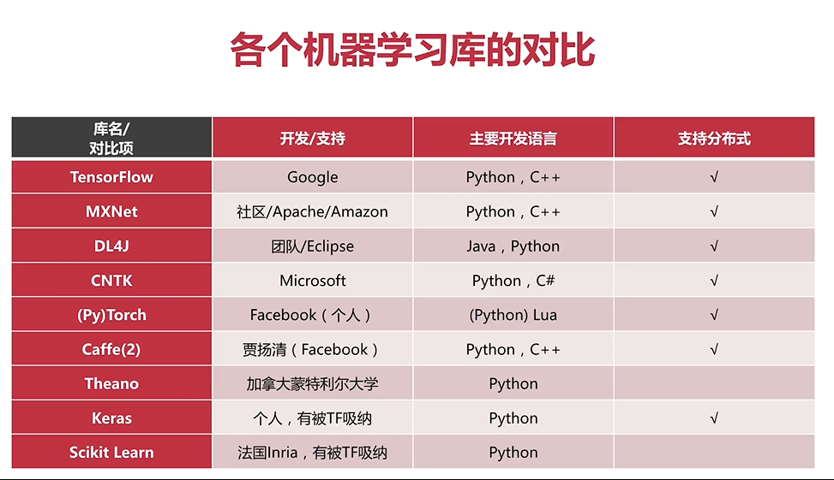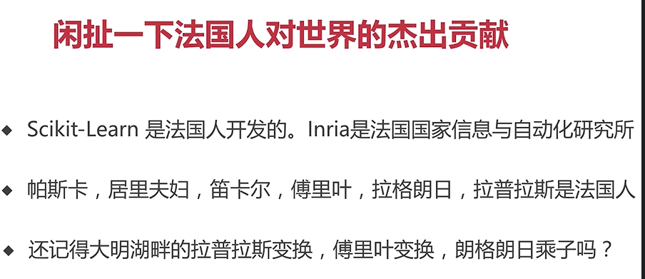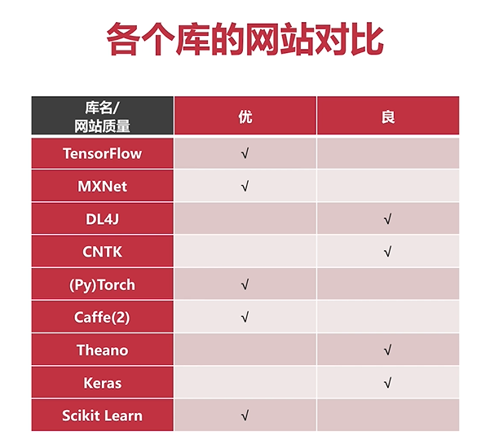

可以各自去各個官網去觀察!!!

並參考推薦好文:

<https://zhuanlan.zhihu.com/p/25547838>

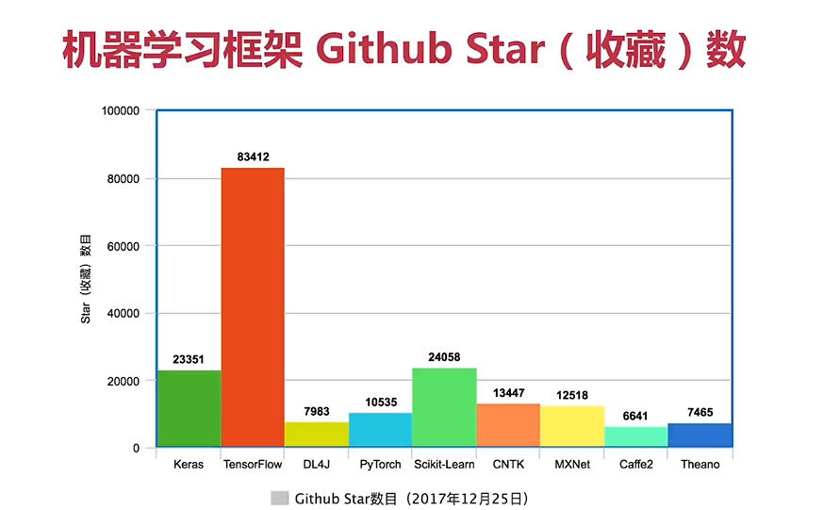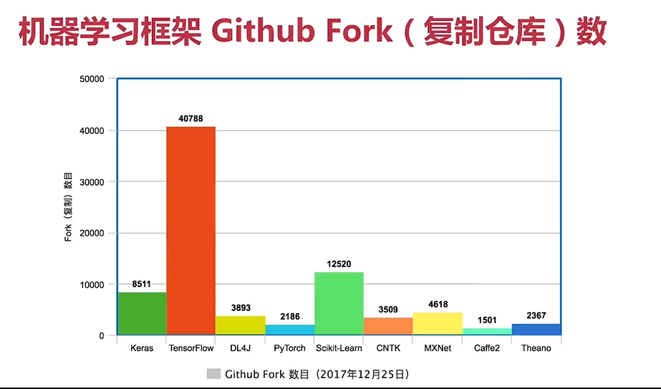

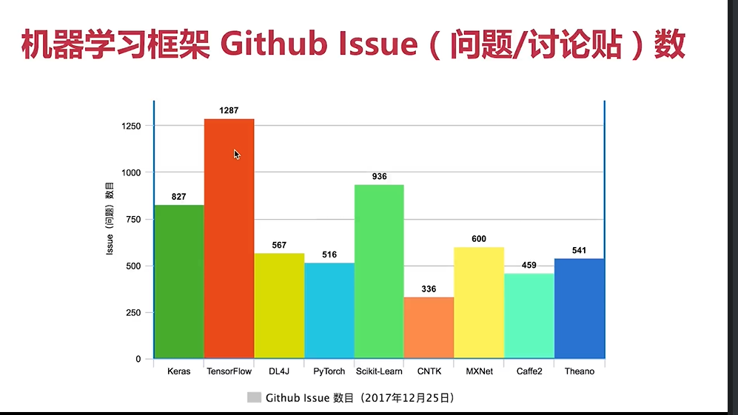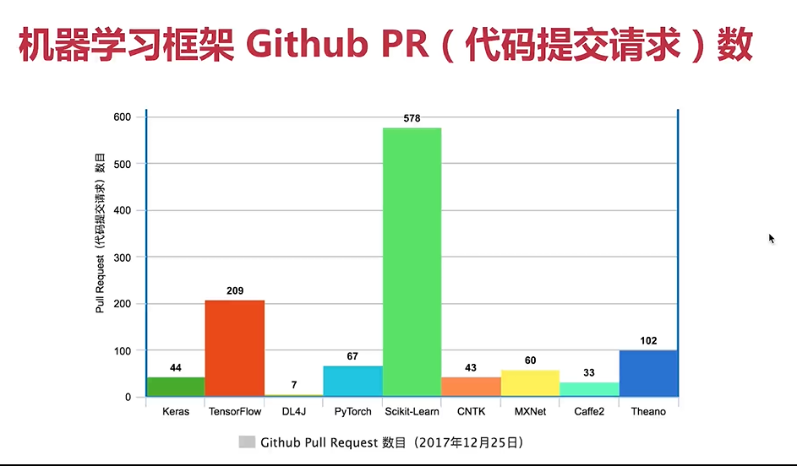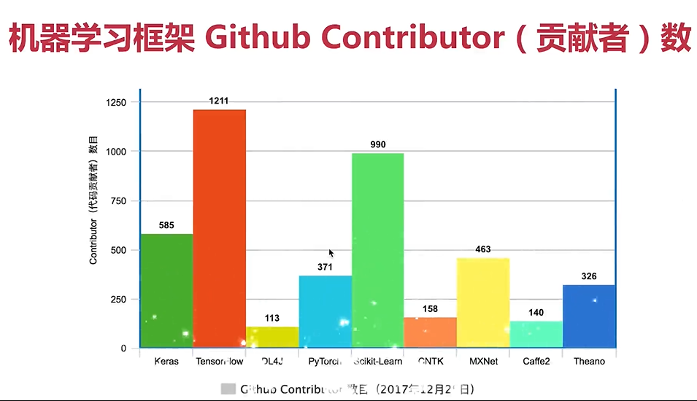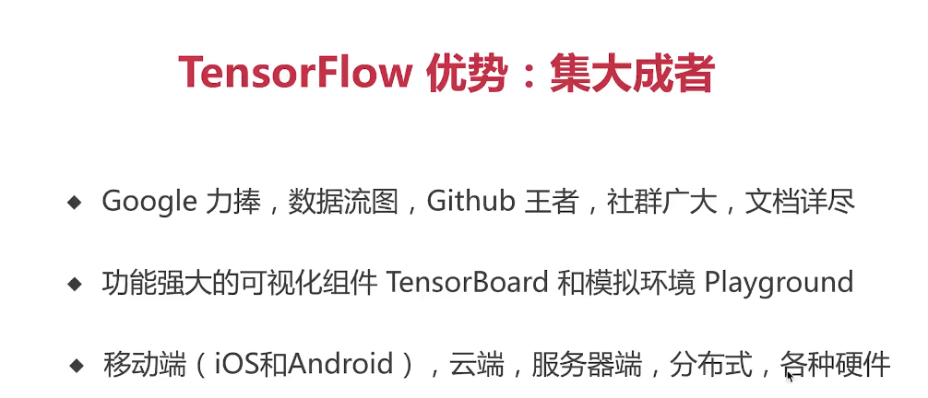

<https://playground.tensorflow.org/#activation=tanh&batchSize=10&dataset=circle&regDataset=reg-plane&learningRate=0.03&regularizationRate=0&noise=0&networkShape=4,2&seed=0.08520&showTestData=false&discretize=false&percTrainData=50&x=true&y=true&xTimesY=false&xSquared=false&ySquared=false&cosX=false&sinX=false&cosY=false&sinY=false&collectStats=false&problem=classification&initZero=false&hideText=false>

