Rbind 可能會把type改掉，所以要記得改

Ex,

load(url("https://storage.googleapis.com/r_rookies/straw_hat_df.RData"))

> view(straw_hat_df)

Error in view(straw_hat_df) : could not find function "view"

> View(straw_hat_df)

> jinbe <- c("Jinbe", "Male", "Shichibukai", 400000000, 46, "04-02", 301)

> View(straw_hat_df)

> straw_hat_df <- rbind(straw_hat_df, jinbe)

> View(straw_hat_df)

> str(straw_hat_df)

'data.frame': 10 obs. of 7 variables:

$ name : chr "Monkey D. Luffy" "Roronoa Zoro" "Nami" "Usopp" ...

$ gender : Factor w/ 2 levels "Female","Male": 2 2 1 2 2 2 1 2 2 2

$ occupation: chr "Captain" "Swordsman" "Navigator" "Sniper" ...

$ bounty : chr "5e+08" "3.2e+08" "6.6e+07" "2e+08" ...

$ age : chr "19" "21" "20" "19" ...

$ birthday : chr "05-05" "11-11" "07-03" "04-01" ...

$ height : chr "174" "181" "170" "176" ...

> straw_hat_df$age <- as.integer(straw_hat_df$age)

> str(straw_hat_df)

'data.frame': 10 obs. of 7 variables:

$ name : chr "Monkey D. Luffy" "Roronoa Zoro" "Nami" "Usopp" ...

$ gender : Factor w/ 2 levels "Female","Male": 2 2 1 2 2 2 1 2 2 2

$ occupation: chr "Captain" "Swordsman" "Navigator" "Sniper" ...

$ bounty : chr "5e+08" "3.2e+08" "6.6e+07" "2e+08" ...

$ age : int 19 21 20 19 21 17 30 36 90 46

$ birthday : chr "05-05" "11-11" "07-03" "04-01" ...

$ height : chr "174" "181" "170" "176" ...

| **name** | | **gender** | **occupation** | | **bounty** | | **age** | **birthday** | | **height** | |
| --- | --- | --- | --- | --- | --- | --- | --- | --- | --- | --- | --- |
|  |  | |  |  | |  | |  |  | |  |
| **1** | Monkey D. Luffy | | Male | Captain | | 5e+08 | | 19 | 05-05 | | 174 |
| **2** | Roronoa Zoro | | Male | Swordsman | | 3.2e+08 | | 21 | 11-11 | | 181 |
| **3** | Nami | | Female | Navigator | | 6.6e+07 | | 20 | 07-03 | | 170 |
| **4** | Usopp | | Male | Sniper | | 2e+08 | | 19 | 04-01 | | 176 |
| **5** | Vinsmoke Sanji | | Male | Cook | | 1.77e+08 | | 21 | 03-02 | | 180 |
| **6** | Tony Tony Chopper | | Male | Doctor | | 100 | | 17 | 12-24 | | 90 |
| **7** | Nico Robin | | Female | Archaeologist | | 1.3e+08 | | 30 | 02-06 | | 188 |
| **8** | Franky | | Male | Shipwright | | 9.4e+07 | | 36 | 03-09 | | 240 |
| **9** | Brook | | Male | Musician | | 8.3e+07 | | 90 | 04-03 | | 277 |
| **10** | Jinbe | | Male | Shichibukai | | 4e+08 | | 46 | 04-02 | | 301 |

2. 篩選straw_hat_df中不是男性的

> straw_hat_df[!straw_hat_df$gender == "Male", ]

name gender occupation bounty age birthday height

3 Nami Female Navigator 6.6e+07 20 07-03 170

7 Nico Robin Female Archaeologist 1.3e+08 30 02-06 188

**刪除觀測值**

* 使用中括號 [] 搭配索引值
* 或使用邏輯值

**load(url("https://storage.googleapis.com/r_rookies/straw_hat_df.RData"))**

**straw_hat_df <- straw_hat_df[-9, ]**

**straw_hat_df <- straw_hat_df[straw_hat_df$name != "Franky", ]**

** 用subset

> subset(straw_hat_df, subset = gender != "Male" )

name gender occupation bounty age birthday height

3 Nami Female Navigator 6.6e+07 20 07-03 170

7 Nico Robin Female Archaeologist 1.3e+08 30 02-06 188

只顯示某些欄位:

> subset(straw_hat_df, subset = gender != "Male", select = c("name", "gender"))

name gender

3 Nami Female

7 Nico Robin Female

## ** 轉換格式

* 新增一個變數為生日的年月日，格式為 Date
* 先算生日的年份，跟原本的月日結合，然後轉換格式

**load(url("https://storage.googleapis.com/r_rookies/straw_hat_df.RData"))**

**this_year <- as.numeric(format(Sys.Date(), '%Y'))**

**birth_year <- this_year - straw_hat_df$age**

**birth_date_chr <- paste(birth_year, straw_hat_df$birthday, sep = "-")**

**straw_hat_df$birth_date <- as.Date(birth_date_chr)**

**str(straw_hat_df)**

slide 12/18

* [Contents](javascript:w3c_slidy.toggle_table_of_contents())

也可以用sprintf的方式來合成string: (C style)

sprintf("%s-%s", birth_air, straw_hat_df$birthday)

“1998-05-05” “XXX”

”

## ** 資料轉置：寬表格變長表格

寬表格:

name age height

1 Monkey D. Luffy 19 174

2 Roronoa Zoro 21 181

3 Nami 20 170

4 Usopp 19 176

5 Vinsmoke Sanji 21 180

6 Tony Tony Chopper 17 90

7 Nico Robin 30 188

8 Franky 36 240

9 Brook 90 277

長表格

name category values

1 Monkey D. Luffy age 19

2 Roronoa Zoro age 21

3 Nami age 20

4 Usopp age 19

5 Vinsmoke Sanji age 21

6 Tony Tony Chopper age 17

7 Nico Robin age 30

8 Franky age 36

9 Brook age 90

10 Monkey D. Luffy height 174

11 Roronoa Zoro height 181

12 Nami height 170

13 Usopp height 176

14 Vinsmoke Sanji height 180

15 Tony Tony Chopper height 90

16 Nico Robin height 188

17 Franky height 240

18 Brook height 277

作法:

> load(url("https://storage.googleapis.com/r_rookies/straw_hat_df.RData"))

>

> straw_hat_wide_df <- straw_hat_df[, c("name", "age", "height")]

> straw_hat_wide_df

name age height

1 Monkey D. Luffy 19 174

2 Roronoa Zoro 21 181

3 Nami 20 170

4 Usopp 19 176

5 Vinsmoke Sanji 21 180

6 Tony Tony Chopper 17 90

7 Nico Robin 30 188

8 Franky 36 240

9 Brook 90 277

> straw_hat_long_df <- gather(straw_hat_wide_df, key = category, value = values, age, height)

> straw_hat_long_df

name category values

1 Monkey D. Luffy age 19

2 Roronoa Zoro age 21

3 Nami age 20

4 Usopp age 19

5 Vinsmoke Sanji age 21

6 Tony Tony Chopper age 17

7 Nico Robin age 30

8 Franky age 36

9 Brook age 90

10 Monkey D. Luffy height 174

11 Roronoa Zoro height 181

12 Nami height 170

13 Usopp height 176

14 Vinsmoke Sanji height 180

15 Tony Tony Chopper height 90

16 Nico Robin height 188

17 Franky height 240

18 Brook height 277

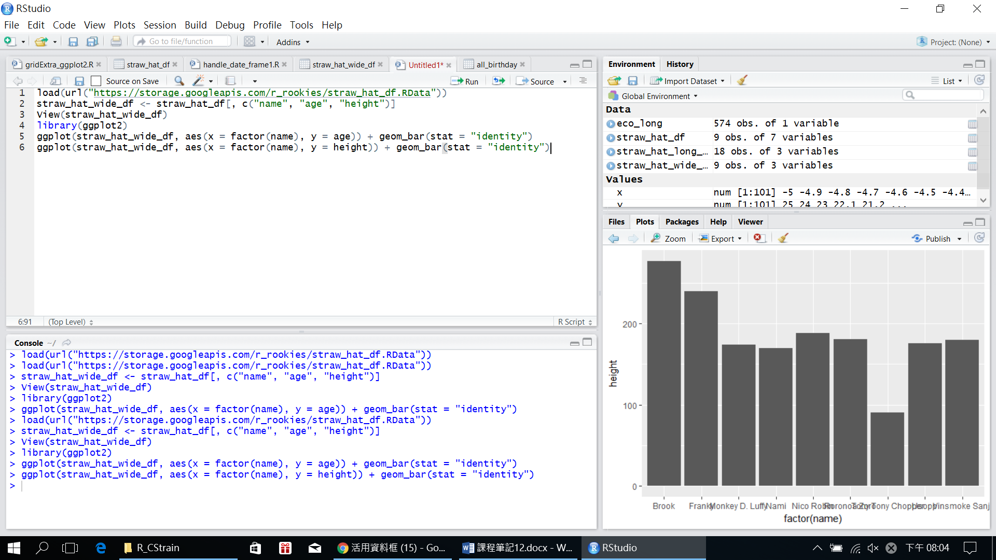

* 先看我們的原始寬表格
* 如果我們想要快速地畫在一個長條圖上畫兩組數據呢？

**load(url("https://storage.googleapis.com/r_rookies/straw_hat_df.RData"))**

**straw_hat_wide_df <- straw_hat_df[, c("name", "age", "height")]**

**View(straw_hat_wide_df)**

**library(ggplot2)**

**ggplot(straw_hat_wide_df, aes(x = factor(name), y = age)) + geom_bar(stat = "identity")**

**ggplot(straw_hat_wide_df, aes(x = factor(name), y = height)) + geom_bar(stat = "identity")**

* 最快的方法就是轉換成長表格

**straw_hat_long_df <- gather(straw_hat_wide_df, key = category, value = values, age, height)**

**ggplot(straw_hat_long_df, aes(x = factor(name), y = values, fill = category)) + geom_bar(stat = "identity", position = "dodge")**

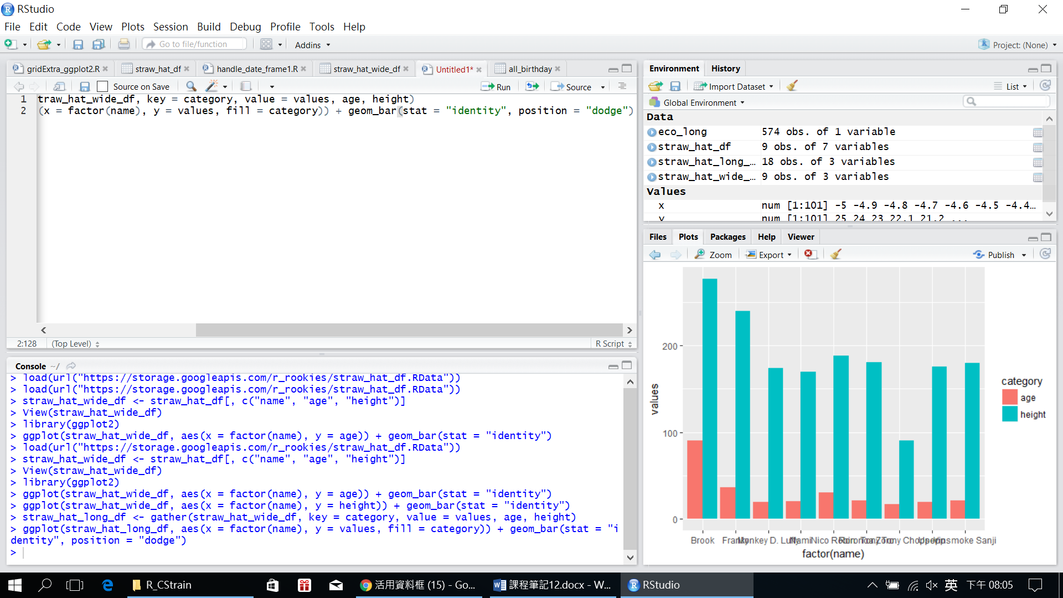

連結資料框:

EXCEL: 可以用VLOOKUP

這裡也

> load(url("https://storage.googleapis.com/r_rookies/straw_hat_df.RData"))

> load(url("https://storage.googleapis.com/r_rookies/straw_hat_devil_fruit.RData"))

> left_df <- straw_hat_df

> right_df <- straw_hat_devil_fruit

> inner_joined <- merge(left_df, right_df)

| **name** | | **gender** | **occupation** | | **bounty** | **age** | **birthday** | | **height** | **devil_fruit** | | **devil_fruit_type** | |
| --- | --- | --- | --- | --- | --- | --- | --- | --- | --- | --- | --- | --- | --- |
|  |  | |  |  | |  |  |  | |  |  | |  |
| **1** | Brook | | Male | Musician | | 8.3e+07 | 90 | 04-03 | | 277 | Revive-Revive Fruit | | Paramecia |
| **2** | Monkey D. Luffy | | Male | Captain | | 5.0e+08 | 19 | 05-05 | | 174 | Gum-Gum Fruit | | Paramecia |
| **3** | Nico Robin | | Female | Archaeologist | | 1.3e+08 | 30 | 02-06 | | 188 | Flower-Flower Fruit | | Paramecia |
| **4** | Tony Tony Chopper | | Male | Doctor | | 1.0e+02 | 17 | 12-24 | | 90 | Human-Human Fruit | | Zoan |

上面的方法只會把join後存在的

不然要這樣>

> left_joined <- merge(left_df, right_df, all.x = TRUE)

| **name** | | **gender** | **occupation** | | **bounty** | | **age** | **birthday** | | **height** | **devil_fruit** | | **devil_fruit_type** | |
| --- | --- | --- | --- | --- | --- | --- | --- | --- | --- | --- | --- | --- | --- | --- |
|  |  | |  |  | |  | |  |  | |  |  | |  |
| **1** | Brook | | Male | Musician | | 8.30e+07 | | 90 | 04-03 | | 277 | Revive-Revive Fruit | | Paramecia |
| **2** | Franky | | Male | Shipwright | | 9.40e+07 | | 36 | 03-09 | | 240 | *NA* | | *NA* |
| **3** | Monkey D. Luffy | | Male | Captain | | 5.00e+08 | | 19 | 05-05 | | 174 | Gum-Gum Fruit | | Paramecia |
| **4** | Nami | | Female | Navigator | | 6.60e+07 | | 20 | 07-03 | | 170 | *NA* | | *NA* |
| **5** | Nico Robin | | Female | Archaeologist | | 1.30e+08 | | 30 | 02-06 | | 188 | Flower-Flower Fruit | | Paramecia |
| **6** | Roronoa Zoro | | Male | Swordsman | | 3.20e+08 | | 21 | 11-11 | | 181 | *NA* | | *NA* |
| **7** | Tony Tony Chopper | | Male | Doctor | | 1.00e+02 | | 17 | 12-24 | | 90 | Human-Human Fruit | | Zoan |
| **8** | Usopp | | Male | Sniper | | 2.00e+08 | | 19 | 04-01 | | 176 | *NA* | | *NA* |
| **9** | Vinsmoke Sanji | | Male | Cook | | 1.77e+08 | | 21 | 03-02 | | 180 | *NA* | | *NA* |

right_joined <- merge(left_df, right_df, all.y = TRUE)

> View(right_joined)

| **name** | | **gender** | **occupation** | | **bounty** | **age** | **birthday** | | **height** | **devil_fruit** | | **devil_fruit_type** | |
| --- | --- | --- | --- | --- | --- | --- | --- | --- | --- | --- | --- | --- | --- |
|  |  | |  |  | |  |  |  | |  |  | |  |
| **1** | Brook | | Male | Musician | | 8.3e+07 | 90 | 04-03 | | 277 | Revive-Revive Fruit | | Paramecia |
| **2** | Monkey D. Luffy | | Male | Captain | | 5.0e+08 | 19 | 05-05 | | 174 | Gum-Gum Fruit | | Paramecia |
| **3** | Nico Robin | | Female | Archaeologist | | 1.3e+08 | 30 | 02-06 | | 188 | Flower-Flower Fruit | | Paramecia |
| **4** | Tony Tony Chopper | | Male | Doctor | | 1.0e+02 | 17 | 12-24 | | 90 | Human-Human Fruit | | Zoan |
| **5** | Trafalgar D. Water Law | | *NA* | *NA* | | *NA* | *NA* | *NA* | | *NA* | Op-Op Fruit | | Paramecia |

如果是聯集呢?

full_joined <- merge(left_df, right_df, all.x = TRUE, all.y = TRUE)

> View(full_joined)

| **name** | | **gender** | **occupation** | | **bounty** | | **age** | **birthday** | | **height** | **devil_fruit** | | **devil_fruit_type** | |
| --- | --- | --- | --- | --- | --- | --- | --- | --- | --- | --- | --- | --- | --- | --- |
|  |  | |  |  | |  | |  |  | |  |  | |  |
| **1** | Brook | | Male | Musician | | 8.30e+07 | | 90 | 04-03 | | 277 | Revive-Revive Fruit | | Paramecia |
| **2** | Franky | | Male | Shipwright | | 9.40e+07 | | 36 | 03-09 | | 240 | *NA* | | *NA* |
| **3** | Monkey D. Luffy | | Male | Captain | | 5.00e+08 | | 19 | 05-05 | | 174 | Gum-Gum Fruit | | Paramecia |
| **4** | Nami | | Female | Navigator | | 6.60e+07 | | 20 | 07-03 | | 170 | *NA* | | *NA* |
| **5** | Nico Robin | | Female | Archaeologist | | 1.30e+08 | | 30 | 02-06 | | 188 | Flower-Flower Fruit | | Paramecia |
| **6** | Roronoa Zoro | | Male | Swordsman | | 3.20e+08 | | 21 | 11-11 | | 181 | *NA* | | *NA* |
| **7** | Tony Tony Chopper | | Male | Doctor | | 1.00e+02 | | 17 | 12-24 | | 90 | Human-Human Fruit | | Zoan |
| **8** | Trafalgar D. Water Law | | *NA* | *NA* | | *NA* | | *NA* | *NA* | | *NA* | Op-Op Fruit | | Paramecia |
| **9** | Usopp | | Male | Sniper | | 2.00e+08 | | 19 | 04-01 | | 176 | *NA* | | *NA* |
| **10** | Vinsmoke Sanji | | Male | Cook | | 1.77e+08 | | 21 | 03-02 | | 180 | *NA* | | *NA* |

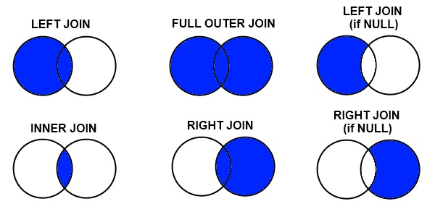

# 讀取不同的資料格式

url <- "https://storage.googleapis.com/r_rookies/iris.csv" # 在雲端上儲存了一份 csv 檔案

iris_csv_df <- read.table(url, sep = ",", header = TRUE, colClasses = c("numeric", "numeric", "numeric", "numeric", "character"))

str(iris_csv_df)

> print("Hello\tWorld")

[1] "Hello\tWorld"

> writeLines("Hello\tWorld")

Hello World

> writeLines("Hello\nWorld")

Hello

World

**載入 JSON**

* 什麼是 JSON(JavaScript Object Notation)？
* 這是一個 JSON Object：

**friends_json <- '{**

**"genre": "Sitcom",**

**"seasons": 10,**

**"episodes": 236,**

**"stars": ["Jennifer Aniston", "Courteney Cox", "Lisa Kudrow", "Matt LeBlanc", "Matthew Perry", "David Schwimmer"]**

**}'**

R語言的JSON無法直接使用，其視為char

使用**install.packages("jsonlite")**

套件