* 重要的 par() 參數
  + *las 軸標籤的方向*
  + *mar 圖的上下左右邊界寬*
  + *mfrow 子圖形的 row 數與 col 數*
* 利用 dev.off() 恢復預設值

**par("las")**

**par("mar")**

**par("mfrow")**

> par("pch")

[1] 1 > 看到點的形狀預設值

> par("col")

[1] "black"

> par("cex")

[1] 1

> par("las") >> 超級重要，

[1] 0

本來:

x <- seq(-5, 5, by =0.1)

y <- x**2

plot(x, y, xlim = c(-10, 10),

ylim = c(-5, 30),

main = "y = x^2", sub = "Fig 1.",

xlab = "X", ylab = "Y",

pch = 23, type = "l",

cex =3, lwd=4, col="red"

):

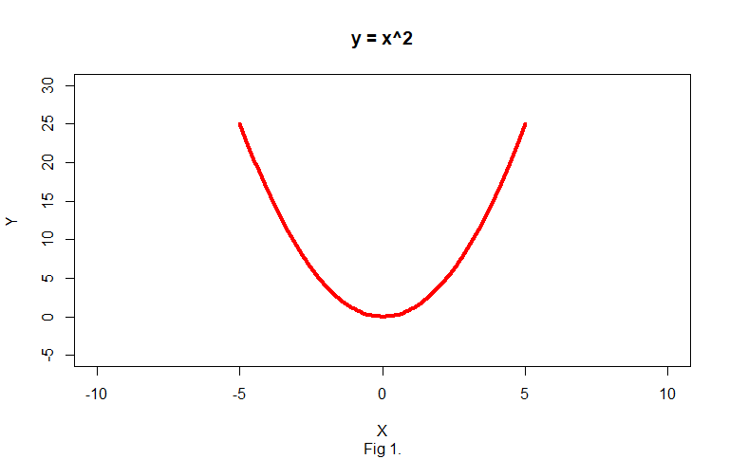

改las:

x <- seq(-5, 5, by =0.1)

y <- x**2

plot(x, y, xlim = c(-10, 10),

ylim = c(-5, 30),

main = "y = x^2", sub = "Fig 1.",

xlab = "X", ylab = "Y",

pch = 23, type = "l",

cex =3, lwd=4, col="red", las = 1

)

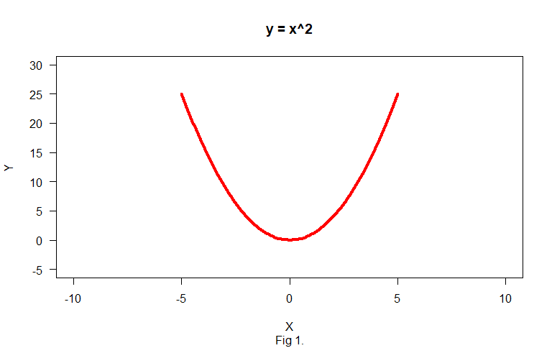

* 有人可能還是會覺得Y軸的Y也要直的:
* 需透過mtext() 去加:
* x <- seq(-5, 5, by =0.1)
* y <- x**2
* plot(x, y, xlim = c(-10, 10),
* ylim = c(-5, 30),
* main = "y = x^2", sub = "Fig 1.",
* xlab = "X", ylab = "Y",
* pch = 23, type = "l",
* cex =3, lwd=4, col="red", las = 1
* )
* mtext("YY", side = 2, las = 1, line =2)

會得到:

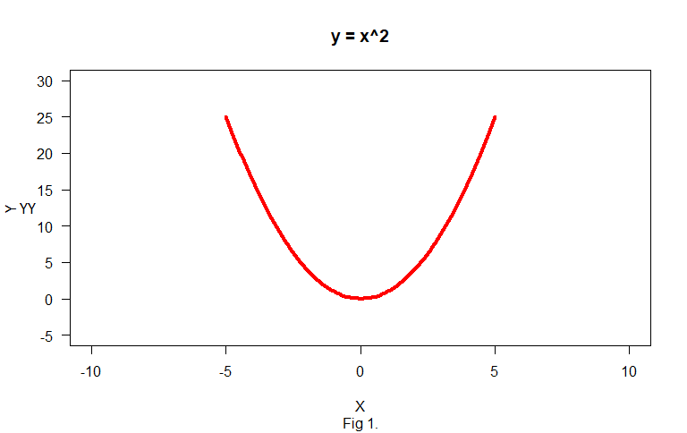

> par("mar")

[1] 5.1 4.1 4.1 2.1

可以看到下左上又得margin值

如果設定為:

> par(mar = c(1, 1, 0, 0))

圖變為:

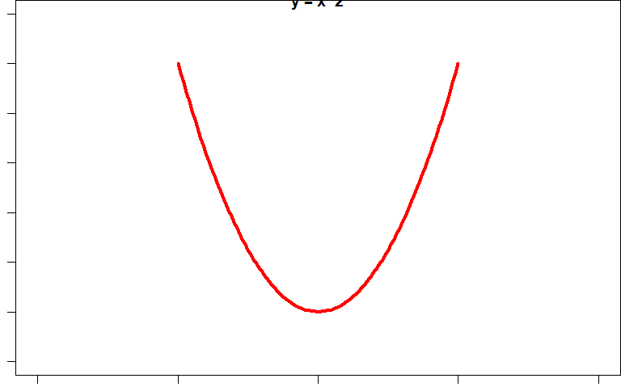

如果想要還原設定!!!:

> dev.off()

null device

重畫即正常了! (可以再用par(“XXX”)去檢查值)

*mfrow

> par("mfrow")

[1] 1 1 >> 一個row 一個col

若設為: > par("mfrow")

[1] 2 2

可以畫4張圖 ex,:

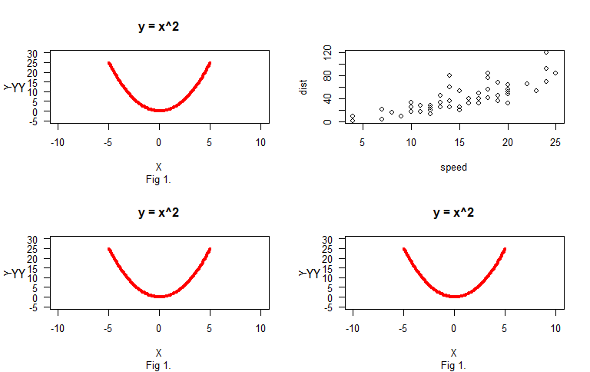

Row name

> row.names(mtcars)

[1] "Mazda RX4" "Mazda RX4 Wag" "Datsun 710"

[4] "Hornet 4 Drive" "Hornet Sportabout" "Valiant"

[7] "Duster 360" "Merc 240D" "Merc 230"

[10] "Merc 280" "Merc 280C" "Merc 450SE"

[13] "Merc 450SL" "Merc 450SLC" "Cadillac Fleetwood"

[16] "Lincoln Continental" "Chrysler Imperial" "Fiat 128"

[19] "Honda Civic" "Toyota Corolla" "Toyota Corona"

[22] "Dodge Challenger" "AMC Javelin" "Camaro Z28"

[25] "Pontiac Firebird" "Fiat X1-9" "Porsche 914-2"

[28] "Lotus Europa" "Ford Pantera L" "Ferrari Dino"

[31] "Maserati Bora" "Volvo 142E"

* 想加字: text( ,labels = “XXXX”)

x <- seq(-5, 5, by =0.1)

y <- x**2

plot(x, y, xlim = c(-10, 10),

ylim = c(-5, 30),

main = "y = x^2", sub = "Fig 1.",

xlab = "X", ylab = "Y",

pch = 23, type = "l",

cex =3, lwd=4, col="red", las = 1

)

text(0, 0, labels = "Global Min.")

mtext("YY", side = 2, las = 1, line =2)

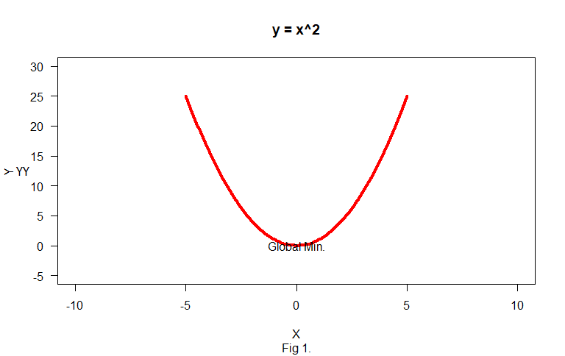

* 加點:
* x <- seq(-5, 5, by =0.1)
* y <- x**2
* plot(x, y, xlim = c(-10, 10),
* ylim = c(-5, 30),
* main = "y = x^2", sub = "Fig 1.",
* xlab = "X", ylab = "Y",
* pch = 23, type = "l",
* cex =3, lwd=4, col="red", las = 1
* )
* points(0, 0, pch = 17, col="blue", cex=2.5)
* text(0, -2, labels = "Global Min.")
* mtext("YY", side = 2, las = 1, line =2)
* 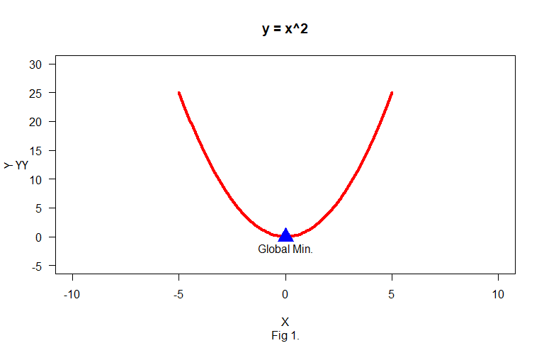

將每個點標name:

plot(mtcars$mpg, mtcars$hp, xlab = "mpg", ylab = "hp")

text(mtcars$mpg, mtcars$hp, labels = row.names(mtcars))

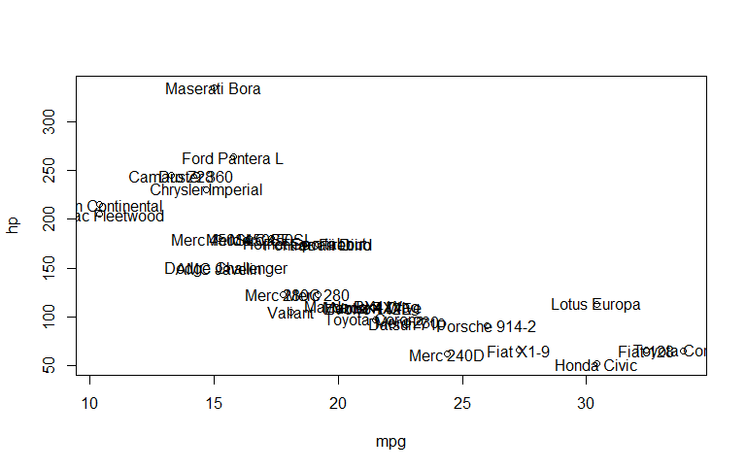

太亂了: 調xlim 和ylim:

plot(mtcars$mpg, mtcars$hp, xlab = "mpg", ylab = "hp",

xlim = c(min(mtcars$mpg)*0.4, max(mtcars$mpg)*1.6),

ylim = c(min(mtcars$hp)*0.4, max(mtcars$hp)*1.6))

text(mtcars$mpg, mtcars$hp, labels = row.names(mtcars), cex = 0.5)

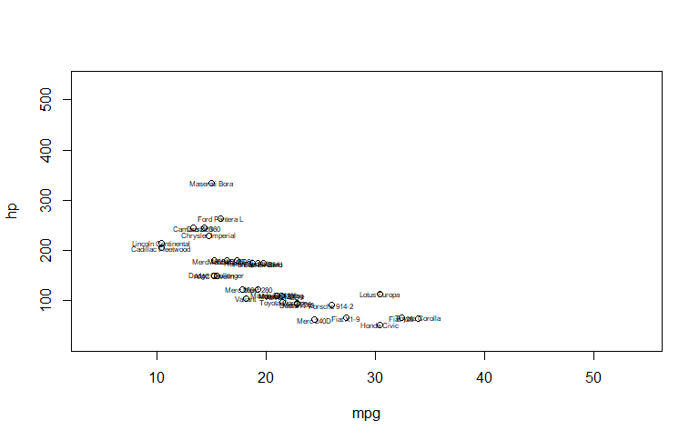

給顏色:

Iris在相同species給同色:>> col (color)

plot(iris$Sepal.Length, iris$Petal.Length, col = iris$Species,

xlab = "Sepal Length", ylab = "Petal Length", pch = 16, cex = 1.5)

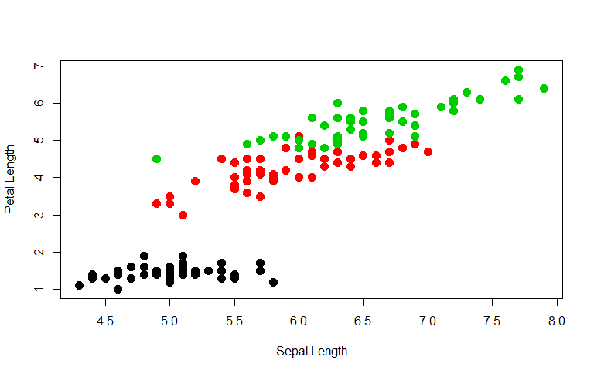

加入顏色說明文字

加上legend:

plot(iris$Sepal.Length, iris$Petal.Length, col = iris$Species,

xlab = "Sepal Length", ylab = "Petal Length", pch = 16, cex = 1.5)

legend("bottomright", col = 1:3, legend = levels(iris$Species), pch = 16, bty = "n")

