1. x^3 左右2色:

x <- seq(from= -5, to = 5, by = 0.1)

y <- x**3

#plot(x, y)

#plot(x, y, type = 'n')

plot(x, y, type = 'n', xaxt = "n", yaxt = "n", xlab = "", ylab = "")

points(x[y < 0], y[y < 0], col = "blue")

points(x[y >= 0], y[y >= 0], col = "red", lwd = 3)

title("y = x^3")

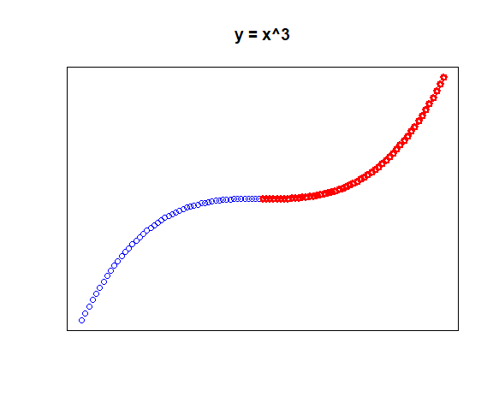

2. 線條:

plot(cars$speed, cars$dist, xlab = "Speed", ylab = "Dist", main = "Cars Dataframe")

#title("Cars Dataframe")

lm_fit <- lm(formula = dist ~ speed, data = cars)

#abline(lm_fit)

abline(lm_fit, lwd = 2, col = "blue")

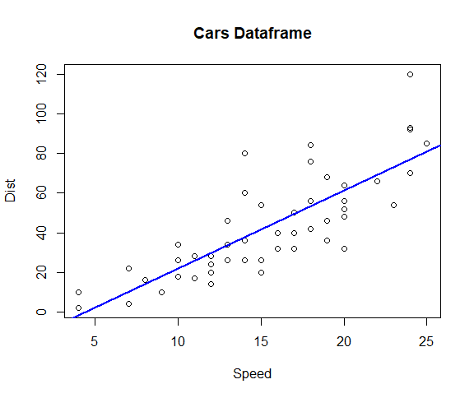

3. > Sys.Date()

[1] "2017-09-06"

> Sys.time()

[1] "2017-09-06 19:32:17 CST"

> format(Sys.time(), "%H%M%S")

[1] "193308"

> format(Sys.time(), "%H:%M:%S")

[1] "19:33:18"

4. ylim:

temperature <- round(runif(30) * 10 + 25)

dates <- as.Date("2017-08-01"):as.Date("2017-08-30")

dates <- as.Date(dates, origin = "1970-01-01")

plot(x = dates, y = temperature, type = "l", ylim = c(15, 40))

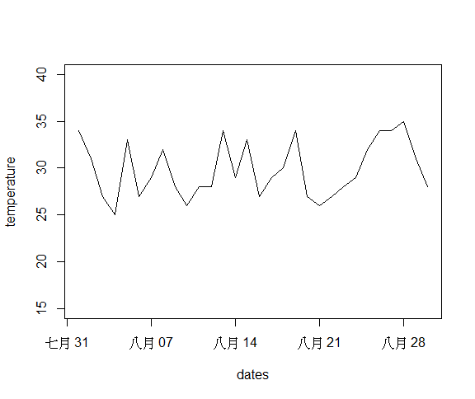

## 直方圖

* 繪製標準常態分佈與均勻分布
* runif() 函數可以幫你產生 0 到 1之間**均勻分配**的隨機數
* rnorm() 函數可以幫你產生**標準常態分配**的隨機數
* 調整 breaks 參數

** 隨機變數:

> runif(10)

[1] 0.10649509 0.04994990 0.05202179 0.47410149 0.45727695 0.60435394 0.18961699 0.99364377

[9] 0.53544278 0.81228013

> runif(10) * 10

[1] 6.575096 6.591227 9.004840 3.075452 7.558978 2.748629 5.532294 5.630014 9.497777 3.749638

> round(runif(10) * 10 )

[1] 2 7 6 5 1 3 3 5 6 8

> set.seed(87) >> 下依樣的種子後，和別人的變數就會相同

> round(runif(10) * 10 )

[1] 0 3 0 9 0 1 2 3 10 4

> set.seed(87)

hist(runif(10000), breaks = 20)

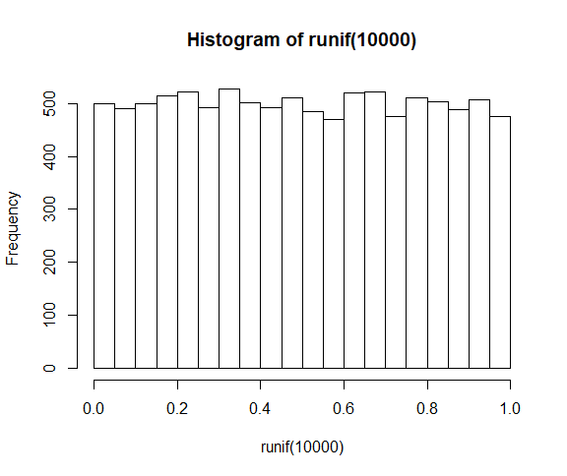

hist(rnorm(10000), breaks = 20)

: 常態分布

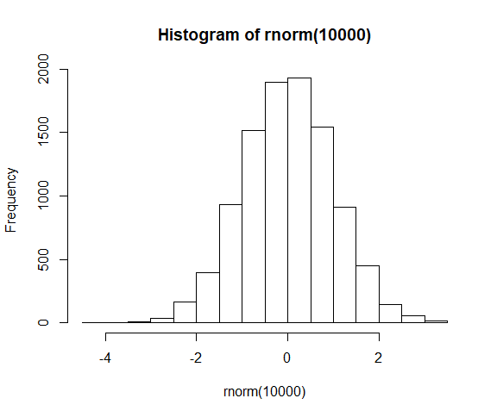

** 盒鬚圖:

> par(mfrow = c(2, 2))

> boxplot(iris$Sepal.Length ~ iris$Species, main = "Sepal length by species")

> boxplot(iris$Sepal.Width ~ iris$Species, main = "Sepal width by species")

> boxplot(iris$Petal.Length ~ iris$Species, main = "Petal length by species")

> boxplot(iris$Petal.Width ~ iris$Species, main = "Petal width by species")

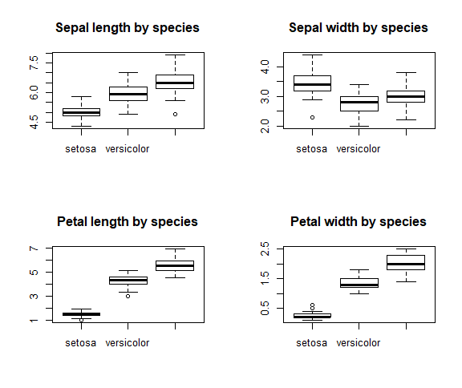

** 函數圖: (就不用自己點了! 但有給範圍)

curve(sin, from = -pi, to = pi)

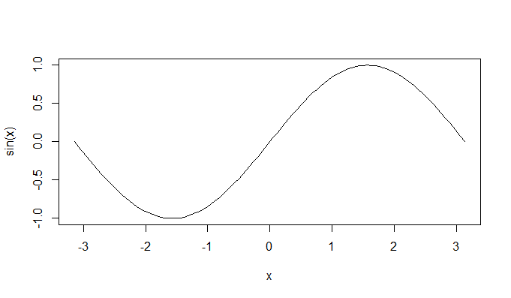

My: 我用原本的作法:

> x <- seq(from= -pi, to = pi, by = 0.1)

> y <- sin(x)

> plot(x, y)

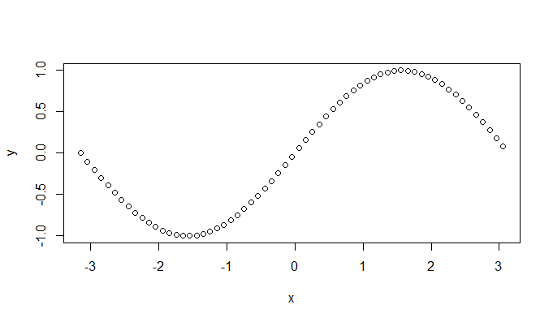

或plot(x, y, type ='l')

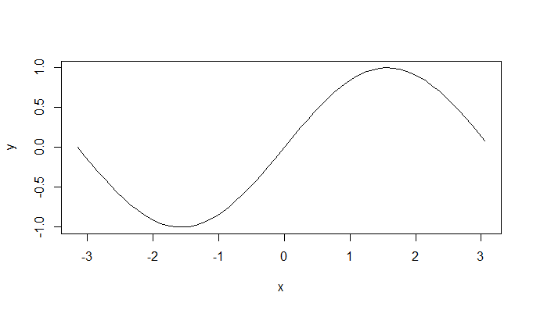

如果加上: grid() 多了隔線:

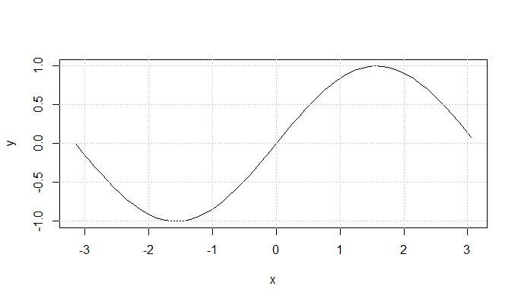

* ** 繪製自訂函數也不是問題
* **sigmoid_func <- function(x){ # S function**
* **return(1 / (1 + exp(-x)))**
* **}**
* **curve(sigmoid_func, from = -10, to = 10)**

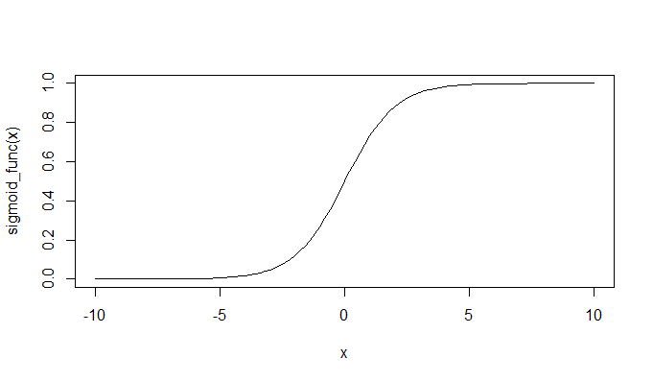

abline(h = 0.5, lty = 2)

: 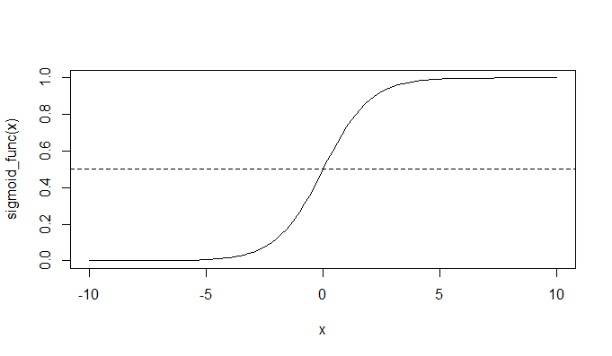

abline(v = 0, lty = 2) (vertical , line type 2為虛線)

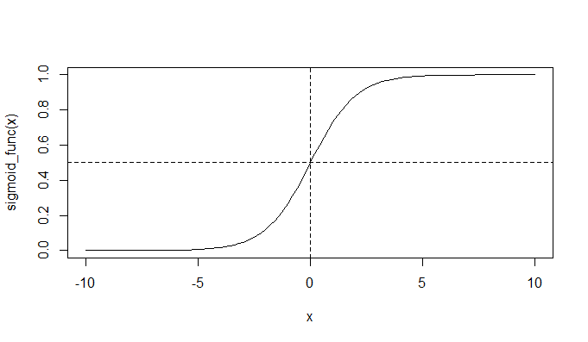

** 長條圖:

* barplot() 繪製長條圖

> View(mtcars)

> class(mtcars$cyl)

[1] "numeric"

> as.factor(mtcars$cyl)

[1] 6 6 4 6 8 6 8 4 4 6 6 8 8 8 8 8 8 4 4 4 4 8 8 8 8 4 4 4 8 6 8 4

Levels: 4 6 8

> table(mtcars$cyl) >> 計算每一個因素的計數是多少:

4 6 8

11 7 14

*** barplot(c(1, 2, 5))

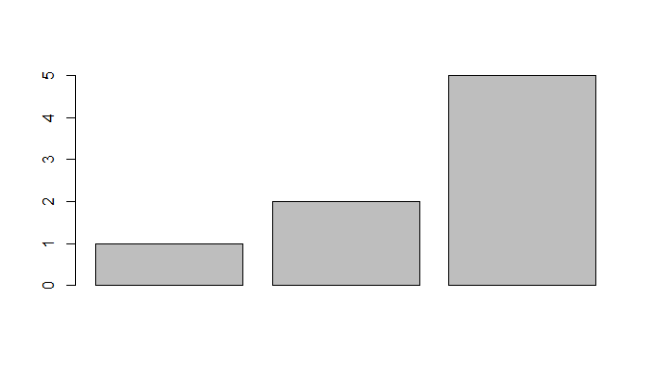

所以:

如果是這樣:

barplot(mtcars$cyl)

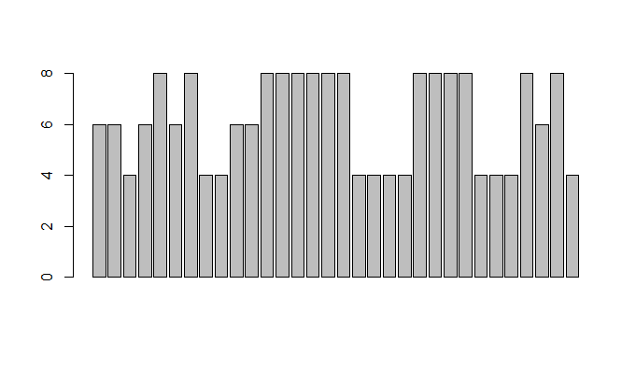

上面這是沒計數，所以不是我們要的:

改為barplot(table(mtcars$cyl)):

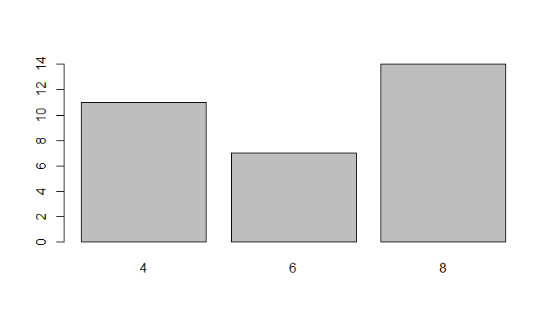

> barplot(table(mtcars$hp))

> barplot(names.arg = row.names(mtcars), height = mtcars$hp)

:

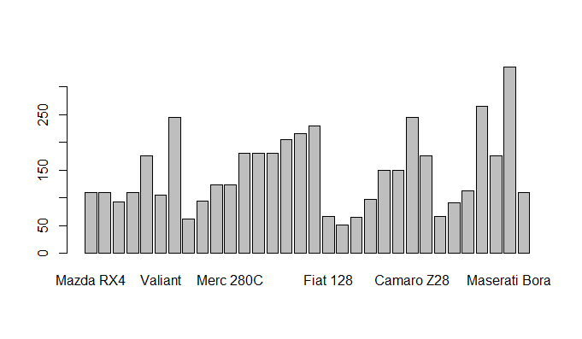

**試著做橫的:**

**vehicle <- row.names(mtcars)**

**barplot(names.arg = vehicle,**

**height = mtcars$hp,**

**horiz = TRUE,**

**las = 1, >> 橫的**

**cex.names = 0.3,**

**cex.axis = 0.7,**

**xlab = "Horsepower",** 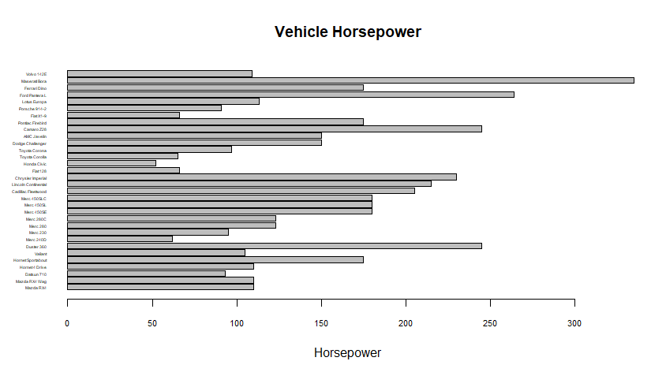

**main = "Vehicle Horsepower"**

**):**

如果要排序呢?:

|  |
| --- |
| my_vec <- c(10, 15, 12)  > sort(my_vec)  [1] 10 12 15  > order(my_vec)  [1] 1 3 2  > my_vec[order(my_vec)]  [1] 10 12 15 |
|  |
| |  | | --- | | > 所以:  sorted_mtcars <- mtcars[order(mtcars$hp),]  vehicle <- row.names(sorted_mtcars)  barplot(names.arg = vehicle,  height = sorted_mtcars$hp,  horiz = TRUE,  las = 1,  cex.names = 0.3,  cex.axis = 0.7,  xlab = "Horsepower",  main = "Vehicle Horsepower"  ): | |

如果要把每一個x的值都標出來:

sorted_mtcars <- mtcars[order(mtcars$hp),]

vehicle <- row.names(sorted_mtcars)

bar_plt <- barplot(names.arg = vehicle,

height = sorted_mtcars$hp,

horiz = TRUE,

las = 1,

cex.names = 0.3,

cex.axis = 0.7,

xlab = "Horsepower",

main = "Vehicle Horsepower"

)

text(y = bar_plt, x = sorted_mtcars$hp, >> x, y 記得顛倒，因為剛已經設horiz = TRUE了!

labels = sorted_mtcars$hp, pos = 4

):

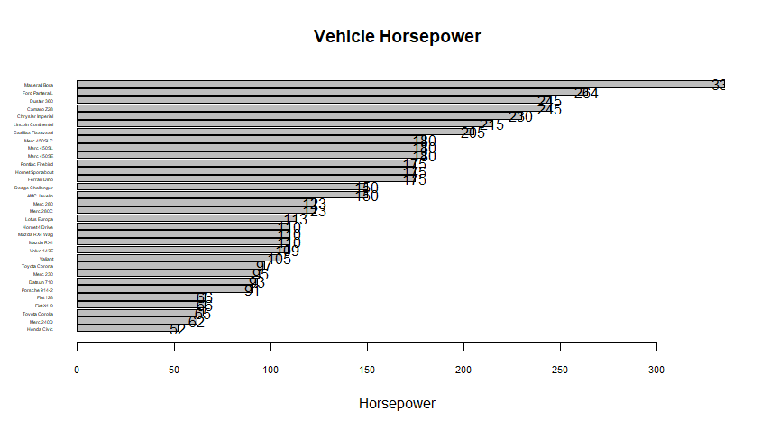

最後:

sorted_mtcars <- mtcars[order(mtcars$hp),]

vehicle <- row.names(sorted_mtcars)

bar_plt <- barplot(names.arg = vehicle,

height = sorted_mtcars$hp,

horiz = TRUE,

las = 1,

cex.names = 0.3,

cex.axis = 0.7,

xlab = "Horsepower",

main = "Vehicle Horsepower",

xlim = c(0, 380) >> 因為有數值超過!

)

text(y = bar_plt, x = sorted_mtcars$hp,

labels = sorted_mtcars$hp,

pos = 4, cex = 0.7 >> position = 4 右邊挪

)

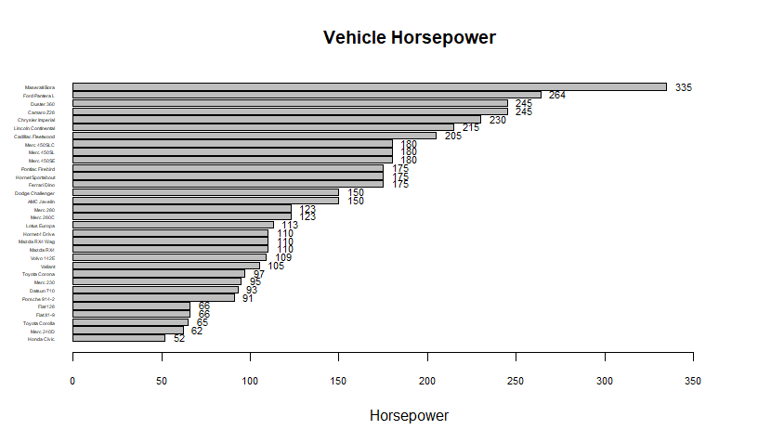

1

R base graph Gallery (搜尋畫廊關鍵字 以後好查)

Ex, : <http://www.r-graph-gallery.com/>

## 期中作業

* 用一個 2x2 的畫布練習使用 Base plotting system 繪製任意四個圖形