GGplot2: 要用管理員模式開啟Rstudio

Geom (geometry)

## 在console: 安裝與載入 ggplot2

* 套件的安裝與載入有什麼不同？

**install.packages("ggplot2")**

**library(ggplot2)**

slide 2/26

* [Contents](javascript:w3c_slidy.toggle_table_of_contents())

library(ggplot2)

ggplot(cars, aes(x = speed, y = dist)) +

geom_point() +

ggtitle("Cars data") +

xlab("Speed") +

ylab("Dist")

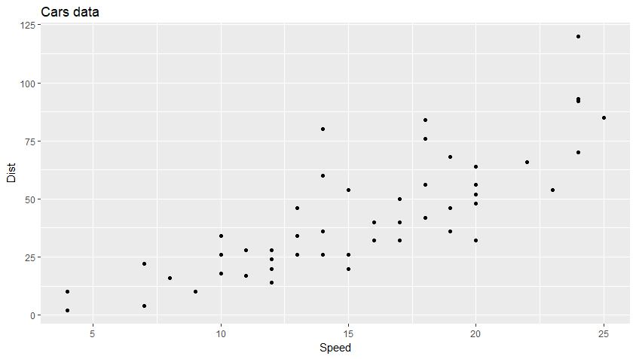

* geom_smooth(method = "lm") :

library(ggplot2)

ggplot(cars, aes(x = speed, y = dist)) +

geom_point() +

geom_smooth(method = "lm") +

ggtitle("Cars data") +

xlab("Speed") +

ylab("Dist"):

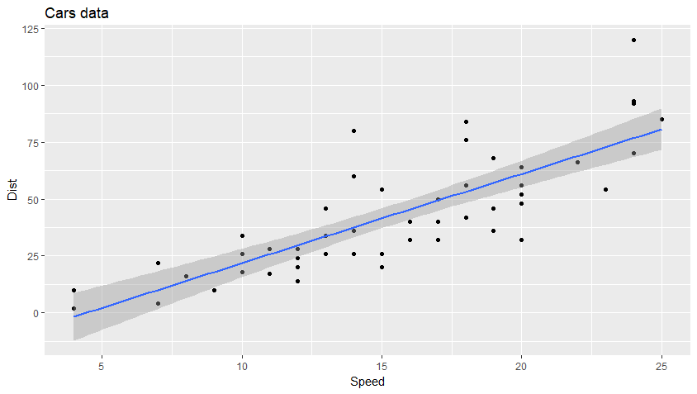

geom_smooth看se doc:

若設為FALSE:

library(ggplot2)

ggplot(cars, aes(x = speed, y = dist)) +

geom_point() +

geom_smooth(method = "lm", se = FALSE) +

ggtitle("Cars data") +

xlab("Speed") +

ylab("Dist")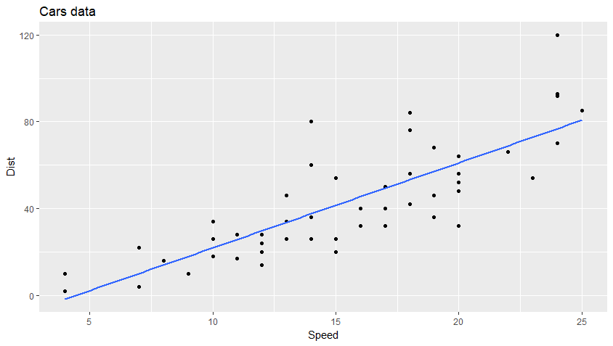

改顏色:

library(ggplot2)

ggplot(cars, aes(x = speed, y = dist)) +

geom_point(col = "red") +

geom_smooth(method = "lm", se = FALSE) +

ggtitle("Cars data") +

xlab("Speed") +

ylab("Dist")

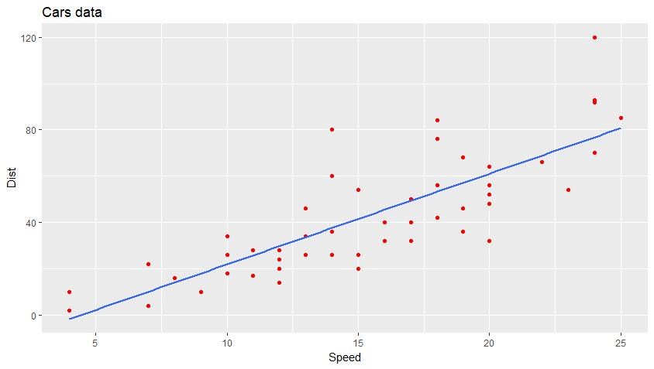

之前的iris:

library(ggplot2)

ggplot(iris, aes(x = Sepal.Length, y = Sepal.Width, color = Species)) +

geom_point() +

ggtitle("Sepal.Length vs. Sepal.Width") +

xlab("Sepal length") +

ylab("Sepal width")

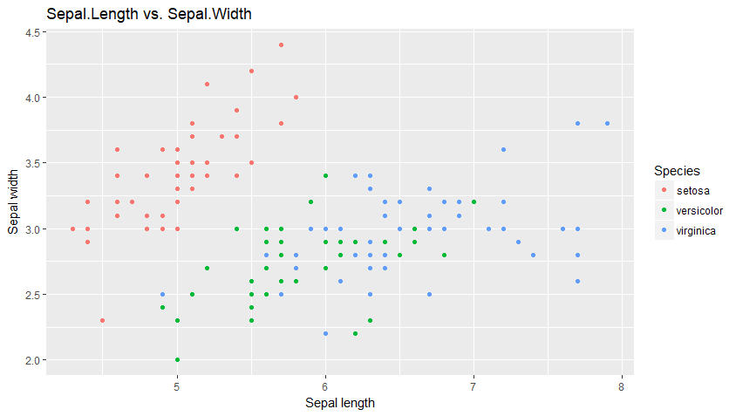

如果要畫diamonds的carat和price: (克拉)

library(ggplot2)

ggplot(diamonds, aes(x = carat, y = price)) +

geom_point() +

ggtitle("carat vs. price") +

xlab("carat") +

ylab("price")

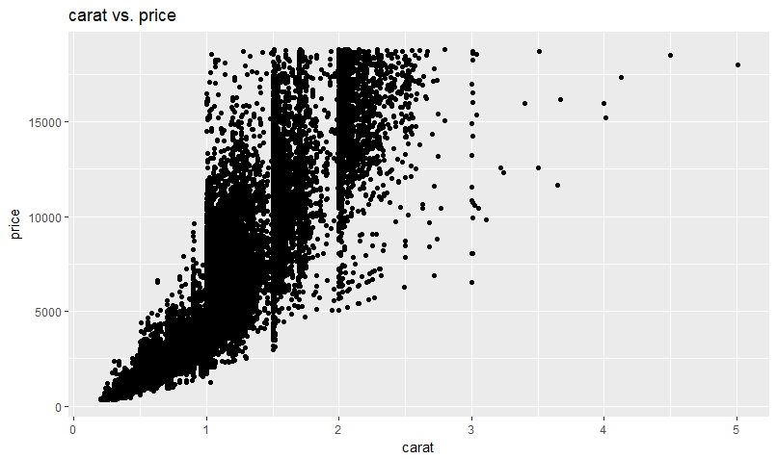

如果是用economics的date vs 失業日:

library(ggplot2)

ggplot(economics, aes(x = date, y = unemploy)) +

geom_line() + >> 因為這邊用line可能比較適合!!! 而不是散步圖

ggtitle("carat vs. price") +

xlab("carat") +

ylab("price")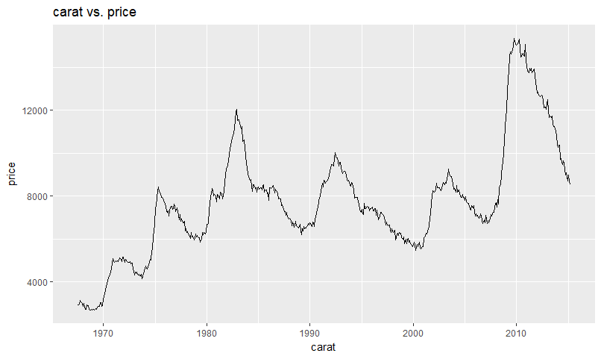

直方圖:

ggplot(cars, aes(x = speed)) +

geom_histogram()

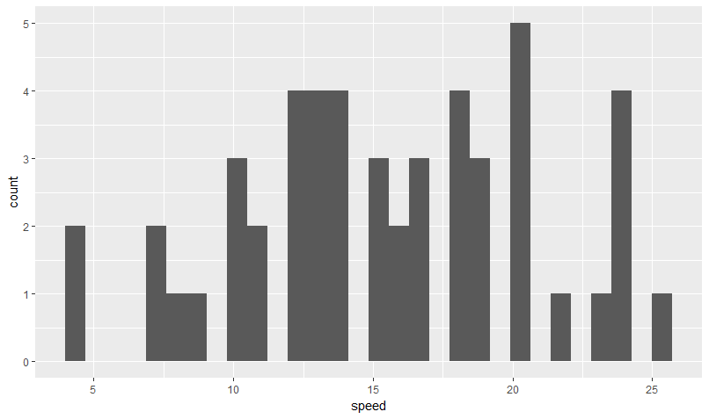

可以再去調binwidth bin越寬 條數就減少

** 納入類別的展開:

ggplot(iris, aes(x = Sepal.Length)) +

geom_histogram(binwidth = 0.2) +

facet_wrap(~ Species)

(分享y軸)

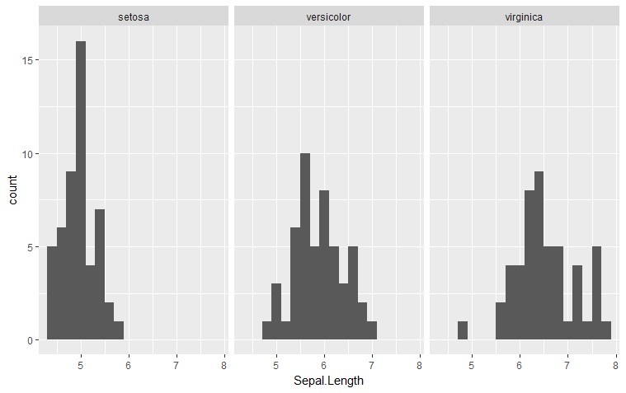

分享x軸:

ggplot(iris, aes(x = Sepal.Length)) +

geom_histogram(binwidth = 0.2) +

facet_wrap(~ Species, nrow = 3)

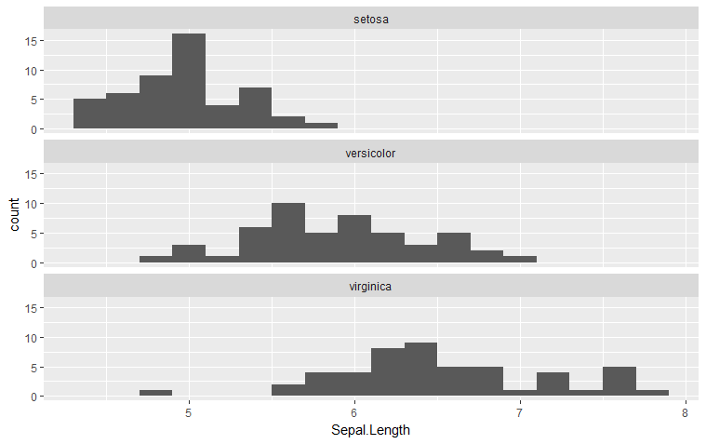

在調binwidth時可以先偷看一下資料:

> summary(diamonds$carat)

Min. 1st Qu. Median Mean 3rd Qu. Max.

0.2000 0.4000 0.7000 0.7979 1.0400 5.0100

例如直方圖的diamonds的carat:

ggplot(diamonds, aes(x = carat)) +

geom_histogram(binwidth = 0.01)

* 盒鬚圖 (box plot)
* ggplot(diamonds, aes(x = cut, y = price)) +
* geom_boxplot():

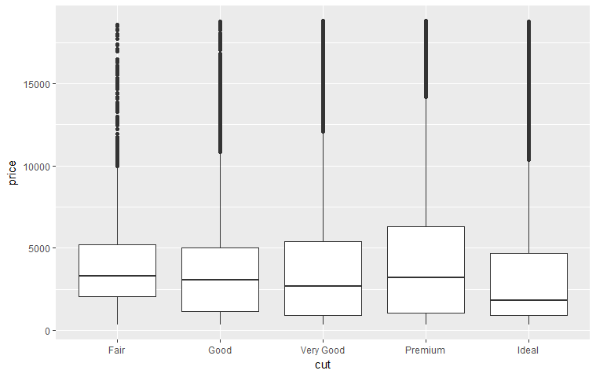

也可以加個顏色:

ggplot(diamonds, aes(x = cut, y = price, color = cut)) +

geom_boxplot()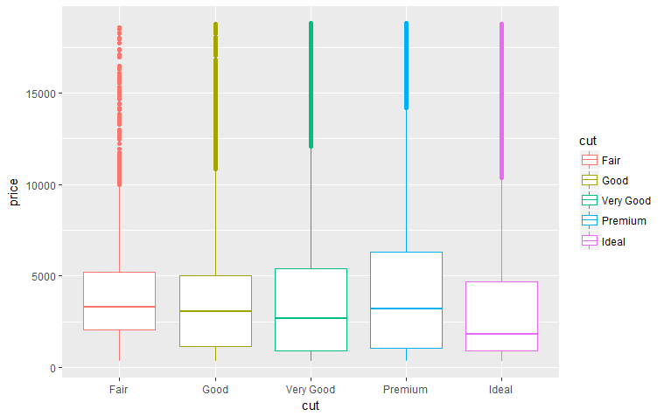

記得: 可以換順序 (原本的資料是有ordered的!!!)

作法:

diamonds_copied <- diamonds

diamonds_copied$cut <- factor(diamonds_copied$cut, ordered = TRUE,

levels = c("Fair", "Good", "Ideal", "Premium", "Very Good")

)

ggplot(diamonds_copied, aes(x = cut, y = price, color = cut)) +

geom_boxplot()

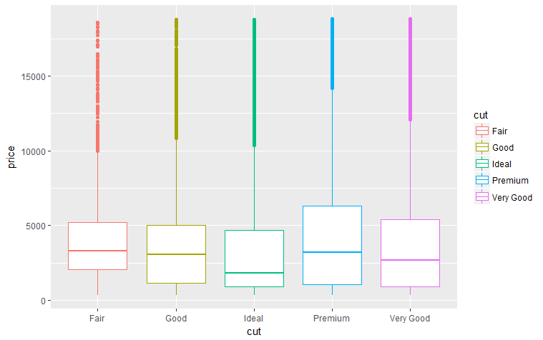

長調圖反轉:

ggplot(mtcars, aes(x = row.names(mtcars), y = hp)) +

geom_bar(stat = "identity") + coord_flip():

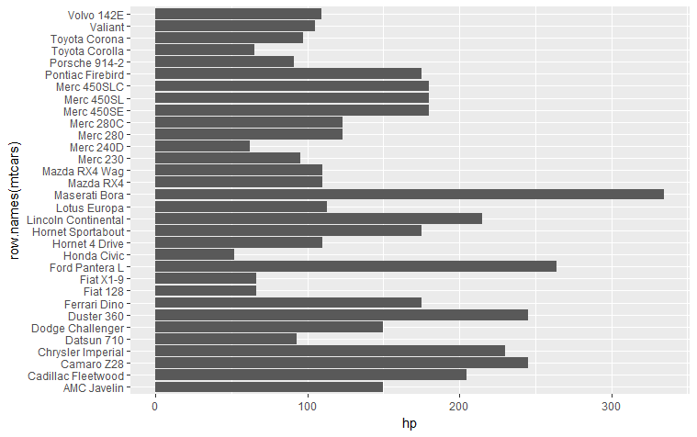

***難題:::!!!***

***若要將mtcars的長條圖按照 hp 順序劃出來呢?***

**mtcars_copied <- mtcars**

**mtcars_copied <- mtcars_copied[order(mtcars_copied$hp), ]**

**vehicle_names <- row.names(mtcars_copied)**

**mtcars_copied$vehicle_names <- factor(vehicle_names,**

**ordered = TRUE,**

**levels = vehicle_names)**

**ggplot(mtcars_copied, aes(x = vehicle_names, y = hp)) +**

**geom_bar(stat = "identity") + coord_flip()**

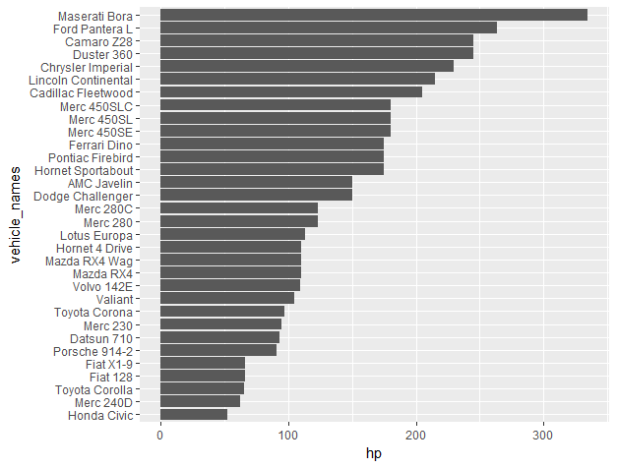

** 在一個畫布上畫多個圖形

Ex:

library(ggplot2)

library(gridExtra)

mtcars_copied <- mtcars

mtcars_copied <- mtcars_copied[order(mtcars_copied$hp), ]

vehicle_names <- row.names(mtcars_copied)

mtcars_copied$vehicle_names <- factor(vehicle_names,

ordered = TRUE,

levels = vehicle_names)

gg1 <- ggplot(mtcars_copied, aes(x = vehicle_names, y = hp)) +

geom_bar(stat = "identity") + coord_flip()

gg2 <- ggplot(mtcars_copied, aes(x = vehicle_names, y = hp)) +

geom_bar(stat = "identity")

grid.arrange(gg1, gg2, nrow = 2)

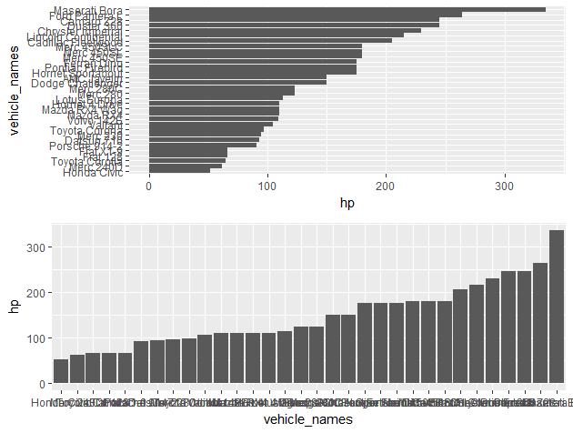

要寫作業!!

## ggplotly() 加入互動性:

* 使用 plotly 套件的 ggplotly() 函數

**install.packages("plotly")**

## library(plotly)

## static_gg <- ggplot(iris, aes(x = Sepal.Length, y = Petal.Length, col = Species)) +

## geom_point()

## ggplotly(static_gg)

## 

**圖形或資料的互動性**

* [D3.js](https://d3js.org/)
* [Plotly](https://plot.ly/)
* [Shiny](https://shiny.rstudio.com/)
* 沒事多看文件，多看文件沒事
* <http://docs.ggplot2.org/current/index.html>