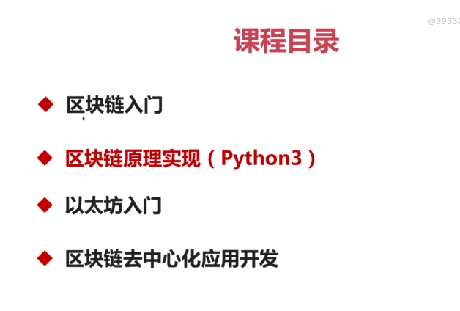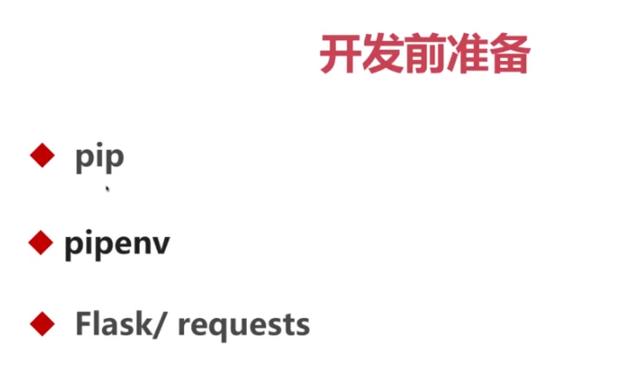

請裝python 3.6以上!!

並裝pipenv: pipenv -–python 3.7

pipenv install flask==0.12.2

pipenv install requests==2.18.4

