以下適用v3 示範

<法一: 用CDN link>

1. 從getting start不載整個

<https://getbootstrap.com/docs/3.3/getting-started/>

copy CDN LINK:

放Head:

<!-- Latest compiled and minified CSS --> <link rel="stylesheet" href="https://maxcdn.bootstrapcdn.com/bootstrap/3.3.7/css/bootstrap.min.css" integrity="sha384-BVYiiSIFeK1dGmJRAkycuHAHRg32OmUcww7on3RYdg4Va+PmSTsz/K68vbdEjh4u" crossorigin="anonymous"> <!-- Optional theme --> <link rel="stylesheet" href="https://maxcdn.bootstrapcdn.com/bootstrap/3.3.7/css/bootstrap-theme.min.css" integrity="sha384-rHyoN1iRsVXV4nD0JutlnGaslCJuC7uwjduW9SVrLvRYooPp2bWYgmgJQIXwl/Sp" crossorigin="anonymous">

放body最後:

<!-- Latest compiled and minified JavaScript --> <script src="https://maxcdn.bootstrapcdn.com/bootstrap/3.3.7/js/bootstrap.min.js" integrity="sha384-Tc5IQib027qvyjSMfHjOMaLkfuWVxZxUPnCJA7l2mCWNIpG9mGCD8wGNIcPD7Txa" crossorigin="anonymous"></script>

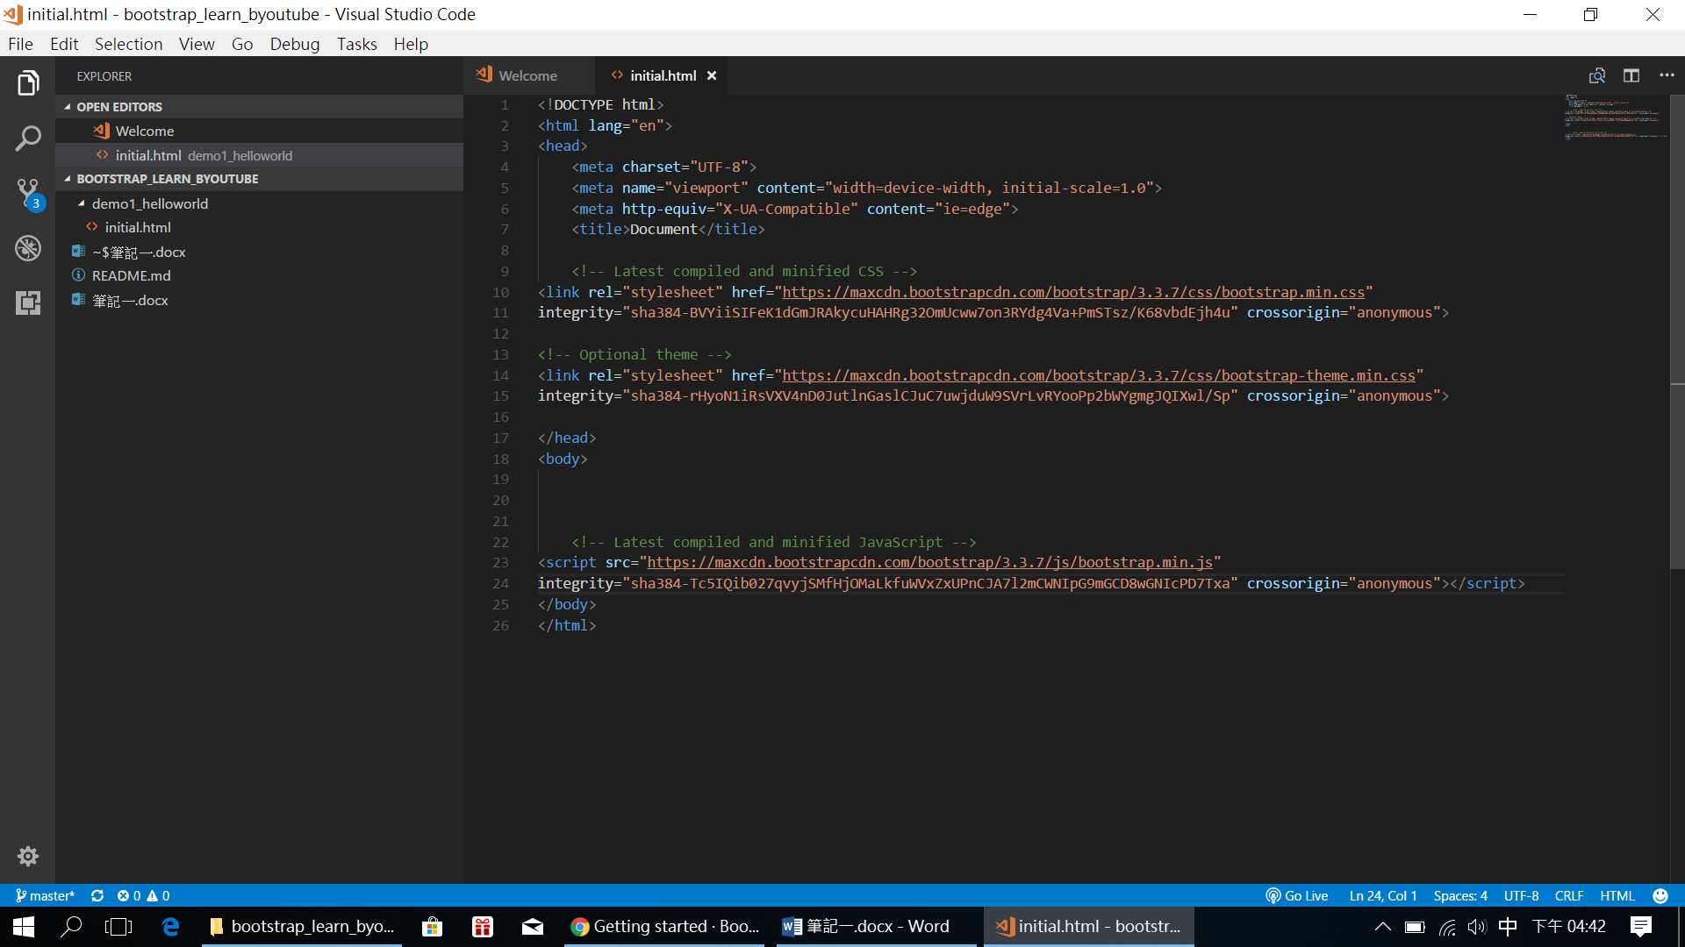

再到JQUERY:

<http://jquery.com/download/>

<script src="https://code.jquery.com/jquery-3.2.1.min.js"></script>

放body後

<法二: 載整包package(依樣用3版示範)>

選download

解壓縮後:

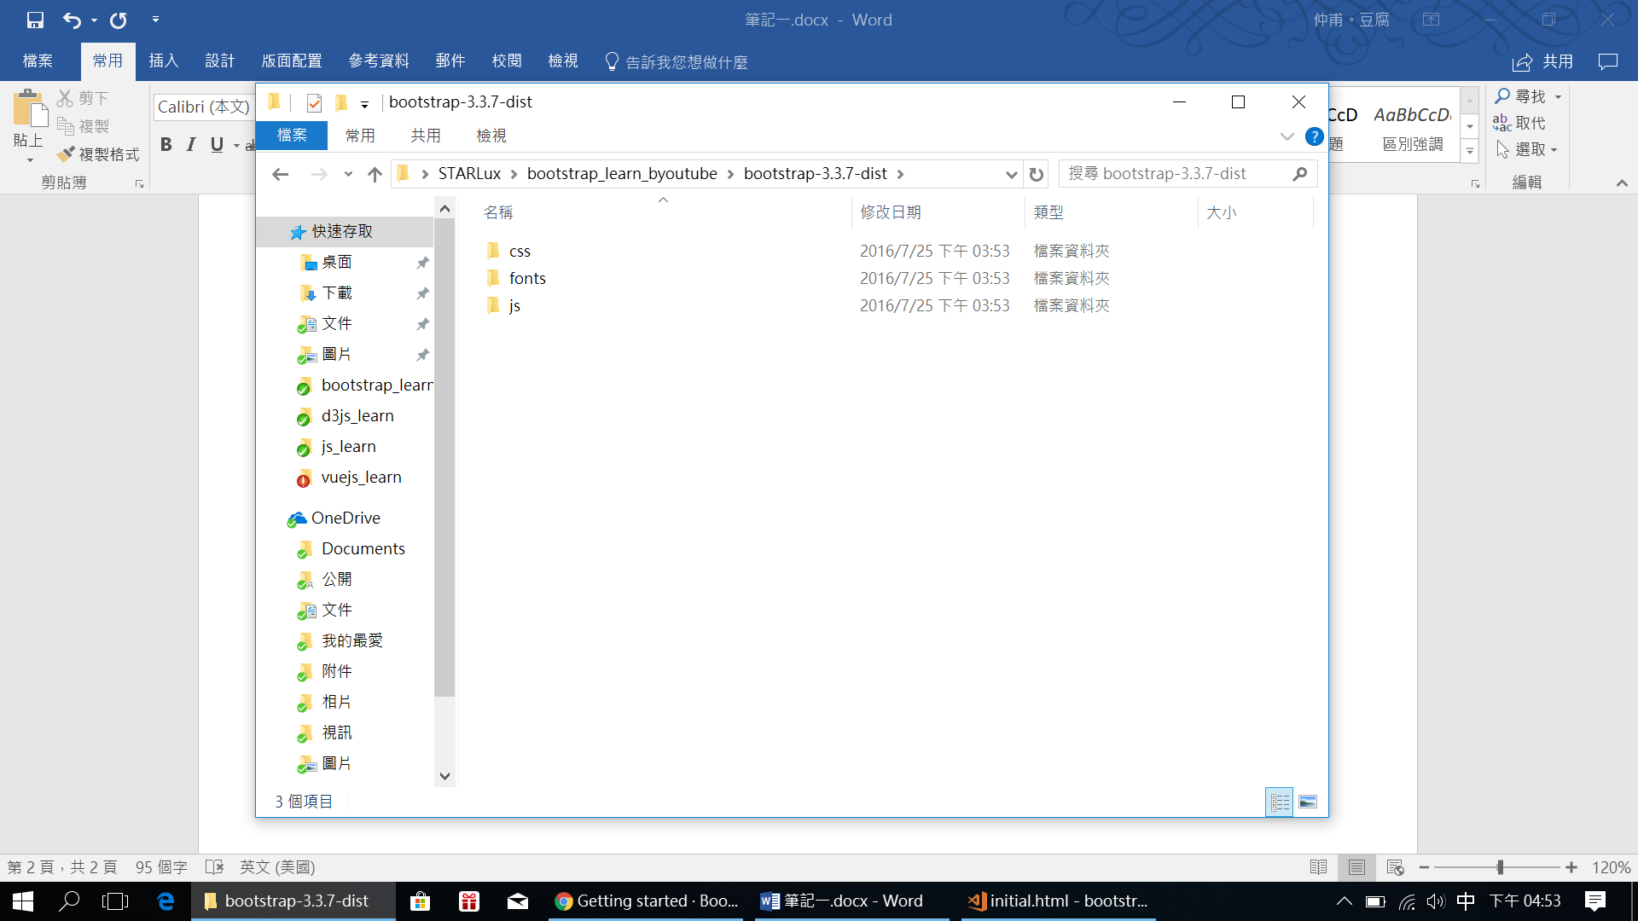

把解壓縮放在我們要寫的template.html同一層:

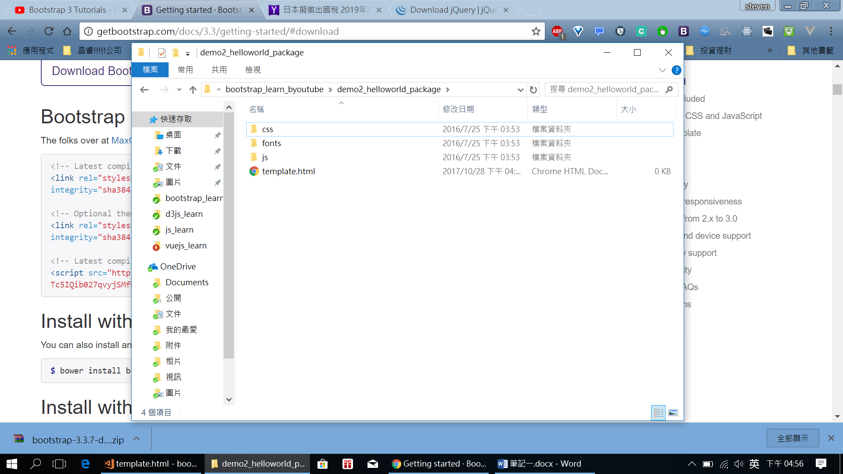

並將以下複製並貼到template.html:

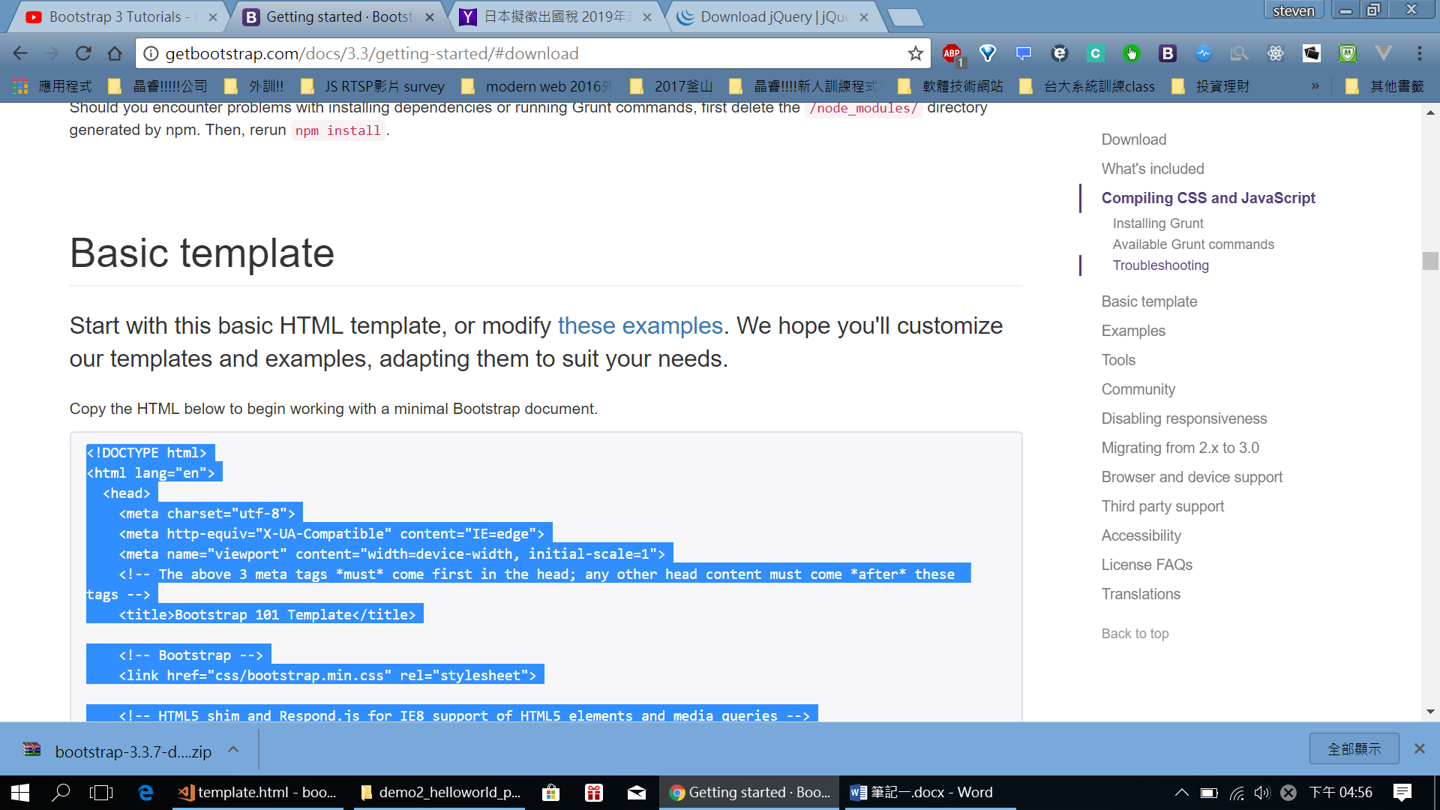

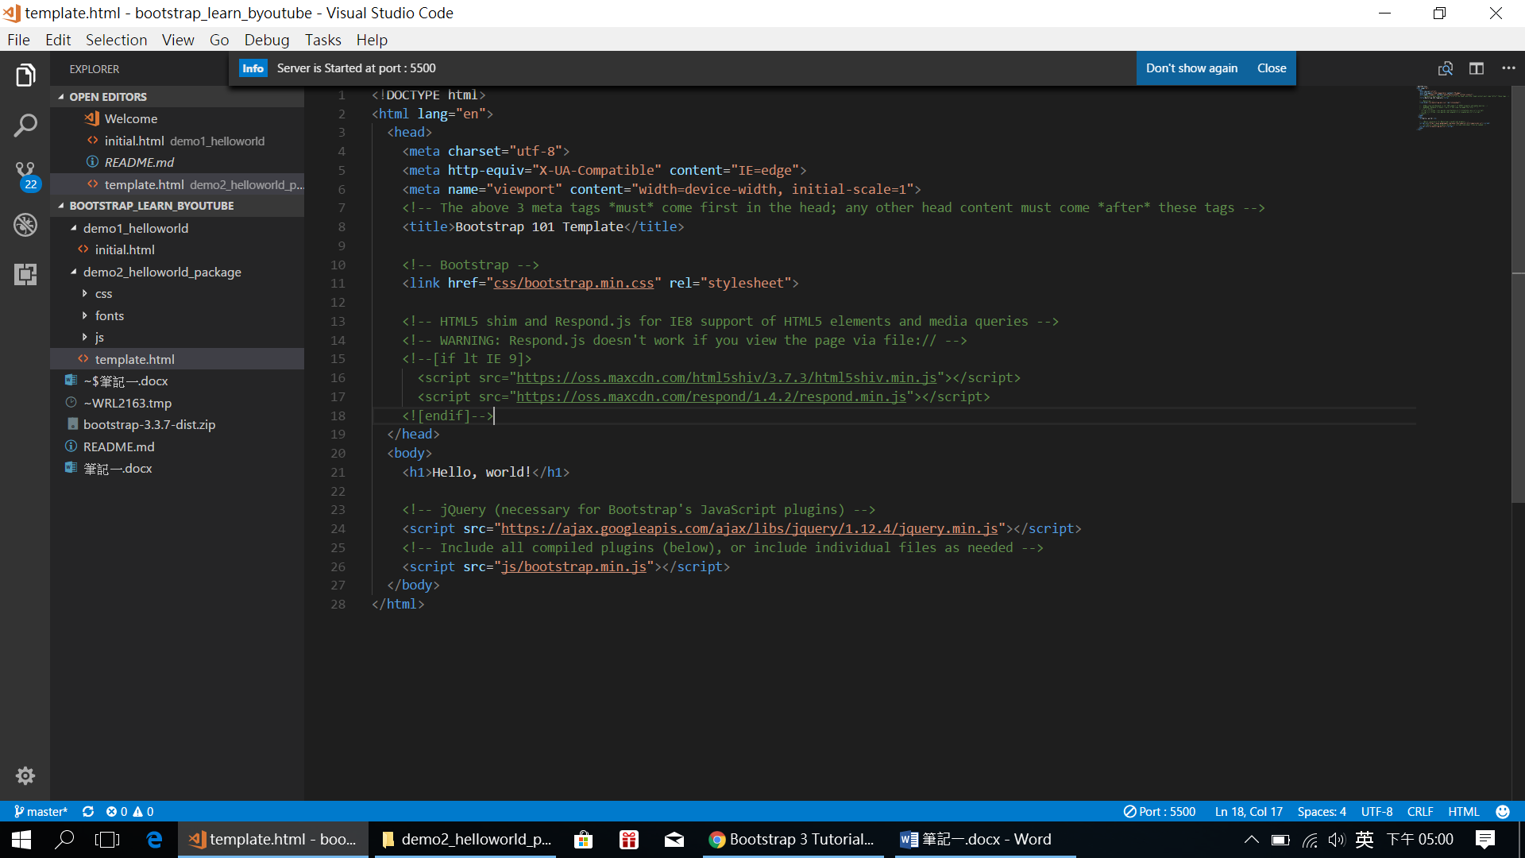

會看到上面有2個link:

依樣可以到該位址: <script src="https://oss.maxcdn.com/html5shiv/3.7.3/html5shiv.min.js"></script>

<script src=" https://oss.maxcdn.com/respond/1.4.2/respond.min.js "></script>

可參考:

Download bootstrap

http://getbootstrap.com/getting-started/

Html5Shiv

<https://code.google.com/p/html5shiv/>

Respond.min.js

<https://github.com/scottjehl/respond>

How to change the Font and theme of Sublime Text

youtube.com/watch?v=0d_VsrKzhGo

Download Meslo font

https://github.com/andreberg/Meslo-Font

Download Kuroir Theme

https://github.com/MarioRicalde/TextMate-Kuroir-Theme

此兩連結去(git)去下載整包

Html5shiv解開後可以看到:

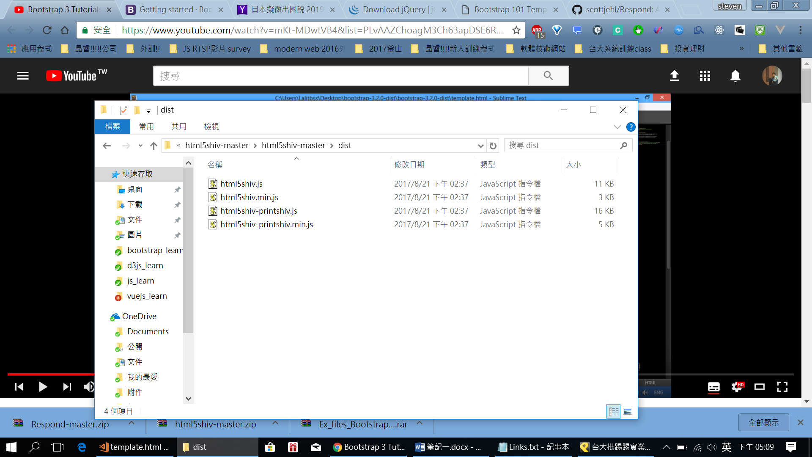

把html5shiv.min.js 放到bootstrap的js 資料夾底下吧!

同理respond.js也是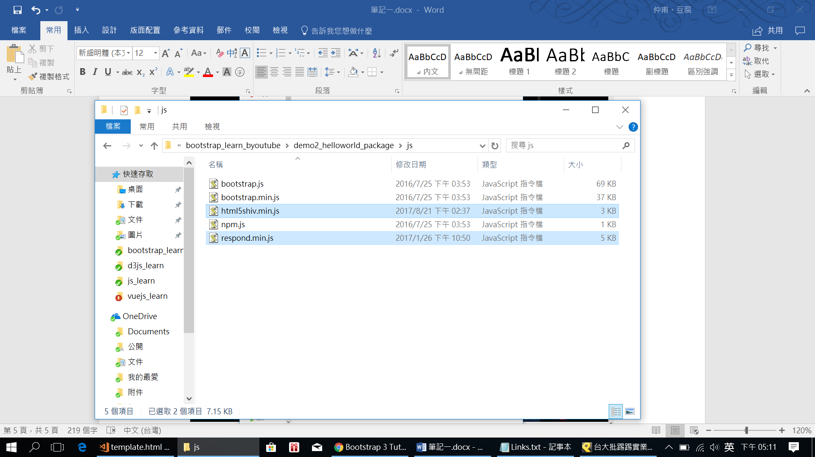

再改掉連結即可:

例如下面寫得那樣:

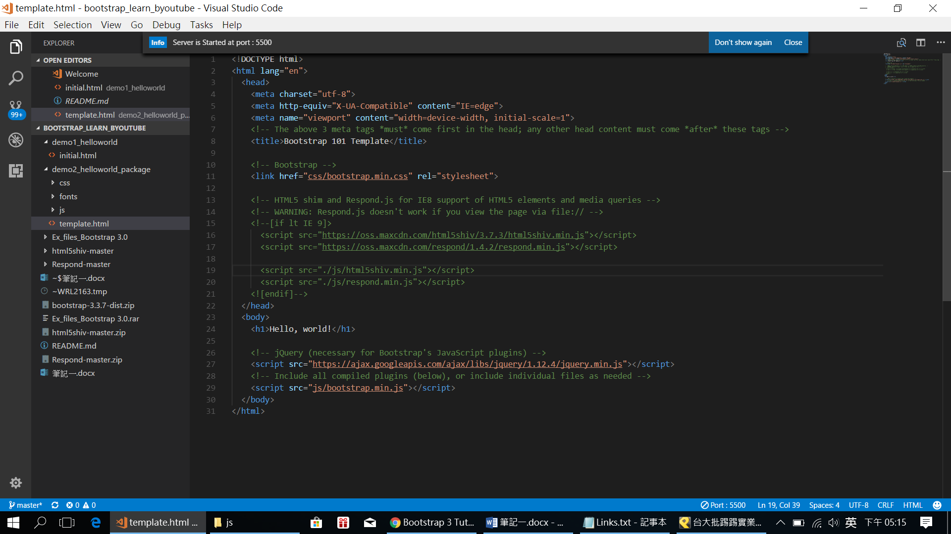

兩種方式都可以喔!