<Button> 以下的header 和 Footer先不秀

<div>

<div class="container">

<div class="row">

<a href="" class="btn">Button</a>

</div>

</div>

</div>

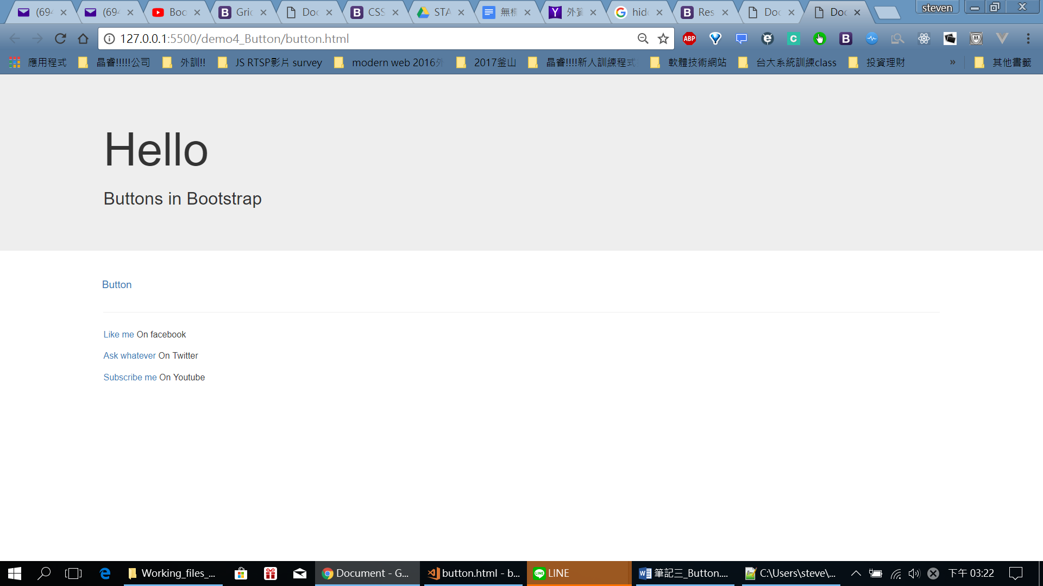

加個well:

<div>

<div class="container">

<div class="row">

<div class="well">

<a href="" class="btn">Button</a>

</div>

</div>

</div>

</div>

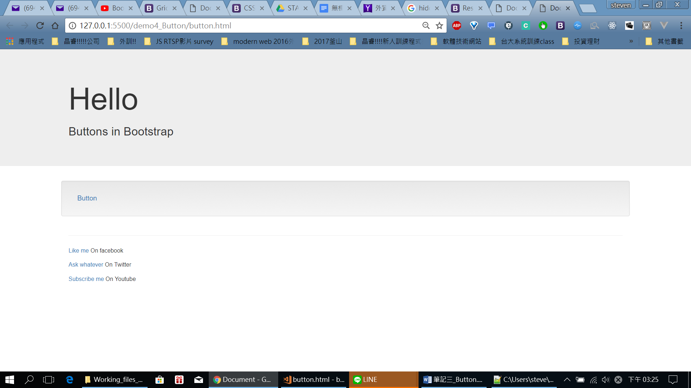

如果btn-primary:

<div>

<div class="container">

<div class="row">

<div class="well">

<a href="" class="btn">Button</a>

<a href="" class="btn btn-primary">Button Primary</a>

</div>

</div>

</div>

</div>

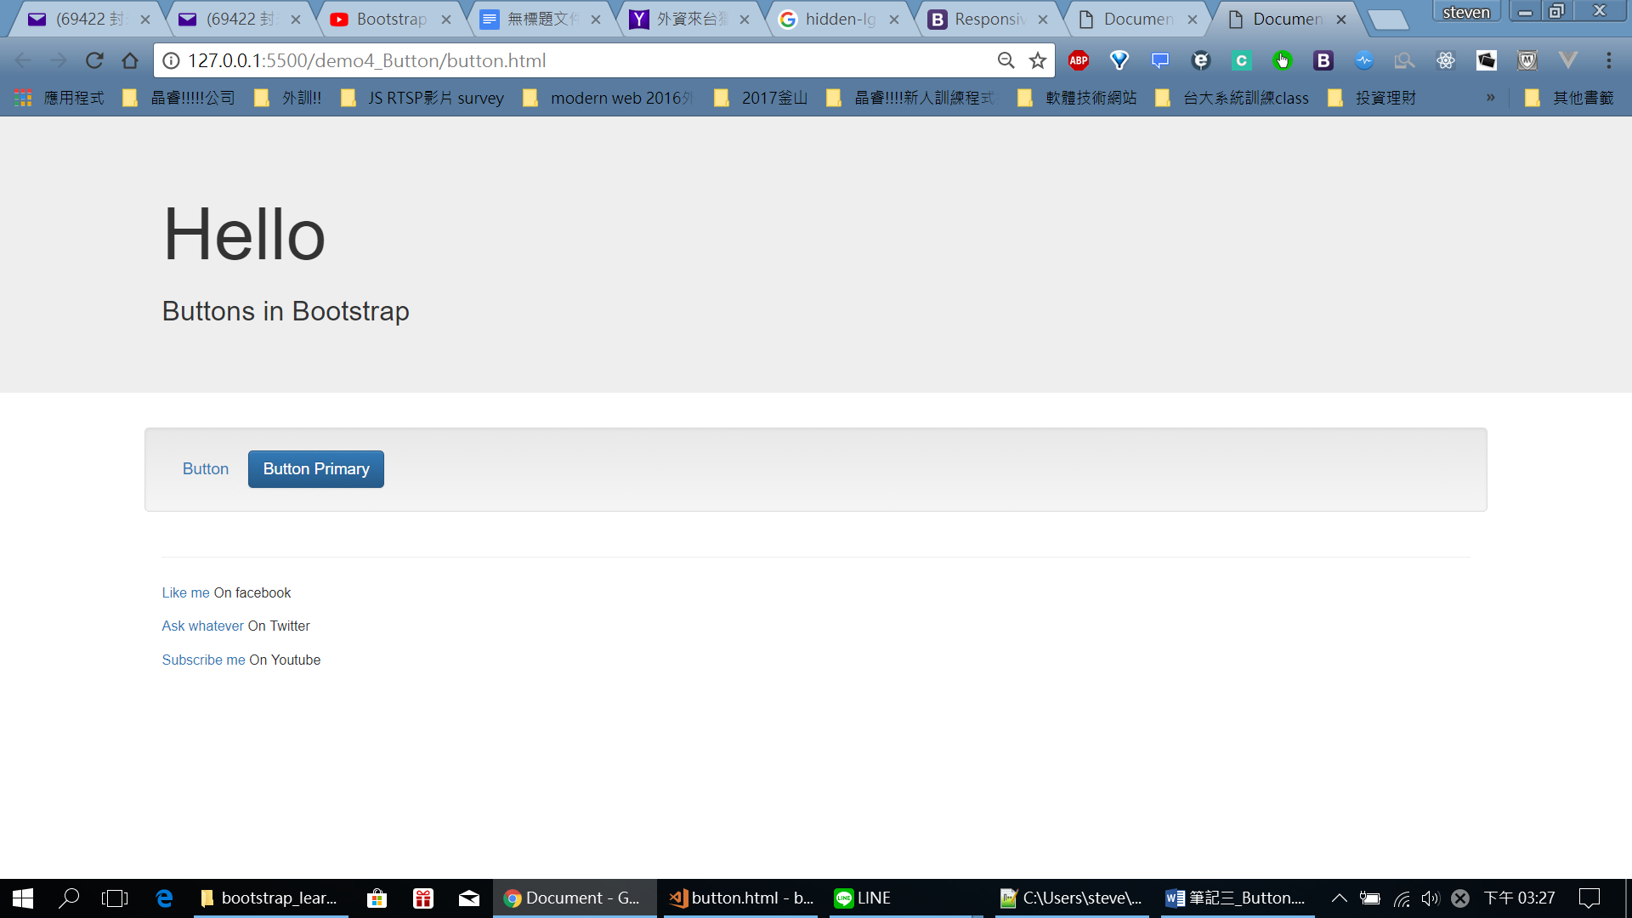

一堆:不同樣式

<div>

<div class="container">

<div class="row">

<div class="well">

<a href="" class="btn">Button</a>

<a href="" class="btn btn-primary">Button</a>

<a href="" class="btn btn-success">Button</a>

<a href="" class="btn btn-info">Button</a>

<a href="" class="btn btn-warning">Button</a>

<a href="" class="btn btn-danger">Button</a>

<a href="" class="btn btn-link">Button</a>

<a href="" class="btn btn-default">Button</a>

</div>

</div>

</div>

</div>

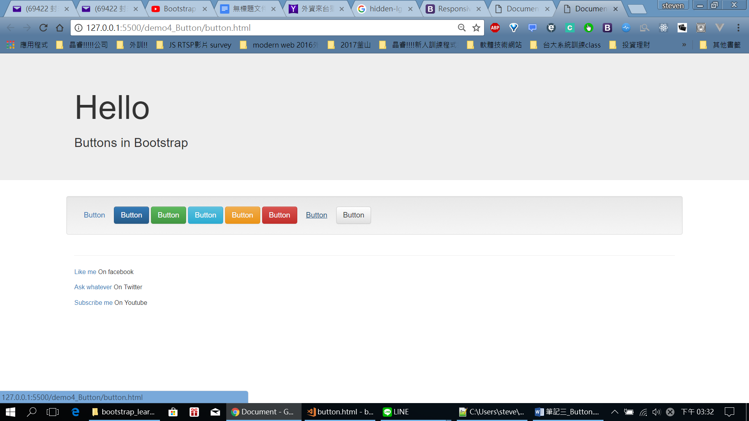

Btn-link和btn不一樣的地方在於滑鼠移過去有底線

另外可以加大btn(預設medium (md)):

<a href="" class="btn btn-default">Button</a>

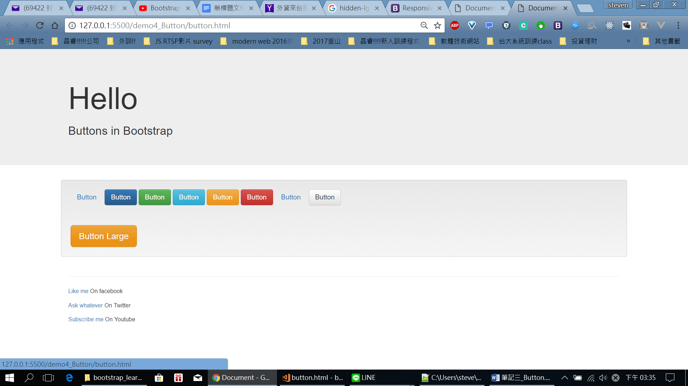

各種大小:

<a href="" class="btn btn-warning btn-lg">Button Large</a>

<a href="" class="btn btn-warning">Button md</a>

<a href="" class="btn btn-warning btn-sm">Button sm</a>

<a href="" class="btn btn-warning btn-xs">Button sm</a>

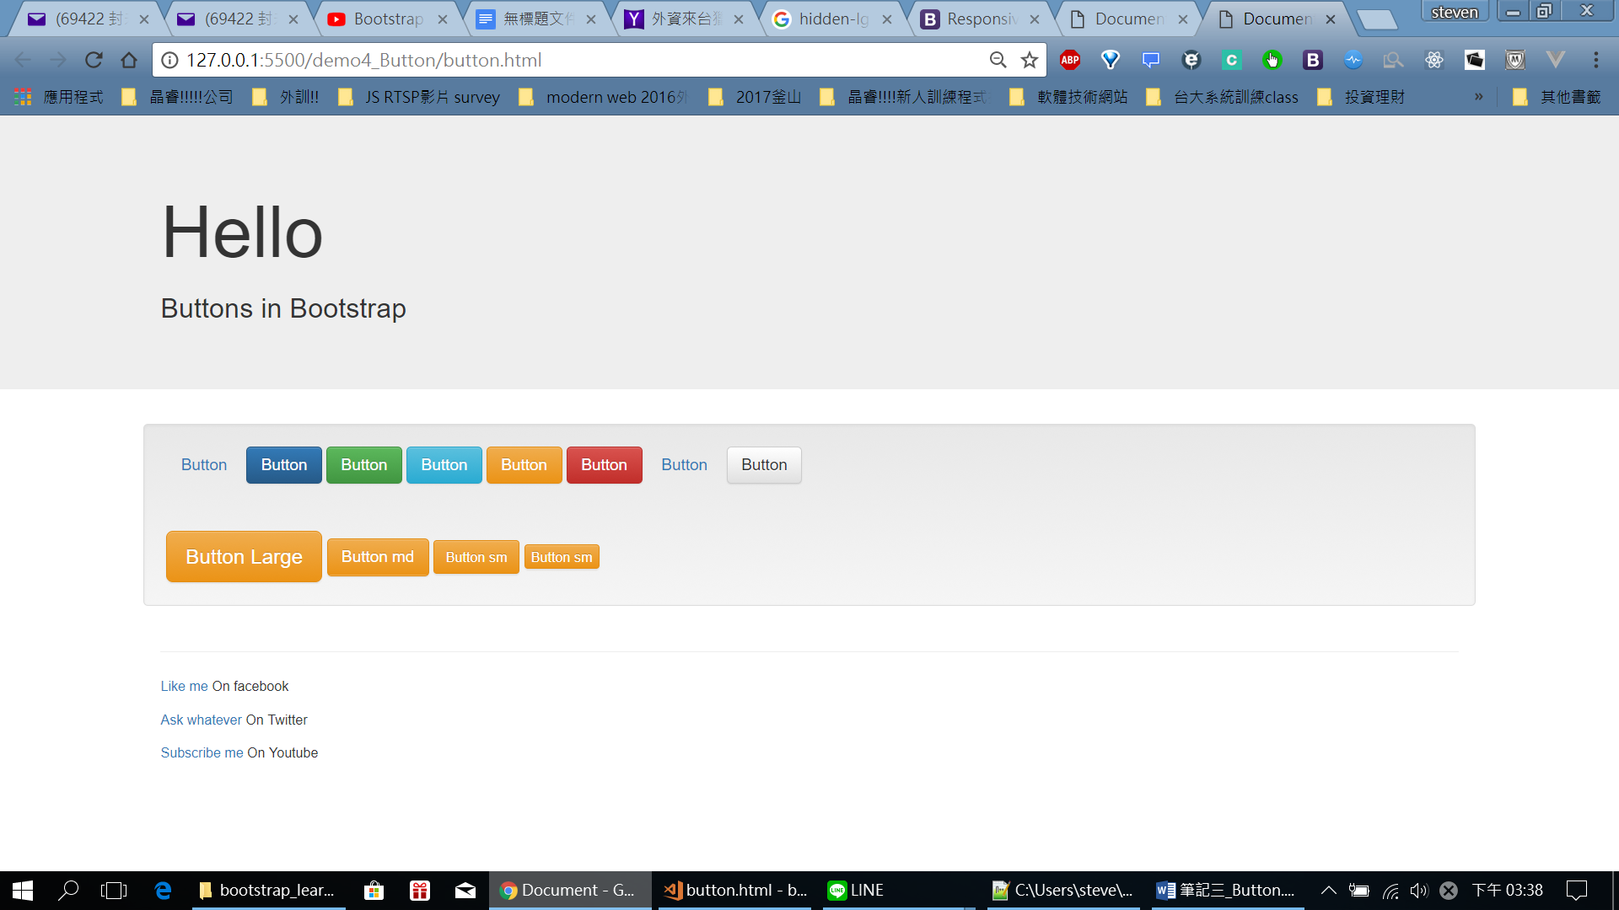

Hold住整列 btn-block :

<a href="" class="btn btn-warning btn-xs btn-block">Button block</a>

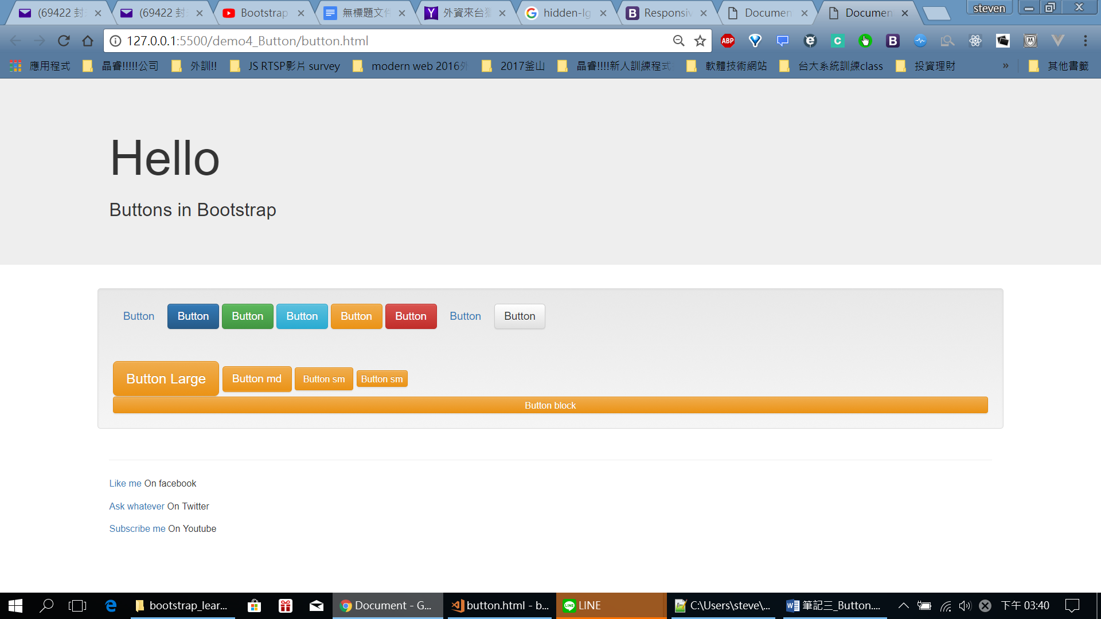

也有button tag:

<button type="button" class="btn btn-info">Button with button tag</button>

:

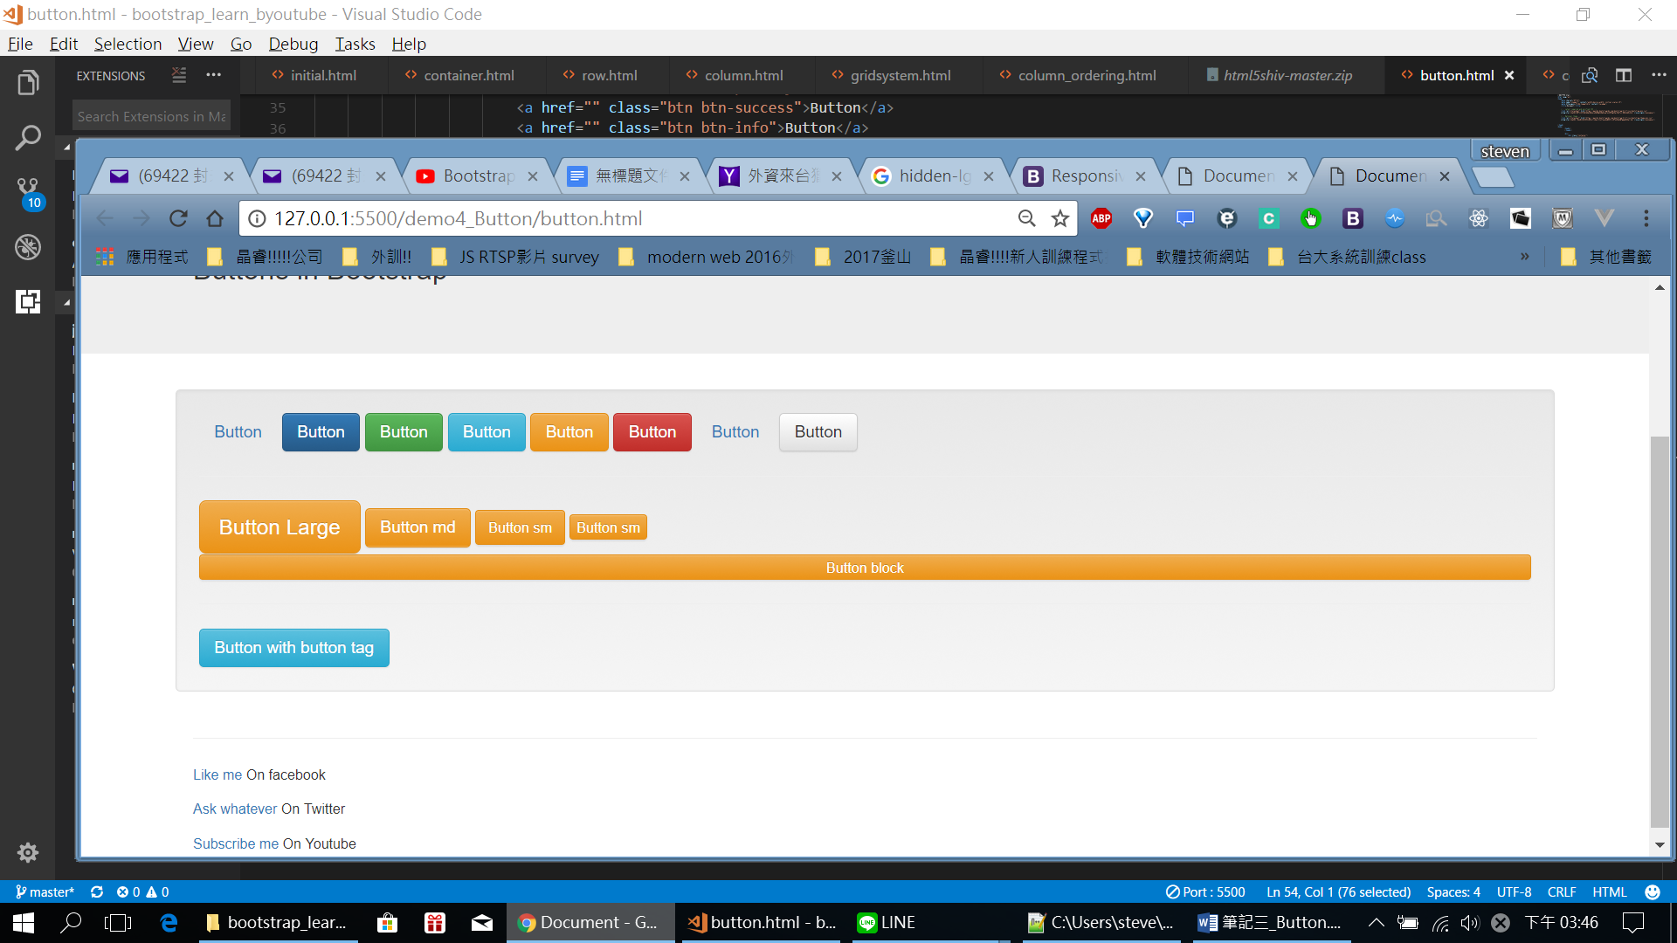

都可以!