Demo3 我是先用link

<Container>

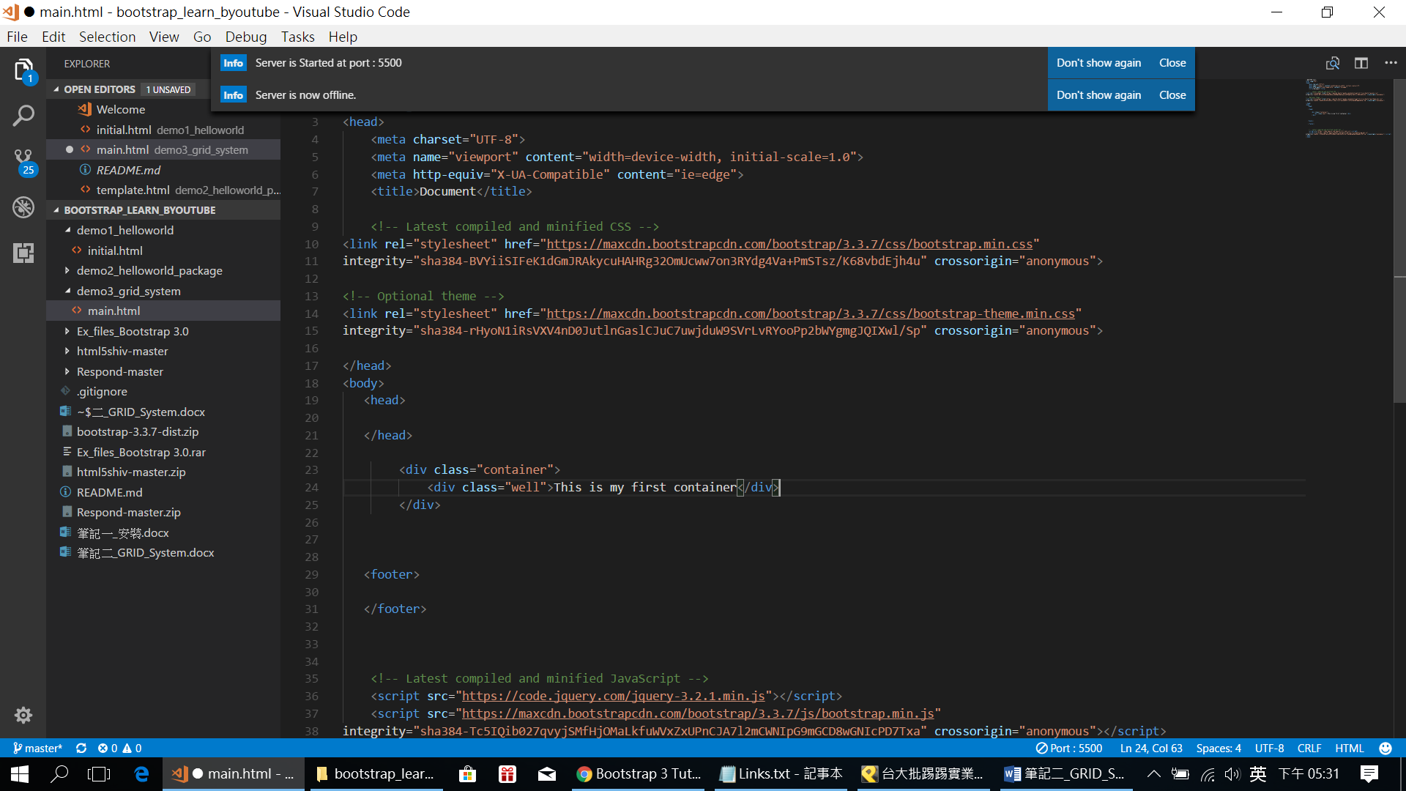

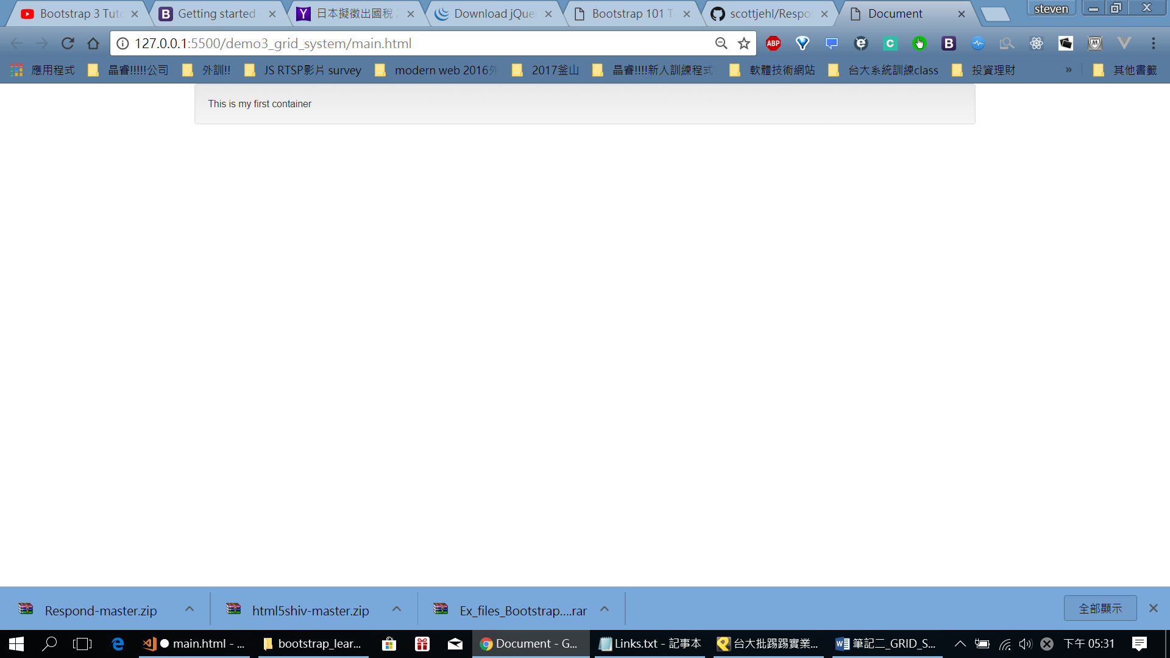

可以再加一層用css補上底色: 和加個padding (注意CSS是用’;’)

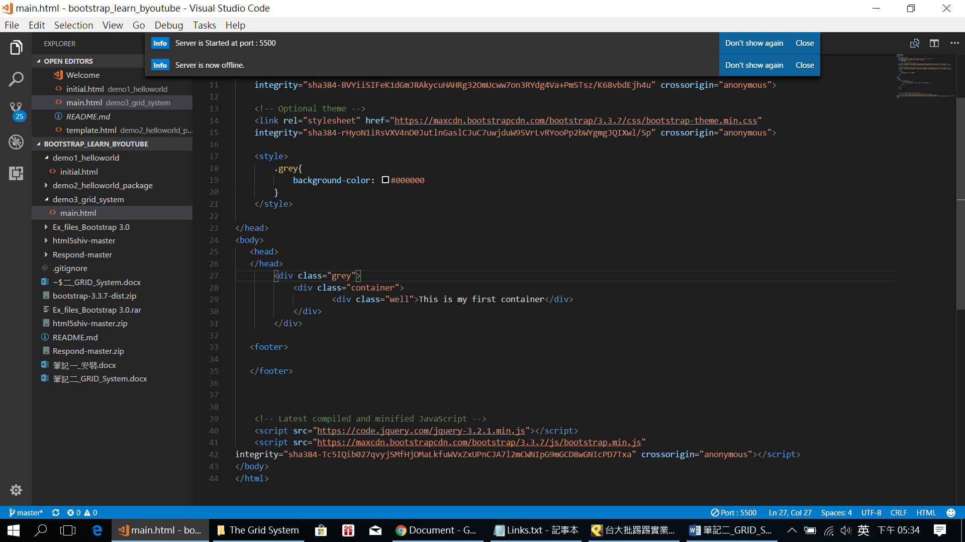

Style再加個padding: 20px

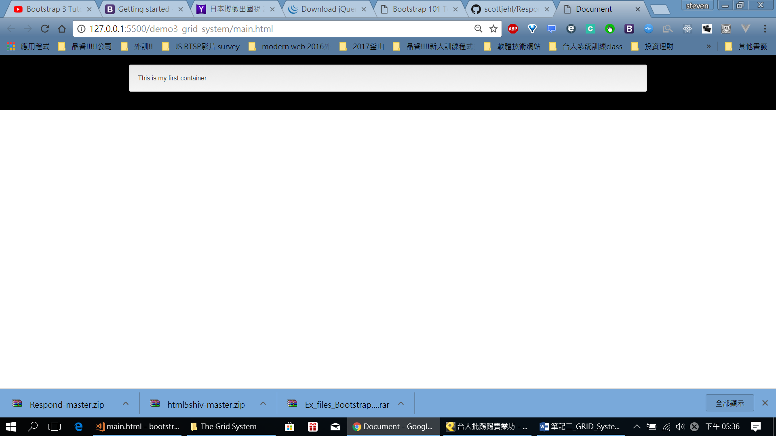

會發現這個container 會根據你視窗做改變唷!:

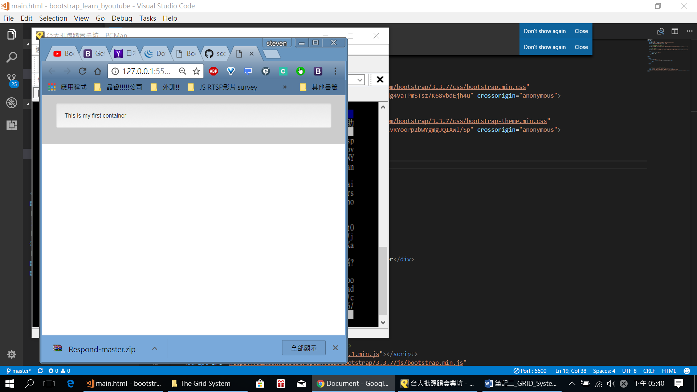

<Row>

1.

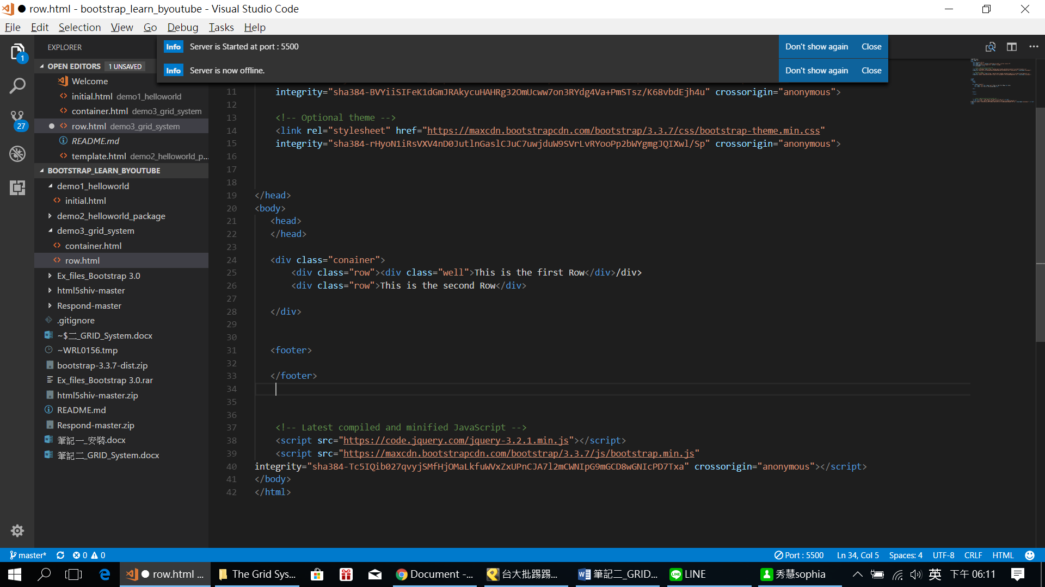

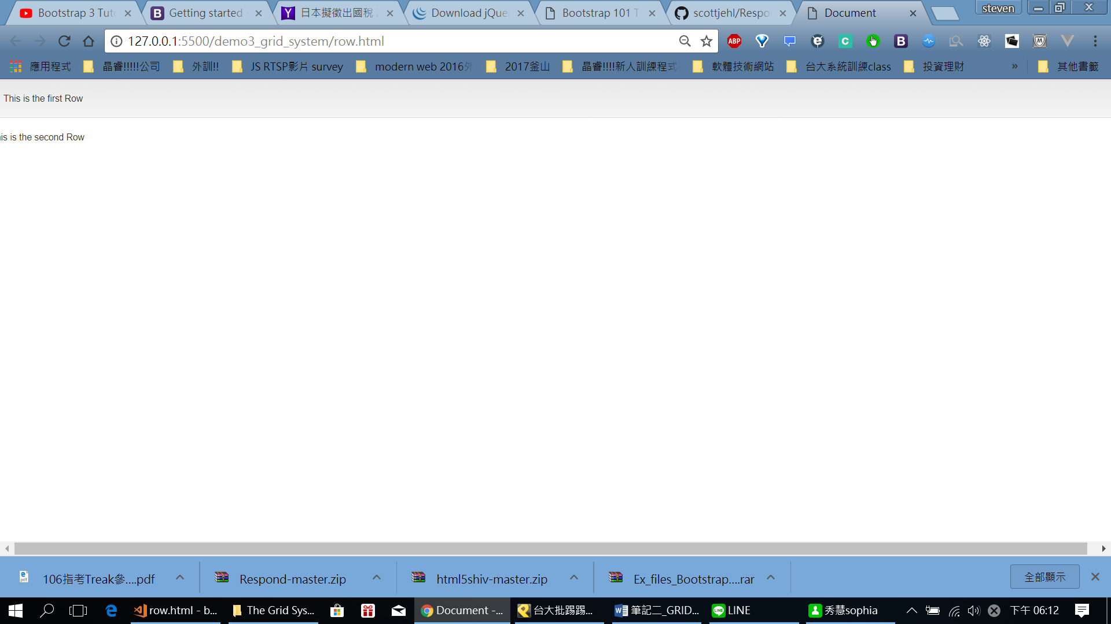

<div class="conainer">

<div class="row"><div class="well">This is the first Row</div></div>

<div class="row"><div class="well">This is the second Row</div></div>

</div>

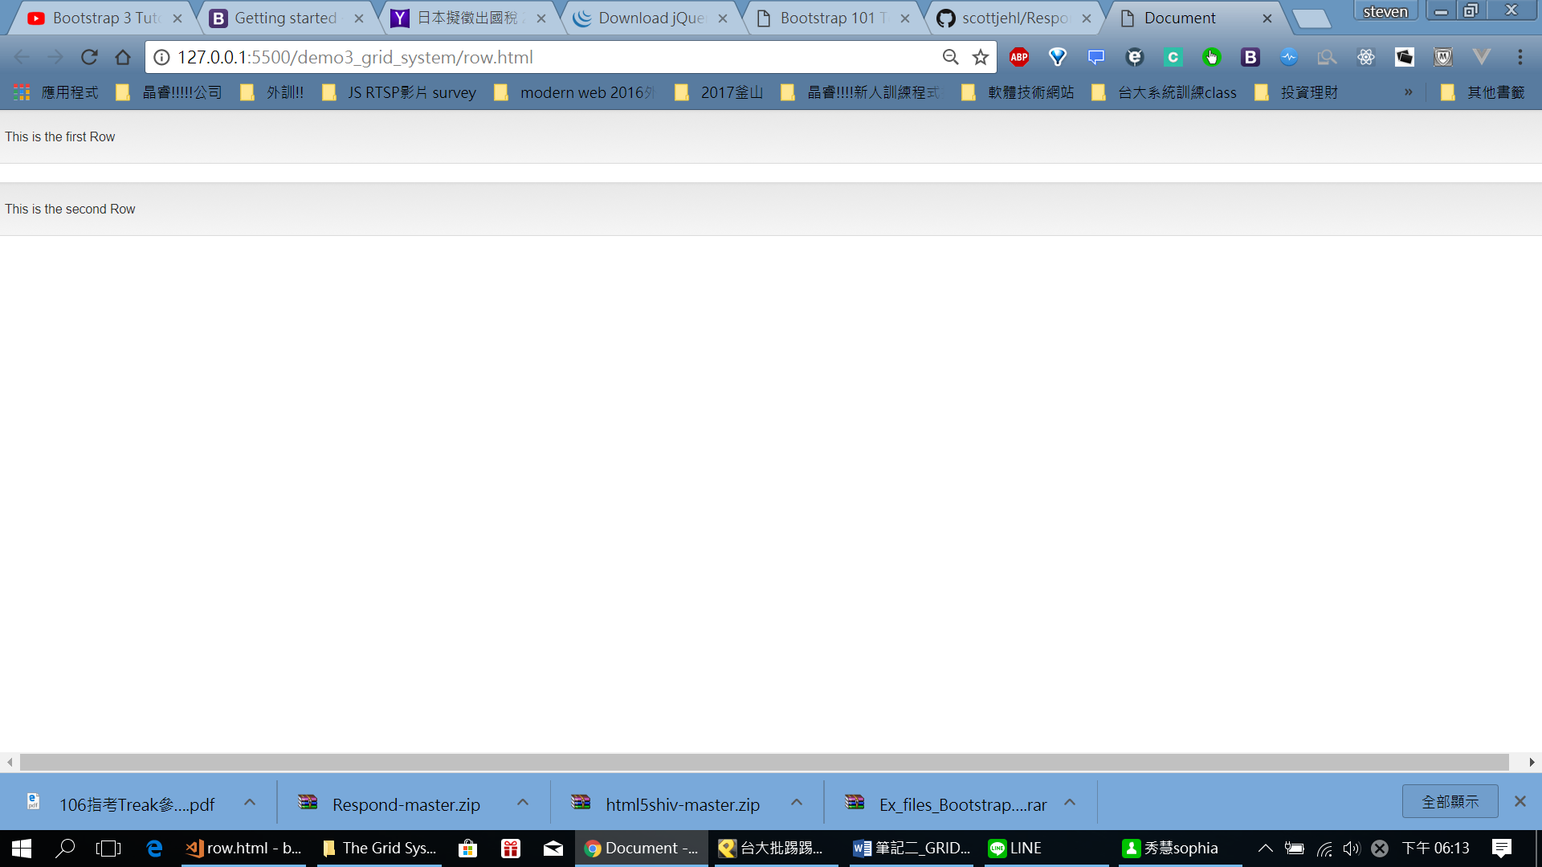

<continue: <https://www.youtube.com/watch?v=mKt-MDwtVB4&list=PLvAAZChoagM3Ch63apDSE6Ra6NeI62sQV>

>