Components:

<https://getbootstrap.com/docs/3.3/components/>

1. 自己取:

例如在上方看到:qrcode的class:

<span class="glyphicon glyphicon-qrcode"></span>

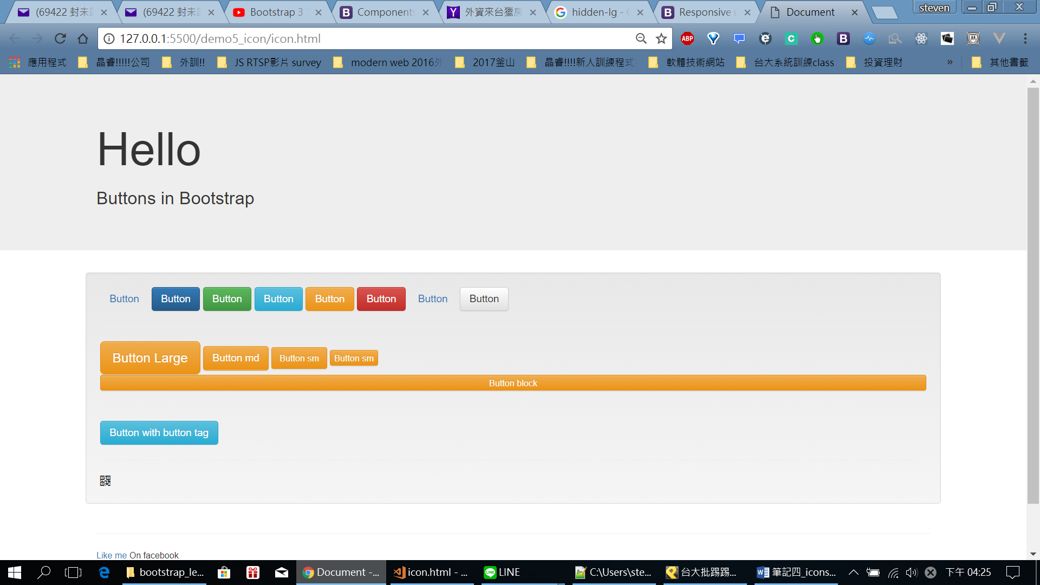

<span class="glyphicon glyphicon-qrcode"></span>

<span class="glyphicon glyphicon-search"></span>

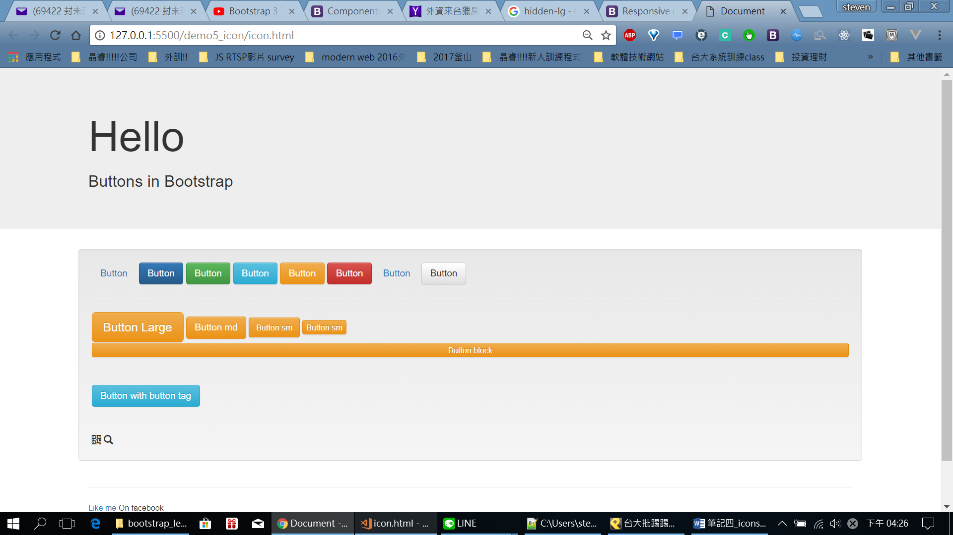

也可以在button內放icon:

<a href="" class="btn btn-default"><span class="glyphicon glyphicon-search"></span></a>

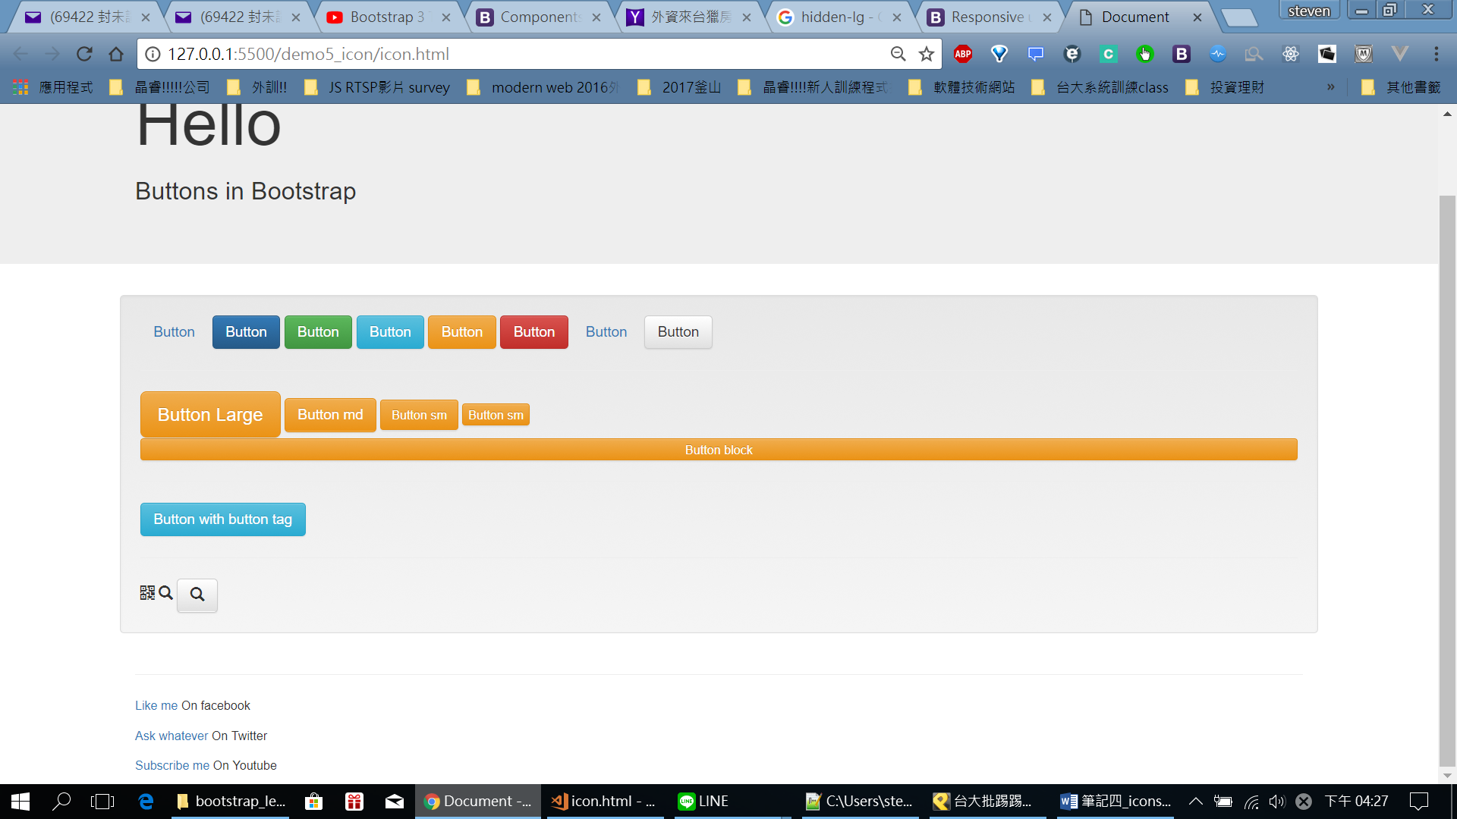

依樣可改button圖:

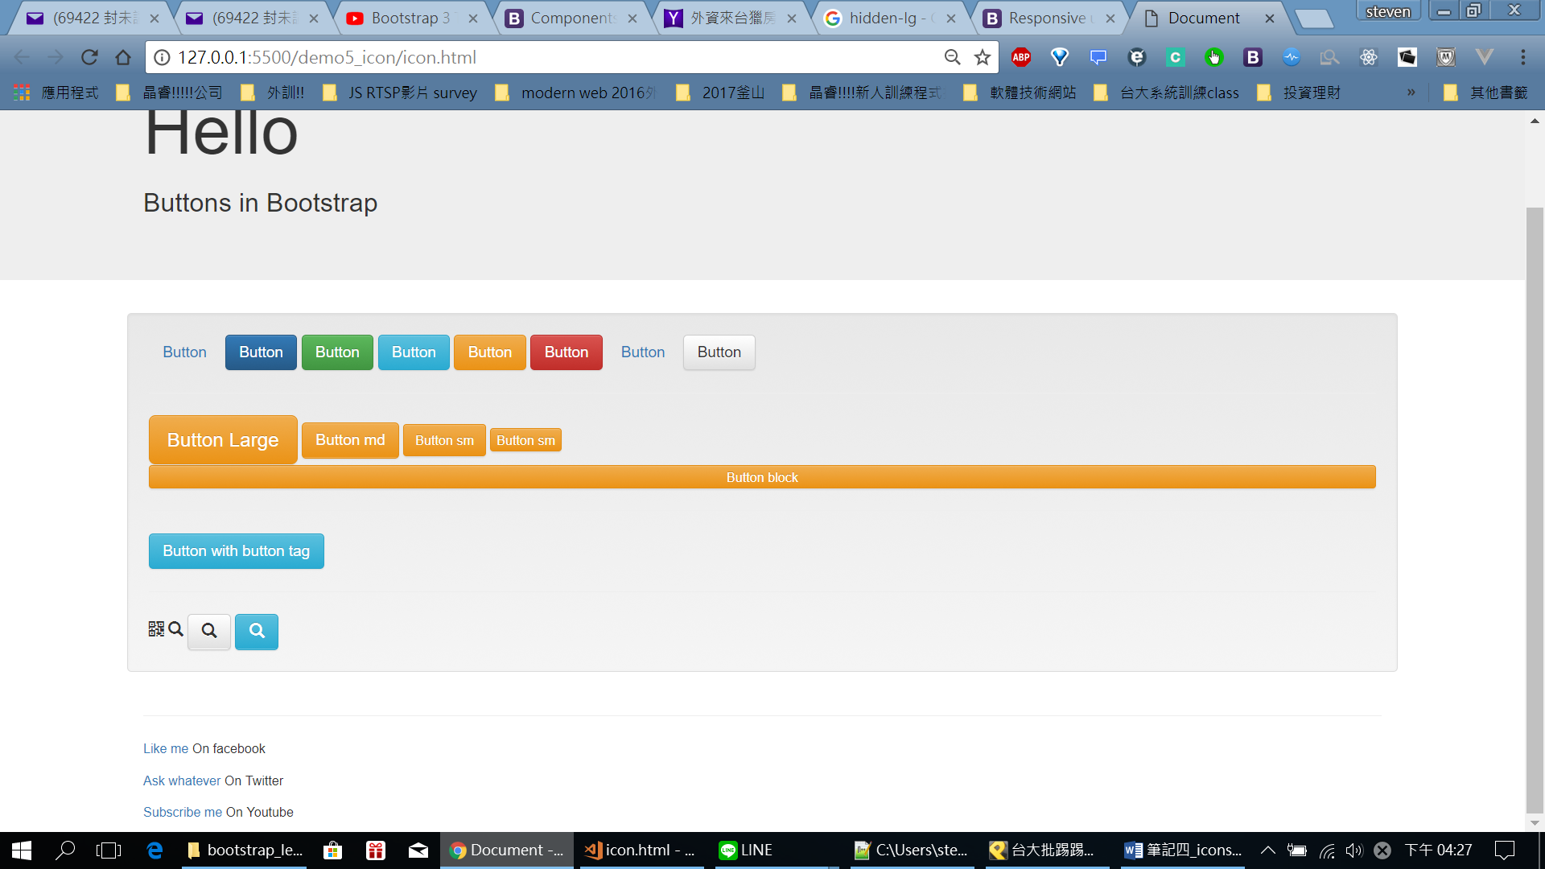

也可以在上面head新增style修改:

<style>

.glyphicon{

font-size: 5em;

}

</style>

