沒有UI可以設定!

所以要透過APP

1. 裝好pc版後
2. 搜尋BotFather:
3. 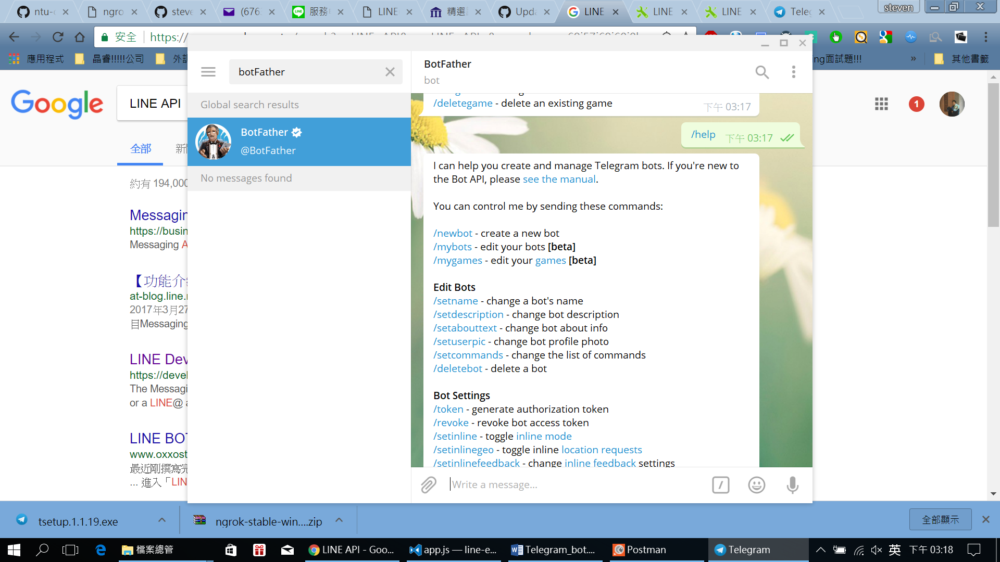
4. 點選/newbot

申請bot名和bot帳號: 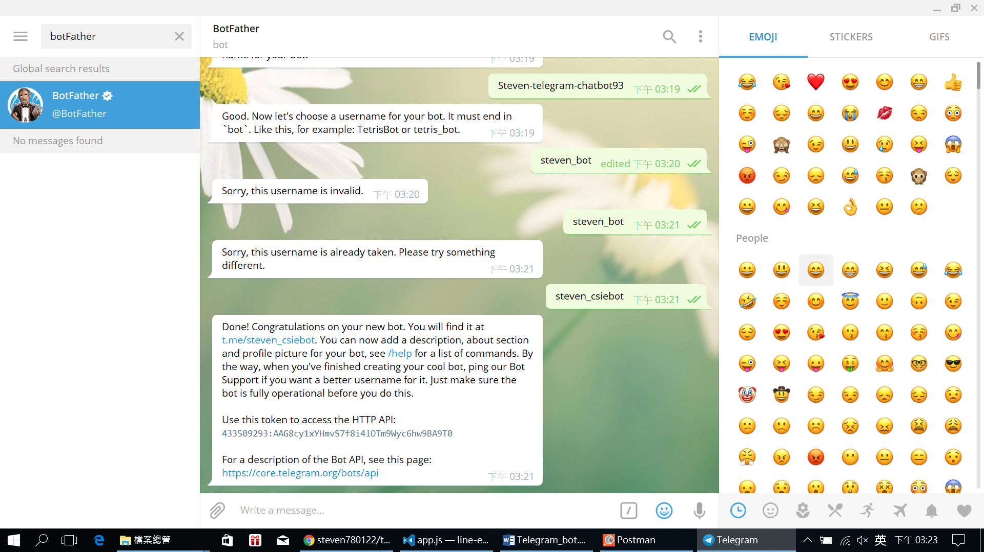

1. 到<https://github.com/ntu-csie-train/telegram-echo-bot-starter> fork後clone下來
2. 把telegram 的token貼到app.js，依樣npm install, node app.js

然後依樣可以先用ngrok轉址來轉localhost到public的網址

Ngrok http 3000 (3000 就是node server啟用時的port)

1. 設定set webhook : <https://core.telegram.org/bots/api#setwebhook>
2. **Making requests**
3. All queries to the Telegram Bot API must be served over HTTPS and need to be presented in this form: https://api.telegram.org/bot<token>/METHOD_NAME. Like this for example:

https://api.telegram.org/bot123456:ABC-DEF1234ghIkl-zyx57W2v1u123ew11/getMe

[https://api.telegram.org/bot<token>/METHOD_NAME](https://api.telegram.org/bot%3ctoken%3e/METHOD_NAME):

及若要Set web hook:

我的url為: <https://api.telegram.org/bot433509293:AAG8cy1xYHmvS7f8i4lOTm9Wyc6hw9BA9T0/setWebhook>

還要設定內容

We support **GET** and **POST** HTTP methods. We support four ways of passing parameters in Bot API requests:

* [URL query string](https://en.wikipedia.org/wiki/Query_string)
* application/x-www-form-urlencoded
* application/json (except for uploading files)
* multipart/form-data (use to upload files)

設定webhook: <https://core.telegram.org/bots/api#setwebhook>

(1). 開啟postman

設定:

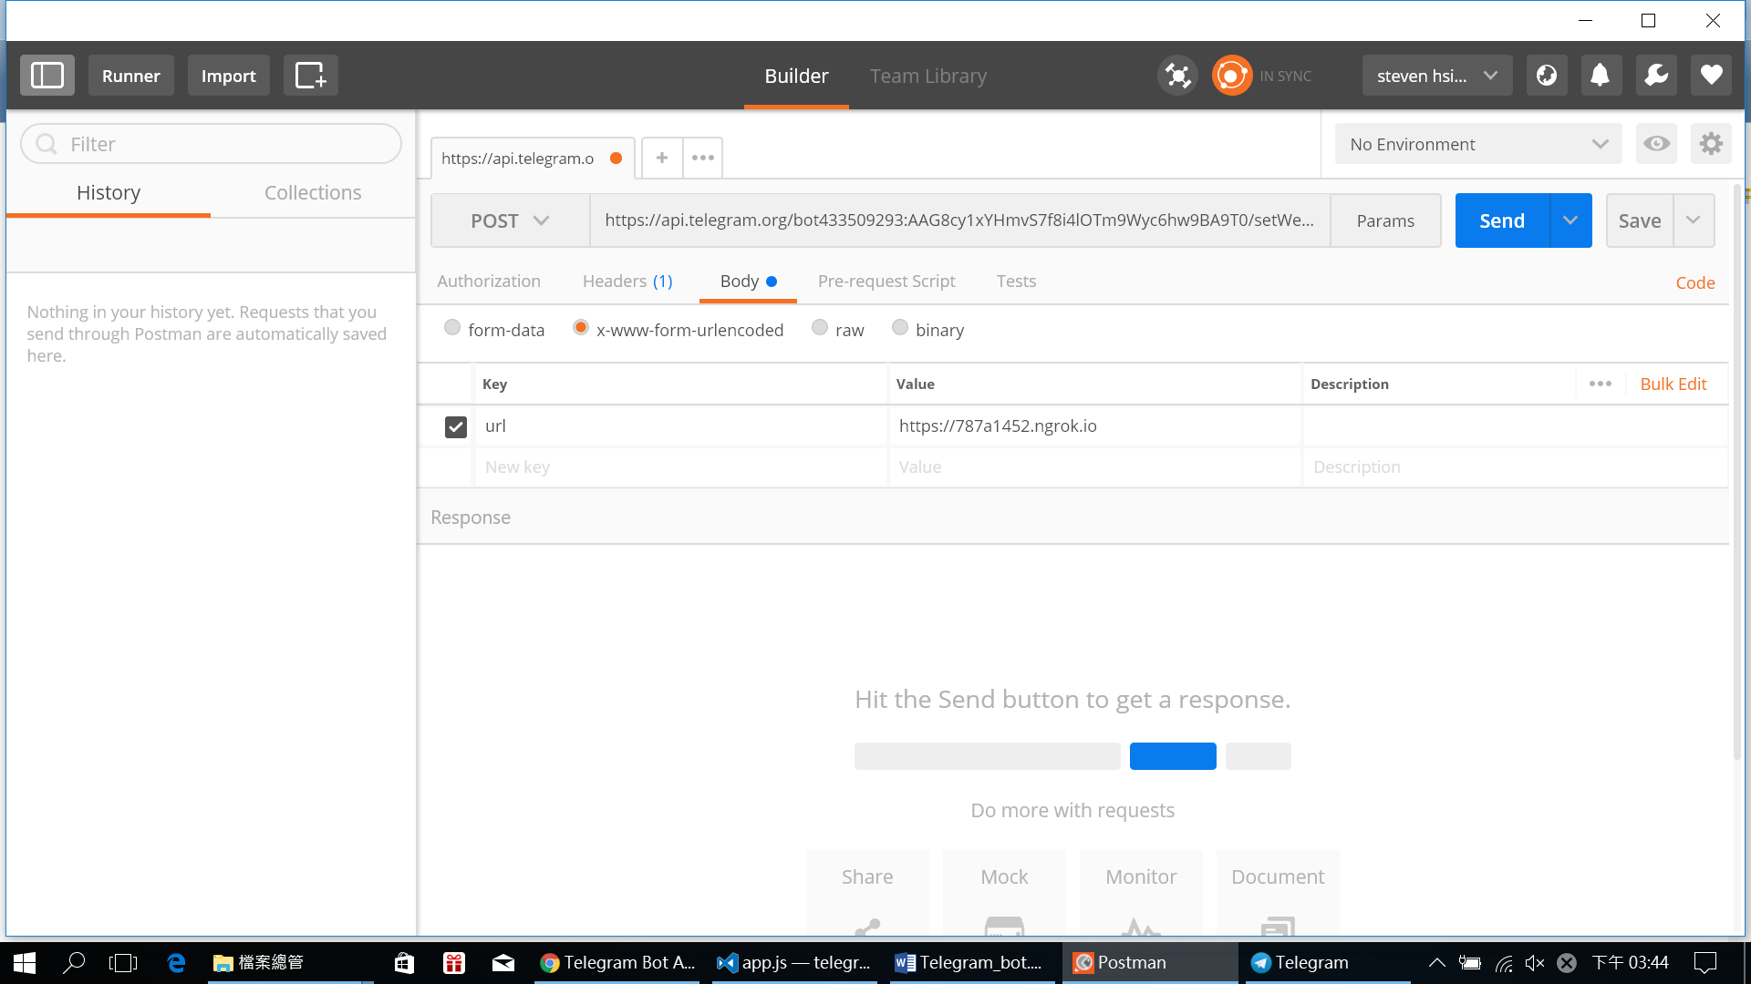

送出後:

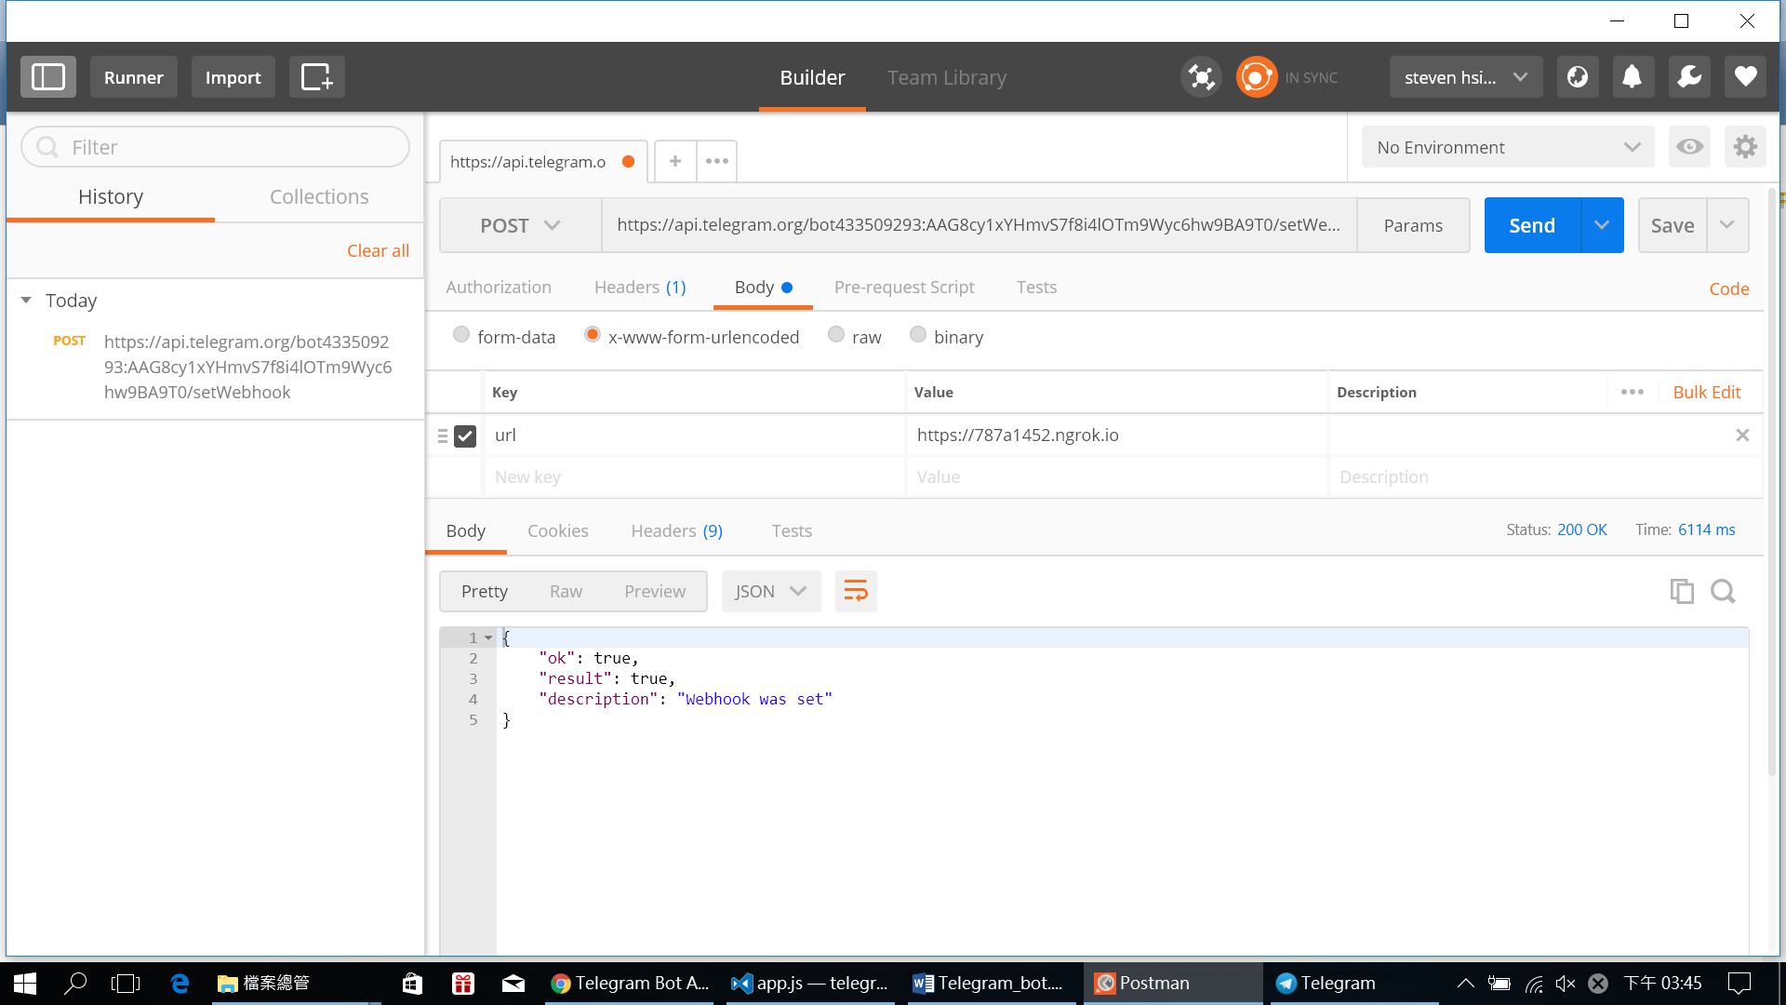

1. 在telegram搜尋我的bot的username就可以找到，然後再app.js那邊修改:
2. app.post('/', function (req, res) {
3. console.log(req.body)
4. // let chatid = res.body
5. res.send()
6. })
7. { update_id: 754753690,
8. message:
9. { message_id: 6,
10. from:
11. { id: 289604175,
12. is_bot: false,
13. first_name: 'Chung Fu',
14. last_name: 'Hsiao',
15. language_code: 'zh-TW' },
16. chat:
17. { id: 289604175,
18. first_name: 'Chung Fu',
19. last_name: 'Hsiao',
20. type: 'private' },
21. date: 1504425246,
22. text: 'sdfwow' } }
23. 在telegram 發訊息後就可以看到囉!

之後可以再部屬到heroku!!

交作業: 之後要交喔!

語意分析: api.ai, python nlt, LUIS, wit.ai