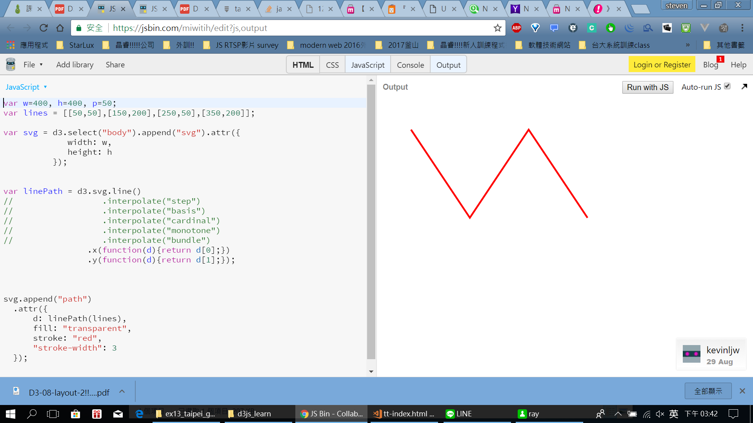

2.

先:

<!DOCTYPE html>

<html lang="en">

<head>

<meta charset="UTF-8">

<meta name="viewport" content="width=device-width, initial-scale=1.0">

<meta http-equiv="X-UA-Compatible" content="ie=edge">

<title>Document</title>

<script src="//d3js.org/d3.v3.min.js"></script>

</head>

<body>

<script>

var w=500, h=400, p=50;

var n=100;

lines=[];

original = random(6,25);

for(var i=0;i<n;i++){

original+=random(-3,4);

lines.push([i\*5+p,original]) // sample資料 (因為會上上下下)

}

console.log(lines)

var svg = d3.select("body").append("svg").attr({

width: w,

height: h

});

var xScale = d3.scale.linear()

.domain([d3.min(lines,function(d){

return d[0];

}),d3.max(lines,function(d){

return d[0];

}) ])

.range([p,w-p]);

var yScale = d3.scale.linear()

.domain([d3.min(lines,function(d){

return d[1];

}),d3.max(lines,function(d){

return d[1];

}) ])

.range([h-p,p]);

var xAxis = d3.svg.axis()

.scale(xScale).orient("bottom");

var yAxis = d3.svg.axis()

.scale(yScale).orient("left");

d3.select("svg").append("g")

.classed("axis",true)

.attr("transform","translate(0,"+(h-p)+")").call(xAxis)

d3.select("svg").append("g")

.classed("axis",true)

.attr("transform","translate("+(p)+",0)").call(yAxis)

// var linePath = ???;

svg.append("path")

.attr({

d: linePath(lines),

fill: "transparent",

stroke: "navy",

"stroke-width": 1

});

function random(N,M){

var rScale = d3.scale.linear()

.domain([0,1])

.range([N,M]);

return rScale(Math.random());

}

</script>

</body>

</html>

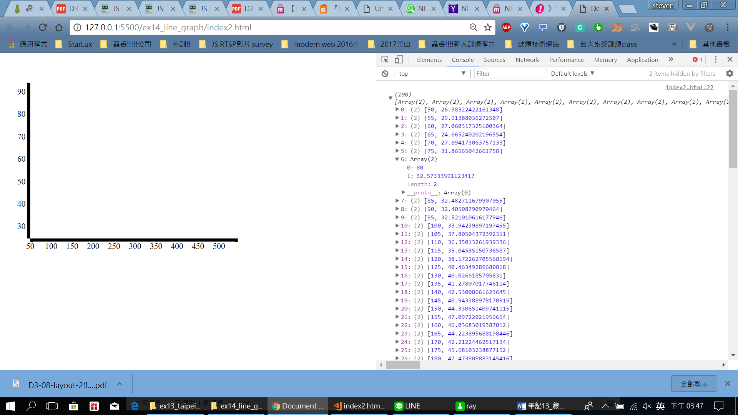

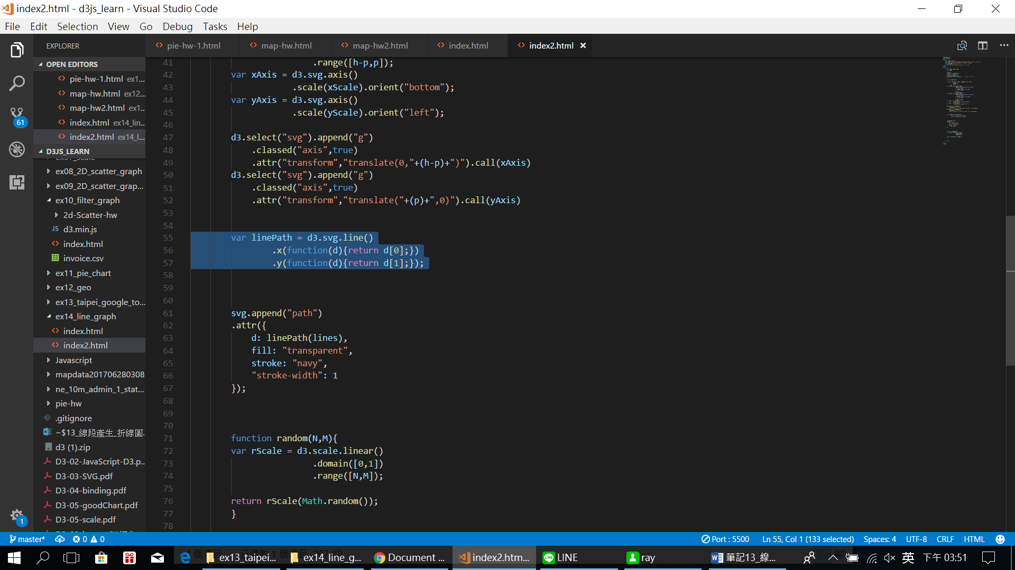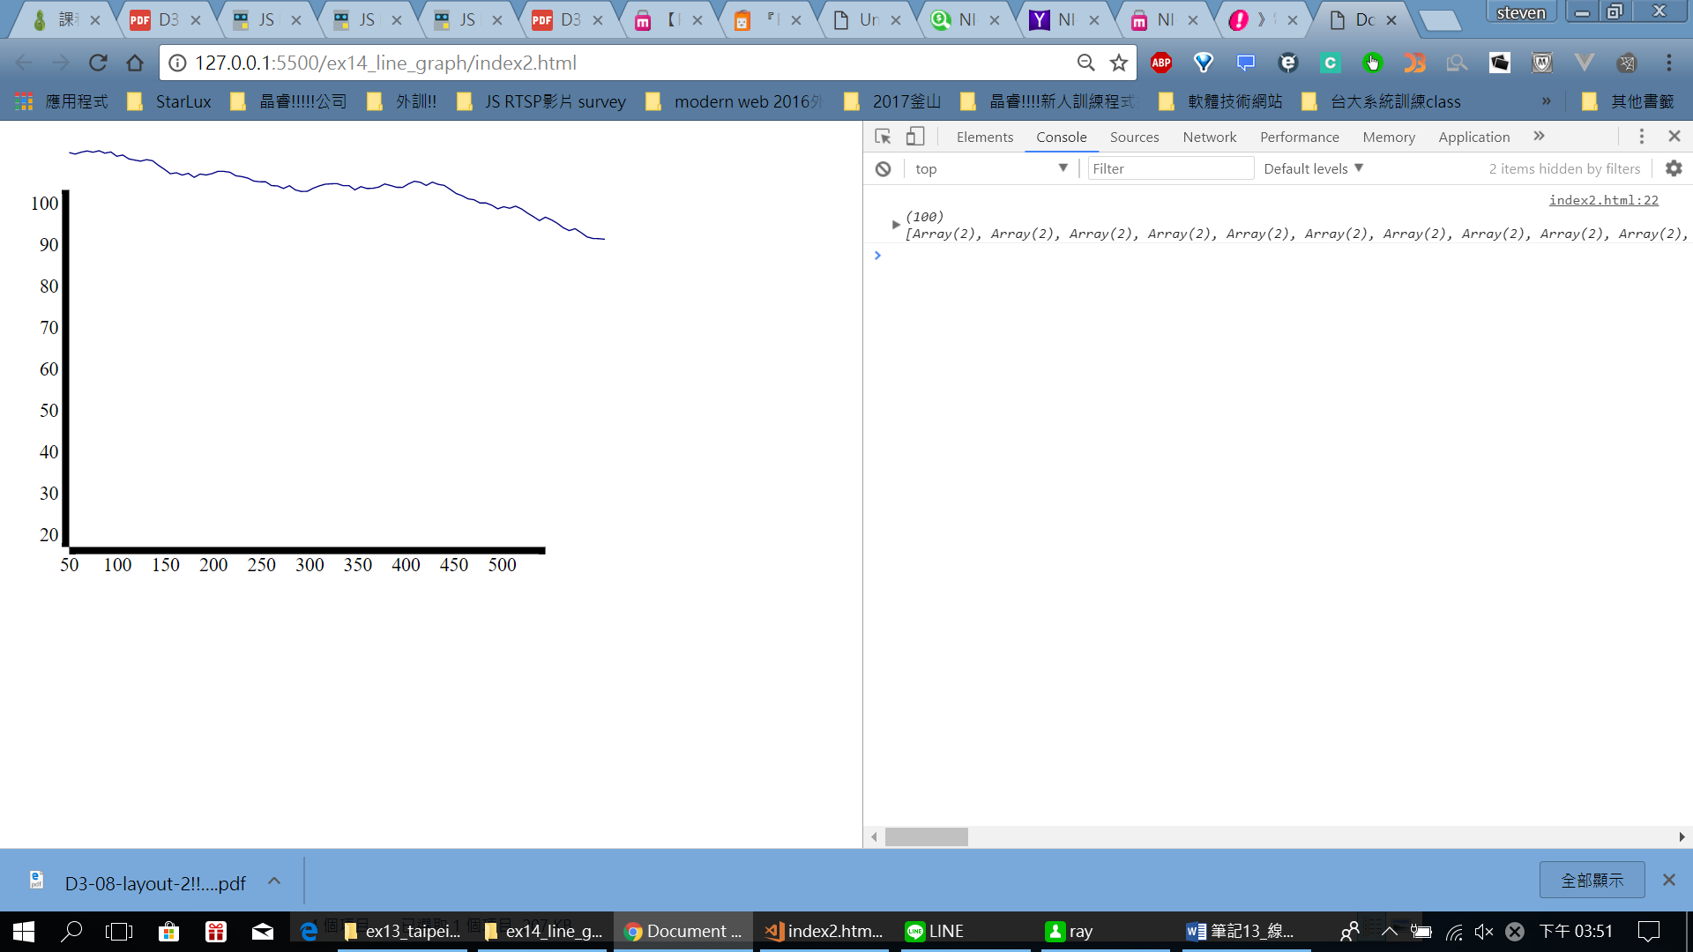

會怪怪是因為目前是接話 沒有對到座標軸!

改為 var linePath = d3.svg.line()

.x(function(d){return xScale(d[0]);})

.y(function(d){return yScale(d[1]);});

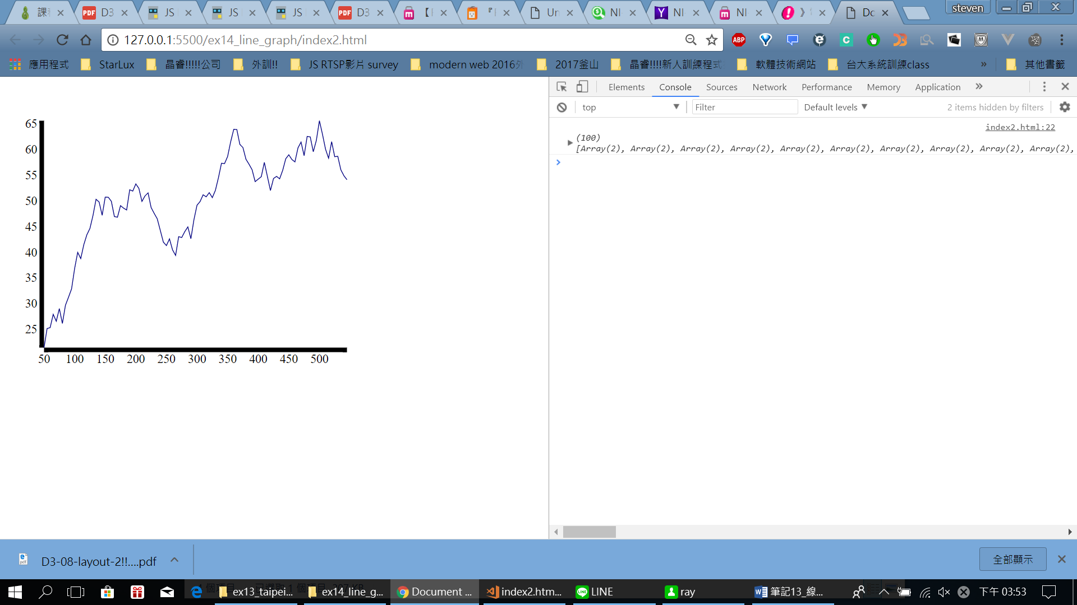

成功拉!!!