1. <https://drive.google.com/file/d/0Bx5_7n7pgohUeEhXbTVqdXQ2WUU/view?usp=drive_web>
2. 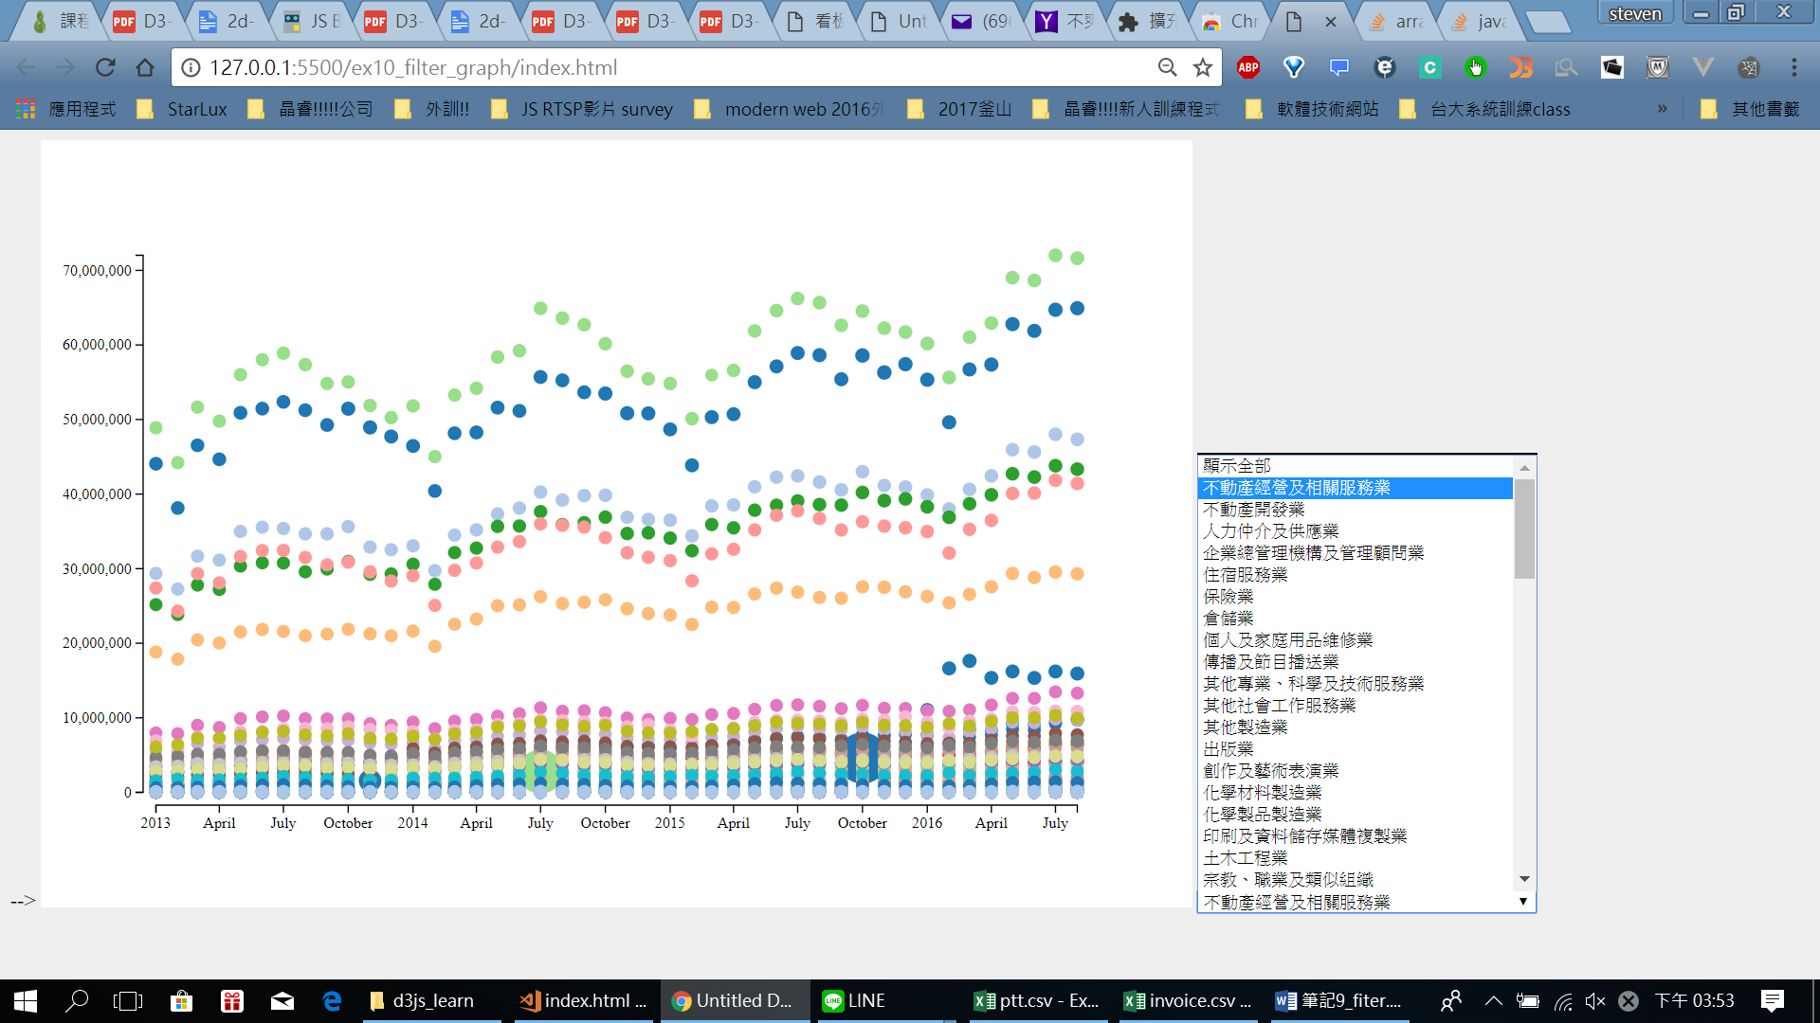

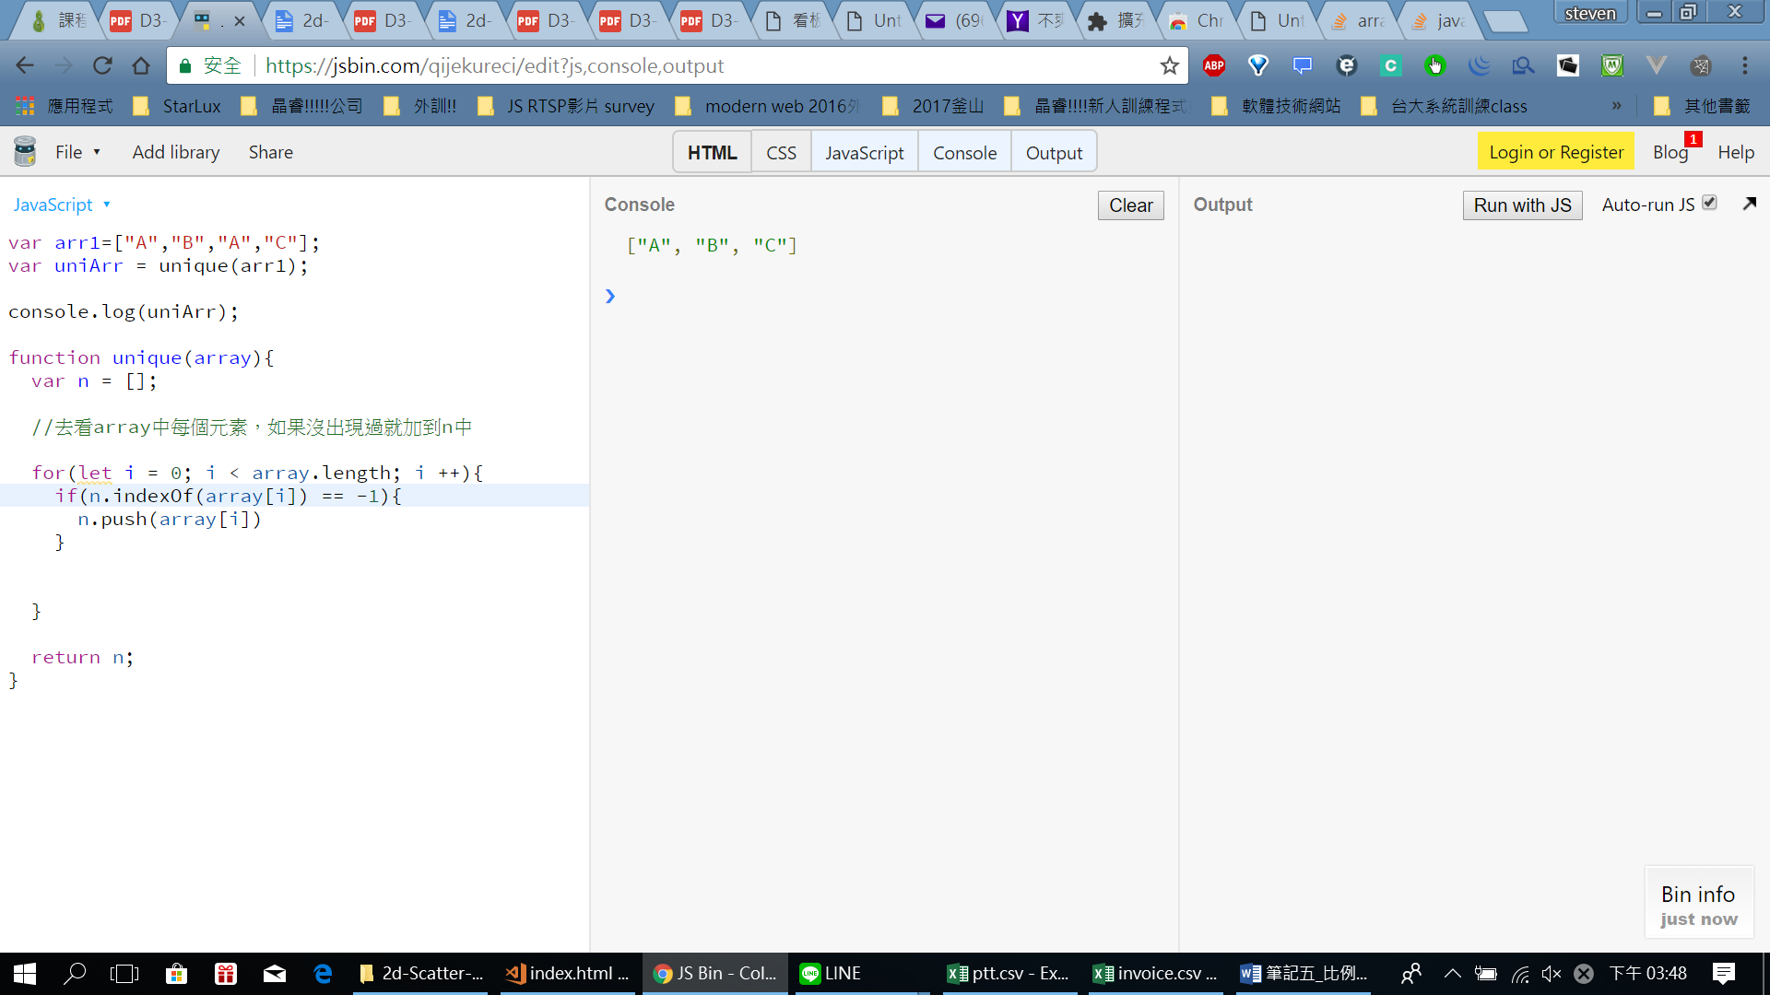

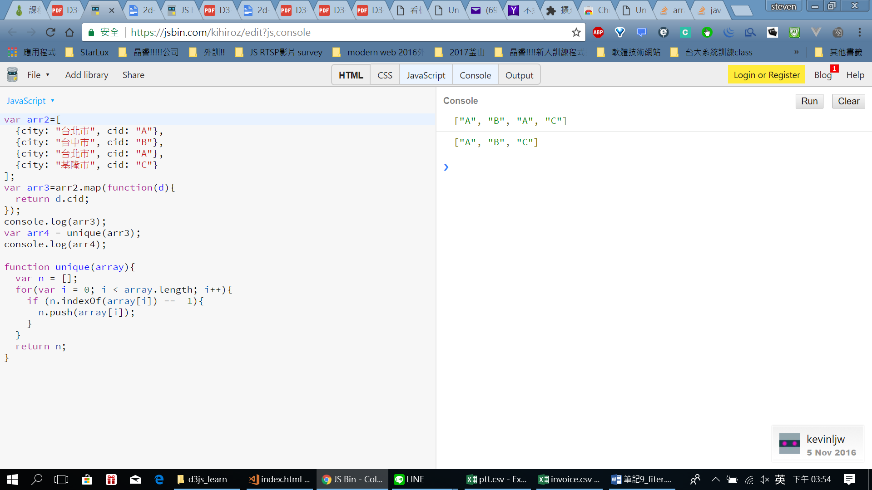

2. 目前先新增:

function btnList(dataSet){

industryArray = dataSet.map(function(d){

return d.industry;

});

let uIndustryArr = unique(industryArray);

d3.select("body")

.append("div")

.text(uIndustryArr.join("/"))

}

function unique(array){

var n = [];

for(var i = 0; i < array.length; i++){

if (n.indexOf(array[i]) == -1){

n.push(array[i]);

}

}

return n;

}

