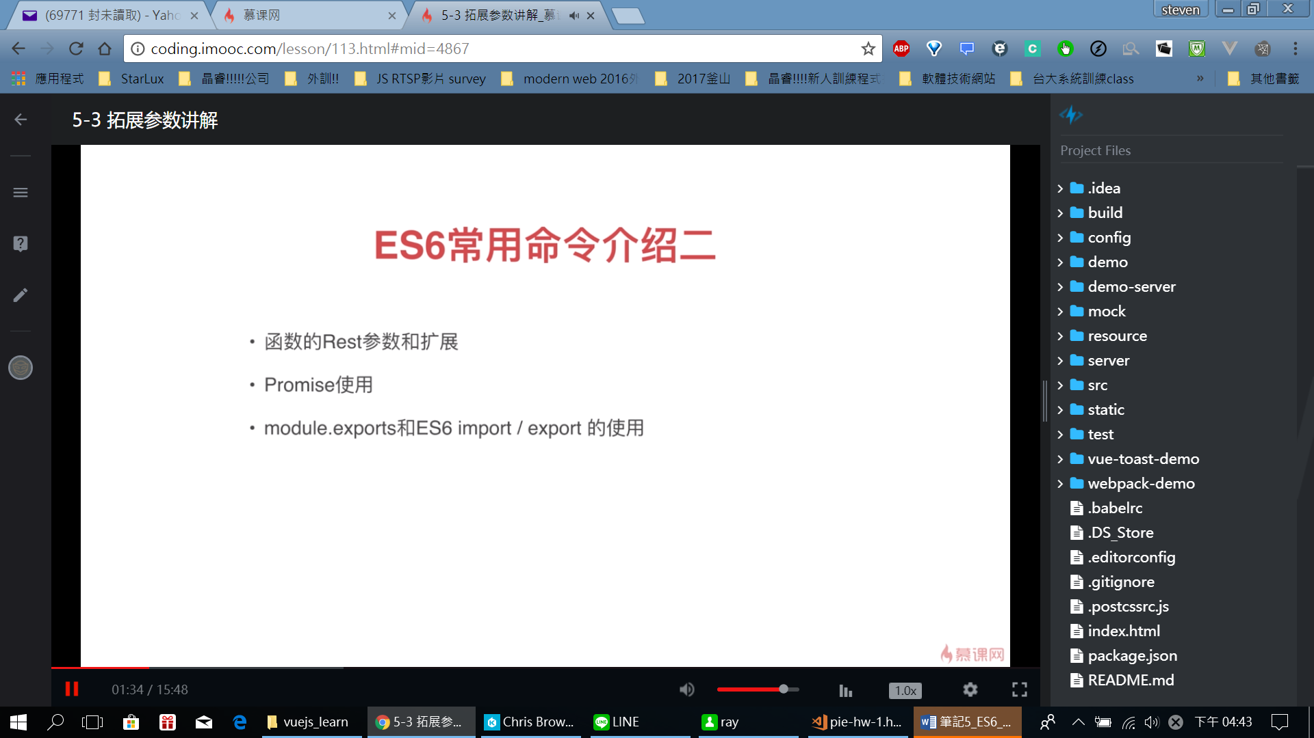

<Rest 參數>

1.

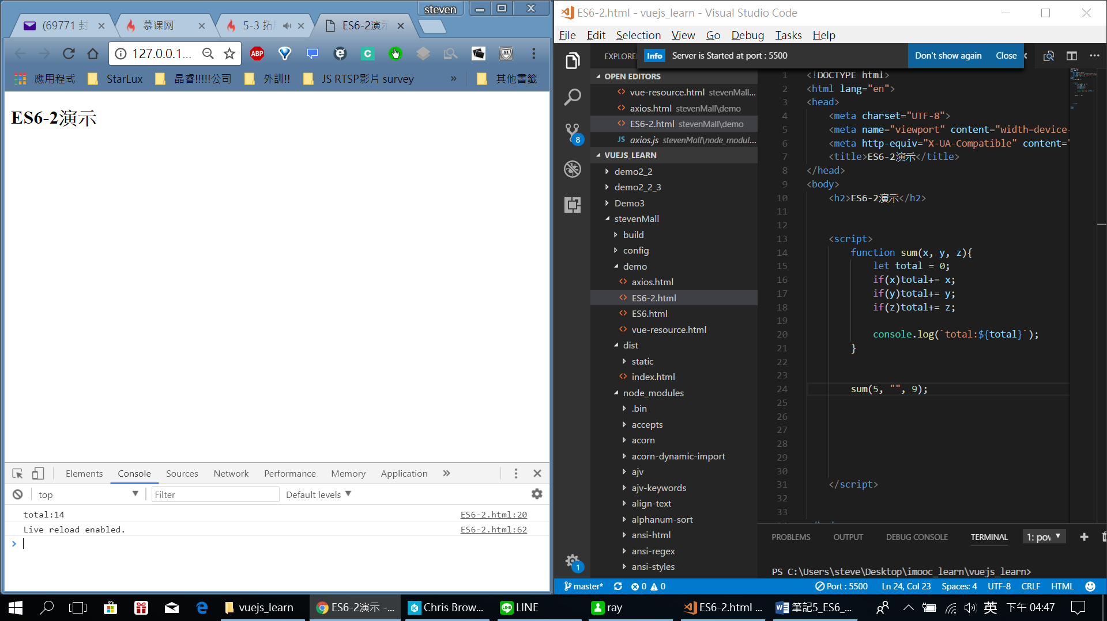

2. 可以用of 遍歷

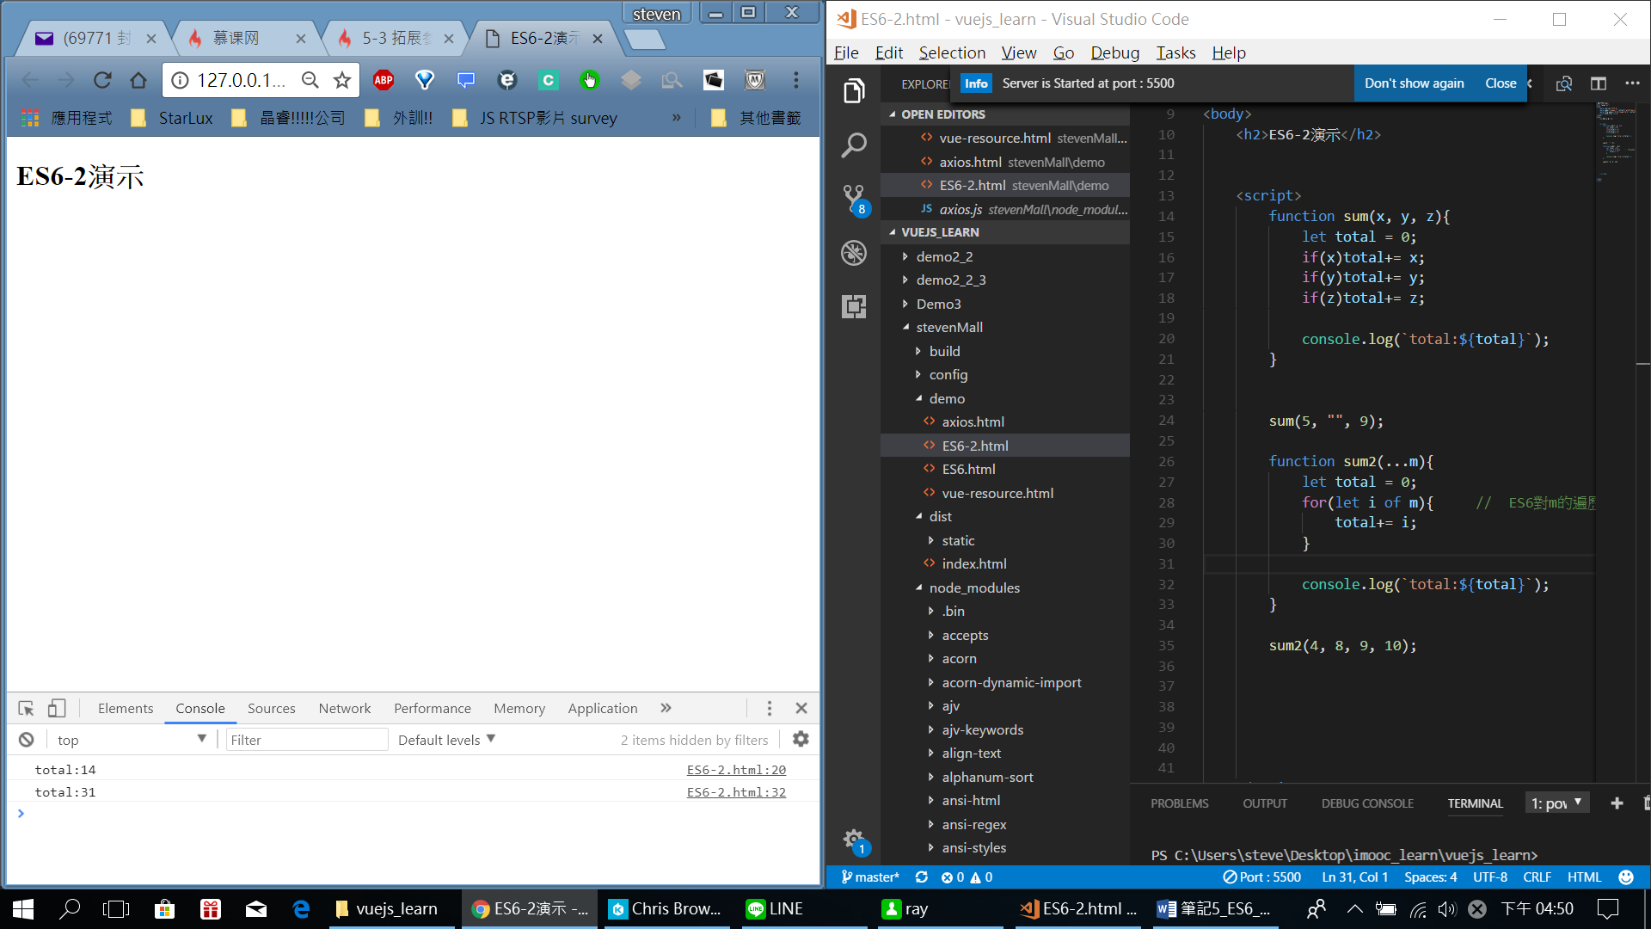

3. 可再改成箭頭函數:

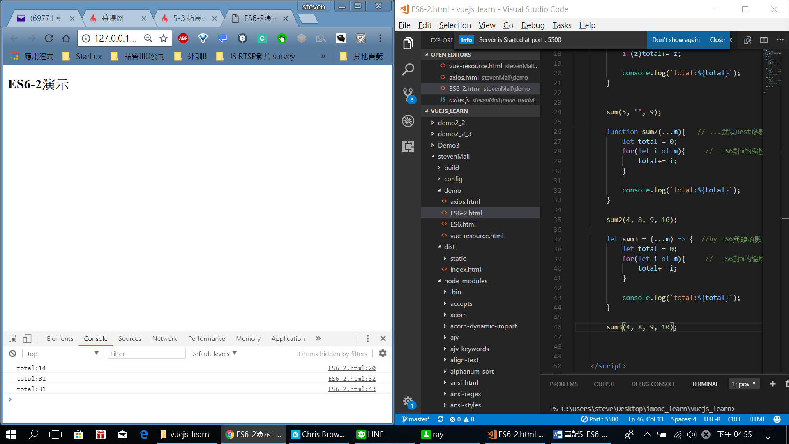

<函數擴展>

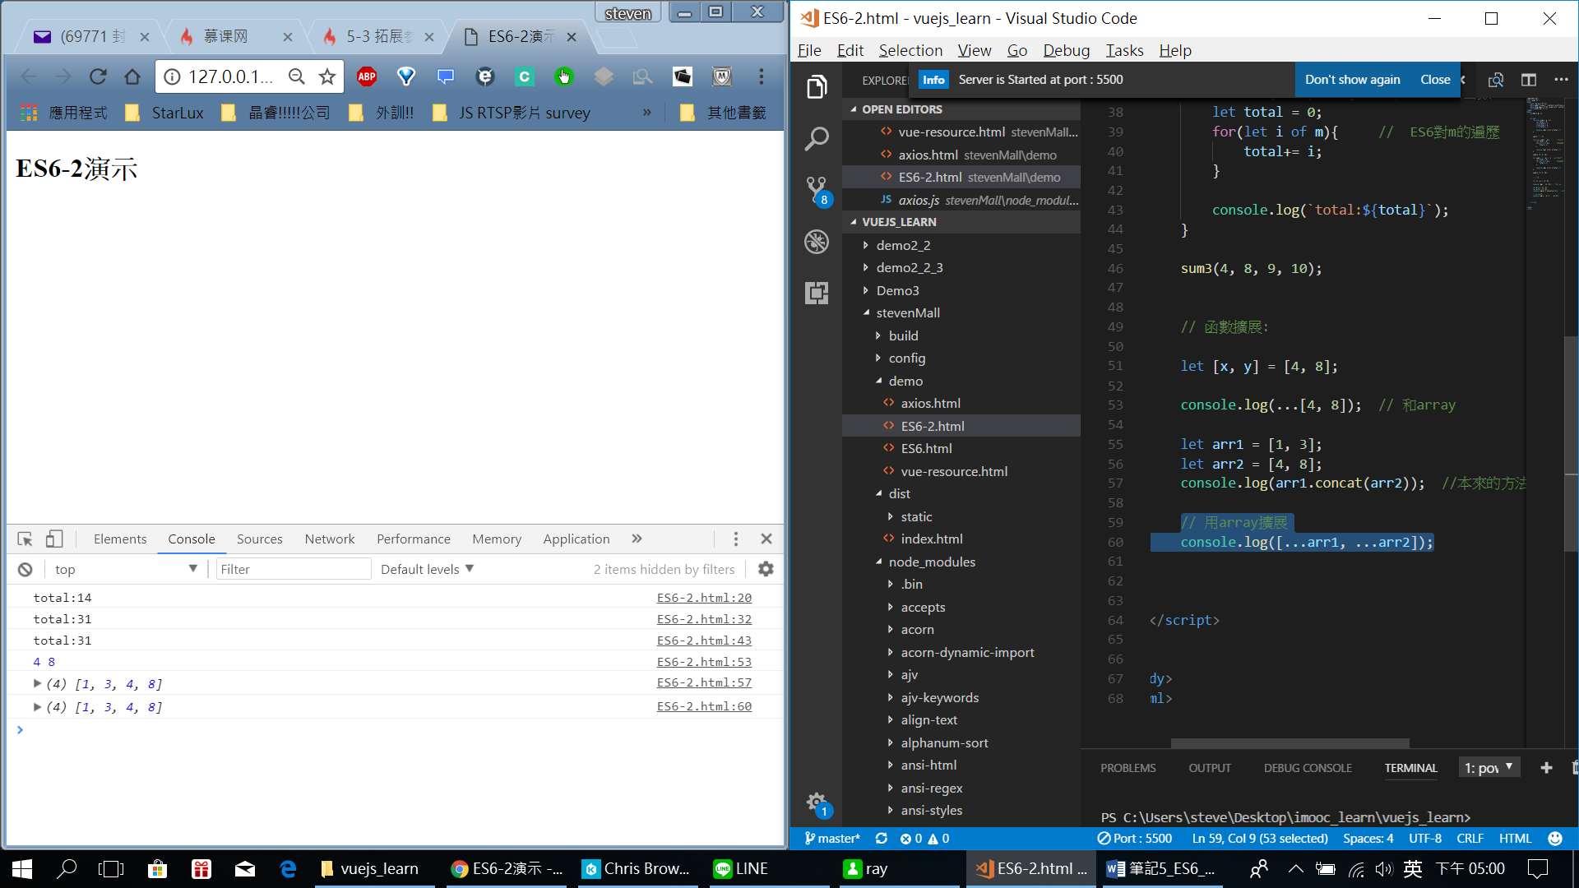

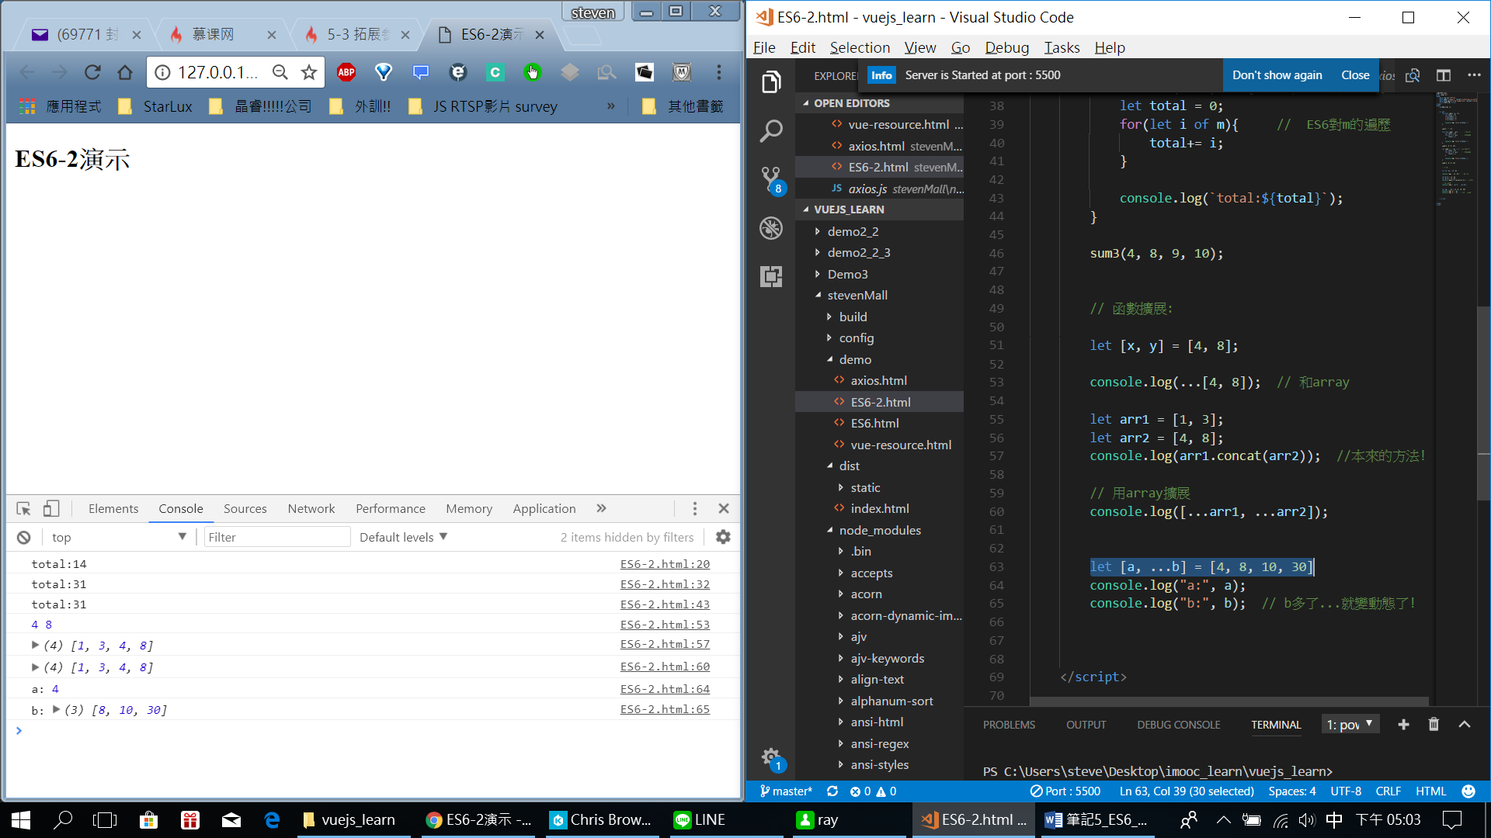

//

let [d, e, f] = "ES6"

console.log("d:", d);

console.log("e:", e);

console.log("f:", f);

let xy = [...'ES6']

console.log(xy);

