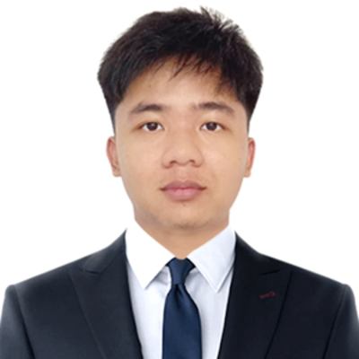

Steven Lansangan | 09293582825 | vastevenlansangan@gmail.com

# About me

AI Software Engineer

# Work Experience

**JC Industries** *2025 - 2025*AI/ML developer

# Skills

* Python
* AI/ML
* Deep learning