- 前期将源文件所有可能用到的信息做进去，每导入不同的源文件，自动保存之前的源文件模板，以源文件名存储，可在下拉菜单中选取或新导入；每导入不同的材料表文件，自动删除前一次导入的材料表信息。
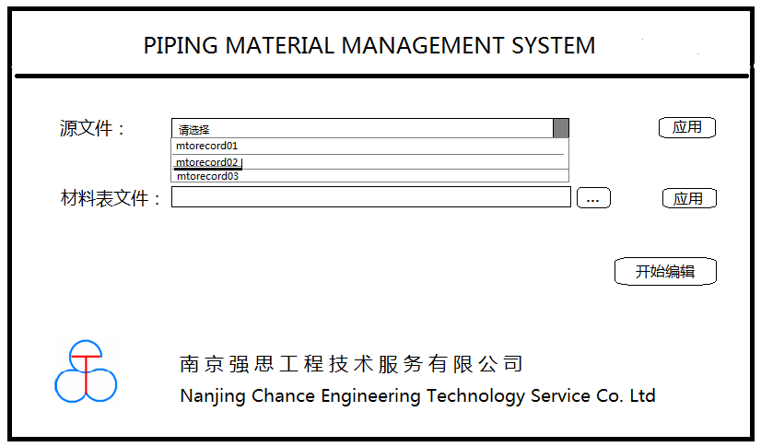
- 点击‘开始编辑’自动打开进入一个空EXCEL，在EXCEL中会出现材料整理插件PMMS。
- 分类下拉菜单会出现之前导入的信息分类，该分类由源文件决定。
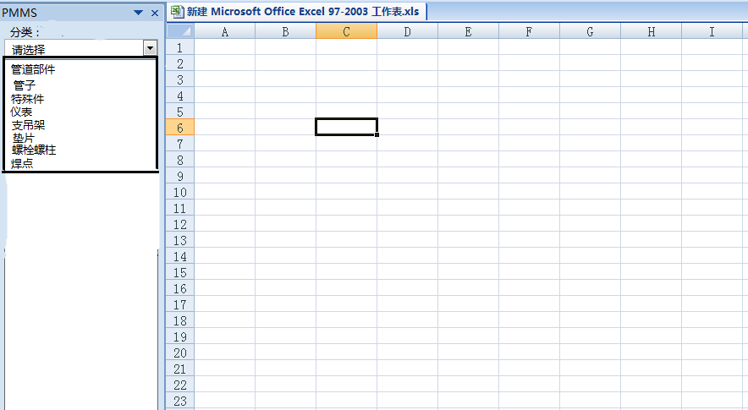
- 选择一种分类，展开部件信息，按照①②③顺序放置所需关联，点击‘材料生成’，则右侧自动生成所需材料信息。
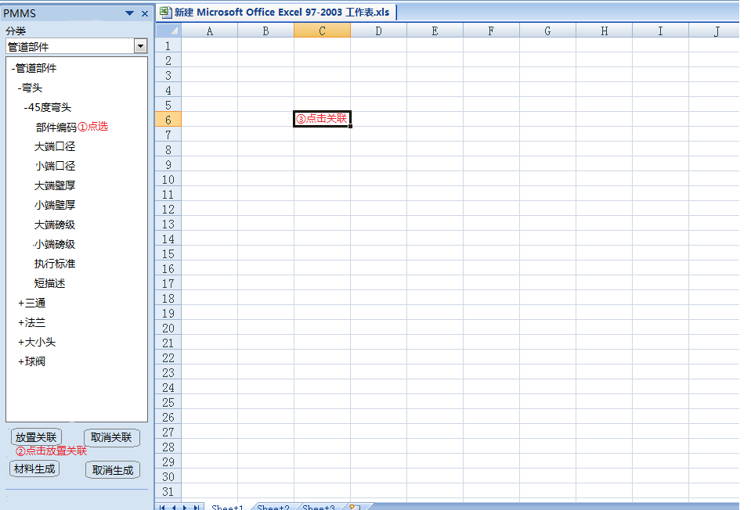

源文件具体释义如下：
COMMON_RECORD_DATA
①，②，③，④，⑤
1.①只有12，-1，-2这三种情况，当①为12时，则②指定的是table12表中某一属性（详见table12表），以对应属性前面数字代号表示。
2.当①为-1时，则②对应以下属性，以对应数字代号表示：
1------component occurrence number
2------segment occurrence number
3------commodity code
4------commodity item material description
5------record type （required）注一
6------reserved for later use
7------file units 注二
8------specialty item material description
9------instrument item material description
10----pipe support item material description
11----generated item material description
12----dry component center of gravity X coordinate
reported in sub-units
13----dry component center of gravity Y coordinate
reported in sub-units
14----dry component center of gravity Z coordinate
reported in sub-units
15----wet component center of gravity X coordinate
reported in sub-units
16----wet component center of gravity Y coordinate
reported in sub-units
17----wet component center of gravity Z coordinate
reported in sub-units
18----model name
19----area name
20----partition number
3.当①为-2时，则②对应以下属性，以对应数字代号表示：
1------piping area
2------primary line ID
3------secondary line ID 1
4------secondary line ID 2
5------drawing number
6------batch reference
7------iso file name
8------model status code
9------model revised date
10----current extraction date
11----current extraction number
12----number of sheets from previous extraction
13----date MTO neutral file was generated
14----date MTO was sent for Material Control
15----current revision number
16----current revision block revision number
17----current revision block By initials
18----current revision block Chk initials
19----current revision block Appv initials
20----current revision block issue date
21----current revision block extraction number
22----current revision block number of sheets
23----current revision block description
注一：record type为必须，生成在材料文件中，释义如下：
COMP------commodity items
PIPE---------pipe
ENGR-------specialty items
INST---------instruments
SUPP--------pipe supports
GASK--------gaskets
BOLT---------bolts
WELD--------welds
GENR---------generated items
注二：file units生成在材料文件中（若需要），释义如下：
ENGL------English units
MIX--------mixed units
METR------all Metric units
4.③表示某属性信息在材料文件中的放置起始位置（从0开始）。
5.④表示定义某属性信息在材料文件中的字符长度。
6.⑤在正常情况下为0，特殊情况⑤为1时，则输出在材料文件中的是对应属性的序号。
COMPONENT_ATTRIBUTES
样式：①，②，③，④，⑤，⑥，⑦，⑧，⑨，⑩，⑪， ⑫， ⑬ ，⑭
- ①和②，③和④，⑤和⑥，⑦和⑧，⑨和⑩成对起作用
- ①的有效值只有0，12或34，当①为0时表示不起作用；当①为12时，则②是对应table12表中某一属性（详见table12表），以对应数字表示；当①为34时，则②是对应table34表中某一属性（详见table34表），以对应数字表示；此①和②对应生成的是COMP信息。
- ③的有效值只有0，12或34，当③为0时表示不起作用；当③为12时，则④是对应table12表中某一属性（详见table12表），以对应数字表示；当③为34时，则②是对应table34表中某一属性（详见table34表），以对应数字表示；此③和④对应生成的是ENGR信息。
- ⑤的有效值只有0，12或50，当⑤为0时表示不起作用；当⑤为12时，则⑥是对应table12表中某一属性（详见table12表），以对应数字表示；当⑤为50时，则⑥是对应table50表中某一属性（详见table50表），以对应数字表示；此⑤和⑥对应生成的是PIPE信息。
- ⑦的有效值只有0，12或67，当⑦为0时表示不起作用；当⑦为12时，则⑧是对应table67表中某一属性（详见table67表），以对应数字表示；当⑦为67时，则⑧是对应table67表中某一属性（详见table67表），以对应数字表示；此⑦和⑧对应生成的是INST信息。
- ⑨的有效值只有0，12或80，当⑨为0时表示不起作用；当⑨为12时，则⑩是对应table80表中某一属性（详见table80表），以对应数字表示；当⑨为80时，则⑩是对应table80表中某一属性（详见table80表），以对应数字表示；此⑨和⑩对应生成的是SUPP信息。
- ⑪在正常情况下有0，1或2这三种，当⑪为0时，则输出属性由①到⑩控制；当⑪为1时，其获取的是连接点大端属性，且①③⑤⑦⑨须全为0，②④⑥⑧⑩对应以下属性，以对应数字表示；当⑪为2时，其获取的是连接点小端属性，且①③⑤⑦⑨须全为0，②④⑥⑧⑩对应以下属性，以对应数字表示。
1------nominal piping diameter
2------outside diameter
3------end preparation
4------schedule thickness
5------pressure rating
6------stress analysis node number
7------face-to-center distance/pipe length
8------weld number
9------weld type
10----gasket gap
11----stress intensification factor
12----head loss factor
13----inspection number
- ⑫表示某属性信息在材料文件中的放置起始位置。
- ⑬表示定义某属性信息在材料文件中的字符长度。
- ⑭在正常情况下为0，特殊情况⑭为1时，则输出在材料文件中的是对应属性的序号。
IMPLIED_ITEMS
样式：①，②，③，④，⑤，⑥，⑦，⑧，⑨，⑩，⑪， ⑫， ⑬ ，⑭
- ②和③，④和⑤，⑥和⑦，⑧和⑨成对起作用。
- ①表示输出隐含材料的类型，对应一下属性，以对应数字表示：
1------Gaskets only
2------Bolts only
3------Welds only
4------All of the above items
- ②的有效值只有0，12或34，当②为0时表示不起作用；当②为12时，则③是对应table12表中某一属性（详见table12表），以对应数字表示；当②为34时，则③是对应table34表中某一属性（详见table34表），以对应数字表示；此②和③对应生成的是COMP和ENGR的隐含材料信息。
- ④的有效值只有0，12或50，当④为0时表示不起作用；当④为12时，则⑤是对应table12表中某一属性（详见table12表），以对应数字表示；当④为50时，则⑤是对应table50表中某一属性（详见table50表），以对应数字表示；此④和⑤对应生成的是PIPE的隐含材料信息。
- ⑥的有效值只有0，12或67，当⑥为0时表示不起作用；当⑥为12时，则⑦是对应table12表中某一属性（详见table12表），以对应数字表示；当⑥为67时，则⑦是对应table67表中某一属性（详见table67表），以对应数字表示；此⑥和⑦对应生成的是INST的隐含材料信息。
- ⑧的有效值只有0或202，当⑧为0时表示不起作用；当⑧为202时，则⑨是对应table202表中某一属性（详见table202表），以对应数字表示。
- ⑩在正常情况下只有0或1，当⑩为0时表示不起作用，当⑩为1时表示输出信息为相应连接点的隐含材料属性，且②④⑥须为0，③⑤⑦对应以下属性，以相应数字表示：
1------nominal piping diameter
2------outside diameter
3------end preparation
4------schedule thickness
5------pressure rating
6------stress analysis node number
7------face-to-center distance/pipe length
8------weld number
9------weld type
10----gasket gap
11----stress intensification factor
12----head loss factor
13----inspection number
- ⑪只有以下这些可能，当⑪为-1时，⑧和⑨起作用；当该行输出的是BOLT属性时，则⑪对应以下属性，以相应数字表示：
1------Number of bolts
2------Bolt length in Project Units
3------Bolt diameter
4------Number of nuts
5------Bolt diameter in English Units
6------Bolt length in English Units
7------Bolt weight in English Units (pounds)
8------Bolt weight in English Units (kilograms)
当该行输出的是WELD属性时，则⑪对应以下属性，以相应数字表示：
1------Weld ID number
2------Weld Type
3------Material A
4------Material B
当⑪为0时，表示输出GASKET属性。
- ⑫表示某属性信息在材料文件中的放置起始位置。
- ⑬表示定义某属性信息在材料文件中的字符长度。
- ⑭在正常情况下为0，特殊情况⑭为1时，则输出在材料文件中的是对应属性的序号。
GENERATED_ITEMS
同COMPONENT_ATTRIBUTES

源文件样板如下：
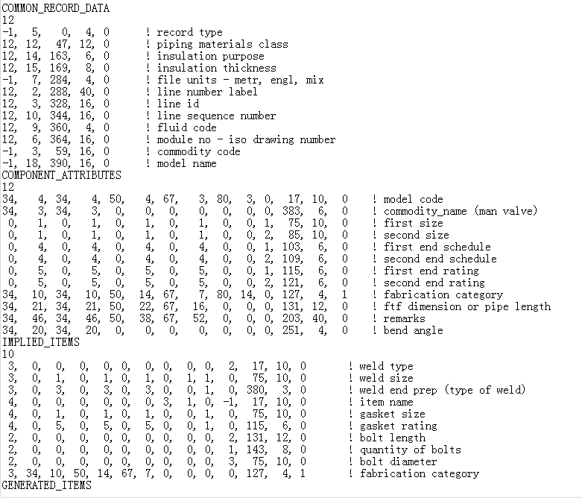
Table12表如下：
1 | , | system_unique_no | , | integer
2 | , | line_number_label | , | character(40)
3 | , | line_id | , | character(24)
4 | , | unit_number | , | character(12)
5 | , | unit_code | , | character(3)
6 | , | module_no | , | character(16)
7 | , | package_system_no | , | character(12)
8 | , | train_number | , | character(2)
9 | , | fluid_code | , | short
10 | , | line_sequence_no | , | character(16)
11 | , | nominal_piping_dia | , | short
12 | , | piping_mater_class | , | character(16)
13 | , | gasket_separation | , | character(8)
14 | , | insulation_purpose | , | short
15 | , | insulation_thick | , | double
16 | , | insulation_density | , | double
17 | , | heat_tracing_reqmt | , | short
18 | , | heat_tracing_media | , | short
19 | , | heat_tracing_temp | , | double
20 | , | construction_stat | , | short
21 | , | hold_status | , | short
22 | , | approval_status | , | short
23 | , | schedule_override | , | character(8)
24 | , | nor_oper_pres | , | double
25 | , | nor_oper_temp | , | double
26 | , | alt_oper_pres | , | double
27 | , | alt_oper_temp | , | double
28 | , | nor_dgn_pres | , | double
29 | , | nor_dgn_temp | , | double
30 | , | alt_dgn_pres | , | double
31 | , | alt_dgn_temp | , | double
32 | , | steam_outlet_temp | , | double
33 | , | mater_of_construct | , | character(6)
34 | , | safety_class | , | short
35 | , | design_standard | , | short
36 | , | design_area_number | , | character(10)
37 | , | design_resp | , | short
38 | , | construction_resp | , | short
39 | , | supply_resp | , | short
40 | , | coating_reqmts | , | short
41 | , | cleaning_reqmts | , | short
42 | , | fluid_category | , | character(4)
43 | , | nor_op_pres_units | , | short
44 | , | nor_op_temp_units | , | short
45 | , | alt_op_pres_units | , | short
46 | , | alt_op_temp_units | , | short
47 | , | nor_dgn_pres_units | , | short
48 | , | nor_dgn_temp_units | , | short
49 | , | alt_dgn_pres_units | , | short
50 | , | alt_dgn_temp_units | , | short
51 | , | steam_temp_units | , | short
52 | , | stress_system_no | , | character(12)
53 | , | stress_reqmts | , | short
54 | , | hyd_system_no | , | character(12)
55 | , | hyd_reqmts | , | short
56 | , | specific_gravity_a | , | double
57 | , | specific_gravity_b | , | double
58 | , | specific_gravity_c | , | double
59 | , | viscosity | , | double
60 | , | density | , | double
61 | , | spec_heat_ratio | , | double
62 | , | sonic_velocity | , | double
63 | , | surface_roughness | , | double
64 | , | test_system_no | , | character(6)
65 | , | test_fluid | , | short
66 | , | test_pressure | , | double
67 | , | PID_id_part_a | , | character(4)
68 | , | PID_id_part_b | , | character(4)
69 | , | end_1_nozzle_id | , | integer
70 | , | end_2_nozzle_id | , | integer
71 | , | alpha_descript_id | , | character(12)
72 | , | standard_note_no | , | short
73 | , | pid_index_no | , | integer
74 | , | color_code | , | character(8)
75 | , | inspection_iso_id | , | character(24)
76 | , | index_to_pi_dwg | , | integer
77 | , | weld_id | , | character(80)
78 | , | sppid_piperun_guid | , | character(32)
79 | , | sppid_drawing_guid | , | character(32)
table34表如下：
1 | , | system_unique_no | , | integer
2 | , | piping_comp_no | , | character(20)
3 | , | commodity_name | , | character(6)
4 | , | model_code | , | character(6)
5 | , | option_code | , | short
6 | , | maximum_temp | , | double
7 | , | sched_thick_basis | , | character(8)
8 | , | commodity_code | , | character(16)
9 | , | MTO_requirements | , | short
10 | , | fabrication_cat | , | short
11 | , | source_of_data | , | short
12 | , | PDS_sort_code | , | character(6)
13 | , | physical_data_id | , | character(8)
14 | , | geometric_standard | , | short
15 | , | weight_code | , | short
16 | , | table_suffix_green | , | short
17 | , | table_suffix_red | , | short
18 | , | materials_grade | , | short
19 | , | bend_radius | , | double
20 | , | bend_angle | , | double
21 | , | face_to_face_dim | , | double
22 | , | dimension_a | , | double
23 | , | dimension_b | , | double
24 | , | dimension_c | , | double
25 | , | surface_area | , | double
26 | , | empty_weight | , | double
27 | , | water_weight | , | double
28 | , | operator_weight | , | double
29 | , | operator_sym_name | , | character(6)
30 | , | chain_operator_no | , | short
31 | , | opening_action | , | short
32 | , | construction_stat | , | short
33 | , | hold_status | , | short
34 | , | heat_tracing_reqmt | , | short
35 | , | heat_tracing_media | , | short
36 | , | heat_tracing_temp | , | double
37 | , | iso_dwg_index_no | , | integer
38 | , | isometric_sheet_no | , | character(2)
39 | , | piece_mark_no | , | character(60)
40 | , | color_code | , | character(8)
41 | , | stress_node_no | , | short
42 | , | stress_intens_fact | , | double
43 | , | head_loss_factor | , | double
44 | , | piping_assembly | , | character(12)
45 | , | component_group_no | , | short
46 | , | remarks | , | character(50)
47 | , | standard_note_no_a | , | short
48 | , | standard_note_no_b | , | short
49 | , | cp_1_nom_pipe_diam | , | short
50 | , | cp_1_outside_diam | , | double
51 | , | cp_1_end_prep | , | short
52 | , | cp_1_sch_thk | , | character(8)
53 | , | cp_1_rating | , | character(8)
54 | , | cp_1_face_to_ctr | , | double
55 | , | cp_1_weld_no | , | character(8)
56 | , | cp_1_weld_type | , | short
57 | , | cp_1_gasket_gap | , | double
58 | , | cp_1_gasket_option | , | short
59 | , | cp_1_stress_node | , | short
60 | , | cp_1_stress_factor | , | double
61 | , | cp_1_head_loss | , | double
62 | , | cp_2_nom_pipe_diam | , | short
63 | , | cp_2_outside_diam | , | double
64 | , | cp_2_end_prep | , | short
65 | , | cp_2_sch_thk | , | character(8)
66 | , | cp_2_rating | , | character(8)
67 | , | cp_2_face_to_ctr | , | double
68 | , | cp_2_weld_no | , | character(8)
69 | , | cp_2_weld_type | , | short
70 | , | cp_2_gasket_gap | , | double
71 | , | cp_2_gasket_option | , | short
72 | , | cp_2_stress_node | , | short
73 | , | cp_2_stress_factor | , | double
74 | , | cp_2_head_loss | , | double
75 | , | cp_3_nom_pipe_diam | , | short
76 | , | cp_3_outside_diam | , | double
77 | , | cp_3_end_prep | , | short
78 | , | cp_3_sch_thk | , | character(8)
79 | , | cp_3_rating | , | character(8)
80 | , | cp_3_face_to_ctr | , | double
81 | , | cp_3_weld_no | , | character(8)
82 | , | cp_3_weld_type | , | short
83 | , | cp_3_gasket_gap | , | double
84 | , | cp_3_gasket_option | , | short
85 | , | cp_3_stress_node | , | short
86 | , | cp_3_stress_factor | , | double
87 | , | cp_3_head_loss | , | double
88 | , | cp_4_nom_pipe_diam | , | short
89 | , | cp_4_outside_diam | , | double
90 | , | cp_4_end_prep | , | short
91 | , | cp_4_sch_thk | , | character(8)
92 | , | cp_4_rating | , | character(8)
93 | , | cp_4_face_to_ctr | , | double
94 | , | cp_4_weld_no | , | character(8)
95 | , | cp_4_weld_type | , | short
96 | , | cp_4_gasket_gap | , | double
97 | , | cp_4_gasket_option | , | short
98 | , | cp_4_stress_node | , | short
99 | , | cp_4_stress_factor | , | double
100 | , | cp_4_head_loss | , | double
101 | , | cp_5_nom_pipe_diam | , | short
102 | , | cp_5_outside_diam | , | double
103 | , | cp_5_end_prep | , | short
104 | , | cp_5_sch_thk | , | character(8)
105 | , | cp_5_rating | , | character(8)
106 | , | cp_5_face_to_ctr | , | double
107 | , | cp_5_weld_no | , | character(8)
108 | , | cp_5_weld_type | , | short
109 | , | cp_5_gasket_gap | , | double
110 | , | cp_5_gasket_option | , | short
111 | , | cp_5_stress_node | , | short
112 | , | cp_5_stress_factor | , | double
113 | , | cp_5_head_loss | , | double
114 | , | unique_name | , | character(12)
115 | , | vlv_operator_dim_a | , | double
116 | , | vlv_operator_dim_b | , | double
117 | , | vlv_operator_dim_c | , | double
118 | , | vlv_operator_dim_d | , | double
119 | , | last_placed_date | , | integer
120 | , | generic_comp_no | , | character(20)
121 | , | inspection_key | , | short
122 | , | cp_1_inspect_key | , | short
123 | , | cp_2_inspect_key | , | short
124 | , | cp_3_inspect_key | , | short
125 | , | cp_4_inspect_key | , | short
126 | , | cp_5_inspect_key | , | short
Table50表如下：
1 | , | system_unique_no | , | integer
2 | , | piping_comp_no | , | character(20)
3 | , | commodity_name | , | character(6)
4 | , | model_code | , | character(6)
5 | , | option_code | , | short
6 | , | maximum_temp | , | double
7 | , | nominal_piping_dia | , | short
8 | , | outside_diameter | , | double
9 | , | schedule_thickness | , | character(8)
10 | , | sched_thick_basis | , | character(8)
11 | , | rating | , | character(8)
12 | , | commodity_code | , | character(16)
13 | , | MTO_requirements | , | short
14 | , | fabrication_cat | , | short
15 | , | source_of_data | , | short
16 | , | PDS_sort_code | , | character(6)
17 | , | geometric_standard | , | short
18 | , | weight_code | , | short
19 | , | table_suffix_green | , | short
20 | , | table_suffix_red | , | short
21 | , | materials_grade | , | short
22 | , | pipe_length | , | double
23 | , | surface_area | , | double
24 | , | empty_weight | , | double
25 | , | water_weight | , | double
26 | , | cold_spring_length | , | double
27 | , | construction_stat | , | short
28 | , | hold_status | , | short
29 | , | heat_tracing_reqmt | , | short
30 | , | heat_tracing_media | , | short
31 | , | heat_tracing_temp | , | double
32 | , | iso_dwg_index_no | , | integer
33 | , | isometric_sheet_no | , | character(2)
34 | , | piece_mark_no | , | character(60)
35 | , | color_code | , | character(8)
36 | , | piping_assembly | , | character(12)
37 | , | component_group_no | , | short
38 | , | remarks | , | character(50)
39 | , | standard_note_no_a | , | short
40 | , | standard_note_no_b | , | short
41 | , | end_1_end_prep | , | short
42 | , | end_1_weld_no | , | character(8)
43 | , | end_1_weld_type | , | short
44 | , | end_1_gasket_gap | , | double
45 | , | end_1_gasket_opt | , | short
46 | , | end_1_stress_node | , | short
47 | , | end_1_stres_int | , | double
48 | , | end_1_head_loss | , | double
49 | , | end_2_end_prep | , | short
50 | , | end_2_weld_no | , | character(8)
51 | , | end_2_weld_type | , | short
52 | , | end_2_gasket_gap | , | double
53 | , | end_2_gasket_opt | , | short
54 | , | end_2_stress_node | , | short
55 | , | end_2_stres_int | , | double
56 | , | end_2_head_loss | , | double
57 | , | unique_name | , | character(12)
58 | , | last_placed_date | , | integer
59 | , | inspection_key | , | short
60 | , | end_1_inspect_key | , | short
61 | , | end_2_inspect_key | , | short
Table67表如下：
1 | , | system_unique_no | , | integer
2 | , | instrument_comp_no | , | character(20)
3 | , | model_code | , | character(6)
4 | , | option_code | , | short
5 | , | sched_thick_basis | , | character(8)
6 | , | MTO_requirements | , | short
7 | , | fabrication_cat | , | short
8 | , | source_of_data | , | short
9 | , | PDS_sort_code | , | character(6)
10 | , | physical_data_id | , | character(8)
11 | , | geometric_standard | , | short
12 | , | weight_code | , | short
13 | , | table_suffix_green | , | short
14 | , | table_suffix_red | , | short
15 | , | materials_grade | , | short
16 | , | face_to_face_dim | , | double
17 | , | dimension_a | , | double
18 | , | dimension_b | , | double
19 | , | dimension_c | , | double
20 | , | surface_area | , | double
21 | , | empty_weight | , | double
22 | , | water_weight | , | double
23 | , | operator_weight | , | double
24 | , | operator_type | , | double
25 | , | operator_sym_name | , | character(6)
26 | , | chain_operator_no | , | short
27 | , | chain_length | , | double
28 | , | opening_action | , | short
29 | , | construction_stat | , | short
30 | , | hold_status | , | short
31 | , | design_resp | , | short
32 | , | construction_resp | , | short
33 | , | heat_tracing_reqmt | , | short
34 | , | heat_tracing_media | , | short
35 | , | heat_tracing_temp | , | double
36 | , | insulation_purpose | , | short
37 | , | insulation_thick | , | double
38 | , | insulation_density | , | double
39 | , | cleaning_reqmts | , | short
40 | , | safety_class | , | short
41 | , | module_no | , | character(16)
42 | , | package_system_no | , | character(12)
43 | , | iso_dwg_index_no | , | integer
44 | , | isometric_sheet_no | , | character(2)
45 | , | piece_mark_no | , | character(60)
46 | , | color_code | , | character(8)
47 | , | stress_node_no | , | short
48 | , | stress_intens_fact | , | double
49 | , | head_loss_factor | , | double
50 | , | piping_assembly | , | character(12)
51 | , | component_group_no | , | short
52 | , | remarks | , | character(50)
53 | , | standard_note_no_a | , | short
54 | , | standard_note_no_b | , | short
55 | , | cp_1_nom_pipe_diam | , | short
56 | , | cp_1_outside_diam | , | double
57 | , | cp_1_end_prep | , | short
58 | , | cp_1_sch_thk | , | character(8)
59 | , | cp_1_rating | , | character(8)
60 | , | cp_1_face_to_ctr | , | double
61 | , | cp_1_weld_no | , | character(8)
62 | , | cp_1_weld_type | , | short
63 | , | cp_1_gasket_gap | , | double
64 | , | cp_1_gasket_option | , | short
65 | , | cp_1_stress_node | , | short
66 | , | cp_1_stress_factor | , | double
67 | , | cp_1_head_loss | , | double
68 | , | cp_2_nom_pipe_diam | , | short
69 | , | cp_2_outside_diam | , | double
70 | , | cp_2_end_prep | , | short
71 | , | cp_2_sch_thk | , | character(8)
72 | , | cp_2_rating | , | character(8)
73 | , | cp_2_face_to_ctr | , | double
74 | , | cp_2_weld_no | , | character(8)
75 | , | cp_2_weld_type | , | short
76 | , | cp_2_gasket_gap | , | double
77 | , | cp_2_gasket_option | , | short
78 | , | cp_2_stress_node | , | short
79 | , | cp_2_stress_factor | , | double
80 | , | cp_2_head_loss | , | double
81 | , | cp_3_nom_pipe_diam | , | short
82 | , | cp_3_outside_diam | , | double
83 | , | cp_3_end_prep | , | short
84 | , | cp_3_sch_thk | , | character(8)
85 | , | cp_3_rating | , | character(8)
86 | , | cp_3_face_to_ctr | , | double
87 | , | cp_3_weld_no | , | character(8)
88 | , | cp_3_weld_type | , | short
89 | , | cp_3_gasket_gap | , | double
90 | , | cp_3_gasket_option | , | short
91 | , | cp_3_stress_node | , | short
92 | , | cp_3_stress_factor | , | double
93 | , | cp_3_head_loss | , | double
94 | , | cp_4_nom_pipe_diam | , | short
95 | , | cp_4_outside_diam | , | double
96 | , | cp_4_end_prep | , | short
97 | , | cp_4_sch_thk | , | character(8)
98 | , | cp_4_rating | , | character(8)
99 | , | cp_4_face_to_ctr | , | double
100 | , | cp_4_weld_no | , | character(8)
101 | , | cp_4_weld_type | , | short
102 | , | cp_4_gasket_gap | , | double
103 | , | cp_4_gasket_option | , | short
104 | , | cp_4_stress_node | , | short
105 | , | cp_4_stress_factor | , | double
106 | , | cp_4_head_loss | , | double
107 | , | cp_5_nom_pipe_diam | , | short
108 | , | cp_5_outside_diam | , | double
109 | , | cp_5_end_prep | , | short
110 | , | cp_5_sch_thk | , | character(8)
111 | , | cp_5_rating | , | character(8)
112 | , | cp_5_face_to_ctr | , | double
113 | , | cp_5_weld_no | , | character(8)
114 | , | cp_5_weld_type | , | short
115 | , | cp_5_gasket_gap | , | double
116 | , | cp_5_gasket_option | , | short
117 | , | cp_5_stress_node | , | short
118 | , | cp_5_stress_factor | , | double
119 | , | cp_5_head_loss | , | double
120 | , | unique_name | , | character(12)
121 | , | bend_angle | , | double
122 | , | vlv_operator_dim_a | , | double
123 | , | vlv_operator_dim_b | , | double
124 | , | vlv_operator_dim_c | , | double
125 | , | vlv_operator_dim_d | , | double
126 | , | last_placed_date | , | integer
127 | , | generic_comp_no | , | character(20)
128 | , | inspection_key | , | short
129 | , | cp_1_inspect_key | , | short
130 | , | cp_2_inspect_key | , | short
131 | , | cp_3_inspect_key | , | short
132 | , | cp_4_inspect_key | , | short
133 | , | cp_5_inspect_key | , | short
Table80表如下：
1 | , | system_unique_no | , | integer
2 | , | pipe_support_no | , | character(20)
3 | , | model_code_phy | , | character(6)
4 | , | model_code_log | , | character(6)
5 | , | iso_support_type_a | , | short
6 | , | iso_support_type_b | , | short
7 | , | iso_support_type_c | , | short
8 | , | iso_support_type_d | , | short
9 | , | details_for_shop | , | character(50)
10 | , | details_for_field | , | character(50)
11 | , | fabrication_orient | , | character(20)
12 | , | commodity_code | , | character(16)
13 | , | MTO_requirements | , | short
14 | , | fabrication_cat | , | short
15 | , | weight | , | double
16 | , | construction_stat | , | short
17 | , | hold_status | , | short
18 | , | standard_note_no | , | short
19 | , | iso_dwg_index_no | , | integer
20 | , | isometric_sheet_no | , | character(2)
21 | , | piece_mark_no | , | character(60)
22 | , | color_code | , | character(8)
23 | , | isometric_dim_a | , | double
24 | , | isometric_dim_b | , | double
25 | , | isometric_dim_c | , | double
26 | , | isometric_dim_d | , | double
27 | , | isometric_dim_e | , | double
28 | , | trans_rigidity_x | , | double
29 | , | trans_rigidity_y | , | double
30 | , | trans_rigidity_z | , | double
31 | , | rot_rigidity_x | , | double
32 | , | rot_rigidity_y | , | double
33 | , | rot_rigidity_z | , | double
34 | , | spring_gap_length | , | double
35 | , | sping_gap_direct | , | short
36 | , | number_of_springs | , | short
37 | , | last_placed_date | , | integer
38 | , | inspection_key | , | short
39 | , | mark_number | , | character(80)
40 | , | group_id | , | integer
41 | , | gang_id | , | integer
42 | , | material_grade | , | short
43 | , | weld_code | , | short
44 | , | material_index | , | character(16)
45 | , | operating_load | , | double
46 | , | installed_load | , | double
47 | , | hydrostatic_load | , | double
48 | , | total_movement_1 | , | double
49 | , | total_movement_2 | , | double
50 | , | rod_diameter | , | double
Table202表如下：
1 | , | system_unique_no | , | integer
2 | , | piping_mater_class | , | character(16)
3 | , | commodity_name | , | character(6)
4 | , | option_code | , | short
5 | , | maximum_temp | , | double
6 | , | gcp_from_nom_diam | , | short
7 | , | gcp_to_nom_diam | , | short
8 | , | gcp_end_prep | , | short
9 | , | gcp_rating | , | character(8)
10 | , | gcp_sch_thk | , | character(8)
11 | , | gcp_table_suffix | , | short
12 | , | rcp_from_nom_diam | , | short
13 | , | rcp_to_nom_diam | , | short
14 | , | rcp_end_prep | , | short
15 | , | rcp_rating | , | character(8)
16 | , | rcp_sch_thk | , | character(8)
17 | , | rcp_table_suffix | , | short
18 | , | commodity_code | , | character(16)
19 | , | model_code | , | character(6)
20 | , | PDS_sort_code | , | character(6)
21 | , | modifier | , | double
22 | , | geometric_standard | , | short
23 | , | weight_code | , | short
24 | , | fabrication_cat | , | short
25 | , | materials_grade | , | short
26 | , | standard_note_no_a | , | short
27 | , | standard_note_no_b | , | short
28 | , | input_form_type | , | short

