**Student Template for: FOOP Skills Demo Three**

**SECTION ONE: CLEARLY DOCUMENTED SOURCE CODE**

1. An algorithm provided to solve problem statement:

The user is called a customer and that person inputs their details that are relevant to this form. They then press the calculate button, which validates the form and extracts all the details inputted. It uses this to create a customer and policy and calculate the insurance premium. It will then display the insurance premium in the total textbox. If the user presses the buy Policy button you get a dialog window appearing on the screen, this gives the user an overview of all the information inputted by the user and what the total is as well as the id number. To reset the form you press the clear Form button this clears all the data previously inputted while incrementing the id number.

1. Record of comments to be used in program (please provide four examples) :

//Assigning variables to the program

//Setting up the total to appear on a text label to 2 decimal places

//Create an empty arraylist for the health conditions

//for loop

1. Printout of the final program correctly indented with comments and line numbers:

See Printed

**SECTION TWO: PROGRAM FUNCTIONALITY**

1. Please provide an appropriately cropped and resized screenshot of your **final GUI front end** program working and insert in the section below:

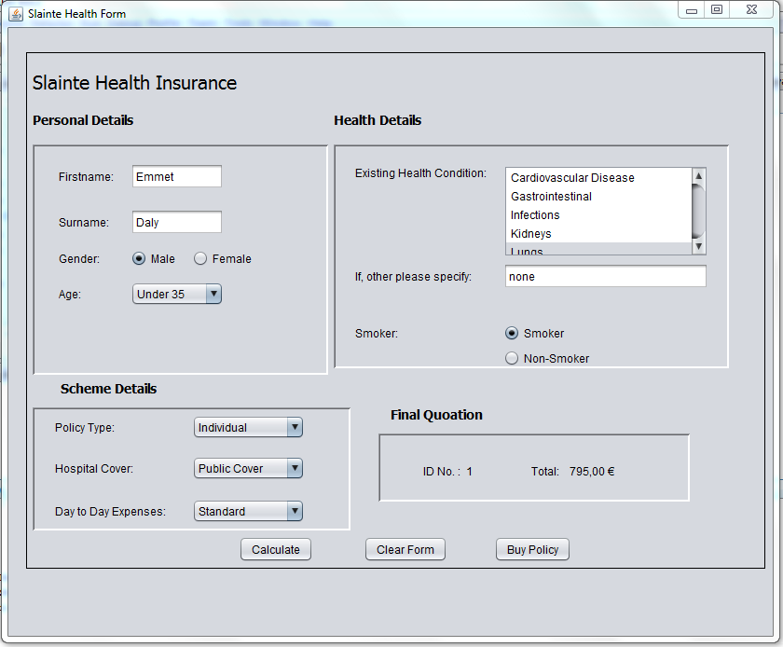

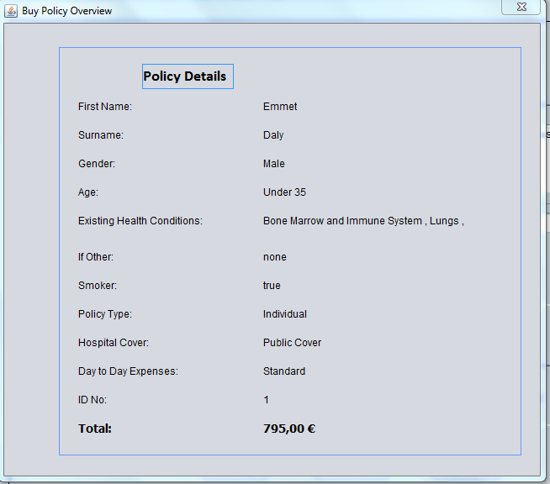

**SECTION THREE: ACCURATE PROGRAMMING (SYNTAX & SEMANTICS)**

1. Identify the IDE you used to generate your source code solution

NetBeans IDE 8.02

1. Identify any packages/ library classes accessed as appropriate

Packages- class Diagrams & slaintehealth

Slaintehealth File- Assignment.java- public class Assignment extends javax.swing.JFrame

Slaintehealth File- BuyPolicy.java- public class BuyPolicy extends javax.swing.JDialog

1. Identify all the named identifiers (classes, methods, fields/variables) in your program:
2. Insert **the UML Class Diagram** you created as part of your Software Architecture Skills Demonstrations.

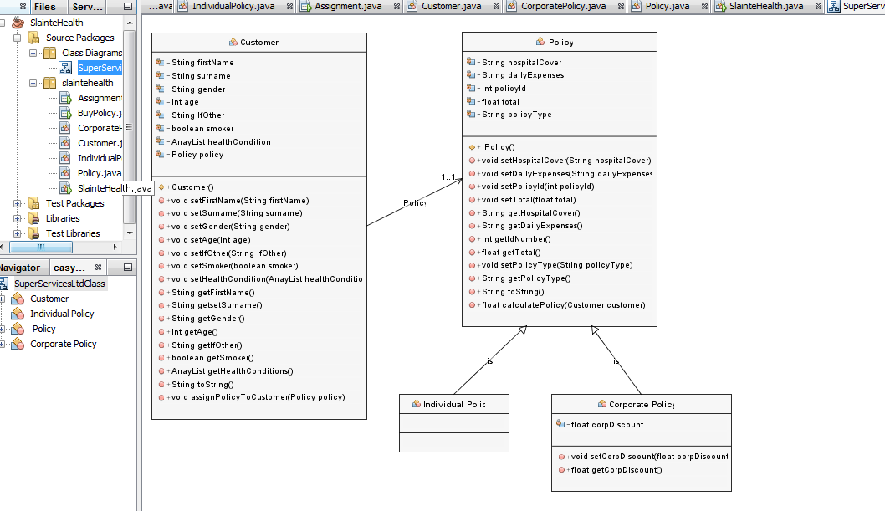

1. Identify a selection of the key variables and methods you also created for the Main GUI and Dialog forms in the table below:

|  |  |  |
| --- | --- | --- |
| **Class Name** | Assignment | BuyPolicy |
| **Variables** | String firstName = "";  String surName = "";  String ifOther = "";  String gender = "";  String ageChoice ="";  String policyCover ="";  String hospitalCover="";  String dayExpenses="";  int idNumber= 0;  String total="";  boolean smoker = false;  //ArrayList  ArrayList healthConditions = new ArrayList();  int policyId = 1;  Policy p1;  Customer c1;  boolean policyForm = false; | String health = "";  ArrayList health2 = new ArrayList();ArrayList health2 = new ArrayList();  int i = 0; |
| **Methods** | validateForm()  extractFormDetails(); | BuyPolicy  Run() |

**SECTION FOUR: EVIDENCE OF SOFTWARE TESTING/ DEBUGGING**

1. Provide a screenshot of at least one bug or problem found in your code:

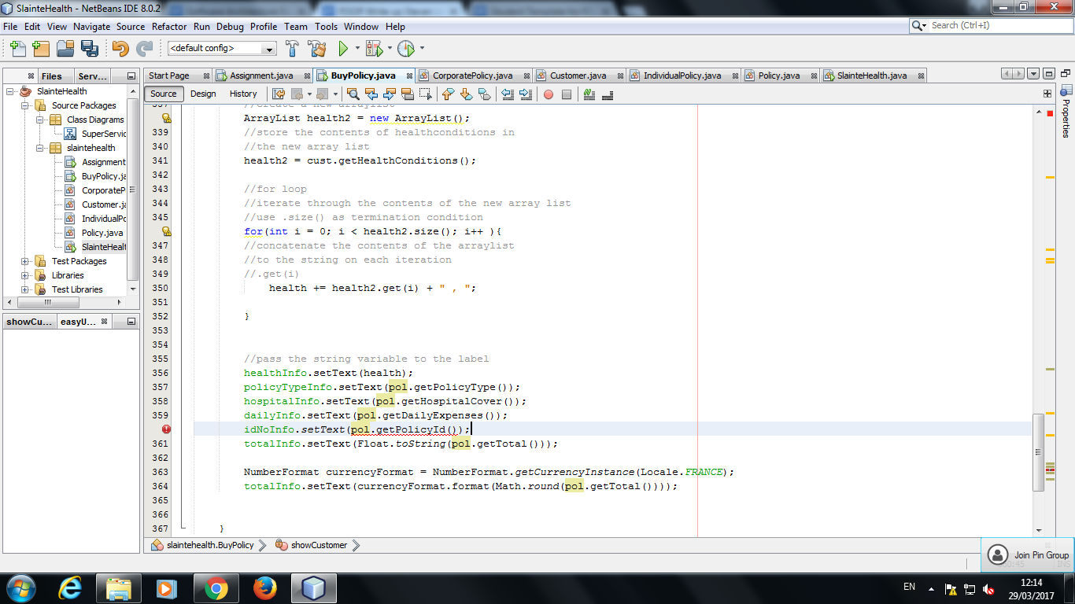

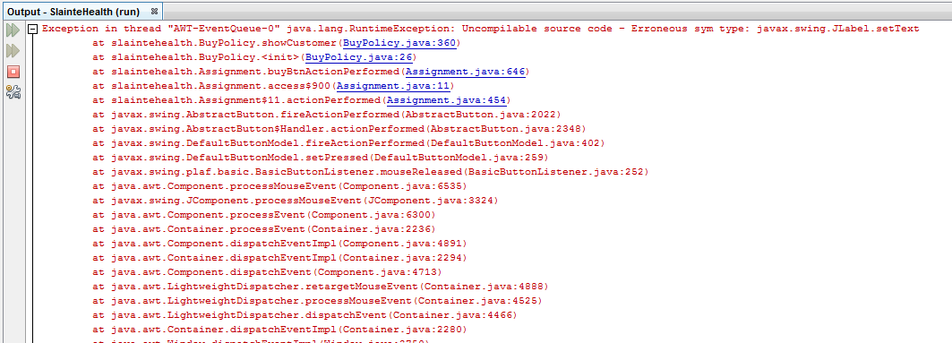

1. Briefly explain how you overcame this error:

We changed the Int variable into a String by using the Integer.toString conversion. We researched through our old programs and found a solution based on a previous GUI from.

1. Please provide **the following** screenshot(s) of your program running demonstrating the functionality required below:

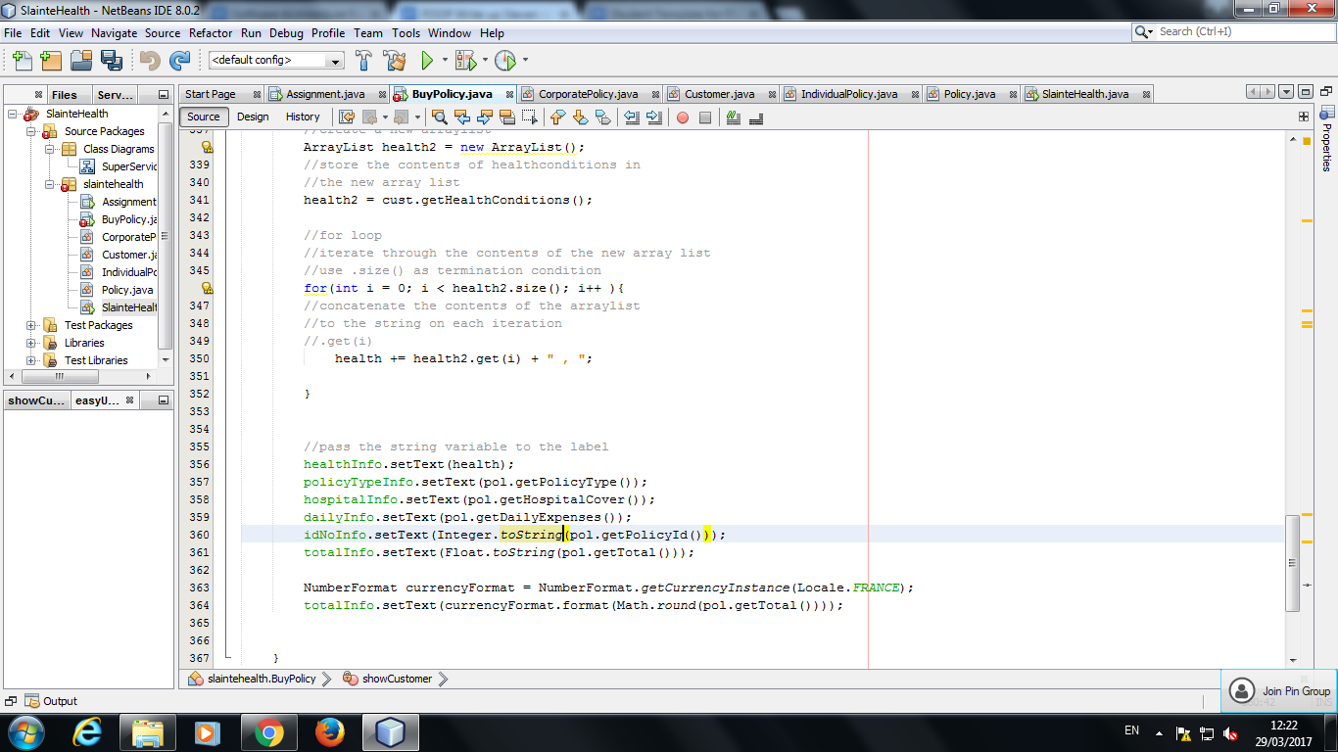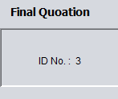

1. **Program correctly processing a calculation - Use the following test data**

**First Name:** Michelle

**Surname:** Hogan

**Gender:** Female

**Age bracket:** 56 to 70 inclusive

**Policy Type:** Corporate Policy

**Hospital Cover:** Comprehensive Hospital Cover

**Day to Day Expenses:** Comprehensive Day to Day Expenses

**Health Condition:** Kidneys

**Other:** No

**Smoker:** Yes

**Enter expected total here: € 553.00**

**Screenshot**

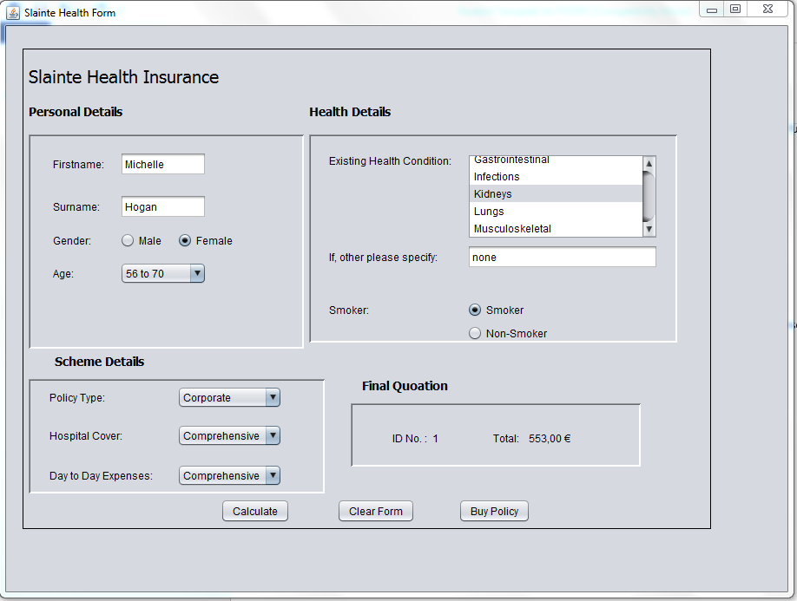

1. **Program validating missing user input**

**Screenshot**

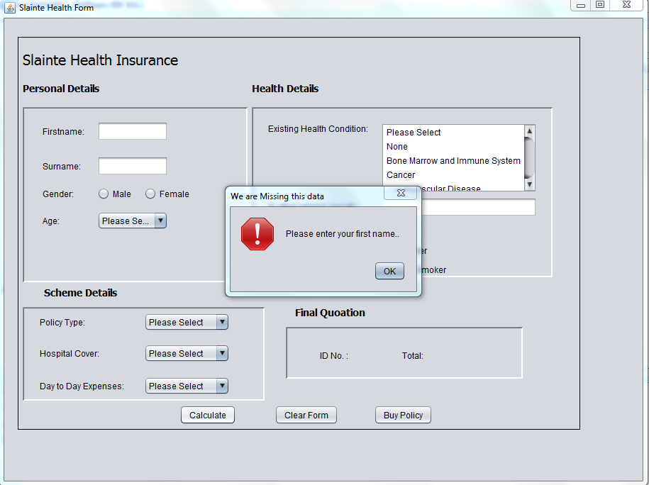

1. **Program checking user is not Over 70 years of age**

**Screenshot**

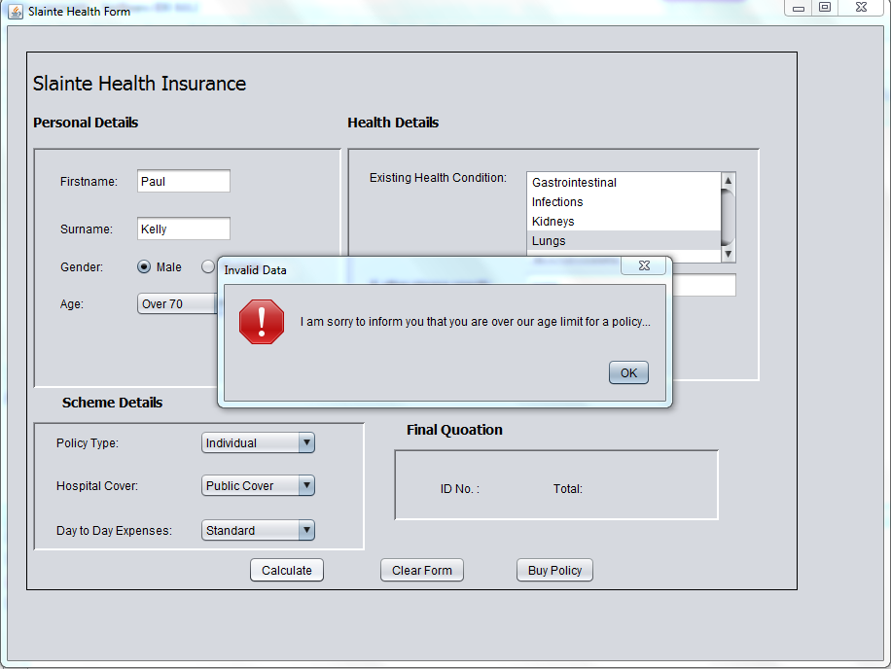

1. **Clear form functions correctly**

**Screenshot:**

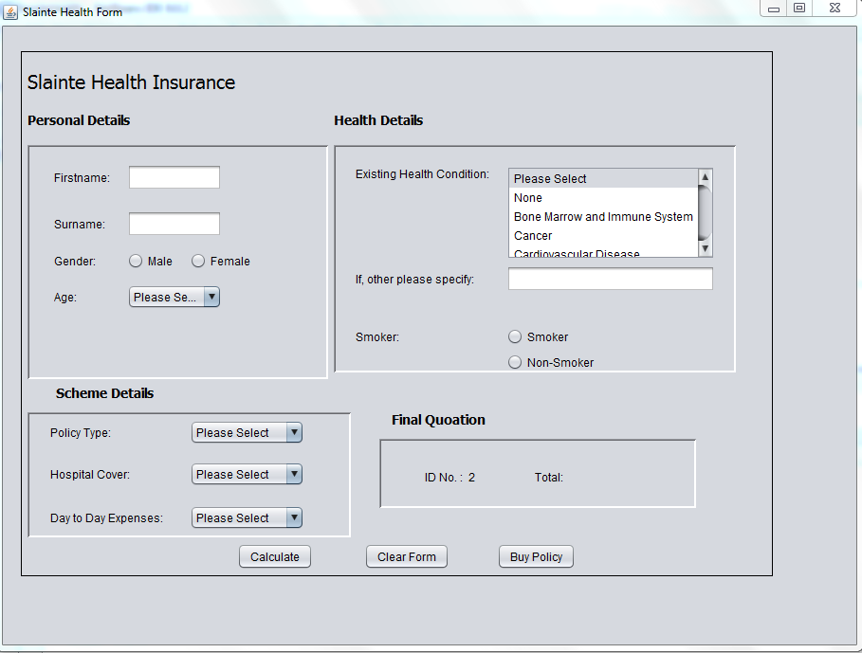

1. **Buy Policy functions correctly**

**Screenshot:**

