**Onderwijsgroep Professionele Opleidingen**

|  |
| --- |
| **Jens Van de Steen**  **Bachelor – Toegepaste Informatica**  **Internationale week** |

Academiejaar 2019 – 2020

|  |
| --- |
| **INTERNATIONAL WEEK 2TI vervangopdracht** |
|  |

Table of Contents

Introduction 3

Challenges 3

Problems/challenges I faced 3

Solutions 3

Tools 4

Tools I used 4

Experience 5

Routine 5

Classes 5

Future 5

Teamwork 6

Teamwork experience 6

Solutions, tips 6

Tips 7

Tips for Students 7

Tips for teachers 7

Social contact 8

Contact with teachers 8

Contact with students 8

Pros and cons 8

PROS 8

CONS 8

Conclusion 8

# Introduction

In this document I will discuss my personal experience from the past couple of months where we received our tutoring from an online source. I will talk about the challenges I had to face, the different tools I had to use and any difficulties I had. I will also share some tips for my fellow students and teachers, so they could improve in the event of another lockdown or online class. In the end I have some pro’s and cons about the online classes that I will share and give my conclusion on the topic.

# Challenges

## Problems/challenges I faced

The hardest challenge I faced during these hard times is to pay attention during classes. Going to classes was no problem at all, but to actively participate in them, pay attention and learn the course was much harder. Mainly because I was at home and it is easier to get distracted by many things (such as your family, friends online, ...). Being at home for such a period also gave off some kind of vacation vibe, which made it much more difficult to discipline myself to the courses since I was laxer in everything.

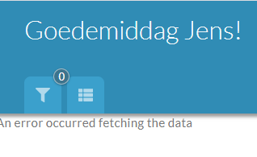Planning my schedule for when I would make what task was also a bit challenging. I had to look on Toledo most of the time or check my mail to see if I had any tasks to make. There was a new feature on Toledo which was in Beta which would solve this problem since it would display all my current tasks in a simplified dashboard, but most of the time it would not work sadly.

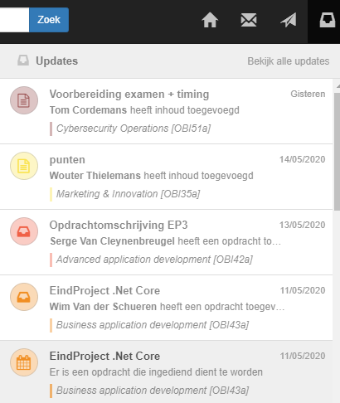Solutions  
A simple solution for helping myself to pay attention was to not participate in the classes on my PC in my room, but rather to go downstairs and participate in the classes on my laptop. That way I had less distracting stuff around me and on my pc. What also helped a lot is taking notes, which made learning the course easier.

I also checked my Odisee mail account every day, and payed extra attention to each Toledo update. That means I always knew when new tasks, course material, updates, ... were posted.

# Tools

Tools I used   
The tool I used the most was without a doubt Microsoft Teams. In the beginning I was a bit sceptic about it, but in the end, I started to love it, especially the feature that lets you take control of the PC that is sharing on Teams. That way I could for example quickly help a friend if he had an error in his c# project or work together with a friend on SQL queries.  
The calendar in Teams (as seen below) was also a feature I adored. Every meeting and course were shown in there, so we could easily see when we had a meeting or when we had class (if the teacher placed their lessons in the calendar, not every teacher did this). It also helped to plan meetings for a teamwork, because we could easily know if we were available at that certain time.

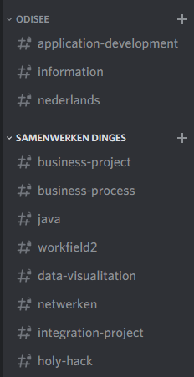A tool I also spend a huge amount of time with is Discord, a free online platform where you can create and manage “servers”, invite friends and hang out in chat or voice calls. I created a server for school 2 years ago and invited my closest friends and classmates to it. We made for each course a text channel, and shared important info in those channels (such as: deadlines, documents, notes, ...). I also gave people certain roles, so that for example 2nd years had access to the 2nd year course text channels. I really love this platform and think it deserves more recognition.  
We used this platform to communicate during and after the online classes.

*Picture of the Calendar in Teams*

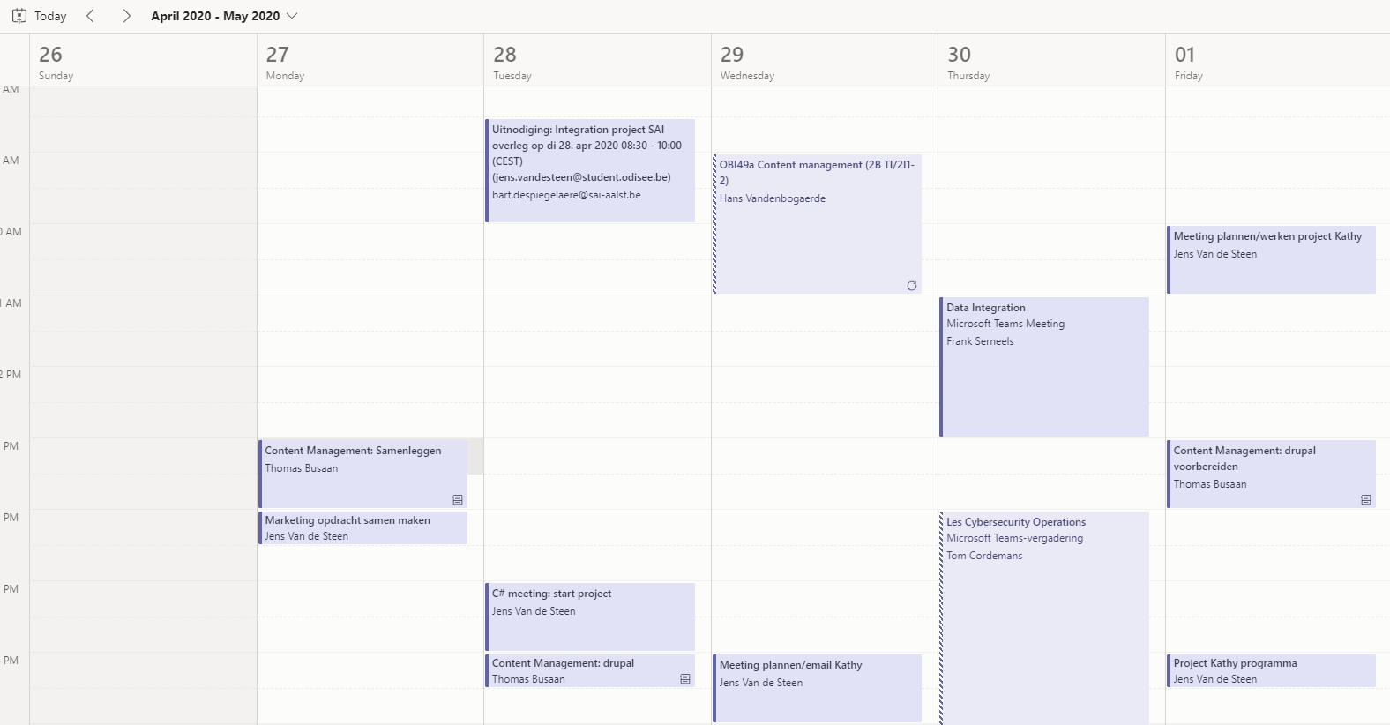

# Experience

## Routine

My routine during the lockdown changed a lot from usual. I had the possibility to wake up 2 hours later than normal, because I did not have to take the train to Brussels. Also, when the class ended, I did not have to take the train home which resulted in me getting a lot of time extra at home.

## Classes

In the beginning most classes struggled to be as effective as the physical classes. But as time progressed, the lessons became better in every way. However, not every course improved.

Something important I learned during this period is that meetings for teamwork’s does not necessarily have to be physical. Surely, it helps and is more effective, but the downside is that it is difficult to plan a meeting (not everyone is in Brussels at the same time, other schedules, no location, ...). You can easily do it online almost every day without a single problem, and if you are using Teams, you are only making it easier.

I also noticed that it takes an amount of discipline to focus on your lessons at home. This new way of learning is not for everyone sadly.

## Future

This digital way of following a course does have its benefits, however, I do not think that I would like to follow courses using this method again. Maybe it is only me, but I found it harder to concentrate and focus on the classes than before. However, this method is a great alternative for if a teacher falls ill. That way, the lesson is not canceled or postponed, but can continue like normal. If a student falls ill, he could notify the teacher, who can broadcast the audio and the screen of his laptop on teams, so that the student can follow it as well, instead of being stuck at home. I would make it so that the students are required to have a doctor’s note as proof of them being ill, otherwise I think a lot of students will take advantage of this system, and just stay at home.

# Teamwork

## Teamwork experience

Teamwork during this period was for me a disaster. Some people never responded or were rarely online, while others never did what we asked them to do. Mostly, the work we received was also wrong, incomplete or in some cases nothing because they did not have the knowledge or motivation to complete the task.  
Maybe it all went bad because I have the wrong teammates, but I think these things are still worth noting.

## Solutions, tips

Meeting very often really helps your team remind them to finish their tasks as soon as possible. For integration project, we had a meeting every 2 days, and I really tried to explain to them how important the project is in hope that they will do their best. In the end, I ended up doing about 70% of the work together with 1 teammate, even when I asked the others for help, I got no reply.

As a tip I could merely ask for less group assignments, and instead focus more on giving creative, innovative individual assignments.

# Tips

## 20 Klantgerichtheid tips - #VerkopenGaatOverVerkopen ...Tips for Students

During these hard times, I have learned that it is not easy to follow a full course online. However, I have come up with some tips and tricks that I would share to other students in case something like this ever happens again, which are listed below.

* Just like regular classes, going to a course is the most important thing to do. Try to limit the amount of times you are unable to attend a class. Also focus on the course and learn the knowledge they are trying to teach you.
* Taking notes not only helps you to remember the course at a later date, but it also helps you to learn the content of the lesson. During online classes, it also helps to remain focus on the class, since it is much more difficult to pay attention to an online course than a physical lesson.
* Sometimes, a teacher will ask a question about the subject just like in physical classes. Try to answer these as much as possible. Not only will it tell the teacher that you are paying attention in class and remain focus, but it will help you to learn the subject as well. You can use these moments to test yourself to see if you understand the current course.
* Last but not least, and I can not tell you how important this is, but start as soon as possible on an assignment, especially during the time of a lockdown. Since you do not see your teacher weekly anymore, if you ever have a question you will have to send a mail. And in my experience, some teachers will take a long time to answer. You will also get more and more tasks, so starting and finishing tasks early one will help you to not get swamped with work.

## Tips for teachers

Teachers also had a hard time adapting to this new way of teaching classes. Some did a perfect job, while others failed. I wrote some tips and tricks to help teachers improve.

* Check your mail daily. The chances of you getting a mail from a student are significantly higher than before. Students also have a lot to do so getting a reply as quick as possible is extremely important to them.
* Try to have some interaction with your students during classes., ask them some questions about the topic. This is not easy since everything is online, but it can not hurt to try. Most students will answer if you ask them a question.
* Plan and hand out your tasks on time, so that students can make time to complete the task. They have other courses too.
* And do not forget, students are humans too, they are going through a tough time as well.

# Social contact

## Contact with teachers

Contacting a teacher was very diverse. You could send a teacher your final project and he would give feedback within the same day, while you could ask another teacher a simple question and he would take 3 weeks to answer.  
What also happened during the online classes is that in extreme cases, a teacher would be late in their online course, and continue to teach 45 minutes extra. This would definitely not happen in case we received physical lessons.

## Contact with students

As mentioned here, me and my fellow students used Discord to communicate with each other, let each other know about updates on Toledo, mails, new tasks, …

# Pros and cons

This document has a lot of text and information in it, so to simplify how it has been, I have made some pros and cons about following courses online.

## PROS

* You can follow the course at any location. You can be at home, on the train, in a library or simply in your bed.
* It is very simple to set everything up for the class. All you must do is have Teams installed in your laptop/PC and join the meeting at the correct time.
* Due to not having to go to a physical place, you actually save a lot of time because of no transportation. In my case, I save 2 hours for each day I can stay at home, and that is a tremendous amount of extra time.

## CONS

* Since you are not physically in a classroom anymore, paying attention requires much more focus than before + you have more distractions.
* It will be harder to contact teachers, and to be aware of new tasks and deadlines. Try to mail a teacher as soon as possible.
* You have less contact with fellow students.
* Working in team will be more difficult since you will not see each other every day.

# Conclusion

As we have come to the conclusion, I would like to thank the teachers for their support and rapid adaption to giving their lessons online in these confusing times. This has definitely not been easy for everyone, but I am very satisfied with the results we have received over the past couple of months. As we were nearing the end, the classes went fluent, and you could really notice the improvement, adaption and most of all motivation of teachers.