Policy brief template
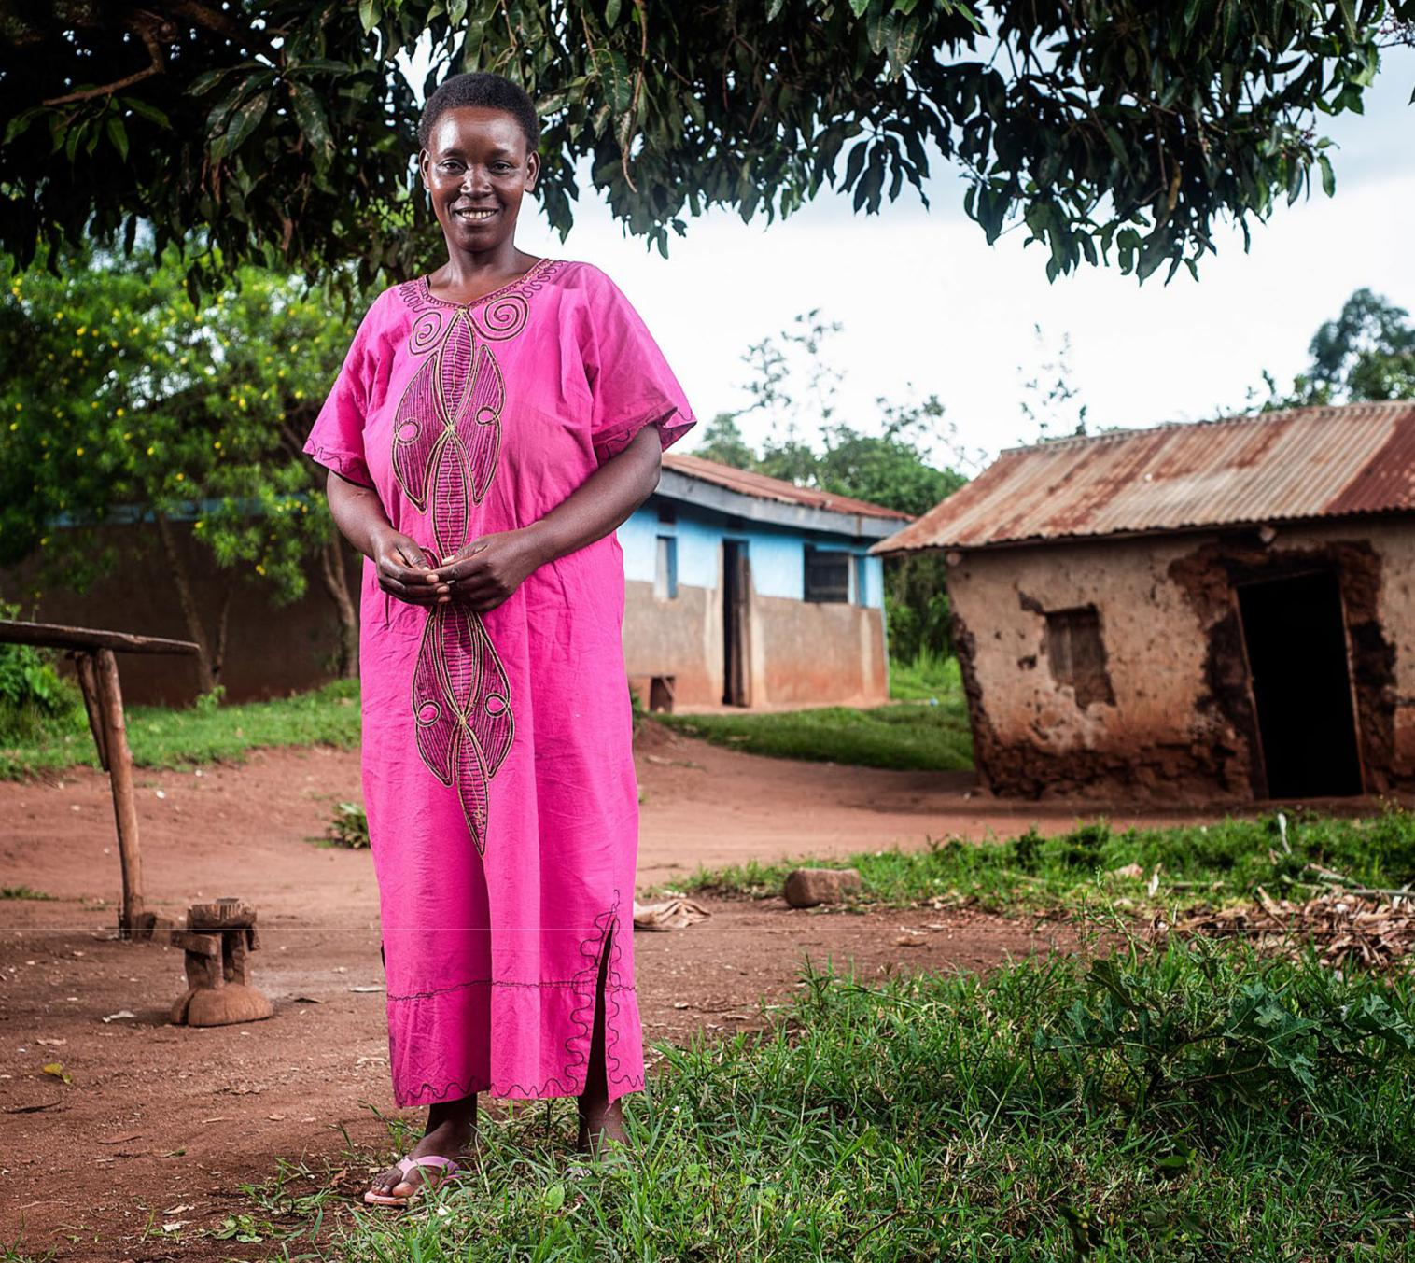

PATH/Will Boase

Policy brief template: A groundbreaking opportunity to increase contraceptive access and options in [country name]

page 1



A new contraceptive option is transforming access

Increasing access to a wide range of contraceptives will improve the health and well-being of women and adolescent girls and will help [insert country] meet its FP2020 commitments and achieve the Sustainable Development Goals. Yet, in [insert country], [insert percentage] of [married] women of reproductive age who want to prevent or space pregnancies are not using contraception, in part because existing methods are not accessible or acceptable.

Recent innovations in injectable contraception can dramatically increase access to contraception

for women and adolescent girls. | ◀
A new type of injectable, known | ◀
as subcutaneous DMPA, or
DMPA-SC,* can make injections
simpler. Sayana® Press is the
brand name of the DMPA-SC
product available today, and is
manufactured by Pfizer Inc. It is
well-suited for reaching women
and adolescent girls where they
live, especially through:
●● Community-based distribution
(CBD).
●● Private-sector outlets, such as
pharmacies and drug shops.
●● Self-injection by clients in
their homes.

*DMPA stands for depot medroxyprogesterone acetate.

Helpful Hint:

To customize the policy brief, cut and paste this text into the template your organization uses for its public materials, and make your edits there. See the “Photo Bank” for pictures you can swap in, including photos of DMPA-SC. Your final policy brief should be no more than two pages.

May 2017


Policy brief template page 2

Experience and evidence support expanding access

Available and emerging evidence from pilot introductions, self-injection research, and other studies shows that DMPA-SC is greatly expanding access to contraception for women and adolescent girls, especially through remote delivery channels. For example: [Include only the bullets below that are relevant to decision-makers in your country.]

●● CBD of DMPA-SC is reaching a substantial number of women who had never used modern family planning (FP) before, as demonstrated by pilot introductions and research studies in countries like Senegal, Uganda, and Nigeria (PATH/United Nations Population Fund, DKT/University of California, San Francisco).

●● Several countries, such as Bangladesh, Nigeria, and Senegal, have opened up access in the private sector by successfully introducing DMPA-SC through pharmacies and drug shops and other social marketing efforts.

●● Self-injection studies from Uganda and Senegal confirm that women can self-inject DMPA-SC with training and support and consider self-injection acceptable (PATH), showing potential for enabling women to initiate and control their own pregnancy protection.

Global momentum builds for DMPA-SC (Sayana Press) [Include this box if it would

be persuasive to decision-makers in your country. Otherwise, delete to save space.]

2011: Sayana Press received stringent regulatory approval in the United Kingdom (followed by registrations in many FP2020 countries).

2014–2016: Successful pilot introductions in Burkina Faso, Democratic Republic of Congo, Madagascar, Mozambique, Niger, Nigeria, Senegal, and Uganda.

2014: A reduced price was negotiated to allow qualified purchasers in FP2020 countries to obtain Sayana Press at approximately US$1 per dose. This price was further reduced to US$0.85 per dose in May 2017.

2015–2017: Registered for self-injection in the United Kingdom, several European countries, and an increasing number of FP2020 countries, including Ghana, Mali, Myanmar, Niger, Nigeria, Uganda, and Zambia.

Policy and advocacy recommendations

To ensure women and adolescent girls have access to a variety of contraceptives including DMPA-SC, strong policies and financing are essential. Decision-makers must take the following actions: [Note: To confirm which set of recommendations you should include in this brief, use the “Access staging tool for subcutaneous DMPA” to identify your country’s stage.]

[INITIATION STAGE — include these recommendations only if your country is in the Initiation stage. Delete this “Initiation stage” heading and recommendations from all other stages.]

●● Be a vocal champion for increasing contraceptive method choice and access. Learn about how new contraceptive methods, including DMPA-SC, can advance your country’s FP goals and FP2020 commitments to improve women’s and adolescent girls’ lives.

●● Engage diverse stakeholders in discussions on introducing new contraceptive methods, including DMPA-SC. Foster policy dialogue on introduction planning, including how to increase access through multiple public and private delivery channels. Reach out to donors and the product manufacturer to initiate registration.

[PREPARATION STAGE — include these recommendations only if your country is in the Preparation stage. Delete this “Preparation stage” heading and recommendations from all other stages.]

●● Help ensure product registration progresses smoothly and is achieved. Check in regularly with your national drug regulatory authority to ensure that registration is moving forward in a timely manner and to address any bottlenecks that may arise.

●● Make sure important building blocks of product introduction are in place.

▶▶ Identify a clear, centralized mechanism to coordinate introduction efforts across partners.

▶▶ Develop a comprehensive introduction or scale-up plan, as well as key policies on use such as guidelines, training materials, and job aids.

▶▶ Ensure that 2017 guidance from the World Health Organization on hormonal contraception and HIV has been addressed appropriately in your country.

▶▶ Ensure that monitoring data collected during introduction will be available to answer the questions of key FP leaders.

May 2017

▶▶ Secure funding to support introduction efforts, and begin identifying sources of funding for scale-up.

●● Identify any policy restrictions on CBD, pharmacy

and drug shop provision, and/or self-injection. Account for which policies will need to be created, updated, aligned, and/or funded to facilitate widespread access to injectables, including DMPA-SC.

[INTRODUCTION STAGE — include these recommendations only if your country is in the Introduction stage. Delete this “Introduction stage” heading and recommendations from all other stages.]

●● Monitor introduction progress, share information, and address any obstacles. For example, track and swiftly address common bottlenecks, such as stockouts of contraceptives (including injectables) at introduction sites.

●● Advance policy and funding changes that expand access to injectable contraceptives. Ensure that injectables, including DMPA-SC products, are included in the following policies: [Add any missing policies and delete the policies that are not relevant to your country context.]

▶▶ The national Essential Medicines List.

▶▶ Policies allowing CBD (service delivery standards for FP/reproductive health, community health worker strategies and training curriculums, task-shifting/sharing policies).

▶▶ Policies allowing private-sector provision.

▶▶ Policies allowing self-injection.

▶▶ Broader FP/reproductive health policies, like national strategies or FP costed implementation plans.

▶▶ FP budget lines.

●● Move forward discussions on scale-up. Convene

diverse partners to discuss strategies for scaling up DMPA-SC. Use data from introduction efforts or research studies to guide decision-making.

[INTEGRATION STAGE — include these recommendations only if your country is in the Integration stage. Delete this “Integration stage’ heading and recommendations from all other stages.]

●● Ensure that DMPA-SC is consistently available and provided within a full range of contraceptive options and quality services.

●● Secure sustainable, long-term funding to support access to DMPA-SC at scale. Commit domestic resources to support scale-up to help build country
Policy brief template page 3


ownership and reduce dependency on donors. Include DMPA-SC in costed implementation plans for FP.

●● Robustly disseminate and implement policies that expand access to FP methods including injectable contraceptives, such as [name types

of approved policies in your country that need to be implemented]. Ensure that policy changes are communicated and made available to relevant stakeholders. Provide sufficient human and financial resources to implement policy changes.

●● Support subnational health officers and decision-makers to ensure adequate supplies and training resources, as well as implementation of task-shifting/sharing policies.

Widespread access on the horizon

Injectable contraception, including DMPA-SC, can make a big difference in the health and lives of women and adolescent girls but can only do so with political commitment, supportive policies, and adequate funding in place. Decision-makers, donors, implementing organizations, supply chain partners, the private sector, and advocates must work together to ensure injectables, as part of a broad method mix, are widely accessible.

Contact us

For more information, please contact: [insert name,

organization, and email]

Where to find data to customize this policy brief

●● Demographic and Health Surveys

●● PMA2020 (Performance Monitoring and Accountability 2020)

●● Track20 (Monitoring progress in family planning)

●● FPwatch (Evidence for family planning policy)

●● FP Costed Implementation Plans

●● Sayana Press Introduction and Research

●● Evidence at-a-glance: What we know about subcutaneous DMPA, a new type of injectable contraception

May 2017

