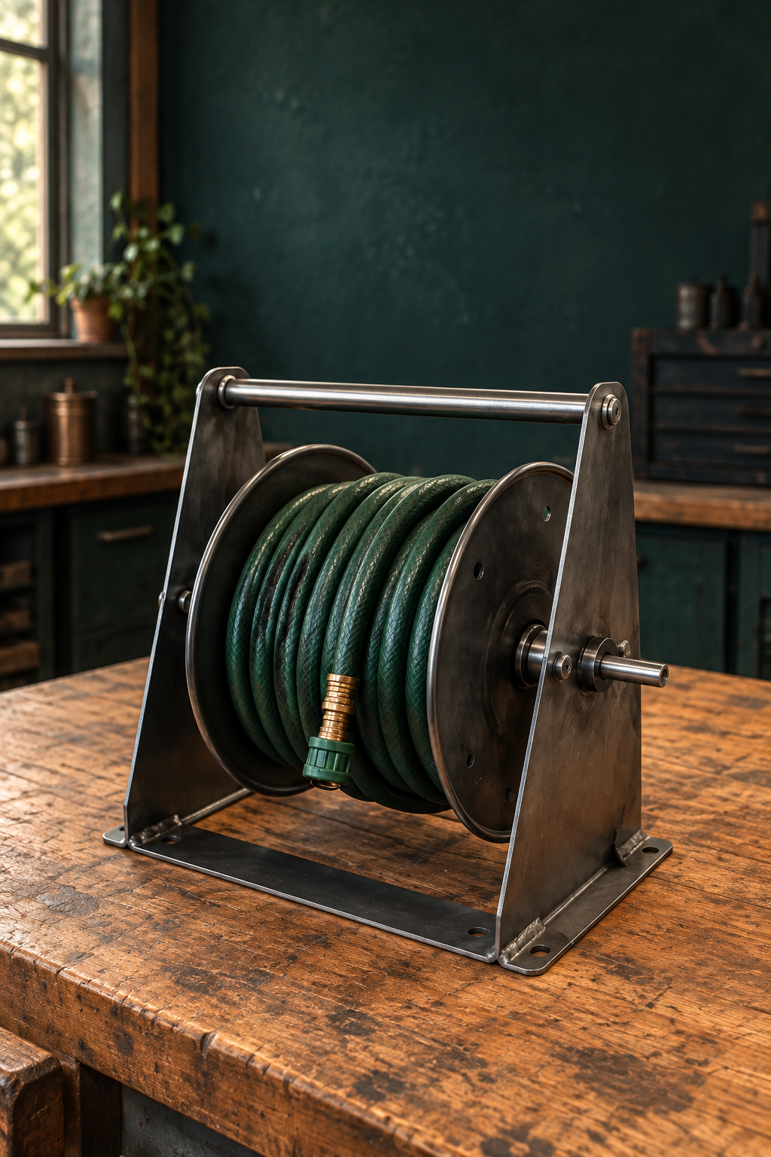
YEAR 8 / INDUSTRIAL TECHNOLOGY – METAL

Hose Reel
Holder
STUDENT WORKBOOK

Name __________________________ Class __________
50 pages · A4 · 25 sheets duplex · Edition 1.0 · 2027 course
Illustrative cover. Use the teacher-issued plan for construction.

THE LEARNING PATHWAY

Your course in this book
Follow the five modules, then assemble the evidence of your own project.
Learning pathway | Student pages
Start here and define the brief | 3–4
01 Project purpose and workshop readiness | 5–12
02 Design, plans and accurate marking | 13–20
03 Cut, shape and drill under control | 21–28
04 Join, assemble and protect | 29–36
05 Test, evaluate and present evidence | 37–44
Project folio and final reflection | 45–50

The complete learning sequence
Each module brings together readings, examples, knowledge checks and applied work. You will explain decisions, inspect evidence, sketch ideas and record your own learning. Use the page references to return to the explanation before completing a task.

Keep the two resources together
The guided course provides lesson media, interactive checks and teacher resources. This workbook provides the print reading and evidence spaces. Your teacher may use the website while you work on paper.
Course: https://stevencowell.github.io/Yr-8-Metal-Technology/
Printing Print all 50 A4 pages at actual size, double-sided on the long edge. The student book uses 25 sheets. The teacher guide is separate.

START HERE

Use the book in the workshop
Learn the reason, show your thinking and keep a useful record.

Read and connect
Begin with the short explanation and look closely at its figure. A useful observation names something you can actually see and connects it to the lesson. An illustration can explain a principle, but it cannot confirm a real component’s dimensions, grade, strength or approval.

Make your thinking visible
Circle one answer for each multiple-choice question. For longer responses, use the writing space to explain a relationship or justify a decision. Drawing tasks need annotations that connect a feature to its purpose. The blank fields belong to your work; they are not missing content.

Use the approved information
Before practical work, obtain the teacher-issued plan and the demonstrated process. Record its title or version so later evidence refers to the same instructions. The class plan controls exact parts, dimensions and tolerances. Current school procedures and teacher direction control tools, joining, finishing and testing. Your assessment notification controls formal submission requirements.

Record honestly
Date entries when useful and describe what you observed. Label a proposed change as a proposal until it is approved. If a check has not happened, write that it is pending. Photographs must show your own work and avoid other students or private information unless permission has been given.
Record where you will keep your teacher-issued plan and assessment notification.

Course identity Year 8, Stage 4. This 50-period introductory unit contributes to an Industrial Technology – Metal elective. It is one part of the wider course.

PROJECT FOLIO

Define the project brief
State the need before you choose a detail.
A brief describes the problem to solve, who needs the solution and the limits within which it must be made. The Hose Reel Holder supports and stores a garden hose reel for outdoor use. Its final form must follow the teacher-issued plan. Separate essential function from a preference about appearance.
Who is the intended user, and what storage or access problem should the holder solve?

Write two requirements. Explain why each matters to function or safe use.

Record two constraints from the issued brief and one preference you may discuss with the teacher.

Plan title or version and the detail you need clarified before making.

READ / OBSERVE / APPLY

Design for a real user
The holder must do a job in an outdoor setting.

A garden hose can become awkward to store when its support is unstable or difficult to reach. A hose reel holder addresses that everyday problem by supporting the reel in a practical position. Start with the user’s actions: approaching the holder, reaching the hose and returning it to storage. These actions help explain why a design feature matters.
Function describes what a product does. A requirement is something essential to meeting that function or to safe use. Convenient access and stable support may be requirements in the approved brief. A preference concerns an optional quality, such as a permitted colour. An attractive finish cannot compensate for a failure to meet an essential requirement.

Constraints are limits that affect decisions. Available steel, lesson time, approved tools and the teacher-issued plan all shape what can be made. Outdoor exposure adds another consideration: moisture and wear can affect steel and its protective finish. These relationships make design a process of reasoning rather than choosing an appearance alone.
Research can reveal useful features in other products. It does not supply authority to copy their sizes or construction. Use the issued plan for the actual holder, and record which detail you are discussing so the teacher can give specific feedback.

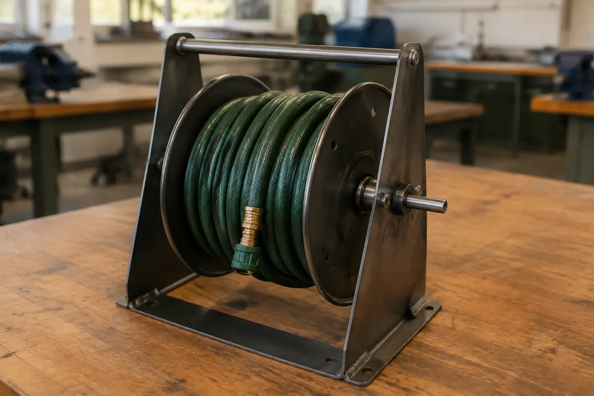
Figure 1. Illustrative product context: notice the support, hose access and outdoor-use purpose. This is not an approved construction plan.
Choose one visible feature. Explain how it could help a user, without assuming a dimension or test result.

READ / OBSERVE / APPLY

Understand the steel you use
Material, form and condition answer different questions.

The current course describes a holder made from mild steel. Steel is an alloy based on iron; adding other elements changes its properties. Mild steel can be cut, formed and joined using suitable approved processes, which makes it useful for fabricated products. Those possibilities do not mean every process is available to every student.
A material name and a stock form are different kinds of information. Steel may be supplied as flat bar, rod, sheet or hollow section. A hollow section has material around an open centre, while a solid bar does not. The form affects where material is placed and how a component can be prepared. The teacher-issued plan determines the required stock and specification.

Condition also matters. Rust, contamination, damaged edges or an unidentified coating can affect preparation and later finishing. A photograph of a silver-grey piece of metal cannot establish its grade or approve it for a task. Identify the material through the supplied information and ask about anything that differs from the class stock.
Good material use begins before cutting. Plan the required parts, identify waste and check marks before an irreversible step. Preventing an avoidable error saves material and the energy already used to produce it. Reuse requires approval and inspection; scrap is not automatically suitable simply because its shape looks convenient.

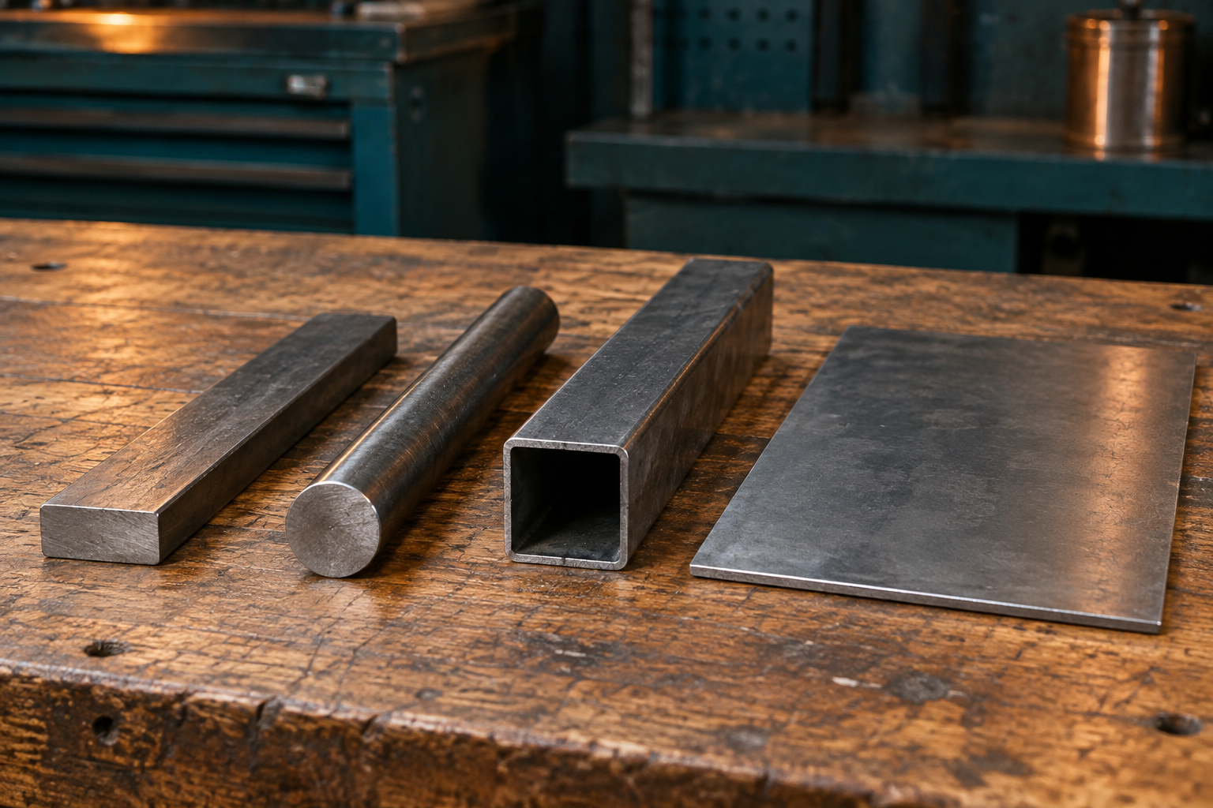
Figure 2. Illustrative stock forms. Identify the cross-sections; appearance alone does not establish the metal grade.
Explain why “mild steel” is not enough information to order the exact project material.

LOOK CLOSELY

Build a complete set of controls
Equipment, behaviour and permission have connected roles.
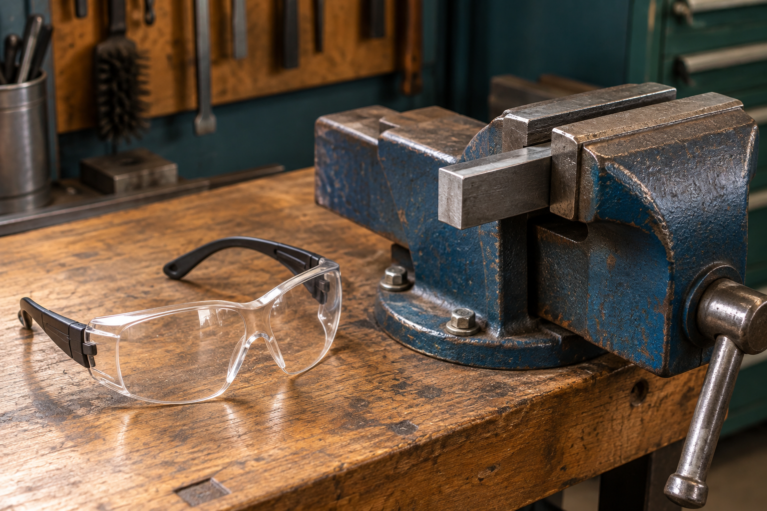
Figure 3. Illustrative tools at rest: glasses protect the eyes; the vice restrains material. Neither establishes permission to operate a machine.

Start before switching on
Workshop readiness begins with a clear area, task-appropriate PPE and the teacher’s demonstrated setup. Tie back long hair, keep bags out of walkways and check that the equipment and material are as expected. These actions address different hazards; one control cannot do every job.
Secure workholding reduces the chance that the material will slip, spin or fall. Guards help separate people from a hazard. Training and supervision help you use the correct process and recognise a change. PPE adds protection, but does not replace these controls.
Permission is specific to the person, tool, task and setup. Previous permission on another machine or yesterday’s task is not automatic permission today. If a guard is missing, material cannot be secured or the setup differs from the demonstration, stop and ask before continuing.
Explain why wearing safety glasses does not make an unsecured drilling setup acceptable.

WORKED EXAMPLE

Read the whole unsafe scenario
Several small omissions can combine in one situation.
Case study Alex enters without safety glasses, leaves a bag in the walkway and begins drilling without teacher permission or clamping the metal.

Step 1 Identify the observations
The case gives four separate facts: missing eye protection, an obstructed walkway, no permission and unsecured material. “Alex is careless” is a judgement about a person; it does not identify what must change. A useful safety explanation names the observable condition.

Step 2 Connect each fact to a hazard
The bag creates a trip hazard. Unsecured metal can move or spin when the tool contacts it. Missing eye protection removes one layer of protection, and starting without permission bypasses the teacher’s check of readiness. These hazards occur together, so fixing only the bag is not a complete response.

Step 3 Choose a controlled response
Stop the unsafe activity and alert the teacher. Follow the teacher’s directions to make the area safe. Restart only when the required controls, demonstrated setup and permission have been established. A student response should not invent a machine setting or attempt to correct moving equipment.
Try a new case: a student has PPE and permission, but the work begins to vibrate differently. Explain the warning sign and the next response.

Reasoning pattern Observation → possible harm → appropriate control → teacher check. Use the pattern to explain a situation, not to improvise a procedure.

KNOWLEDGE CHECK

Check your starting decisions
Circle one answer for each question. Return to the reading to justify it.
1. Which item should control the holder’s exact dimensions?
○ A. A photograph of a similar product
○ B. The teacher-issued working drawing
○ C. The length of the nearest offcut
○ D. A classmate’s estimate

2. Which statement is a design requirement rather than a preference?
○ A. I prefer a darker colour
○ B. I like a curved outline
○ C. The holder must support the reel during approved normal use
○ D. I would choose a different decorative detail

3. A guard is missing from the demonstrated setup. What is the best response?
○ A. Wear extra PPE and continue
○ B. Ask a friend to watch closely
○ C. Try a short operation only
○ D. Stop and tell the teacher

4. Which statement about stock is best supported?
○ A. A silver surface proves the grade
○ B. Any scrap of the right length can be used
○ C. Stock form and specification must match the approved information
○ D. A hollow section is always better than solid bar

Explain one answer in your own words, naming the reason rather than repeating the option.

INVESTIGATE / APPLY

Investigate a storage solution
A useful comparison begins with a shared set of questions.
Use the illustrative product on page 5 and a teacher-selected example, catalogue image or observed storage arrangement. Research on paper can use a printed image. Record the source and distinguish what is visible from what would need a test or further information.
Question | Example A | Example B
Where is the hose stored?
What helps access?
What supports the reel?
What cannot be verified from the image?

Record the source of each example, then compare one useful feature. Explain which user need it addresses.

Write one question you would ask before recommending either solution.

INVESTIGATE / APPLY

Communicate one safety message
A clear poster tells its audience what to notice and what to do.
Choose a workshop-entry issue from this module. Your poster should name the condition, give one clear action and explain why it matters. Use an original illustration or a permitted source. A poster supports a teacher demonstration; it does not create a new machine procedure.
Design a safety poster for workshop entry. Include a clear message, a useful visual and the reason for the action.

Explain how your words and visual help another Year 8 student act correctly.

PROJECT FOLIO

Record workshop readiness
Your explanation and the teacher’s permission are different kinds of evidence.
Identify one user need and two constraints for your Hose Reel Holder. Explain how each could affect the finished project.

Readiness record | Your entry
Demonstration or instruction received
Control I checked and why it matters
Question or changed setup to report

What does this readiness record show, and what still requires the teacher’s decision?

Before the next module Have the issued plan available. Bring a clear question about any detail that remains uncertain.

READ / OBSERVE / APPLY

Read the plan before the metal
A drawing carries decisions that a photograph cannot.

The Hose Reel Holder begins as a need: organise a hose in a useful outdoor position. An idea sketch can explore possible shapes, but an approved working drawing gives the information needed to prepare the actual parts. A photograph may help you recognise a product. It cannot reliably tell you its material specification, hidden features or written dimensions.
Read the teacher-issued drawing as a connected set of information. Different views may show different faces of the same part. A feature that appears clearly in one view may be hidden in another. Notes and symbols can explain details that the outline alone cannot. Check the views together before deciding what a line represents. Written dimensions control size; measuring the printed picture introduces an error if it has been resized.

Then connect the information to the metal in front of you. Identify the part, the face you will mark and the reference edge from which positions will be measured. Select the measuring and marking tools shown by the teacher. A steel rule measures length; an engineer’s square helps check or mark a right angle. Their usefulness depends on correct placement and a clear starting point.
If information is missing or two details appear to disagree, pause the affected step and ask the teacher. Guessing transfers uncertainty into the material. You can still organise tools, label your planning page or list the information needed while the drawing is clarified.


Figure 4. Illustrative metal stock forms. The teacher-issued plan determines actual components and specifications.
Name one detail you must obtain from the issued plan rather than estimate from a photograph.

READ / OBSERVE / APPLY

Develop an idea with reasons
Compare options against the same need before choosing.

Designing is a sequence of decisions, not a race to the first attractive sketch. Begin with the user and the problem. For a hose holder, useful questions concern how the hose is stored, how the user reaches it and what outdoor conditions the product will face. Research can reveal approaches, but a picture of another product is a source of ideas rather than permission to copy its construction.
Explore more than one possibility. Two quick sketches can reveal a difference that is difficult to describe in words: one might make access clearer, while another might reduce unnecessary material. Add notes explaining what each idea is intended to achieve. At this stage, an honest question mark is more useful than an invented dimension.

Compare the ideas using the same criteria. A criterion is a feature of success, such as accessible storage or suitability for outdoor use. Explain how each idea responds to it. “I like this one” states a preference; “this arrangement gives the user clearer access to the hose” identifies a reason that can later be checked. Also consider whether the idea can be produced with the school’s available materials and approved processes.
The selected direction still needs teacher approval and a suitable working drawing before production. Design thinking continues during making: a problem may require a revised sequence or a clearer check. Record the reason for any approved change. This shows how evidence improved the decision, rather than making the project appear to have worked perfectly from the beginning.


Figure 5. Concept illustration for discussing access and outdoor storage. It is not a construction plan.
Rewrite “I chose it because it looks best” as a reason linked to a user need.

LOOK CLOSELY

One reliable starting point
A datum links separate measurements to a common reference.
A datum is a chosen reference from which positions are measured. Think of it as the agreed starting point for the part. If several marks are located from the same approved edge, each can be compared directly with the drawing. You do not have to trust the accuracy of every earlier mark to locate the next one.
Stepping measurements from one fresh mark to another creates a chain. An error near the start can be carried forward, even when later measurements seem careful. A consistent datum helps reduce this accumulation. It does not make measuring automatic: the correct edge, scale reading, tool position and clear mark still matter.
A second check is useful when it checks the information again rather than simply glancing at the same marks. Return to the issued drawing, confirm the datum and compare each required position. Identify the intended waste side before cutting. If a mark is unclear, have it clarified using the approved process; competing lines can leave the next person unsure which one controls the cut.
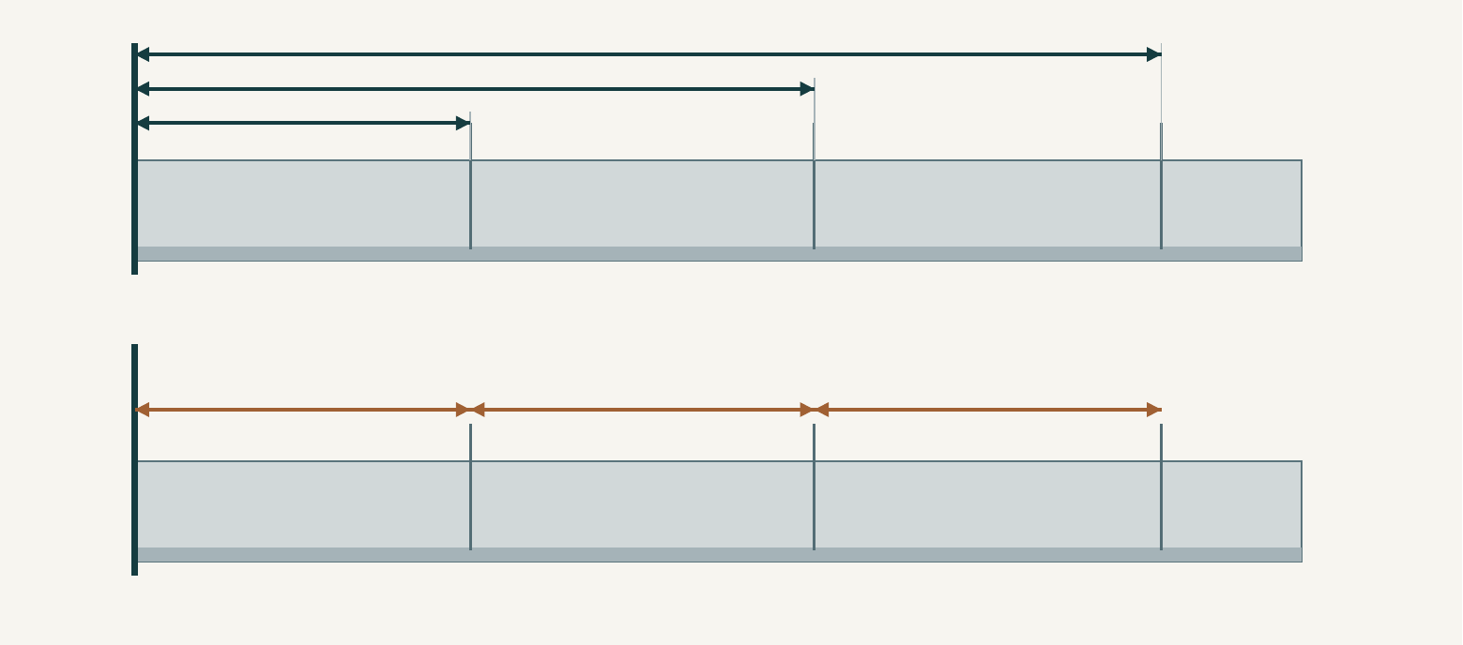
Figure 6. Conceptual comparison: upper arrows share the left-hand datum; lower arrows begin at the previous mark. No project dimensions are shown.
Explain why a common datum and a separate check work together to improve accuracy.

WORKED EXAMPLE

Catch the error while it is reversible
Worked example • hypothetical classroom evidence
Amira has marked a practice strip. She notices that one position appears different from the drawing. Her first thought is to add a second line where she thinks the cut belongs. This would leave two competing marks and would not explain why the first line was wrong.
She starts the check again. First, she identifies the part and the face shown on the issued drawing. Next, she compares the datum on the drawing with the edge she used on the strip. She discovers that one position was measured from an earlier mark instead of the datum. The appearance of a neat line did not prove that it was correctly located.
Amira stops before cutting and asks the teacher to confirm the correction process. Once clarified, she records the approved correction and repeats the check. Her folio caption names the problem, the evidence and the action: “One mark used the wrong starting point. I checked it against the drawing and corrected it through the demonstrated process before cutting.” This records a useful decision, not a claim that mistakes never occurred.
Reasoning move Locate the source of uncertainty before changing the material.
Your marked part looks correct, but you cannot identify which edge was used as the datum. Explain your next steps and the evidence you would record before cutting.

KNOWLEDGE CHECK

Check your planning decisions
Circle one answer for each question.
Q1. A printed drawing has been reduced to fit a page. Which information should control the size of the part?
○ A. The size measured from the printed outline
○ B. The written dimensions on the approved drawing
○ C. The size of the nearest example photograph
○ D. The amount of stock that is easiest to reach

Q2. Which record gives the strongest reason for choosing an idea?
○ A. “This was my first sketch.”
○ B. “My friend chose the same shape.”
○ C. “It looks more expensive.”
○ D. “It gives the intended user clearer access to the hose.”

Q3. A student measures each new position from the mark just made. What is the main concern?
○ A. An early marking error can affect later positions.
○ B. The steel will change its material type.
○ C. The drawing will no longer have written dimensions.
○ D. Every mark will automatically be in the waste area.

Q4. Which photograph would best support a pre-cut marking check?
○ A. A close-up that excludes every edge of the part
○ B. A picture of the cutting tool alone
○ C. A clear view linking the plan, datum and marked feature
○ D. A finished project belonging to another student

DRAW / EXPLAIN

Two ideas, one need
Paper design exploration • no construction dimensions required
Imagine a user who wants to place and remove a garden hose easily and keep the storage area organised. Explore two different arrangements. These are concepts for discussion, not approved designs for making.
Concept A: sketch an arrangement and annotate the feature that is intended to help the user.

Concept B: change one important design decision and annotate its intended benefit.

Compare both ideas using one shared criterion. Which would you explore further, and why?

INVESTIGATE / APPLY

Rebuild a reliable mark-out check
A process puzzle about decisions, not machine operation.
A planning record has been shuffled. Read the six cards, then place them in a defensible order for preparing and checking marks. The teacher still controls the practical method.
Card | Recorded action
A | Compare all required marks with the issued drawing.
B | Identify the correct part, face and approved datum.
C | Record the completed check and its result.
D | Read the issued drawing, its notes and written dimensions.
E | Make the required marks using the demonstrated tools.
F | Resolve unclear information with the teacher before marking.

Write your order. Explain why two of the actions must occur before a later action.

Which action would you repeat if the teacher issued a revised drawing before cutting? Explain.

PROJECT FOLIO

Make the marking check visible
Folio record • use your own checked work
Use a labelled sketch or an approved photograph of your own mark-out. Show enough of the part to locate its reference edge. Do not include other students or private information. If practical work has not reached this stage, label the record “planning only” and complete it after the real check.
Record the marked part. Label the datum, one checked feature and the intended waste area where relevant.

Plan or revision used, check completed, and result:

Explain how the reference edge and a second measurement check improved, or will improve, the accuracy of your marked metal.

READ / OBSERVE / APPLY

Control begins with the workpiece
Support, restraint and attention work together.

A cutting or drilling tool applies force to material. If the workpiece can move unexpectedly, the line you planned may no longer be the line the tool follows. Loose metal may slip, spin, vibrate or fall. Controlling the workpiece therefore supports both safety and accuracy; neat marking alone cannot keep it in position.
Support and restraint have related but different jobs. Support carries the material where it is needed. Restraint limits unwanted movement. The teacher-approved setup must suit the material, shape and operation. A setup that worked for a different part is not automatically suitable for this one. Another student’s hands are not a substitute for approved workholding near a cutting or drilling operation.

Before starting, confirm the demonstrated tool, guards, workholding, protective equipment and permission requirements. Use the body position demonstrated by the teacher, with a balanced stance and your body clear of the likely tool path. These decisions help you remain in control; they are not permission to improvise a process.
Control continues while work is happening. Changes in sound, movement, resistance or workpiece position can signal a developing problem. Stop safely using the demonstrated stopping procedure and tell the teacher. Do not push harder, hold a moving part or alter the setup while the process continues. A pause allows the cause to be checked before a small change becomes an injury or an irreversible error.


Figure 7. Workholding must be approved for the actual part and operation. This still-life image is material context, not an operating setup.
Explain one way secure workholding can improve accuracy as well as reduce risk.

LOOK CLOSELY

A cut has an edge as well as a shape
Edge preparation is part of completing the stage.
Cutting separates material, but the new edge may still need attention. A burr is a raised, unwanted lip or rough projection left by a process. It can be small enough to miss in a quick glance yet interfere with handling, fit or later finishing. A component can be the right overall shape and still be unready for the next stage.
A safe edge check begins with observation and the teacher’s approved inspection method. Do not slide a finger along the metal to find sharp areas. Similarly, do not clear swarf with bare hands. Swarf is the waste produced by processes such as drilling and cutting, and it can have sharp edges or retain heat.
The demonstrated filing or finishing process treats the affected edge while keeping the work controlled. The aim is to prepare the required feature, not to remove material indiscriminately until it looks smooth. Removing too much can change fit or geometry. Check the part against the plan and the demonstrated quality requirement before moving on. This connects edge safety, dimensional accuracy and the quality of the later assembly.
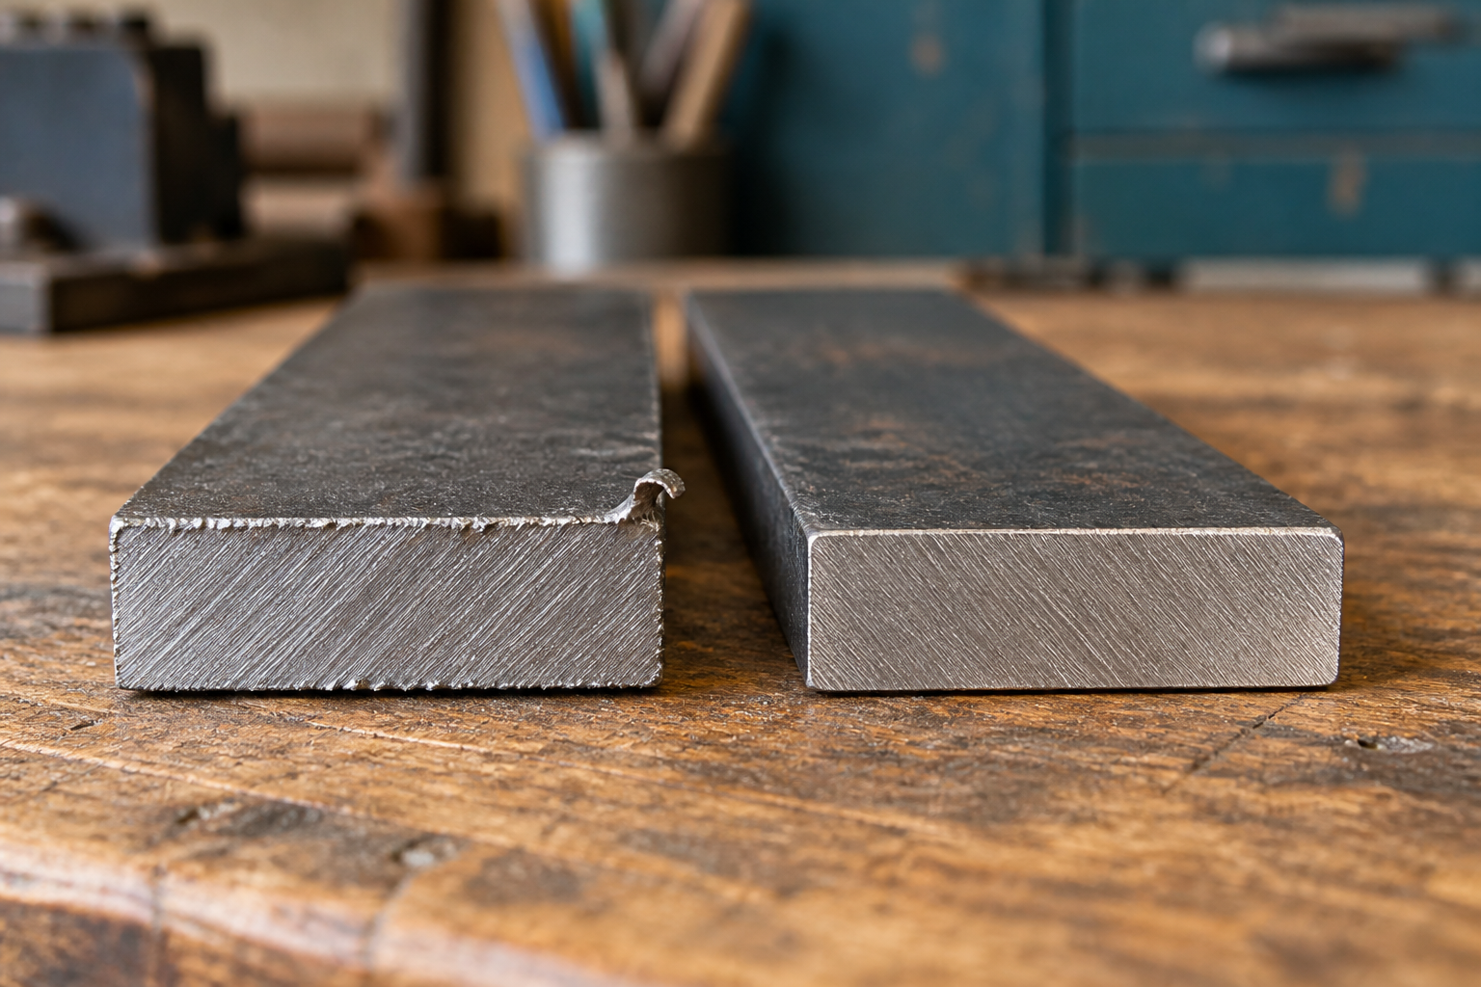
Figure 8. Conceptual edge detail: a burr projects beyond an otherwise cut edge; the prepared comparison has that projection treated. The illustration is not a handling test.
Explain why “the part is cut to shape” is not enough evidence that it is ready for assembly.

READ / OBSERVE / APPLY

Forming changes the next decision
A planned sequence protects the features already made.

Forming changes the shape of a piece without simply cutting away the unwanted area. A bend can alter how faces meet, where a hole points or whether another tool can reach a feature. This means the order of operations matters. A step that looks possible while the part is flat may be difficult after it has been formed.
Start with the issued plan and teacher demonstration. Confirm the relevant face, location, direction and sequence. These details cannot be guessed from an attractive finished photograph. Use only the approved vice, jig, former or machine arrangement for the actual task. The workbook explains why planning matters; the teacher supplies the practical method and permissions.

Work through the demonstrated stages and check progress at the specified points. Gradual, controlled forming gives an opportunity to notice a difference before going further. Uncontrolled force can hide the cause of an error and introduce another one. If a feature no longer appears to line up, stop and report what you can observe rather than forcing the part towards an assumed shape.
A trial check is a pause for evidence. Compare the relevant feature with the plan or approved reference, state the result and decide with the teacher whether the next step is ready. Recording this check in the process diary helps explain how the final shape was achieved. An honest record of a problem and its approved correction shows more understanding than a sequence of photographs with no decisions attached.

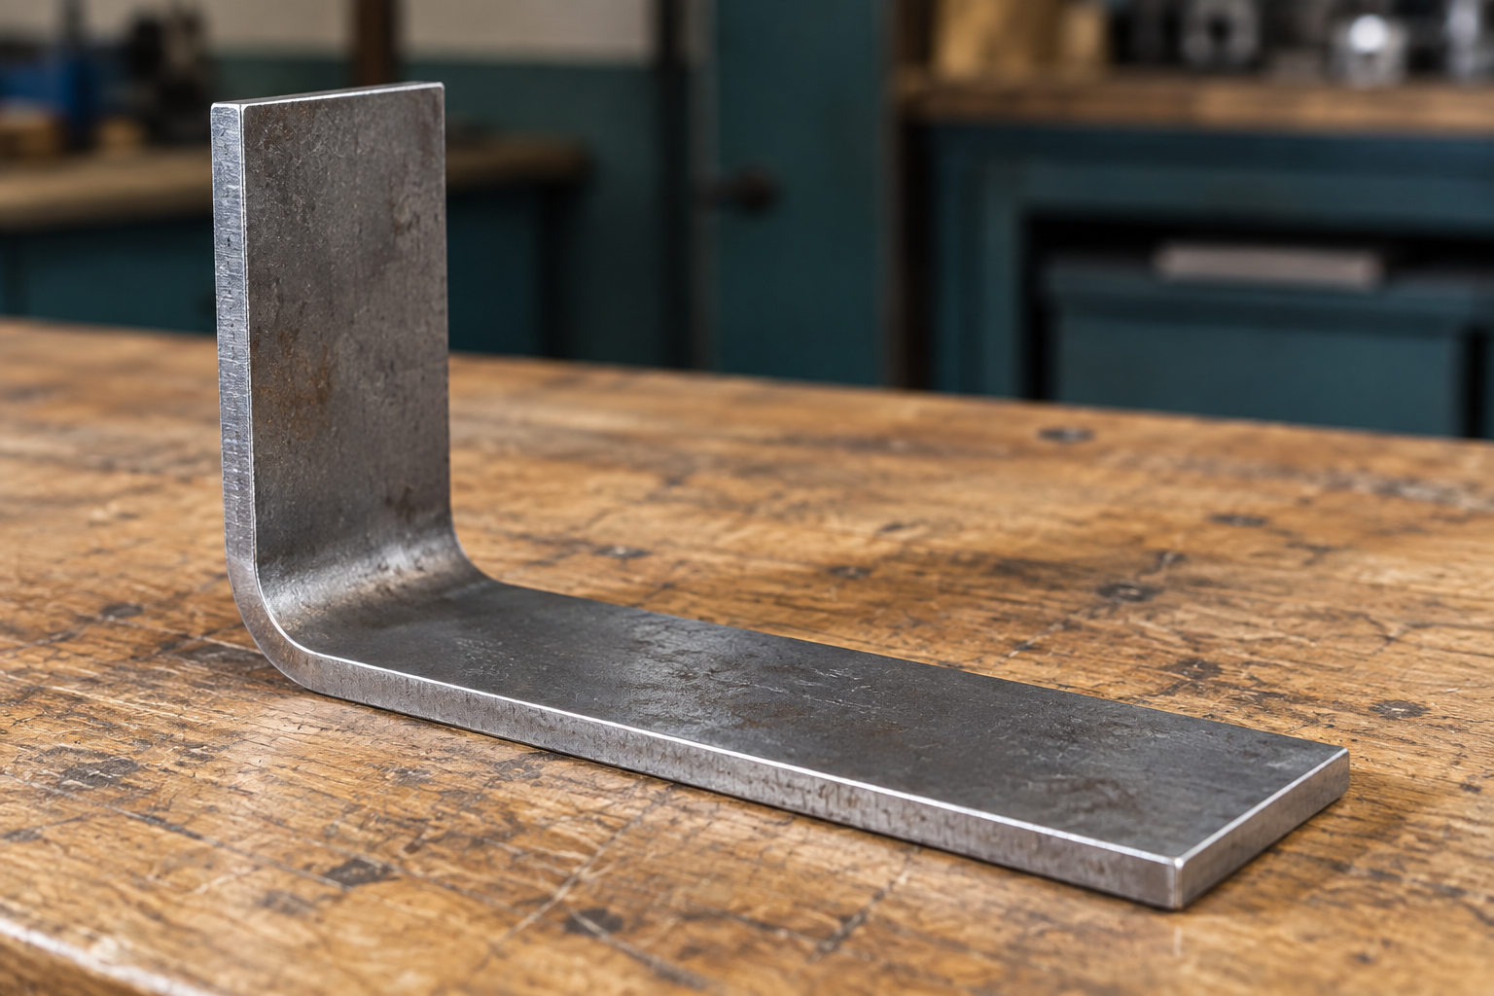
Figure 9. Illustrative formed steel detail for discussing changes in direction and access. The issued plan controls the actual forming sequence.
Name one way forming could affect a later operation.

WORKED EXAMPLE

Notice the change, explain the response
Worked example • hypothetical classroom evidence
During a supervised practice task, Theo notices a new vibration and sees that the material’s position is no longer the same as at the start. He does not know the cause. Continuing to find out would turn the moving process into an experiment.
Theo stops safely using the procedure demonstrated for the task, keeps clear and tells the teacher what changed. His report separates observation from explanation: “The vibration increased and the marked feature moved relative to the support.” He does not claim that a particular clamp failed, because that has not yet been established.
The teacher checks the setup and controls any correction and restart. Theo records the interrupted stage, the warning signs and the action taken. The useful learning is not simply “be careful”. It is that a changed condition is a reason to stop, and that an accurate description helps the teacher investigate. Waiting for clarification protects people and prevents another operation being based on an uncertain part position.
Observation or assumption? “The part moved” reports what was seen. “The clamp was faulty” proposes a cause that needs checking.
A forming trial leaves a feature pointing in an unexpected direction. Explain what you would report, what you would avoid doing, and what must be confirmed before continuing.

KNOWLEDGE CHECK

Choose a controlled response
Circle one answer for each question.
Q1. A marked part can still rotate in its proposed holding arrangement. What should happen next?
○ A. Start slowly and hope it stays still.
○ B. Ask a classmate to hold it near the tool.
○ C. Have the teacher confirm an appropriate secure setup.
○ D. Add more marks so its movement is easier to see.

Q2. Which statement best describes a burr?
○ A. An unwanted raised lip or projection left by a process
○ B. A written dimension on the working drawing
○ C. A protective coating applied to outdoor steel
○ D. A required reference edge for all measurements

Q3. A new sound occurs during a practical operation. Which response best follows the learning?
○ A. Keep going until the stage is finished.
○ B. Stop safely and describe the change to the teacher.
○ C. Move the workpiece while the process continues.
○ D. Increase force to make the sound disappear.

Q4. Why does a forming sequence need planning?
○ A. Forming removes the need to read dimensions.
○ B. All bends can be corrected without consequences.
○ C. The final finish determines every earlier step.
○ D. Changed shape can affect alignment and later access.

INVESTIGATE / APPLY

Read the warning signs
Separate an observation from a risky proposed response.
These are paper scenarios, not instructions to try. For each case, name the concern and replace the proposed action with a controlled response.
Case | Observation and proposed action
A | A piece vibrates more than it did at the start. “I will push harder.”
B | A cut edge has a visible projection. “I will slide my finger along it.”
C | A formed feature does not align with the reference. “I will force it further.”

Case A — concern and response:

Case B — concern and response:

Case C — concern and response:

DRAW / EXPLAIN

Show what your check needs to reveal
Plan an evidence view before practical work.
An evidence view should make the important relationship visible. Draw a conceptual part rather than a machine procedure. Do not invent tool settings, clamp arrangements or project dimensions.
Sketch a cut edge before and after approved preparation. Use labels to distinguish the required edge from an unwanted projection.

Sketch the evidence view you would use to show a formed feature against its approved reference. Label the feature, reference and comparison.

What detail would be lost if your evidence picture were taken too close?

PROJECT FOLIO

Record a controlled production decision
Folio record • a check is more useful than a tool list
Choose one cutting, edge-preparation, drilling or forming stage you have actually completed under teacher direction. If it has not happened, label the page “planning only” and return later. Record observations accurately; do not turn an intended check into a claimed result.
Production record | Your entry
Stage and date or sequence label
Approved plan/reference and demonstrated process
Observed check and result

Sketch or attach permitted evidence of the checked feature. Label what the image proves.

Explain how secure work, a balanced body position and stopping when conditions change reduce risk. Link at least one point to your record.

Complete the production record above using actual evidence or clearly labelled planning.

READ / OBSERVE / APPLY

Fit first, then fix
A trial assembly reveals relationships between parts.

An individual part can look accurate on the bench while the assembly still has a problem. Joining brings the parts into a relationship: edges must meet as intended, features must line up and the overall form must sit correctly. A dry check, or trial fit, places the components together without making the joint permanent. It is a chance to inspect that relationship while changes remain easier to manage.
Compare the assembly with the teacher-issued plan. Look at fit, alignment and orientation together. Fit concerns how the parts meet; alignment concerns whether their relevant edges, holes or features are positioned as intended. Orientation concerns which way each part faces. A component turned the wrong way might seem close to fitting but still prevent another feature from lining up.

Do not use force or an improvised alteration to hide a mismatch. First identify what differs from the reference and ask the teacher to confirm the cause and correction. The issue might involve preparation, orientation or a previous operation. A specific observation gives the teacher something useful to investigate; “it is wrong” gives very little.
Once the approved joint is completed, later checks still matter. A join can hold parts together without proving that the entire assembly is correct. Record the fit check before joining and the relevant check afterwards. This creates evidence of a controlled sequence. It also makes your final evaluation stronger, because you can explain how the finished form was checked rather than only saying that it looks right.

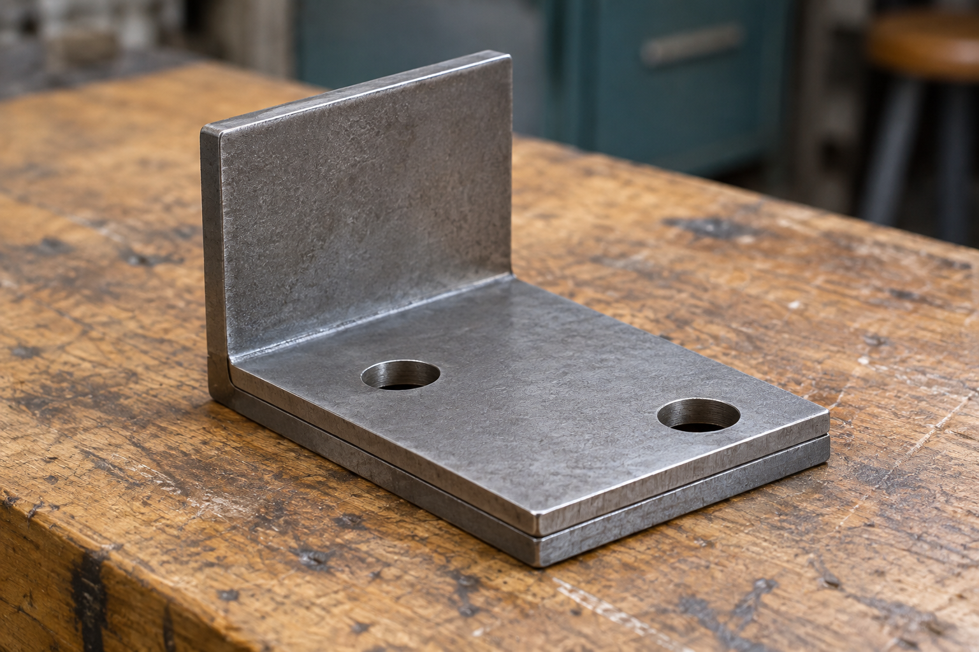
Figure 10. Conceptual trial fit: the relationship between components is visible before permanent joining. Actual geometry and joint details come from the issued plan.
Why can a correctly shaped individual part still create an assembly problem?

LOOK CLOSELY

Keep the protection continuous
Outdoor durability begins at the metal surface.
Mild steel is useful for many fabricated products, but its iron can rust when exposed to moisture and oxygen. Outdoor use makes protection a design and maintenance concern. A surface may look sound at first while an unprotected area becomes a starting point for corrosion later.
A suitable protective coating helps separate the steel from its surroundings. Its performance depends on more than its colour. The surface must be safe, clean and prepared as directed so the approved finish can cover and protect it properly. Burrs, scale, dirt and contamination can interfere with preparation and the final result. Coating over a problem does not remove the problem.
Protection also depends on following the correct product instructions. The teacher controls the selected product, ventilation, protective equipment, application and curing requirements. Do not choose a product or invent a drying time from memory. Record the actual classroom product information and protect prepared surfaces from dirt and moisture before the next stage. Later damage or an exposed patch is evidence to report and evaluate, not something to conceal with an unsupported durability claim.
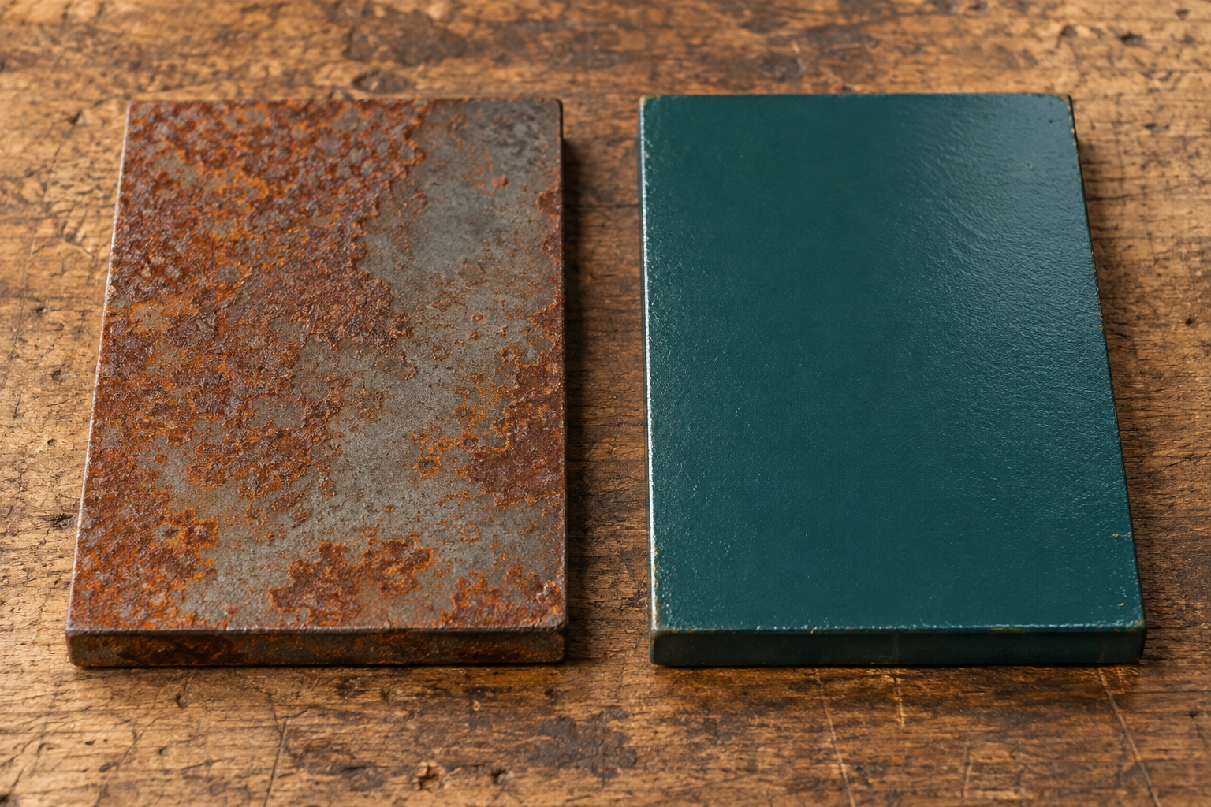
Figure 11. Illustrative surface comparison: exposed steel shows corrosion; the coated sample has small areas of edge wear. Inspect coverage as well as colour; this is not a durability test.
A student says, “The colour is even, so the holder will last outdoors.” Explain what this statement overlooks.

READ / OBSERVE / APPLY

The joint belongs to the design
Connection choices depend on function and the approved process.

A joint connects components so they can work as an assembly. Different joining methods create different possibilities. Some mechanical fasteners may allow parts to be removed or replaced; some methods create a connection intended to remain permanent. These broad categories help you ask design questions, but they do not tell you which method is approved for the Hose Reel Holder.
The teacher-issued plan and demonstration determine the correct joint, setup and sequence. A method that seems faster may not suit the material, the intended forces, the shape or the classroom equipment. Students must not substitute a connection because it appears convenient. In particular, heat-based joining is teacher-controlled and requires specific permission, ventilation, protective equipment and supervision.

Joint quality begins before the connection is completed. The intended contact surfaces need appropriate preparation. The parts need the correct orientation and alignment. There must be suitable access for the approved process, and the components must remain controlled while it is carried out. If these conditions are uncertain, completing the joint can make the underlying problem harder to correct.
A useful record therefore explains both the method and its context. State which joint was specified, what was checked before joining and what evidence shows the result. You do not need to reproduce a machine procedure in your folio. You need to show that your decisions followed the controlling information and that you understood why fit, preparation and checking mattered. Exact settings or permissions should be recorded only from the relevant teacher-controlled source.


Figure 12. Illustrative component contact before joining. Matching surfaces and accessible features help a trial-fit check; the actual joint is teacher-specified.
What is the difference between knowing a joining method exists and being authorised to use it?

WORKED EXAMPLE

A mismatch is information
Worked example • hypothetical classroom evidence
During a trial fit, Priya notices that two intended meeting edges do not sit together as shown on the reference. One classmate suggests joining the parts and dealing with the appearance afterwards. Priya recognises that this would make the uncertain relationship harder to inspect and correct.
She records the observation without guessing the cause: “The meeting edges do not align in the trial fit.” She compares orientation and the relevant features with the issued plan, then asks the teacher to confirm what needs checking. The teacher controls any correction and the decision to proceed. Priya records the actual outcome after the approved recheck.
Her later evaluation can now explain a quality decision: the trial fit identified a mismatch before permanent joining. This does not prove every joint is strong or that the coating will last indefinitely. It proves that one fit concern was identified and addressed through the approved process. Keeping the claim this precise makes the evidence more trustworthy and gives a future improvement a clear starting point.
Useful evidence language Name the feature, state the comparison and report the observed difference.
A trial assembly lines up, but a contact surface still has visible contamination. Explain why the project is not ready to proceed, and describe the evidence needed after the issue is resolved.

INVESTIGATE / APPLY

Build a quality pathway
Choose the check that prevents a later problem.
Read the situations below. For each, decide which quality concern must be resolved before the next stage. Then explain the connections between the stages.
Situation | Proposed next step
A. Parts meet at the wrong angle in a trial fit. | Make the joint permanent.
B. A joint has been completed, but alignment has not been checked. | Record that the whole assembly is correct.
C. Dirt remains on the surface. | Apply the protective finish.
D. Product curing requirements are unknown. | Begin handling or testing the finished part.

For A–D, state what needs checking or confirming first.

Choose one situation. Explain how an early check protects the quality of a later stage.

KNOWLEDGE CHECK

Check fit, joining and protection
Circle one answer for each question.
Q1. Which observation is most useful during a dry check?
○ A. The bench colour matches the steel.
○ B. The parts are close to the tool cupboard.
○ C. Intended meeting edges and features align with the plan.
○ D. Another student has already completed a joint.

Q2. A student finds a quicker joining method online. What should determine the method used in class?
○ A. The teacher-issued plan and approved demonstration
○ B. The number of views on the online video
○ C. Which method produces the brightest surface
○ D. The method that avoids all preparation

Q3. Why is careful surface preparation important before protection?
○ A. It replaces the need for a suitable coating.
○ B. It ensures every possible joint can be taken apart.
○ C. It proves the holder has passed all functional tests.
○ D. It helps the approved finish cover and protect the steel.

Q4. A coating looks dry, but its curing requirements are unknown. What is the best next step?
○ A. Assume a familiar product has the same requirements.
○ B. Confirm the actual product instructions with the teacher.
○ C. Invent a time and write it in the folio.
○ D. Test the holder immediately to see what happens.

DRAW / EXPLAIN

Make the comparison visible
Use drawing to plan two different quality checks.
Use simple conceptual metal parts. Draw the information a viewer would need to understand each check. Your drawings are evidence-planning exercises, not replacement working drawings.
Draw a trial fit with one possible alignment problem. Label the intended meeting feature, observed difference and reference needed.

Draw a close detail of an outdoor steel surface with one area needing attention before protection. Annotate why the detail matters.

How do the two drawings show different kinds of quality?

PROJECT FOLIO

Connect the checks to the finish
Folio record • distinguish the result from the prediction
Record your own assembly and protection evidence. Use “not yet completed” where a stage is still planned. Identify the actual product from the classroom label or teacher information; do not guess.
Quality record | Your evidence or source
Dry check: feature and observed result
Approved joint/reference used
Surface preparation check
Finish product and teacher instruction reference

Sketch or attach permitted evidence of one completed check. Label what the detail proves.

Explain how trial fitting, careful alignment and surface preparation improve the quality and durability of the Hose Reel Holder.

Complete the quality record with actual evidence, sources or an honest “not yet completed”.

READ / OBSERVE / APPLY

Evidence shows the thinking
A finished photograph tells only part of the story.

A finished product is important evidence, but it cannot show every decision that led to it. A reader cannot see from the final photograph which reference you used, when a marking error was caught or why a production step was paused. A useful folio makes those decisions visible through carefully selected records.
Capture evidence at meaningful stages. A sketch may explain an idea; a photograph of a marked part may show the datum and the feature checked; a process note may explain an approved correction. Choose the format that reveals the point. A detailed view gives information, while a wider view can establish orientation or context. Neither is automatically better: the framing must match what you want the evidence to show.

A caption should name the stage, explain the purpose of the check or decision and report the result. Avoid captions that merely repeat the visible object, such as “this is my metal”. Instead, connect the object to learning: what was compared, what was noticed and what happened next? Do not claim that an image proves something hidden or that a check happened when it was only planned.
Use your own work, acknowledge help and record changes honestly. Follow permission requirements for photographs and keep other students’ personal information out of the record. A folio is strongest when another reader can follow the evidence and understand its limits. A mistake, clearly explained and appropriately addressed, can show stronger learning than an unexplained picture of a result that appears flawless.

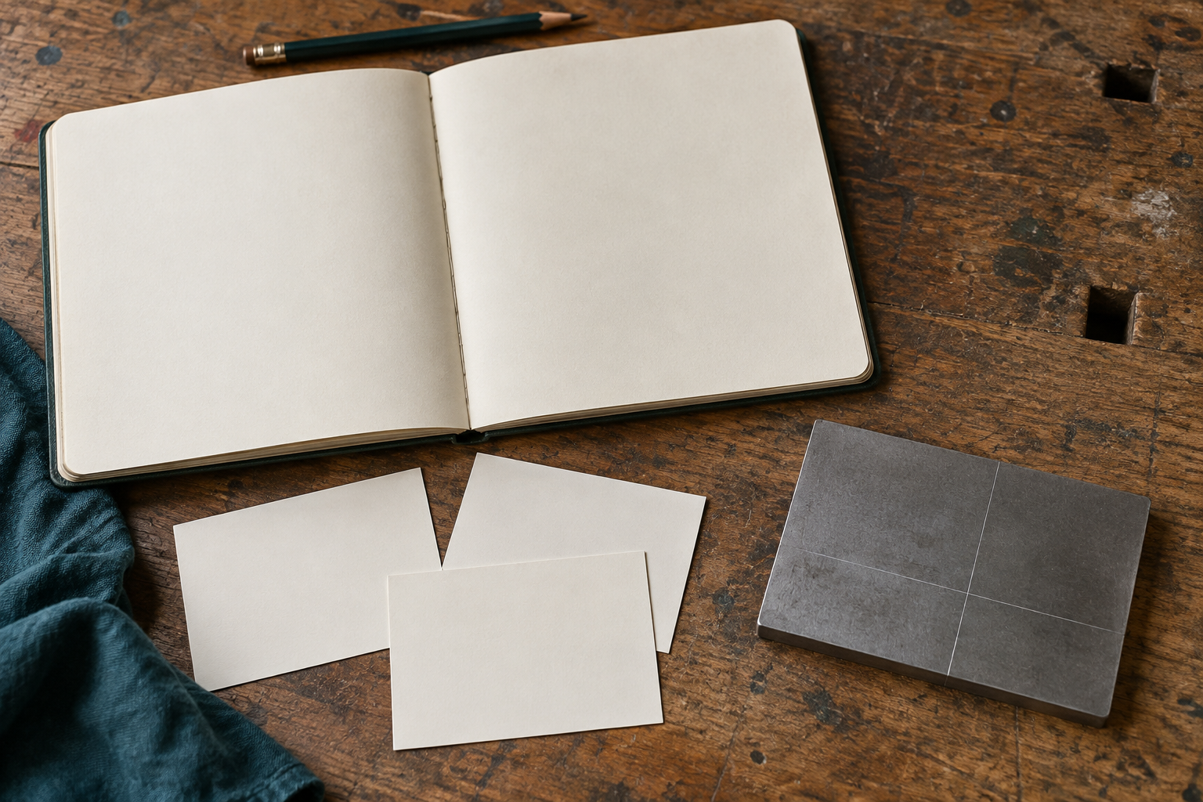
Figure 13. Illustrative evidence arrangement: image, reference and written note each contribute different information. No generated image represents a student’s actual work.
Name one decision a final product photograph alone would not reliably prove.

READ / OBSERVE / APPLY

Give the folio a clear route
Organise the evidence so a reader can follow the project.

A folio is an evidence trail from the original need to the final judgement. Its order helps the reader understand the project without being present in every lesson. Begin with the brief and research, then show ideas, planning, production, testing and evaluation. Use the teacher’s required format and submission instructions for the actual course record.
Selection matters as much as quantity. Several near-identical photographs can make a folio longer without making the process clearer. Choose evidence that adds a new point: a decision, an important check, a problem, a correction or a result. Keep enough context to make that point understandable. A photograph that excludes the reference may be attractive but weak evidence of an accurate comparison.

Use headings and dates or sequence labels to connect the stages. Give figures short, useful captions and keep the image close to the explanation that refers to it. If a decision changes, show the earlier issue and the later response in an understandable order. Do not erase the reasoning by presenting a revised choice as though it was always the plan.
Before submitting, read the folio as if it belonged to someone else. Can you identify the user need, the controlling plan, the important production decisions and the evidence behind the final judgement? Can you distinguish completed work from planned work? A tidy page helps navigation, but completeness depends on the learning shown. Check the teacher’s current requirements rather than assuming that a workbook page count is an assessment rule.

Stage | What the evidence helps a reader understand
Ideas and planning | Why a direction was selected and how making was prepared
Production | Which decisions and checks controlled the work
Testing and evaluation | What the approved checks showed and what should improve

Two photos show the same stage from almost the same angle. When might keeping both be useful?

LOOK CLOSELY

Connect a claim to its evidence
A reason explains why an observation supports a judgement.
An evaluation contains a judgement about how well the project met its purpose and the teacher-approved criteria. A claim states that judgement. Evidence is the relevant observation or recorded test result. Reasoning explains the connection between them. All three are needed if another reader is to follow your conclusion.
For example, “the alignment met the checked requirement” is a claim. A recorded comparison with the approved reference supplies evidence. The explanation must identify which features were compared and how the result relates to the requirement. “It looks good” gives neither a clear criterion nor enough evidence.
Keep the size of the claim within the reach of the evidence. A surface inspection can reveal visible coverage or an exposed patch; it cannot by itself establish years of outdoor durability. Use the teacher-approved test methods and record what they actually show. An improvement should respond to a specific finding. A clearer pre-join check, better evidence timing or more practice of an approved skill may be realistic improvements when their expected benefit is explained.

Figure 14. Read the relationship as: claim → relevant evidence → explanation of the connection. The pictured records are illustrative, not test results.
Explain the difference between “the finish is even” and “the holder will never corrode”. What extra issue does the second claim raise?

WORKED EXAMPLE

Make the judgement precise
Worked example • hypothetical evidence, not a student result
Hypothetical recorded evidence | What it can support
The approved alignment check found the compared features aligned. | A judgement about that alignment check
A finish inspection found one exposed patch. | A need to address incomplete protection
No long-term exposure evidence was collected. | A limit on claims about outdoor durability

A weak evaluation says, “My holder is perfect and will last forever.” It ignores the exposed patch and goes beyond the recorded checks. A stronger evaluation separates the findings: “The compared features aligned in the approved check. The finish inspection found an exposed patch, so protection needs attention through the teacher-approved process. Long-term durability has not been established.”
The improvement should also be specific. In this example, the student could propose a more systematic surface inspection at the appropriate stage and explain that it may help identify missed areas before the work is declared complete. The teacher controls the actual correction. The evaluation does not need to invent a successful retest or pretend that the improvement has already been carried out. It shows what the evidence supports and what should happen next.
Write a more precise version of this claim: “My folio proves that every stage was accurate.” The record contains a clear marking check but no evidence of the later assembly check.

KNOWLEDGE CHECK

Judge the strength of the evidence
Circle one answer for each question.
Q1. Which caption provides the most useful process evidence?
○ A. “This is a nice photo of my project.”
○ B. “This photo took a long time to upload.”
○ C. “My metalwork was the best in the room.”
○ D. “I compared the marked feature with the issued plan before cutting and recorded the result.”

Q2. Which record should control a functional test?
○ A. A challenge suggested by another student
○ B. The teacher-approved criteria and method
○ C. A social-media demonstration with no course context
○ D. The quickest method the student can invent

Q3. A close-up shows an even surface finish. Which claim stays closest to that evidence?
○ A. The visible surface appears evenly finished.
○ B. Every hidden joint has been tested successfully.
○ C. The holder can never corrode outdoors.
○ D. All production steps followed the correct sequence.

Q4. Which improvement is the most specific and useful?
○ A. “Make everything better next time.”
○ B. “Use more pictures regardless of what they show.”
○ C. “Record the pre-cut comparison immediately so the datum and result are clear.”
○ D. “Remove any photo that shows a corrected mistake.”

INVESTIGATE / APPLY

Match the evidence to the claim
An evidence puzzle with a limit to recognise.
Match each claim to the strongest available record. A record may support one narrow claim without proving everything about that stage.
Record | Available evidence
A | Dated sketch comparing two ideas against the same user need
B | Labelled mark-out image with the datum and a recorded pre-cut comparison
C | Production note describing a changed condition, safe stop and teacher review
D | Teacher-approved test record with the actual observation and criterion
E | Finished product photograph with no caption or process record

Choose the best record for each claim: 1. I compared design options. 2. I checked the marks before cutting. 3. I responded to a changed condition. 4. I evaluated the result against an approved criterion.

Which claim could record E support? Explain one important limit.

EXTENDED RESPONSE

Evaluate without inventing a result
Use this paper case to practise a balanced judgement.
Hypothetical case: a student’s folio identifies the user need and includes an approved trial-fit record showing the checked features aligned. A later surface inspection records an exposed patch. The folio does not include a completed functional test. The student writes, “The product is a complete success.”
Write an evidence-based evaluation. Include one supported strength, one concern and one conclusion that cannot yet be made.

Propose one realistic improvement to the student’s process or evidence record. Explain its likely benefit and what must be confirmed before action.

PROJECT FOLIO

Make your final reflection traceable
Folio record • one stage, one judgement, one improvement
Choose a project stage with evidence you can identify. Use a sketch or permitted photograph, and state whether the record shows completed work or a plan. Your final judgement must be based on what the evidence actually shows.
Place or sketch your chosen evidence. Add its stage and date or sequence label.

What decision or check does the evidence show? Explain its result and one limit on what it proves.

Name one realistic improvement for future work and explain why it would help.

PROJECT FOLIO

Explore two permitted options
Keep the required project form. Explore only details your teacher allows.
Option A — sketch the whole idea and annotate a feature, its intended benefit and a constraint.

Option B — show a meaningful alternative and explain how its effect differs.

Compare the options against one shared criterion and record the teacher feedback needed.

PROJECT FOLIO

Keep the approved plan traceable
Record the source of each practical decision before making.
Control document | Record the actual information
Plan title or version
Teacher clarification and date
Approved material specification
Approved tools and their purpose
Approved production sequence reference

Add a reference sketch or attach a permitted copy of the issued plan. Identify the datum and one feature to check. Use written dimensions from that plan.

Explain one check you will complete before the next irreversible step.

PROJECT FOLIO

Keep a useful production record
Select moments that show a decision, a check or a change.
Use concise dated entries. Attach or refer to your own permitted photographs where they make the check clearer. Record a problem honestly, including the teacher-directed response; do not rewrite the history as though the error never occurred.
Stage or date | Decision and check | Result and next step

Choose the entry that best shows your learning. Explain the evidence and what you changed or confirmed.

PROJECT FOLIO

Record an approved test
Write the method first and the actual observation afterwards.
Agree the criterion and method with the teacher before testing. Use the approved conditions and stop instructions. Do not invent a load, mounting arrangement or stress test. A pending test should remain recorded as pending.
Test record | Your evidence
Criterion linked to user need
Teacher-approved method and conditions
Observation or measured result
Met, not met or not yet established — why?

Explain what this test establishes and one limit of the evidence.

Record the teacher-directed next step if the result differs from the criterion.

PROJECT FOLIO

Evaluate the project with evidence
Make a judgement a reader can follow.
Function — explain how well the holder meets the intended user need. Refer to one recorded check.

Quality — discuss one strength and one limitation in accuracy, alignment, edge preparation or finish.

Improvement — propose one realistic change to a decision, checking point or skill practice. Explain its likely effect.

PROJECT FOLIO

Present a clear evidence trail
Help another reader follow the project from the brief to your reflection.
Evidence to locate | Workbook page or attachment
Brief and requirements
Research and source notes
Ideas and selection reasons
Approved plan and materials
Safety understanding and production record
Testing, evaluation and improvement

Check the index, then explain one skill or idea you can now use more confidently. Refer to evidence that shows the change.

Sources and figure credits
Companion to the current Hose Reel Holder guided course and its twelve-card folio, viewed 12 September 2026. The teacher guide records the source details and authority boundaries. Workbook activities are original formative adaptations. Figures are original illustrative images, conceptual teaching diagrams or credited course imagery; they are not authenticated student work or approved plans.
Course and teacher resources: https://stevencowell.github.io/Yr-8-Metal-Technology/
Before submission Use the teacher’s current notification for required evidence, format, dates and submission destination.

