THE GUIDED COURSE WORKBOOK

Concrete Beam
Materials • Concrete • Design • Cast, test and evaluate
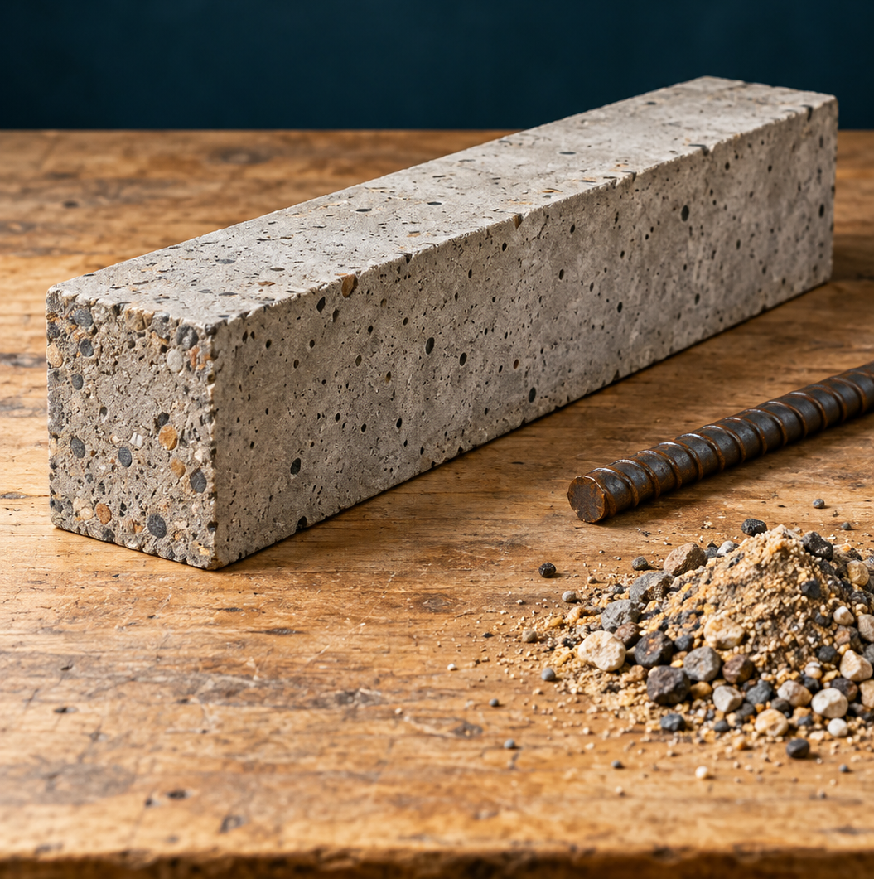
Figure. Concrete, steel and evidence: investigate how a beam carries load. Illustrative samples, not approved project dimensions.
Name ______________________________________ Class __________________
Group _____________________________________ Teacher ________________
Investigate materials. Explain beam behaviour. Plan carefully. Record what happened. Use evidence to evaluate.
Year 9 Engineering • Term 2 • Student learning and folio companion
START HERE

Your learning and evidence route
Use this workbook with the current Concrete Beam website, your teacher’s approved practical instructions and the assessment notification. Read the explanation, try the paper task, then use feedback to improve your evidence. The workbook supports learning; your teacher confirms how its pages contribute to the submitted folio.
Learning route | Pages
Materials and corrosion | 4–13
Concrete and composite materials | 14–21
Design and planning | 22–31
Class beam setups and practical evidence | 32–50
Analysis, redesign and evaluation | 51–58
Teacher-led video notebooks | 59–63
Checklist and handover | 64–65

Keep evidence traceable
Give each beam a clear ID. Put dates, units, photo labels and page references beside your records. Keep predictions separate from results. If something was not measured, write “not measured” and explain why; do not fill a gap with a guess.
“Source question” and “Source activity” preserve website tasks. “Practice” prompts are newly written formative learning tasks. The teacher guide contains model reasoning; your practical pages must describe your own group’s work.
What is one thing you want to understand about the way a concrete beam behaves?

START HERE

Your assessment and practical boundaries
Linked assessment draft: teacher confirmation needed
The linked draft notification names Projects & Reports 1, Task 1, a summative assessment worth 30%, with folio submission in Week 7, Term 2. These are draft-source records until your teacher confirms the issued notice. Issue date, exact calendar due date/time, submission method and component mark allocation are Teacher to confirm. Use the teacher-issued notification and current school assessment policy for formal requirements.
Required evidence in the notification | Where to prepare it
Brief, criteria, drawings, materials/tools and casting sequence | 22–31
WHS controls and build log with dated stage photos | 29, 40–44
Span, mix/water, reinforcement, cure time, first crack/failure evidence | 45–48
Table/graph where applicable; predicted versus actual analysis | 51–54
Evaluation, at least two specific improvements and reflection | 55–58

Practical work needs teacher confirmation
Before any work, confirm the assigned setup, mould/dimensions, cover and reinforcement details, mix measurement method, curing and demoulding procedure, test supports/span/loading, exclusion zone and stop protocol. The printed theory is not permission to operate equipment or conduct a destructive test.
Some website toolkit timing and numerical examples differ from the notification and class setup sheets. Record the teacher-confirmed details rather than combining different examples.
Teacher-confirmed detail | Our record
Issue / due date and time
Submission method / individual and group evidence
Assigned setup and next approval point

MATERIALS AND CORROSION

Choosing engineering materials

Engineering materials are grouped by what they are made from and how they behave. Metals such as steel, aluminium and copper are usually useful conductors; many can be shaped without immediately breaking. Polymers such as PVC and polyethylene are often lightweight, electrically insulating and easy to mould. Ceramics such as brick and glass are hard and heat-resistant, but often brittle.
A composite brings materials together so they perform useful roles as a system. Concrete contains cement paste and aggregate; reinforced concrete also contains steel. This explains why concrete can be described as a ceramic-based composite. A material family is a starting point, not a guarantee: engineers still check the actual product and conditions.

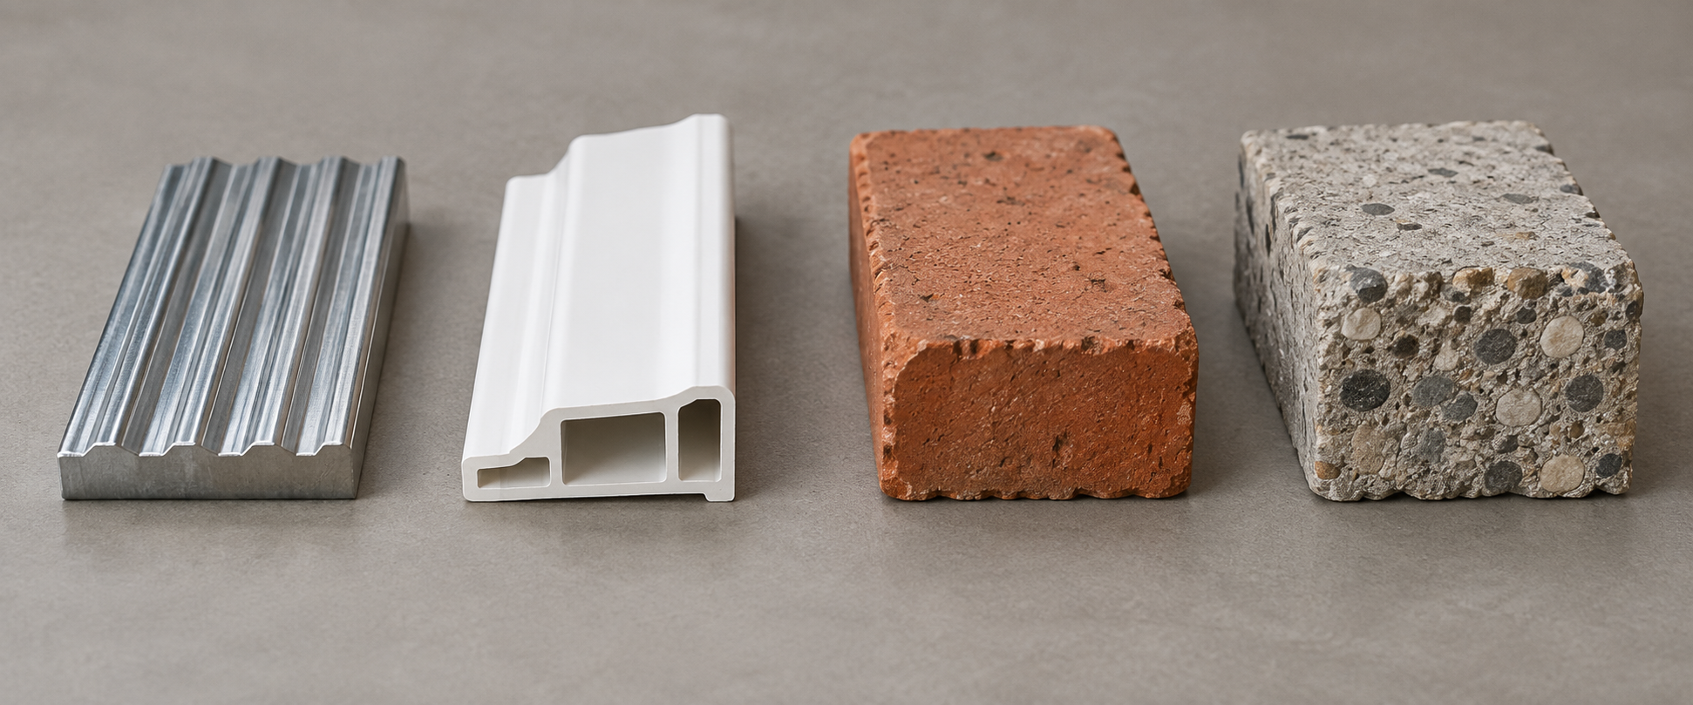
Figure. Material families help us ask useful property questions; the chosen product still needs checking. Illustrative samples, not approved project dimensions.
What are the main differences between metals, polymers, and ceramics?

Practice: classify steel reinforcement, a plastic formwork panel, a brick and concrete. Give one reason for each choice.

MATERIALS AND CORROSION

Properties that shape a decision

Strength is the ability to resist force without failure. Stiffness is resistance to deformation: a stiff member bends less under a given load. Toughness describes how much energy a material can absorb before fracturing. Ductility describes the ability to deform before breaking. These properties answer different questions, so “strong” does not automatically mean “stiff”, “tough” or “ductile”.
Durability concerns deterioration over time. Workability concerns shaping or processing the material. Material choice also includes manufacture, maintenance, replacement and environmental impact. A low purchase price may be poor value if a component quickly corrodes or needs frequent replacement.

Worked decision: two formwork options
Illustrative comparison: a reusable panel costs more initially than a one-use panel. If its surfaces remain sound and the teacher-approved system permits reuse, it may reduce later replacement and waste. The sensible choice depends on total use and condition; the example is not a price quote or class purchase instruction.
What is the relationship between material cost and material selection?

Practice: a beam carries a large load but bends noticeably. Which two properties must your evaluation discuss? Explain what evidence would show each.

MATERIALS AND CORROSION

Why corrosion happens

Corrosion is deterioration through reactions with the environment. Rusting steel is an electrochemical process: one region loses electrons (anode), another receives electrons (cathode), a conducting liquid acts as an electrolyte, and an electrical connection completes the process. Water, dissolved salts, oxygen and material type affect what happens.
Saltwater conducts better than fresh water because it contains dissolved ions. This can speed steel corrosion. Galvanic corrosion involves different metals in contact with an electrolyte; the more reactive metal can corrode preferentially. Uniform corrosion is spread across a surface, whereas pitting and crevice corrosion are localised. “A little rust” in one location may still matter to the component.

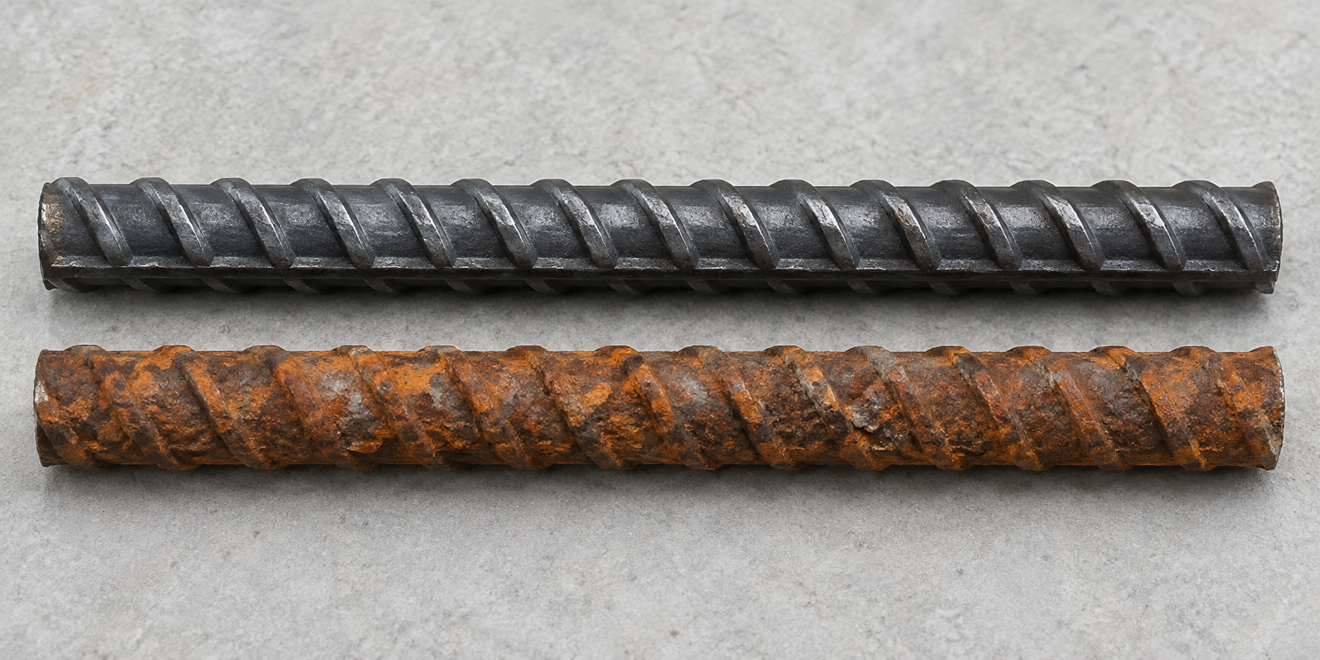
Illustrative clean steel and widespread corrosion. Describe the visible surface; appearance alone does not establish a corrosion mode or approve material for use.
Why does steel rust more quickly in saltwater than in fresh water?

What factors influence the rate of corrosion in metals?

MATERIALS AND CORROSION

Corrosion investigation record
Source activity: Corrosion Investigation
• Set up saltwater corrosion tests with different materials (mild steel, galvanised steel, aluminium, plastic).
• Observe and record changes over time (rust formation, pitting, discolouration).
• Compare corrosion rates and identify which materials are most resistant.
• Document your observations with photos and notes in your folio.

Use the teacher-approved setup. Keep sample size, solution/exposure conditions, observation time and recording method as consistent as the investigation allows. A photo supports a written observation; it does not measure a corrosion rate by itself.
Sample / protection | Initial condition | Date / later observation
Mild steel
Galvanised steel
Aluminium
Plastic

Practice: compare two samples. What observation supports your conclusion, and what limit makes you cautious?

MATERIALS AND CORROSION

Protecting metals for longer service

Protection works by changing the conditions that allow corrosion. Paint or epoxy can form a barrier between metal and the environment. The barrier needs to stay effective; a damaged coating may expose the metal. Galvanising also uses zinc, which can corrode preferentially and protect the underlying steel even where small areas are exposed.
Cathodic protection deliberately makes the protected metal the cathode. Material selection, dry enclosures, drainage, avoiding crevices and compatible metal combinations can also reduce risk. Engineers compare protection effectiveness, maintenance and the actual service environment instead of assuming one treatment solves every problem.

For reinforced concrete, cover and good-quality concrete limit harmful agents reaching steel. Cracks and chloride exposure can change durability. Coated or corrosion-resistant reinforcement may suit harsh environments, but its suitability and cost need checking for the particular structure.
How does galvanising protect steel from corrosion?

Why might an engineer choose epoxy-coated reinforcement for a concrete beam?

Practice: a steel fitting is frequently wet. Propose two different protection approaches and explain how each reduces exposure or corrosion.

MATERIALS AND CORROSION

Moisture and damp-proof courses

Water can move through small connected spaces in masonry by capillary action. Rising damp can damage finishes, promote mould and contribute to deterioration. A damp-proof course (DPC) interrupts that moisture pathway. The source describes plastic, bitumen or metal barriers used in construction.
A DPC has a different purpose from curing concrete. A DPC limits unwanted moisture movement through a building. Curing maintains suitable moisture around new concrete so cement hydration can continue. Keeping these purposes separate helps you explain why water can be useful at one stage yet damaging in another situation.

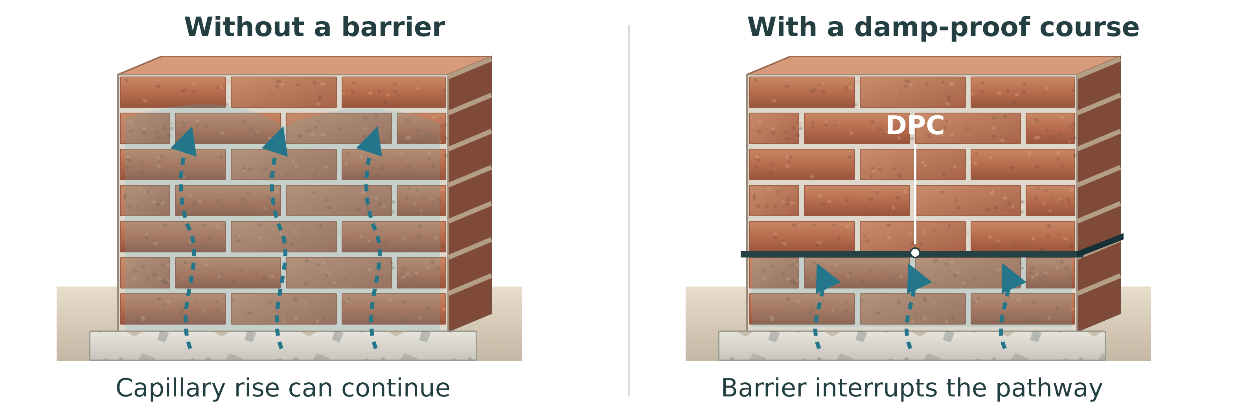
Conceptual comparison: a damp-proof course interrupts capillary moisture rising through masonry. This is not a construction detail or an approved installation specification.
Why is a damp-proof course important in construction?

Practice: explain why “all water is bad for concrete” is an unreliable statement.

MATERIALS AND CORROSION

Damp-proof course investigation
Source activity: Damp-Proof Course Investigation
• Observe DPC demonstrations showing how moisture rises through masonry.
• Compare walls with and without DPC to see the difference.
• Identify DPC materials and their properties (flexibility, durability, cost).
• Document findings in your folio with sketches and explanations.

Practice record: sketch the demonstration with and without DPC. Label what you actually saw; distinguish the barrier from the moisture path.
What happened in the demonstration? Identify the barrier material, one useful property and a limitation of your evidence.

MATERIALS AND CORROSION

Choosing and checking formwork

Formwork holds wet concrete until the beam can retain its shape. Its dimensions, joints and support affect the final shape and surface quality. It must stay stable while concrete is placed and compacted. A distorted or leaking mould can produce a beam that differs from the intended design.
Timber can be workable and reusable; steel can be strong and durable; polymer surfaces can be smooth and lightweight. None is automatically best. A useful selection explains strength, finish, workability, reuse and cost together. Mould preparation and any release agent follow the teacher-approved procedure.

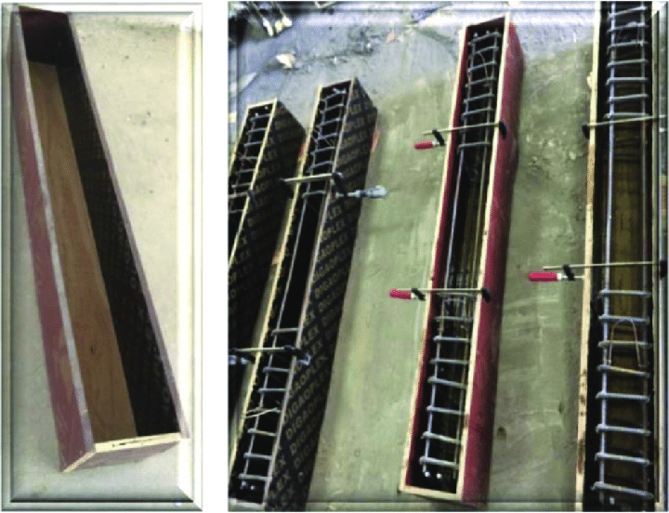
Source example of moulds and reinforcement. It does not specify the class beam dimensions, cover or approved method; use the teacher-confirmed class plan.
How do material properties affect the selection of formwork for concrete?

Practice: list three checks that could help prevent the actual mould from producing an inaccurate beam. Explain the reason for one.

MATERIALS AND CORROSION

Your materials brief
Source activity: Materials Brief
• Create a one-page materials brief for your concrete beam project.
• For each key material (concrete, steel reinforcement, formwork), comment on: strength, durability, workability, cost, and environmental impact.
• Link material choices to the beam's structural requirements and service environment.
• Include the brief in your project folio.

Material and job | Property-based reason | Cost / environment / limit
Concrete
Steel option / assigned reinforcement
Formwork

How does understanding material properties help in concrete beam design?

Use this materials brief in your folio. Note whether your assigned beam is plain or reinforced rather than describing a different group’s setup as your own.
MATERIALS AND CORROSION

Materials understanding check
What is a composite material, and why is concrete considered one?

Practice: which statement correctly distinguishes strength and stiffness?
○ A. Strength is load resistance; stiffness is resistance to deformation.
○ B. Stiffness means the material cannot corrode.
○ C. Any strong beam must show no deflection.
○ D. Toughness and stiffness are the same property.

Practice: which observation alone can support a visible-corrosion comparison?
○ A. Matched samples observed over the same period and exposure.
○ B. Samples with unknown start dates and different solutions.
○ C. A photograph with no sample identification.
○ D. A numerical corrosion rate invented from colour.

Source activity: Google Classroom Check-in
• Submit responses for Materials & Corrosion before starting experiments.
• Capture notes in your folio to use when evaluating your concrete beam materials.

Record the teacher-confirmed check-in method, feedback and one change you will make to your materials reasoning.

CONCRETE AND COMPOSITES

Concrete: a working composite

Concrete combines a binder with particles of different sizes. Cement reacts with water to form the paste that binds fine aggregate (sand) and coarse aggregate. The source describes aggregate as roughly 60 to 75% of concrete volume; this is background information, not a measurement of your batch. Reinforced concrete adds steel to carry tensile forces that concrete alone handles poorly.
Concrete is not simply “dried cement”. Hydration changes the cement-water system chemically. Aggregate contributes bulk, strength and material efficiency. Optional admixtures can change workability or setting behaviour, but their appearance in theory does not authorise their use in your class mix.

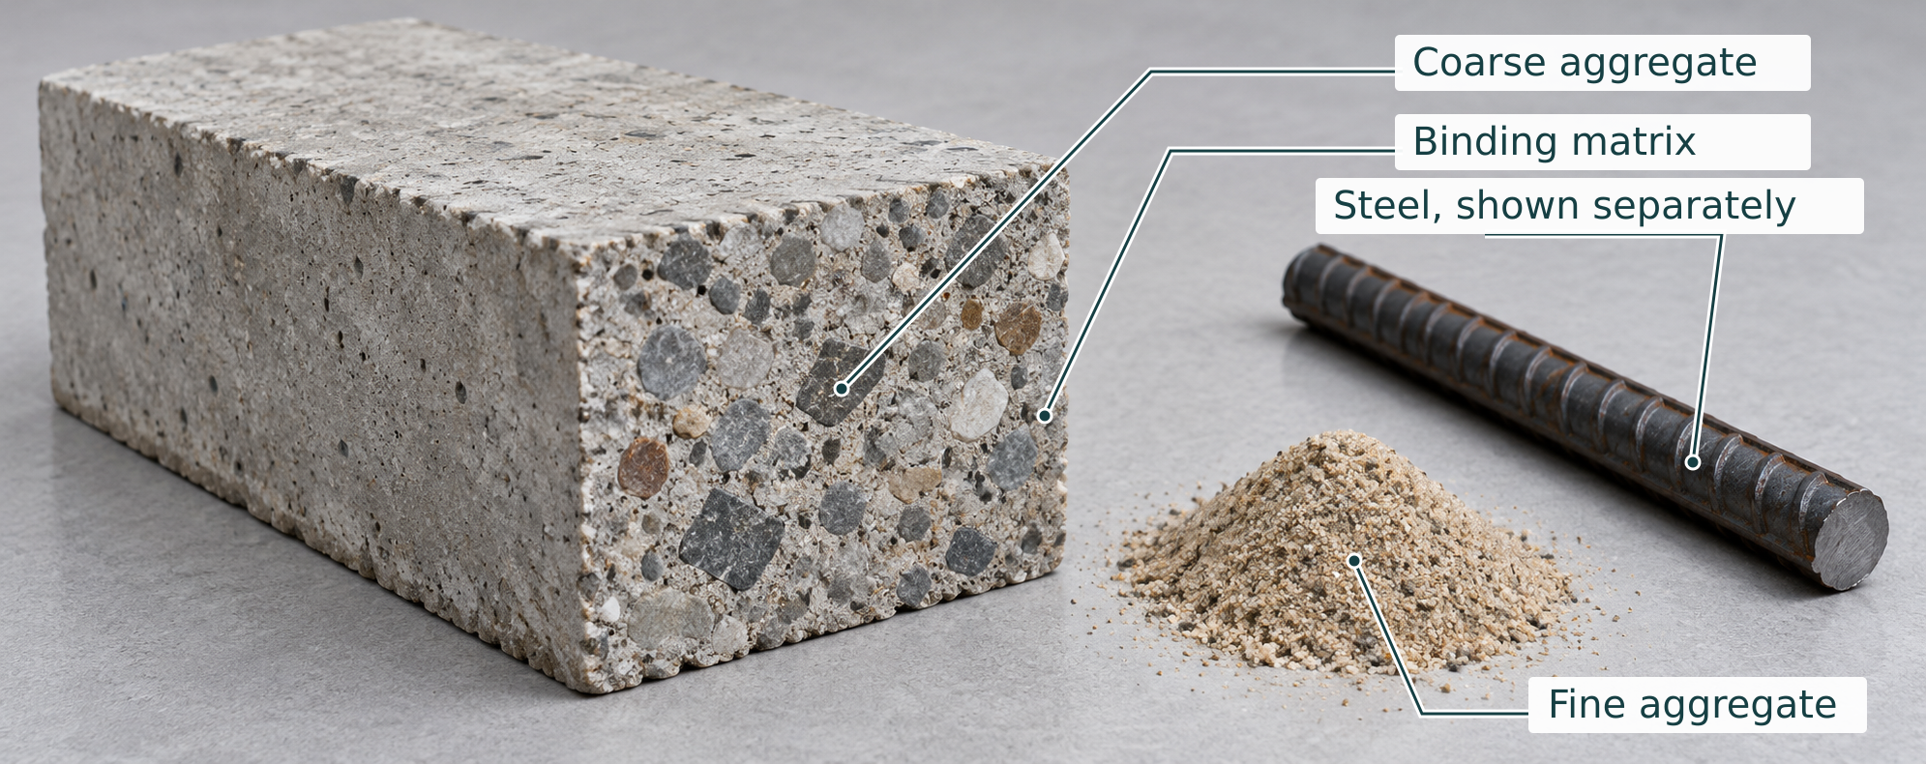
Illustrative concrete shows coarse aggregate bound within a cement-paste and fine-aggregate matrix. Steel is shown separately: the plain A/E beams intentionally contain no reinforcement.
Why is concrete considered a composite material?

Folio evidence: Materials and Concrete Components
Describe concrete as a composite material and justify the material choices in your beam.
• Describe cement, sand, aggregate, and water.
• Explain concrete as a composite material.
• Justify reinforcement as the tensile material.
Sentence starters: Concrete is a composite because ... . The role of aggregate is ... . Reinforcement was needed because ... .
Class boundary: Assigned A/E beams are deliberately plain. Explain steel’s tensile role for comparison without claiming your beam contains steel.

CONCRETE AND COMPOSITES

Water–cement ratio: reason with quantities

Water–cement ratio compares the mass of water with the mass of cement: W/C = water mass ÷ cement mass. The ratio has no unit when both masses use the same unit. It is not the ratio of scoop counts, and it does not compare water with the combined dry-material mass.
Water affects workability as well as strength. Too little for the chosen materials and method can make placement and compaction difficult. Excess water can leave greater porosity after the material hardens. Good concrete involves controlled water, sound placement and curing, not simply the smallest possible ratio.

Worked mathematics only
1 Identify the two masses. Use the same mass unit for water and cement.
Hypothetical mix | Water mass | Cement mass | Water ÷ cement
P | 0.45 kg | 1.00 kg | 0.45 ÷ 1.00 = 0.45
Q | 0.60 kg | 1.00 kg | 0.60 ÷ 1.00 = 0.60

2 Compare the results. Q has more water per kilogram of cement. Consider both workability and the possible effects of excess water. These are maths examples, not class recipes.

What is the water-cement ratio, and why does it matter?

Practice: calculate W/C for 0.40 kg water with 0.80 kg cement, then for 0.48 kg water with 0.80 kg cement. Show the divisions and explain one trade-off.

CONCRETE AND COMPOSITES

Mix design investigation
Source activity: Mix Design Investigation
• Research different concrete mix proportions and their typical uses.
• Calculate water-cement ratios for different mixes.
• Compare strength vs workability trade-offs.
• Select a mix design for your beam project and justify your choice.

The specific experiment uses dry ratios by volume: A–D use 1 cement : 2 sand : 3 aggregate; E uses 1 : 3 : 3. Use the same measuring container for every part. The sheet says to add water gradually until workable, not runny, and record the amount. The teacher confirms the practical method and batch quantity.
How does the mix proportion affect concrete properties?

What factors affect the workability of concrete?

Comparison / source | Ratio and basis | Use / trade-off
Teacher-provided example 1
Teacher-provided example 2
Our assigned class setup

CONCRETE AND COMPOSITES

Steel and concrete working together

Under a downward load on a simply supported beam, bending shortens the upper region and stretches the lower region. Concrete is much more effective in compression than tension. Steel near the tensile region can carry tensile force after concrete cracks, provided the reinforcement, bond and placement are suitable.
Composite action means the materials work together through their connection. Steel merely lying inside concrete does not guarantee a successful beam. Cover, anchorage/bond, reinforcement location, workmanship and curing influence behaviour. The class experiment deliberately compares low rods, high rods, mesh and plain concrete.

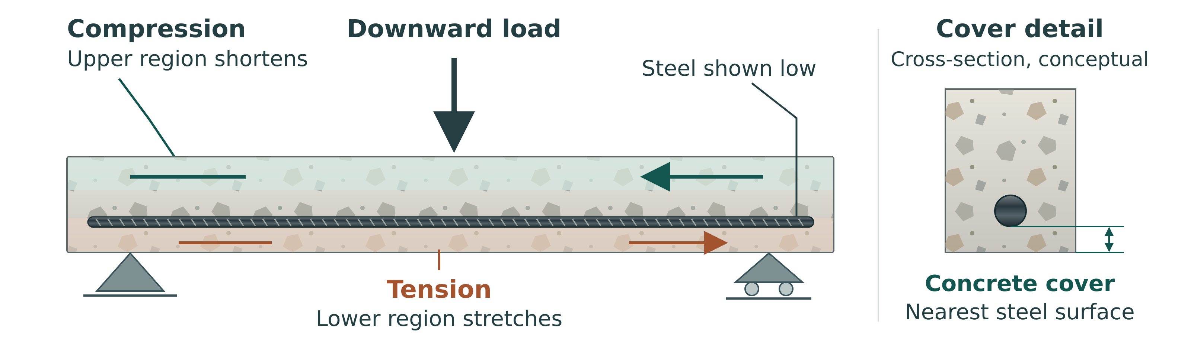
Conceptual relationship, not a project plan. Compression acts above and tension below for this loading case. Cover is measured to the nearest steel surface; the teacher confirms the class geometry.
Why does concrete need reinforcement?

Where should reinforcement be placed in a simply supported beam?

CONCRETE AND COMPOSITES

Cover, cracking and load direction

Cover is the distance from reinforcement to the concrete surface. It helps protect steel from environmental exposure and fire and contributes to an effective concrete–steel system. Reinforcement touching the mould has no concrete cover at that contact. The actual class cover and spacer method must be teacher-confirmed because the website gives conflicting generic ranges.
Cracking can arise from tensile loading, shrinkage or temperature effects. A crack’s location, direction and development help interpretation. Some tensile cracking is expected in reinforced concrete, but crack width, exposure and function affect whether it is acceptable. A small classroom crack does not prove a full-size structure is safe.

What is concrete cover, and why is it important?

What causes concrete to crack, and is cracking always bad?

Source activity: Reinforcement Investigation
• Observe examples of reinforced concrete structures (photos, videos, or site visits).
• Identify where reinforcement is placed and why.
• Understand the relationship between reinforcement placement and load direction.
• Sketch reinforcement layouts for different beam loading scenarios.

Practice: sketch the stated simply supported/downward-load case. Label load, supports, upper compression, lower tension and conceptual reinforcement. No project dimensions.
CONCRETE AND COMPOSITES

Curing is a chemical process

Hydration is the chemical reaction between cement and water. Curing keeps moisture and temperature suitable for that reaction to continue. Surface dryness is not a test of full strength. Concrete gains strength with age, but the rate depends on materials and conditions; 28 days is a conventional comparison age, not a universal finishing point.
The source describes water curing, moist coverings, plastic covers and curing compounds. These aim to maintain suitable conditions; they are not interchangeable instructions for every classroom. Record the teacher-approved method, start time, conditions and inspection. The folio requires at least seven days of curing before testing, and the teacher still decides when the beam can be demoulded, handled and tested.

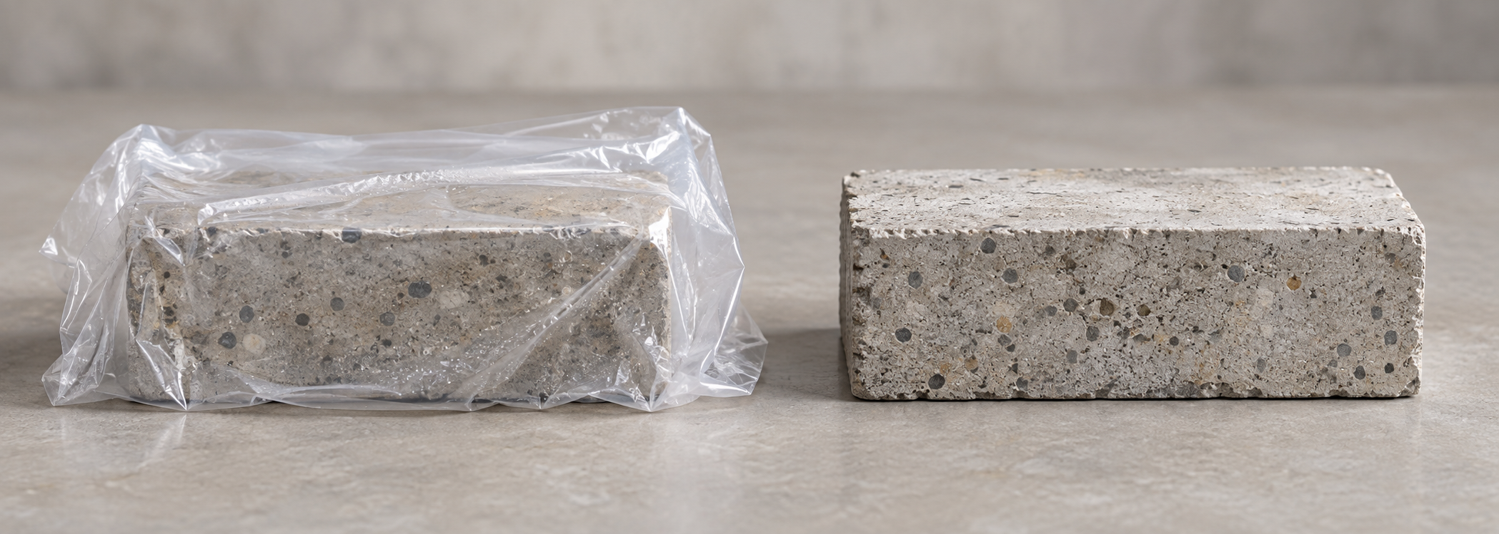
Illustrative comparison of moisture retention and exposure. Curing supports hydration; appearance does not establish strength, and the teacher confirms the actual method and handling.
What happens during concrete curing?

How long does concrete take to reach full strength?

CONCRETE AND COMPOSITES

Curing investigation and plan
Source activity: Curing Investigation
• Research curing methods and their effectiveness.
• Understand why curing time matters for strength development.
• Plan curing procedures for your beam project.
• Document curing conditions and methods in your folio.

Plan detail | Teacher-confirmed method / reason
Method and moisture control
Protected location and identification
Start date/time and planned checks
Handling/demoulding approval point
Testing readiness confirmation

Practice: why could two beams cast on the same day develop differently? Use two curing or construction factors.

CONCRETE AND COMPOSITES

Concrete understanding check
Strength development also depends on cement content, aggregate quality, compaction, curing conditions and age. Poor compaction can leave voids; those voids reduce effective material and can affect bond. A good evaluation considers several causes while using observations to decide which explanations are plausible.
Practice: which calculation is a valid water–cement ratio?
○ A. Water mass ÷ cement mass, using the same mass unit.
○ B. Water scoops ÷ all dry scoops.
○ C. Cement mass ÷ water mass.
○ D. Total concrete volume ÷ beam length.

Practice: which claim needs stronger evidence?
○ A. The beam was cured for the recorded number of days.
○ B. The cover was checked against the teacher-approved plan.
○ C. The surface is dry, so the beam has reached full strength.
○ D. The photo shows a visible crack on the underside.

Practice: complete and explain this cause chain: poor compaction → ______ → possible effect on beam behaviour. Then name the evidence needed before blaming this cause.

Source activity: Google Classroom Check-in
• Submit your mix design selection and justification.
• Share your reinforcement layout sketches.
• Document your understanding of concrete as a composite material.

DESIGN AND PLANNING

Your project brief and criteria
A design brief tells you what the project is intended to achieve and the limits you must follow. A success criterion should be checkable: describe the evidence needed to judge it. “A good beam” is too vague. A clear identification label, a recorded assigned mix and an explanation supported by observations are more useful because they can be checked.
Folio evidence: Project Brief and Success Criteria
Introduce the task and define the criteria your concrete beam will be judged against.
• State the design challenge.
• List the constraints.
• Define what a successful beam must do.
Sentence starters: The design challenge was to ... . A successful concrete beam needed to ... . The main limits we had to follow were ... .

Source activity: Design Brief Analysis
• Read and annotate the design brief, highlighting all requirements.
• Create a checklist of requirements to ensure your design meets all criteria.
• Identify any constraints or limitations.

Requirement / constraint | Evidence of success | Teacher-confirmed detail
Assigned beam setup
Construction / identification
Test and explanation

DESIGN AND PLANNING

Beam geometry: width, depth and span

Width and depth describe the beam cross-section; length describes the whole member. Span is the distance between the supports and is not automatically the full beam length. Under the same support and load arrangement, increasing the distance between supports increases bending demand. Comparisons need the actual span, not only a photograph of the beam.
Depth strongly influences bending behaviour because material farther from the neutral region has a larger role in resisting bending. Rotating a rectangular section changes which dimension is vertical. This explains a useful design relationship; it does not authorise changing the shared mould or give a guaranteed capacity for a concrete beam.

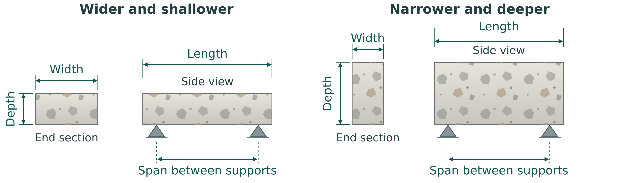
Conceptual comparison of one rectangular section in two orientations. Width, depth, overall beam length and support span are different measurements; no class dimensions or capacity are stated.
Why should beam depth usually increase before beam width when trying to improve bending strength?

Practice: two beams have identical dimensions but were tested over different spans. Why is a direct capacity comparison limited?

DESIGN AND PLANNING

Your beam design and load path
Folio evidence: Beam Design and Load Path
Explain your beam design using load path, tension, compression, and reinforcement action.
• Show where tension and compression occur.
• Explain reinforcement position.
• Predict likely cracking or failure.
Sentence starters: When the beam bends, the top face is ... and the bottom face is ... . We placed reinforcement ... because ... . Our predicted failure mode was ... .
Class boundary: Explain your assigned experiment: A/E plain, B rods low, C rods high, D mesh as instructed. Do not silently replace a comparison setup with a different design.

Source activity: Beam Design
• Select beam dimensions (width, depth, length) and justify your choices.
• Design reinforcement layout (type, size, placement).
• Create technical sketches showing beam cross-section and reinforcement placement.
• Calculate beam volume and required concrete quantities.

For a plain control beam, label “no reinforcement: assigned comparison”. For Setup C, explain that high rods are the deliberate variable. Put predicted behaviour on the drawing and later compare it with observed behaviour.
Your approved beam concept: draw a longitudinal view and a cross-section. Label supports/load context, beam ID, compression, tension, assigned reinforcement or no reinforcement, and predicted crack region.
Why is reinforcement placed near the bottom of a simply supported beam under downward load?

DESIGN AND PLANNING

Mould and reinforcement plan
Folio evidence: Mould and Reinforcement Plan
Document the mould, dimensions, reinforcement layout, cover, and labelling plan.
• Record mould dimensions.
• Show reinforcement layout and cover.
• Explain how the beam ID will be labelled.
Sentence starters: Our mould dimensions were ... . The reinforcement was placed ... mm from ... . We checked cover by ... .
Class boundary: Record teacher-approved dimensions and cover. For plain A/E, reinforcement/cover entries are not applicable. Source starter distances are blanks, not supplied specifications.

Use the dimensions you checked against the approved class mould. Do not copy the illustrative answer-deck dimensions or any generic cover range. Refer to your drawings on page 24 and attach a dated image that shows the actual measurement or layout.
Confirmed detail | Our record / units
Length × width × depth
Reinforcement / location / cover or plain setup
Spacers / label method / teacher confirmation

Required photo / still | Date, file or attached label | What the evidence shows
Mould Assembled
Reinforcement Layout
Cover / Spacers
Beam ID Label

DESIGN AND PLANNING

Concrete quantities: show your method
Use consistent units before multiplying. A rectangular mould volume is length × width × depth. One litre is 1,000,000 mm³. The mould volume estimates the space to fill; it does not by itself provide the measured mass of cement or the water–cement ratio. Dry materials pack and change volume when mixed, so a simple split of wet volume into dry parts needs a teacher-approved batch method.
Worked quantity method, hypothetical only
An example mould measuring 400 mm × 80 mm × 60 mm has a volume of 1,920,000 mm³ = 1.92 L. A hypothetical 10% planning allowance gives 1.92 × 1.10 = 2.112 L. This is an arithmetic example, not the class mould, batch recipe or authorised allowance.
What is a practical reason for adding a 10–20% waste factor to concrete quantity calculations?

Practice: a hypothetical rectangular mould measures 500 mm × 100 mm × 80 mm. Calculate its volume in mm³ and litres. If a teacher specified a 15% allowance for this example, calculate the planned volume.

Your approved quantity calculation: record confirmed mould dimensions, show the volume conversion and note the teacher-approved batch method/allowance. If a detail is pending, identify it.

DESIGN AND PLANNING

Your mix and casting plan
Folio evidence: Mix Design and Casting Plan
Record the mix design and the planned sequence for mixing, placing, compacting, and finishing.
• Record the mix ratio.
• Explain water control and compaction.
• List the casting steps in order.
Sentence starters: Our mix ratio was ... . We controlled water by ... . The casting sequence was ... .
Class boundary: Class dry volume recipes are A–D 1:2:3 and E 1:3:3; water is gradually added and separately recorded. Do not label volume counts as mass W/C.

Source activity: Mix Design
• Select concrete mix proportions and justify your choice.
• Calculate quantities of each component needed.
• Plan mixing procedure and workability checks.

Worked equal-container method
Hypothetical only: if one dry “part” is two equal scoops, a standard 1:2:3 batch uses 2 scoops cement, 4 scoops sand and 6 scoops aggregate. The changed 1:3:3 batch uses 2, 6 and 6 scoops. These dry counts are not the yield in litres and are not mass W/C.
Plan detail | Our teacher-confirmed record
Setup / container / dry ratio
Cement / sand / aggregate amounts
Water recording and workability check
Approved mixing / compaction method

DESIGN AND PLANNING

A logical casting sequence
A useful casting sequence explains what must be checked before the next stage. Identification, mould checks and the assigned reinforcement arrangement need attention before evidence is hidden inside concrete. Compaction limits air pockets; finishing and curing protection follow placement. Demoulding and handling need teacher confirmation rather than a generic time copied from a toolkit.
Source activity: Casting Plan
• Create a detailed step-by-step casting sequence.
• Plan mould preparation and reinforcement placement.
• Identify safety hazards and controls for casting operations.

Practice: arrange these planning cards in a logical order, then explain one dependency: A protect and record curing; B check approved mould/label and assigned reinforcement; C prepare/record the authorised mix and water; D place/compact by the approved method; E finish, label and record casting evidence.

Stage / approval point | Our assigned sequence and evidence
Before casting
Mix / place / compact
Finish / label / protected curing
Demould / handle / readiness confirmation

DESIGN AND PLANNING

Your WHS and risk-control record
Folio evidence: WHS and Risk Controls
Explain the hazards, PPE, and controls used during mixing, casting, curing, and destructive testing.
• Identify cement dust, wet concrete, tools, lifting, and test hazards.
• Explain PPE and safe zones.
• Link controls to your SWMS.
Sentence starters: The main hazards were ... . We controlled these risks by ... . During testing, the safe zone was important because ... .

Hazard means a possible source of harm. A control reduces the chance or consequence of harm. Link each control to the hazard it addresses: a barrier and agreed stop process serve a different role from gloves. Record the current school procedure and ask the teacher about missing controls before work proceeds.
Hazard / task | Approved control and reason | SWMS / confirmation
Dry cement dust
Wet concrete contact
Tools / mould / reinforcement edges
Lifting / pinch points
Loading / fragments / observation zone

Teacher confirmation / unresolved control: __________________________________________
DESIGN AND PLANNING

Plan a repeatable beam test
Repeatable testing means the important conditions are described and controlled. Support span, load location and beam orientation affect bending. A deflection reading also needs a fixed reference and the same reading method. A clear table preserves observations as the test unfolds; memory after failure is a weaker record.
Source activity: Test Plan
• Design test setup and loading arrangement.
• Plan data collection procedures and recording methods.
• Identify safety requirements for testing.

When planning a beam test, why should load be applied in small increments instead of one large step?

Plan detail | Teacher-confirmed method / record
Support span / orientation / load location
Equipment / permitted loading / stop decision
Measurement / datum / units / recorder
Observation zone / authorised photo role

DESIGN AND PLANNING

Planning review and teacher feedback
Planning is useful when feedback changes a decision before casting. Bring the brief, drawings, quantities, assigned setup, WHS record and test plan together. Check that the same beam ID and measurement basis appear throughout. A plan can be complete on paper while still awaiting teacher permission for a practical stage.
How does curing quality affect your later test results?

Source activity: Google Classroom Check-in
• Submit your beam design, mix design, and casting plan before starting construction.
• Get teacher feedback on your design before casting.

Plan / source page | Teacher feedback | Revision / next confirmation
Design and reinforcement, pages 24–25
Quantities and casting, pages 26–28
WHS and testing, pages 29–30

Choose one piece of feedback. Explain what you changed and why it will improve the quality of evidence or construction.

MAKE AND TEST EVIDENCE

The class experiment and group record
Each beam setup is made twice. The repeated beam checks whether the result was fair or just a one-off. Match your assigned group to its beam ID, setup and repeat partner; later reports need this traceable class record.

Keep these the same
• Use the same mould size unless your teacher says otherwise.
• Use the same casting method.
• Use the same curing time.
• Use the same test setup.
• Label your beam clearly before it cures.
Every group records its number/setup, dimensions, mix, water amount, reinforcement/type/position, stage photos, maximum recorded load and cracking behaviour. Use “not measured” when the approved test cannot provide a value.

Groups | Setup / main variable
1 and 2 | A: plain; standard mix
3 and 4 | B: rods low; standard mix
5 and 6 | C: rods high; standard mix
7 and 8 | D: mesh; standard mix
9 and 10 | E: leaner mix; no reinforcement

Dry ratios use one identical volume container: A–D = 1 cement : 2 sand : 3 aggregate; E = 1 : 3 : 3. Water is slowly added to a workable, not runny, consistency and separately recorded. This is not a mass water–cement ratio.
MAKE AND TEST EVIDENCE

Your class group and beam register
Keep the ten source group entries together so each beam can be traced to its assigned setup and record. Complete only the names and beam IDs confirmed by your teacher. The A–E setup sheets and your actual records control the comparison; do not fabricate another group’s result.
Group | Setup | Student names
1 | A
2 | A repeat
3 | B
4 | B repeat
5 | C
6 | C repeat
7 | D
8 | D repeat
9 | E
10 | E repeat

MAKE AND TEST EVIDENCE

Setup A: Plain concrete

Groups 1 and 2
Make a plain concrete beam with no reinforcement. This is the control beam used for comparison.
Source sequence
1. Collect one clean mould.
2. Write your group number and Setup A on the beam label.
3. Lightly oil or line the mould if instructed.
4. Mix the standard concrete mix: 1 cement : 2 sand : 3 aggregate.
5. Add water slowly and record how much you used.
6. Fill the mould in layers.
7. Tap or vibrate the mould gently to remove air pockets.
8. Level the top with a trowel or straight edge.
9. Place the label where it can be seen after curing.
10. Move the beam to the curing area.
Carry out practical work only under the teacher-approved method, supervision and controls. Exact dimensions, cover and readiness are Teacher to confirm.
Check before you finish
□ No steel rods.
□ No mesh.
□ Standard concrete mix only: 1 cement : 2 sand : 3 aggregate.
□ Water amount has been recorded.
□ Beam is labelled.

Field | Our record
Beam ID / casting date
Groups / student names
Mix ratio / volume container
Water added / units
Important details for report writers

Will this beam be stronger or weaker than reinforced beams? Why?

MAKE AND TEST EVIDENCE

Setup B: Steel rods near bottom

Groups 3 and 4
Test how well steel rods work when placed near the bottom of the beam.
Source sequence
1. Collect one clean mould and the steel rods provided.
2. Write your group number and Setup B on the beam label.
3. Place small spacers in the bottom of the mould if provided.
4. Place the steel rods lengthways near the bottom of the beam.
5. Keep the rods away from the edges so concrete can cover them.
6. Mix the standard concrete mix: 1 cement : 2 sand : 3 aggregate.
7. Add water slowly and record how much you used.
8. Carefully fill the mould without moving the rods.
9. Tap or vibrate the mould gently to remove air pockets.
10. Level, label, and move the beam to the curing area.
Carry out practical work only under the teacher-approved method, supervision and controls. Exact dimensions, cover and readiness are Teacher to confirm.
Check before you finish
□ Steel rods are near the bottom.
□ Rods run along the length of the beam.
□ Rods are covered by concrete.
□ Standard concrete mix only: 1 cement : 2 sand : 3 aggregate.
□ Water amount has been recorded.

Field | Our record
Beam ID / casting date
Groups / student names
Mix ratio / volume container
Water added / units
Important details for report writers

Why might steel near the bottom help when the load pushes down from above?

MAKE AND TEST EVIDENCE

Setup C: Steel rods near top

Groups 5 and 6
Test what happens when the steel rods are placed near the top of the beam instead of the bottom.
Source sequence
1. Collect one clean mould and the steel rods provided.
2. Write your group number and Setup C on the beam label.
3. Mix the standard concrete mix: 1 cement : 2 sand : 3 aggregate.
4. Add water slowly and record how much you used.
5. Add a shallow layer of concrete to the mould first.
6. Place the steel rods lengthways near the top of the beam.
7. Keep the rods away from the top surface and side edges.
8. Fill the rest of the mould carefully.
9. Make sure the rods stay near the top and do not sink.
10. Tap or vibrate the mould gently to remove air pockets.
11. Level, label, and move the beam to the curing area.
Carry out practical work only under the teacher-approved method, supervision and controls. Exact dimensions, cover and readiness are Teacher to confirm.
Check before you finish
□ Steel rods are near the top.
□ Rods run along the length of the beam.
□ Rods are fully covered by concrete.
□ Standard concrete mix only: 1 cement : 2 sand : 3 aggregate.
□ Water amount has been recorded.

Field | Our record
Beam ID / casting date
Groups / student names
Mix ratio / volume container
Water added / units
Important details for report writers

Do you think this will be stronger or weaker than Setup B? Explain your reason.

MAKE AND TEST EVIDENCE

Setup D: Mesh reinforced beam

Groups 7 and 8
Test whether mesh reinforcement improves the beam strength compared with plain concrete.
Source sequence
1. Collect one clean mould and one piece of mesh.
2. Write your group number and Setup D on the beam label.
3. Check that the mesh fits inside the mould.
4. Place the mesh inside the beam, slightly below the middle if instructed.
5. Keep the mesh away from the bottom, top, and side edges.
6. Mix the standard concrete mix: 1 cement : 2 sand : 3 aggregate.
7. Add water slowly and record how much you used.
8. Fill the mould carefully so the mesh stays in position.
9. Tap or vibrate the mould gently to remove air pockets.
10. Level, label, and move the beam to the curing area.
Carry out practical work only under the teacher-approved method, supervision and controls. Exact dimensions, cover and readiness are Teacher to confirm.
Check before you finish
□ Mesh is inside the beam, not touching the mould.
□ Mesh is covered by concrete.
□ Standard concrete mix only: 1 cement : 2 sand : 3 aggregate.
□ Water amount has been recorded.
□ Beam is labelled.

Field | Our record
Beam ID / casting date
Groups / student names
Mix ratio / volume container
Water added / units
Important details for report writers

How might mesh change the way the beam cracks?

MAKE AND TEST EVIDENCE

Setup E: Changed concrete mix

Groups 9 and 10
Test how changing the concrete mix affects beam strength. This beam has no reinforcement.
Source sequence
1. Collect one clean mould.
2. Write your group number and Setup E on the beam label.
3. Use the changed mix ratio: 1 cement : 3 sand : 3 aggregate.
4. Measure the materials carefully. Do not guess.
5. Mix until the concrete looks even.
6. Add water slowly. The mix should be workable, not runny.
7. Record how much water you used.
8. Fill the mould in layers.
9. Tap or vibrate the mould gently to remove air pockets.
10. Level, label, and move the beam to the curing area.
Carry out practical work only under the teacher-approved method, supervision and controls. Exact dimensions, cover and readiness are Teacher to confirm.
Check before you finish
□ No steel rods.
□ No mesh.
□ Changed mix ratio has been recorded: 1 cement : 3 sand : 3 aggregate.
□ Water amount has been recorded.
□ Beam is labelled.

Field | Our record
Beam ID / casting date
Groups / student names
Mix ratio / volume container
Water added / units
Important details for report writers

Will this mix make the beam stronger or weaker? Why?

MAKE AND TEST EVIDENCE

Class beam test observations by setup
Record the actual teacher-led observations for your assigned setup. Add other class setups only from teacher-provided observations. Identify each beam and group; write not measured where the test does not provide a calibrated load. Keep these records separate from predictions.
Setup A: Plain concrete
Test result notes: maximum recorded load, crack location and failure type, or measurement limits.

Setup B: Steel rods near bottom
Test result notes: maximum recorded load, crack location and failure type, or measurement limits.

Setup C: Steel rods near top
Test result notes: maximum recorded load, crack location and failure type, or measurement limits.

Setup D: Mesh reinforced beam
Test result notes: maximum recorded load, crack location and failure type, or measurement limits.

Setup E: Changed concrete mix
Test result notes: maximum recorded load, crack location and failure type, or measurement limits.

MAKE AND TEST EVIDENCE

From plan to cast beam
A cast beam hides important construction details. Before concrete covers them, record the assigned reinforcement or the deliberately plain mould, beam identity and checked geometry. During casting, note actual mix/water, placement and any movement or problem. The finished surface alone cannot show whether the hidden arrangement matches the plan.
Source mould and reinforcement example, not the class dimensions or permission to make. Record the assigned A–E setup and approved class details separately.
Source testing-day sequence
1. Collect your cured beam and check the label.
2. Measure and record the beam dimensions.
3. Set the beam on the supports exactly as shown by your teacher.
4. Load the beam slowly and safely.
5. Record the maximum load before failure.
6. Photograph the crack pattern.
7. Compare your result with the group that made the same setup.
8. Explain whether the repeat test was similar or different.
This source sequence is an observation/planning reference under teacher control. It does not grant permission to handle, load or approach a failed beam. Follow local readiness, exclusion-zone and stop controls; record measurement limits.
Practice: what is one important detail a final beam photograph cannot establish, and which earlier record would provide evidence?

MAKE AND TEST EVIDENCE

Casting build log
Folio evidence: Casting Evidence
Use build-log evidence to explain what happened during casting and how the group solved problems.
• Add dated photos of mould preparation and pour.
• Record problems during casting.
• Explain how the group corrected issues.
Sentence starters: During casting, we ... . One problem was ... and we fixed it by ... . The photos show evidence of ... .

Useful entries connect action and reason. “Poured the beam” is incomplete if it omits identification, the recorded mix or a problem that changed placement. If a step followed the plan without a problem, say so instead of inventing a dramatic correction.
Date / stage / people | What happened and why | Photo / advice / result

MAKE AND TEST EVIDENCE

Casting photo evidence
Select photographs that prove something about the actual group’s work. A caption should identify the stage, date/beam ID and visible detail. “This is concrete” adds little. “Beam B3 before pouring: lengthways rods remained near the approved lower position” identifies the evidence; it still needs a separate measurement record to establish cover.
Required photo / still | Date, file or attached label | What the evidence shows
Mould Prep
Reinforcement
Pour
Finish
Problem + Fix

Write two evidence captions for your own casting photos. Explain what each photo can show and one detail it cannot establish.

If there was no casting problem, write “no observed problem” in the Problem + Fix slot and document the check or feedback. If the photo was not taken safely, record an approved alternative.
MAKE AND TEST EVIDENCE

Your actual curing record
Folio evidence: Curing Record
Record curing conditions and explain how curing affects strength, cracking, and final performance.
• Record curing start date and method.
• Explain why moisture and time matter.
• Note any cracks or handling damage before testing.
Sentence starters: Our beam cured for ... days. We kept it curing by ... . Curing matters because ... .

Curing history helps explain differences between nominally identical beams. Record interruptions or damaged covers honestly. If temperature was not measured, describe the known setting without inventing a numerical value.
Date / elapsed time | Method / conditions / check | Change / damage / evidence
Start
Check 1
Check 2
Check 3
Pre-test

What condition or interruption might affect your later interpretation? If none was observed, explain one limit in your curing record.

MAKE AND TEST EVIDENCE

Curing evidence and pre-test inspection
Pre-test inspection establishes what was already present. Label and photograph a crack before loading so you do not later treat it as a new test event. Distinguish a surface mark, a visible crack and handling damage. Inspection records help interpretation but do not establish structural safety or permission to test.
Required photo / still | Date, file or attached label | What the evidence shows
Curing Setup
Beam ID / Date
Covered / Moist
Pre-test Inspection

Feature checked | Actual observation / evidence | Teacher advice / limit
ID and dimensions
Cracks / surface / handling damage
Curing dates and readiness

MAKE AND TEST EVIDENCE

Your actual test method
Folio evidence: Test Method
Describe the test setup clearly enough that another group could repeat it safely.
• Describe support spacing and load position.
• Record load increments.
• Explain how deflection was measured fairly.
Sentence starters: To test the beam, we ... . The load was applied at ... . The test was fair because ... .
Class boundary: Report the actual teacher-approved method. Generic source loading prose is not student permission or a locally approved operating procedure.

Method detail | Actual record / units / limits
Span / support / load position
Loading / increments / stop decision
Deflection method / datum / recorder

Required photo / still | Date, file or attached label | What the evidence shows
Support Setup
Load Point
Deflection Measurement
Safety Zone

The original tractor sheet records an estimated rear-wheel load of 750 kg. That estimate does not establish a measured load transferred to the beam, an incremental test, or a failure capacity. Only the teacher may authorise and control the demonstration.
MAKE AND TEST EVIDENCE

Results: record before interpreting
Folio evidence: Results and Data
Report measured results and interpret what they show about strength, stiffness, and performance.
• Report first crack load.
• Report failure load.
• Use the test record sheet to record prediction, crack location, observations, and what happened during the tractor rear wheel load test.
• Summarise load, deflection, and observations in a table or graph.
Sentence starters: The first crack occurred at ... . The maximum load was ... . The data shows that ... .
Class boundary: The source estimated 750 kg rear-wheel label is not a measured failure load or beam rating. Record measurements only when the approved method provides them.

Step / time | Load / basis / units | Deflection mm or not measured | Observation / evidence
Before
1
2
3
4
Final

First crack / location | Peak recorded / failure / units

MAKE AND TEST EVIDENCE

The original beam test record

Original teacher-led observation record, reproduced unchanged and resized to fit. The source’s estimated 750 kg rear-wheel load is not a measured beam failure load or capacity.
MAKE AND TEST EVIDENCE

The original sketch and observation sheet

Original teacher-led observation record, reproduced unchanged and resized to fit. The source’s estimated 750 kg rear-wheel load is not a measured beam failure load or capacity.

MAKE AND TEST EVIDENCE

Original test record: editable companion
Teacher-led observation record. Estimated rear-wheel load in the source: 750 kg. It is not a measured beam failure load, a rating or permission to operate equipment.
Original record detail | Your actual observation / record
Names
Class / date / group
Beam ID / number
Beam type / mix
Prediction
Failed? Where did it crack? What happened?

Explain why recording pre-existing damage matters when you compare your prediction with the test.

MAKE AND TEST EVIDENCE

Original sketch and evidence: editable companion
Original sketch and observations sheet. Use labels, show where the crack started, and keep the sketch simple and clear. Record only the teacher-approved demonstration you observed.
Draw the beam, paver supports, tractor rear wheel, and where the crack/failure happened.
Labelled sketch / observation reference
Original conclusion question | Your actual evidence and reasoning
Did the beam hold or fail?
Where did the beam crack?
How could the beam be improved?

Describe one observed feature, name a plausible explanation, and state the evidence or limitation that affects your confidence.

ANALYSIS AND EVALUATION

Strength, stiffness and useful data
Strength and stiffness describe different evidence. The largest reliably recorded load before failure concerns load resistance; movement at a stated comparable load concerns stiffness. Use the same measurement basis, support span and load position when comparing beams. A beam can resist breaking yet deflect noticeably.
Required photo / still | Date, file or attached label | What the evidence shows
First Crack
Max Load / Failure
Final Damage
Data Table / Graph

What is the difference between strength and stiffness in your concrete beam?

What are the main sources of error in your beam tests?

Source numerical examples are illustrations, not your result. State whether an error was observed, estimated or merely possible. An unsupported “±1 to 2 mm” copied from a model answer is not a measured uncertainty.
ANALYSIS AND EVALUATION

Draw and interpret your graph
A table preserves values and units; a graph makes a pattern easier to see. Choose variables supported by the test. For a load–deflection plot, label horizontal load in N and vertical deflection in mm, use a regular scale and identify notable events. A loading-stage observation chart may suit a test that did not measure deflection. Do not invent intermediate values to make a smooth line.
Hypothetical coherent graphing example
Load N | Deflection mm | Observation
0 | 0 | Before loading
100 | 1 | No visible crack
200 | 2 | No visible crack
300 | 4 | First visible crack
400 | 7 | Final recorded step; failure observed

These invented teaching values form one internally consistent example. They replace no class record. The source answer slide’s table, graph and paragraph conflict numerically, so that slide is not used as a coherent dataset.
Plot the hypothetical dataset or your reliable approved data. Title the graph; label axes, units and scale; mark the observed first crack/final event. State which dataset you used.
How can graphs and tables improve your folio?

ANALYSIS AND EVALUATION

Compare repeated class setups
The repeat beam helps distinguish an apparent setup effect from a one-off result. Compare A with E to investigate changed dry mix while both remain plain. Compare B with C to investigate rod position under the same load case. Compare A with D to explore the assigned mesh effect. Keep other conditions and measurement limits visible.
Why might two beams with the same design fail at very different loads?

Setup / paired groups | Recorded results and units | Similar / different / limit
A: 1 and 2
B: 3 and 4
C: 5 and 6
D: 7 and 8
E: 9 and 10

Choose one comparison. Make a cautious claim, cite the evidence, and explain one reason it cannot prove a universal rule.

ANALYSIS AND EVALUATION

Failure analysis: follow the evidence
Folio evidence: Failure Analysis and Redesign
Analyse the failure mode using test evidence and propose a specific redesign or process improvement.
• Identify the failure mode.
• Use evidence to explain why it happened.
• Propose one realistic design or process improvement.
Sentence starters: The beam failed by ... . This happened because ... . Next time, I would improve ... by ... .
Class boundary: The source card asks for one improvement; the linked draft notice asks for at least two. Page 55 prepares two proposals; your teacher’s issued notice controls submission.

Reading beam failure cues
In the stated simply supported beam under a downward load, the upper region is in compression and the underside is in tension. Concrete cracks readily in tension, so the place a crack starts helps you interpret the behaviour.
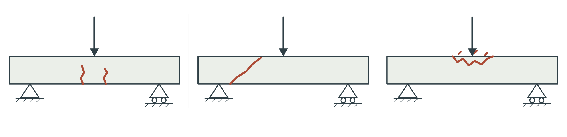
Conceptual beam cues, left to right: flexural bending, shear and compression. Arrows show downward load; the supports show the stated case. These are comparison cues, not class results or a setup drawing.
Flexural bending: cracks start on the underside tension face and may widen and extend upward as loading increases.
Shear: diagonal cracks near a support may indicate shear failure.
Compression: crushing in the upper region may indicate compression failure.
Compare crack location, direction and development with your actual load/support case and test history. A cue supports an interpretation; one image alone does not prove a unique cause or steel yielding. State what was observed and what remains uncertain.
Required photo / still | Date, file or attached label | What the evidence shows
Failure Close-up
Crack Path
Tension / Compression
Improvement Sketch

ANALYSIS AND EVALUATION

Redesign one cause at a time
A redesign should test a reasoned idea. Choose the factor most strongly supported by the evidence, then state the proposed change, why it might help, what must stay the same and how the next result would be compared. Changing everything makes it difficult to identify which change mattered. Proposed changes need teacher review before any new practical work.
When you re-design, should you change everything at once?

Specific improvement | Evidence and expected benefit | Fair comparison / teacher review
1
2

Sketch your most useful proposed change. Label what changes, what stays the same and the teacher-confirmation point. This is a proposal, not permission to rebuild.
ANALYSIS AND EVALUATION

Evaluate against your criteria
Folio evidence: Final Evaluation and Reflection
Write a final judgement that links evidence, engineering theory, WHS, and sustainability.
• Judge how well the beam met the criteria.
• Connect to WHS and sustainability.
• Explain what you would do differently next time.
Sentence starters: Overall, our beam ... . The strongest evidence for this judgement is ... . This project taught me that ... .

What makes a strong evaluation paragraph in your folio?

Write a final evaluation paragraph: judgement against a criterion → evidence with units or clear observation → engineering explanation → limitation → specific next step.

Concrete beam test video | Date / beam ID / file or approved alternative
Test Video Evidence

Digital folio reminder: photos and test video are included in the ZIP backup. The smaller JSON-only download does not contain the test video. Confirm the teacher’s final submission method and check the exported files actually open.
ANALYSIS AND EVALUATION

WHS, sustainability and reflection
Engineering responsibility includes construction choices, safe work and the service life of a product. Cement production, aggregate sourcing, reuse, material waste and possible recycling belong in the discussion. Longer service life can reduce replacement, but an unverified durability claim is not enough to justify a choice.
How should you talk about safety and environment in your evaluation?

Actual decision / action | Safety or environmental reason | Evidence / next improvement
Materials / waste
Handling / observation / approved controls
Reuse / service life / end of use

What did you contribute, what did the group learn from evidence, and what would you do differently in a future teacher-approved investigation?

ANALYSIS AND EVALUATION

Model testing: what the evidence can show
A small model lets you connect theory, construction and observation, but it does not scale perfectly to a full-size structure. Material size, reinforcement detail, support/loading method and measurement precision matter. Testing near failure can reveal behaviour in an authorised demonstration; permission, loading control and stopping decisions belong to the teacher.
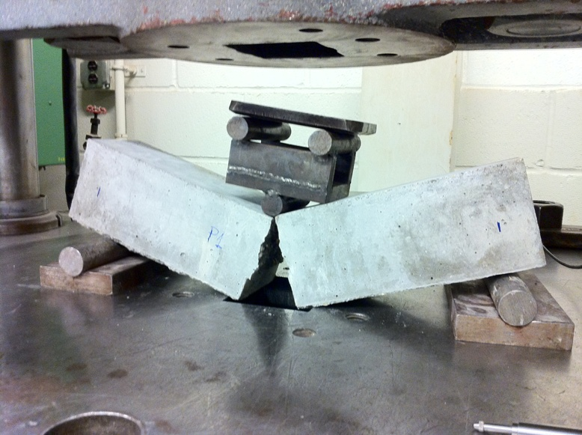
Source observation of a fractured beam in a test machine. This teacher-led example gives no class load rating, loading instructions or permission to operate equipment.
Why do we cast and test a small concrete beam instead of just calculating a full-size design?

Why do we test beams close to failure instead of stopping when they "look safe"?

What makes a good test method for your concrete beam?

A single teacher-led tractor-wheel event may show hold/fail and crack behaviour. The source’s estimated wheel figure cannot alone establish calibrated first-crack/failure load or load–deflection points. State what the method can and cannot show.
TEACHER-LED MEDIA

Video notebook: safety and mixing

Teacher-led media notebook. The three titles and links below come from the course clip index. Your teacher chooses suitable excerpts and checks playback. If a clip is unavailable, use the printed alternative and record that choice.
The printed alternative is pages 6 to 8 for hazard reasoning and corrosion, pages 14 to 16/27 for components, equal-volume dry ratios and measured water, and page 29 for local WHS records. Wet-concrete contact and cement dust need hazard-specific controls from the current school SWMS. A video is a discussion source, not a practical authorisation.

Concrete Burns: What They Are + How to Prevent Them
https://www.youtube.com/watch?v=W57PbWkY2VM
Watch for: Identify a hazard and the control shown; compare with the current school SWMS, not with an assumption that the clip is your local procedure.
How to Mix Concrete (Beginner-friendly)
https://www.youtube.com/watch?v=MTHYL6SYn6I
Watch for: Look for even mixing and consistency. Record what the clip shows without treating its equipment/timing as a class instruction.
Basic Concrete Mix Ratio (Simple explanation)
https://www.youtube.com/watch?v=_blO07aznEM
Watch for: Identify how quantities are measured. Compare its example with assigned A–D 1:2:3 or E 1:3:3; keep water separately recorded.

Clip / timestamp or printed page | Observed detail → engineering meaning
1 / Concrete Burns: What They Are + How to Prevent Them
2 / How to Mix Concrete (Beginner-friendly)
3 / Basic Concrete Mix Ratio (Simple explanation)

TEACHER-LED MEDIA

Video notebook: beam behaviour

Teacher-led media notebook. The three titles and links below come from the course clip index. Your teacher chooses suitable excerpts and checks playback. If a clip is unavailable, use the printed alternative and record that choice.
The printed alternative is pages 17 to 18 and 23 to 24. For the stated simply supported/downward-load case, upper concrete shortens and lower concrete stretches. Reinforcement where assigned contributes a tensile role; support span and load location define the comparison. Changing the load case can change the tension region.

Tension vs Compression in a Beam
https://www.youtube.com/watch?v=1mrtPn55Yqw
Watch for: Identify the support/load case and which regions stretch or shorten. Sketch the concept, not a class dimensioned plan.
Why Concrete Needs Reinforcement
https://www.youtube.com/watch?v=cZINeaDjisY
Watch for: Explain steel’s tensile role and the connection with concrete. A/E are intentionally plain and C intentionally high rods.
Beam Sections + Supports (Simplified)
https://www.youtube.com/watch?v=tciysZ7Syhs
Watch for: Distinguish full length from support span. Explain why the load path matters before making a comparison.

Clip / timestamp or printed page | Observed detail → engineering meaning
1 / Tension vs Compression in a Beam
2 / Why Concrete Needs Reinforcement
3 / Beam Sections + Supports (Simplified)

TEACHER-LED MEDIA

Video notebook: moulds and reinforcement

Teacher-led media notebook. The three titles and links below come from the course clip index. Your teacher chooses suitable excerpts and checks playback. If a clip is unavailable, use the printed alternative and record that choice.
The printed alternative is pages 11, 24–25 and 28. Formwork contains the wet material and helps maintain geometry. Record mould condition and the assigned reinforcement position before it is hidden. Cover means the distance to the nearest steel surface; its class value is teacher-confirmed.

Formwork Basics (Make a Straight, Strong Mould)
https://www.youtube.com/watch?v=x2y3-9TH2_w
Watch for: Observe straightness, joints and stability as evidence categories. The local mould/method remains teacher-approved.
Concrete Beam Formwork (Workshop-style build)
https://www.youtube.com/watch?v=60LDoqHoJQU
Watch for: Identify one useful detail and one fact the video cannot establish for your class mould. No dimensions copied by guesswork.
Rebar Placement in a Beam (3D visual)
https://www.youtube.com/watch?v=bwjgxR04VUY
Watch for: Describe position relative to the concrete surface. Record teacher-confirmed class cover rather than a generic video value.

Clip / timestamp or printed page | Observed detail → engineering meaning
1 / Formwork Basics (Make a Straight, Strong Mould)
2 / Concrete Beam Formwork (Workshop-style build)
3 / Rebar Placement in a Beam (3D visual)

TEACHER-LED MEDIA

Video notebook: curing, casting and testing

Teacher-led media notebook. The three titles and links below come from the course clip index. Your teacher chooses suitable excerpts and checks playback. If a clip is unavailable, use the printed alternative and record that choice.
The printed alternative is pages 19 to 20 and 40 to 54. Curing records moisture/time conditions for hydration. Casting records preserve hidden construction details. Testing records separate observations, measurements and inferences. Use actual evidence and method limits; the video’s apparatus or increments are not the class specification.

Curing: Why Keeping Concrete Moist Matters
https://www.youtube.com/watch?v=pi5ezmmV8aU
Watch for: Explain why curing supports hydration and strength development; avoid equating surface dryness with full strength.
Casting a Concrete Test Beam (Process overview)
https://www.youtube.com/watch?v=ym1cbVJxueI
Watch for: Observe stage dependencies and evidence capture. Compare with the assigned sheet without replacing the approved local method.
Flexural Test Demo (Reinforced Concrete Beam)
https://www.youtube.com/watch?v=ZtKjsRBJZyg
Watch for: Track support/load case, deflection, crack development and failure features. Do not infer measured load from appearance.

Clip / timestamp or printed page | Observed detail → engineering meaning
1 / Curing: Why Keeping Concrete Moist Matters
2 / Casting a Concrete Test Beam (Process overview)
3 / Flexural Test Demo (Reinforced Concrete Beam)

TEACHER-LED MEDIA

From media notes to your own evidence
Use your clip notes or the printed alternatives to explain what you can transfer to your folio. For each lesson group, identify one useful idea and one detail that still requires teacher confirmation. The media do not authorise a practical method.
Safety and mixing
What is one useful idea for your folio and one detail that still needs local teacher confirmation?

Beam behaviour
What is one useful idea for your folio and one detail that still needs local teacher confirmation?

Moulds and reinforcement
What is one useful idea for your folio and one detail that still needs local teacher confirmation?

Curing, casting and testing
What is one useful idea for your folio and one detail that still needs local teacher confirmation?

FOLIO HANDOVER

Testing and observation checklist
Use the source checklist to locate evidence and identify gaps. A tick means the evidence/check is recorded; it is not a practical sign-off. Teacher approval and current school procedure still control every activity. Mark not measured, unavailable or not applicable clearly rather than guessing.

□ SWMS reviewed and controls in place for mixing/casting and destructive testing.
□ PPE on: safety glasses, enclosed shoes, dust mask for cement, gloves for wet concrete, apron/long sleeves as required.
□ Work area clear; mould/fixtures stable; lifting and pinch points identified; first aid kit accessible; supervisor aware.
□ Testing machine/setup checked: supports aligned, load point centred, guards/barriers set, clear stop protocol agreed.
□ Record beam dimensions, reinforcement layout (size/position), and beam mass before testing.
□ Record mix details used (cement/sand/aggregate ratios, water amount) and curing time (days).
□ Capture load increments and total load at first crack and at failure (include photos at key stages).
□ Note failure mode: tension cracking, compression crushing, shear failure, reinforcement slip, or poor bond/voids.
□ Photos: mould/prep, reinforcement in mould, pour/finish, curing setup, final beam, test setup, failure close-up.
□ Video: side angle during loading showing deflection/crack development and the failure moment (if safe to record).
□ Data table updated (load vs observations) and one simple graph prepared (load vs stage or load vs deflection if measured).
□ Reflection drafted: what failed first, why it failed, and one change to improve strength/reliability (mix, reinforcement, curing, compaction).

Unfinished item / evidence | Action / teacher-confirmed alternative

Final check: readable labels and units; actual group records; predictions separate from results; graph supported by data; two specific improvements prepared; sources credited; teacher-confirmed submission details.
FOLIO HANDOVER

Your folio evidence index and handover
A useful folio can be followed by someone who did not watch the whole project. Index each source card to your response and actual evidence. Check that photos/video belong to your group or are clearly approved source examples, and that predictions, observations and proposed improvements remain distinct.
Folio card | Pages / files / original evidence
1. Project Brief and Success Criteria
2. WHS and Risk Controls
3. Materials and Concrete Components
4. Beam Design and Load Path
5. Mould and Reinforcement Plan
6. Mix Design and Casting Plan
7. Casting Evidence
8. Curing Record
9. Test Method
10. Results and Data
11. Failure Analysis and Redesign
12. Final Evaluation and Reflection

Teacher-confirmed submission detail | Our record / last check
Issued notice / exact due date and time
Destination / format / individual vs group evidence
Backup opens / photos and video present

